# **Drones will build houses from the sky**

https://medium.com/@VladShatalov/drones-will-build-houses-from-the-sky-eec389dbf6b6



[Vlad Shatalov](https://medium.com/@VladShatalov?source=post_page-----eec389dbf6b6--------------------------------)

[Apr 14, 2016](https://medium.com/@VladShatalov/drones-will-build-houses-from-the-sky-eec389dbf6b6?source=post_page-----eec389dbf6b6--------------------------------) · 3 min read

**Multicopters fly higher over construction sites and move further in their abilities**

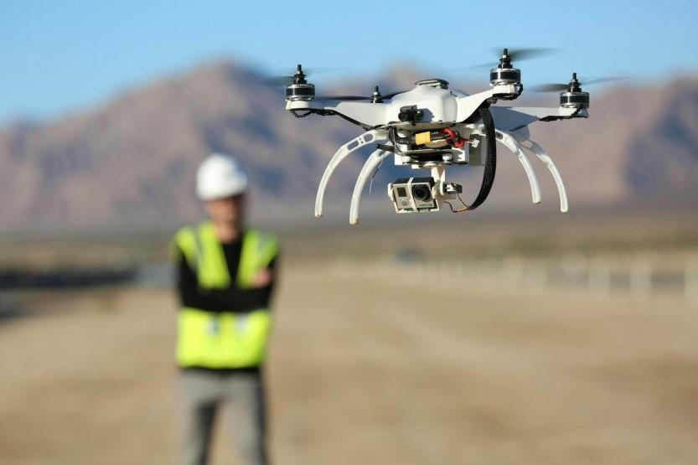

Photo 1. The drone with photo and video equipment takes off over a construction site Source: dronetrac.net

Today multicopters surprise nobody. Though they are possessed not by everyone and lawmakers try to control their usage, drones are used by professionals and amateurs. But if the latter do it episodically, specialists including builders have far-reaching plans for drones.

A good example of it — a recent publication in NVIDIA Corporation blog, American developer of graphics accelerators and CPU. The company informs that it installed an advanced graphics processor in the module Jetson TX1 on Kespry drones, which make monitoring of construction sites. Computing power of the module — more than 1 teraflops.

Video 1. The Company Kespry uses the supercomputer Jetson TX1 to improve construction sites monitoring.

Multicopters serve builders not the first year. The American newspaper The Washington Post called construction sites orchestras without conductors if actions at them are not coordinated with drones. The world leader in engineering and design Autodesk launched the project Skycatch which analyzes construction works from a multicopter in real time.

By what drone is useful on a construction site? Supposably a group of builders arrived for performing some assigned task but the previous work is not completed. They are wasting time waiting for the end of the previous work and this causes damage to business. In what state is the structure of the object, whether the area is free of garbage and security demands are followed — all is quickly tracked and sent by the drone to a control room.

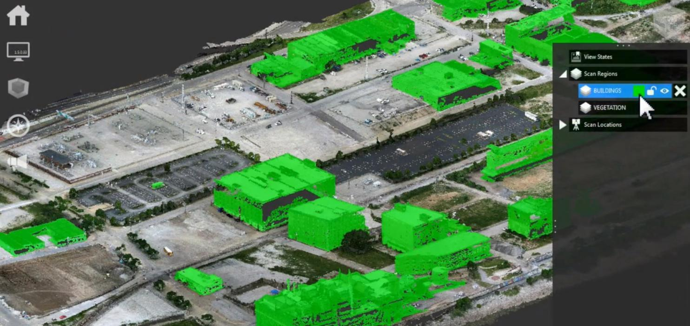

Photo 2. The example how Autodesk software is working which points out buildings on snapshots made by a drone

Meanwhile creators of construction drones move from realized projects to promising areas. The UK’s Engineering and Physical Sciences Research Council provided a grant in the amount of 2,3 millions pounds for making drones putting up temporary housing in disaster areas. Drones will build houses directly from the sky.

Perhaps during 4 years of the project implementation it will be possible to make drones able to carry enough construction materials because according to Wikipedia modern multicopters capacity is in the range of 0,5–30 kilograms. Though recently an Israeli project able to carry 150 kilograms was announced. But yet this project is on a prototype stage. For development drones for disaster areas such famous firms are invited as: the manufacturer of vacuum cleaners Dyson; BuroHappold Engineering, providing engineering consultancy; engaged in 3D-printing Ultimaker and other companies.

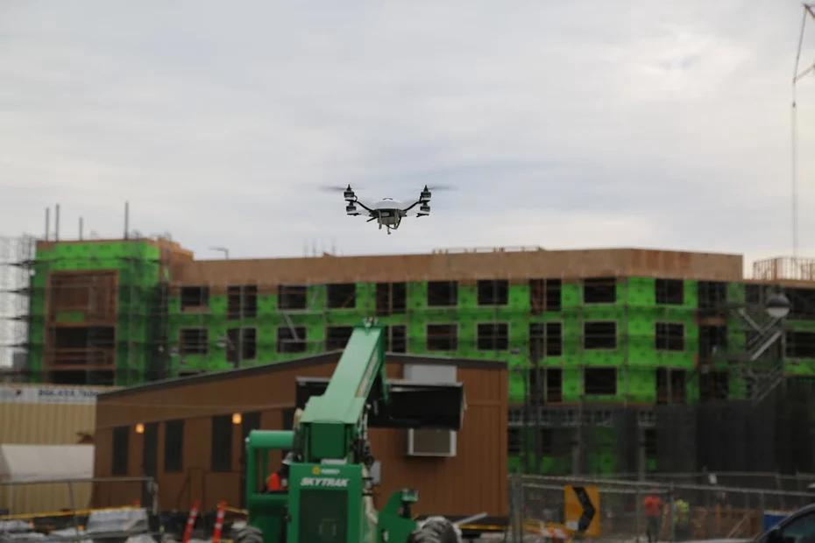

Photo 3. The drone for construction monitoring worked out by the Japan company Komatsu together with the project Skycatch

Dr Mirko Kovac, Director of the Aerial Robotics Laboratory — the participant of the project — explains that at first drones-observers will be sent to disaster areas. The gathered information will become the basis for making a virtual model of a shelter or a house, also created with the help of BIM. It will be layed in the program of a construction drone which will start 3D-printing from the sky on arrival at the designated point. The houses built in this way will have the form of a dome and will support their structure automatically.

The usage of drones in construction in spite of ambitions of engineers yet isn’t wide spread. But it’s a question of time. Multicopters are already being used in such spheres as archeology, mining, Internet services, medical aid, advertising, catering, law enforcement, agriculture, sport and mass media. Profit from drones usage is being forecasted in other fields of business. All this predicts drones great professional future.

Vlad Shatalov

Sources of information: [The Washington Post](https://www.washingtonpost.com/news/innovations/wp/2015/11/12/what-drones-can-do-for-construction-sites/), [GCR](http://www.globalconstructionreview.com/innovation/scientists-develop-flying-rob7ots-ca7n-pri7nt/), [blogs.nvidia.com](http://blogs.nvidia.com/blog/2015/11/19/kespry-jetson-tx1/), [kespry.com](http://www.kespry.com/construction/)