5 ways to save money while travelling in your own country

It always seems like the grass is greener on the other side. But if you decide to travel on your own country you will be pleasantly surprised by how amazing it is! You can take the time to visit smaller towns and regions further away from your home and still get to know new places, landscapes and local cultures.

When it comes to traveling in your own country, it’s all about traveling deeper . If you are ready to explore your homeland, here are the 5 tips for the best ways to save money while traveling in your own country!

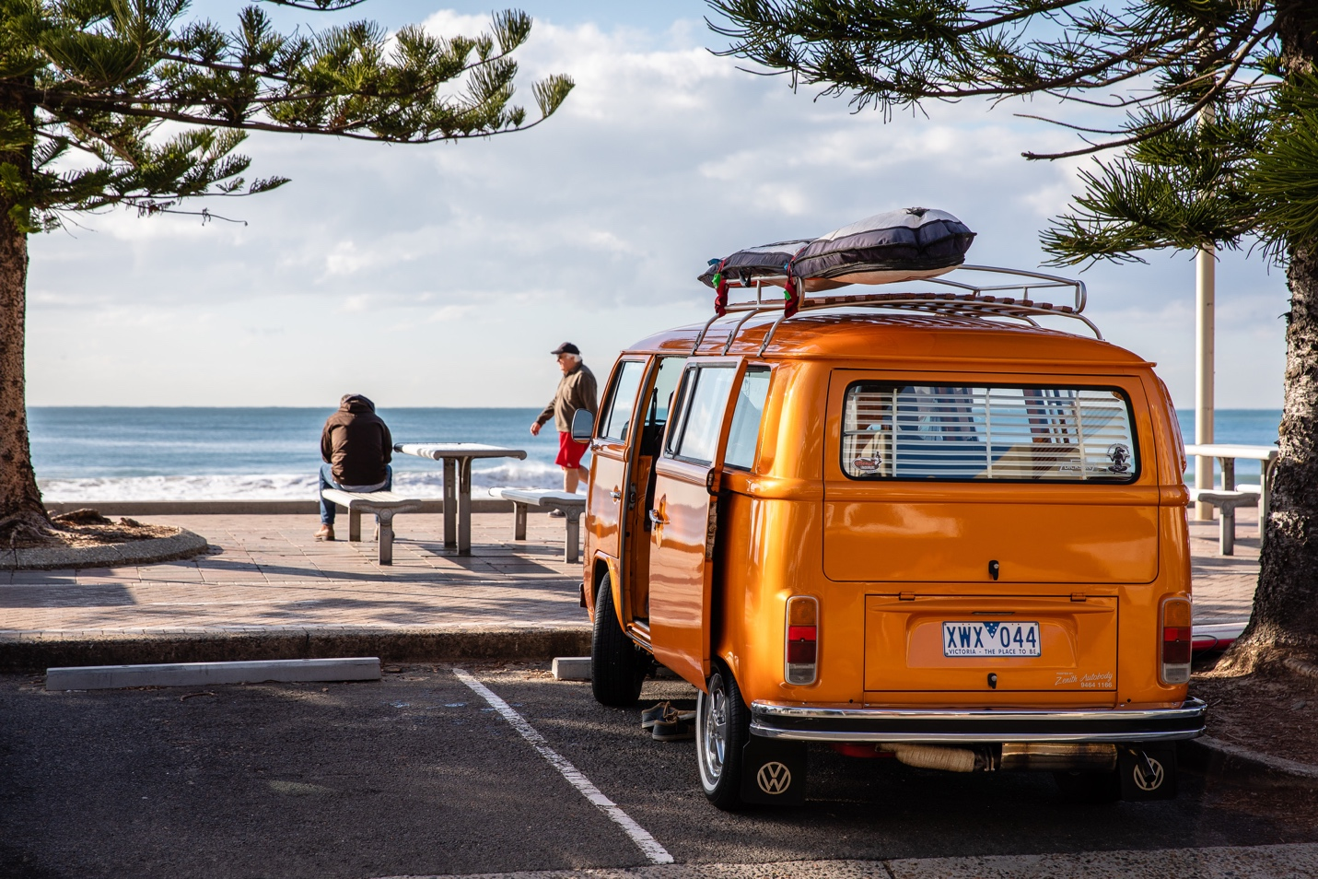
(Photo by Simon Rae on unsplash)

1. Transport

First, let’s talk about the highest expenses when we travel. Any guesses here? You are right, flight tickets! The good news is that when you travel in your own country, you most likely know the cheapest ways to get around. You can easily use your own car, rent it, or use a bus or train to get you there. It’s also possible to negotiate a reduced fare on long-distance or inter-city bus journeys. Here’s an interesting post about Huckstah train hopping experience.

For domestic flights, it is also possible to find low-cost airlines for short flights between cities at affordable prices. We suggest that you bring your snacks and water before you board the flight and skip the extra fees. We all know that packing light can help to reduce your transportation costs, so try to maximize the included luggage with these packing tips. Try to check discount fares on certain days of the week or month.

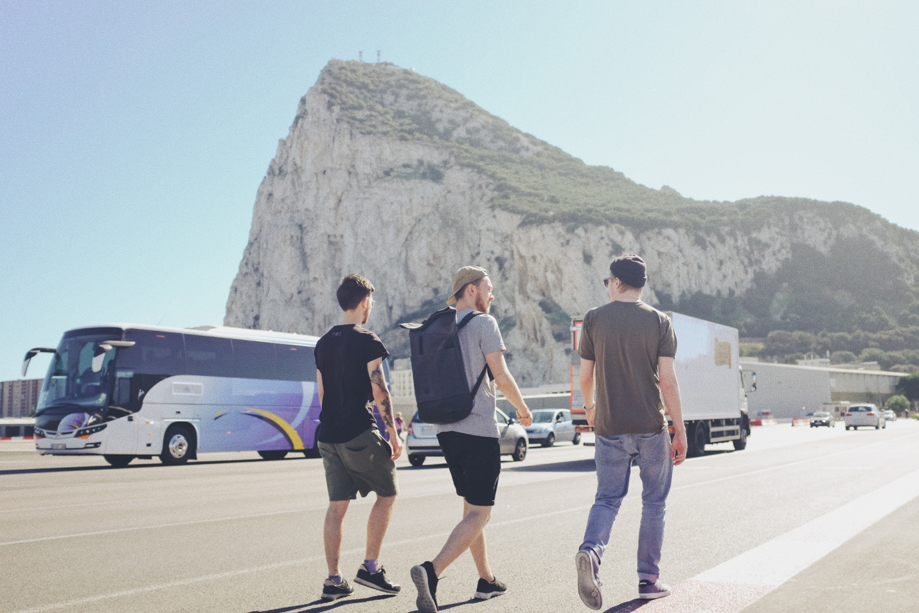
(Photo by Mike Kotsch on unsplash)

After you have bought your tickets, you can start planning your trip. If you only have a few days look for destinations not too far from home, you can make the most of it in a short time. But, if you have a few weeks, we suggest you exploring exotic destinations further away.

If you have some time to spare, you can save even more by choosing a slow transport like a bicycle. You might feel that it is the most economical option for a day of sightseeing! The slower you go the more time you have to appreciate what you see.

As Werner Herzog said: "The world reveals itself to those who travel on foot".

Pro tip: Eurovelo has cycling routes across Europe between countries for you to explore by bike

2. Accomodation
Another high expense to budget for when you travel is accommodation. Did you count how much money you actually spend on a hotel room? How many times did you use amenities such as the hotel’s swimming pool, spa or gym on your last stay?

Traveling in your home country means that you have the opportunity to reconnect with friends and family. This is especially good if you haven’t seen them for some time. It could be friends from school or university living in other cities or friends of friends who will allow you to stay in their spare room.

Depending on where your friends live, you'll save from $50 -$250 (or more) per night. It is an excellent way to save a lot of money for a hotel and reconnect with old friends.
Another plus on staying at a friend’s place is the availability of washing machines. Having a place to do your laundry can save you around $2 per week.

(Photo by Toa Heftiba on unsplash)

Once you arrive at their place, your hosts may also be willing to pick you up from the airport, train station, or bus terminal when you arrive. Perhaps, they wold also be willing to drive you around the city. Is there a better guide tour than that? No travel guidebook will ever give you the insider tips your hosts can provide.
While its all well and good, don't overstay your welcome. It’s better to agree on arrival and departure dates with your hosts before you arrive. Also, accepting hospitality means you must be ready to offer it in return. This means encouraging your friends to visit you and welcoming them with open arms when they arrive.
Pro tip: Go the extra mile and write a thank-you note before you leave, your hosts will surely appreciate it.

3. Meals
Once you arrange a place to stay, you must be ready for some food. We recommend to spend less on lunch in restaurants and prepare your own meal where you are staying in!

An easy way to make it fun at the same time is to arrange a culinary trip. It is easy to find various recipes on the internet, especially if you like to experiment with new things. So why not cook Italian or Chinese for dinner, for example? Set the table, buy the right ingredients, play some music and viola: a night to remember.

(Photo by Alyson McPhee on unsplash)

If you cannot cook, but still want to save more, then you can find a good meal for a low price near business centers or factories in certain hours.

Another option is to shop for groceries locally. Let us discuss some advantages of it! First of all, small shops usually focus on quality rather than quantity. This way you can get better and cheaper products!

For example, fresh bread, a few slices of cheese, and a piece of fruit or fresh salad will be a great meal that costs you just a few dollars. Also, be aware that on some big supermarket names, prices vary across the different branches due to nearby competitors and other factors. For those who don't have time to visit several supermarkets, keep an eye out for bargain supermarket names such as Lidl and Aldi.

The other tip to save money is to go grocery shopping in the evening! Many shops, bakeries, and supermarkets are selling perishable foods at discounted rates near their closing time. Also, check public parks, where you can barbecue your own veggies, meats, and sausages.

4. Explore the outdoors
Now we came to an important part of your expenses: activities! We suggest you try outdoor activities; it will help you to save a lot on tourist attractions. Don’t be shy to explore your country by hiking or climbing mountains! Take some time to explore hiking routes and enjoy the view from up above is a great way to explore something new without spending a penny. What more could you want!

Also take the time to visit free museums instead of expensive top ten touristic attractions. You will be surprised on how much fun it can be!

(Photo by Doran Erickson on unsplash)

5. Admission fees
Finally, once you have tried all options outdoors, you might want to visit other places. Let’s be honest, for the famous attractions, entrance fees will usually be high enough. But as a local, you will most likely not be charged extra fees or admission fees for tourist attractions. Most of the tourist attractions have some sort of fee reduction for local residents, so keep an eye out for that!

Another way to keep costs down is to use your transport passes or discount cards, this also makes the trip even more eco-friendly! Whatever choices you choose to make, stay safe and have a great time!

Pro tip: Purchase a discounted weekly, monthly, or seasonal public transport pass, this may allow for unlimited use of the service for one week, month, or longer.

(Photo by Thiebaud Faix on unsplash)

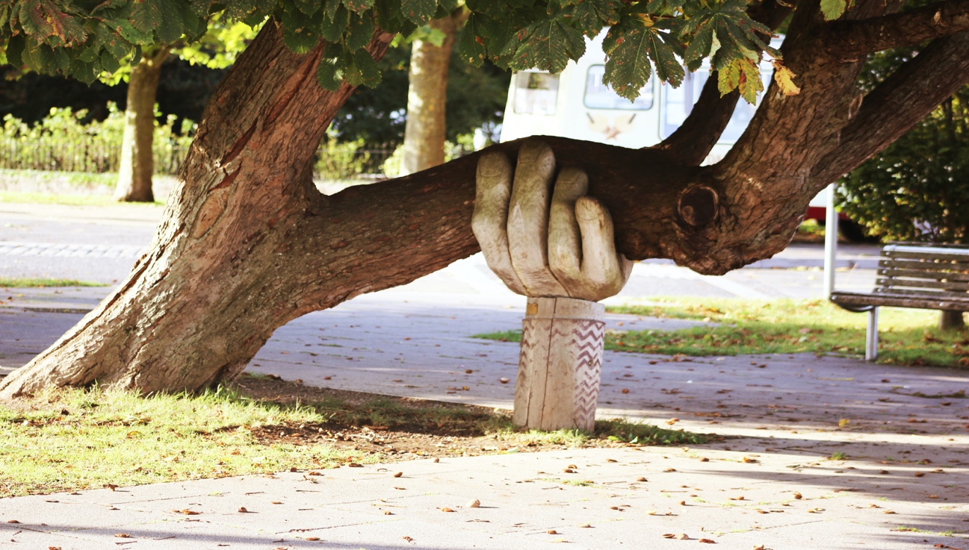
(Photo by Neil Thomas on unsplash)

If you are looking for more insider information on what to do in your country hop on Travilous app to receive top notch recommendations from fellow avid travelers and share your experiences with your community today.

