Loughborough University Institutional Repository

Effect of energy restriction on appetite regulation and metabolism at rest and during exercise

This item was submitted to Loughborough University's Institutional Repository by the/an author.

Additional Information:

A Doctoral Thesis. Submitted in partial fulfilment of the requirements for the award of Doctor of Philosophy of Loughborough University.
•

Metadata Record: https://dspace.lboro.ac.uk/2134/23290

Publisher: §c
David J. Clayton

Rights: This work is made available according to the conditions of the Cre- ative Commons Attribution-NonCommercial-NoDerivatives 4.0 International (CC BY-NC-ND 4.0) licence. Full details of this licence are available at: https://creativecommons.org/licenses/by-nc-nd/4.0/

Please cite the published version.

Effect of energy restriction on appetite regulation and metabolism at rest and during exercise

By

David John Clayton

Submitted in partial fulfilment of the requirements of the award of Doctor of Philosophy of Loughborough University

July 2016

©David J Clayton (2016)

Abstract

Current methods of energy restriction are not successful for achieving long-term weight loss and maintenance for the majority of individuals. As a result, the prevalence of obesity and obesity related diseases continue to increase. This calls for the development of novel lifestyle interventions to combat the obesity epidemic.
Hunger has been highlighted as a major factor influencing the long-term success of weight management methods and therefore how a given dietary intervention affects the appetite regulatory system may dictate the success of the diet by augmenting long-term adherence. In addition, the effect of a given dietary intervention on exercise may determine its suitability for exercising individuals and may influence the energy deficit that can be achieved by the diet.
This thesis investigated the acute effects of two novel methods of dietary restriction; breakfast omission and severe energy restriction. The main aims for this thesis were to determine the effect of these methods of energy restriction on ad-libitum energy intake, subjective appetite sensations, and peripheral concentrations of hormones involved in appetite regulation. In addition, this thesis also investigated the effects of these methods of energy restriction on metabolism and glycaemic control at rest, and performance and perceived exertion during exercise.
This work found that moderate and severe energy deficits induced by breakfast omission and 24 h of severe energy restriction, respectively, resulted in either no (Chapter VIII) or partial (Chapters IV and VII) energy intake compensation over the subsequent 24-48 h. Subjective appetite was increased during (Chapters IV, V, VII and VIII) and shortly after (Chapter VII) energy restriction, but this effect was transient and was offset after an ad-libitum (Chapters IV and VII) or standardised (Chapters V and VIII) meal. In addition, none of the work presented in this thesis demonstrated an appetite hormone response to energy restriction that was indicative of compensatory eating behaviour.
Compared to breakfast omission, breakfast consumption resulted in an increased in resting energy expenditure and carbohydrate oxidation, with a concurrent reduction in fat oxidation during the morning. However, there were no differences after lunch (Chapter V). In response to a standardised breakfast, resting energy expenditure was supressed (Chapter VII) or not

different (Chapter VIII) the following morning, after 24 h severe energy restriction compared to energy balance. Plasma NEFA and fat oxidation was greater, carbohydrate oxidation was reduced, and postprandial insulin sensitivity was impaired in the after 24 h severe energy restriction (Chapter VI, VII and VIII).
In Chapter IV, omission of breakfast in the morning was shown to reduce exercise performance in evening, even after provision of an ad-libitum lunch 4 h before. However, there was no difference in perception of effort during steady state exercise, independent of breakfast consumption or omission in the morning (Chapters IV and V).
Collectively, breakfast omission and 24 h severe energy restriction reduce energy intake and promote an appetite regulatory response conducive to maintenance of a negative energy balance. Chronic intervention studies are now required to confirm whether these effects persist after long-term practise of these dietary interventions.

Key words: obesity, weight management, appetite, energy intake, energy balance, metabolism, acylated ghrelin, GLP-1₇₋₃₆, glucose, insulin, NEFA, glycaemic control

Acknowledgements

Firstly, thank you to all the subjects that have given up their time (and food) to enable me to complete this PhD. I am forever indebted to you. I am also grateful to the nutrition group staff and students who have helped me with data collection and analysis: Carl, Steve, Phil, Asya, Claire, Kirsty, Georgina, Mark C, Nicki, Tyler, Jack and Mark F. Much of the work in this thesis would not have been possible without your help.
Special thanks must go to my supervisor Dr Lewis James for giving me the opportunity to complete this PhD. It is difficult to overstate the impact that you have had on my life both professionally and personally. You have guided and supported me since my days as a hooded undergraduate student, ever-present and a constant source of inspiration. You have encouraged me to believe in my own ability and pushed me to reach my potential. Thank you for being a fantastic mentor and a great friend. I would also like to express my gratitude to Dr David Stensel for his expertise, encouragement, friendly nature and endless generosity. I feel honoured to have worked with such an incredible supervisory team.
To the many friends that I have made during my time at Loughborough, thank you for making this journey so enjoyable. So many of you have been there with me to celebrate the peaks and pull me out of the troughs associated with life as a PhD student. Thank you all for your support, with special thanks to the boys of 10 Adam Dale!
I am incredibly fortunate to be here today. Despite no experience of higher education, my parents never hesitated to encourage me and my sisters to educate ourselves and follow our ambitions. To my Mom, you have taught me never to set myself boundaries and always believed in me. To my Dad, you have instilled in me a work ethic that has allowed me to stand out from the crowd and make a success of myself in this environment. To my sisters, thank you for your unconditional love and support. I hope that one day I can replay you for the faith you have shown in me.
Finally, to my beautiful wife Connie. More than anyone else you have been there for me throughout this process. You were the one that convinced me to follow this route when I wasn’t sure I was capable. Since then, your love, support and unwavering belief in me has enabled me to get to where I am today. I am incredibly blessed to have found someone who inspires every day.

Preface

Several elements of the work presented in this thesis have been published in peer-reviewed journals and/or presented at conferences:

Published Original Investigations

Clayton DJ, Stensel DJ, Watson P and James LJ (2014) The effect of post-exercise drink macronutrient content on appetite and energy intake. Appetite 82: 173-179.
Clayton DJ, Barutcu A, Machin C, Stensel DJ and James LJ (2015) Breakfast omission reduces 24 h energy intake and evening exercise performance. Medicine and Science in Sport and Exercise 47: 2645-2652.
Clayton DJ, Stensel DJ and James LJ (2016) Effect of breakfast omission on subjective appetite, metabolism, acylated ghrelin and GLP-1₇₋₃₆ during rest and exercise. Nutrition 32: 179-185.
Clayton DJ, Creese M, Skidmore N, Stensel DJ and James LJ (2016) No effect of severe energy restriction on appetite, energy intake and metabolism in overweight and obese males. International Journal of Obesity 40: 1662-1670.
Clayton DJ, Burrell K, Mynott G, Creese M, Skidmore N, Stensel DJ and James LJ (2016) Effect of 24 h severe energy restriction on appetite regulation and ad-libitum energy intake in lean mean and women. American Journal of Clinical Nutrition [EPub ahead of print]

Published Review Article

Clayton DJ and James LJ (2015) The effect of breakfast on appetite regulation, energy balance and exercise performance. Proceedings of the Nutrition Society 75: 319-327.

Conference Presentations

Clayton DJ, Stensel DJ, Watson P and James LJ (2013) The effect of post-exercise drink macronutrient content on appetite and energy intake. Nutrition Society Annual Summer Meeting, Northumbria University (Poster Presentation). Abstract published in Proceedings of the Nutrition Society 72: E197.
Clayton DJ, Stensel DJ and James LJ (2015) Effect of breakfast omission on subjective appetite, metabolism, acylated ghrelin and GLP-1. Satiety – from Origins to Applications (ASO and Satin), London (Poster Presentation). Abstract published in Appetite 91: 433.
Clayton DJ, Mynott G, Burrell K, Skidmore N, Creese M, Stensel DJ and James LJ (2015) Effect of severe energy restriction on appetite, energy intake and metabolism. Thirty-ninth Meeting of the British Feeding and Drinking Group, Wageningen Univeristy (Oral Presentation). Abstract published in Appetite 101: 224-225.
Clayton DJ, Barutcu A, Machin C, Stensel DJ and James LJ (2015) Breakfast omission reduces 24 h energy intake and evening exercise performance. American College of Sports Medicine Conference, San Diego (Poster Presentation). Abstract published in Medicine and Science in Sport and Exercise 47: 639.
Clayton DJ (2015) Does dietary restriction induce compensatory alterations in appetite, energy intake and metabolism? Nutrition Society Annual Summer Meeting, Nottingham University (Oral Presentation). Review article published in Proceedings of the Nutrition Society 75: 319-327.
Clayton DJ, Creese M, Skidmore N, Stensel DJ and James LJ (2016) Effect of severe energy restriction on appetite, energy intake and metabolism in overweight and obese males. Fortieth Meeting of the British Feeding and Drinking Group, Roehampton University (Oral Presentation). Abstract published in Appetite 107: 679.
Clayton DJ, Biddle J, Maher T, Stensel DJ and James LJ (2016) Effect of severe energy restriction on insulin, glucose and incretin response. European Obesity Summit, Gothenburg (Poster Presentation). Abstract published in Obesity Facts 9: 126.

Awards

GSSI-ACSM Young Investigator Award (2015) American College of Sports Medicine Conference, San Diego.
Nutrition Society Postgraduate Competition Winner (2015) Nutrition Society Annual Summer Meeting, Nottingham University.
Student Bursary Recipient (2016) Fortieth Meeting of the British Feeding and Drinking Group, Roehampton University.

Table of Contents

Abstract i
Acknowledgements iii
Preface iv
Table of Contents vii
List of Tables x
List of Figures xi
List of Abbreviations xiii
Chapter I Introduction 1
Chapter II
Literature Review 3
Energy Balance 3
Methods of Assessing Energy Balance 5
Appetite Regulation 9
Insulin Sensitivity 18
Energy Restriction 22
Breakfast 26
Severe Energy Restriction 40
Aims 53
Chapter III
General Methods 54
Recruitment 54
Pre-trial Measures 54
Standardised Test Meals 55
Study Outcomes 59
Exercise Testing (Chapters IV and V) 64
Statistical Analysis 64
Chapter IV
Breakfast omission reduces 24 h energy intake and evening exercise performance
Abstract 66
Introduction 66
Methods 68
Results 70
Discussion 76
Chapter V
Effect of breakfast omission on subjective appetite, metabolism, acylated ghrelin and GLP-1₇₋₃₆ during exercise and rest
Abstract 82
Introduction 82
Methods 83
Results 86
Discussion 91
Chapter VI
Effect of 24 h severe energy restriction on insulin, glucose and incretin response
Abstract 95
Introduction 96
Methods 97
Results 100
Discussion 103
Chapter VII
Effect of 24 h severe energy restriction on appetite, energy intake and metabolism in lean males and females
Abstract 107
Introduction 108
Methods 109
Results 112
Discussion 120
Chapter VIII
No effect of 24 h severe energy restriction on appetite, energy intake and metabolism in overweight and obese males
Abstract 124
Introduction 124
Methods 125
Results 128
Discussion 135
Chapter IX
General Discussion 140
References 155
Appendices 183

List of Tables
Table 2.1. Intervention studies assessing energy intake after a single breakfast omission.

29

Table 2.2. Intervention studies assessing energy intake after multiple breakfast
omissions. 34

Table 2.3. Intermittent fasting studies assessing weight loss. 45

Table 3.1. Energy and macronutrient intake during Chapters IV and V. 56

Table 3.2. Day 1 standardised energy and macronutrient intake for each experimental chapter. 58

Table 3.3. Intra assay coefficient of variation for each assay conducted. 63

Table 4.1. Carbohydrate (CHO), protein (PRO), fat, fibre and water intake over the course of the each trial. 71

Table 4.2. Area under the curve for each appetite variable. 74

Table 4.3. Plasma concentrations of glucose, insulin, acylated ghrelin and GLP-1₇₋₃₆
over the course of the trial during BC and BO. 76

Table 5.1. Energy and macronutrient intake. 85

Table 5.2. Plasma concentrations of acylated ghrelin, GLP-1₇₋₃₆, insulin and glucose. 90

Table 5.3. Variables collected during exercise. 91

Table 6.1. Energy and macronutrient intake at each meal (meal time in brackets) during
day 1. 99

Table 7.1. Energy and macronutrient intake during each day of the experimental trial. 113

Table 8.1. Energy and macronutrient intake during each day of the experimental trial. 129

List of Figures
Figure 2.1. The “satiety cascade”, first constructed by Blundell et al. and subsequently modified by Mela (2006). 10
Figure 2.2. Action of peripheral appetite-regulatory signals on neural pathways to influence eating behaviour. 12
Figure 2.3. Role of insulin in the regulation of glucose homeostasis. 19
Figure 2.4. Simplified insulin signalling cascade and pathways involved in dysregulation of insulin signalling. 21
Figure 4.1. Energy intake (kJ) at each test meal and over the total 24 h during BC (■)
and BO (□). 72
Figure 4.2. Subjective sensations of hunger (A), fullness (B), desire to eat (DTE) (C)
and prospective food consumption (PFC) (D) during BC (■) and BO (○). 73
Figure 4.3. Work completed (kJ) during the exercise performance test. 75
Figure 5.1. Subjective feelings of hunger (A), fullness (B), desire to eat (C) and prospective food consumption (D) (left panel) and AUC analysis (right panel) during BC (■) and BO (□). 87
Figure 5.2. Respiratory exchange ratio (RER) during BC (■) and BO (□) (A); and Resting energy expenditure AUC (B). 89
Figure 6.1. Serum glucose (A), serum insulin (B), and plasma NEFA (C) concentration during EB (■) and ER (○). Bar charts represent AUC during EB (■) and
ER (□). 101
Figure 6.2. HOMA-IR at -24 and 0 h during EB (A) and ER (B). 102
Figure 6.3. Plasma GLP-1 (A) and GIP (B) concentration, during EB (■) and ER (○). 103 Figure 7.1. Schematic representation of study protocol. 110

Figure 7.2. | Energy expenditure (A) and substrate oxidation (B) during EB (■) and ER
 | (○). | 115
Figure 7.3. | Plasma glucose (A), insulin (B), and NEFA (C) during EB (■) and ER (○). | 117
Figure 7.4. | Plasma acylated ghrelin (A) and GLP-1₇₋₃₆ (B) during EB (■) and ER (○). | 118
Figure 7.5. | AUC for hunger (A), fullness (B), DTE (C), and PFC (D), on day 1, and
 | during the morning (0-4 h), afternoon (5-11 h), and evening (11.5-24 h) of
 | day 2, during EB (■) and ER (□). | 119
Figure 8.1. | Schematic representation of study protocol. | 127
Figure 8.2. | Line graphs represent energy expenditure (A) and substrate oxidation (B)
 | during EB (■) and ER (○). | 130
Figure 8.3. | Line graphs represent glucose (A), insulin (B) and NEFA (C)
 | concentrations, during EB (■) and ER (○). | 132
Figure 8.4. | Line graphs represent acylated ghrelin (A), GLP-1₇₋₃₆ (B) and GIP₁₋₄₂ (C) concentrations, during EB (■) and ER (○). | 133
Figure 8.5. | AUC for hunger (A), fullness (B), DTE (C), and PFC (D), on day 1, the
 | morning of day 2 (0-4 h) and the afternoon of day 2 (4.5-11.5 h), during
 | EB (■) and ER (□). | 134

List of Abbreviations

α-MSH: | α-melanocyte-stimulating hormone | DIT: | Dietary induced thermogenesis
ADF: | Alternate day fasting | DPP-IV: | Dipeptidyl peptidase-IV
ADMF: | Alternate day modified fasting | DTE: | Desire to eat
AgRP: | Agouti-related peptide | EB: | Energy balance
ANOVA: | Analysis of variance | EDTA: | Ethylenediaminetetraacetic acid
ARC: | Arcuate nucleus of the hypothalmus | EER: | Daily estimated energy requirements
ATP: | Adenosine triphosphate | ELISA: | Enzyme-linked immunosorbent assay
AUC: | Area under the curve | ER: | Energy restriction
BC: | Breakfast consumption | FOXO1: | Forkhead box protein O1
BMI: | Body mass index | GABA: | Gamma-aminobutyric acid
BO: | Breakfast omission | GHS-R: | Growth hormone secretagogue receptor
CCK: | Cholecystokinin | GIP: | Glucose-dependant insulinotropic peptide
CD36 | Cluster of differentiation 36 | GLP-1: | Glucagon-like peptide-1
CHO: | Carbohydrate | GLUT4: | Glucose transporter type-4
GOAT: | Ghrelin O-acyl transferase | PHMB: | P-hydroxymercuribenzonic acid
HCl: | Hydrochloric acid | POMC: | Pro-opiomelanocortin

HOMA- IR:  IKK: | Homeostatic model of insulin resistance  Kappa-B kinase | PP:  PP2A: | Pancreatic peptide  Protein phosphatase 2A
IL-6 | Interleukin-6 | PRO: | Protein
IR: | Insulin receptor | PVC: | Paraventricular nucleus
IRS1: | Insulin receptor substrate-1 | PYY: | Peptide YY
JNK1: | c-Jun N-terminal kinase | REE: | Resting energy expenditure
LPL: | Lipoprotein lipase | RMR: | Resting metabolic rate
MC4R: | Melanocortin-4 receptors | RPE: | Rate of perceived exertion
NaOH: | Sodium hydroxide | SD: | Standard deviation
NEFA: | Non-esterified fatty-acid | TAG: | Triglyceride
NTS: | Nucleus of the solitary tract | TNF-α: | Tumor necrosis factor-α
NYP: | Neuropeptide Y | VCO₂ | Carbon dioxide production
OGTT: | Oral glucose tolerance test | V_{E}: | Volume of expired gas
PAEE: | Physical activity energy expenditure | V_{I}: | Volume of inspired air
PBS: | Potassium phosphate buffer | VLED: | Very-low energy diet
PFC: | Prospective food consumption | VO₂: | Oxygen uptake
PKC: | Protein kinase C | VO₂peak: | Peak oxygen uptake

Chapter I

Introduction

Overweight and obesity are defined by a body mass index (BMI) of 25-29.9 kg·m⁻² and equal to or greater than 30 kg·m⁻², respectively. Obesity is further characterised by a body fat percentage greater than 25% for males and greater than 35% for females (Romero-Corral et al. 2008). Maintenance of a stable body weight is achieved by careful balance between energy intake and energy expenditure. In today’s ‘obesogenic’ society, an abundance of food and reduced reliance on physical activity for transportation and recreational activities, has led to mismanagement of energy balance and consequently weight gain, in a large proportion of the population.
BMI has increased by ~0.5 kg·m⁻² per decade (Finucane et al. 2011) and the worldwide prevalence of obesity rose 27.5% for adults and 47.1% for children between 1980 and 2013, with overweight and obesity estimated to affect ~37 % of adults in 2013 (Ng et al. 2014). Obesity is associated with an increase in the prevalence of several chronic diseases, including type-2 diabetes, heart disease, hypertension and cancer (Bray 2004). In the UK, these trends for increasing obesity predict 11 million more obese adults by 2030, with associated annual medical costs of ~£2 billion (Wang et al. 2011).
For obese individuals, weight loss of as little as 5% of initial body mass is sufficient to reduce the risk factors of obesity-related disease (Anderson and Fernandez 2013). Whilst this appears to be achievable for a large number of individuals, part of the obesity problem stems from poor long-term maintenance of a reduced body mass (Anderson et al. 1999). Whether weight loss is achieved via dietary restriction, increased exercise or a combination of both, a fundamental obstacle in the attainment of a lower body mass is control of appetite. Appetite control has been identified as a major factor contributing to poor long-term dietary adherence, contributing to weight regain (Vogels and Westerterp-Plantenga 2005).
Traditional dietary restriction methods involve continuous energy restriction, achieved by reducing each meal by ~25%, to induce a moderate daily energy deficit. However, the requirement for constant restriction of food intake in order to create a sufficiently large energy deficit to induce weight loss may contribute to poor long-term adherence to this

method of energy restriction. Recently, time-restricted eating has been proposed as a method of dietary restriction, popularised in the media as ‘intermittent fasting’. This style of dieting requires abstinence from food (or consumption of a very-low energy diet) for distinct periods of time and facilitates unrestricted consumption outside of these ‘food restriction windows’.
Current weight management programmes appear to be unsuccessful in achieving and sustaining weight loss, highlighting a need for the development of novel and effective weight management programmes that encourage long-term adherence. How a given method of dietary restriction affects the appetite regulatory system may be a central factor governing dietary adherence and may also determine its suitability as a long-term weight management programme.

Chapter II

Literature Review

Energy Balance
The first law of thermodynamics states that energy cannot be created or destroyed, but can be transferred from one state to another. Therefore, in a closed system, the total amount of energy is constant. In the context of human physiology, energy is present in three forms; energy intake, energy expenditure and stored energy. If the amount of energy consumed is greater than the amount of energy expended, the surplus energy is stored as potential energy in the body.
Carbohydrate and fat, and to a lesser extent protein, are responsible for the regeneration of adenosine triphosphate (ATP) to fuel metabolic activities. When energy intake exceeds energy expenditure, excess energy will be stored for future use as either glycogen (carbohydrate) or triglycerides (fat). Glycogen is stored in the liver and muscle and is hydrophilic in nature, with ~3 g of water stored per gram of glycogen. This imposes finite limits on the amount of energy that can be stored as glycogen. Total glycogen stores in adults are estimated to be ~200-500 g, but this varies dependant on body size, carbohydrate consumption, and patterns of energy intake and energy expenditure (Flatt 1995). In contrast, fat can be stored with only ~10 % water (Sawka et al. 1990) in adipocytes located throughout the body. For example, a 70 kg lean male with 15% body fat would have ~81,000 kcal (340,000 kJ) of stored energy, contained within ~35 billion adipocytes, each with ~0.4-0.6 µg triglycerides (Hall et al. 2012). These adipocytes can shrink, expand and even multiply, essentially providing infinite energy storage capacity (Flatt 1995). Due to the limited storage capacity for energy as carbohydrate and protein, a net positive energy balance will be reflected in an increase in adiposity (Schrauwen 2007).
Energy intake is determined by macronutrient composition and amount of food consumed. The amount of energy in food that is available for metabolism is dependent on several factors, including gut flora, food preparation and the chemical composition of the food (Hall et al. 2012). The energy density of different macronutrients varies and is typically reported in the literature as 4 kcal·g⁻¹ (17 kJ·g⁻¹) for carbohydrate and protein; 9 kcal·g⁻¹ (38 kJ·g⁻¹) for fat; 2 kcal·g⁻¹ (8 kJ·g⁻¹) for fibre; and 7 kcal·g⁻¹ (29 kJ·g⁻¹) for alcohol (Hall et al. 2012). Therefore

a typical adult male diet, consistent with UK guidelines, containing 2500 kcal (10460 kJ) and with 50, 35 and 15 % of energy as carbohydrate, fat and protein, respectively, will provide
~313 g of carbohydrate, ~97 g of fat and ~94 g of protein.

Absorbed carbohydrate, fat and protein are converted into substrates that can be used to fuel metabolic processes. Total energy expenditure is comprised of three primary components; resting energy expenditure (REE), dietary induced thermogenesis (DIT) and physical activity energy expenditure (PAEE).
REE is the energy required for basic survival processes, such as breathing, circulating blood and cell renewal. For the average individual, REE accounts for approximately two-thirds of total energy expenditure, and varies dependant on body size and composition (Johnstone et al. 2005). Energy imbalance has also been shown to affect REE, with hypocaloric dieting reducing REE to a greater extent than predicted by the reduction in body size (i.e. weight loss) (Doucet et al. 2001).
DIT is the energy required for digestion and absorption of food and represents the smallest component of energy expenditure. The proportion of ingested energy required for digestion and absorption varies dependant on macronutrient content. DIT is 20-30% (of energy consumed) after protein ingestion, 5-15% after carbohydrate ingestion, and 0-3% after fat ingestion (Westerterp et al. 1999). Whist DIT varies dependant on the energetic load and macronutrient content of a meal, when an individual is in energy balance, DIT typically accounts for 10% of daily energy expenditure (Westerterp 2004).
REE and DIT varies little day-to-day within an individual, but the most malleable component of energy expenditure is physical activity. As a result, this component of energy expenditure varies substantially person to person. For a sedentary individual, ~20% of daily energy expenditure occurs through physical activity, but PAEE could account for up to 75% of total energy expenditure, during periods of heavy sustained exercise (Westerterp and Saris 1991).
From conception, stored energy is net positive which enables growth and development, reflected by an increase in body weight throughout childhood. As an adult, if weight is maintained over time, stored energy approaches zero and an approximate state of energy balance is present (Hall et al. 2012). A typical person eats several meals during the day with energy balance is strongly positive after each meal. Energy expenditure is continuous, but is elevated during periods of physical activity and reduced during sleep. Therefore, energy

balance constantly fluctuates within and between days and this variability is reflected in dynamic changes in stored energy (Hall et al. 2012). The development of obesity is the result of net positive energy balance maintained over a prolonged period of time, above that required for normal growth and development. Counter to this, maintenance of a negative energy balance over time will lead to weight loss. For example, in the absence of behavioural change, an acute reduction in energy intake will lead to weight loss. However, over time, alterations in REE, DIT and PAEE will gradually reduce energy expenditure as weight is lost, leading to restoration of a new steady state at a lower body weight. The same is true after weight gain, therefore weight-stable overweight/ obese individuals are in energy balance, but this balance is achieved with a higher amount of body fat (Hall et al. 2012). To remain weight stable within 1 kg of body weight, energy balance must be maintained on average within ~24 kcal·d⁻¹, which demonstrates the remarkable precision required for weight maintenance (Hall et al. 2011).

Methods of Assessing Energy Balance
With a constant of time, energy balance can be assessed during scientific investigation. There are several methods of assessment that can be used to determine energy intake and energy expenditure, and these vary in terms of accuracy and reliability.

Energy intake
Eating behaviour is a complex and multifaceted phenomenon which is likely influenced by physiological, cognitive and hedonic factors, in addition to learned behaviours. Therefore, the optimal protocol for measuring food intake is likely to remain elusive and inevitably compromises between external and internal validity have to be made (Blundell et al. 2010). Laboratory controlled studies often utilise an ad-libitum meal paradigm, which enables accurate quantification of energy intake by weighing food items before and after consumption. The internal validity for this method of energy intake assessment is high, as long as one factor (i.e. the intervention) is varied, whilst holding all other important factors constant. There are two main options available to researchers for assessing ad-libitum energy intake in the laboratory; either a single-item or multi-item buffet meal, with each of these approaches having various strengths and limitations.

The single item approach involves provision of a homogenous meal, often comprising of several ingredients, and each gram of food consumed is considered to have identical energy and macronutrient content. Consequently, this method only assesses energy intake and cannot determine food preference (Blundell et al. 2010). Care should be taken to ensure that the suitability of the meal selected is consistent with cultural ideals. In the UK, pasta with tomato sauce, sometimes with the addition of cheese and/or olive oil, is a frequently used example of a single-item ad-libitum meal (Deighton et al. 2013a; Gonzalez et al. 2013; James et al. 2015; Chowdhury et al. 2015a; Chowdhury et al. 2015b). With this type of energy intake assessment, the properties of the meal should be matched as closely as possible between trials to avoid any alterations in the sensory properties of the food, as this can independently affect amount consumed (Weenen et al. 2005). Care should be taken to ensure that the water content (e.g. water absorbed by the pasta during cooking), and therefore energy density of the meal, is consistent between trials, as this may influence the amount of food consumed (Bell et al. 2003). In addition, visual satiety cues should also be minimised. For example, it has been previously reported that humans will usually consume the entirety of the food on their plate (de Graaf et al. 2005), therefore when assessing ad-libitum energy intake, this visual satiety cue should be avoided. A caveat with the single-item ad-libitum energy intake assessment is the potential for boredom of taste, as opposed to satiation, causing the termination of eating (Blundell et al. 2010).
An alternative to the single-item food intake assessment is the multi-item ad-libitum buffet paradigm, which has also been used extensively in the literature (King et al. 2010; King et al. 2011; Deighton et al. 2013b; Corney et al. 2015; Douglas et al. 2015). The principles of the multi-item buffet are similar to the single item and it is essential that identical food options are provided between trials and that food is provided in excess of expected consumption. An advantage of the multi-item buffet is that it allows researchers to gauge food preferences (i.e. macronutrient selection) in addition to energy intake. However, it has been suggested that a free-selection buffet is an unreliable method of measuring food preference (Blundell et al. 2010). This is because of difficulty in controlling the sensory properties of foods, which inevitably means subjects are likely to opt for familiar and palatable foods, as opposed to having a specific desire for a particular food type. Whilst it is also likely that an increase in food choices will delay satiety and lead to elevated energy intake (Rolls et al. 1981), single and multi-item ad-libitum energy intake assessments can reliably assess food intake (Blundell et al. 2010) with a similar degree of sensitivity (Wiessing et al. 2012). However, a common

limitation between both these methods of energy intake assessment is the low external validity, as the contrived environment for food intake assessment is unlikely to reflect a habitual environment and this may influence eating behaviour (Blundell et al. 2010).
In contrast to the laboratory, free-living assessments of energy intake have greater external validity, but internal validity is generally poor (Blundell et al. 2010). There are two main methods of determining free-living energy intake; concurrent recording of food and drink intake at time of consumption (via food records) or retrospective recall of food and drink intake (via experimenter questioning). Retrospective recall requires subjects to remember exactly their eating habits and this method is likely to result in underestimated energy intake compared to concurrent reporting (Martin et al. 2002). In extension to this, completing a weighed food record, where each item is weighed and recorded at the time of consumption, may increase accuracy by reducing potential errors in estimating portion size (Gittelsohn et al. 1994). However, these methods of reporting energy intake are prone to bias and/or misreporting. Aside from technical errors in reporting food intake, such as inaccurate weighing and incomplete descriptions of food (Whybrow et al. 2016), error can be introduced via two main avenues. Firstly, subjects may alter eating behaviour to report a diet that is closer to their perceptions of social norms, or for convenience as some foods are easier to weigh than others (Macdiarmid and Blundell 1997). Secondly, subjects may, either accidently or intentionally, omit some food items from their food record (Stubbs et al. 2014). As a result, self-reported energy intake from food records tends to be underreported (Livingstone and Black 2003; Whybrow et al. 2016), and it has been suggested that self-reported energy intake should not be used as a basis of scientific conclusions (Dhurandhar et al. 2015). However, these sources of error can be minimised by ensuring subjects are properly instructed and motivated to produce accurate food records (de Castro 1994). It is also important that the duration required to complete food diaries is short because reported energy intake has been shown to decrease as duration increases, indicative of inaccuracy (Gersovitz et al. 1978).
Whilst there are inherent limitations in the measurement of self-reported energy intake, measurement error in a within-subjects study design should be similar between trials. Due to the likelihood of underreporting (Livingstone and Black 2003; Whybrow et al. 2016), self- reported energy intake should not be used to evaluate energy balance (Subar et al. 2015), but can provide valuable information about whether energy intake is altered during or after an intervention (de Costa 1994; Subar et al. 2015).

Energy expenditure
The interaction between dietary intake and energy expenditure will determine overall energy balance, and by virtue weight management, so an appreciation of energy expenditure is crucial.
A simple method to calculate total energy expenditure is using predictive equations. Examples of these include the Mifflin-St Jeor (Mifflin et al. 1991), the Harris-Benedict (Harris and Benedict, 1919), the Owen (Owen et al. 1986; Owen et al. 1987) and the Schofield (Schofield, 1985) equations. The Mifflin-St Jeor equation, which uses weight, height, age and gender to estimate resting metabolic rate (RMR), is thought to be the most accurate (Frankenfield et al. 2005). Once calculated, RMR can be multiplied by a physical activity level, which is determined individually dependent on subjects’ habitual activity level, with 1.40-1.69 representative of a sedentary lifestyle, 1.70-1.99 for a moderately active to active lifestyle, and 2.00-2.40 for a vigorously active lifestyle (FAO/WHO/UNU, 2004). These values have been generated from doubly labelled water assessment, which is considered the ‘gold standard’ method for measuring total energy expenditure (Schoeller and Van Santen, 1982). The doubly labelled water technique is considered to be 93-99% accurate (Bluck, 2008), but the cost, practicalities and inability to determine individual components of energy expenditure (i.e. REE, DIT and PAEE) limit the wider usage of this method in research.
In a laboratory, RMR can be determined by indirect calorimetry, whereby changes in volume and composition between inspired air and expired gas (in a specific time frame), can be used to calculate energy expenditure and substrate oxidation using the stoichiometric equations described by Frayn (1983). This method can accurately and reliably determine RMR provided certain conditions are met, including accurate calibration of equipment, subjects are in a rested steady state and that laboratory conditions remain similar measurement to measurement (Compher et al. 2006; Betts and Thompson 2012). Ideally, RMR should also be determined in the fasted state, but if the conditions described above are met, a postprandial elevation above fasted values can be attributed to DIT (Westerterp 2004).
For a laboratory investigation, measurement of PAEE may not be a true representation of PAEE, as the confines of the laboratory are likely to restrict this aspect of energy expenditure. But in a free-living environment, PAEE is likely to be the most malleable component of energy expenditure. Previous research has attempted to measure free-living physical activity

using wearable devices, such as accelerometers, but an accurate determination of PAEE is difficult (Dhurandhar et al. 2015). Accelerometry is limited by the possibility for a high level of energy expenditure in the absence of acceleration (for example, running on a treadmill). This source of error can be countered by measuring heart rate, but this can vary independently of energy expenditure through stress or high-individual variability (Rennie et al. 2000). Actiheart monitors have enabled more accurate estimates of free-living energy expenditure to be achieved through combining accelerometry with heart rate (Rennie et al. 2000). These devices have been recently used to investigate the effect of chronic energy restriction on energy expenditure (Betts et al. 2014; Chowdhuy et al. 2016). However, due to the extended time that subjects were required to remain in the laboratory and the acute monitoring period, free-living energy expenditure was not determined in the studies presented in this thesis.

Appetite Regulation
The appetite regulatory system affects energy balance by modulating energy intake. For the average individual, alterations in energy intake has a higher magnitude of impact on energy balance than alterations in energy expenditure (Thomas et al. 2012). In addition, a recent paper found that for every kilogram of body mass loss, energy intake was upregulated by
~100 kcal·d⁻¹, which is several fold greater than any energy expenditure adaptation to weight loss (Polidori et al. 2016). Therefore, understanding how the appetite regulatory system responds to an intervention may have a profound influence on whether the intervention can assist with long-term weight loss and management.
Food intake is controlled by both satiation (the process that terminates an eating occasion) and satiety (the process that inhibits subsequent eating). The appetite regulatory system controls both satiation and satiety, but these are complex phenomenon, likely influenced by homeostatic, hedonic and behavioural cues (Figure 2.1).

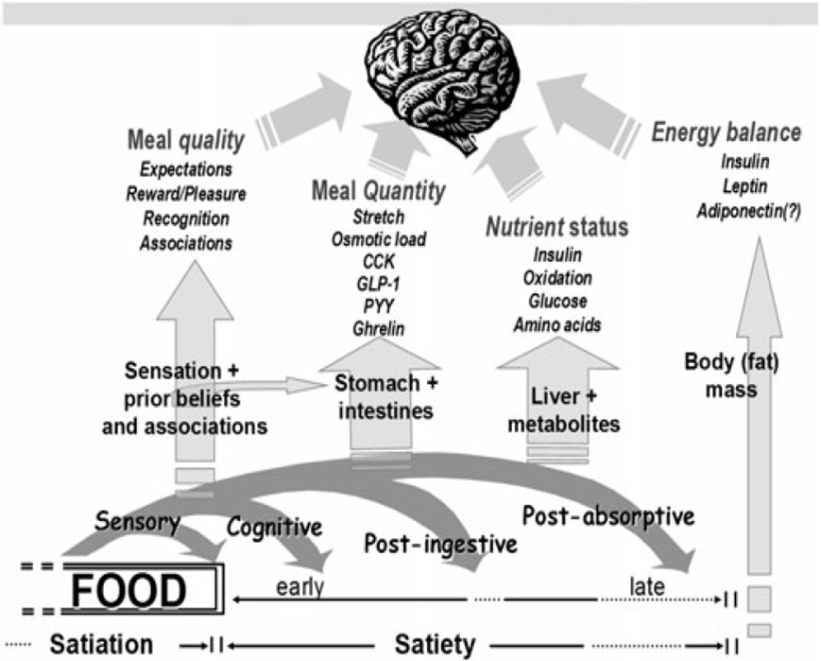

Figure 2.1. The “satiety cascade”, first constructed by Blundell et al. and subsequently modified by Mela (2006).

Central regulation of appetite
The hypothalamus is the key brain area that regulates energy homeostasis. Within the hypothalamus, the ventromedial hypothalamus is the appetite supressing (anorexigenic) centre and lateral hypothalamic area is the appetite stimulating (orexigenic) centre (Sohn 2015). These brain regions are responsible for the integration and interpretation of several physiological and hedonic stimuli.
The arcuate nucleus of the hypothalamus (ARC) contains two distinct neuronal pathways that have opposite effects on eating behaviour; the anorexigenic pro-opiomelanocortin (POMC) and the orexigneic neuropeptide Y/ agouti-related peptide (NPY/AgRP) neurons. POMC neurons suppress feeding by releasing α-melanocyte-stimulating hormone (α-MSH), which exerts an agonistic effect on the melanocortin-4 receptors (MC4R), a key anorexigenic pathway in the central nervous system. In contrast, AgRP produces an orexigenic effect by blocking α-MSH, exerting an antagonistic effect on MC4R (Sohn 2015), and NPY stimulates

food intake through activation of neuropeptide Y1 and Y5 receptors (Neary et al. 2004). The neurotransmitter gamma-aminobutyric acid (GABA) may also mediate orexigenic pathways involving GABAergic input from NPY/AgRP neurons, which inhibits POMC neurons to form an appetite regulatory circuit within the central nervous system (Sohn 2015).
These neuropeptides are regulated in response to hormonal inputs from the circulation and neural inputs from the vagus nerve, which has nerve endings located in the gastrointestinal tract (Neary et al. 2004). The ARC is ideally positioned, with a rich blood supply due to close proximity to the median eminence and receives neural input from multiple parts of the central nervous system, including the nucleus of the solitary tract (NTS) in the brainstem (Sohn 2015). Stimulation of ARC and NTS neurons induces neurotransmission to multiple parts of the hypothalamus, particularly the paraventricular nucleus (PVN). The PVN integrates these signals and initiates a coordinated behavioural response (Figure 2.2).

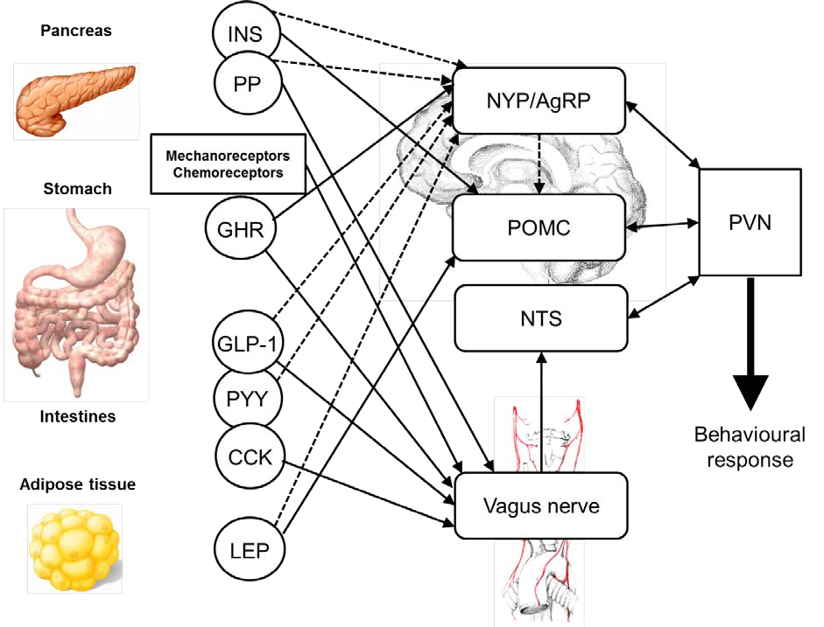

Figure 2.2. Action of peripheral appetite-regulatory signals on neural pathways to influence eating behaviour. Adapted from Neary et al. 2004, Wynne et al. 2005 and Murphy and Bloom 2006. INS, insulin; PP, pancreatic peptide; GHR, ghrelin; GLP-1, glucagon-like peptide-1; PYY, peptide YY; CCK, cholecystokinin; LEP, leptin; NPY, neuropeptide Y; AgRP, agouti-related peptide; POMC, pro-opiomelanocotin; NTS, nucleus of the solitary tract; PVN, paraventricular nucleus. Solid lines indicate a stimulatory effect and dashed lines indicate an inhibitory effect.

Peripheral regulation of appetite
As illustrated in figure 2.2, there are several tonic and episodic hormones that have been implicated in the regulation of appetite and help to maintain energy balance homeostasis. Tonic hormones are altered in response to long-term changes in energy balance, whereas episodic hormones are thought to respond to short term fluctuations in fasting and feeding cycles.

Tonic signals
Kennedy (1953) postulated that hypothalamic regulation of food intake was determined by a circulating factor that responds to changes in adipose tissue mass to achieve long-term weight stability. Leptin, primarily secreted by adipose cells in concentrations proportional to fat mass (Zhang et al. 1994; Considine et al. 1996), has been identified as a candidate for this role. As concentrations of leptin increase, leptin exerts an anorexigenic action through inhibition of the NPY/AgRP neurons and stimulation of the POMC neurons (Cowley et al. 2001). Leptin increases after several days of overfeeding (Kolaczynski et al. 1996) and falls dramatically during periods of energy restriction (Weigle et al. 1997). The magnitude of this response to energy restriction is disproportionate to fat-mass loss, suggesting that leptin may prompt an increase in energy intake prior to body mass loss, to stabilise body mass (Neary et al. 2004). The importance of leptin in energy homeostasis has been shown in leptin-deficient, hyperphagic obese children, with recombinant leptin reducing hyperphagia and fat mass (Farooqi et al. 2002). However, plasma leptin concentrations are elevated in obese individuals (Considine et al. 1996), reflecting their high fat mass, but also indicating resistance to the anorexigneic effects of leptin may occur with obesity.
Insulin also fits the criteria described by Kennedy (1953), as insulin increases in response to nutrient intake and greater plasma concentrations tend to be present in overweight and obese individuals (Porte et al. 2002). Insulin is secreted from the pancreas and has a central role in metabolism. Once insulin penetrates the blood-brain barrier, it produces an anorexigneic effect through inhibition of the NPY/AgRP pathways and stimulation of the POMC pathways (Wynne et al. 2005). In line with leptin, fasted and postprandial concentrations of plasma insulin increase with adiposity, and the development of peripheral insulin resistance appears to coincide with hypothalamic insulin resistance, which reduces the anorexigenic effects of the hormone (De Souza et al. 2005).

Episodic signals
Whilst alterations in fasting and postprandial leptin and insulin concentrations tend to occur over long periods of time, there are several hormones that have been implicated in the short term regulation of food intake. These hormones are primarily secreted from the gastrointestinal tract in response to nutrient intake and may be involved in satiation and satiety. After food intake, mechanoreceptors in the stomach respond to gastric distention,

sending anorexigenic signals via the vagus nerve to the NTS (Janssen et al. 2011). Concurrently, an array of appetite mediating gut peptides are secreted, which influence appetite regulation and energy homeostasis through various pathways.

Ghrelin

Ghrelin is a 28-chain amino-acid peptide, secreted primarily from the oxyntic cells in the stomach (Kojima et al. 1999). Ghrelin is unique as it is the only peripherally circulating peptide understood to stimulate the NYP/AgRP orexigenic pathway (Wynne et al. 2005). Plasma concentrations are highly responsive to feeding, with high concentrations in the fasted state which are rapidly suppressed after feeding (Cummings et al. 2001). Intravenous administration of ghrelin increased food intake 28% compared to saline infusion (Wren et al. 2001) and concentrations of ghrelin also correlate with perception of hunger (Cummings et al. 2004), suggesting a central role for ghrelin in short term appetite regulation. However, in the study of Wren et al. (2001), it should be noted that the intravenous infusion of ghrelin (5 pmol·kg⁻¹·min⁻¹) produced supraphysiological plasma ghrelin concentrations in order to suppress food intake. In a more recent study, ghrelin was intravenously infused at a far lower, but still supraphysiological, concentration (0.3 pmol·kg⁻¹·min⁻¹), and there was no effect on appetite perceptions (Lippl et al. 2012). Therefore caution is necessary when interpreting intravenous infusion studies. Ghrelin also appears to be involved in chronic energy homeostasis, as plasma concentrations of ghrelin are lower in obese individuals and higher in anorexia nervosa patients (Tschop et al. 2001).
In order to exert its biological function, ghrelin requires acylation with n-octanoic acid, by the enzyme ghrelin O-acyl transferase (GOAT) (Yang et al. 2008). Acylated ghrelin is therefore orexigenic, with desacylated ghrelin a by-product of its degradation, although recent work suggests desacylated ghrelin may have a distinct biological action (Delhanty et al. 2012). Ghrelin is an endogenous agonist of the growth hormone secretagogue receptor (GHS-R) and stimulates the release of growth hormone through the type 1a receptor in the hypothalamus (Wynne et al. 2005). However, the orexigenic effects of ghrelin are independent to the effects on growth hormone. Ghrelin stimulates the NPY/AgRP pathways and inhibits the POMC pathways (Cowley et al. 2003), with GHS-R also located on the vagus nerve (Date et al. 2002), suggesting that ghrelin may effect both the ARC and NTS to stimulate an orexigenic action.

Glucagon-like peptide-1 (GLP-1)

GLP-1 is secreted from the intestinal L-cells in response to nutrient intake and exerts an anorexigenic action, in addition to its role in insulin secretion (Holst 2007). Peripheral administration of GLP-1 reduces food intake in a dose dependant manner in lean and obese individuals (Verdich et al. 2001), although at a physiological concentration these effects were attenuated (Flint et al. 2001). Plasma concentrations of GLP-1 are also reduced after weight loss (Adam et al. 2005; Adam et al. 2006) and GLP-1 has been shown to reduce the rate of gastric emptying (Nauck et al. 1997). GLP-1 is primarily present in two forms; GLP-1₇₋₃₆ (the biologically active form) and GLP₉₋₃₇ (the inactive form). Upon release, GLP₇₋₃₆ is rapidly degraded into its inactive form by the enzyme dipeptidyl peptidase-IV (DPP-IV) (Holst 2007). Therefore, concentrations of GLP₇₋₃₆ detected peripherally may not accurately represent GLP₇₋₃₆ secreted from the intestine.
Anorexigenic effects appear to be mediated primarily by GLP-1 receptors located in the ARC and NTS (Neary et al. 2004). Receptors in the NTS are activated (show c-fos expression) by distension of the stomach via afferent feedback from the vagus nerve (Vrang et al. 2003). The effect of GLP-1 on gastric emptying may also contribute the anorexigenic effect, by increasing satiation and satiety (Nauck 2009).

Peptide YY (PYY)

PYY is a member of the NPY family and is co-secreted with GLP-1 from the intestinal L- cells (Habib et al. 2013). Plasma concentrations of PYY are low in the fasted state (Batterham et al. 2007) and increase rapidly after food intake (Adrian et al. 1985). Like GLP- 1, PYY is present peripherally in two forms. PYY₃₋₃₆ is the most abundant and bioactive form and is produced by cleavage of the N-terminal from the biologically inactive PYY₁₋₃₆, by the enzyme DPP-IV (Karra et al. 2009). The anorexigneic effect of this peptide was demonstrated with peripheral administration of PYY₃₋₃₆, which reduced food intake in lean and obese individuals (Batterham et al. 2003). However, this study induced supraphysiological concentrations of PYY₃₋₃₆ to see this effect. Infusion of PYY₃₋₃₆ to induce a physiological increase in plasma PYY₃₋₃₆ does not inhibit food intake (Degen et al. 2005), suggesting that pharmacologic doses of exogenous PYY₃₋₃₆ are required to inhibit food intake in humans. The anorexigenic action of PYY₃₋₃₆ appears to be due to high affinity with the Y2 receptor, which produces inhibitory expression on NPY neurons (Wynne et al. 2005).

Cholecystokinin (CCK)

CCK is an anorexigenic hormone, released from intestinal I cells in response to nutrient intake, peaking approximately 25 min after eating (Harrold et al. 2012). CCK has been suggested to be important for satiation, as pre-meal peripheral administration of CCK has been shown to reduce food intake via earlier meal termination (Kissileff et al. 1981), but has little effect on satiety, possibly due to its short half-life (1-2 min) (Wynne et al. 2005). Consequently, meal frequency has been shown to increase with pre-meal peripheral administration of CCK in animals (West et al. 1984). CCK exerts an anorexigenic effect through the NTS, via activation of CCK1 receptors on the vagus nerve (Wynne et al. 2005).

Pancreatic Peptide (PP)

PP is produced by pancreatic islet cells in response to gastric distension (Wynne et al. 2005). PP binds with greatest affinity to Y4 and Y5 receptors but cannot cross the blood brain barrier (Wynne et al. 2005). Therefore PP is likely to exert an anorexigenic influence through the vagus nerve and may modulate the action of other gut hormones, such as ghrelin (Wynne et al. 2005).

Measurement of subjective appetite
As well as interpreting the hormonal regulators of appetite, it is important to understand that subjective sensations of appetite, such as hunger, fullness, desire to eat and prospective food consumption, are likely to have an important role in determining energy intake at a single meal, and also subsequent meal initiation. In research, these subjective responses are typically quantified using visual analogue scales (Blundell et al. 2010).
It is important to note that the validity of these scales are not dependant on the outcome measure (i.e. energy intake), as there are times when humans will eat without the sensation of hunger, and conversely can avoid eating when hungry (Mattes, 1990). Instead, these subjective measures should be considered an indicator of subject’s susceptibility to be influenced (e.g. by external stimuli) to consume food. When conducted appropriately, visual analogue scales can produce valid and reproducible results (Blundell et al. 2010). Using a
100 mm visual analogue scale to assess hunger, satiety, fullness, prospective food consumption, desire to eat and sensory variables, Flint et al. (2000) found good test-retest reliability in fasting and mean postprandial appetite sensations. In addition, this study also

determined that differences between subjective appetite sensations in a paired research design could be detected in 8-11 subjects. Therefore, when sufficiently powered, visual analogue scales can be used as a surrogate measure for determining subjective appetite sensations in research.

Eating behaviour
Fundamentally, eating is a rewarding and pleasurable process, intrinsically linked to mood and emotions, which can challenge homeostatic regulation of energy intake (Meule and Vogele 2013). For our ancestors, this emotional attachment to food led to the engagement in food seeking behaviour, which was essential for our survival as a species. Whilst this pleasurable attachment to food remains important to our survival, the abundance of food and omnipresence of food related cues in today’s society often means these tendencies are counterproductive for the regulation of a healthy body weight. Dietary restraint and disinhibition are two counteracting eating behaviours that form the basis for regulating energy intake. Whilst many individuals are able to balance restraint and disinhibition, others exhibit overexpression of one or both of these tendencies, which can lead to disorders such as anorexia, bulimia, or obesity (Meule and Vogele 2013).
Numerous factors are thought to determine or guide eating behaviour. Social interaction (Higgs and Thomas 2016) and environmental cues (such as packaging, portion size and advertising) (Cohen and Babey 2012) have been shown to increase energy intake, as it is thought that these factors override the cognitive effort required to successfully practise dietary restraint (Mitchell and Brunstrom 2005). In addition, conforming to the behaviour of others is adaptive and rewarding, which is often why ‘social-facilitation’ leads to increased energy intake (Higgs and Thomas 2016).
In a laboratory environment efforts are made to limit these influences. For example, subjects consume food at distinct meal times, in an isolated booth to avoid any effect of meal planning or social interaction on energy intake. In addition, individuals exhibiting high levels of dietary restraint or disinhibition, determined using the three-factor eating questionnaire (Stunkard and Messick 1985), are excluded from these studies, allowing results to be generalised to a greater proportion of the population. However, in a free-living environment, it is likely that eating behaviours and tendencies will play a role in governing energy intake.

Insulin Sensitivity
Despite constantly cycling between periods of fasting and feeding, plasma glucose concentrations are consistently maintained within a narrow range of ~4-10 mmol·L⁻¹. This is achieved by regulation of glucose absorbance from the intestine, glucose production from the liver, and uptake and metabolism of glucose primarily in the body’s peripheral tissues (Saltiel and Kahn 2001). Insulin is the key hormone at the centre of this regulatory process with concentrations of plasma insulin directly affecting endogenous production and exogenous glucose delivery. In the fasted state, low concentrations of insulin (and increased concentrations of glucagon), which will promote hepatic glucose production and reduce uptake of glucose into the peripheral tissues After feeding, insulin is released from the pancreas, signalling glucose uptake in muscle and fat for metabolism and storage, inhibiting hepatic glucose production. (Saltiel and Kahn 2001). This ability to balance the utilisation and storage of glucose has enabled humans to cope with prolonged periods of food scarcity, but can become counter expedient in a sedentary society with an abundant food supply (Samuel and Shulman 2012). Excess food intake and lack of exercise can lead to the development of insulin resistance, essentially dampening the body’s response to insulin, requiring greater concentrations to elicit the same response. Typically, this results in prolonged elevation of plasma glucose, which causes oxidative stress and damage to several organs and tissues (Kawahito et al. 2009). Prolonged resistance to insulin can lead to the development of type-2 diabetes, a condition characterised by prolonged periods of hyperglycaemia, due to almost complete resistance to the action of insulin and/or dysfunction of the insulin secreting pancreatic β-cells (Kahn 2003).
Insulin increases glucose uptake in cells via translocation of glucose transporter type 4 (GLUT4) from intracellular to cell surface (Saltiel and Kahn 2001). The skeletal muscle is the primary site of insulin-dependent glucose uptake, with a small amount insulin-dependent uptake in adipose tissue (Klip and Paquet 1990). Although insulin does not directly stimulate hepatic glucose uptake, insulin does block glycogenolysis and gluconeogenesis and stimulates glycogen synthesis, thereby maintaining normal plasma glucose concentrations (Saltiel and Kahn 2001; Figure 2.3).

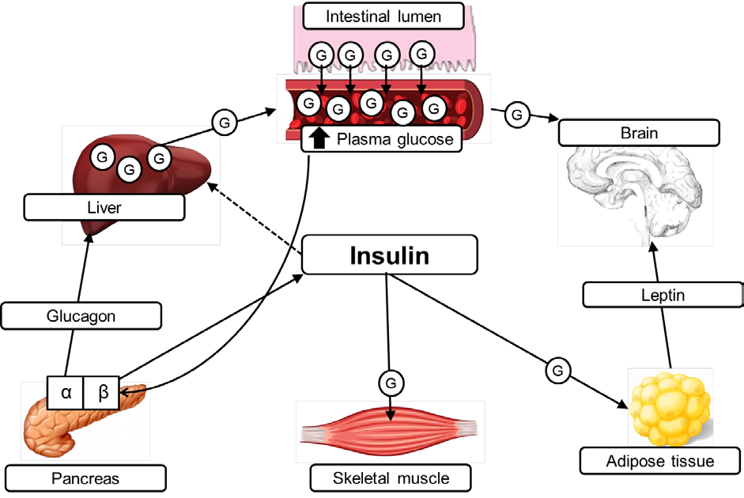

Figure 2.3. Role of insulin in the regulation of glucose homeostasis. Exogenous glucose from the digestive absorption of nutrients and endogenous hepatic glucose production enter the blood. This stimulates pancreatic β-cells to release insulin, which then signals the uptake of glucose in skeletal muscle and adipose tissue and inhibits hepatic glucose production. Non- insulin-dependent glucose uptake occurs in other tissues, including the brain. Adapted from Saltiel and Kahn 2001. G, glucose. Solid lines indicate a stimulatory effect and dashed lines indicate an inhibitory effect.

Insulin signalling pathways
A full examination of insulin signalling pathways is beyond the scope of this thesis. Interested readers are directed to the following papers for more comprehensive reviews (Saltiel and Kahn 2001; Samuel and Shulman 2012).
After secretion from pancreatic β-cells, insulin activates the insulin receptor (IR) tyrosine kinase on the cell membrane. Downstream regulation then requires phosphorylation of insulin receptor substrate-1 (IRS1), which then leads to the activation of Akt2, through a series of intermediary steps. Akt2 then phosphorylates AS160, which promotes the translocation of GLUT4 from the intercellular to the cell surface, allowing glucose to enter the cell. The

enzyme glycogen synthase then promotes the storage of glucose as glycogen. This pathway is particularly important for glucose uptake in the muscle, which is responsible for 75% of total insulin-dependent glucose uptake (Klip and Paquet 1990). Concurrently, Akt also inactivates forkhead box protein O1 (FOXO1) to reduce gluconeogenesis, thereby reducing hepatic glucose production (Samuel and Shulman 2012). In sum, this pathway regulates blood glucose concentration during times of high exogenous glucose availability (i.e. after a meal) by increasing glucose uptake in active tissues and reducing hepatic glucose production.
The accumulation of excess adiposity (particularly visceral adiposity) is associated with the development of insulin resistance through dysregulation of insulin signalling (Hardy et al. 2012). One mechanism of insulin resistance may be due to an increase in metabolically toxic fatty acids, such as ceramides and diacylglycerides, which are products of incomplete fatty acid oxidation (Hardy et al. 2012). These may impair downstream insulin signalling via activation of protein kinase C (PKC) proteins, which impairs Akt activation, thus limiting GLUT4 translocation. In addition, impaired Akt activation limits the inactivation of FOXO1, which increases gluconeogenesis in liver, resulting in reduced suppression of hepatic glucose production (Samuel and Shulman 2012). Consequently, plasma glucose is elevated due to reduced glucose uptake and greater hepatic glucose production.
A second mechanism of impaired insulin action is the release of inflammatory cytokines, such as tumor necrosis factor-α (TNF-α) and interleukin-6 (IL-6). Visceral adipose tissue has a propensity to secrete cytokines that impair insulin signalling and this may contribute to insulin resistance (Hardy et al. 2012). Specifically, these cytokines may activate nuclear factor kappa-B kinase (IKK) and c-Jun N-terminal kinases (JNK1), which impact insulin signalling via ceramide synthesis and via reduced serine phosphorylation of IRS1, respectively (Samuel and Shulman 2012; Figure 2.4.).
Therefore the accumulation of body fat (particularly visceral fat) with obesity may increase the risk of insulin resistance, potentially progressing to type-2 diabetes, through dysregulation of the insulin signalling cascade. Therefore, methods to prevent the accumulation of body fat are of critical importance.

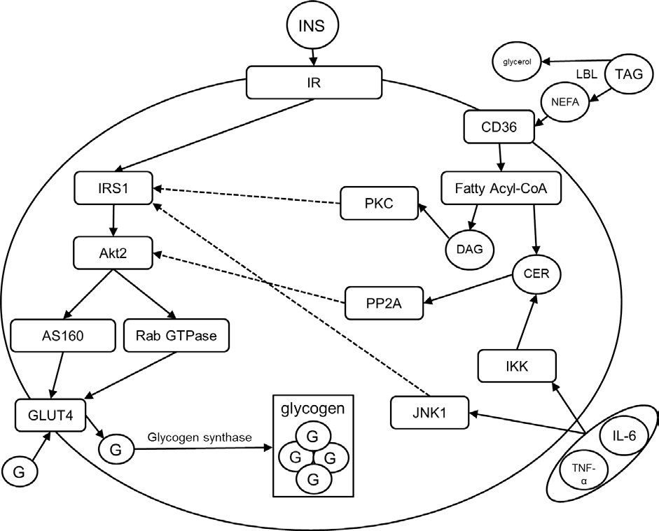

Figure 2.4. Simplified insulin signalling cascade and pathways involved in dysregulation of insulin signalling. Adapted from Samuel and Shulman (2012). INS, insulin; TAG, triglycerides; NEFA, non-esterified fatty-acid; G, glucose; IR, insulin receptor; IRS1, insulin receptor substrate 1; GLUT4, glucose transporter type 4; LPL, lipoprotein lipase; CD36, cluster of differentiation 36; PKC, protein kinase C; PP2A, protein phosphatase 2A; DAG, diacylglycerol; CER, ceramide; IKK, inhibitor of nuclear factor kappa-B kinase; JNK1, c-Jun N-terminal kinases; IL-6, interkeukin-6; TNF-α, tumor necrosis factor alpha. Solid lines indicate a stimulatory effect and dashed lines indicate a pathway of dysregulation.

The ‘incretin effect’
The ‘incretin effect’ was first recognised when it was observed that the insulinemic response to a glucose load was greater when ingested orally compared to when administered intravenously (Nauck et al. 1986). This postprandial elevation in insulin secretion is potentiated by two gut hormones, GLP-1 and glucose-dependant insulinotropic peptide (GIP),

which are released in response to glucose consumption (i.e. prior to absorption), and thought to account for up to 70% of total insulin secretion in healthy individuals (Baggio and Drucker 2007).
GIP is released in its active form (GIP₁₋₄₂) from the intestinal K-cells in the proximal intestine and the insulinotropic action of GIP is mediated by G-protein-coupled receptors located on islet β-cells (Baggio and Drucker 2007). Due to its proximal location in the intestine, it is thought that GIP is primarily responsible for first-phase insulin secretion. In diabetic individuals GIP may be hypersecreted, but sensitivity to the insulinotropic action is largely lost. This may be due to reduced expression of GIP-receptors or reduced β-cell sensitivity (Nauck 2009).
In contrast, GLP-1₇₋₃₆ is secreted from intestinal L-cells located in the distal intestine (Baggio and Drucker 2007), but GLP-1 exerts an effect on both first and second phase insulin secretion. Like GIP, GLP-1₇₋₃₆ binds to receptors on islet β-cells, directly stimulating insulin secretion. However, GLP-1 also mediates postprandial glycaemia by delaying gastric emptying, thus slowing the delivery of nutrients into the circulation (Nauck et al. 1997). This likely occurs via effects on vagal neurotransmission (Nauck et al. 1997). GLP-1 also inhibits the release of glucagon from pancreatic α-cells, which subsequently suppresses hepatic glucose production (Baggio and Drucker 2007)
Upon release, GLP-1₇₋₃₆ and GIP₁₋₄₂ are rapidly degraded into GLP-1₉₋₃₆ and GIP₃₋₄₂ by DPP- IV within 2-7 min, after which they can no longer exert their biological effect (Nauck 2009).

Energy Restriction
As previously discussed, the accumulation of excess adiposity is associated with development of several chronic diseases (Bray 2004) and even a modest (~5%) reduction in weight can reduce risk factors of these diseases significantly (Anderson et al. 1999). In reference to the laws of thermodynamics, interventions either decreasing energy intake or increasing energy expenditure should have equal effects on energy balance and weight loss. However, these two methods of inducing an energy deficit appear to have disparate effects on appetite regulation and energy intake (King et al. 2011; Cameron et al. 2016). In the short term, energy intake appears to be unaffected by exercise (King et al. 2011; King et al. 2010; Deighton et al.

2013a), whereas energy restriction has been shown to markedly increase hunger and energy intake (King et al. 2011; Hubert et al. 1998; Cameron et al. 2016).
Despite this, in a free-living environment, weight-loss interventions utilising energy restriction or a combination of energy restriction and exercise, achieve far superior weight loss, compared to interventions utilising exercise alone (Miller et al. 1997). One reason for this could be that even modest energy restriction has the potential to exert a profound effect on energy balance. For example, typical energy restriction diets aim to reduce daily energy intake by about 25% (~2615 kJ), which would require approximately 60 min of moderate intensity exercise each day (65 % VO₂max), to achieve a comparable energy deficit with exercise alone (Deighton et al. 2013a).
Independent of this, long-term weight loss maintenance after a weight-loss intervention is poor, with only 30-40% of individuals able to maintain a 5% reduction in body mass (Anderson et al. 1999; Greenberg et al. 2009; Sacks et al. 2009). This demonstrates an outstanding need for the development of novel, effective dietary programmes that can assist with long-term weight management.

Time-restricted eating
Traditional weight management programmes involve continuous energy restriction to induce a moderate daily energy deficit. However, one problem with this style of dieting might be the requirement for constant adherence to the diet in order to create a sufficiently large energy deficit to induce weight loss. Recently, restricting ‘time to eat’ as oppose to ‘amount to eat’ has emerged as an alternative method of energy restriction. The basic premise behind this style of dieting is that individuals abstain from food during distinct periods of time, which then permits an ad-libitum approach to eating outside of these windows of complete energy restriction. This negates some of the arduous characteristics of continuous energy restriction diets, such as the requirement for practising continuous dietary restraint and ‘counting calories’. Examples of this style of dieting include breakfast omission (Betts et al. 2011) and intermittent fasting (Heilbronn et al. 2005).
An extension of time-restricted eating is intermittent severe energy restriction. This method of dieting permit the consumption of a very-low energy diet on 1-4 days in the week, with ad- libitum or adequate energy intake permitted on other days. In tightly controlled dietary

intervention studies, intermittent severe energy restriction has been shown to achieve considerable weight loss (Varady et al. 2009, Varady et al. 2011, Varady et al. 2013; Harvie et al. 2011, Harvie et al. 2013).

Diet composition manipulation
Manipulating the composition of the diet can also have an indirect effect on food intake, through modulation of appetite. Gram-for-gram, protein is thought to be a more satiating macronutrient than carbohydrate or fat, potentially mediated by promotion of anorexigenic and suppression of orexigenic hormones (Leidy et al. 2015). In addition to the satiating properties of protein, DIT is greater after protein ingestion compared to carbohydrate and fat, and consequently may potentiate an energy deficit by increasing energy expenditure (Westerterp 2004).
During energy restriction, reductions in fat-free mass account for ~20% of overall weight loss (Krieger et al. 2006). In particular, reducing skeletal muscle during weight loss is likely to be counter-productive to long-term weight management and health, as skeletal muscle increases energy expenditure via REE (Ravussin et al. 1986) and is also the body’s primary site for glucose uptake (DeFronzo et al. 1985). Evidence suggests that increasing protein intake during energy restriction can attenuate fat-free mass loss and may also increase fat mass loss (Wycherley et al. 2012).
Therefore, ensuring adequate (≥0.8 g·kg⁻¹ body mass·d⁻¹) protein intake during energy restriction may facilitate fat mass loss through preservation of fat-free mass and modulation of appetite (Leidy et al. 2015).

Diet and exercise interactions
Weight management interventions combining energy restriction and exercise have been shown to be more effective for sustaining long-term weight loss and maintenance (Franz et al. 2007), and there is overwhelming evidence that physical activity can reduce the risk of developing numerous chronic diseases (Roberts and Bernard 2005). Therefore, if energy restriction was to affect compliance to exercise, or vice-versa, this could have large implications for the success of these interventions in achieving and sustaining weight loss. This also applies to individuals engaged in sports of which reducing body weight might benefit performance. Many of these individuals may consume a hypoenergetic diet to attain a

lower body mass, whilst also striving to achieve optimal exercise performance and training adaptation.
It is generally considered that energy restriction reduces exercise performance (Maughan et al. 2010). In the extreme, complete abstinence from food for 24-48 h, severely reduces exercise performance (Loy et al. 1986; Maughan and Gleeson 1988), although this scenario would be rare for the majority of individuals. However, athletes often experiment with popular dietary ‘trends’ (Rosenbloom 2014), but in the majority of cases, the effects of these diets on exercise are relatively unknown.
Therefore, an improved understanding of the interaction between novel methods of energy restriction and exercise will help inform whether these diets can be used effectively in combination with exercise, with implications for individuals concerned with weight management and/or exercise performance.
The previous sections have sought to introduce the overarching themes assessed and discussed in the experimental chapters of this thesis. The subsequent sections will address the current literature related to the specific dietary interventions investigated; breakfast omission and severe energy restriction.

Breakfast
Breakfast has long been considered an integral part of a ‘healthy balanced diet’ (Marangoni et al. 2009). This is partly due to associations in the literature that show individuals who regularly omit breakfast have a higher BMI (Cho et al. 2003; Purslow et al. 2008) and increased prevalence of obesity related chronic diseases (Timlin and Pereira 2007), including type-2 diabetes (Mekary et al. 2012) and coronary heart disease (Cahill et al. 2013). Despite this, breakfast omission is becoming more common in western society (Haines et al. 1996) and it was recently reported that 36% of the UK population either ‘sometimes’ or ‘always’ omit breakfast (Reeves et al. 2013). Interestingly, a major reason given for omitting breakfast is weight management, which would appear to contradict a proportion of the scientific evidence (Zullig et al. 2006). A particular problem when determining breakfast habits on a large scale is how ‘breakfast’ is defined. Individual perceptions of what is considered ‘breakfast’ may be contingent on the time of the day the meal is consumed or the types of food that are consumed. This is a major problem when reviewing research on breakfast habits, particularly epidemiological research, as subjects may be permitted to define breakfast themselves and this definition may differ person to person. In research, breakfast is typically defined as the first meal of the day, consumed within 2 h of waking, before commencing daily activities, and has been suggested to contain 20-35% of daily EER (Timlin and Pereira 2007).
Whilst the efficacy of controlling energy intake via breakfast omission appears to contradict a portion of the scientific evidence, individuals who regularly consume breakfast often exhibit other healthy lifestyle factors, such as increased physical activity (Wyatt et al. 2002), improved dietary profiles (Galvin et al. 2003) and reduced consumption of snacks (O’Connor et al. 2009). Therefore, it is difficult to determine whether improved weight control is mediated through breakfast consumption per-se, or whether this may be the result of other lifestyle factors. A recent study also found that presumptions and beliefs about the importance of breakfast on health may predispose studies to biased reporting, further confounding the matter (Brown et al. 2013). This demonstrates a need for causal data from randomised controlled trials, and a number of studies have recently been performed, helping to elucidate causal links between breakfast and energy balance.

Effect of breakfast on energy intake

Single exposure studies
The association of regular breakfast omission with a higher BMI (Cho et al. 2003; Purslow et al. 2008) has led to the wide spread belief that breakfast omission causes overeating at subsequent meals and greater daily energy intake (Pereira et al. 2011). However, the weight of evidence from well controlled laboratory intervention studies (Table 2.1.) does not support this belief (Levitsky and Pacanowski 2013; Gonzalez et al. 2013; Chowdhury et al. 2015a; Chowdhury et al. 2015b; Hubert et al. 1998). The majority of single exposure studies have reported either no difference (Levitsky and Pacanowski 2013; Gonzalez et al. 2013; Chowdhury et al. 2015b), or an increase (Astbury et al. 2011; Levitsky and Pacanowski 2013; Chowdhury et al. 2015a; Hubert et al. 1998) in energy intake, at the first meal consumed after breaking the fast (i.e. lunch). However, with the exception of one study (Astbury et al. 2011) the increase in energy intake at lunch was not sufficient to fully compensate for the energy omitted at breakfast, resulting in a reduced gross energy intake (i.e. breakfast + lunch energy intake) (Levitsky and Pacanowski 2013; Gonzalez et al. 2013; Chowdhury et al. 2015a; Chowdhury et al. 2015b; Hubert et al. 1998). With the exception of Astbury et al. (2011), who reported 78% compensation at lunch for the energy omitted at breakfast, studies have generally reported compensation in the range 0-35% (Levitsky and Pacanowski 2013; Gonzalez et al. 2013; Chowdhury et al. 2015a; Chowdhury et al. 2015b; Hubert et al. 1998). The amount of compensation observed at lunch might, in part, be related to the energy content of the breakfast provided. Consuming a low energy breakfast has been shown to be more accurately compensated for at subsequent meals (Schusdziarra et al. 2011) and might explain why Astbury et al. (2011) observed almost complete compensation, whilst others reported much less compensation (Levitsky and Pacanowski 2013; Gonzalez et al. 2013; Chowdhury et al. 2015a; Chowdhury et al. 2015b; Hubert et al. 1998). Whilst it may be possible to increase food intake to compensate for a small energy deficit, a certain threshold may exist, above which complete energetic compensation at a subsequent meal (or meals) is unlikely.
Levitsky and Pacanowski (2013) also assessed energy intake beyond a single meal (Table 2.1). Consistent with other findings, an increase in energy intake was observed at lunch following the omission of breakfast. However, no additional energetic compensation occurred at subsequent eating occasions and therefore gross energy intake (including breakfast) was reduced by 1885 kJ following breakfast omission. Similarly, Thomas et al. (2015) also

reported no difference in energy intake at an ad-libitum dinner, provided 5 h after a standardised lunch, independent of breakfast consumption in the morning. In this study gross energy intake was reduced by ~710 kJ when breakfast was omitted, but this did not reach statistical significance. These studies suggest that energy intake is not accurately regulated in the short term (Levitsky 2005) and that omission of a single breakfast meal is unlikely to lead to compensation later in the day.

Table 2.1. Intervention studies assessing energy intake after a single breakfast omission

Reference | Subjects | Breakfast | Study Design | Results
Hubert et al. | n=11 (all F); 23 y; | BC: 2090 (175) kJ | EI assessed at AL lunch 4 h | EI at lunch ~655 kJ greater during BO (P<0.05)
(1998)* | 22 kg·m⁻²; 23% | BO: 270 (30) kJ | post BO/BC | Gross EI ~1165 kJ greater during BC (P<0.05)
 | BF; active
Astbury et al. | n=12 (all M); 23 | BC: ~1080 kJ | EI assessed at AL lunch 4.5 h | EI at lunch ~860 kJ greater during BO (P<0.01)
(2011) | y; 25 kg·m⁻²; | BO: 0 kJ | post BO/BC | Gross EI not different between trials (P>0.05)
 | 100% RBC
Levitsky et | n=24 (19 F); 22 y; | BC (high CHO): | EI assessed at AL lunch 3.5 h | EI at lunch not different between trails (P>0.05)
al. (2013) | 21 kg·m⁻²; 75% | 1400 kJ | post BO/BC | Gross EI ~1435 kJ greater during BC (P<0.05)
 | RBC | BC (high fibre):
 |  | 1415 kJ
 |  | BO: 0 kJ
Levitsky et | n=16 (13 F); 24 y; | BC: 2610 (300) kJ | EI assessed at AL lunch 3 h | EI at lunch ~730 kJ greater during BO (P<0.05)
al. (2013) | 24 kg·m⁻²; 61% | BO: 0 kJ | post BO/BC, and at afternoon | No difference at other AL meals (P>0.05)
 | RBC |  | snack, dinner and evening | Gross EI ~1885 kJ greater during BC (P<0.01)
 |  |  | snack.

Gonzalez et | n=12 (all M); 23 | BC: 1859 kJ | EI assessed at AL lunch 4.5 h | EI at lunch not different between trails (P=0.78)
al.(2013) | y; 25 kg·m⁻²; | BO: 0 kJ | post BO/BC | Gross EI ~1393 kJ greater during BC (P<0.001)
 | active
Chowdhury | n=35 (21 F); 36 y; | BC: 1963 (238) kJ | EI assessed at AL lunch 3 h | EI at lunch ~640 kJ greater during BO (P<0.01)
et al. (2015a) | 23 kg·m⁻²; 24% | BO: 0 kJ | post BO/BC | Gross EI ~1326 kJ greater during BC (P<0.001)
 | BF; 77% RBC
Chowdhury | n=24 (16 F); 44 y; | BC: 2183 (393) kJ | EI assessed at AL lunch 3 h | EI at lunch not different between trials (P=0.10)
et al. (2015b) | 34 kg·m⁻²; 37% | BO: 0 kJ | post BO/BC | Gross EI ~1964 kJ greater during BC (P<0.01)
 | BF; 58% RBC
Thomas et al. | n=18 (all F); 29 y; | BC: ~2085 kJ | Standardised lunch provided 4 | No difference in dinner or snack EI (P>0.05)
(2015) | 30 kg·m⁻²; 50% | BO: 0 kJ | h post BO/BC. EI assessed at | Gross EI not different between trials (P>0.05)
 | RBC |  | AL dinner 5 h post lunch and
 |  |  | evening snacks.

Where available, energy intake at breakfast is presented as mean (SD). Otherwise, mean or absolute intake is presented, as appropriate.
Subjects: n, total number; M, number of males; F, number of females; y, average age; BF, body fat percentage; RBC, percentage of regular breakfast consumers in cohort; activity level of subjects given where available.
BO, breakfast omission; BC, breakfast consumption; EI, energy intake; AL, ad-libitum
*This study compared a very small with a large breakfast, rather than the complete omission of breakfast

Multiple exposure studies
In a descriptive study, Schusdziarra et al. (2011) measured energy intake of 380 subjects over 10 days, finding that daily energy intake was associated with the amount of energy consumed at breakfast. Specifically, lower energy intake at breakfast was indicative of a reduced daily energy intake. A number of intervention studies have investigated breakfast omission over longer periods of time, often using food records to estimate daily energy intake (Table 2.2). Whilst the results of these studies are slightly more varied, once again the weight of evidence suggests that omission of breakfast in the morning will reduce daily energy intake in the longer term (Martin et al. 2000; Betts et al. 2014; Reeves et al. 2014). In one of these studies, a reduction in energy intake was observed in a 6 week between groups breakfast intervention study. Subjects were instructed to consume ≥2930 kJ before 11:00, or abstain from food completely until 12:00. Timing, type and quantity of foods ingested after 12:00 were unaffected by consumption or omission of breakfast in the morning, resulting in a reduced energy intake of approximately 2300 kJ·d⁻¹ when breakfast was omitted (Betts et al. 2014). In contrast to this, Halsey et al. (2011) found no difference in daily energy intake, independent of consumption or omission of an ad-libitum breakfast.
In a study designed primarily to investigate glycaemic control, Farshchi et al. (2005) found that daily energy intake was increased during 2 weeks of breakfast omission, compared to breakfast consumption. In this study, the authors balanced energy intake in both conditions by providing cereal and milk at a traditional breakfast time (7:00-8:00; breakfast consumption) or later in the day (12:30; breakfast omission). A chocolate covered cookie was also consumed at 10:30 on both trials, and therefore subjects only fasted about 2.5 h longer during the breakfast omission period. The study was designed this way to determine whether the timing of food intake influenced glycaemic control and energy intake, independent of the amount of energy consumed. The experimental design may at least partially explain why the results of this study differ from the majority of the literature.
Surprisingly, there is a sparsity of studies that have investigated breakfast omission in overweight or obese individuals. In a repeat of their study in lean individuals, Chowdhury et al. (2016) found no difference in daily energy intake in obese individuals consuming or omitting breakfast for 6 weeks. One study investigated whether daily meal pattern would affect energy intake in obese subjects. Meals were provided as either 6 meals per day (constituting 4200 kJ) or, 4 meals per day (constituting 2800 kJ), with the 2 remaining meals

omitted during the morning requiring subjects to fast until 12:00. In addition to the provided meals, subjects were permitted to eat ad-libitum after 13:00. This study found a non- significant reduction (~960 kJ) in daily energy intake when daily meals were provided as 4 meals per day (Taylor and Garrow 2001). Reeves et al. (2014) reported that during 1 week of breakfast omission, energy intake was increased between 12:00-18:00 in lean subjects and between 12:00-21:00 in overweight subjects, compared to during 1 week of breakfast consumption. Furthermore, habitual breakfast omitters consumed more after 21:00 than habitual breakfast consumers. Despite differing eating patterns, absolute energy intake was reduced by ~670 kJ per day during breakfast omission compared to breakfast consumption.
Although not directly assessing energy intake, three further studies assessed the impact of breakfast on weight loss in overweight and obese subjects (Geliebter et al. 2014; Schlundt et al. 1992; Dhurandhar et al. 2014). Schlundt et al. (1992) investigated a prescribed energy restricted diet in 2 groups, with equal energy provisions provided in either 2 (breakfast omission) or 3 (breakfast consumption) meals per day. Whilst subjects in both groups lost weight, no difference in weight loss was observed between groups after 12 weeks. The authors also stratified subjects according to their habitual breakfast habits and found that subjects who changed their breakfast habits lost more weight than those who maintained their breakfast habits. This suggests that the success of a dietary regime might be governed, in part, by the degree in which that regime differs to an individual’s normal dietary behaviour. However, this study involved a degree of dietary restriction beyond the consumption or omission of breakfast in the morning, and as such, may not reflect true alterations in eating behaviour. Dhurandhar et al. (2014) investigated the effect of recommendations to consume or omit breakfast, in free-living adults attempting to lose weight. Two-hundred and eighty- three subjects were randomly assigned to either consume or omit breakfast for 16 weeks and results were compared to a control group. Although subjects in this study were attempting to lose weight, in contrast to Schlundt (1992) this study did not impose any dietary restraint on subjects after 11:00. Results found that either consuming or omitting breakfast did not significantly affect weight change over a 16 week period (Dhurandhar et al. 2014). In another study, Geliebter et al. (2014) found that 4 weeks consuming water in the morning (i.e. breakfast omission) reduced body weight to a greater extent than when 1470 kJ high or low fibre breakfasts were consumed.
Overall, these findings do not support the notion that omission of breakfast causes overeating at subsequent meals. Indeed several studies have found that energy intake is not sufficiently

increased to compensate for omission of breakfast in the morning, therefore at least partially preserving the energy deficit achieved by breakfast omission.

Table 2.2. Intervention studies assessing energy intake after multiple breakfast omissions

Reference | Subjects | Breakfast | Duration | Study Design | Results
Taylor et al.  (2001) | n=8; 39 y; 42  kg·m⁻² | BC: 1400 kJ (2  meals) | 2 days | EI assessed at AL meals after 12:00. | No difference in daily EI between trials (P=0.40)
 |  | BO: 0 kcal
Halsey et | n=49 (26 F); 23 | BC: AL 8:00-9:00 | 1 week | EI assessed from 3 d food | No difference in daily EI between trials
al. (2011) | y | BO: Fasted until |  | records. | (P=0.131)
 |  | 12:00
Reeves et al. (2014) | NW: n=21; 30  y; 21 kg·m⁻² | BC: Ate within 1 h of waking | 1 week | EI assessed from 7 d food records. | Daily EI ~670 kJ greater during BC (P<0.05)
 | OW: n=19; 36  y; 30 kg·m⁻² | BO: Fasted until 12:00
Martin et al.  (2000)* | n=10 (all M); 28 y; 22 kg·m⁻² | BC: 2964 (8) kJ  BO: 464 (8) kJ | 2 weeks | EI assessed from food records. | Daily EI ~1483 kJ greater during BC (P<0.05)
Farshchi et al. (2005) | n=10 (all F); 26 y; 23 kg·m⁻²; | BC: 1080 kJ  BO: Fasted until | 2 weeks | A 1080 kJ breakfast was consumed at 12:00 during | Daily EI ~380 kJ greater during BO (P<0.01)
 | 25% BF; 100% | 10:30 |  | BO only. EI assessed from 3
 | RBC |  |  | d food records from 12:30.

Betts et al.
(2014)
n=32 (21 F); 36
y; 22 kg·m⁻²;
25% BF; 79% RBC
BC: ≥2930 kJ
before 11:00 BO: Fasted until 12:00
6 weeks EI assessed from food records
Daily EI ~2255 kJ greater during BC (P<0.01)

Chowdhury
et al. (2016)
n=23 (15 F); 44
y; 34 kg·m⁻²;
40% BF; 61% RBC
BC: ≥2930 kJ
before 11:00 BO: Fasted until 12:00
6 weeks EI assessed from food records
No difference in daily EI between trials (P=0.30)

Where available, energy intake at breakfast is presented as mean (SD). Otherwise, mean or absolute intake is presented, as appropriate.
Subjects: n, total number; M, number of males; F, number of females; y, average age; BF, body fat percentage; RBC, percentage of regular breakfast consumers in cohort; NW, normal weight group; OW, overweight group.
BO, breakfast omission; BC, breakfast consumption; EI, energy intake; AL, ad-libitum
*This study compared a very small with a large breakfast, rather than the complete omission of breakfast

Effect of breakfast on subjective appetite
It is generally believed that omission of breakfast will increase appetite and cause overeating at subsequent meals, resulting in weight gain (Pereira et al. 2011). However as previously discussed, in regard to the latter, this does not appear to be the case. As would be expected, a well-established pattern of appetite suppression has been observed during the morning when breakfast is consumed, compared to when breakfast is omitted (Astbury et al. 2011; Levitsky and Pacanowski 2013; Gonzalez et al. 2013; Chowdhury et al. 2015a; Chowdhury et al. 2015b). However, it is interesting to note that the subjective appetite response to subsequent meals appears to be unaffected by prior omission of breakfast, suggesting that consumption of breakfast only provides a transient suppression of appetite (Astbury et al. 2011; Levitsky and Pacanowski 2013; Chowdhury et al. 2015a; Chowdhury et al. 2015b). Levitsky and Pacanowski (2013) found a reduction in appetite throughout the morning when breakfast was consumed compared to when breakfast was omitted. However, the consumption of an ad- libitum lunch meal offset appetite to the same extent, independent of breakfast consumption, and this effect persisted throughout the remainder of the day. Similar studies have also observed a transient suppression of appetite after breakfast consumption in both lean (Chowdhury et al. 2015a) and obese (Chowdhury et al. 2015b) subjects, with subjective appetite appearing to be offset after an ad-libitum lunch meal, independent of breakfast consumption. Further to this, Allerton et al. (2016) found that breakfast omission caused a greater increase in fullness than breakfast consumption, after a standardised lunch was consumed. Whilst absolute fullness was not different between trials, this finding suggests a more positive perception of this variable after breakfast omission compared to breakfast consumption. In sum, results from these studies demonstrate an imprecise regulation of appetite in response to an energy deficit.

Effect of breakfast on peripheral appetite hormones
Astbury et al. (2011) found that anorexigenic hormones (GLP-1; PYY) were greater up to 30 min after consumption of a 1050 kJ liquid meal 2.5 h after breakfast consumption, compared to after breakfast omission. However, no differences in the orexigenic hormone ghrelin were observed. Additionally, breakfast omission caused an increase in glucose and insulin response to the preload, compared to breakfast consumption. This dampened glycaemic response to the second meal of the day, is known as the ‘second meal effect’ which may be related to glycogen storage (Jovanovic et al. 2009). Gonzalez et al. (2013) similarly found a

tendency for an increased glucose and insulin response to a 1500 kJ liquid meal consumed 3 h after omission, compared to consumption of breakfast, although active GLP-1 concentrations were not different between trials. The different GLP-1 findings may be due to whether total (Astbury et al. 2011) or active (Gonzalez et al. 2013) GLP-1 was measured. In contrast to these studies, Allerton et al. (2016) recently found no difference in the insulin or glucose response to a standardised lunch whether subjects had consumed breakfast in the morning or not. In addition, this study also found that plasma triglyceride profiles were improved after breakfast omission. Thomas et al. (2015) examined whether habitual breakfast patterns influence the hormonal regulation of appetite, in response to a standard lunch consumed 4 h after breakfast consumption/ omission. Ghrelin concentrations were not affected by the omission or consumption of breakfast, but elevated concentrations of PYY and GLP-1 were reported when subjects consumed breakfast. Additionally, this study found that the glycaemic response to a standardised lunch was attenuated in habitual breakfast omitters, suggesting some metabolic adaptation may occur over time. Collectively, these studies suggest breakfast minimally affects the orexigenic appetite hormone ghrelin, with some evidence that breakfast may increases anorexigenic hormone profiles, in response to subsequent standardised feeding. However, breakfast omission may affect eating behaviour, and the provision of standardised meals does not allow for appetite hormone profiles to be assessed under these circumstances.
This was investigated as part of the Bath Breakfast Project (Betts et al. 2012). In these studies, the glycaemic, orexigenic and anorexigenic hormonal responses 3 h after breakfast consumption/ omission and 3 h after an ad-libitum lunch were determined in both lean (Chowdhury et al. 2015a) and obese (Chowdhury et al. 2015b) subjects. Consumption of breakfast suppressed acylated ghrelin, with concomitant increases in PYY, GLP-1, insulin and glucose, compared to breakfast omission, in both lean (Chowdhury et al. 2015a) and obese (Chowdhury et al. 2015b). After an ad-libitum lunch, elevated concentrations of PYY were maintained although no differences in GLP-1 (measured in lean group only) were observed. Paradoxically, acylated ghrelin concentrations were greater in the breakfast consumption trial after lunch in both the lean and obese groups.
Current research suggests that hormonal markers of appetite are transiently suppressed by breakfast and appear to be diminished following lunch, which is in line with subjective appetite sensations. This results in similar hormone concentrations in the afternoon, independent of breakfast consumption. However, there is some evidence of a prolonged

anorexigenic response to breakfast, particularly with PYY. Further research is required to determine the long term effect of breakfast on the hormonal regulation of appetite. This has been partly addressed, with two studies finding evidence for an impairment in postprandial insulin sensitivity after 2 (Farshchi et al. 2005) and 6 (Chowdhury et al. 2016) weeks of breakfast omission, with another study finding no change in insulin sensitivity (Betts et al. 2014). In addition, 6 weeks of either consuming or omitting breakfast did not affect fasted concentrations of acylated ghrelin, PYY, GLP-1 or leptin in lean (Betts et al. 2014) or obese (Chowdhury et al. 2016) individuals.

Effect of breakfast on energy expenditure
It is interesting to note that some of the aforementioned longer term breakfast intervention studies have failed to observe a reduction in body weight (Betts et al. 2014; Schlundt et al. 1992), despite observing reductions in energy intake when breakfast is omitted. This may be due to underreporting of energy intake as appose to a genuine reduction (Livingstone et al. 1990), but also could suggest an interaction between breakfast and energy expenditure. The intake of food in the morning will inevitably increase morning energy expenditure due to an increase in DIT (Westerterp 2004). Consumption of breakfast has been shown to increase REE during the morning, compared to when no breakfast was provided (Martin et al. 2000; Thomas et al. 2015). Beyond lunch, breakfast does not appear to affect REE (Kobayashi et al. 2014; Thomas et al. 2015). Previous studies have assessed energy expenditure using a calorimetry chamber (Taylor and Garrow 2001; Kobayashi et al. 2014) or indirect calorimetry (Martin et al. 2000; Thomas et al. 2015). However, PAEE is likely to be underestimated from these studies, as confined testing spaces and experimental control is likely to restrict free-living physical activity.
Wyatt et al. (2002) administered physical activity questionnaires during a cross-sectional study and reported an association between breakfast consumption and greater physical activity. However, there are very few studies that have directly investigated the effect of breakfast on physical activity, particularly in adults. Two studies used pedometers to estimate free-living physical activity and found no difference after 1 week of breakfast consumption or omission (Reeves et al. 2015; Halsey et al. 2011). Stote et al. (2007) used accelerometers to estimate physical activity and similarly found no difference when food was provided as 1 evening meal or 3 (breakfast/lunch/dinner) meals per day. Verboeket-van der Venne et al. (1993) used doubly-labelled water to determine energy expenditure and also found no difference in PAEE when energy was provided in 2 or 7 meals per day. Whilst, these studies

provide some information about free-living physical activity, the methodology employed in the studies limits their interpretation or makes it difficult to apply the findings directly to breakfast habits. The measurement tools used in some of these studies (Reeves et al. 2015; Halsey et al. 2011; Stote et al. 2007) may lack reliability and sensitivity when applied to free living environments (Corder et al. 2008) or these studies have assessed daily meal patterns (Stote et al. 2007; Verboeket-van der Venne et al. 1993), as opposed to the consumption or omission of breakfast.
Recently, using a combined heart rate and accelerometer device, one study reported a reduction in PAEE in lean individuals during 6 weeks of breakfast omission compared to breakfast consumption, which was primarily attributable to a decline in light intensity physical activity (Betts et al. 2014). However in this study, this reduction in PAEE (1885 kJ·d⁻¹) was not sufficient to fully offset the decrease in energy intake (2300 kJ·d⁻¹). Contrasting results were reported in obese subjects undergoing the same protocol, as breakfast had no effect on daily physical activity, although a decline in physical activity during the morning was noted (Chowdhury et al. 2016). Whilst no change in body weight occurred during these studies, this does demonstrate a potential causal effect of breakfast on PAEE.

Effect of breakfast on exercise performance
Traditional western breakfasts tend to be high in carbohydrate, and previous studies have observed that omission of breakfast alters dietary profiles, primarily through a reduction in daily carbohydrate intake (Deshmukh-Taskar et al. 2010; Shriver et al. 2013). Therefore, it appears that breakfast could play a crucial role in meeting daily carbohydrate requirements and thus maximising carbohydrate availability (Williams and Lamb 2008). Whilst individuals concerned purely with weight management may not be overly concerned about carbohydrate availability, consuming adequate carbohydrate is of primary importance to individuals wanting to maximise athletic performance (Cermak and Van Loon 2013).
Several studies have demonstrated that consumption of carbohydrate in the morning can improve exercise performance compared to performing exercise in the overnight fasted state (Neufer et al. 1987; Sherman et al. 1989; Sherman et al. 1991; Wright et al. 1991; Thomas et al. 1991; Schabort et al. 1999; Chryssanthopoulos et al. 2002). However, the majority of these studies provided carbohydrate drinks, rather than a typical breakfast meal, and therefore

may not accurately represent breakfast consumption and omission per se. Chryssanthopoulos et al. (2002) demonstrated that consumption of a high carbohydrate breakfast meal 3 h before exercise, increased exercise capacity by ~9% compared to when no breakfast was provided. This would likely be due to the effect of an overnight fast on glycogen stores. An overnight fast results in a substantial (~40%) reduction in liver glycogen (Nilsson and Hultman 1973), therefore decreasing endogenous glucose availability. Consumption of a high carbohydrate breakfast will replenish liver glycogen content (Hawley and Burke 1997) and has also been shown to increase muscle glycogen concentrations by 11-17% (Chryssanthopoulos et al. 2004; Wee et al. 2005). Therefore, the omission of breakfast may limit glycogen availability for muscle metabolism and potentially reduce exercise performance (Coyle et al. 1984).
This evidence would suggest that individuals performing exercise in the morning should aim to consume breakfast between 1-4 h before exercise in order to avoid any decrements in exercise performance. However, it has been reported that exercise in the evening may be more acceptable and tolerable than exercise in the morning (Maraki et al. 2005), suggesting that this may be a more preferable time to exercise for some individuals. However, it is not known whether the detrimental effect of breakfast omission on exercise performance is exclusive to the morning, or whether these effects continue throughout the day.

Severe Energy Restriction
The most comprehensive account of long-term severe energy restriction is the classic ‘Minnesota Experiment’, documenting the physiological and psychological effects of semi- starvation and refeeding in normal weight subjects (Keys et al. 1950). Thirty-six male conscientious objectors were provided a severely hypoenergetic diet (40% EER; ~6500 kJ·d⁻¹) for 168 days, reducing body weight by ~24%, to an average BMI of 17.5 kg·m⁻². A period of ad-libitum eating followed, with subjects exhibiting pronounced hyperphagia, consuming up to 27000 kJ·d⁻¹ and ultimately recovering the body weight lost. Further data extracted from World War 2 prisoners of war similarly found that 8 weeks of ad-libitum eating resulted in substantial energy intake of 25000 kJ·d⁻¹ (McCance and Widdowson 1951). These findings led to the hypothesis that weight loss from severe energy restriction will be countered by rebound hyperphagia until lean mass is recovered, by which point fat mass has exceeded initial levels and consequently body weight is greater than baseline (Johnstone et al. 2015).

However, starvation was used during the 1950’s and 1960’s as an inpatients procedure for rapid weight loss in ‘gross refractory obesity’ (Johnstone et al. 2015). One study reported a 382 day ‘therapeutic fast’ in a morbidly obese male (Stewart and Fleming 1973), resulting in weight loss of 75% (126 kg) of initial body mass. Furthmore, this individual was weight stable within 9% (7 kg) of his newly attained body weight. Several complications are associated with prolonged fasting, including ventricular fibrillation and vitamin/electrolyte deficiency (Johnstone et al. 2015), but it is important to consider these risks in relation to alternative weight loss strategies. Bariatric surgery is one of the most successful treatments for obesity, but carries a 13% risk of serious complications and a 0.25% risk of death (Sjostrom 2013). However, in both the case of fasting and bariatric surgery, this risk may well be worth the long-term benefits to cardiovascular health (Sjostrom 2013). The development of effective and sustainable lifestyle interventions, targeting both the prevention of weight gain and weight loss, may help to reduce the prevalence of obesity and the need to resort to higher risk treatments.
Novel dietary interventions are currently being researched to determine whether periods of fasting can be introduced into weight management programmes. Intermittent fasting and intermittent severe energy restriction are examples of these diets, which involve alternation between days of complete or severe energy restriction (~25% EER) and days of adequate or ad-libitum energy intake. The advantage of ‘intermittent’ energy restriction diets is that adherence is only required during distinct periods of time, which allows for ad-libitum eating outside of these periods. This avoids some of the arduous characteristics of traditional continuous energy restriction diets and permits a more flexible approach to dieting. This area of research is still in its infancy in humans, but in animal models intermittent complete/ severe energy restriction has been shown to be successful in promoting weight loss, leading to improvements in a range of cardiometabolic health indices and improvements in clinical end points, such as disease progression (Antoni et al. 2014).
In human studies, three main methods of intermittent energy restriction have received considerable attention. Alternate day fasting (ADF), which involves a day of complete energy restriction alternating with a day of ad-libitum energy intake, was one of the first proposed methods of intermittent energy restriction. However, whilst this style of dieting could successfully induce weight loss (Hill et al. 1989; Heilbronn et al. 2005), subjects experienced severely elevated hunger and irritability on fast days that were not attenuated over the course of the intervention (Heilbronn et al. 2005). From these early studies, it was determined that

ADF may not promote long-term adherence and therefore would likely be unsuccessful as a method of weight loss. To address this issue, days of complete energy restriction were substituted for severe energy restriction (~25% EER) and became known as alternate day modified fasting (ADMF) (Varady et al. 2007). Consumption of a very-low energy diet (VLED) on ‘fast’ days provides an opportunity to consume essential micro and macro nutrients, which may ultimately improve adherence and long-term success of the diet (Johnstone et al. 2015). However, ADMF is an intensive dietary regime, inducing a weekly energy deficit of ~20000 kJ, dependant on energetic compensation on non-restricted days. Whilst this method of dieting can successfully induce rapid weight loss (Varady et al. 2009; Varady et al. 2011; Varady et al. 2013), longevity of such an intensive diet is questionable. Reducing the number of weekly episodes of severe energy restriction may resolve this problem. In the media, this has become known as ‘5:2 dieting’, the concept of which is to consume a VLED (~25% EER) on 2 days of the week and consume adequate energy intake (100% EER) during the other 5 days (Harvie et al. 2011; Harvie et al. 2013). However, ad- libitum eating periods have not been investigated in combination with intermittent severe energy restriction, which could improve adherence and long-term weight management, dependent on the degree of energy intake compensation incurred on unrestricted days.

Effect of severe energy restriction on energy intake Acute studies
Historical accounts describe a pronounced hyperphagic response to severe energy restriction (Keys et al. 1950; McCance and Widdowson 1951), although this may be indicative of the circumstances and duration of the energy restriction. A recent study (O’Connor et al. 2016) in severely energy restricted male and female soldiers (consumed 10% EER for 2-days) found that ad-libitum energy intake over the subsequent 2-days was ~3390 kJ greater after severe energy restriction, compared after consuming a 100% EER control diet. However, energy intake was only significantly greater in the first 12 h after commencing ad-libitum eating and only compensated for ~15% of the energy deficit created during the previous 2-days of severe energy restriction (O’Connor et al. 2016). Therefore, whilst a degree of hyperphagia was observed in response to acute severe energy restriction, this was insufficient to fully compensate for the energy deficit induced.

Similarly, Johnstone et al. (2002) completed a 2-day crossover intervention study in lean individuals, during which subjects were either completely energy restricted (no energy consumed) or consumed a control diet (100% EER consumed) on day 1, and permitted to eat ad-libitum on day 2. Although energy intake was ~20% greater after complete energy restriction, the majority of the energy deficit achieved by complete energy restriction was preserved after day 2. In a similar study, Levitsky and DeRosimo (2010) conducted a 5-day crossover intervention study in lean females, to investigate whether compensatory eating behaviour occurred up to 4 days (days 2-5) after 1 day (day 1) of either complete energy restriction (no energy consumed), moderate energy restriction (~60% EER consumed) or ad- libitum energy consumption. Interestingly, Levitsky and DeRosimo (2010) reported the lowest ad-libitum energy intakes on days 2-5 occurred after complete food restriction on day 1, which is counter to the anticipated response to energy restriction and previous findings (Johnstone et al. 2002; O’Connor et al. 2016). One further study in lean males, restricted energy intake to 40% EER for 2-days and assessed ad-libitum energy intake during the subsequent 2-days (Mars et al. 2005). This study found that energy intake was 30% greater than estimated energy requirements, sufficient to compensate for ~60% of the energy deficit induced, but the lack of a control trial in this study makes these findings difficult to interpret.
Similar to the findings on breakfast omission, these studies demonstrate that energy intake is not accurately adjusted, in response to an acutely imposed severe energy deficit in lean individuals, suggesting that this may be an effective method of reducing energy intake. However, the short-term effects of severe energy restriction on energy intake have not been assessed in overweight and obese individuals.

Chronic studies
Due to difficulties in assessing ad-libitum energy intake during chronic intervention studies, this has seldom been done in the literature. Only one study has reported ad-libitum energy intake during a chronic ADMF study, finding that mean energy intake on non-restricted days was ~7535 kJ·d⁻¹, 5% less than calculated EER (~7933 kJ·d⁻¹) for these subjects (Klempel et al. 2010). This data suggests that subjects did not experience hyperphagia on non-restricted days, which may have resulted in greater than anticipated overall energy retriction during the intervention period. However, this could be attributed to underreporting of energy intake in food records, particularly given the nature of the study (i.e. weight loss), characteristics of the

subjects (obese; mostly female) and the already considerable subject burden associated with a 10 week dietary controlled study. For these reasons, the majority of study’s report weight loss and changes in body composition to assess energy balance.
Table 2.3 clearly demonstrates that intermittent severe energy restriction is an effective method for weight loss. The smallest reported weight loss was 2.5 kg (4%) after 3 weeks ADF (Heilbronn et al. 2005) and the largest weight loss was 8.5 kg (8%) after 8 weeks of ADMF involving consumption of ~1465 kJ·d⁻¹ (20% EER) alternated with ad-libitum energy intake (Johnson et al. 2007). Typically, ADF and ADMF appear to be successful in reducing body weight in obese subjects by 4-8% over a 3-12 week period (Heilbronn et al. 2005; Johnson et al. 2007; Varady et al. 2009; Klemple et al. 2012; Hoddy et al. 2014; Varady et al. 2015; Varady et al. 2011; Varady et al. 2013; Table 2.3). In these studies, weight loss occurred primarily from a reduction of fat-mass, however two studies also observed a reduction in fat-free mass (Heilbronn et al. 2005; Hoddy et al. 2014).
In obese female subjects, two studies utilised a VLED (consuming 25% EER) on 2 consecutive days in the week, and consumed 100% of estimated energy requirements on the remaining 5 days. This was compared to an isoenergetic continuous energy restriction diet (Harvie et al. 2011; Harvie et al. 2013). After 12-24 weeks, subjects had lost ~5 kg (6%) of initial body weight, primarily due a reduction in fat-mass, although fat-free mass also decreased concurrently. In these studies, weight, fat and fat free mass losses were comparable between intermittent and continuous energy restriction diets (Harvie et al. 2011; Harvie et al. 2013). In the Harvie et al. (2013) study, a third trial was conducted which permitted the consumption of ad-libitum protein and fat on restricted days. Whilst this did not appear to affect weight loss, fat-mass decreased to a greater extent in this trial compared to the continuous energy restriction trial.
Collectively, these studies demonstrate that intermittent severe energy restriction may be an effective method of energy restriction for weight and fat loss, but does not appear to have any greater effect on these two variables, compared to continuous energy restriction.

Table 2.3. Intermittent fasting studies assessing weight loss

Reference | Design | Subjects | Duration | Diet Regime | WL | FML | FFML
Halberg et al. (2005) | ADF | n=8 (all M); 25 y; 26 kg·m⁻²; | 2 weeks | 20 h Complete fast (0 kJ) alternating with AL EI | ↔ 0 kg | ↔ 0 kg | -
 |  | 20% BF
Soeters et al. (2009) | ADF | n=8 (all M); 24 y; 21 kg·m⁻²; | 2 weeks | IER: 20 h Complete fast (0 kJ) alternating with AL EI | ↔ 0 kg (IER) | ↔ 0 kg (IER) | ↔ 0 kg (IER)
 | CON | 15% BF |  | CON: AL EI | ↔ 0 kg (CON) | ↔ 0 kg (CON) | ↔ 0 kg (CON)
Heilbronn  et al. | ADF | n=16 (8 M); 32  y; 24 kg·m⁻²; | 3 weeks | Complete fast (0 kJ) alternating with AL EI | ↓ 1.4 kg (2.5%) | ↓ 0.8 kg | ↓ 0.6 kg
(2005) |  | 24% BF
Johnson et al. (2007) | ADMF | n=10 (8 F);  BMI>30 kg·m⁻² | 8 weeks | VLED (20% EER) alternating with AL EI | ↓ 8.5 kg (8%) | - | -
Bhutani et al. (2010) | ADMF | n=16 (12 F); 46  y; 34 kg·m⁻²; | 8 weeks | VLED (25% EER) alternating with AL EI | ↓ 5.7 kg (6%) | ↓ 5.4 kg | ↓ 0.1 kg
 |  | 45% BF

Klempel  et al. | ADMF | n=32 (all F); 43  y; 35 kg·m⁻²; | 8 weeks | VLED (25% EER) alternating with  125% EER. | ↓ 3.9 kg (4%) | ↓ 4.8 kg | ↑ 0.9 kg
(2013) |  | 47% BF
Varady et al. (2015) | ADMF | n=29 (all F); 43 y; 35 kg·m⁻²; | 8 weeks | VLED (25% EER) alternating with AL EI | ↓ 4.5 kg (5%) | ↓ 2.2 kg | -
 |  | 41% BF
Varady et al. (2011) | ADMF | n=13 (10 F); 47  y; 32 kg·m⁻² | 12 weeks | IER: VLED (25% EER)  alternating with AL EI | ↓ 5% (IER) | - | -
Hill et al.  (1989) | IER | IER: n=16 (all F); 37 y; 31  kg·m⁻²; 43% BF | 12 weeks | IER: Alternating EI of 2508, 5016,  7254 kJ·d⁻¹ | ↓ 7.5 kg (9%) (IER) | ↓ 6 kg (IER) | ↓ 1.4 kg (CER)
 | CER | CER: n=16 (all F); 37 y; 31  kg·m⁻²; 44% BF |  | CER: Daily energy restriction (5016 kJ·d⁻¹) | ↓ 7.8 kg (9%) (CER) | ↓ 6.1 kg (CER) | ↓ 1.4 kg (IER)
Ash et al.  (2003) | ADMF | n=14 (all M); 54 y; 31 kg·m⁻²; | 12 weeks | IER: 4180 kJ·d⁻¹ for 4 d·week⁻¹; AL EI for 3 d·week⁻¹ | ↓ 6.5 kg (7%) (IER) | ↓ 2.3 kg (IER) | -
 |  | 27% BF; T2D
 |  | n=14 (all M); 54

 | CER | y; 31 kg·m⁻²;  26% BF; T2D |  | CER: Daily energy restriction (6900 kJ·d⁻¹) | ↓ 6.5 kg (7%) (CER) | ↓ 2.3 kg (CER) | -
Varady et | ADMF | ADMF: n=15 | 12 weeks | IER: VLED (25% EER) | ↓ 5.2 kg (6.5%) | ↓ 3.6 kg (IER)* | ↓ 1.6 kg (IER)
al. (2013) |  | (10 F); 47 y; 26  kg·m⁻²; 34% BF |  | alternating with AL EI | (IER)*
 | CON | CON: n=15 (12 |  | CON: AL EI | ↔ 0 kg (CON) | ↔ 0 kg (CON) | ↔ 0 kg (CON)
F); 48 y; 26
kg·m⁻²; 35% BF
Bhutani et | ADMF | ADMF: n=25 | 12 weeks | IER: VLED (25% EER) | ↓ 3 kg (3%) | ↓ 2 kg (IER) * | ↓ 1 kg (IER) *
al. (2013) |  | (24 F); 42 y; 35  kg·m⁻²; 46% BF |  | alternating with AL EI | (IER) *
 | CON | CON: n=16 (15 |  | CON: AL EI | ↔ 0 kg (CON) | ↔ 0 kg (CON) | ↔ 0 kg (CON)
F); 49 y; 35
kg·m⁻²; 46% BF
Harvie et al. (2013) | IER | IER: n=37 (all F); 46 y; 30  kg·m⁻²; 47% BF | 12 weeks | IER: VLED (30% EER) for 2  d·week⁻¹; restricted EI (100% EER) for 5 d·week⁻¹ | ↓ 5 kg (6%) (IER) | ↓ 3.7 kg (IER)* | ↓ 1.8 kg (IER)

 | IER | IER+PF: n=38  (all F); 31 kg·m⁻ 2; 41% BF |  | IER+PF: VLED (30% EER) for 2  d·week⁻¹ (with AL protein and fat);  restricted EI (100% EER) for 5 d·week⁻¹ | ↓ 4.8 kg (6%) (IER+PF) | ↓ 3.8 kg (IER+PF)* | ↓ 1.1 kg (IER+PF)
 | CER | CER: n=40 (all |  | CER: Daily energy restriction | ↓ 3.7 kg (4%) | ↓ 2 kg (CER) | ↓ 1.7 kg (CER)
 |  | F); 48 y; 32  kg·m⁻²; 42% BF |  | (75% EER) | (CER)
Harvie et al. (2011) | IER | IER: n=53 (all F); 40 y; 31  kg·m⁻²; 41% BF | 24 weeks | IER: VLED (25% EER) for 2  d·week⁻¹; restricted EI (100% EER) for 5 d·week⁻¹ | ↓ 6.1 kg (8%) (IER) | ↓ 5.1 kg (IER) | ↓ 1.4 kg (IER)
 | CER | CER: n=54 (all |  | CER: Daily energy restriction | ↓ 5.7 kg (7%) | ↓ 4.5 kg CER) | ↓ 1.2 kg (CER)
 |  | F); 40 y; 31  kg·m⁻²; 41% BF |  | (75% EER) | (CER)
Subjects: n, total number; M, number of males; F, number of females; y, average age; BF, body fat percentage; T2D, subjects were type-2 diabetics
Abbreviations: WL, weight loss; FML, fat mass loss; FFML, fat-free mass; Fast, complete fasting; ADF, alternate day fasting; ADMF, alternate day modified fasting; IER, intermittent energy restriction; CER, continuous energy restriction; CON, control; IER+PF, intermittent energy restriction with ad-libitum protein and fat; AL, ad-libitum; EI, energy intake; VLED, very-low energy diet; EER, estimated (daily) energy requirements; WL, FML and FFML is compared to baseline. *denotes a significant difference between IER and CER/CON.

Effect of severe energy restriction on subjective appetite
Several studies have found that intermittent severe energy restriction can successfully achieve weight loss. However, energy intake is tightly controlled and closely monitored in these studies, therefore weight loss is a reflection of the dietary induced negative energy balance and not entirely unexpected. It is therefore surprising that so few studies have sought to determine how severe energy restriction affects appetite, as difficulty managing hunger sensations is a key reason for poor dietary adherence (Vogels and Westerterp-Plantenga 2005) and may have a bearing on the long-term success of a dietary programme. In regard to this, it is interesting to note that a recent review determined that the dropout rate is similar between intermittent and continuous energy restriction dietary interventions (Seimon et al. 2015).
The acute effects of 24 h complete energy restriction followed by 24 h ad-libitum energy intake were described by Johnstone et al. (2002). As might be expected, subjective sensations of hunger were elevated and satiety reduced, during the 24 h of complete energy restriction. Subjective appetite was also elevated the following morning before breakfast, but consumption of an ad-libitum breakfast offset appetite to levels comparable with a control trial (consuming 1.6 x RMR). In line with these findings, an increase in appetite was observed during 48 h of severe energy restriction (consuming 10% EER) (Karl et al. 2016) and after 4 days of severe energy restriction (consuming 36% EER) (Mars et al. 2006). However, with the exception of Johnstone et al. (2002), the acute effects of severe energy restriction on subjective appetite regulation after resumption of unrestricted eating are relatively unexplored.
The chronic effects of intermittent severe energy restriction on subjective appetite are similarly unclear. Appetite sensations collected at a single time point, in a non-fasted state, indicate that hunger is decreased or unchanged after 3-12 weeks of ADF (Heilbronn et al. 2005) or ADMF (Johnson et al. 2007; Klempel et al. 2010; Bhutani et al. 2013; Varady et al. 2013). It is noteworthy that in four of these studies, decreases or lack of change in appetite indices occurred despite observing significant weight loss (Johnson et al. 2007; Klempel et al. 2010; Bhutani et al. 2013; Varady et al. 2013). However, it is unlikely that assessing subjective appetite at a single time-point is of relevance.
Indirect evidence for intermittent severe energy restriction having a positive effect on appetite regulation can be gleaned from studies that have attempted to increase energy intake on non- restricted days. In an ADMF study, subjects were encouraged to consume 125% of EER on

non-restricted days. However subjects average energy intake was only ~95% of EER, which consequently enlarged the negative energy deficit incurred on restricted days (Klempel et al. 2010). Similarly, lean individuals were asked to consume 200% of EER on non-restricted days during an ADF study, in order to maintain weight, however they were unable to achieve this and therefore lost weight (Heilbronn et al. 2005).
These studies suggest that the acute and chronic effects of severe energy restriction may facilitate appetite control and therefore may assist in achieving and maintaining a negative energy balance. Whilst not fully understood, this could be mediated by an increase in ketone bodies, which are associated with very low energy intake (i.e. a very-low carbohydrate diet) and appear to modulate drive to eat during weight loss (Gibson et al. 2015).

Effect of severe energy restriction on peripheral appetite hormones
Logic would suggest that an episode of severe energy restriction would increase concentration of the orexigenic hormone ghrelin and reduce concentrations of anorexigenic hormones, such as PYY and GLP-1, as a physiological mechanism to drive food intake and correct the negative energy balance (Cummings et al. 2002). Contrary to this hypothesis, research has found no effect of 1-4 days of energy restriction of varying severity on fasting (Pasiakos et al. 2011; Blom et al. 2006; Douchet et al. 2004) and postprandial (Blom et al. 2006; Douchet et al. 2004) ghrelin concentrations. Further to this, O’Connor et al. (2016) recently found that postprandial concentrations of GLP-1, PP and insulin were increased, and acylated ghrelin suppressed, after 48 h of severe energy restriction (consuming 10% EER) in male and female soldiers. Whilst unexpected, this may suggest altered sensitivity of the NYP/AgRP appetite regulatory pathways. The paradigm for the study of O’Connor et al. (2016) was to determine how periods of severe energy restriction affect military personnel, undergoing intense physical exertion with limited access to food sources. Therefore, this study incorporated meal replacement gels and a large volume of exercise, which might limit the translation of these findings into a weight management situation.
Comprehensive assessment of purported appetite regulatory hormones is lacking in the chronic intermittent severe energy restriction literature. Studies that have attempted to investigate this have found that leptin concentrations decrease after 8-24 weeks of intermittent severe energy restriction (Bhutani et al. 2010; Varady et al. 2013; Klempel et al. 2013; Klempel et al. 2012; Harvie et al. 2011; Harvie et al. 2013). This again is counter to

what might be expected, given the anorexigenic effect of leptin (Cowley et al. 2001), but leptin is secreted in proportion to fat mass, so may reflect a reduction in fat mass in these studies (Zhang et al. 1994; Considine et al. 1996). Fasting concentrations of total ghrelin were unchanged in obese subjects after 8 weeks of ADMF (Johnson et al. 2007) or 24 weeks of intermittent severe energy restriction (Harvie et al. 2011). Similarly, fasting and postprandial total ghrelin concentrations were unchanged after 3 weeks of ADF in lean subjects (Heilbronn et al. 2005).
Limited data exists on the effects of intermittent severe energy restriction on appetite hormone profile and clearly more research is required to determine the effect of this style of dieting on appetite regulation. However, these initial findings suggest appetite hormone profiles are unchanged, or do not respond in a manner indicative of an up-regulation in appetite. This is in contrast to continuous energy restriction, which have generally found increased anorexigenic and reduced orexigenic hormone profiles after 3-8% weight loss, along with an increase in hunger (Adam et al. 2005; Cummings et al. 2002; Sumithran et al. 2011). This differential appetite hormone response to severe energy restriction may assist with appetite control and facilitate improved dietary adherence outside of rigid experimental control.

Effect of severe energy restriction on energy expenditure
In the short-term (12-72 h), RMR is maintained during and after a period of complete food restriction (Bergman et al. 2007; Klein et al. 1993; Horton and Hill 2001). This is achieved by an alteration in substrate utilisation, with greater reliance on fat metabolism to utilise the bodies abundant energy stores contained in adipose tissue and preserve limited carbohydrate stores (Maughan et al. 2010). RMR was also unchanged after 2 weeks of ADF (Heilbronn et al. 2005), but as the duration of the dietary intervention is extended, RMR has been shown to decline after 8-12 weeks of ADF (Soeters et al. 2008) or ADMF (Hill et al. 1989). Whilst part of this decrease is certainly due to a reduction in fat-free mass, research suggests that RMR is decreased greater than anticipated from the reduction in body mass, which may be a defence mechanism to compensate for the dietary induced energy deficit by reducing energy expenditure (Byrne and Hills 2013).
In regard to PAEE, 2-8 weeks of ADMF or ADF dieting did not appear to affect objective measures of physical activity (Halberg et al. 2005; Klempel et al. 2010). However, these

studies used pedometers or daily-average heart rate to assess physical activity, which may have lacked the sensitivity required to detect changes. Two other studies used subjective methods to determine the effect of intermittent severe energy restriction on ‘energy levels’ compared to an isoenergetic continuous energy restricted diet. In one of these studies, subjects reported to feel a ‘lack of energy’ during intermittent severe energy restriction compared to continuous energy restriction (Harvie et al. 2011); whereas the other study reported no difference in ‘fatigue’ between diets (Harvie et al. 2013).
Currently, research suggests some reduction in RMR after prolonged intermittent severe energy restriction, but this is likely due to overall weight loss as opposed to any diet specific alterations. Greater accuracy of assessment is required to determine if there are any diet specific effects on PAEE.

Effect of severe energy restriction on insulin sensitivity
In general, fasting concentrations of glucose (Varady et al. 2015; Heilbronn et al. 2005; Bhutani et al. 2013; Johnson et al. 2007; Eshghinia and Mohammadzadeh 2013; Klempel et al. 2012; Harvie et al. 2011; Harvie et al. 2013) and insulin (Johnson et al. 2007; Heilbronn et al. 2005; Bhutani et al. 2013; Harvie et al. 2011; Harvie et al. 2013) have been shown to decrease after intermittent severe energy restriction of various methods and durations. By virtue of this, a reduction in the homeostatic model of assessment for fasting insulin resistance (HOMA-IR) has also been noted (Harvie et al. 2011; Harvie et al. 2013). However, a more relevant assessment of insulin sensitivity is the response to consuming nutrients (i.e. postprandial), and this has not been determined after chronic intermittent severe energy restriction.
In the short-term 12-72 h of complete energy restriction consistently causes a reduction in dynamic insulin sensitivity assessed by intravenous glucose tolerance test or hyperinsulinemic-euglycaemic clamp (Johnson et al. 2006; Soeters et al. 2008; Hoeks et al. 2010; Bergman et al. 2006). Interestingly, this reduction in postprandial insulin sensitivity occurs despite an improvement in HOMA-IR after 24 h complete energy restriction (Horne et al. 2013).
Whilst weight loss of 5-7% can improve insulin sensitivity (Anderson and Fernandez 2013), whether the methodology employed to achieve weight loss has any independent effects on

insulin sensitivity is unknown. Complete energy restriction clearly impairs insulin sensitivity, but whether severe energy restriction exerts a similar effect in the short term is unclear. If a similar effect exists, the consequences of continuous cycling between states of reduced insulin sensitivity on long-term metabolic health would be of critical importance and could determine the suitability of intermittent severe energy restriction as an effective weight loss method.

Aims

In light of the reviewed literature, this thesis will investigate novel methods of energy restriction on markers of energy balance, metabolism and insulin sensitivity. The dietary interventions assessed will be breakfast omission and severe energy restriction; with the overall aims of the thesis four fold:

- To determine the acute effects of energy restriction on components of energy balance. Specifically;
  - Energy intake by examining compensatory eating behaviour
  - Energy expenditure by determining the effect on REE
- To determine the acute effects of energy restriction on subjective appetite and appetite hormone profiles.
- To determine the acute effects of energy restriction on fasting and postprandial metabolism and glycaemic control.
- To determine the effect of energy restriction on metabolism, performance and perceived exertion during exercise.

Chapter III

General Methods

This chapter describes the experimental methods employed throughout this thesis. All studies were approved by the Loughborough University’s Ethics Advisory Committee and written consent was obtained from all subjects before participation in experiments.

Recruitment

Subjects

Subjects were recruited from Loughborough University and the local area by word of mouth, poster, email and social media advertising. Participant information sheets were provided to volunteers, explaining the purpose, protocol and demands of the study. After a verbal explanation and an opportunity to ask any questions about the study, volunteers provided informed consent (Appendix B) and a completed a health screen questionnaire (Appendix C). Subject’s physical activity (Appendix D) and eating tendencies (Stunkard and Messick, 1985; Appendix E) were assessed. Food preferences were also determined (Appendix F for Chapters IV, VII and VIII only) to ensure adherence to standardised diets.
The inclusion criteria for participation were:

- Non-smoker
- Not currently on any weight management diet and been weight stable for 6 months
- No history of cardiovascular disease, metabolic, digestive or renal disease
- No severe dislike or intolerance of any study foods
- Recreationally active (<10 h·week⁻¹)
- Does not exhibit restrained, disinhibited or hungry eating tendencies

Pre-trial Measures

Anthropometry

Height was measured to the nearest 1 mm (Seca, Birmingham, UK) and body mass measured in underwear/ nude to nearest 0.2 kg using a digital scale (Adam Equipment Co Ltd, Milton Keynes, UK). Body mass index was subsequently calculated as the weight in kilograms

divided by squared height in meters. Subcutaneous body fat was estimated from skinfold measurements at four sites (triceps, biceps, suprailliac and subscapular) using callipers (Harpenden, West Sussex, UK), with subjects in a standing relaxed position. Measurements were made in duplicate, with a third measurement made if previous measurements were not within 2 mm of each other. The sum of all four sites was used to estimate body density (Durnim and Wormsley 1974) and percentage body fat (Siri 1956).
Familiarisation trials

All subjects completed a preliminary trial during which height, weight and body fat was assessed as described above. They were also familiarised with all aspects of the study, including exercise protocols, ad-libitum meals, assessments of subjective appetite, measurements of resting metabolism and blood sampling procedures (described in detail below).
Pre-trial standardisation

Subjects recorded all dietary intake and physical activity during the 24 h (Chapters VI) or 48 h (Chapters IV, V, VII and VIII) before the first experimental trial and these patterns were replicated in the 24/ 48 h before subsequent trials. Alcohol consumption was not permitted during this pre-trial period or during trials. Strenuous exercise was not permitted during this pre-trial period, and non-protocol related exercise was not permitted during experimental trials. On the morning of experimental trials, subjects arrived at the laboratory having fasted for at least 10 h, with the exception of plain water, consumed ad-libitum prior to the first trial and replicated prior to subsequent trials. Subjects exerted themselves minimally when arriving or leaving the laboratory, travelling via motorised transport when possible.

Standardised Test Meals

Estimating daily energy requirements (EER)

Resting energy requirements (RMR) were calculated for each subject using the Mifflin-St Jeor equation (Mifflin et al. 1990), as detailed below:

RMR (males) = (10 x body mass in kg) + (6.25 x height in cm) – (5 x age in y) + 5 RMR (female) = (10 x body mass in kg) + (6.25 x height in cm) – (5 x age in y) - 161
For Chapters IV and V, RMR was multiplied by a physical activity level of 1.7, to account for the exercise component of the trial (FAO/WHO/UNU, 2004). For Chapters VI, VII and VIII, RMR was multiplied by a physical activity level of 1.4, representing a sedentary day, as subjects were asked not to conduct any exercise during these studies.
Standardised breakfast (Chapter’s IV and V)

These two chapters investigated the effects of omitting, compared to consuming, a standardised breakfast meal. The standardised breakfast consisted of crisped rice cereal, semi- skimmed milk, bread, margarine, strawberry jam and orange juice and contained 25% of subjects estimated energy requirements. On breakfast omission trials, subjects were provided with a bolus of water isovolume to that contained within the breakfast provided on the breakfast consumption trial. Standardised meals for lunch and dinner meals were also provided on both trials during Chapter V. Table 3.1 details the energy and macronutrient intake at standard meals during Chapters IV and V.

Table 3.1. Energy and macronutrient intake during Chapters IV and V

CHO (g) PRO (g) FAT (g) FIBRE (g) ENERGY (kJ)

Breakfast

Chapter IV | 130.0 (8.2) | 19.5 (1.2) | 13.9 (0.9) | 4.5 (0.3) | 3095 (195)
Chapter V | 130.0 (9.1) | 19.5 (1.4) | 13.7 (1.0) | 4.5 (0.3) | 3085 (217)
Lunch

Chapter V 118.9 (8.3) 38.6 (2.7) 41.1 (2.9) 12.0 (0.8) 4162 (301)

Dinner

Chapter V 150.6 (10.5) 41.2 (2.9) 43.2 (3.0) 6.8 (0.5) 4914 (345)

Values are means (SD)

Twenty-four hour standardised diets (Chapter’s VI, VII and VIII)

These three Chapters investigated the effects of a 24 h severely energy restricted diet (25% of EER), compared to an adequate energy intake diet (100% of EER). Diets were formulated to contain palatable, recognisable foods, and in some cases were tailored slightly to suit individual preferences (Appendix F).
The adequate energy diet (energy balance; EB) was distributed into four meals. Breakfast was consumed at 08:00, consisted of crisped rice cereal, semi-skimmed milk and orange juice, and contained 20% of estimated energy requirements. Lunch was consumed at 12:00, consisted of white bread, mayonnaise, chicken, lettuce, tomato, red pepper, balsamic vinegar and chocolate-chip cookies, and contained 30% of estimated energy requirements. A mid- afternoon snack was consumed at 16:00, consisted of yoghurt and cereal bar, and contained 10% of estimated energy requirements. Dinner was consumed at 19:30, consisted of chicken, pasta, Bolognese sauce, olive oil and chocolate-chip cookies, and contained 40% of estimated energy requirements.
The severely energy restricted diet (energy restriction; ER) was distributed into two meals; lunch and dinner. Lunch was consumed at 12:00, consisted of chicken, lettuce, tomato, red pepper and balsamic vinegar, and contained 34% of energy provision for the day. Dinner was consumed at 19:30, consisted of chicken, pasta, Bolognese sauce and olive oil, and contained 66% of the energy provision for the day. A water-only breakfast was also provided at 08:00, isovolume to the water content of the breakfast provided on EB. Due to the beneficial effects of dietary protein on satiety and preservation of fat-free mass during energy restriction (Wycherley et al. 2012), the ER diet was created by removing/ reducing high carbohydrate and high fat foods from the EB diet (i.e. pasta, bread, mayonnaise and snack foods). Daily energy and macronutrient intake from these diets are provided in Table 3.2.
Additional water intake was prescribed at 35 mL·kg⁻¹ body mass and was evening distributed throughout the day. Water intake for each chapter is detailed below as mean (SD):
- Chapter VI: 2853 (329) mL
- Chapter VII: 2438 (347) mL
- Chapter VIII: 3661 (606) mL

Table 3.2. Day 1 standardised energy and macronutrient intake for each experimental chapter

Trial Protein (g) Carbohydrate (g) Fat (g) Fibre (g) Energy (kJ)

Chapter VI

EB | 111 (8) | 338 (23) | 81 (6) | 12 (1) | 10742 (728)
ER | 69 (5) | 65 (4) | 11 (1) | 4 (0) | 2697 (183)

Chapter VII

EB | 97 (14) | 294 (41) | 70 (9) | 11 (2) | 9321 (1273)
ER | 60 (9) | 56 (8) | 9 (1) | 3 (1) | 2340 (320)

Chapter VIII

EB | 125 (12) | 381 (37) | 91 (9) | 14 (1) | 12105 (1174)
ER | 78 (8) | 73 (7) | 12 (1) | 4 (0) | 3039 (295)

EB, energy balance (100% EER); ER, energy restriction (25% EER). Values are means (SD).

Standardised breakfast (Chapter’s VII and VIII)

On both trials, after consuming a 24 h standardised diet (Day 1), subjects retuned to the laboratory after a ≥10 h overnight fast (~08:00) and consumed a standardised breakfast over 20 min providing 25% of EER. This consisted of crisped rice cereal, semi-skimmed milk, white bread, butter and strawberry jam. In Chapter VI, this breakfast provided 2454 (338) kJ; 16 (2) g protein; 93 (13) g carbohydrate; 16 (2) g fat; and 3 (0) g fibre. In Chapter VIII, this
breakfast provided 3216 (341) kJ; 21 (3) g protein; 112 (12) g carbohydrate; 20 (2) g fat; and
4 (1) g fibre.

Study Outcomes

Assessment of subjective appetite sensations
Subjective appetite sensations of hunger, fullness, desire to eat (DTE) and prospective food consumption (PFC) were assessed periodically throughout each experiment presented in this thesis, using a validated 100 mm visual analogue scale (Flint et al. 2000; Appendix G). Verbal anchors of ‘not at all/ no desire at all/ none at all’ and ‘extremely/ a lot’ were placed at 0 and 100 mm, respectively. Subjects rated each appetite sensation by placing a mark along the 100 mm horizontal line corresponding to the degree they felt each sensation. These were then quantified by measuring the distance from the left hand side of the scale to the point indicated by the subject.

Assessment of energy intake
Energy intake was assessed via laboratory-based ad-libitum meals or weighed food records during main trials in Chapters IV, VII and VIII. Subjects consumed each ad-libitum meal in a custom-made isolated feeding booth to negate any environmental and social influence on food consumption. Subjects were given 30 min access to each ad-libitum meal, and were explicitly instructed to ‘eat until comfortably full and satisfied’. Subjects indicated satiation by leaving the feeding booth and sitting in the adjacent resting laboratory, but remained in isolation for the entire 30 min period. The amount consumed at each meal was quantified by weighing food before and after consumption, with energy and macronutrient content of food ascertained from manufacturer values. Water and/ or sugar-free squash were also provided with each ad-libitum meal.
During Chapters IV, VII and VIII, an ad-libitum multi-item lunch was provided, consisting of ready-to-eat foods, including cooked meats, bread, butter, salad, fruit and biscuits (see Appendix H for full details). Food items were identically presented prior to each meal and were provided in excess of expected consumption, with more food available on request.
A homogenous pasta meal (see Appendix I for full details), consisting of fusilli pasta, Bolognese sauce and olive oil (Tesco, Cheshut, UK), was used to assess energy intake at lunch and dinner (Chapters IV, VII and VIII). For each meal, 500 g of dry pasta was cooked in 2 L of unsalted water in a microwave at 900 W for 7 min, stirred, and then returned to the microwave for a further 7 min. The cooked pasta was then drained and weighed within 1 min.

To ensure each batch of pasta was matched as closely as possible for energy density, each cooked batch of pasta was required to weigh 1700-1900 g and was standardised between trials, with further cooking periods of 0.5-1 min used to achieve this. Once the cooked pasta had achieved the desired weight, 490 g of Bolognese sauce was thoroughly mixed through the pasta, following which the pasta was allowed to cool, before being refrigerated overnight. In Chapters IV, 205 g of cheese was also added to the meal, before the Bolognese sauce. Approximately 30 min prior to serving, 40 g of olive oil was thoroughly mixed into the meal. The whole meal was then weighed and was distributed into 4 bowls of ~350 g. Immediately prior to serving, each bowl was heated for 1.5 min in the microwave and was weighed after being allowed to cool for 2 min. Subjects were provided with the first bowl, which was replaced with a fresh bowl of pasta once ½ to ¾ of the bowl had been consumed. This process was continued until subjects indicated satiation. Fresh bowls were provided at an appropriate rate, determined for each subject individually during the familiarisation trial, which ensured that warm food was always available and that finishing a bowl did not serve as a cue to terminate the meal.
In Chapter VII, energy intake at breakfast was assessed at an ad-libitum porridge meal. Subjects selected their preferred flavour (plain, golden syrup or chocolate) of porridge (Ready Brek, Weetabix, Kettering, UK) during the familiarisation trial. Each bowl of porridge consisted of 90 g dry porridge oats combined with 434 g of semi-skimmed milk, was microwaved for 2.5 min and allowed to stand for 3 min before being served to subjects. As above, bowls of porridge were replaced at a rate for each subject that allowed ½ to ¾ of the bowl to be consumed before replacement (see Appendix J for full details).
In Chapters VII and VIII, subjects also completed a weighed food record to enable habitual energy intake to be estimated (Appendix K). Subjects were explicitly instructed on how to complete accurate and complete food records. To ensure competency, a 24 h food record was completed prior to the familiarisation trial, which was assessed and recommendations were made on how accuracy could be improved. Subjects were asked to weigh food before and after consumption, and include information on cooking methods and brands of food consumed. Where possible, energy and macronutrient content were determined from manufacturer values, or in instances where brands were not provided or food was fresh, NetWisp 4.0 dietary analysis software was used (NetWisp Inc, Chicago, USA).

Expired gas sampling and analysis
Resting expired gas samples were collected after 20 min of supine rest. Subjects breathed through a silicone mouth-piece, one-way valve and falconia tube (Hans Rudolf, Oklahoma, USA) for 10 min, in accordance to the guidelines described by Compher (2006). The first 5 min of each sample was discarded with the subsequent 5 min collected into a Douglas Bag (Plysu Protection Systems, Milton Keynes, UK). During exercise, 4 min expired gas samples were collected, with the first 2 min discarded and the subsequent 2 min collected into a Douglas bag.
Concentrations of oxygen and carbon dioxide were determined using a paramagnetic oxygen analyser and an infrared carbon dioxide analyser (1400 Series Servomex, East Sussex, UK). The analysers were calibrated prior to sample analysis with certified reference gases (BOC, Guildford, UK). The volume (Harvard Dry Gas Meter, Harvard Ltd, Kent, UK) and temperature (Edale thermistor, Cambridge, UK) of each expired gas sample were also determined. In addition, the atmospheric concentrations of oxygen and carbon dioxide in the laboratory were obtained during each expired gas sample collection, to account for any variation in ambient air within a confined environment (Betts and Thompson, 2012). Laboratory temperature (Omega, Manchester, UK) and barometric pressure (ClimeMET, Suffolk, UK), as well as the composition of inspired air (measured within 1 meter of the subject) were measured and incorporated into the stoichiometric calculations.
Expired gas sample volumes were converted to standard temperature and pressure dry (i.e. 273 K and 760 mmHg; V_{E} _{(STPD)}), and the volume of inspired air (V_{I}) was determined using the Haldane Transformation. Oxygen uptake (VO₂) and carbon dioxide production (VCO₂) were calculated from changes between inspired and expired gas sample. Energy expenditure and substrate oxidation were then calculated from VO₂ and VCO₂, using the equations of Frayn (1983).

Blood sampling and analysis
Blood samples were obtained from a superficial forearm vein (typically antecubital vein) via either venepuncture (≤4 blood samples per day) or cannula. Cannulas were kept patent by flushing with 5 mL non-heparinised saline (0.9% sodium chloride, Baxter Healthcare Ltd, Norfolk, UK) after each sample and at regular intervals between sampling. Prior to each blood sample, subjects rested in a semi-supine position for >20 min and remained in this

position during the collection, to control for any postural changes in plasma volume (Sheriffs and Maughan 1994).
The first 2 mL of each sample drawn was discarded. Blood samples were drawn in 15 mL volumes and dispensed into pre-chilled tubes containing 1.75 mg·mL⁻¹ K₂EDTA (Sarstedt, Leicester, UK). A 5 mL aliquot of EDTA treated blood was used for determination of insulin, glucose and NEFA. A 5 mL aliquot of blood was immediately mixed with 50 µL of dipeptidyl-peptidase 4 inhibitor (Merck Millipore, Watford, UK) and dispensed into an EDTA tube, to prevent the degradation of GLP-1₇₋₃₆ and GIP₁₋₄₂ (Chapter VIII only). A 2.5 mL aliquot of blood was dispensed into an EDTA tube containing 25 µL (10 µL·mL⁻¹ of whole blood) of a potassium phosphate buffer (PBS; 0.05 M), P-hydroxymercuribenzonic acid (PHMB; 0.05 M) and sodium hydroxide (NaOH; 0.006 M) solution, to prevent the degradation of acylated ghrelin.
All samples were centrifuged at 1750g for a total of 15 min in a refrigerated (4°C) centrifuge (Thermo Fisher Scientific, Massachusetts, USA). After 10 min centrifugation, the supernatant (1 mL) of the PHMB/PBS/NaOH treated blood was mixed with 100 µL of hydrochloric acid (HCl; 1 M), and all samples were then centrifuged for a further 5 min. The supernatant of each sample was then removed, separated into 0.5 mL aliquots (Fisher Scientific, Loughborough, UK) and stored at -20°C until frozen and then transferred to -80°C for later analysis.
In Chapter VI, 12 mL volumes of blood were drawn, with 5 mL dispensed into an untreated EDTA tube and treated as above, and 5 mL dispensed into a tube containing a clotting catalyst (Sarstedt, Leicester, UK) and stored for 15 min at room temperature until completely clotted. Tubes were then centrifuged (as above) and the plasma/ serum supernatant separated and stored (as above). In this study, serum was used for determination of insulin, glucose and NEFA, and plasma was used for determination of total GLP-1 and total GIP.
At each sampling point, 2 mL of EDTA treated whole blood was used for determination of haemoglobin and haematocrit concentration. Haemoglobin was measured in duplicate by the cyanmethaemoglobin method using a spectrophotometer (Shimadzu, Milton Keynes, UK), and haematocrit was measured in triplicate using a micro-centrifuge (Hawksley, Sussex, UK). Haematocrit and haemoglobin concentrations were used to estimate plasma volume change relative to baseline (Dill and Costill 1974), enabling plasma concentration of hormones to be adjusted to account for changes in plasma volume.

Plasma/ serum concentrations of insulin (Immunodiagnostic systems, Boldon, UK) acylated ghrelin (Bioquote Ltd, York, UK), GLP-1₇₋₃₆ (Merck Millipore, Watford, UK), GIP₁₋₄₂ (Chapter VIII only; Immuno-Biological Laboratories Ltd, Minneapolis, USA), total GLP-1 (Chapter VI only; Merck Millipore, Watford, UK) and total GIP (Chapter VI only; Merck Millipore, Watford, UK) were measured by ELISA. In Chapter VIII, plasma insulin concentrations were measured using an alternative ELISA (Mercodia, Uppsala, Sweden), as several subjects in this study exhibited high concentrations of insulin, necessitating the use of an insulin ELISA with a greater range. Plasma/ serum concentrations of glucose (Horiba, Montpellier, France) and NEFA (Randox Laboratories Ltd, Crumlin, UK) were determined by enzymatic colorimetric assay using a benchtop analyser (Pentra 400, Horiba, Montpellier, France). For each variable (with the exception of haemoglobin and haematocrit), all samples for an individual subject were analysed on the same ELISA plate, or during the same analysis cycle on the Pentra. Intra assay coefficients of variation are presented in Table 3.4.

Table 3.3. Intra assay coefficient of variation for each assay conducted

Variable | Chapters | Intra-Assay CV
Glucose | IV, V, VI, VII, VIII | 0.5 (0.3-1.2) %
NEFA | VI, VII, VIII | 1.3 (0.0-2.9) %
Insulin (IDS) | IV, V, VI, VII | 4.7 (2.2-10.3) %
Insulin (Mercodia) | VIII | 6.9 (1.9-14.9) %
Acylated ghrelin | IV, V, VII, VIII | 5.8 (1.4-14.5) %
GLP-1₇₋₃₆ | IV, V, VII, VIII | 4.2 (1.0-8.9) %
Total GLP-1 | VI | 7.9 (5.2-10.6) %
GIP1-42 | VIII | 2.9 (2.7-3.0) %
Total GIP | VI | 6.1 (5.7-6.5) %

CV data is presented as mean (range).

Exercise Testing (Chapters IV and V)

Preliminary fitness testing

Subjects completed a discontinuous incremental exercise test on an electrically braked cycle ergometer (Lode Corival, Groningen Holland) to determine peak oxygen consumption (VO₂peak). The initial workload was set between 50-100 W, dependant on the fitness level of each subject, and was increased 50-100 W during each increment. Increments lasted for 4 min, were separated by ~5 min rest and workload increased until volitional exhaustion. VO₂ was determined from expired gas samples collected during the last minute of each increment and during the final minute of the test. VO₂peak was defined as the highest VO₂ measured. Verbal encouragement was provided throughout. VO₂ was plotted against work load at each stage to determine the work rate-oxygen consumption relationship. Linear regression was used to determine the work rate required to elicit the desired percentage of oxygen uptake during exercise for subsequent trials (60% in Chapter IV and 50% in Chapter V; 60%). This work load was used for the familiarisation trial, but adjustments were made for main trials if necessary.
Heart rate measurement

Heart rate was recorded during exercise using short-range radio telemetry (Polar beat, Kempele, Finland). Heart rate was recorded at the end of each increment during the VO₂peak test.
Rating of perceived exertion (RPE)

Subject’s level of exertion during exercise was ascertained using the Borg scale (Borg 1973), ranging from six (no exertion) to 20 (maximal exertion). RPE was assessed at the end of each increment during the VO₂peak test.

Statistical Analysis

Data were analysed using SPSS 21.0 (Somers, NY, USA). Correction of hormone concentrations for plasma volume changes did not alter the interpretation of the results in any of the Chapters presented in this thesis, therefore the unadjusted values are presented throughout. All data was checked for normality of distribution using a Shapiro-Wilk test. All

area under the curve (AUC) values were calculated using the trapezoidal method and were analysed using a t-test (normally distributed) or a Wilcoxon signed-rank test (non-normally distributed), as appropriate. AUC were calculated for plasma/ serum concentrations of hormones/ substrates, appetite sensations, energy expenditure and substrate oxidation, and divided into specific time periods (Chapters VI, VII, VIII). Data containing one factor (e.g. energy intake at individual meals) were analysed using a t-test or Wilcoxon signed-rank test, as appropriate. Two-way repeated measures ANOVA were used to examine differences between trials over time for appetite sensations, plasma/ serum hormone concentrations (Chapters IV, V, VI, VII, VIII), plasma/ serum substrate concentrations (Chapters IV, V, VI, VII, VIII) and resting metabolism (Chapters V, VII, VIII). Assumptions of sphericity of the ANOVA were checked and adjustments for the degrees of freedom were made using the Greenhouse-Geiser correction, where appropriate. Post-hoc paired t-tests or Wilcoxon signed-rank tests were used to identify any time, trial or interaction effects. Where significant effects were observed, the Bonferroni (Chapters IV and V) or the Holm-Bonferroni (Chapters VI, VII, VIII) correction was used to control the familywise error rate. Data sets were determined to be significantly different when P<0.05. Data are presented as mean (standard deviation) unless otherwise stated.

Chapter IV

Breakfast omission reduces 24 h energy intake and evening exercise performance in lean males

Abstract
Breakfast omission may reduce daily energy intake. Exercising fasted impairs performance compared to exercising after breakfast, but the effect breakfast omission has on evening exercise performance is unknown. This study assessed the impact of omitting breakfast on evening exercise performance, as well as within-day energy intake. Ten male, habitual breakfast eaters completed two trials, in randomised, counterbalanced order. Subjects arrived at the laboratory overnight fasted and either consumed (3095 (195) kJ) (BC) or omitted (BO) breakfast. Ad-libitum energy intake was assessed at 4.5 h (lunch) and 11 h (dinner). At 9 h subjects completed 30 min cycling exercise at ~60% VO₂peak, followed by a 30 min maximal cycling performance test. Food was not permitted for subjects once they left the laboratory after dinner until 08:00 the following morning. Acylated ghrelin, GLP-1₇₋₃₆, glucose and insulin were assessed at 0, 4.5 and 9 h. Subjective appetite sensations were recorded throughout. Energy intake was greater (P<0.01) at lunch during BO than BC (5678 (1878) vs. 4970 (1987) kJ) and tended to be greater at dinner during BC (P=0.052). Consequently, total ad-libitum energy intake was similar between trials (P=0.357), with 24 h energy intake (including breakfast in BC) 20 (5) % greater during BC than BO (P<0.001). Total work completed during the exercise performance test was greater during BC than BO (314 (53) kJ vs. 300 (56) kJ; P<0.05). Insulin was greater during BC at 4.5 h (P<0.05), with no other interaction effect for hormone concentrations. In conclusion, breakfast omission might be an effective means of reducing daily energy intake, may impair performance later that day, even after consuming lunch.

Introduction
Regular breakfast consumption has been recommended as part of a “healthy balanced diet” (Marangoni et al. 2009) and individuals who regularly consume breakfast tend to have a lower BMI (Cho et al. 2003) and reduced prevalence of several chronic diseases including type-2 diabetes (Mekary et al. 2012). Traditionally, recommendations for regular breakfast consumption have been based on correlational studies that associate a lower BMI with

regular breakfast consumption (Cho et al. 2003). However, these findings do not infer causality as individuals who regularly consume breakfast have often been shown to exhibit healthy lifestyle factors, such as increased physical activity (Cohen et al. 2003) and improved dietary profiles (Galvin et al. 2003). Therefore it is difficult to determine whether improved weight control is mediated by breakfast consumption per-se.
Acute intervention studies have generally found that the omission of breakfast induces increased feelings of hunger over the morning, leading to greater energy intake in the first meal following breakfast omission (Hubert et al. 1998; Levitsky and Pacanowski 2013). However, energy intake over the course of the day rarely results in complete compensation for the energy omitted at breakfast, consequently reducing daily energy intake (Betts et al. 2014; Hubert et al. 1998; Levitsky and Pacanowski 2013; Martin et al. 2000; Reeves et al. 2014). Although this is not a universal finding as Astbury et al. (2011) found that energy omitted at breakfast was fully compensated for at an ad-libitum lunch meal, and Farshchi et al. (2005) found energy intake to be greater following breakfast omission compared to breakfast consumption.
Lifestyle interventions that combine both dietary restriction and exercise have been shown to be more effective for long term sustainable weight loss and maintenance (Franz et al. 2007). Therefore it is important to consider the effect that a given dietary intervention has on physical activity and the ability to perform exercise, as this will influence the magnitude of energy deficit that can be achieved. Recently it was reported that daily energy intake was reduced by approximately 2250 kJ during a 6 week period of breakfast omission, however this deficit was countered by concomitant decreases in habitual energy expenditure of approximately 1850 kJ (Betts et al. 2014). The incorporation of structured exercise into weight management programs may have the potential to offset this decline in habitual energy expenditure somewhat, if exercise performance and/or adherence are not affected as a result of breakfast omission.
A working lifestyle may restrict time for exercise to early mornings or evenings. Evening exercise classes have been associated with increased alertness, enthusiasm and reduced effort compared to morning classes (Maraki et al. 2005), suggesting that evening exercise may be the more acceptable option and may improve long-term adherence to an exercise program. Furthermore, some athletes have been reported to compete or train without the consumption of breakfast (Shriver et al. 2013) and it is important to consider what the effects of breakfast

omission are for individuals aiming to achieve peak exercise performance. Whilst it is well established that exercise performance is compromised in the fasted compared to postprandial state (Sherman et al. 1989; Sherman et al. 1991), no study has attempted to determine whether exercise performed later in the day is affected by the prior omission of breakfast.
Therefore the aim of this investigation was to examine the impact of breakfast omission/ consumption on subsequent energy intake and evening exercise performance 4 h after provision of an ad-libitum lunch. We hypothesised that total 24 h energy intake (including breakfast) would be reduced by breakfast omission and that exercise performance would not be different between trials

Methods
Subjects

Subjects were ten healthy, weight stable, recreationally active males (age: 22 (3) y; weight: 73.1 (9.7) kg; height: 1.76 (0.05) m; BMI: 23.5 (3.2) kg·m⁻²; body fat: 17 (6) %; VO₂peak:
45.9 (6.1) mL·kg⁻¹). Subjects regularly consumed breakfast and were not restrained, disinhibited or hungry eaters.
Preliminary trials

Subjects completed three preliminary trials. During the first trial, height, weight and body fat percentage were measured. A discontinuous incremental exercise test was also performed on an electrically braked cycle ergometer to determine VO₂peak. During the second preliminary trial, subjects were fully familiarised with the experimental protocol (described below), with the exception that subjects could come and go from the laboratory between feeding periods and the exercise protocol. On the third preliminary trial, subjects completed the exercise protocol for a second time.
Protocol

Subjects completed two experimental trials; breakfast consumption (BC) and breakfast omission (BO). Trials were separated by at least 7 days, conducted at the same time of day, on the same day of the week and were administered in a randomised, counterbalanced order.

Subjects arrived at the laboratory at ~07:30, were weighed and a fasted blood sample was collected by venepuncture of an antecubital vein, after a 30 min period of supine rest (0 h). Baseline measures of subjective appetite sensations on a visual analogue scale were obtained before participants received either a standardised breakfast containing 25% of estimated energy requirements (BC) or a bolus of water equal to the water contained in the breakfast provided on BC (BO; Table 4.1). After breakfast (0.5 h) subjects rested quietly in the laboratory. A second blood sample was drawn at 12:30 (4.5 h), following which a multi-item ad-libitum lunch buffet was served consisting of cold, ready-to-eat foods (Appendix H). Upon termination of the meal, subjects again rested in the laboratory. At 17:00 (9 h) a blood sample was drawn before subjects began the exercise protocol (described below). One hour after completion of the performance test (11 h), an ad-libitum homogenous pasta meal (8.01 (0.04) kJ·g⁻¹) was served (Appendix I). Following the test meal (11.5 h), subjects were transported home and instructed not to eat or drink anything other than plain water. Subjects returned to the laboratory the following morning at 08:00 (24 h) by motorised transport for body mass measurement and to complete a subjective appetite sensations questionnaire. Ad- libitum water and sugar-free squash was available on request throughout the study period and was provided with each buffet meal.
Exercise performance

Subjects began exercise at 17:00 (9 h) and initially performed 30 min steady state cycling at a workload of ~60% VO₂peak. After 30 min, subjects completed a performance test, during which they were instructed to complete as much work as possible in 30 min. The workload was set at 75% VO₂peak and subjects were able to manipulate the workload by pressing up or down on the bikes control unit. The control unit was completely covered, so that subjects received no feedback related to the workload completed and subjects were not provided any encouragement, although they were able to see the time remaining. During the steady state exercise, expired gas was collected between 14-15 and 29-30 min, and heart rate and RPE was obtained at the end of each collection. During the performance test, workload and heart rate were recorded every 5 min and RPE every 10 min. Energy expenditure and substrate utilisation were calculated from VO₂ and VCO₂ values using stoichiometric equations (Frayn 1983).

Subjective appetite sensations

Subjects rated their hunger, fullness, desire to eat (DTE) and prospective food consumption (PFC) at 0, 0.5, 2.5, 4.5, 5, 7, 9, 11, 11.5, 13 and 24 h.
Blood sampling

Blood samples (12 mL) were drawn after 30 min supine rest at 0, 4.5 and 9 h, and were treated and analysed for acylated ghrelin, GLP-1₇₋₃₆, glucose and insulin concentrations, as described in Chapter III.
Statistical analysis

Area under the curve (AUC) was calculated for subjective appetite using the trapezoidal method. Subjective appetite sensations were separated in three periods (0-4 h, 5-10.5 h and 11-24 h). Data was analysed using the methods described in Chapter III.

Results
Baseline measurements

Baseline body mass (P=0.831), subjective appetite sensations (P>0.418), plasma glucose (P=0.113), insulin (P=0.183), acylated ghrelin (P=0.124) and GLP-1₇₋₃₆ (P=0.131) were not different between trials.
Energy and macronutrient intake

A breakfast of 3095 (195) kJ was provided during BC. Subsequent total ad-libitum energy intake was 11560 (1979) kJ compared to 11329 (2117) kJ, for BO and BC, respectively (P=0.357). At lunch, energy intake was greater during BO (5678 (1878) kJ) than BC (4970 (1987) kJ; P<0.01), whereas at dinner, there was a tendency for greater energy intake during BC (6359 (1631) kJ) than BO (5882 (1443) kJ; P=0.052). Including breakfast, total energy intake was 20 (5) % greater during BC (14424 (2255) kJ) than BO (11560 (1979) kJ) (Figure.
4.1).

Carbohydrate intake was significantly higher at lunch during BO compared to BC (P<0.05), but there was no difference in fat (P=0.097), protein (P=0.145) or fibre (P=0.314) intake. The dinner meal was homogenous in nature; therefore macronutrient selection could not be gauged from this meal. Including breakfast, total carbohydrate, fat, protein and fibre intake were all greater during BC compared to BO (all P<0.01; Table 4.1).

Table 4.1. Carbohydrate (CHO), protein (PRO), fat, fibre and water intake over the course of the each trial.

CHO (g) PRO (g) Fat (g) Fibre (g) Water (ml)

Breakfast
BC 130.3 (8.2) 19.5 (1.2) 13.9 (0.9) 4.5 (0.3) 625 (39)
BO 0 † 0 † 0 † 0 † 625 (39)

Lunch

BC | 128.5 (69.0) | 44.3 (22.8) | 52.7 (20.2) | 10.2 (4.5) | 814 (211)
BO | 148.1 (65.1) † | 50.2 (22.2) | 60.0 (27.6) | 11.1 (4.2) | 898 (208)
 |  |  | Dinner
BC | 194.2 (49.8) | 53.6 (13.7) | 55.9 (14.3) | 9.7 (2.5) | 477 (121)
BO | 179.6 (44.1) | 49.5 (12.2) | 51.7 (12.7) | 9.0 (2.2) | 443 (108)
 |  |  | Total
BC | 453.0 (80.9) | 117.4 (24.9) | 122.5 (9.7) | 24.4 (5.5) | 3395 (627)
BO | 327.7 (78.3) † | 99.7 (25.1) † | 111.7 (22.9) † | 20.1 (5.5) † | 3334 (490)

Data are means (standard deviations). † indicates values significantly different to BC (P<0.05)

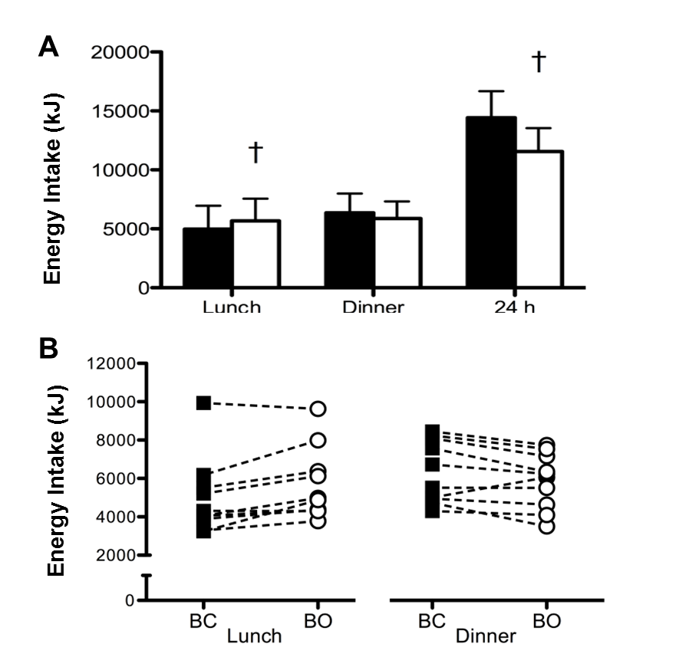

Figure 4.1. Energy intake (kJ) at each test meal and over the total 24 h during BC (■) and BO (□). Values are means with vertical error bars representing standard deviation. † indicates values are different to BC (P<0.05).

Subjective appetite sensations

Subjective sensations of hunger, fullness, DTE and PFC showed a main effect of trial (P<0.05), time (P<0.001) and an interaction effect (P<0.001; Figure 4.2.). Subjects reported increased hunger, DTE and PFC, as well as lower fullness, in the post-breakfast period (0.5-
4.5 h) during BO compared to BC (P<0.01). Subjects also reported increased fullness at 7 h during BO compared to BC (P<0.05). For AUC analysis, data was divided into 3 sections; breakfast to lunch (0-4.5 h), lunch to dinner (5-11 h) and post dinner (11.5-24 h). These analyses revealed differences between trials for all subjective appetite variables between

breakfast and lunch (P<0.01). Fullness was also increased between lunch and dinner during BO compared to BC (P<0.05; Table 4.2).

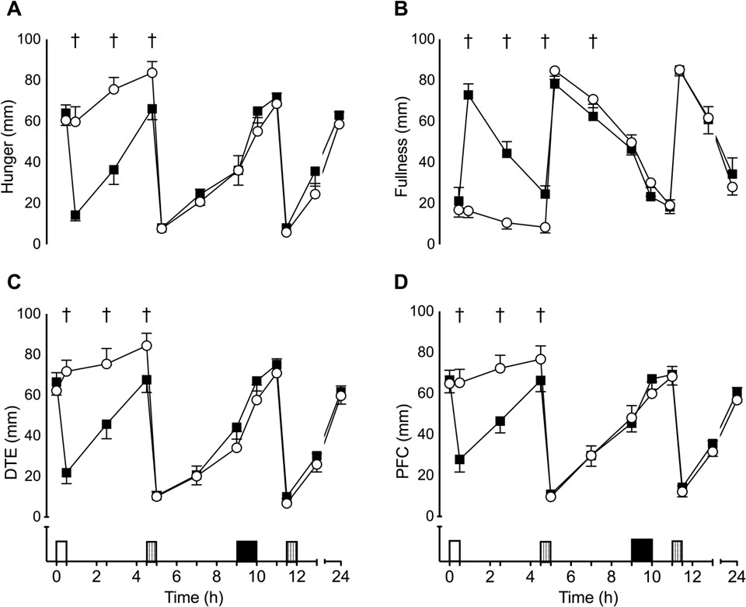

Figure 4.2. Subjective sensations of hunger (A), fullness (B), desire to eat (DTE) (C) and prospective food consumption (PFC) (D) during BC (■) and BO (○). Data points are means with vertical error bars representing standard error of the mean. White rectangle indicates standard meal feeding, vertical hatched rectangles indicate an ad-libitum meal and black rectangle indicates exercise period. All appetite variables showed a main effect of time. † indicates values are significantly different between trials (P<0.05).

Table 4.2. Area under the curve for each appetite variable.

Post breakfast (0-4 h)
Post lunch (5-10.5 h)
Post dinner (11-24 h)

Hunger (mm)

BC | 173 (65) | 212 (72) | 576 (201)
BO | 325 (76) † | 193 (90) | 480 (180)
 |  | Fullness (mm)
BC | 210 (60) | 305 (73) | 633 (215)
BO | 54 (41) † | 341 (67) † | 603 (192)
 |  | DTE (mm)
BC | 203 (80) | 223 (69) | 536 (189)
BO | 340 (93) † | 195 (87) | 495 (143)
 |  | PFC (mm)
BC | 211 (70) | 240 (66) | 565 (165)
BO | 319 (90) † | 235 (73) | 519 (195)
Data are means (standard deviations). † values are significantly different to BC (P<0.05).

Steady state exercise and performance test

Total work completed during the performance test was greater during BC (314 (53) kJ) than BO (300 (56) kJ; P<0.05; Figure. 4.3). There was no effect of trial order on exercise performance (P=0.297). During the 30 min steady state period, energy expenditure was greater during BO (1407 (210) kJ) than BC (1330 (191) kJ; P<0.05). Fat oxidation was also greater during BO compared to BC (P<0.05), but there was no difference in carbohydrate oxidation between trials (P=0.126). Average heart rate was higher during BO (155 (9) bpm) than BC (151 (8) bpm; P<0.001) during steady state, but was not different during the performance test (P=0.397). There was no difference in RPE at 15 (12 (2) vs. 12 (2); P=0.381) or 30 (13 (2) vs. 13 (2); P=0.763) min during steady state exercise, or at 10 (16 (1) vs. 16 (1);
P=0.826), 20 (18 (1) vs. 18 (1); P=0.685) or 30 (20 (1) vs. 20 (1); P=0.598) min during the
performance test.

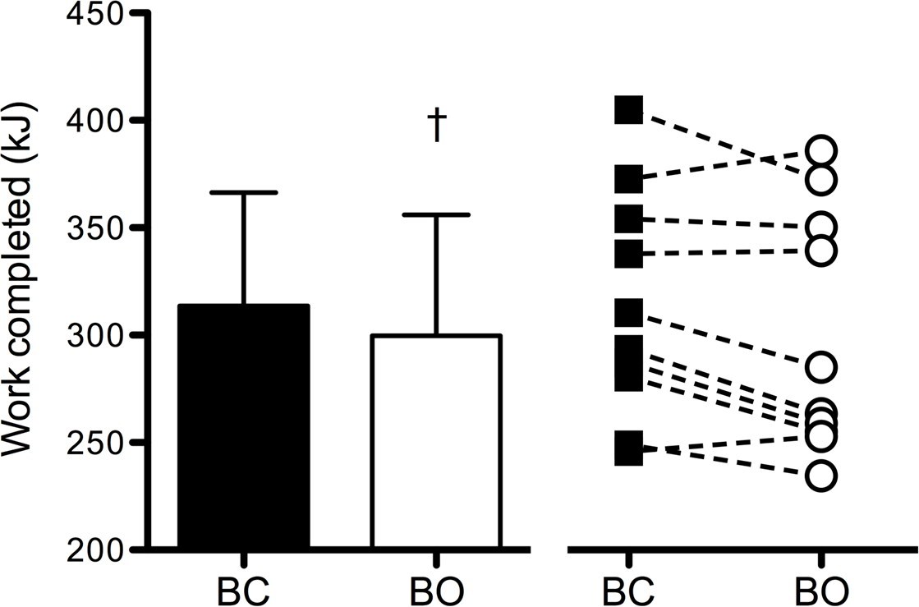

Figure 4.3. Work completed (kJ) during the exercise performance test. Left panel displays mean work completed during BC (■) and BO (□) with vertical error bars representing standard deviation. Right panel displays individual subject’s performance during BC (■) and BO (○). † indicates values are significantly different to BC (P<0.05).

Blood parameters

Plasma glucose (P<0.05), insulin (P<0.001), acylated ghrelin (P<0.001) and GLP-1₇₋₃₆ (P<0.05) all showed a main effect of time. There were no main effects of trial or interaction effects for plasma glucose (P≥0.201), acylated ghrelin (P≥0.189) or GLP-1₇₋₃₆ (P≥0.056). There was a time x trial interaction effect for insulin (P<0.01), with higher insulin concentrations at 4.5 h during BC than BO (P<0.01), while insulin concentrations tended to be higher at 9 h during BO compared to BC (P=0.073; Table 4.3).

Table 4.3. Plasma concentrations of glucose, insulin, acylated ghrelin and GLP-1₇₋₃₆ over the course of the trial during BC and BO.

 | Pre-breakfast (0 h) | Pre-lunch (4.5 h) | Pre-exercise (9 h)
 |  | Glucose (mmol·L⁻¹)
BC | 5.33 (0.18) | 4.89 (0.42) * | 5.27 (0.39)
BO | 5.18 (0.25) | 4.91 (0.33) * | 5.13 (0.67)
 |  | Insulin (µlU·mL⁻¹)
BC | 15.0 (4.4) | 16.1 (5.8) | 24.2 (6.8) *
BO | 13.9 (3.5) | 10.7 (4.1) † * | 30.7 (11.5) *
Acylated Ghrelin (pg·mL⁻¹)
BC | 108 (114) | 115 (65) | 92 (90)
BO | 97 (99) | 118 (121) * | 71 (94) *
 |  | GLP-1₇₋₃₆ (pM)
BC | 7.22 (6.06) | 9.85 (9.30) | 8.51 (7.29)
BO | 6.61 (6.41) | 6.55 (6.82) | 12.99 (12.26) *
For consistency, all data are presented as means (standard deviations). † indicates values are significantly different to BC; * indicates values are significantly different compared to baseline (P<0.05).

Discussion
The primary aim of this investigation was to determine the effect of breakfast omission/ consumption on subsequent energy intake and evening exercise performance. It was found that total work completed over a 30 min cycling performance test was reduced by approximately 4.5% following breakfast omission. This study also observed no difference in subsequent ad-libitum energy intake between trials, meaning total 24 h energy intake was reduced after breakfast omission. From a weight management perspective, occasional breakfast omission could be used as a viable means of energy restriction in habitual breakfast consumers, although this may slightly impair exercise performance. Further study is required

to determine whether breakfast omission can be used chronically to assist with long term weight management.
The global increase in the prevalence of obesity has coincided with a gradual decline in breakfast consumption (Haines et al. 1996), with epidemiological evidence suggesting that those who regularly omit breakfast have a higher BMI than those who regularly consume breakfast (Cho et al. 2003). However, due to a number of confounding factors, including variations in activity patterns (Cohen et al. 2003) and dietary profiles (Galvin et al. 2003), there is a lack of causal data linking breakfast eating behaviour with energy balance. The results of the current investigation in young lean males, demonstrate that the total energy restricted at breakfast is not accurately compensated for over an acute 24 h period, resulting in a net energy deficit of 2864 kJ. These findings are comparable with those of Levitsky and Pacanowski (2013), who found total energy intake was reduced by approximately 1883 kJ following the omission of an ad-libitum breakfast meal. Similarly, 7 days consecutive breakfast omission was found to reduce energy intake by 670 kJ·d⁻¹ on average compared to 7-days consecutive breakfast consumption (Reeves et al. 2014). Taken collectively, data from these acute investigations suggest that, contrary to popular belief, breakfast omission does not lead to elevated energy intakes over the course of the day. As such, there is potential for breakfast omission to be used in successful weight management programmes.
Consistent with previous findings, energy intake at lunch was greater during BO than BC (Astbury et al. 2011; Hubert et al. 1998; Levitsky and Pacanowsky 2013; Reeves et al. 2014). Following the omission of breakfast, subjective appetite sensations were elevated throughout the morning compared to when breakfast was consumed (Figure 4.2), and accordingly energy intake at lunch was increased by approximately 17%. However, this modest increase in energy intake (708 (667) kJ) only partially compensated for the energy deficit created by the omission of the breakfast meal (3095 (195) kJ), and as such subjects remained in energy deficit throughout the afternoon. Similar to the findings in the current study, Levitsky and Pacanowski (2013) reported elevations in hunger following the omission of an ab-libitum breakfast meal, leading to increased energy consumption at lunch. Hubert et al. (1998) found that reducing breakfast energy intake by 1824 kJ resulted in an average elevation in energy intake at lunch of 500 kJ. The average compensation at lunch for breakfast omission is remarkably consistent between these studies, with the current investigation revealing 23% compensation at lunch, compared to 22% (Levitsky and Pacanowsky 2013) and 26% (Hubert et al. 1998) previously reported.

Under free-living conditions, the increase in appetite observed throughout the morning period may have caused an increase in energy consumption during the time between breakfast and lunch, as was found previously (Martin et al. 2000). Although not measured during this period, it would be expected that breakfast consumption would cause a decline in acylated ghrelin and a concomitant increase in GLP-1₇₋₃₆ (Cummings 2006; Holst 2007). As acylated ghrelin and GLP-1₇₋₃₆ were only measured 4 h after breakfast consumption/omission and immediately prior to exercise, the dynamic response of these hormones to feeding may have been missed. Following lunch, no differences were observed in subjective appetite sensations, suggesting that differences in gut hormone concentrations would be similar between trials. Accordingly, the appetitive responses to breakfast omission appear to be transient and do not influence energy intake following the provision of lunch.
Whilst there is general agreement in the literature that breakfast omission reduces daily energy intake, two investigations contest these findings. Astbury et al. (2011) found that the provision of a 1080 kJ breakfast was completely compensated for in the no breakfast condition at an ad-libitum lunch meal. This study was designed primarily to investigate the effect of breakfast on gastrointestinal hormonal regulation of food intake and incorporated a liquid pre-load between breakfast and lunch that may have influenced energy intake at lunch. Additionally, the provision of a low energy breakfast (10% of daily energy requirements) has previously been shown to be more accurately compensated for at subsequent meals than higher energy breakfasts (Schusdziarra et al. 2011). Farshchi et al. (2005) aimed to investigate whether the timing of breakfast consumption affected subsequent energy intake. Over a 2 week period, subjects either consumed cereal and milk at a traditional breakfast time (7-8am) or later in the day (12-12:30pm), which ensured that the energy provided was consistent across both interventions. Energy intake was found to be greater following breakfast omission compared to breakfast consumption. This was likely due to the experimental design, which does not necessarily represent typical practise for those utilising breakfast omission as a method of weight management.
The current investigation found that exercise performance in the evening was decreased by 4.5% following breakfast omission. Breakfast consumption is highly encouraged to maximise carbohydrate stores prior to competition (Williams and Serratosa 2006). It is also well documented that exercise performance is compromised after an overnight fast compared to in a postprandial state (Sherman et al. 1989; Sherman et al. 1991), with glucose availability a potentially limiting factor due to glycogen depletion (Coyle and Coggan 1984). In particular,

liver glycogen stores, which are important for blood glucose maintenance during exercise, have been shown to decrease by ~40% following an overnight fast (Taylor et al. 1996). Provision of a high carbohydrate breakfast will help replenish liver glycogen (Hawley and Burke 1997) and has been shown to increase muscle glycogen concentrations in the vastus lateralis by 11-17% (Chryssanthopoulos et al. 2004; Wee et al. 2005). A recent study reported that 73% of female college athletes regularly omitted breakfast, resulting in suboptimal daily carbohydrate and energy intakes (Shriver et al. 2013). This was also shown in the present study, as carbohydrate intake prior to exercise was reduced during BO compared to BC (148 (65) vs. 259 (73) g), which may have influenced glucose availability and reduced exercise performance. It appears breakfast may play a central role in meeting daily carbohydrate requirements for exercising individuals and that consumption of breakfast might be important in order to maximise exercise performance thought the whole day.
Fat oxidation was greater during the 30 min steady state exercise period on BO. Increasing fat oxidation has been suggested to be beneficial for reducing fat mass and may also promote carbohydrate sparing, potentially improving performance (Jeukendrup and Achten 2001). However, there was no difference in carbohydrate oxidation between trials therefore it is unlikely that glycogen sparing occurred during BO. Accordingly, energy expenditure was greater during BO, which may be attributable to an increase in dietary induced thermogenesis induced by greater energy intake at the previous ad-libitum lunch meal. An increased contribution of dietary induced thermogenesis to energy expenditure may also explain the higher heart rate observed during BO. Following food intake, the splanchnic tissues require an increase in blood supply to assist with the digestion and absorption of nutrients. Therefore, during sub-maximal exercise, an increase in cardiac output is required to meet the oxygen requirements of both the skeletal muscle and splanchnic tissues (Yi et al. 1990). Another indicator of sympathetic nervous activity is noradrenaline, which has been shown to peak after breakfast, with an attenuated response at subsequent feeding periods (Panev et al. 2005). Following the omission of breakfast, lunch becomes the first meal of the day. It could be considered that the sympathetic nervous response to feeding was greater following lunch during BO compared to BC, thus heart rate was increased to a greater extent during steady state exercise. Noradrenaline also increases lipolysis (Klein et al. 1989) and may explain the elevation in fat oxidation during the steady state exercise on BO.
A limitation with any research that investigates breakfast omission is the difficulty in blinding subjects to the study intervention. In the multifactorial ‘central governor theory’

model of fatigue described by Noakes (2012), subject awareness of the study intervention may lead to an expectation in regard to exercise performance and performance may decline as a result. This may be particularly pertinent with the current study as all subjects were habitual breakfast consumers, so the withdrawal of breakfast in the morning may have produced a particularly strong expectation of reduced performance. Prior knowledge of the performance test in this study may have also influenced feeding behaviour at lunch, as subjects may have expectations in regard to pre-exercise carbohydrate requirements. Future research should investigate this effect in habitual breakfast omitters and also attempt to blind subjects to the treatment.
It has recently been shown that the omission of breakfast over a 6 week period has a negative effect on physical activity levels, reducing habitual physical activity thermogenesis on average by 1850 kJ·d⁻¹ compared to when breakfast was consumed (Betts et al. 2014). Physical activity of this nature is difficult to manipulate or avoid as the nutritional intervention seemingly imposes a sub-conscious restriction on energy expenditure. Incorporating structured exercise into weight management programs may offset the magnitude of this deficit somewhat, provided adherence to exercise isn’t affected. Whilst exercise performance might be important to maximise energy expenditure, the difference in exercise performance observed in the current study had a negligible influence on energy balance. Assuming a cycling efficiency of 20% (Hopker et al. 2007), estimated energy expenditure was ~70 kJ greater during BC.
The results from this study suggest that occasionally omitting breakfast may be an effective way to reduce energy intake. Whether breakfast omission can be used chronically to assist with the restriction of energy intake is beyond the scope of this investigation. However, the few studies that have attempted to investigate this have reported promising results. Two weeks of consuming a very low energy breakfast (418 kJ) or a high energy (2920 kJ) breakfast resulted in marginally increased mid-morning snack intake in the very low energy breakfast trial with no additional elevation in energy intake throughout the rest of the day (Martin et al. 2000). Therefore, energy intake was significantly decreased in the low energy breakfast condition. Over a 6 week period, subjects who consumed at least 2930 kJ before 11am consumed more energy per day than subjects that abstained from food until 12pm (Betts et al. 2014). Collectively, the present and previous studies suggest that the energy deficit achieved by breakfast omission may reduce energy intake. Whilst breakfast omission has been shown to have a restrictive influence on energy expenditure, this compensation

appears to be incomplete (Betts et al. 2014), and thus breakfast omission may assist with long term management of energy balance.
In conclusion, the results of the present study demonstrate that occasionally omitting breakfast may be an effective method of reducing energy intake over a 24 h period in habitual breakfast consumers. However, exercise performance in the evening may be compromised following the omission of breakfast in the morning. For individuals concerned purely with weight management, the reduction in exercise performance is unlikely to be sufficient to influence energy balance. However, for those concerned with maximising training and/or competition performance, breakfast omission might impair performance or interfere with training adaptation.

Chapter V

Effect of breakfast omission on subjective appetite, metabolism, acylated ghrelin and GLP-1₇₋₃₆ during exercise and rest

Abstract
Breakfast omission induces compensatory eating behaviour at lunch, but often reduces daily energy intake. This study investigated the effect of breakfast omission on within-day subjective appetite, energy expenditure, substrate utilisation and appetite hormone profiles, in response to standardised feeding and exercise. Eight male, habitual breakfast eaters completed two randomised trials. Subjects arrived overnight fasted (0 h) and either consumed (BC) or omitted (BO) a standardised breakfast (3085 (217) kJ). Lunch (4162 (510) kJ) and dinner (4914 (345) kJ) were provided at 4.5 and 10 h, respectively and subjects performed 60
min fixed-intensity cycling (50% VO₂peak) at 8 h. Blood samples were collected at 0, 4.5, 6 and 8 h, with expired gas and subjective appetite sensations (hunger, fullness, desire to eat (DTE) and prospective food consumption (PFC)) collected throughout. Heart rate and perceived exertion were measured during exercise. Hunger, DTE and PFC were greater and fullness lower during BO between breakfast and lunch (P<0.05), with no differences after lunch (P>0.193). Resting energy expenditure was greater at 2.5 h during BC (P<0.05) with no other differences between trials (P>0.156). GLP-1₇₋₃₆ was greater (P<0.05) and acylated ghrelin tended to be greater (P=0.078) at 4.5 h during BC. Heart rate was greater on BO (P<0.05) during exercise. The results of this laboratory-based study suggest that the effects of breakfast omission are transient and do not extend beyond lunch, even when the negative energy balance created by breakfast omission is sustained via standardised feeding and exercise.

Introduction
In the absence of behavioural compensation, refraining from eating at a prescribed mealtime, such as breakfast, will create an energy deficit. It is thought that the appetite regulatory system will counter perturbations in energy balance, with metabolic and behavioural compensatory responses that target both energy intake and expenditure (Martin et al. 2000). However, the previous chapter demonstrated incomplete energy intake compensation over a

24 h period, with compensatory eating behaviour only exhibited at lunch, which is in line with previous studies (Hubert et al. 1998; Martin et al. 2000; Levitsky and Pacanowski 2013). However, it is currently unclear whether the increase in energy intake at this meal suppresses further energy intake through the remainder of the day, or whether the appetitive effects of breakfast omission are diminished after the initial stimulation of food intake. It would therefore be of interest to determine how the appetite regulatory system responds after lunch, as this may dictate feeding behaviour outside of rigid experimental control.
Energy expenditure may also be altered in response to fluxes in energy balance due to breakfast omission. In one study energy expenditure was shown to decrease in the morning in response to breakfast omission, but was not different over a 24 h period (Kobayashi et al. 2014). In this study, energy intake at lunch and dinner was increased to account for the energy omitted at breakfast, but complete energy intake compensation rarely occurs in response to acute breakfast omission (Levitsky 2014). Low intensity physical activity has been shown to reduce after chronic breakfast omission (Betts et al. 2014). An exercise intervention may have the potential to offset this decrement somewhat, provided the subjective response to exercise and/or adherence is not affected by breakfast omission. Lifestyle interventions that combine both dietary restriction and exercise have been shown to be more effective for weight management in the long-term (Franz et al. 2007); therefore it is important to consider the effect that a given dietary intervention has on physical activity.
This study was designed to investigate the appetite and metabolic responses to breakfast omission, with energy intake at lunch and dinner held constant, which has not been previously investigated. The aim of this study was to investigate the effect of breakfast omission on subjective appetite sensations and metabolism in response to standardised feeding and sub-maximal exercise.

Methods
Subjects

Subjects were eight healthy, recreationally active, regular breakfast consuming males (age: 27 (6) y; weight: 75 (8.1) kg; height: 1.74 (0.07) m; BMI: 25 (2) kg·m⁻²; body fat: 18 (3) %;
VO₂peak: 53.4 (5.1) mL·kg⁻¹).

Preliminary trial

Subjects height, weight and body fat percentage were determined, before completing a discontinuous incremental exercise test on an electrically braked cycle ergometer to determine VO₂peak.
Protocol

Subjects completed two experimental trials; breakfast consumption (BC) and breakfast omission (BO). Trials were separated by at least 7 days, conducted at the same time of day, on the same day of the week and administered in a randomised, counterbalanced order.
Subjects travelled to the laboratory via motorised transport arriving at approximately 08:00, following at least a 10 h fast and were weighed nude. After 30 min supine rest (0 h), blood and expired gas samples were collected. Subjective appetite sensations were then assessed on a visual analogue scale (VAS) before subjects consumed either a standardised breakfast (BC) or no breakfast (BO). Subjects then rested quietly in the laboratory. At 4.5 h, a blood sample was collected, before a standardised lunch was consumed. Subjects again rested in the laboratory with blood samples collected at 6 h and 8 h. Subjects then completed 60 min cycling at 50% VO₂peak (8-9 h). Heart rate and RPE were recorded after 20, 40 and 60 min of exercise. One hour after exercise (10 h) a standardised dinner meal was consumed. Subjects then left the laboratory, but were not permitted to eat until the following morning, completing VAS scales at 12, 13.5 and 24 h.
Standardised meals

During BC subjects were provided with a standardised breakfast containing 25% of estimated energy requirements (EER), and this was replaced during BO with a bolus of water isovolume to the water contained in the breakfast provided during BC (624 (44) mL). Subjects were provided the same lunch and dinner on both trials. Lunch consisted of ham sandwiches, crisps and yoghurt (35% EER) and dinner consisted of pasta, Bolognese sauce, cheese and olive oil (40% EER). Subjects consumed each meal gradually over a 30 min period (Table 5.1).
After breakfast, subjects ingested 45 mL·kg⁻¹ body mass of water throughout the day on each trial (2318 (284) mL). This water was distributed so that 100 mL was provided every 20 min

during exercise. Of the remaining water, 25% was ingested at lunch and dinner, and 12.5% at 2.5, 7, 12 and 13.5 h.
Table 5.1. Energy and macronutrient intake.

CHO (g) PRO (g) Fat (g) Fibre (g) Energy (kJ)

Breakfast

BC | 130.0 (9.1) | 19.5 (1.4) | 13.7 (1.0) | 4.5 (0.3) | 3085 (217)
BO | 0 | 0 | 0 | 0 | 0

Lunch
BC
118.9 (8.3) 38.6 (2.7) 41.1 (2.9) 12.0 (0.8) 4162 (301)

BO
Dinner
BC
150.6 (10.5) 41.2 (2.9) 43.2 (3.0) 6.8 (0.5) 4914 (345)

BO
Total

BC | 399.6 (28.0) | 99.4 (7.0) | 94.4 (13.0) | 23.2 (1.6) | 12162 (988)
BO | 270.0 (18.9) | 79.9 (5.6) | 80.7 (12.3) | 18.8 (1.3) | 9077 (789)

Values are mean (SD).

Subjective appetite sensations

Hunger, fullness, desire to eat (DTE) and prospective food consumption (PFC) were assessed at 0, 0.5, 1.5, 2.5, 3.5, 4.5, 5, 6, 7, 8, 9, 10, 10.5, 12, 13.5 and 24 h.
Expired gas samples

Rested expired gas samples were collected at 0, 2.5, 4.5, 6, 8 and 10 h, with additional samples collected after 20, 40 and 60 min of exercise. Expired gas samples were collected and analysed as described in Chapter III.

Blood sampling

Blood samples (12 mL) were drawn after 30 min supine rest at 0, 4.5, 6 and 8 h, and were treated and analysed for determination of acylated ghrelin, GLP-1₇₋₃₆, glucose and insulin concentrations, as described in Chapter III.
Statistical analysis

Area under the curve (AUC) was calculated using the trapezoidal method and averaged over time. Subjective appetite sensations were separated in three periods (0-4.5 h, 5-10 h and 10.5- 24 h) and energy expenditure presented as total (0-10 h) and also separated into two periods (0-4.5 h and 5-10 h). Data was analysed using the methods described in Chapter III.

Results
Pre-trial values

Pre-trial body mass (P=0.155), subjective appetite sensations (all P>0.346), RMR (P=0.393), carbohydrate oxidation (P=0.815) and fat oxidation (P=0.290) were not different between trials. Plasma concentrations of glucose (P=0.512), insulin (P=0.488), acylated ghrelin (P=0.526) and GLP-1₇₋₃₆ (P=0.636) were also not different between trials at baseline.
Subjective appetite sensations

All subjective appetite sensations showed an interaction effect (P<0.001). Sensations of fullness were lower concurrent with greater hunger, DTE (all P<0.01) and a tendency for greater PFC (P=0.078) at 0.5 h during BO compared to BC. Between 1.5 and 3.5 h, lower fullness and greater hunger, DTE and PFC (all P<0.05) was observed during BO compared to BC. Lower hunger (P<0.01), PFC (P<0.05) and a tendency for lower DTE (P=0.078) was found immediately prior to lunch (4.5 h) during BC compared to BO, but there was no difference between trials for fullness (P=0.234). After lunch there were no differences between trials for any appetite variables (5.5-24 h) (P>0.125; Figure 5.1).
Data was divided into 3 sections for AUC analysis; baseline to lunch (0-4.5 h), post-lunch to dinner (5-10 h) and post-dinner (10.5-24 h). These analyses revealed differences between trials for all appetite variables between baseline and lunch (all P<0.05), with no further differences between trials (all P>0.719; Figure 5.1).

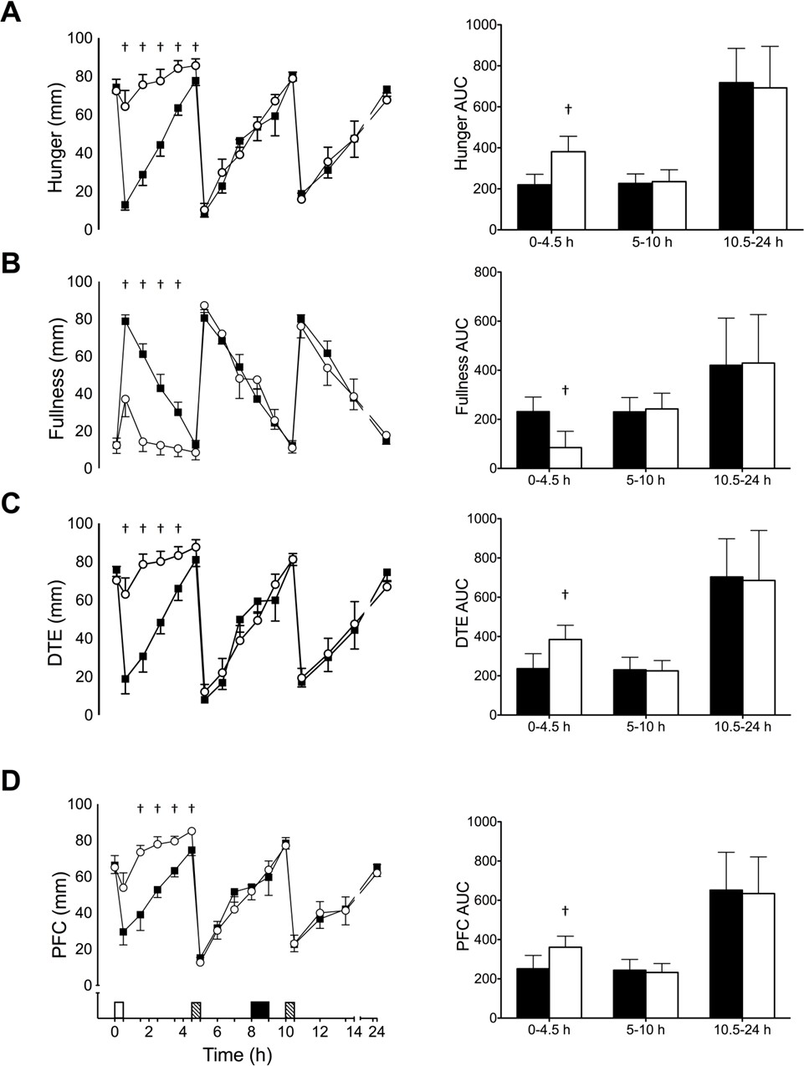

Figure 5.1. Subjective feelings of hunger (A), fullness (B), desire to eat (C) and prospective food consumption (D) (left panel) and AUC analysis (right panel) during BC (■) and BO (□) . Data are mean (SE) for the left panel and mean (SD) right panel. White rectangle indicates breakfast, hatched rectangles indicate standard meals, black rectangle represents exercise. † Significantly different to BC (P<0.05).

Energy expenditure and substrate oxidation

Due to a fault with the gas collection equipment during one trial for one subject, this subjects gas samples were removed from the analysis. Therefore data from 7 subjects is presented.
Respiratory exchange ratio (RER) showed an interaction effect (P<0.05) and was greater at
2.5 (P<0.01), 4.5 (P<0.05) and 10 h (P<0.05) during BC compared to BO (Figure 5.2a). Carbohydrate oxidation was greater at 2.5 (P<0.001) and 4.5 h (P<0.05) during BC, but fat oxidation was not different between trials (P=0.413).
There was an interaction effect for energy expenditure (P<0.01), with greater energy expenditure at 2.5 h during BC (P<0.05) compared to BO, with no other differences between trials (P>0.156; Figure 5.2b). AUC analyses revealed a tendency for increased energy expenditure at 0-4.5 h (P=0.066) during BC, but no difference at 5-10 h (P=0.523) or total (P=0.193).
Blood parameters

Plasma acylated ghrelin concentrations showed a main effect of time (P<0.001), but no interaction effect (P=0.238). Bloxplot analysis revealed one consistently outlying subject within the data set, exhibiting acylated ghrelin concentrations ~11 standard deviations greater than the mean of the 7 other subjects. Therefore, this subject was removed from the analysis. After removal, an interaction effect was identified (P<0.05). Acylated ghrelin tended to be higher during BC compared to BO at 4.5 h (P=0.078). Compared to 0 h, acylated ghrelin was greater at 4.5 h during BC (P<0.05) and reduced at 6 h during BO (P<0.05) (Table 5.2).
An interaction effect (P<0.05) was identified for GLP-1₇₋₃₆, with greater concentrations at 4.5 h during BC compared to BO (P<0.05). Compared to baseline, GLP-1₇₋₃₆ was greater at 6 and 8 h during BC and at 8 h during BO (P<0.05; Table 5.2)
Plasma insulin showed a main effect of time (P<0.001) and was greater than baseline at 6 h during BC (P<0.05) as well as at 6 and 8 h during BO (P<0.05). No interaction effect was observed for plasma insulin (P=0.468) or glucose (P=0.067) concentration (Table 5.2).

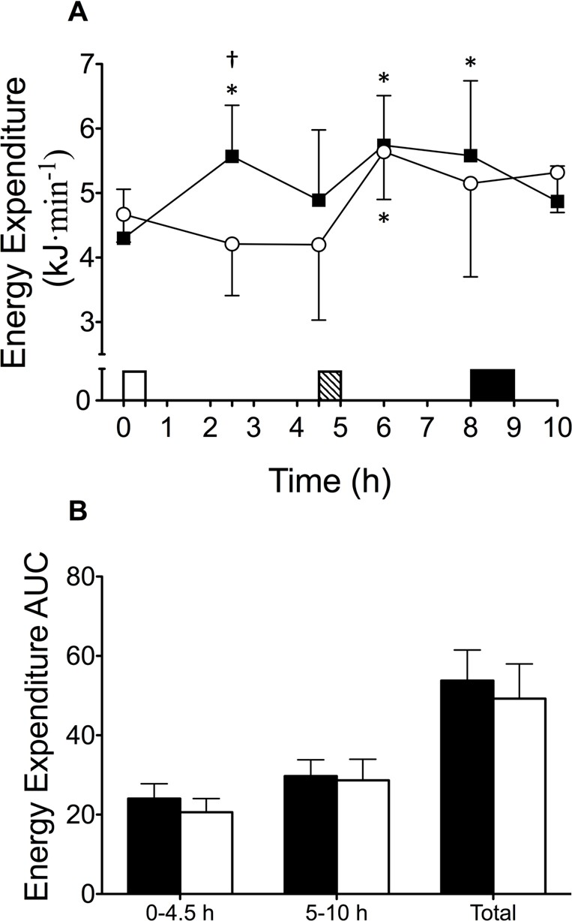

Figure 5.2. Resting energy expenditure during BC (■) and BO (□) (A); and resting energy expenditure AUC (B) . Data are mean (SD). On x-axis, white rectangle indicates breakfast, hatched rectangle indicates standard meal, black rectangle represents exercise. † Significantly different to BC (P<0.05); * Significantly different to baseline (P<0.05).

Table 5.2. Plasma concentrations of acylated ghrelin, GLP-1₇₋₃₆, insulin and glucose.

0 h 4.5 h 6 h 8 h

Acylated Ghrelin (pg·mL⁻¹)

BC | 162 (132) | 213 (147)* | 114 (132) | 156 (150)
BO | 168 (150) | 178 (171) | 111 (148)* | 150 (165)
GLP-1₇₋₃₆ (pM)
BC | 9.67 (8.49) | 10.13 (8.22) | 12.34 (7.67)* | 11.72 (8.32)*
BO | 9.92 (9.78) | 8.52 (8.83)† | 13.01 (7.92) | 12.85 (8.88)*
Insulin (µlU·mL⁻¹)
BC | 9.56 (4.29) | 7.03 (3.98) | 30.09 (11.68)* | 18.49 (8.67)
BO | 8.74 (3.90) | 7.56 (3.35) | 34.90 (15.86)* | 15.58 (3.78)*
Glucose (mmol·L⁻¹)
BC | 5.33 (0.22) | 4.77 (0.42) | 5.28 (0.79) | 5.17 (0.45)
BO | 5.35 (0.23) | 5.26 (0.47) | 5.69 (0.88) | 4.88 (0.56)

Data are mean (SD). † Significantly different to BC; * Significantly different to baseline (P<0.05)

Exercise responses

There was a main effect of trial for heart rate (P<0.05), which was elevated at 60 min during BO compared to BC (P<0.05), and tended to be elevated at 40 min (P=0.068). VO₂ (P=0.503), RER (P=0.135), carbohydrate oxidation (P=0.143), fat oxidation (P=0.143), energy expenditure (P=0.289) and RPE (P=0.129) were not different between trials (Table 5.3).

Table 5.3. Variables collected during exercise.

 | BC | BO | P-value
VO₂ (L·min⁻¹) | 1.95 (0.25) | 1.92 (0.26) | 0.503
RER | 0.92 (0.03) | 0.90 (0.01) | 0.107
Carbohydrate oxidation (g·min⁻¹) | 1.93 (0.34) | 1.72 (0.14) | 0.143
Fat oxidation (g·min⁻¹) | 0.25 (0.14) | 0.31 (0.08) | 0.143
Energy Expenditure (kJ·min⁻¹) | 42.05 (5.01) | 40.78 (5.16) | 0.289
Heart rate (beats·min⁻¹) | 130 (5) | 134 (6)† | 0.032
RPE | 11 (1) | 12 (1) | 0.129

Data are mean (SD). † Significantly different to BC (P<0.05).

Discussion
This investigation found that subjective appetite sensations, appetite hormones and energy expenditure were not different after lunch, regardless of whether the subject consumed or omitted breakfast. Therefore, it appears that the appetitive and metabolic effects of breakfast omission are transient and might be offset by a standardised lunch. Breakfast omission also does not influence perception of effort or energy expenditure during 60 min of steady-state cycling exercise performed 3 h after lunch. This data suggests that occasional breakfast omission may not stimulate appetite and promote energy intake as has been previously inferred (Cho et al. 2003).
Irregular consumption of breakfast consumption has been identified as a risk factor for obesity, with correlational evidence to suggest that habitual breakfast consumers have a lower BMI than breakfast omitters (Cho et al. 2003). However, habitual breakfast consumers also tend to exhibit healthy lifestyle practices, such as greater levels of physical activity (Cohen et al. 2003) and better dietary profiles (Galvin et al. 2003) than breakfast omitters, making causal mechanisms difficult to elucidate. Acute studies that have directly manipulated the consumption or omission of breakfast have generally reported that the omission of breakfast will increase appetite and induce compensatory eating behaviour at lunch (Levitsky and

Pacanowski 2013; Hubert et al. 1998). Whilst one study found that the energy omitted at breakfast was fully compensated for at an ad-libitum lunch meal (Astbury et al. 2011), the majority of studies have reported that energy intake at a single meal (Levitsky and Pacanowski 2013; Hubert et al. 1998; Gonzalez et al. 2013) or over a 24 h period (Martin et al. 2000; Levitsky and Pacanowski 2013; Reeves et al. 2014; Betts et al. 2014) is not sufficient to fully compensate for the energy omitted at breakfast. In the current investigation, the energy consumed at each meal was fixed so an increase in energy intake could not occur. These results demonstrate that even when energy consumed at lunch is controlled, there were no differences in appetite sensations or concentrations of appetite regulatory hormones (acylated ghrelin and GLP-1₇₋₃₆) were observed after lunch.
The transient suppression of appetite after consumption compared to omission of breakfast has previously been observed after an ad-libitum lunch meal, which was used to gauge voluntary food intake (Levitsky and Pacanowski 2013; Hubert et al. 1998). However, the present investigation has demonstrated that appetite in the post-lunch period can be offset by an absolute energetic load, as opposed to subjects eating to satiation. This effect was shown to persist throughout the rest of the day, despite subjects consuming ~3000 kJ less during BO. Therefore, controlling food intake at subsequent meals does not appear to affect the appetitive response to acute breakfast omission, and this could allow greater energy deficits to be achieved, compared to when ad-libitum meals are consumed. However, subjective appetite sensations do not always accurately predict subsequent food intake (Clayton et al. 2014).
Energy expenditure increased at 2.5 h during BC, compared to BO. This would be anticipated due to dietary induced thermogenesis (DIT). The thermogenesis associated with feeding is dependent on the energetic load and the macronutrient content of the meal. When the breakfast meal was broken down into its constituents, the estimated DIT of the meal was approximately 9.8% of the total energy content of the meal, which is in line with the typically reported DIT of a mixed meal of 10% (Westerterp 2004). Taking this into account, it is likely that the majority of the post-prandial increase in energy expenditure at 2.5 h was due to an increase in DIT. Even including DIT in the morning, AUC analysis did not reveal any differences between trials over the 10 h expired gas sampling period. This is in line with the finding of Kobayashi et al. (2014) who reported that breakfast consumption increased energy expenditure in the morning, compared to breakfast omission, but 24 h energy expenditure was not different between trials. In this study, the energy content of the lunch and dinner meals were increased in the no breakfast condition to match total daily energy intake between

trials. The results of the current study have therefore extended those of Kobayashi et al. (2014) and determined that, even in an energy deficient state, energy expenditure is not affected by occasional breakfast omission.
The nature of measuring energy expenditure in a laboratory requires the subject to be at rest and therefore changes in habitual activity patterns may have been overlooked. Betts et al. (2014) found that over a 6 week period, breakfast omission decreased habitual energy expenditure by ~1850 kJ·d⁻¹ compared to when breakfast was consumed. This was attributed to a decrease in low intensity physical activity, as opposed to a reduction in exercise intensity/duration, which was not measured in the current investigation. It is possible that physical activity of this nature is subconsciously affected by breakfast omission. Results of the present study show that any reduction in energy expenditure is not due to changes in resting metabolism. Therefore the incorporation of exercise into daily routines may help offset this reduction in low intensity physical activity, provided that adherence to exercise is not affected by the dietary intervention.
Time constraints of a working lifestyle often restrict time to exercise to the morning or evening. Evening exercise classes are associated with increased alertness and enthusiasm, as well as being deemed to require less effort than morning classes (Maraki et al. 2005). These factors may help improve adherence to an exercise program in the long term. The current study implemented a prescribed exercise protocol on both experimental trials and found that heart rate was elevated during exercise on BO compared to BC. This suggests that subjects were more physiologically challenged during exercise on BO, although this was not reflected in RPE, VO₂ or energy expenditure. Digestion and absorption of nutrients from the gut is a process that requires oxygen to be delivered to the splanchnic tissue, typically achieved via a redistribution of blood away from the skeletal muscle or an increase in cardiac output (Yi et al. 1990). During exercise, where the skeletal muscle requirements for oxygen are high, an increase in heart rate would facilitate meeting the metabolic requirements of skeletal muscle activity and digestion and absorption of nutrients. Heart rate may have been increased to a greater extent during exercise on BO, as splanchnic blood supply for digestion and absorption of nutrients may be prioritised, due to the subjects peripheral fuel supply being reduced during BO compared to BC (Van Baak et al. 2005). Noradrenaline is an indicator of peripheral sympathetic nervous activity and has been shown to peak after breakfast, and progressively decline following lunch and dinner meals (Panev et al. 2005). By removing

breakfast during BO, it is possible that the peak sympathetic response occurred after lunch, which subsequently increased heart rate to a greater extent during exercise on BO.
The increase in appetite over the morning period during BO has been suggested to lead to the consumption of energy dense snacks (O’Connor et al. 2009), and indeed an increase in snacking behaviour has been observed in a previous study (Martin et al. 2000). Elevated levels of the appetite stimulating hormone ghrelin and suppression of satiety hormones, such as GLP-1, have been suggested as biological mechanisms that stimulate hunger and promote food intake (Cummings et al. 2001; Holst 2007). In the present study, GLP-1₇₋₃₆ was suppressed immediately prior to lunch in BO compared to BC, which may be linked to greater fullness and lower hunger, DTE and PFC in the present study, following breakfast consumption. Interestingly, acylated ghrelin tended to be higher prior to lunch during BC compared to BO (P=0.078). The reason for this is unclear; however ghrelin has been shown to respond diurnally, peaking at anticipated meal times. Extending the overnight fast during BO may have affected this diurnal variation, which may be governed primarily by post- prandial decreases rather than pre-prandial increases (Chan et al. 2004). After lunch, there were no differences in acylated ghrelin and GLP-1₇₋₃₆ suggesting, in line with the subjective appetite sensations, there was no additional desire to increase food intake after lunch.
In conclusion, this laboratory-controlled investigation found that subjective appetite sensations, acylated ghrelin, GLP-1₇₋₃₆ and resting energy expenditure were not different, independent of whether breakfast was consumed or omitted. This was found in spite of sustaining the negative energy balance induced by breakfast omission, via standardised lunch and dinner feeding and a prescribed exercise protocol. Consuming breakfast in the morning appears to only transiently suppress appetite compared to when breakfast is omitted, and appetite can be offset with provision of a standardised lunch meal. This extends findings from ad-libitum feeding studies and suggests that a similar effect can be achieved with a standardised lunch, which may help enhance the energy deficit that can be achieved. Therefore, this study supports occasional breakfast omission as a means to reduce daily energy intake.

Chapter VI

Effect of 24 h severe energy restriction on insulin, glucose and incretin response

Abstract
Obesity is a risk factor for several chronic diseases, including type-2 diabetes, emphasising the need for successful weight management programmes. Intermittent severe energy restriction can achieve ~6% weight loss in 6 months and improve fasting insulin sensitivity. However, prolonged (24-72 h) complete energy restriction has been shown to impair postprandial insulin sensitivity. To determine the effects of this style of dieting on metabolic health, the effect of intermittent severe energy restriction on markers of insulin sensitivity requires investigation. Therefore, the aim of this study was to investigate the acute effects of 24 h severe energy restriction on indices of insulin sensitivity. In randomised order, eleven healthy, lean males consumed a 24 h diet containing 100% (10742 (728) kJ; EB) or 25% (2697 (183) kJ; ER) of estimated energy requirements. The following morning, plasma glucose, insulin, non-esterified fatty acid (NEFA), glucagon-like peptide-1 (GLP-1) and glucose-dependant insulinotropic peptide (GIP) concentrations were determined before and at regular intervals up to 2 h after consumption of 75g glucose in 300 mL water. The homeostatic model of insulin resistance (HOMA-IR) was used to assess fasting insulin resistance and area under the curve (AUC) used to assess postprandial responses. HOMA-IR decreased 25% during ER (P<0.05) but was unchanged during EB (P=0.575). AUC for plasma glucose (P<0.01) and NEFA (P<0.01) were greater during ER than EB, but AUC for plasma insulin (P=0.406), GLP-1 (P=0.419) and GIP (P=0.376) were not different between trials. Results demonstrate that acute severe energy restriction improved fasting insulin sensitivity, but impaired postprandial glycaemic control. This might have implications for individuals using intermittent severe energy restriction diets for weight management and therefore the chronic effects of intermittent severe energy restriction on postprandial insulin sensitivity warrants further investigation.

Introduction
Obesity is a major risk factor for several chronic diseases, including type-2 diabetes, and has become a significant health concern worldwide (Kahn et al. 2006). Evidence suggests that weight loss of 5-7% can help improve insulin sensitivity, a significant risk factor for type-2 diabetes (Anderson and Fernandez 2013). Restricting food intake daily by 20-50% of estimated energy requirements (EER) is currently the most widely used weight loss method (Omodei and Fontana 2011), but the requirement for daily adherence to the diet in order to achieve a sufficiently large energy deficit to induce weight loss, may limit the long term success of this diet in some individuals. Data suggests that only 30-40% of individuals manage to achieve long term weight loss (Anderson et al. 1999), which has contributed to rates of obesity more than doubling between 1980 and 2008 (Finucane et al. 2011).
Intermittent severe energy restriction has been proposed as an alternative to daily energy restriction, and typically involves short periods (24-48 h) of severe energy restriction (~25% EER), allowing ad-libitum or adequate (i.e. 100% EER) energy intake on non-restricted days. Previous studies have demonstrated weight loss of 4-12%, after 8-24 weeks of severe energy restriction (Varady et al. 2009; Varady et al. 2011; Varady et al. 2013; Harvie et al. 2011; Harvie et al. 2013). This is comparable with weight loss reported from daily energy restriction diets (Varady 2011) and therefore appears to represent a viable alternative method of energy restriction.
Intermittent and daily energy restriction may affect metabolic health via distinct pathways. The nutritional stress of acute periods of severe energy restriction may help to repair and optimise cellular processes, thereby reducing several risk factors for cardiovascular disease (Horne et al. 2015). However, very few studies have quantified the metabolic and physiological changes after severe energy restriction. Studies have reported that fasting insulin sensitivity (i.e. HOMA-IR) is improved after 4-6 months of intermittent severe energy restriction, but the subsequent response to nutrient ingestion was not assessed in these studies (Harvie et al. 2011; Harvie et al. 2013). In contrast, short (12-72 h) periods of complete energy restriction (i.e. fasting) consistently impairs postprandial insulin sensitivity, assessed by an intravenous glucose tolerance test or hyperinsulinemic euglycaemic clamp (Johnson et al. 2006; Soeters et al. 2008; Hoeks et al. 2010; Bergman et al. 2007). This contrasts conclusions from other studies utilising similar periods of complete energy restriction, demonstrating a reduction in HOMA-IR (Horne et al. 2013). Given humans tend to spend the majority of their time in the postprandial state, these impairments in insulin sensitivity

suggest short periods of complete energy restriction might not represent a suitable long-term method of weight management. Postprandial glycaemic control is now also recognised as an independent risk factor for cardiovascular disease (Gerich 2003), therefore the effect of severe energy restriction on post-prandial glycaemic control requires investigation.
The aim of the current study was to investigate the effects of 24 h of severe energy restriction (25 % of EER) on indices of glycaemic control.

Methods
Subjects

Eleven, healthy, recreationally active, weight stable, non-dieting males (age: 24 (4) y; weight:
81.5 (9.4) kg; height: 1.80 (0.06) m; BMI: 26 (1) kg·m⁻²; body fat: 17 (4) %) volunteered to take part in this study.
Study design

Subject’s height, weight and body fat percentage were determined during a preliminary visit to the laboratory. Subjects then completed two experimental trials in random order, separated by ≥7 days. Each trial consisted of a 24-h dietary intervention where subjects received 100% (EB) or 25% (ER) of their estimated energy requirements (EER), followed by an oral glucose tolerance test (OGTT).
Protocol

For each trial, subjects attended the laboratory on two consecutive mornings, arriving via motorised transport at ~07:30 after a ≥10 h fast. On day 1, a blood sample was collected via venepuncture of an antecubital vein (-24 h). Subjects were then provided with food and drink for the day and instructions on when to consume each item, leaving the laboratory at ~08:15. Upon arrival on day 2, a cannula was inserted into an antecubital vein and a fasted blood sample was collected (0 h). Subjects then consumed a solution containing 75 g glucose dissolved in 250 mL of water, plus an additional 50 mL of water used to rinse the beaker to ensure all glucose was consumed. Blood samples were collected 0.25, 0.5, 0.75, 1, 1.5 and 2 h after ingestion of the solution.

Standardised diet preparation

Diets contained palatable, familiar foods and were tailored to individual preferences to help ensure adherence. EER was determined by multiplying estimated resting metabolic rate (Mifflin et al. 1990) by a sedentary physical activity level of 1.4. EB provided 100% EER, divided between four meals and ER provided 25% EER, divided between two meals (Table 6.1). Water intake was prescribed at 35 mL·kg⁻² of body mass (2853 (329) mL) and was evenly distributed throughout the day. On ER, in place of breakfast (08:00), subjects consumed a bolus of water equal to the water content of the breakfast provided on EB, which was additional to prescribed water.
Blood sampling

Blood samples (12 mL) were drawn after 30 min of seated rest at -24, 0, 0.25, 0.5, 0.75, 1,
1.5 and 2 h, and were analysed for determination of glucose and insulin (from serum), as well as NEFA, total GLP-1 and total GIP concentrations (from plasma), as described in Chapter III.
Statistical analysis

Homeostatic model of insulin resistance assessment (HOMA-IR) was used to determine changes in fasting insulin resistance before and after the dietary intervention (Mathews et al. 1985). Area under the curve (AUC) was calculated using the trapezoidal method and averaged over time during the OGTT (0-2 h). Data was analysed using the methods described in Chapter III.

Table 6.1. Energy and macronutrient intake at each meal (meal time in brackets) during day 1

Energy balance (EB) Energy restriction (ER)

Breakfast (08:00)

Foods | Cereal, semi-skimmed milk, orange juice | Water
Protein (g) | 14 (1) | 0 (0)
Cho (g) | 91 (6) | 0 (0)
Fat (g) | 10 (1) | 0 (0)
Fibre (g) | 1 (0) | 0 (0)
Energy (kJ) | 2157 (146) | 0 (0)
 | Lunch (12:00)
Foods | White bread, mayonnaise, chicken, | Chicken, lettuce, tomato, red
 | lettuce, tomato, red pepper, balsamic | pepper, balsamic vinegar
 | vinegar, chocolate-chip cookies
Protein (g) | 47 (3) | 36 (3)
Cho (g) | 73 (5) | 8 (1)
Fat (g) | 31 (2) | 4 (0)
Fibre (g) | 4 (0) | 1 (0)
Energy (kJ) | 3214 (218) | 899 (61)
 | Snack (16:00)
Foods | Yoghurt, cereal bar | NA
Protein (g) | 5 (0) | 0 (0)
Cho (g) | 31 (2) | 0 (0)
Fat (g) | 12 (1) | 0 (0)
Fibre (g) | 1 (0) | 0 (0)
Energy (kJ) | 1069 (72) | 0 (0)
 | Dinner (19:30)
Foods | Pasta, Bolognese sauce, olive oil, | Pasta, Bolognese sauce, chicken,
 | chicken, chocolate-chip cookies | olive oil
Protein (g) | 46 (3) | 33 (2)
Cho (g) | 142 (10) | 56 (4)
Fat (g) | 29 (2) | 7 (0)
Fibre (g) | 5 (0) | 2 (0)
Energy (kJ) | 4301 (291) | 1798 (122)
 | Total
Protein (g) | 111 (8) | 69 (5)
Cho (g) | 338 (23) | 65 (4)
Fat (g) | 81 (6) | 11 (1)
Fibre (g) | 12 (1) | 4 (0)
Energy (kJ) | 10742 (728) | 2697 (183)
Data are means (SD)

Results
Baseline variables and body weight change

Body mass (P=0.429), glucose (P=0.230), insulin (P=0.600), GLP-1 (P=0.646) and GIP (P=0.253) were not different between trials at -24 h. Body mass decreased between -24 h and 0 h during both trials (P<0.001), but to a greater extent during ER (EB: 0.53 (0.34) kg; ER: 1.31 (0.49) kg; P<0.00001).
Glucose, insulin and NEFA responses

There were time (P<0.00001), trial (P<0.00001) and interaction (P<0.001) effects for serum glucose concentration, with a lower concentration at 0 h (P<0.05) and a greater concentration at 1 h (P<0.01) during ER compared to EB. Glucose AUC was greater during ER than EB (P<0.01; Figure 6.1). There were time (P<0.00001), trial (P<0.00001) and interaction (P<0.001) effects for serum insulin concentration, with a greater insulin concentration at 1.5 h during ER compared to EB (P<0.05). There was no difference in insulin AUC between trials (P=0.406; Figure 6.1). There were time (P<0.01) and trial (P<0.05), and a tendency for an interaction (P=0.092) effect for HOMA-IR. HOMA-IR decreased from -24 h to 0 h during ER (P<0.05), but did not change during EB (P=0.575; Figure 6.2). There were time (P<0.00001), trial (P<0.01) and interaction (P<0.00001) effects for plasma NEFA concentration, with a greater concentration at 0 and 0.5 h (P<0.05), and a tendency for a greater concentration at 0.75 h (P=0.074) during ER. Plasma NEFA AUC was greater during ER than EB (P<0.01; Figure 6.1).

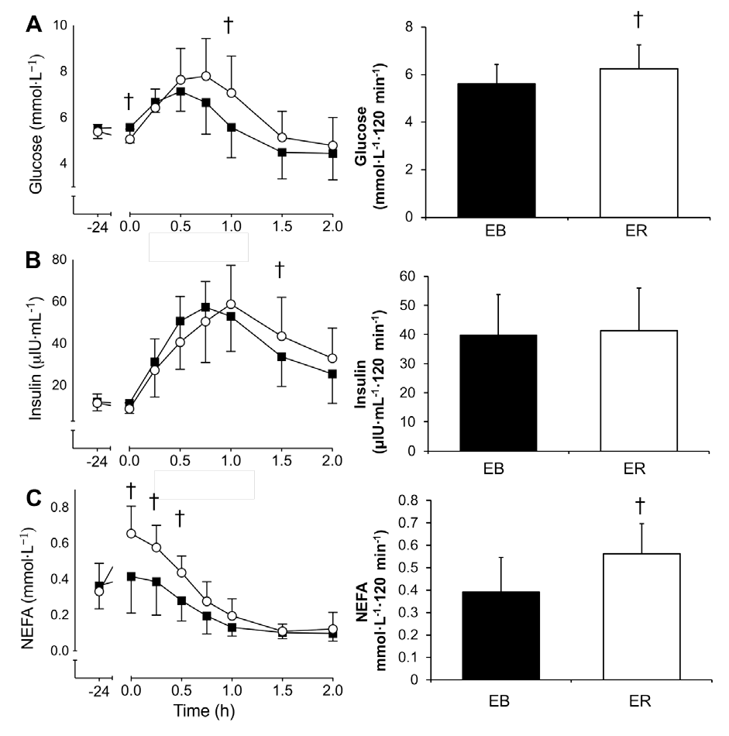
Figure 6.1. Serum glucose (A), serum insulin (B) and plasma NEFA (C) concentration during EB (■) and ER (○). Data points are means with vertical error bars representing standard deviation. Bar charts represent AUC during the OGTT (0-2 h) on EB (■) and ER (□).
† indicates values are significantly different to EB.

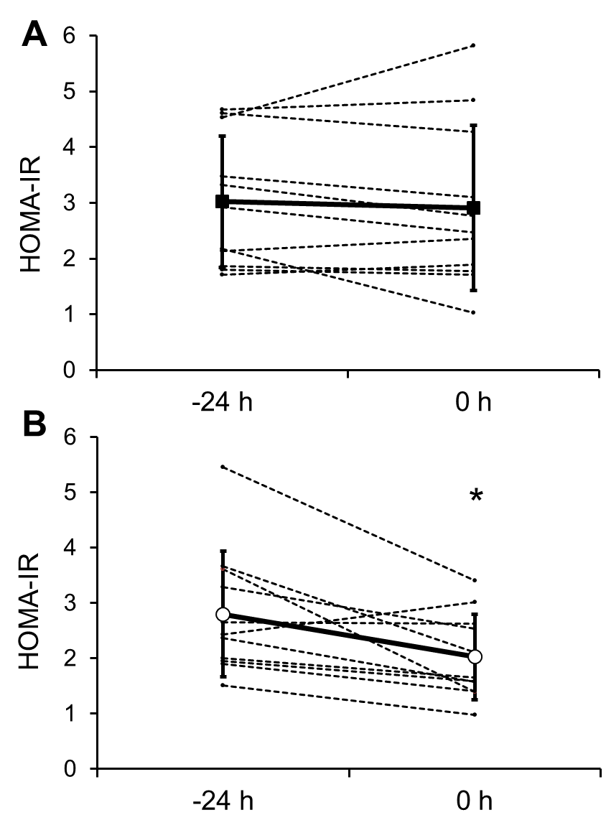

Figure 6.2. HOMA-IR at -24 and 0 h during EB (A) and ER (B). Dotted lines represent individual data, solid line represent the mean with vertical error bars representing standard deviation. * indicates values were significantly different to -24 h within trial (P<0.05).

GLP-1 and GIP responses

There was a main effect of time (P<0.0001) but no trial (P=0.438) or interaction (P=0.361) effects for plasma GLP-1 concentration (Figure 6.2). GLP-1 AUC was not different between trials (P=0.419). There was a main effect of time (P<0.0001) but no trial (P=0.245) or interaction (P=0.625) effects for plasma GIP concentration (Figure 6.2). GIP AUC was not different between trials (P<0.376).

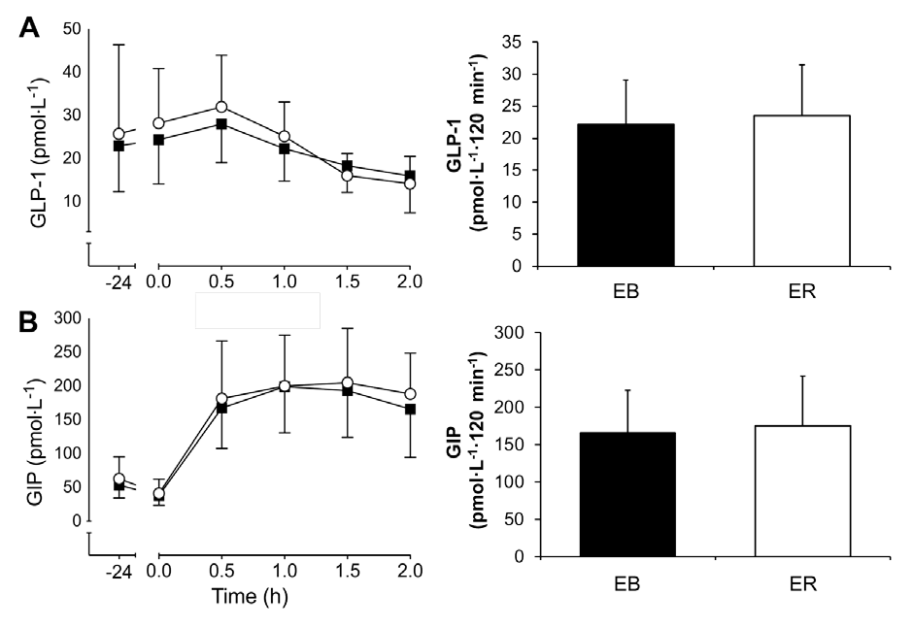
Figure 6.3. Plasma GLP-1 (A) and GIP (B) concentration, during EB (■) and ER (○). Data points are means with vertical error bars representing standard deviation. Bar charts represent AUC during the OGTT (0-2 h) on EB (■) and ER (□).

Discussion
The aim of this study was to determine the acute effects of 24 h severe energy restriction on indices of insulin sensitivity. The results indicate that 24 h of severe energy restriction improved fasting, but reduced post-prandial glycaemic control, compared to 24 h of adequate energy intake.

Intermittent severe energy restriction has been shown to induce comparable weight loss to continuous energy restriction (Varady et al. 2011) and may encourage adherence to dieting in the long-term (Harvie et al. 2013). Therefore, 1-4 days a week of severe energy restriction in combination with ad-libitum or adequate energy intake on other days appears to represent a viable alternative weight loss strategy to continuous daily energy restriction. In addition to weight loss, significant improvements in fasted insulin sensitivity have also been observed after 4-6 months of intermittent severe energy restriction diet 2 days a week (Harvie et al. 2011; Harvie et al. 2013). In line with this, HOMA-IR was reduced ~25% after 24 h of severe energy restriction in the current study. Similarly, a non-significant reduction in HOMA-IR has also been observed after 24 h of water only fasting (Horne et al. 2013).
A short period of complete or severe energy restriction will deplete hepatic glycogen stores (Nilsson and Hultman 1973), increase hepatic triglyceride mobilisation (Kirk et al. 2007) and reduce glycogenolysis (Rothman et al. 1991). This will suppress endogenous glucose production, and as HOMA-IR is calculated from fasting glucose and insulin concentrations (Mathews et al. 1985), it is predicable that HOMA-IR will be reduced immediately after severe energy restriction. There is evidence that this reduction is transient, as Harvie et al. (2011) reported ~29% acute reduction in HOMA-IR immediately after 2-days of severe energy restriction, which normalised after 2-days of resuming adequate energy intake. Therefore, these results show that a short period of severe energy restriction appears to cause an acute improvement in fasting insulin sensitivity but the clinical significance of this is unclear.
The observed improvement in fasting insulin sensitivity appears to be reversed in the post- prandial state. In the current study, serum glucose AUC was greater after 24 h of severe energy restriction, without a concomitant increase in insulin concentration. The origin of the observed elevation in glucose cannot be determined by the current study, however these findings are consistent with the Randle-cycle hypothesis (Randle et al. 1963), suggesting reciprocal rates glucose and fatty acid oxidation, dependant on substrate availability and energy balance. During periods of severe or complete energy restriction, a reduction in carbohydrate intake/ availability increases lipolysis, to provide substrate for metabolism (Maughan et al. 2010). This was reflected in the current study in greater fasting and postprandial plasma NEFA concentrations during ER, which would likely increase fat oxidation and reduce the oxidation of endogenous glycogen (Fery et al. 1998). In addition, an elevated plasma NEFA concentration reduces peripheral insulin sensitivity. Oxidation of

NEFA increases mitochondrial ratios of acetyl-coenzyme/ coenzyme and nicotinamide adenine dinucleotide + hydrogen/ nicotinamide adenine dinucleotide, leading to an accumulation of citrate, which inhibits 6-phosphofructo-1-kinase, a key enzyme involved in glycolysis (Hue and Taegtmeyer 2009; Roden et al. 1996; Soeters et al. 2008; Johnson et al. 2006). Therefore, prolonged postprandial elevation of serum glucose during ER may be due to a reduction in peripheral glucose uptake, mediated by elevated NEFA concentrations.
Alternatively, the prolonged postprandial elevation of serum glucose during ER may have occurred due to maintenance of endogenous glucose production, causing an additive serum glucose response after feeding. However, Kirk et al. (2007) found that endogenous glucose production was decreased after 48 h of energy restriction (~50% EER) providing ~4600 kJ·d⁻
1. Inducing a similar absolute energy deficit, the current study found that fasted serum
glucose was reduced, indicative of reduced hepatic glucose production, after 24 h of energy restriction (25% EER). Therefore elevated postprandial endogenous glucose production is unlikely after an acute period of severe energy restriction. A third potential mechanism would involve an alteration is gastro-intestinal motility, consequently affecting the rate of glucose appearance in the blood. A short period (96 h) of complete energy restriction has been shown to reduce gastric emptying rate, resulting in the delayed appearance of glucose in the blood during an OGTT (Corvilain et al. 1995). However this did not appear to occur in the current study after 24 h severe energy restriction, as no differences in serum glucose concentration were observed between trials until 1 h after feeding. This suggests a similar rate of gastric emptying and absorption on both trials.
Incretin hormones (such as GIP and GLP-1) are secreted rapidly in the intestine in response to food ingestion and stimulate insulin release prior to nutrient absorption to assist with the disposal of glucose from the blood (Baggio and Drucker 2007). In the current study, GIP was elevated from baseline throughout the OGTT, but this was not different between trials. In addition, there was no difference in GLP-1 response throughout the experimental protocol. As identical glucose loads were ingested on both trials during the OGTT, the similar incretin hormone response between trials suggests that alterations in insulin sensitivity were due to factors external to the gastrointestinal tract.
These findings demonstrate that post-prandial glycaemic control is impaired after 24 h of severe energy restriction, which may have implications for individuals following intermittent severe energy restricted diets. The energy deficit induced in the current study was comparable

to the energy deficit achieved during days of severe energy restriction in weight loss trials (Varady et al. 2009; Varady et al. 2011; Varady et al. 2013; Harvie et al. 2011; Harvie et al. 2013). Whilst immediate improvements in HOMA-IR in response to intermittent severe energy restriction may be transient (Harvie et al. 2013), whether short-term reductions in postprandial glycaemic control are transient, persistent, or additive, after multiple exposures to periods of severe energy restriction warrants further investigation. Intermittent severe energy restriction diets can achieve considerable weight loss (Varady et al. 2009; Varady et al. 2011; Varady et al. 2013; Harvie et al. 2011; Harvie et al. 2013), which in itself has been shown to improve postprandial insulin sensitivity (Svendsen et al. 2012; Kirk et al. 2007). But the diet-specific effect of intermittent severe energy restriction on postprandial insulin sensitivity has not been previously investigated. Further information about the effects of intermittent severe energy restriction on insulin sensitivity would be of particular importance to individuals utilising this style of dieting for weight maintenance. Results from the current study indicate that an acute period of severe energy restriction reduces postprandial insulin sensitivity in this population, but the long term effects of repeated exposures to acute periods of severe energy restriction, remains to be determined. The specific effects of different dietary practises on metabolic health, for both weight loss and weight maintenance will facilitate accurate prescription of energy restricted diets for curtailing the prevalence of obesity and obesity related disease in the future.
In conclusion, this study found that an acute 24 h period of severe energy restriction led to an increase in fasting, but a decrease in postprandial insulin sensitivity, in a group of healthy males. Whether this effect is present after multiple exposures to severe energy restriction is currently unknown and warrants further investigation. This will help to determine whether intermittent severe energy restriction can promote long term health benefits, particularly in individuals where weight maintenance, as oppose to weight loss, is the primary objective.

Chapter VII

Effect of 24 h severe energy restriction on appetite, energy intake and metabolism in lean males and females

Abstract
How a method of energy restriction on appetite may determine its long term success. Intermittent severe energy restriction has been shown to induce weight loss, but the appetite regulatory response to severe energy restriction is unknown. The aim of this study was to determine the effect of 24 h severe energy restriction on appetite regulation, metabolism and energy intake. Eighteen lean males and females completed two 3-day trials, in randomised counterbalanced order. On day 1 subjects consumed standardised diets containing 100% (9321 (1273) kJ; EB) or 25% (2340 (320) kJ; ER) of estimated energy requirements (EER). On day 2, a standardised breakfast was consumed (2454 (338) kJ), with plasma concentrations of acylated ghrelin, GLP-1₇₋₃₆, insulin, glucose and NEFA determined for 4 h. Ad-libitum energy intake was assessed at lunch and dinner, with subjective appetite and resting metabolism assessed throughout. On day 3, ad-libitum energy intake was assessed at breakfast and via weighed food records. Energy intake was 7% greater on day 2 (P<0.05) during ER, but not different on day 3 (P=0.557). Subjective appetite was greater during ER on day 1 (P<0.0001) and during the morning of day 2 (P<0.05), but was not different after lunch (P>0.145). Postprandial acylated ghrelin concentration was lower during ER (P<0.05), whilst postprandial GLP-1₇₋₃₆ concentration was not different between trials (P=0.784). Postprandial glucose (P<0.05) and NEFA (P<0.0001) concentrations were greater during ER, whilst insulin concentration tended to be greater (P=0.06). Energy expenditure was lower during ER in the morning (P<0.01), but was not different after lunch (P=0.665). In lean young adults, 24 h severe energy restriction transiently elevated subjective appetite and marginally increased energy intake, but hormonal appetite markers did not respond in a manner indicative of hyperphagia. These results suggest intermittent severe energy restriction might be useful to attenuate energy intake and control body weight in this population.

Introduction
The majority of weight management research tends to focus on methods to assist obese individuals lose weight, but recent research suggests that part of this problem is attributable to lean individuals gaining weight throughout adulthood, eventually contributing to increasing rates of obesity (Ostbye et al. 2011). This highlights a need for an improved understanding of how weight loss programmes translate to weight maintenance programmes, therefore helping to curtail the prevalence of obesity in the future.
Traditional weight management diets involve daily energy restriction to induce a moderate energy deficit over time, but more recently, intermittent severe energy restriction has been proposed as an alternative to daily energy restriction, capable of inducing comparable weight loss (Varady 2011). Studying the acute effects of severe energy restriction may elucidate some of the mechanisms of action. Persistent hunger is often cited as a reason for poor adherence to weight management regimes (Vogels and Westerterp-Plantenga 2005), suggesting that long-term adherence and weight loss may depend on how that dietary intervention influences appetite. Orexigenic and anorexigenic hormones may influence appetite to correct perturbations in energy balance (Cummings et al. 2002; Holst 2007). Ghrelin is an orexigenic hormone that is suppressed after food intake and returns to fasting levels between meals (Cummings et al. 2002). This suggests ghrelin’s response to food intake may be important in determining post-meal satiety and/ or subsequent meal initiation (Doucet and Cameron 2007). However, little is known about how appetite hormone profiles respond after short periods of severe energy restriction. Fasting hormone concentrations do not appear to change after short periods of severe energy restriction (Pasiakos et al. 2011; Doucet et al. 2004; Blom et al. 2006). However, a recent study reported that 48 h of severe energy restriction (providing 10% EER) produced a postprandial appetite hormone profile that would be expected to suppress, rather than stimulate appetite, in male and female soldiers (O’Connor et al. 2016). This study incorporated meal replacement gels, rather than real foods and a large amount of exercise (to simulate occupational activities), which possibly limits its translation to weight management settings.
The aim of the current study was to examine the effect of 24 h of severe energy restriction (providing 25% of EER) on subjective and hormonal appetite regulation, ad-libitum food intake and metabolism, compared to an adequate energy control diet (providing 100% EER).

Methods
Subjects

Subjects were ten healthy males (mean (SD); age: 24 (2) y; weight: 74.4 (7.2) kg; height:
1.78 (0.06) m; BMI: 24 (2) kg·m⁻²; body fat: 14 (4) %) and eight healthy females (age: 22 (2) y; weight: 63.8 (8.6) kg; height: 1.61 (0.05) m; BMI: 24 (2) kg·m⁻²; body fat: 27 (5) %). Subjects were not restrained, disinhibited or hungry eaters, had been weight stable for >6 months and were not currently dieting. Female participants completed a menstrual cycle questionnaire, and trials were conducted during the post-menstruation follicular phase (~5-12 days after start of menstruation). Sample size was estimated to detect a difference in energy intake, using energy intake data from a similar study (Johnstone et al. 2002), data from our laboratory using similar ad-libitum meals (Chapter IV) and an estimated between group correlation of 0.5 (G*Power 3.1.6; Dusseldorf, Germany). Using an α of 0.05 and β of 0.05, it was determined at least 16 subjects would be required to reject the null hypothesis.
Study design

During a 1-day preliminary trial, height, weight and body fat percentage were determined and subjects were familiarised with the ad-libitum meals and blood sampling procedures. Subjects then completed two 3-day experimental trials, administered in a crossover, randomised, counterbalanced order. Trials were separated by ≥14 days for males and exactly 1 menstrual cycle for females. On day 1 of each experimental trial, subjects received either 100% (EB) or 25% (ER) of EER. On day 2 and 3, food intake, behaviour and metabolic responses to each diet were assessed (Figure 7.1).
Protocol

For each trial, subjects arrived at the laboratory via motorised transport at ~07:30 on three consecutive mornings, after a ≥10 h overnight fast and after voiding, nude body mass was measured (Adam Equipment Co, Milton Keynes, UK). On day 1, expired gas and blood (via venepuncture) samples were collected and subjective appetite assessed (~08:00; -24 h). Subjects left the laboratory at ~08:30, after receiving all food and drink for the day, along with instructions on when to consume each item. On day 2, an indwelling cannula was inserted and the measurements from day 1 were repeated (~08:00; 0 h). A standardised breakfast consisting of cereal, semi-skimmed milk, white bread, butter and jam (2454 (338) kJ; 16 (2) g protein; 93 (13) g carbohydrate; 16 (2) g fat; 3 (0) g fibre) and providing 25%

EER was then consumed over 20 min. Subjects then rested in the laboratory, with subjective appetite sensations, blood and expired gas collected periodically between breakfast and lunch. The cannula was removed after the final collection and an ad-libitum multi-item lunch was provided (~12:00-12:30; 4-4.5 h). After lunch, subjects rested in the laboratory, with further expired gas (5, 7, 9, 11 h) and subjective appetite sensations collected (5, 6, 7, 8, 8.25, 9, 10,
11 h). A standardised yoghurt and cereal bar snack (862 (118) kJ; 4 (1) g protein; 25 (3) g carbohydrate; 10 (1) g fat; 1 (0) g fibre) was consumed at ~16:00 (8 h), and a single-item ad- libitum dinner was provided at ~19:00-19:30 (11-11.5 h), with subjective appetite assessed immediately after dinner (11.5 h). On day 3, blood (via venepuncture) and an expired gas sample were collected, subjective appetite assessed (~08:00; 24 h) and an ad-libitum porridge breakfast was provided 24-24.5 h. Final subjective appetite sensations were collected at 24.5 h and subjects completed a weighed record of all food and drink consumed for the remainder of the day (24.5-48 h).

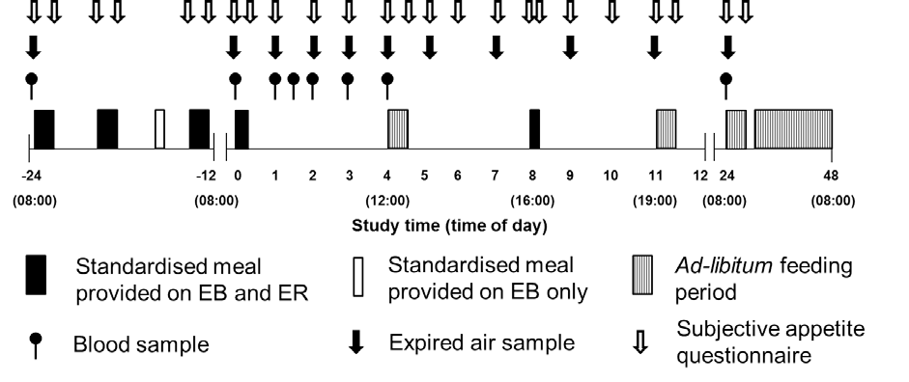

Figure 7.1. Schematic representation of study protocol

Standardised diet preparation

Diets were tailored to individual preferences and formulated to contain palatable and recognisable foods to ensure adherence. Estimated resting metabolic rate was multiplied by a sedentary physical activity level of 1.4 to determine EER for each subject. Details of day 1 standardised diets are provided in Table 3.2 in Chapter III.

Energy intake

Energy intake was assessed at a multi-item ad-libitum lunch (4-4.5 h; Appendix H), a homogenous ad-libitum dinner (11-11.5 h; Appendix I), a homogenous ad-libitum breakfast (24-24.5 h; Appendix J) and via habitual food records (24.5-48 h; Appendix K).
Energy expenditure and substrate oxidation

Resting expired gas samples were collected pre-breakfast on day 1 (-24 h); at 0, 1, 2, 3, 4, 5, 7, 9 and 11 h on day 2; and pre-breakfast on day 3 (48 h). Expired gas samples were collected and analysed as described in Chapter III.
Subjective appetite

Hunger, fullness, desire to eat (DTE) and prospective food consumption (PFC) were assessed pre-breakfast (-24 h), post-breakfast (-23.5 h), pre-lunch (-20 h), post-lunch (-19.5 h), pre-
dinner (-13 h) and post-dinner (-12.5 h) on day 1; pre-breakfast (0 h), post-breakfast (0:20 h)
and at 1, 2, 3, 4, 4.5, 5, 6, 7, 8, 8.25, 9, 10, 11, 11.5 h on day 2; and pre-breakfast (24 h) and
post-breakfast (24.5 h) on day 3.

Blood sampling

Due to problems with blood sampling, blood samples were only collected for 16 (8 male; 8 female) of the 18 subjects. Blood samples (15 mL) were drawn after 30 min of supine rest at - 24, 0, 1, 1.5, 2, 3, 4 and 48 h, and were treated and analysed for determination of acylated ghrelin, GLP-1₇₋₃₆, insulin, glucose and NEFA, as described in Chapter III.
Statistical analysis

Area under the curve (AUC) was calculated using the trapezoidal method and averaged over time. AUC for subjective appetite sensations were calculated for day 1 (-24-0 h), in response to the standard breakfast (0-4 h), during the afternoon (4.5-11 h) and during the evening/ overnight (11.5-24 h) on day 2. AUC for energy expenditure and substrate oxidation were calculated in response to the standard breakfast (0-4 h) and during the afternoon (4.5-11 h) on day 2. Data was analysed using the methods described in Chapter III. Additionally, gender was entered as a between-subjects factor in repeated measures ANOVA to test for gender-by- trial-by-time interactions, and gender-by-trial interactions (AUC and energy intake).

Results
Gender analysis

There were main effects of gender for some variables, with plasma NEFA concentration greater in females (P<0.05), and ad-libitum energy intake (P<0.001), energy expenditure (P<0.001), carbohydrate oxidation (P<0.001) and body mass (P<0.01) greater in males. There were no gender-by-trial interaction effects for energy intake at any ad-libitum meal (P>0.338) or reported energy intake on day 3 (P=0.469). There was a gender-by-trial interaction effect for fullness AUC between lunch and dinner on day 2 (P<0.05), with fullness lower in males on ER compared to EB (P<0.05). There were no other gender-by-trial (P>0.274) or gender-by-trial-by-time (P>0.342) interaction effects for AUC or raw data, respectively. Therefore, male and female data are presented together.
Energy intake

On day 2, ad-libitum energy intake was greater at lunch (ER: 4820 (1335) kJ; EB: 4322 (1538) kJ; P<0.05) and tended to be greater at dinner (ER: 4627 (1219) kJ; EB: 4322 (971) kJ; P=0.056) during ER. Therefore, total ad-libitum energy intake on day 2 was 7% greater during ER compared to EB (P<0.05). On day 3, ad-libitum energy intake was not different at breakfast (EB: 2185 (566) kJ; ER: 2355 (543) kJ; P=0.162) and there was no difference in reported energy intake over the remainder of the day (EB: 9034 (2983) kJ; ER: 8532 (2788) kJ; P=0.362). Over the 2 day period, the increase in energy intake (471 (2902) kJ) was only sufficient to replace ~7% of the energy deficit created on day 1. Therefore energy intake over the 3-day trial was 6509 (3308) kJ greater during EB (P<0.00001; Table 7.1).

Table 7.1. Energy and macronutrient intake during each day of the experimental trial.

Protein (g) Carbohydrate (g) Fat (g) Fibre (g) Energy (kJ)

Day 1

EB | 97 (14) | 294 (41) | 70 (9) | 11 (2) | 9321 (1273)
ER | 60 (9) † | 56 (8) † | 9 (1) † | 3 (1) † | 2340 (320) †

Day 2

EB | 95 (21) | 403 (89) | 90 (22) | 22 (5) | 11960 (2419)
ER | 99 (20) | 424 (100) | 100 (21) † | 23 (6) | 12763 (2545) †

Day 3

EB | 117 (43) | 336 (96) | 90 (36) | 26 (7) | 11219 (2994)
ER | 115 (45) | 316 (98) | 90 (31) | 27 (10) | 10887 (2911)

Daily averaged intake

EB | 103 (22) | 344 (67) | 83 (19) | 20 (4) | 10833 (2050)
ER | 91 (21) † | 265 (56) † | 66 (12) † | 18 (5) † | 8663 (1561) †

† indicates significant difference to EB (P<0.05). Data are mean (SD)

Energy expenditure and substrate oxidation

There was a main effect of time (P<0.0001), but no trial (P=0.153) or interaction (P=0.101) effects for energy expenditure (Figure 7.2). Post-breakfast energy expenditure AUC was lower during ER (P<0.01) but was not different between trials after lunch (P=0.665) or at 24 h (P=0.867; Figure 7.2). For carbohydrate and fat oxidation, there were time (P<0.00001), trial (P<0.001) and interaction (P<0.001) effects (Figure 7.2). Carbohydrate oxidation was lower between 0-4 h (P<0.05) and fat oxidation greater at 0, 1, 3 and 4 h (P<0.05) during ER compared to EB. Post-breakfast AUC was lower for carbohydrate oxidation (P<0.00001) and greater for fat oxidation (P<0.0001; Figure 7.2) during ER. Furthermore, post-lunch AUC was greater for fat oxidation (P<0.05) and lower for carbohydrate oxidation (P<0.05; Figure 7.2) during ER.

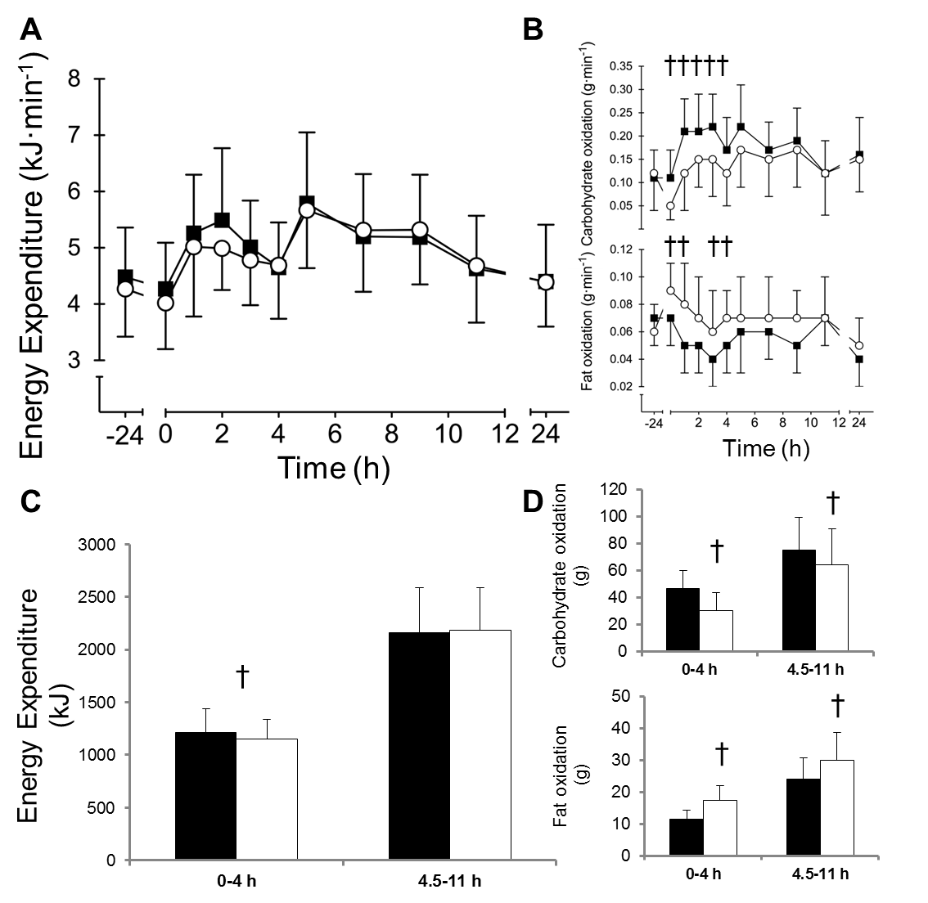
Figure 7.2. Energy expenditure (A) and substrate oxidation (B) during EB (■) and ER (○). Data points are means with vertical error bars representing standard deviation. Bar charts represent energy expenditure (C) and substrate oxidation (D) AUC during EB (■) and ER (□).
† indicates values are significantly different to EB (P<0.05).

Blood parameters

There were time (P<0.00001), trial (P<0.05) and interaction (P<0.00001) effects for plasma glucose concentration (Figure 7.3). Plasma glucose was lower at 0 h and greater between 1-
1.5 h (P<0.05) during ER. Plasma glucose AUC was greater during ER compared to EB (P<0.05). For plasma insulin concentration, there was a main effect of time (P<0.0001) but no trial (P=0.057) or interaction (P=0.120) effects (Figure 7.3). Plasma insulin AUC tended to be greater during ER (P=0.06). There were time (P<0.00001), trial (P<0.0001) and interaction (P<0.00001) effects for plasma NEFA concentration (Figure 7.3). Plasma NEFA concentration was greater between 0-1 h (P<0.01) and tended to be greater at 1.5 h (P=0.076) during ER. Plasma NEFA AUC was also greater during ER (P<0.0001). There were time (P<0.00001), trial (P<0.05) and interaction (P<0.01) effects for plasma acylated ghrelin concentration (Figure 7.4). Acylated ghrelin concentration was greater at 0 and 3 h during EB compared to ER (P<0.05) and acylated ghrelin AUC was greater during EB (P<0.05). There was a main effect of time (P<0.001) but no trial (P=0.540) or interaction (P=0.524) effect for plasma GLP-1₇₋₃₆ and plasma GLP-1₇₋₃₆ AUC was not different between trials (P=0.784; Figure 7.4).

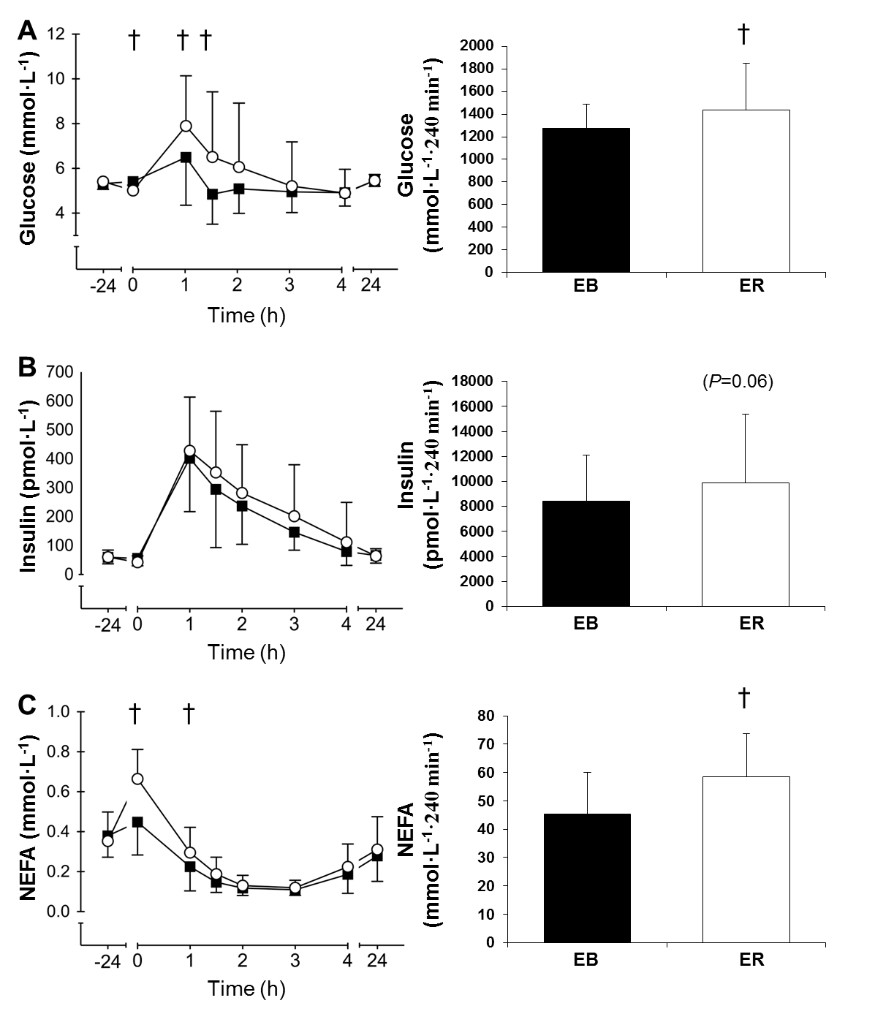
Figure 7.3. Plasma glucose (A), insulin (B) and NEFA (C) during EB (■) and ER (○). Data points are means with vertical error bars representing standard deviation. Bar charts represent post-breakfast AUC during EB (■) and ER (□). † indicates values are significantly different to EB (P<0.05).

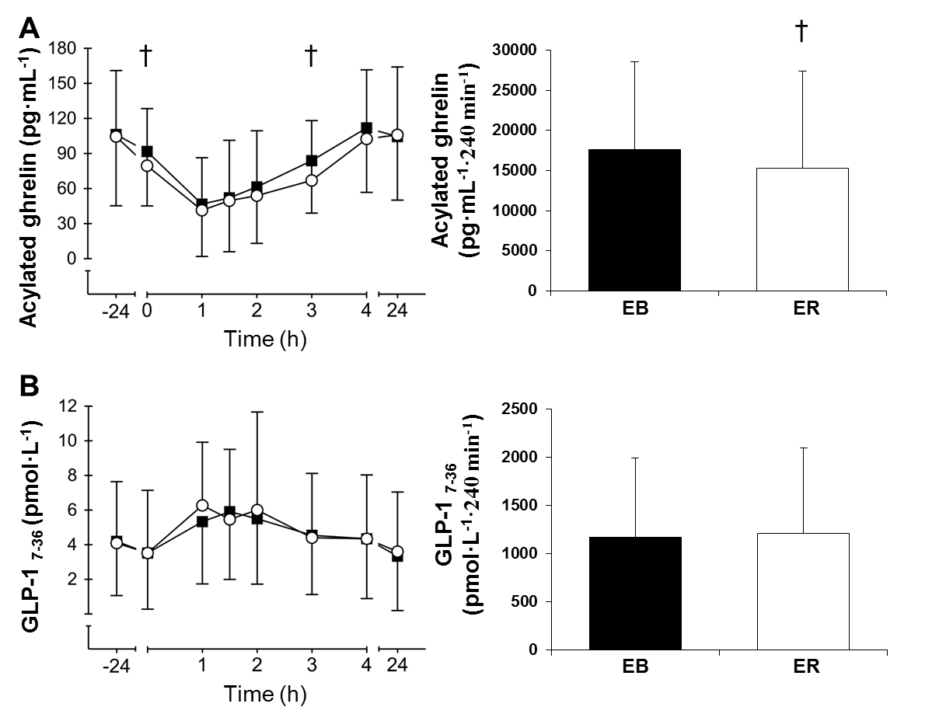
Figure 7.4. Plasma acylated ghrelin (A) and GLP-1₇₋₃₆ (B) during EB (■) and ER (○). Data points are means with vertical error bars representing standard deviation. Bar charts represent post-breakfast AUC during EB (■) and ER (□). † indicates values are significantly different to EB (P<0.05).

Subjective appetite sensations

AUC for hunger, DTE and PFC were greater, and fullness lower for Day 1 (P<0.00001) and post-breakfast on day 2 (P<0.05) on ER compared to EB. There were no differences in post- lunch (P>0.145) or overnight (P>0.214) AUC for appetite sensations (Figure 7.5).

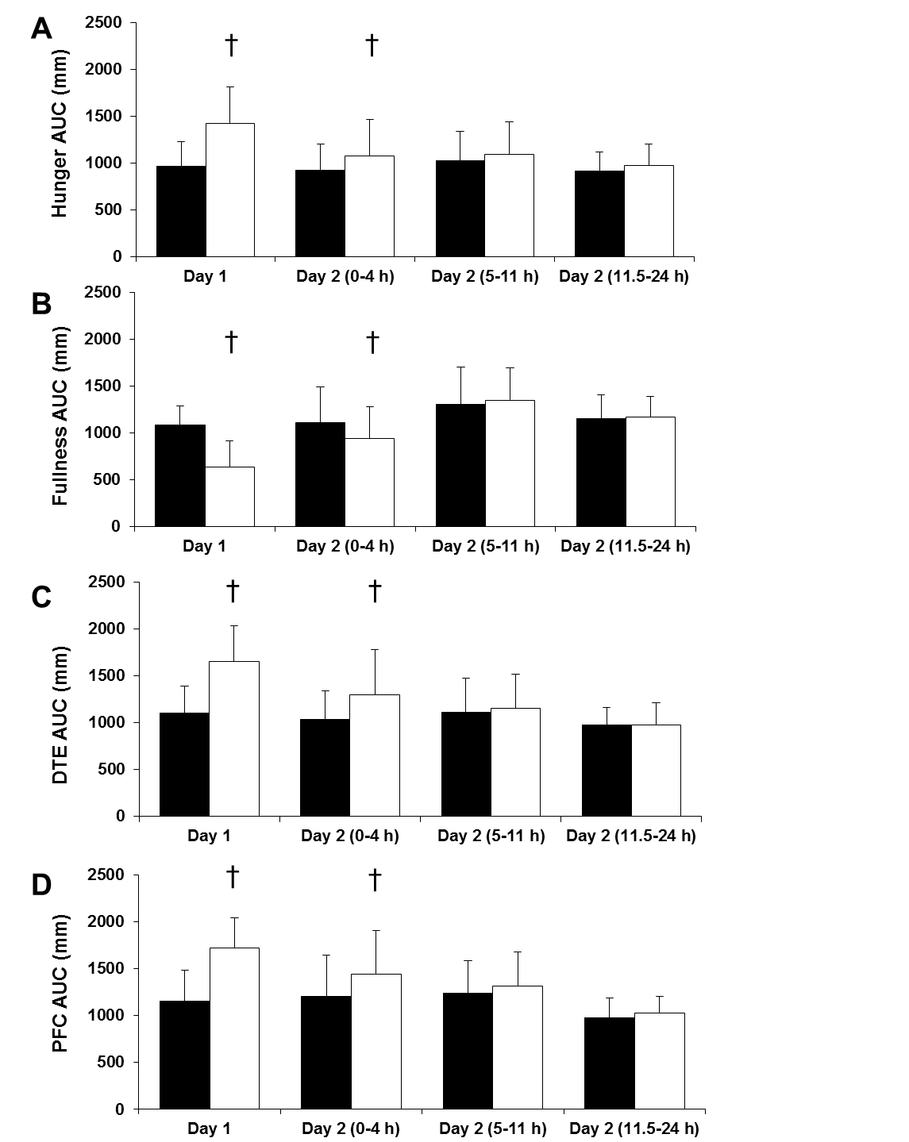

Figure 7.5. AUC for hunger (A), fullness (B), DTE (C) and PFC (D), on day 1, and during the morning (0-4 h), afternoon (5-11 h), and evening (11.5-24 h) of day 2, during EB (■) and ER (□). Data points are mean with vertical error bars representing standard deviation. † indicates values are significantly different to EB (P<0.05).

Body mass

Morning body mass on day 1, 2 and 3, respectively was 69.2 (9.4) kg, 68.9 (9.3) kg and 68.8
(9.4) kg during EB and 69.5 (9.5) kg, 68.4 (9.2) kg and 68.9 (9.4) kg during ER. There were time (P<0.001) and interaction (P<0.001) effects for body mass. Body mass loss from day 1 to day 2 was greater during ER compared to EB (P<0.001) and body mass on day 2 was lower during ER compared to EB (P<0.001). Day 3 body mass was not different between trials (P=0.594).

Discussion
The aim of the current study was to compare the effects of 24 h of adequate (100% EER consumed) or severely restricted energy intake (25% EER consumed) on appetite regulation and ad-libitum energy intake in the subsequent 48 h. The main findings were that 24 h of severe energy restriction caused a transient elevation in subjective appetite and increased ad- libitum energy intake by ~7% in the first 24 h and by ~2% overall. In addition there was no difference in subjective appetite between trials after an ad-libitum lunch and 24 h of severe energy restriction did not promote an appetite hormone response indicative of hyperphagia. These results suggest that short periods of severe energy restriction may reduce energy intake and assist with appetite control in lean males and females.
Previous studies have reported that lean individuals do not accurately adjust energy intake in response to a dietary induced energy deficit (O’Connor et al. 2016; Johnstone et al. 2002; Levitsky and DeRosimo 2010; Mars et al. 2005). Consistent with the current study, either no compensation (Levitsky and DeRosimo 2010) or only partial compensation (O’Connor et al. 2016; Johnstone et al. 2002; Mars et al. 2005) in the 1-4 days after an acute (24-48 h) period of severe or complete energy restriction has been reported. Consequently, the majority of the energy deficit induced by energy restriction in these studies was preserved. Ad-libitum energy intake was ~7% greater during ER on day 2, with no difference on day 3, and average energy intake over the 3-day study was ~20% (2170 kJ) lower during ER compared to EB. Therefore, short-term severe energy restriction appears to represent a viable method of reducing energy intake in lean males and females.
Subjects reported greater hunger, DTE, PFC and lower fullness on day 1 during ER compared to EB. This might be expected as a previous study found that subjective appetite in the

morning was elevated after 36 h of complete energy restriction, but consumption of an ad- libitum breakfast normalised subjective appetite to levels comparable to a control trial, in which adequate energy intake was consumed in the previous 36 h (Johnstone et al. 2002). However in the current study, subjective appetite remained elevated throughout the morning during ER after consumption of a standardised breakfast containing 25% EER. This suggests that the breakfast used in the current study was not sufficient to offset appetite to the same extent as the ad-libitum breakfast provided by Johnstone et al. (2002). However, subjective appetite sensations were not different between trials after the ad-libitum lunch meal. This suggests subjective appetite can be offset by an ad-libitum meal independent of energetic compensation, and thereafter maintenance of the energy deficit might be achieved in the absence of elevated subjective appetite.
Acylated ghrelin is an orexigenic hormone that has been suggested to initiate food intake as concentrations increase before and decrease after eating (Cummings et al. 2004). Therefore, acylated ghrelin might be expected to increase after energy restriction, as a mechanism to restore energy balance homeostasis (Cummings et al. 2002). However, 1-4 days of energy restriction of varying severity has shown no effect on fasting and/or postprandial ghrelin concentrations (Pasiakos et al. 2011; Doucet et al. 2004; Blom et al. 2006). The current study differs from these previous studies, as fasting and postprandial acylated ghrelin concentrations were reduced after 24 h of severe energy restriction. The current findings are consistent with a recent study, reporting suppressed postprandial acylated ghrelin concentration after consumption of a diet providing 10% EER for 2-days and including a large component of physical exercise. Intralipid infusion has previously been show to suppress acylated ghrelin (Gormsen et al. 2007), potentially via inhibition of ghrelin o-acyl transferase (GOAT), the enzyme responsible for the acylation of ghrelin (Liu et al. 2008). Therefore elevated plasma NEFA concentrations observed in the current study during ER, may explain why acylated ghrelin was suppressed in this, as well as a previous (O’Connor et al. 2016) study.
Intravenous infusion of the anorexigenic hormone GLP-1₇₋₃₆ has been shown to suppress appetite and food intake, suggesting a role in meal termination and post-meal satiety (Holst 2007). Whilst GLP-1₇₋₃₆ concentration has been shown to increase after weight loss (Adam et al. 2005; Adam et al. 2006), 24 h severe energy restriction did not affect fasting or postprandial GLP-1₇₋₃₆ concentration in the current study, suggesting this might not be an important regulator of day-to-day energy balance. GLP-1₇₋₃₆ is also an incretin hormone

which responds to ingested nutrients in the stomach and stimulates insulin secretion prior to nutrient absorption (Baggio and Drucker 2007). As no between-trial differences in insulin concentration were observed, it appears that neither the anorexigenic or insulinotropic actions of GLP-1₇₋₃₆ were affected by 24 h of severe energy restriction in the current study. However, GLP-1₇₋₃₆ is rapidly degraded into its inactive form (GLP-1₉₋₃₆) by the enzyme dipeptidyl peptidase IV upon release from intestinal L-cells (Holst and Deacon 2005). Therefore, GLP- 1₇₋₃₆ could potentially still influence appetite centrally without being detected peripherally.
Whilst dietary interventions are generally developed to aid weight loss in overweight and obese individuals, research suggests that BMI progressively increases throughout adulthood (Ostbye et al. 2011). To prevent the progression towards obesity, effective methods to assist weight management in lean individuals might be as important as weight loss in overweight/ obese individuals. Intermittent severe energy restriction has been shown to effectively reduce weight under tightly controlled conditions (Harvie et al. 2011; Harvie et al. 2013; Varady et al. 2009; Varady et al. 2011; Varady et al. 2013) and therefore could also be a successful method of reducing energy intake for weight maintenance. However, compliance to periods of very-low energy intake under free-living conditions has not been fully elucidated. Persistent hunger and requirements for daily adherence have been highlighted as reasons for poor compliance to diets (Anderson et al. 2001; Vogels and Westerterp-Plantenga 2005) and could ultimately dictate long-term success. In the current study, the appetite hormone response to severe energy restriction was not indicative of elevated appetite, but paradoxically, subjective appetite was increased and energy intake was ~12% greater at lunch. This may reveal the complexity of human eating behavior, which is likely governed by cognitive and external factors, in addition to physiological cues. However, subjective appetite was offset after lunch and there was no further difference in energy intake. Therefore a flexible dietary approach permitting ad-libitum eating with intermittent periods of very-low energy intake may assist with appetite control and aid long-term dietary compliance.
A small (~0.2 kJ·min⁻¹), transient reduction in resting energy expenditure was observed during ER, but ER and EB were not different over the 24 h assessment period (i.e. day 2). Whilst this minor decrement is unlikely to influence energy balance, the laboratory procedures utilised in this study are likely to have restricted physical activity energy expenditure. Therefore, the effects on energy expenditure cannot be fully determined from this study. An increase in fat and reduction in carbohydrate oxidation was observed on day 2 during ER. This is indicative of altered nutrient supply and/ or endogenous stores after severe

energy restriction, and has been reported previously (Bergman et al. 2007; Klein et al. 1993; Horton and Hill 2001). Twenty-four hours of complete energy restriction has been shown to reduce liver glycogen stores (Nilsson and Hultman 1973). Carbohydrate provision in the current study may have been insufficient to meet obligate glucose requirements (Maughan et al. 2010), resulting in an increase in lipolysis to provide NEFA for energy metabolism to preserve endogenous glycogen (Maughan et al. 2010).
Glucose AUC was greater and insulin AUC tended to be greater (P=0.06) on ER, suggesting glycaemic control was impaired after 24 h severe energy restriction. This has been observed after short periods of complete energy restriction (Lundbaek 2006) and could be driven by elevated plasma NEFA concentrations, which may reduce the rate of glucose uptake into the muscle (Soeters et al. 2008; Johnson et al. 2006). However, the practical relevance of this finding is unclear and has not been determined after chronic intermittent severe energy restriction. Fasting insulin sensitivity has been shown to improve after 4 months of intermittent (2 days per week) severe energy restriction (Harvie et al. 2013), but the effect of long term severe energy restriction and refeeding cycles on postprandial insulin sensitivity is unknown and warrants further investigation.
In conclusion, 24 h of severe energy restriction causes a transient increase in subjective appetite and a small increase in energy intake during the subsequent 24 h. Hormonal markers of appetite were not upregulated after severe energy restriction and did not respond in a manner indicative of hyperphagia. Therefore, an acute period of severe energy restriction may assist with energy balance management in lean males and females. Future studies should aim to examine the chronic effects of intermittent severe energy restriction on appetite regulation.

Chapter VIII

No effect of 24 h severe energy restriction on appetite, energy intake and metabolism in overweight and obese males

Abstract
Long-term success of weight loss diets might depend on how the appetite regulatory system responds to energy restriction. This study determined the effect of 24 h severe energy restriction on subjective and hormonal appetite regulation, subsequent ad-libitum energy intake and metabolism. In randomised order, eight overweight or obese males consumed a 24 h diet containing either 100% (12105 (1174 kJ; EB) or 25% (3039 (295) kJ; ER) of estimated daily energy requirements (EER). An individualised standard breakfast containing 25% of EER (3216 (341) kJ) was consumed the following morning and resting energy expenditure, substrate utilisation, and plasma concentrations of acylated ghrelin, GLP-1₇₋₃₆, GIP₁₋₄₂, glucose, insulin and NEFA were determined for 4 h after-breakfast. Ad-libitum energy intake was assessed in the laboratory on day 2 and via food records on day 3. Subjective appetite was assessed throughout. Energy intake was not different between trials for day 2 (EB: 14946 (1272) kJ; ER: 15251 (2114) kJ; P=0.623), day 3 (EB: 10580 (2457) kJ; 10812 (4357) kJ;
P=0.832) or day 2 and 3 combined (P=0.693). Subjective appetite was increased during ER on day 1 (P<0.01), but was not different between trials on day 2 (P>0.381). Acylated ghrelin, GLP-1₇₋₃₆ and insulin were not different between trials (P>0.104). Post-breakfast AUC for NEFA (P<0.05) and GIP₁₋₄₂ (P<0.01) were greater during ER compared to EB. Fat oxidation was greater (P<0.01) and carbohydrate oxidation was lower (P<0.01) during ER, but energy expenditure was not different between trials (P=0.158). These results suggest that 24 h severe energy restriction does not affect appetite regulation or energy intake in the subsequent 48 h. This style of dieting may be conducive to maintenance of a negative energy balance by limiting compensatory eating behaviour, and therefore may assist with weight loss.

Introduction
Overweight and obesity are positively associated with several chronic diseases and consequently represent a considerable health and economic burden (Bray 2004; Roberts and Bernard 2005). In these populations weight loss of >5% body mass reduces the prevalence of

some of these chronic diseases (Anderson and Fernandez 2013). Traditional weight loss diets involve continuous daily energy restriction to induce a moderate daily energy deficit. This style of dieting is successful in some, and typically results in long term weight loss of >5% body mass in approximately 30-40% of dieters (Anderson et al. 1999; Greenberg et al. 2009; Sacks et al. 2009). One problem with such diets is thought to be the requirement for daily adherence to the diet in order to create a sufficiently large energy deficit to induce weight loss (Anderson et al. 2001). Intermittent severe energy restriction, which negates some of the arduous factors of continuous energy restriction, can achieve 4-8% weight loss in 8-24 weeks (Varady et al. 2009; Varady et al. 2011; Varady et al. 2013; Harvie et al. 2011; Harvie et al. 2013) and therefore may represent a viable alternative weight loss strategy.
In line with the findings in the previous chapter, the majority of studies have reported a small increase in energy intake in the days after an acute episode of severe or complete energy restriction, but this is insufficient to fully compensate for the energy restricted and consequently the energy deficit is sustained (Johnstone et al. 2002; Mars et al. 2005; Levitsky and DeRosimo 2010; O’Connor et al. 2016). However, the effect of severe energy restriction on energy intake in overweight and obese populations has not been determined, and little is known about how hormonal and subjective appetite markers respond after an acute period of severe energy, particularly in this population.

Therefore, the purpose of this study was to examine the effect of 24 h severe energy restriction (~25% of EER) on appetite regulation (hormonal and subjective) and ad-libitum energy intake compared to an adequate energy control trial (100% of EER).

Methods
Subjects

Eight overweight/ obese (BMI ≥28 kg·m⁻²; Body fat >20%), but otherwise healthy, weight stable and non-dieting males (age: 26 (4) y; weight 104.6 (17.6) kg; height: 1.82 (0.06) m; BMI: 32 (4) kg·m⁻²; body fat: 28 (4) %) completed this study. Subjects were not restrained, disinhibited or hungry eaters. Sample size was estimated from energy intake data from a similar study (Johnstone et al. 2002) and from unpublished energy intake data from our laboratory using the same ad-libitum meals, which provided a between group correlation of
0.83 (G*Power 3.1.6; Dusseldorf, Germany). Using an α of 0.05 and β of 0.2, it was

determined 7 subjects would be required to reject the null hypothesis. Therefore we recruited 8 subjects to counterbalance the study and ensure an adequate sample size for the primary outcome (i.e. energy intake).
Study design

Subjects completed a 1-day preliminary trial, during which height, weight and body fat percentage were measured, before they were familiarised with the ad-libitum meals and blood sampling procedures. Subjects then completed two 3-day experimental trials in randomised, crossover, counterbalanced order, separated by ≥14 days. Each trial consisted of a 24 h dietary intervention period where subjects received 100% (i.e. energy balance; EB) or 25% (i.e. energy restriction; ER) of EER, followed by two days where dietary intake, behavioural and metabolic responses were measured (Figure 8.1).
Protocol

For each trial, subjects attended the laboratory on two consecutive mornings, arriving via motorised transport at ~07:30 after a ≥10 h fast. On day 1, blood (by venepuncture of an antecubital/ forearm vein) and expired gas samples were collected and subjective appetite assessed (-24 h). Subjects were provided food and drink for the day, along with instructions about when to consume each item and left the laboratory at ~08:30. Upon arrival on day 2, a cannula was inserted into an antecubital/ forearm vein and measurements made on day 1 were repeated (0 h). A standardised breakfast, providing 25% EER and consisting of white bread, jam, butter, cereal and semi-skimmed milk (3216 (341) kJ; 123 (12) g carbohydrate; 21 (2) g protein; 20 (3) g fat; 4 (1) g fibre) was consumed over 20 min. Subjects then rested in the laboratory, with blood and expired gas samples collected and subjective appetite assessed periodically after breakfast. After the 4 h sample, the cannula was removed and an ad-libitum multi-item lunch was provided (4-4.5 h). After lunch, subjects left the laboratory, but were not permitted to consume any food or drink, with the exception of ad-libitum water and a standardised yoghurt and cereal bar snack (1135 (235) kJ; 33 (7) g carbohydrate; 5 (1) g protein; 13 (3) g fat; 1 (0) g fibre) at ~16:00 (8 h). Subjects returned at ~19:00 and were provided with an ad-libitum single-item dinner (11-11.5 h), after which they left the laboratory and were instructed not to consume any food or drink (other than water in the evening) until 08:00 the following morning (24 h). At 08:00 on day 3, subjective appetite was assessed (24 h) and subjects then completed a weighed food record for the rest of the day (24- 48 h).

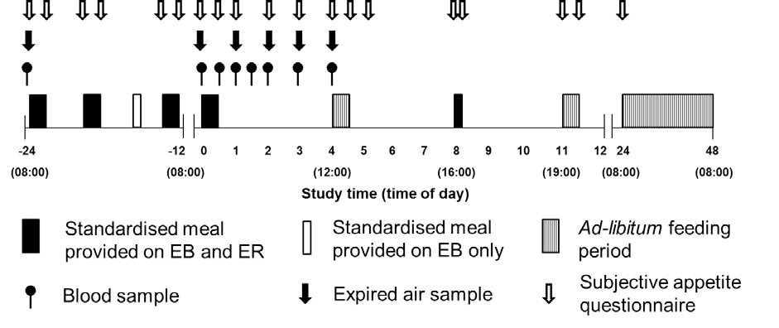

Figure 8.1. Schematic representation of study protocol

Energy intake

Energy intake was assessed at a multi-item ad-libitum lunch (4-4.5 h; Appendix H), a homogenous ad-libitum dinner (11-11.5 h; Appendix I), and via habitual food records (24.5- 48 h; Appendix K).
Energy expenditure and substrate oxidation

Rested expired gas samples were collected pre-breakfast on day 1 (-24 h); and at 0, 1, 2, 3 and 4 on day 2. Expired gas samples were collected and analysed as described in Chapter III.
Subjective appetite

Hunger, fullness, desire to eat (DTE) and prospective food consumption (PFC) were assessed pre-breakfast (-24 h), post-breakfast (-23.5 h), pre-lunch (-20 h), post-lunch (-19.5 h), pre-
dinner (-13 h) and post-dinner (-12.5 h) on day 1; pre-breakfast (0 h), post-breakfast (0:20 h)
and at 1, 2, 3, 4, 4.5, 5, 8, 8.25, 11, 11.5 h on day 2; and pre-breakfast (24 h) on day 3.

Blood sampling

Blood samples (15 mL) were drawn after 30 min of supine rest at -24, 0, 0.5, 1, 1.5, 2, 3 and 4 h, and were treated and analysed for determination of acylated ghrelin, GLP-1₇₋₃₆, GIP₁₋₄₂, insulin, glucose and NEFA, as described in Chapter III.

Statistical analysis

Area under the curve (AUC) values were calculated using the trapezoidal method. AUC was calculated for the response to the standardised breakfast (0-4 h) for all variables, as well as for day 1 (-24-0 h) and the period post-lunch on day 2 (4.5-11.5 h) for subjective appetite sensations. Data was analysed using the methods described in Chapter III.

Results
Energy intake

There was no difference between trials for ad-libitum energy intake at lunch (EB: 5445 (792) kJ; ER: 5731 (1663) kJ; P=0.558) and dinner (EB: 5149 (1070) kJ; ER: 5169 (1141) kJ;
P=0.912) on day 2. Furthermore, total ad-libitum energy intake on day 2 (P=0.623), day 3 (P=0.832) or day 2 and 3 combined (P=0.693) was not different between trials (Table 8.1). Consequently, the energy deficit created on day 1 was maintained and total energy intake over the 3 day trial was 11567 (2710) kJ greater during EB (P>0.0001). There was also no difference in ad-libitum protein, carbohydrate, fat or fibre intake during day 2 (P>0.192), day 3 (P>0.255) or day 2 and 3 combined (P>0.326).

Table 8.1. Energy and macronutrient intake during each day of the experimental trial.

Protein (g) Carbohydrate (g) Fat (g) Fibre (g) Energy (kJ)

Day 1

EB | 125 (12) | 381 (37) | 91 (9) | 14 (1) | 12105 (1174)
ER | 78 (8) † | 73 (7) † | 12 (1) † | 4 (0) † | 3039 (295) †
Day 2
EB | 119 (21) | 494 (52) | 117 (14) | 24 (3) | 14946 (1272)
ER | 117 (24) | 500 (52) | 123 (29) | 25 (4) | 15251 (2114)
Day 3
EB | 105 (32) | 310 (85) | 91 (41) | 19 (7) | 10580 (2457)
ER | 133 (58) | 318 (134) | 83 (55) | 20 (8) | 10812 (4357)
Daily averaged intake
EB | 117 (12) | 395 (39) | 100 (14) | 19 (3) | 12543 (1174)
ER | 83 (25) † | 273 (48) † | 69 (27) † | 15 (4) † | 8688 (1922) †
† indicates significant difference to EB (P<0.05). Data are means (SD)

Energy expenditure and substrate oxidation

There was an effect of time (P<0.0001), but no trial (P=0.094) or interaction (P=0.571) effects for energy expenditure (Figure 8.2). For carbohydrate and fat oxidation, there were time (P<0.001), trial (P<0.05) and interaction effects (P<0.05) (Figure 8.2). Carbohydrate oxidation was lower (P<0.01) and fat oxidation higher (P<0.001) at 1 h during ER compared to EB. Post-breakfast AUC (P=0.158; Figure 8.2) was not different between trials for energy expenditure. AUC was lower for carbohydrate oxidation (P<0.01) and higher for fat oxidation (P<0.01; Figure 8.2) during ER.

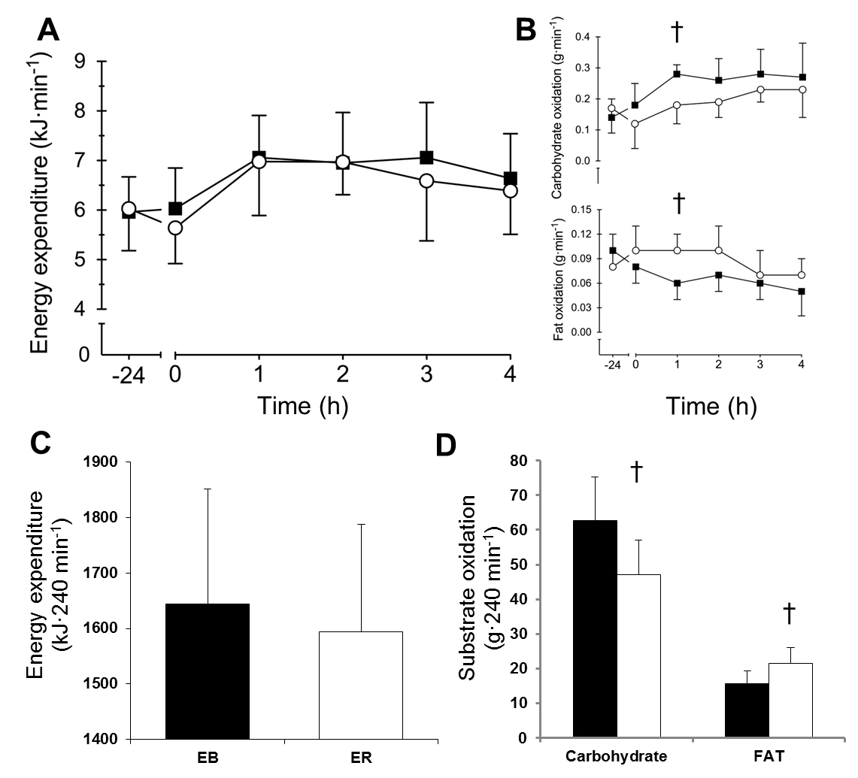
Figure 8.2. Line graphs represent energy expenditure (A) and substrate oxidation (B) during EB (■) and ER (○). Data points are means with vertical error bars representing standard deviation. Bar charts represent post-breakfast AUC for energy expenditure (C) and substrate oxidation (D) during EB (■) and ER (□). † indicates values are significantly different to EB (P<0.05).

Blood parameters

For plasma glucose concentration (Figure 8.3), there were time (P<0.0001) and interaction (P<0.05) effects, but no trial effect (P=0.837). Plasma glucose concentration was greater at 4 h during EB (P<0.05). There was a main effect of time (P<0.0001), but no trial (P=0.499) or interaction (P=0.787) effects for plasma insulin concentration (Figure 8.3). Post-breakfast AUC for plasma glucose (P=0.938) and insulin (P=0.359) concentrations were not different between trials. Plasma insulin and glucose concentrations peaked 1 h after breakfast in both trials, decreasing thereafter. There were time (P<0.0001), trial (P<0.05) and interaction (P<0.0001) effects for plasma NEFA concentration (Figure 8.3). Plasma NEFA concentration was greater at 0 and 0.5 h during ER (P<0.05). Post-breakfast AUC (P<0.05) was greater during ER compared to EB. Plasma NEFA concentration peaked at 0 h in both trials, decreasing thereafter.
For plasma acylated ghrelin concentration (Figure 8.4), box plot analysis revealed one consistently outlying subject, exhibiting concentrations ~13 SD greater than the mean of the 7 other subjects. Therefore, this subject was removed from the analysis. For acylated ghrelin concentration, there was a time effect (P<0.001), but no trial (P=0.265) or interaction (P=0.619) effects. Post-breakfast acylated ghrelin AUC (P=0.109) was not different between trials. Plasma acylated ghrelin concentration was suppressed after breakfast in both trials, retuning to fasting levels by 4 h. For plasma GLP-1₇₋₃₆ concentration (Figure 8.4), there was a time effect (P<0.0001) but no trial (P=0.162) or interaction (P=0.119) effects. Post-breakfast GLP-1₇₋₃₆ AUC (P=0.217) was not different between trials. Plasma GLP-1₇₋₃₆ peaked at 1.5 h in EB and 0.5 h in ER, decreasing thereafter. For plasma GIP₁₋₄₂ concentration (Figure 8.4), there were time (P<0.0001) and trial (P<0.05) effects, but no interaction effect (P=0.157). Post-breakfast GIP₁₋₄₂ AUC (P<0.01) was greater during ER compared to EB. Plasma GIP₁₋₄₂ peaked at 2 h during EB and 1 h during ER, decreasing thereafter.

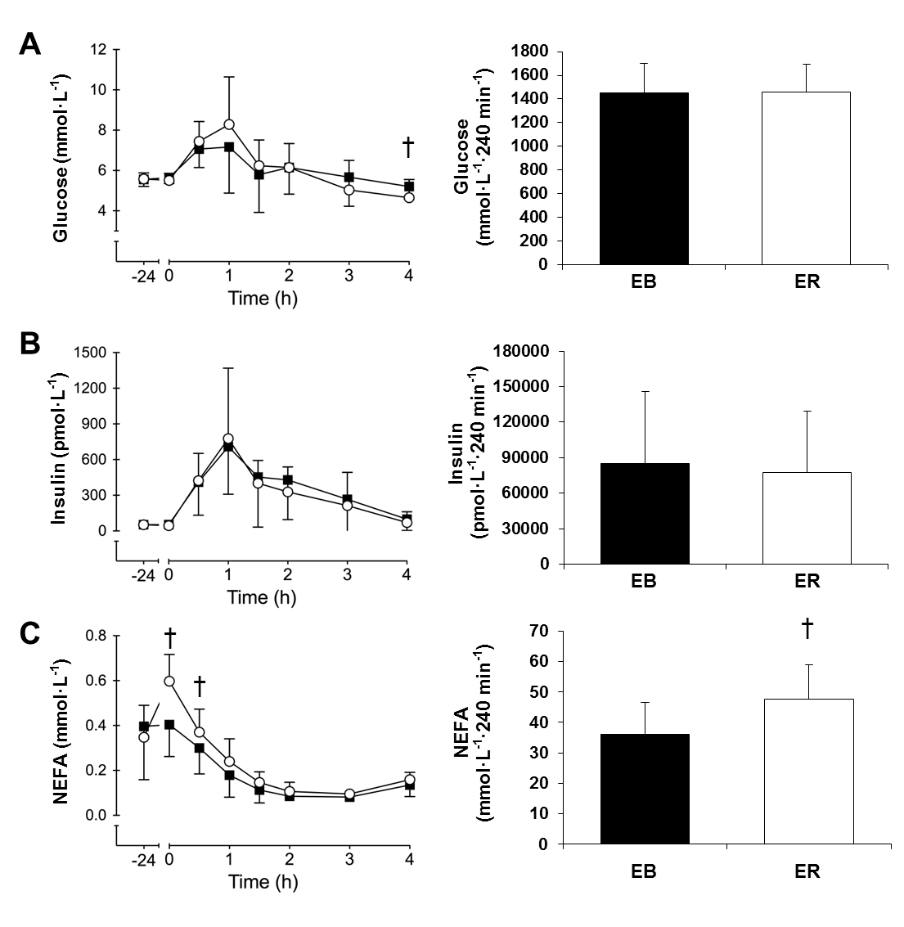
Figure 8.3. Line graphs represent glucose (A), insulin (B) and NEFA (C) concentrations, during EB (■) and ER (○). Bar charts represent post-breakfast AUC during EB (■) and ER (□). Data points are means with vertical error bars representing standard deviation. † indicates values are significantly different to EB (P<0.05).

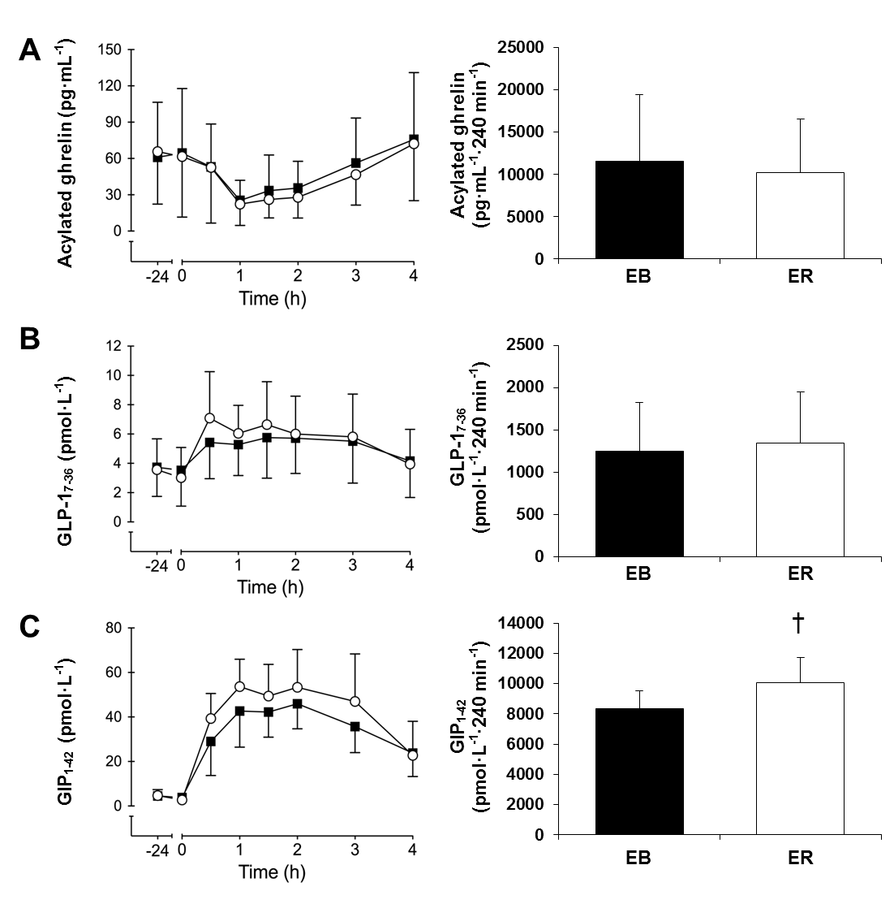
Figure 8.4. Line graphs represent acylated ghrelin (A), GLP-1₇₋₃₆ (B) and GIP₁₋₄₂ (C) concentrations, during EB (■) and ER (○). Bar charts represent post-breakfast AUC during EB (■) and ER (□). Data points are means with vertical error bars representing standard deviation. † indicates values are significantly different to EB (P<0.05).

Subjective appetite sensations

AUC for Hunger, DTE and PFC were greater, whilst AUC for fullness was lower during day 1 (P<0.01), with no other differences in appetite sensations (P>0.381; Figure 8.5).
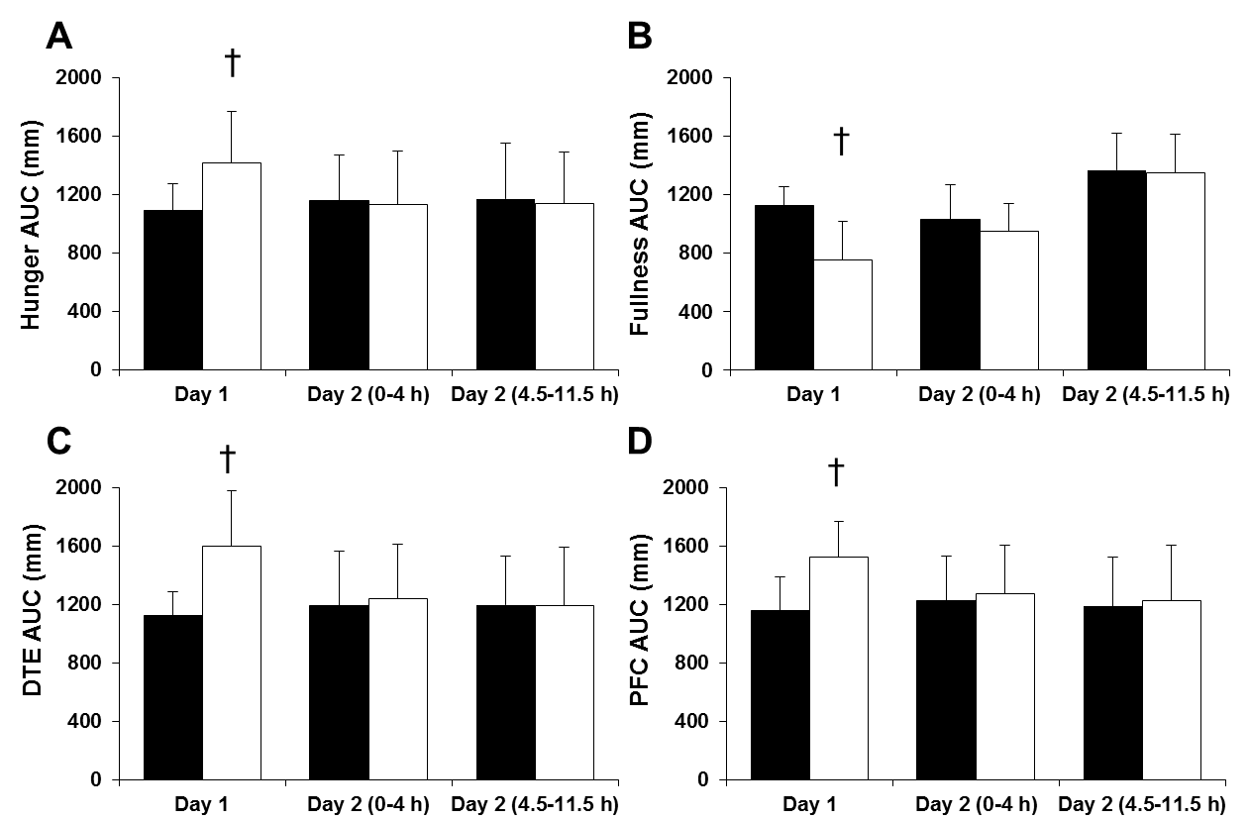

Figure 8.5. AUC for hunger (A), fullness (B), DTE (C) and PFC (D), on day 1, the morning of day 2 (0-4 h) and the afternoon of day 2 (4.5-11.5 h), during EB (■) and ER (□). Data points are means with vertical error bars representing standard deviation. † indicates values are significantly different to EB (P<0.05).

Body mass

Morning body mass on day 1 and 2, respectively was 104.4 (18.0) kg and 103.2 (17.9) kg during ER and 104.4 (18.3) kg and 104.2 (18.2) kg during EB. There were time (P<0.0001) and interaction (P<0.0001) effects for body mass with greater body mass loss from day 1 to day 2 during ER (P<0.0001). Compared to day 1, body mass was reduced on day 2 during ER (P<0.0001), but not EB (P=0.126).

Discussion
This study found that, following a single episode of severe energy restriction, overweight and obese individuals did not experience elevated appetite in the subsequent 24 h and there was no change in resting or postprandial appetite hormone profiles. In addition, there was no increase in ad-libitum energy intake during the subsequent 48 h, suggesting that 24 h severe energy restriction may be an effective method of reducing energy intake in overweight and obese males, without any counter-regulatory effects on appetite.
In the current study, overweight and obese individuals did not adjust their energy intake in response to 24 h of severe energy restriction. Subjects consumed a similar amount of energy during days 2 and 3, irrespective of their energy intake on day 1. Consequently, the energy deficit creating during day 1 on the ER trial was maintained. This is similar to previous studies in lean individuals, investigating 24-48 h periods of complete (Johnstone et al. 2002; Levitsky and DeRosimo 2010) or severe (provided 40% EER) (Mars et al. 2005) energy restriction. These studies reported either no compensation (Levitsky and DeRosimo 2010) or partial compensation (Johnstone et al. 2002; Mars et al. 2005) in the 1-4 days after the period of energy restriction. Taken together with findings from the current study, these studies demonstrate that energy intake is not accurately adjusted in the short term, in response to an acutely induced severe energy deficit. Therefore, this might represent a viable method for reducing energy intake.
In the current study, subjects reported greater hunger, DTE, PFC and lower fullness on day 1, during ER compared to EB. This is expected given the disparate energy intakes between trials on this day and has previously been reported during 36 h complete energy restriction compared to an adequate energy diet (Johnstone et al. 2002). In this study, consumption of an ad-libitum breakfast after energy restriction normalised subjective appetite (Johnstone et al. 2002). In the current study, there was no difference in subjective appetite during day 2, suggesting that appetite is only transiently affected during a 24 h period of severe energy restriction, with no carry over onto subsequent days.
Acylated ghrelin is an orexigenic hormone that increases prior to a meal and might initiate food intake suggesting a role in energy balance homeostasis (Cummings et al. 2004). However, previous studies have reported that fasting ghrelin concentrations appear to be unchanged after 1-4 days energy restriction of varying severity (Blom et al. 2006; Pasiakos et al. 2011; Doucet et al. 2004). In the current study, feeding reduced acyalted ghrelin

concentration, but fasting and postprandial acylated ghrelin concentrations were similar between trials, independent of whether subjects consumed 100 or 25 % of their estimated energy requirements during the previous 24 h. Doucet et al. (2007) similarly observed no difference in ghrelin suppression in response to a standardised breakfast, before and after consumption of a moderately hypoenergetic diet (~70% EER) for 4 days. The anorexigneic hormone GLP-1₇₋₃₆ was also not different between trials. Intravenous infusion of GLP-1₇₋₃₆ has been shown to reduce appetite and food intake (Verdich et al. 1998), suggesting GLP-1₇₋ 36 may be involved in satiation and satiety (Holst 2007). Fasting and postprandial GLP-1₇₋₃₆ concentrations are reduced after weight loss (Adam et al. 2005; Adam et al. 2006), but fasting and postprandial GLP-1₇₋₃₆ concentrations were not different between trials in the current study. Taken together, both GLP-1₇₋₃₆ and acylated ghrelin may serve as feeding cues within day, but data from the current study suggest they are not altered after a single episode of severe energy restriction.
Given the proposed role of these hormones in appetite regulation, these findings may have important implications for energy balance homeostasis during chronic intermittent severe energy restriction. Considering there was also no difference in subjective appetite response after day 1 between ER and EB, the current study suggests that 24 h severe energy restriction does not affect subjective or hormonal appetite regulation. These findings likely explain the lack of hyperphagia observed in the current study and may at least partly explain the weight loss achieved and improved adherence to chronic intermittent severe energy restriction diets in overweight/ obese populations (Varady et al. 2009; Varady et al. 2011; Varady et al. 2013; Harvie et al. 2011; Harvie et al. 2013).
In the current study, resting energy expenditure was unaffected by severe energy restriction, which is in line with findings from studies investigating short periods of complete energy restriction (Bergman et al. 2007; Klein et al. 1993; Horton and Hill 2001). However, fasting and postprandial substrate metabolism was affected by 24 h of severe energy restriction, with fat oxidation greater and carbohydrate oxidation lower on day 2, during the ER trial. This is indicative of altered nutrient supply and/ or endogenous stores and has been reported previously (Maughan et al. 2010). Complete energy restriction for 24 h has been shown to greatly reduce liver glycogen (Nilsson and Hultman 1973), but in the absence of exercise, muscle glycogen stores are largely preserved (Loy et al. 1986). Although some carbohydrate was provided in the present study, it seems likely that this was not sufficient to meet the obligate requirement of this group of subjects (Maughan et al. 2010). Consequently this

reduction in carbohydrate intake/ availability would stimualte lipolysis to provide substrate to preserve endogenous glycogen (Maughan et al. 2010). This is reflected in the greater plasma NEFA concentration during ER, which would increase fat oxidation and concomitantly reduce carbohydrate oxidation (Klein et al. 1993).
These changes in substrate availability may have led to a slight alteration in glycaemic control. Whilst, there was no difference in glucose AUC, there appeared to be an altered pattern of postprandial glycaemia in response to the breakfast meal, evidenced by the observed interaction effect. Plasma glucose concentration was lower at 4 h during ER and whilst there was no other significant difference between trials, there appeared to be some disturbance in glycaemic control during the first 2 h post-breakfast. Indeed, before correction for multiple comparisons, serum glucose concentration was higher at 1 h during ER compared to EB (P=0.04). Prolonged complete energy restriction (i.e. starvation) is known to impair glycaemic control (Lundbaek 2006), an effect that is likely attributable to increased plasma NEFA concentrations, which have been shown to reduce the rate of glucose uptake into muscle (Soeters et al. 2008; Johnson et al. 2006). In addition, GIP₁₋₄₂ AUC was greater after ER compared to EB. GIP₁₋₄₂ and GLP-1₇₋₃₆ are incretin hormones, synthesised rapidly from the stomach in response to nutrient intake and stimulate the release of insulin prior to nutrient absorption (Baggio and Drucker 2007). In the current study, despite elevated GIP₁₋₄₂ during ER, the insulinotropic response to the standardised breakfast was not different between trials. The incretin effect is known to be impaired in obese and insulin resistant individuals (Creutzfeldt et al. 1978), which might explain why there was an increase in GIP₁₋ 42, but not insulin after-breakfast. Although not an aim of the current study, these results suggest that severe energy restriction may impact glycaemic control, and whilst this study might be underpowered to elucidate the precise effects/ mechanisms, these results suggest this topic warrants further investigation.
A potential issue with intermittent severe energy restriction is whether the degree of energy restriction required for this type of dieting to be successful is achievable under free-living conditions. Whilst appetite is increased during a period of severe energy restriction, the current study suggests these feelings are transient and constrained to the day of severe energy restriction. This and a previous study (Johnstone et al. 2002) suggest that severe energy restriction does not lead to any increase in appetite sensations in the days after a 24 h period of severe energy restriction. Daily energy restriction is the traditional method of dietary induced weight loss (Omodei and Fontana 2011), however compliance to such diets may be

compromised by continuous hunger and the need for daily adherence to the diet (Anderson et al. 2001). In theory, intermittent severe energy restriction might represent a more flexible dietary strategy compared to daily energy restriction and may facilitate better long term compliance by assisting with appetite regulation, although this theory remains to be tested.
Previous studies have demonstrated weight loss of 4-12% after 8-24 weeks of intermittent severe energy restriction (Varady et al. 2009; Varady et al. 2011; Varady et al. 2013; Harvie et al. 2011; Harvie et al. 2013). In one study, weight loss was greater after 12 weeks intermittent severe energy restriction compared to isoenergetic daily energy restriction (Harvie et al. 2013). The current study observed no difference in subjective appetite and no difference in resting or postprandial concentrations of the appetite hormones acylated ghrelin and GLP-1₇₋₃₆ after 24 h energy balance or severe energy restriction. These results suggest short periods of severe energy restriction may produce an appetite profile conducive to weight loss, but whether this appetite profile is maintained after long term exposure to intermittent severe energy restriction has yet to be determined. Whilst no change in fasting ghrelin concentration was reported after 16 weeks of intermittent severe energy restriction (Harvie et al. 2013), the dynamic response to feeding of appetite hormones after long term intermittent severe energy restriction is unknown.
The current study had the following limitations. The sample size for the study (n=8) was calculated to be sufficient to detect a difference in ad-libitum energy intake, however this sample size may be too small to detect differences in some blood parameters. This study also investigated a homogenous cohort of overweight/ obese, young (20-40 y) adult males and it is not known whether these findings extend to females, lean individuals, or older populations. The energy expenditure assessment in the current study did not account for physical activity and therefore the effect of severe energy restriction on this component of energy balance remains to be determined. Finally, whether the acute effects observed in the current study extend to the chronic intermittent severe energy restriction paradigm is unknown, with long term intervention studies required to determine this.
In conclusion, the results of this study demonstrate that subjective appetite is only transiently affected during, and not after severe energy restriction, and that fasting and postprandial appetite hormone profiles are unaffected by an acute 24 h period of severe energy restriction. In addition, no difference in energy intake was observed up to 48 h after 24 h severe energy restriction, thereby preserving the deficit induced by energy restriction. This is the first study

to assess this in overweight/ obese subjects and suggests that 24 h of severe energy restriction induces an appetite response conducive to weight loss in these individuals, which may help explain findings from longer-term intervention studies.

Chapter IX

General Discussion

Obesity is a major risk factor for several chronic diseases and represents a considerable health and economic burden worldwide (Bray 2004; Robert and Bernard 2005). Fundamentally, obesity develops when energy intake exceeds energy expenditure over a prolonged period of time. It has been conclusively proven that significant weight loss can be achieved via dietary restriction (Varady 2011), however long term maintenance of weight loss is poor (Anderson et al. 2001), suggesting adherence to dietary interventions may decline over time. Recent research has found that novel dietary interventions, such as breakfast omission and intermittent severe energy restriction, can be effective methods of reducing daily energy intake (Chowdhury et al. 2015a; Chowdhury et al. 2015b; Betts et al. 2014; Levitsky and Pacanowski 2013; Levitsky and DeRosimo 2010; Johnstone et al. 2002; Klemple et al. 2010; O’Connor et al. 2016), with several studies also demonstrating that significant weight loss can occur from prolonged practise of these dietary interventions under tightly controlled experimental conditions (Varady et al. 2009; Varady et al. 2011; Varady et al. 2013; Harvie et al. 2011; Harvie et al. 2013; Geliebter et al. 2014). Hunger is often cited as an underlying cause for declining adherence to a diet (Vogels et al. 2005). This highlights an important mechanism that could determine the success of a method of dieting in the long term, and therefore understanding how a given dietary intervention affects appetite regulation may predict long term adherence to the diet. The work presented in this thesis has sought to determine the acute effects of breakfast omission and 24 h severe energy restriction on several variables central to appetite regulation and energy balance, including subjective appetite sensations, concentrations of gut hormones involved in appetite regulation and ad- libitum energy intake. In addition, these studies also determined the effect of these dietary interventions on resting metabolism and insulin sensitivity.

Effect of energy restriction on energy intake

The success of a dietary intervention to induce changes in body weight will be determined by how it affects components of energy balance. The results from the studies presented in this thesis demonstrate that moderate (breakfast omission) or severe energy restriction

(consuming 25% of daily EER) is not countered in the short term by an increase in energy intake sufficient to fully compensate for the energy deficit induced. In Chapters IV, VII and VIII, the energy deficit induced via breakfast omission or severe energy restriction was at least partially preserved and therefore total energy intake was reduced.
The association of regular breakfast omission with a higher BMI (Cho et al. 2003; Purslow et al. 2008) has led to the widespread belief that breakfast omission will increase appetite, causing overeating at subsequent meals and greater daily energy intake (Pereira et al. 2011). As discussed in previous sections, any increase in appetite appears to be constrained to the morning, with no carry-over effect to subsequent meals. Chapter IV found that, when breakfast was omitted, energy intake was increased ~16 % at an ad-libitum lunch and there was no further increase in energy intake at dinner. However, this marginal increase in energy intake at lunch was not sufficient to fully compensate for the energy omitted at breakfast and therefore daily energy intake was reduced. These results are in line with several previous studies, reporting either no difference (Levitsky and Pacanowski 2013; Gonzalez et al. 2013; Chowdhury et al. 2015b) or a small increase (Levitsky and Pacanowski 2013; Chowdhury et al. 2015a; Hubert et al. 1998) in energy intake at the first meal consumed after breakfast. With the exception of one study (Astbury et al. 2011), incorporation of Chapter IV into the existing body of literature demonstrates that breakfast omission may increase energy intake at a subsequent meal, but this is only sufficient to compensate for 0-35 % of the energy omitted at breakfast (Levitsky and Pacanowski 2013, Gonzalez et al. 2013, Chowdhury et al. 2015b, Chowdhury et al. 2015a, Hubert et al. 1998). Collectively, these studies refute the strongly engrained public message that omitting breakfast will increase daily energy intake.
Building on this evidence, Chapters VII and VIII sought to determine whether inducing a severe energy deficit would prompt a more profound compensatory feeding response in lean (Chapter VII) and overweight/obese (Chapter VIII) subjects. The findings from these studies reflect the results from Chapter IV, demonstrating inaccurate short-term regulation of energy intake in response to a dietary induced energy deficit. In lean subjects, Chapter VII found an increase in energy intake of 7% after 24 h of severe energy restriction, but the energy deficit induced was not fully compensated up to 48 h after the period of severe energy restriction. Similarly, despite a subsequent increase in energy intake of ~20-30%, total energy intake was reduced 8400-9000 kJ after 24 h of complete (Johnstone et al. 2002) or 48 h of severe (consuming 40% EER) (Mars et al. 2005) energy restriction. However, these findings differ slightly from the results of Chapter VIII, which found no compensatory increase in energy

intake after 24 h of severe energy restriction in overweight and obese subjects. This could be due to differences in subject cohort and a similar effect was recently shown after breakfast omission. Two identical studies were performed in lean (Chowdhury et al. 2015a) and obese (Chowdhury et al. 2015b) subjects, with breakfast either consumed or omitted during two separate trials. At an ad-libitum lunch, lean subjects increased energy intake by 20% after breakfast omission, but energy intake was not different between trials in the obese subjects. Conversely, the same authors found that when habitual energy intake was assessed (via food records) at the end of a 6 week period of either consuming or omitting breakfast every morning, lean individuals consumed significantly less energy when omitting breakfast (Betts et al. 2014), whereas there was no difference in daily energy intake for obese individuals (Chowdhury et al. 2016). These finding demonstrate that obese individuals were able to at least partially compensate for the energy deficit imposed at breakfast in their habitual environment, but not under laboratory conditions. This might suggest that obese individuals are more strongly influenced by environmental factors governing energy intake (Mela 2006) and this could lead to an increase in feeding frequency and food selection in a free-living environment. The studies by Chowdhury et al. (2015a; 2015b), as well as Chapters VII and VIII from this thesis, employed ad-libitum laboratory feeding protocols, which provides meals at set times and limits external influences of food intake, in order to examine mechanisms of appetite regulation. As a result this removes the opportunity to increase the number of feeding occasions and limits food choices, which may affect overweight and obese individuals more than lean individuals.
Irrespective of these minor discrepancies, the studies presented in this thesis suggest that humans are unable or unwilling to compensate for moderate or severe energy deficits in short (24-48 h) time periods. Therefore both breakfast omission and severe energy restriction may represent effective methods of reducing energy intake.

Effect of energy restriction on subjective appetite regulation

The work presented in Chapters IV, V, VII and VIII demonstrate that appetite is only transiently elevated in response to varying degrees of energy restriction. Chapter’s IV and V investigated a moderate energy deficit (~3090 kJ) induced by breakfast omission. In both of these studies, consumption of breakfast suppressed appetite compared to omitting breakfast during the morning, but appetite was offset to a similar extent after lunch, independent of

whether breakfast had been consumed or omitted ~4.5 h earlier. In Chapter IV, subjective appetite was offset by an ad-libitum lunch, during which subjects ate until they were ‘comfortably full and satisfied’, and in the process they partially compensated for the energy deficit induced by breakfast omission. Several previous studies have similarly found that subjective appetite after ad-libitum lunch or dinner meals was not affected by prior omission of breakfast (Astbury et al. 2011; Levitsky and Pacanowski 2013; Chowdhury et al. 2015a; Chowdhury et al. 2015b). This was extended by the findings in Chapter V, demonstrating that subjective appetite could be offset to a similar extent by standardising lunch (containing 35% EER) and dinner (containing 40% EER) meals. Consequently this fully preserved the energy deficit created by breakfast omission, without appearing to affect subjective appetite sensations. Therefore, Chapters IV and V demonstrate that a moderated energy deficit induced via breakfast omission only transiently elevates appetite, even when the energy deficit is fully or partially preserved after subsequent meals.
Extending this concept, Chapters VII and VIII investigated whether inducing a severe energy deficit by consumption of a 24 h very-low energy diet (containing 25% EER), would differentially affect appetite compared to a control diet (containing 100% EER). These studies found that subjective appetite sensations were elevated during consumption of the very-low energy diet, which might be expected given the disparate energy provided during this day and difficultly blinding subjects to the intervention. After this 24 h period, subjective appetite was found to be elevated during the morning in Chapter VII, but this was not observed in Chapter VIII. In both of these studies, and in line with the findings in Chapter IV, subjective appetite was not different between trials after an ad-libitum lunch meal and no further differences were observed throughout the study period. An elevation in subjective appetite has been reported previously during a 24 h period of complete energy restriction and, similar to Chapter VII, this study also demonstrated that subjective appetite was offset by an ad-libitum meal (Johnstone et al. 2002). Differences between the findings in Chapter VII and VIII may be due to the subject cohort investigated and suggest that lean individuals (Chapter
VII) exhibit more precise regulation of short term energy balance than overweight/ obese individuals (Chapter VIII), as has been previously suggested (Flint et al. 2007).
Collectively, these studies all demonstrate an imprecise regulation of subjective appetite following moderate (Chapters IV and V) and severe (Chapters VII and VIII) dietary induced energy deficits. These studies suggest that subjective appetite is only transiently increased by

an acute period of energy restriction, and can be offset by an ad-libitum (Chapters IV and VII) or standardised (Chapters V and VIII) meal.

Effect of energy restriction on peripheral appetite hormones

Part of the appetite regulatory response may involve several gut peptides, which may influence post-meal satiety and subsequent meal initiation (Doucet and Cameron 2007). In this thesis, the orexigenic hormone acylated ghrelin and the anorexigenic hormone GLP-1₇₋₃₆ were assessed in response to breakfast omission (Chapters IV and V) and severe energy restriction (Chapters VII and VIII), which may help identify underlying physiological factors determining the success of dietary interventions outside of rigid laboratory control.

In regard to breakfast, no difference in acylated ghrelin was observed 4.5 h after breakfast omission or consumption in Chapters IV and V. This is in line with recently published studies, reporting a suppression of acylated ghrelin after breakfast consumption compared to breakfast omission, but these differences appear to converge after 3 h (Chowdhury et al. 2015a, Chowdhury et al. 2015b). These studies suggest that the orexigenic hormone acylated ghrelin is only transiently suppressed by breakfast, and in the absence of additional food intake during the morning, acylated ghrelin concentrations return to baseline by lunch, independent of breakfast consumption in the morning. In contrast to this, Chapter V found that GLP-1₇₋₃₆ was elevated 4.5 h after breakfast consumption. This might be intuitive given that subjects reported to be hungrier after breakfast omission and GLP₇₋₃₆ is linked to satiety (Holst et al. 2007), but these findings differ from Chapter IV and Chowdhury et al. (2015a; 2015b). Following lunch, no differences in acylated ghrelin or GLP-1₇₋₃₆ were observed in Chapters IV and V, but this again differs somewhat from previous literature. Chowdhury et al. (2015a; 2015b) reported a paradoxical suppression of acylated ghrelin after an ad-libitum lunch, but no difference in GLP-1 concentrations, when breakfast had been omitted in the morning. However, different consumption patterns make it difficult to isolate the effects of breakfast on appetite hormone profiles after an ad-libitum lunch.

In Chapter V, consumption of a standardised lunch revealed no differences in acylated ghrelin response, which is in line with a previous study (Thomas et al. 2015). However, studies have reported conflicting results in regard to the GLP-1 response to standardised feeding, with suppressed (Astbury et al. 2011), elevated (Thomas et al. 2015) and no difference (Gonzalez et al. 2013; Chowdhury et al. 2015a; Chapter V) in GLP-1

concentrations found after breakfast consumption, compared to breakfast omission. Some of these discrepancies may be explained by whether GLP-1₉₋₃₆ (i.e. total: Astbury et al. 2011; Thomas et al. 2015) or GLP-1₇₋₃₆ (i.e. active: Gonzalez et al. 2013; Chapter V) was assessed, or whether liquid (Astbury et al. 2011; Gonzalez et al. 2013) or solid (Thomas et al. 2015; Chapter V) standardised meals were consumed. In Chapter IV, a tendency for an interaction effect (P<0.056) was observed and mean values were greater prior to lunch after breakfast consumption compared to breakfast omission (9.85 vs. 6.55 pmol·L⁻¹). Therefore it is possible this study may have been insufficiently powered to detect differences, due to large individual variation in the GLP-1₇₋₃₆ response. It should also be noted, that GLP-1₇₋₃₆ is rapidly degraded into its inactive form (GLP-1₉₋₃₆) by the enzyme dipeptidyl peptidase IV upon release from the intestinal L-cells (Holst and Deacon 2005) and therefore peripheral concentrations of GLP-1₇₋₃₆ may not truly reflect concentrations secreted centrally.
Whilst the appetite hormone response to breakfast consumption/ omission has been researched in several studies, the response to acute severe energy restriction, described in Chapters VII and VIII, is relatively unknown. In lean males and females (Chapter VII), although 24 h of severe energy restriction increased subjective appetite and energy intake, this was preceded by alterations in postprandial appetite hormone profile that would be expected to suppress, rather than stimulate appetite. Specifically, acylated ghrelin AUC was reduced after 24 h of severe energy restriction, compared to adequate energy intake, and there was no difference in GLP-1₇₋₃₆. Appetite hormones also did not respond in a compensatory manner in overweight/ obese males (Chapter VIII), with no difference in acylated ghrelin or GLP-1₇₋₃₆ between trials. The pattern of acylated ghrelin response was similar in Chapters VII and VIII, with acylated ghrelin lower after severe energy restriction compared to energy balance, but this failed to achieve statistical significance in Chapter VIII. This may be because the study was powered to detect a difference in energy intake, but may have been underpowered to detect a change in acylated ghrelin.
Similar results were recently reported in male and female (army) soldiers, undergoing 48 h of severe energy restriction (providing 10% of EER) concurrent with exercise training (O’Connor et al. 2016). Similar to Chapter VII, this study found suppressed acylated ghrelin and elevated GLP-1 concentrations after 48 h of severe energy restriction. This observed suppression of acylated ghrelin is potentially due to an increase in NEFA concentrations, which is typically observed in response to fasting/ severe energy restriction, and indeed was observed in Chapters VII and VIII. NEFA may inhibit the action of GOAT, the enzyme

responsible for the acylation of ghrelin, leading to a reduction in plasma concentrations in acylated ghrelin (Liu et al. 2008). Independent of this, consistent with the proposed orexigenic action of acylated ghrelin, this observed suppression may be conducive to weight loss and may partially explain the weight loss demonstrated from chronic intermittent severe energy restriction studies (Varady et al. 2009, Varady et al. 2011, Varady et al. 2013; Harvie et al. 2011, Harvie et al. 2013).
Very recently, the first study to assess the subjective and appetite hormone responses to prolonged severe energy restriction was published (Hoddy et al. 2016). This study assessed fasting and postprandial appetite hormone concentrations, as well as subjective appetite sensations, after an 8 week ADMF intervention, alternating very-low energy diet (25% EER) with ad-libitum energy intake. On average subjects body mass decreased 3.9 kg over the 8 week dietary intervention. Compared to baseline, postprandial ghrelin and PYY concentrations increased and there was no difference in postprandial GLP-1 concentrations after the 8 week dietary intervention. In addition, fullness was greater and there was no difference in hunger. Ghrelin concentrations have been shown to increase after weight loss from continuous energy restriction (Cummings et al. 2002). Therefore an increase in ghrelin after weight loss from intermittent severe energy restriction might be expected and suggests ghrelin may respond specifically to weight loss, independent of the method. However, increases in PYY and fullness, with no change in GLP-1 and hunger after weight loss is inconsistent with previous literature (Doucet et al. 2004). This might suggest that intermittent severe energy restriction differentially affects anorexigenic appetite hormones compared to continuous energy restriction, and this may enhance dietary adherence by increasing satiety.
The work presented in Chapters IV, V, VII and VIII has demonstrated that the acylated ghrelin and GLP-1₇₋₃₆ response to moderate and severe energy deficits, induced by breakfast omission and 24 h of severe energy restriction, is not indicative of compensatory eating behaviour. However, compensatory eating behaviour was observed in Chapters IV and VII. Murine studies have demonstrated increased hypothalamic ghrelin receptor mRNA expression and increased acylated ghrelin transport across the blood-brain barrier with complete energy restriction, suggesting an increase in hypothalamic sensitivity to appetite- mediating hormones in response to a dietary induced energy deficit (Kim et al. 2003, Banks et al. 2008). Results from Chapters IV and VII lend support this hypothesis, but further research is required.

Effect of energy restriction on resting metabolism

In addition to factors governing food intake, several studies from this thesis also examined whether these dietary interventions impacted REE and substrate utilisation.
An increase in REE was observed during the morning after breakfast consumption compared to breakfast omission, but total resting energy expenditure was not different between trials (Chapter V). As previously discussed, this transient elevation in energy expenditure during the morning is likely due to DIT, as the digestion of food is an energy-requiring process and produces an exothermic reaction. However, there were no further differences in energy expenditure after a standardised lunch meal, which is similar to observations after consumption of an ad-libitum lunch meal (Chowdhury et al. 2015a, Chowdhury et al. 2015b). Whilst one study did report that breakfast omission increased evening energy expenditure, it should be noted that the energy content of afternoon and evening meals were increased after breakfast omission, in order to match total (24 h) energy intake across trials (Kobayashi et al. 2013). Therefore, the increase in energy expenditure observed during the evening is likely due to increased DIT after greater energy intake at subsequent meals, consequently offsetting energy expenditure over the 24 h study period. These findings suggest that consumption of breakfast does not affect REE, whether the energy deficit is maintained (Chapter V) or recovered (Kobayashi et al. 2013), but will cause a small increase in energy expenditure during the morning due to DIT.
In both lean (Chapter VII) and overweight/ obese (Chapter VIII) subjects, a small reduction (~0.2 kJ·min⁻¹) in resting energy expenditure was observed during the morning after 24 h of severe energy restriction, although this was not statistically significant in Chapter VIII. However, total resting energy expenditure calculated for the morning and afternoon during Chapter VII, was not significantly different between trials. This data suggests that 24 h of severe energy restriction only marginally reduces resting energy expenditure the following day, however large postprandial alterations in substrate utilisation were noted in both Chapters VII and VIII. In the energy balance condition, consumption of a standardised breakfast caused a rapid increase in carbohydrate oxidation concurrent with a reduction in fat oxidation, and although a similar relative effect was noted in the energy restricted condition, absolute carbohydrate oxidation was lower and fat oxidation greater after severe energy restriction. This pattern of postprandial substrate utilisation has similarly been reported after short-term complete energy restriction and is indicative of altered endogenous stores and

nutrient supply (Bergman et al. 2007, Klein et al. 1993, Horton and Hill 2001). Twenty-four h of complete energy restriction has been demonstrated to reduce hepatic glycogen by ~85% (Nilsson and Hultman 1973), which reduces hepatic glucose output and increases lipolysis (Maughan et al. 2010). In turn NEFA’s are mobilised from triglycerides stored in adipose tissue to provide substrate and preserve endogenous glycogen (Maughan et al. 2010). Plasma NEFA concentrations were elevated after severe energy restriction in Chapters VI, VII and VIII and this likely explains the increase in fat oxidation and reduction in carbohydrate oxidation observed in Chapters VII and VIII.
Together, these studies demonstrate that 24 h of severe energy restriction induces metabolic alterations consistent with short-term complete energy restriction (i.e. starvation), which is likely a mechanism to preserve endogenous glucose stores. However, these effects appear to be transient, as no differences in fasting REE or substrate utilisation were observed 24 h after the resumption of ad-libitum feeding in Chapter VII.

Effect of energy restriction on insulin sensitivity

Plasma glucose and insulin concentrations were measured in Chapters IV, V, VI, VII and VIII, and this data was used to provide information about insulin sensitivity. However limited information about insulin sensitivity could be gleaned from the breakfast consumption/ omission studies in this thesis (Chapters IV and V) due to infrequent blood sampling. This has been more comprehensively assessed in other studies with similar designs, revealing that extending the morning fast via omission of breakfast reduces insulin sensitivity at a subsequent meal (typically lunch) compared to when breakfast is consumed, a phenomenon termed the ‘second meal effect’ (Chowdhury et al. 2015a; Chowdhury et al. 2015b).
In this thesis, the glycaemic response to 24 h of severe energy restriction was assessed (Chapters VI, VII and VIII). In each of these studies, plasma/ serum insulin and glucose data suggests a reduction in postprandial insulin sensitivity after 24 h of severe energy restriction. This was specifically investigated in Chapter VI with an OGTT in lean male subjects. This study found that HOMA-IR was reduced, but postprandial serum glucose AUC concentrations were greater, with no change in serum insulin AUC after severe energy restriction. This suggests a reduction in the rate of glucose clearance from the blood for a given amount of insulin, indicative of insulin resistance. Similarly, plasma glucose AUC was

greater with no change in insulin AUC after consumption of a standardised breakfast in lean males and females (Chapter VII), and there was a tendency for greater glucose AUC in overweight/ obese males (Chapter VIII). A lack of statistical power in Chapter VIII likely explains why only a tendency was observed in this data set. Conclusively, it appears an acute period of severe energy restriction will impair postprandial glycaemic control.
Data from these studies demonstrate the importance of dynamic (postprandial) assessments of insulin sensitivity, as opposed to fasting measures, in order to determine the effects of a dietary intervention on insulin secretion and insulin action to a given nutrient load (Muniyappa et al. 2008). The HOMA-IR measure of insulin sensitivity requires only fasting plasma glucose and insulin, which are independently affected by alterations in hepatic triglycerides (Kirk et al. 2007), hepatic glycogen (Nilsson and Hultman 1973) and glycogenolysis (Rothman et al. 1991). During periods of energy restriction these are all likely to decrease, which will reduce fasted plasma glucose. Therefore, a reduction in HOMA-IR under these conditions is likely a reflection of glucose availability and also likely to be transient. Indeed, one study reported a ~52% reduction from baseline in HOMA-IR immediately after a 48 h period of severe energy restriction, but this had recovered to a ~16% reduction from baseline after 3 days of adequate energy intake (Harvie et al. 2013). Whilst generally HOMA-IR may be able to detect long-term changes in insulin sensitivity, these studies suggest HOMA-IR may not be an appropriate way to assess acute alterations in dietary intake.
As discussed in the previous section, a reduction in glucose availability will stimulate lipolysis to mobilise NEFA for energy metabolism, consequently increasing fat oxidation. In addition, this alteration in substrate availability may also explain the impairment in postprandial glycaemic control. Elevated concentrations of NEFA, observed after severe energy restriction in Chapters VI, VII and VIII, has previously been shown to reduce the rate of glucose uptake into the muscle (Soeters et al. 2008, Johnson et al. 2006), possibly to facilitate the replenishment of hepatic glycogen stores (Randle et al. 1963). These metabolic adaptations may explain the prolonged postprandial elevation of plasma/ serum glucose observed in Chapters VI, VII and VIII. In light of this, these effects are also likely to be transient. Nevertheless, how multiple exposures to short term periods of severe energy restriction and refeeding effect indices of insulin sensitivity are currently unknown and warrant further investigation.

Chapter’s VI, VII and VIII also investigated whether the incretin hormones were affected by a short period of severe energy restriction. Correlating findings between these studies is difficult as different variables were measured in each. GLP-1₇₋₃₆ was measured in Chapter VII; GLP-1₇₋₃₆ and GIP ₁₋₄₂ were measured in Chapter VIII; and GLP-1₉₋₃₆ and GIP₃₋₄₂ were measured in Chapter VI. From these variables, only GIP₁₋₄₂ demonstrated an effect, with postprandial GIP₁₋₄₂ AUC greater after 24 h severe energy restriction. The reason for this finding is unclear, but may represent a degree of ‘incretin resistance’ after severe energy restriction, although this was not observed in the other incretin hormones assessed in Chapters VI, VII and VIII. The findings in Chapter VIII may be because the biologically active form of the peptide was assessed in this study, compared to the total (active and inactive; GIP₃₋₄₂) form measured in Chapter VI. Alternatively, it could be due to an impaired incretin response in the overweight and obese subjects in Chapter VIII (Omodei and Fontana 2011). Although the incretin response was not a primary focus of this thesis, the results presented here may warrant further investigation in the future.

Limitations and directions for future research

Whilst it is important to determine the acute effects of dietary interventions prior to conducting long-term randomised control trials, an inherent limitation with all of the studies presented in this thesis is the short-term intervention and follow up period. The results of these studies demonstrate an appetite and energy intake response conducive to maintaining the dietary induced energy deficit, but future studies should aim to investigate the effects of repeated exposure to breakfast omission or 24 h periods of severe energy restriction on subjective and hormonal appetite regulation as well as energy balance and changes in body weight and body fat. This has been addressed in two studies after 6-weeks of breakfast omission (Betts et al. 2014; Chowdhury et al. 2016), but despite breakfast omission appearing to promote a negative energy balance, no change in body weight was observed, suggesting more than 6-weeks may be required to elucidate chronic effects. Long-term effects of ADMF on appetite regulation were recently investigated in one study (Hoddy et al. 2016). However this study had several limitations, including lack of pre-trial dietary standardisation, assessment of total (rather than active) appetite hormones, large intra and inter-assay coefficient of variation in certain hormone analysis and a relatively short postprandial assessment period (2 h). In addition, this study assessed appetite hormone

responses after 2-3 days of unrestricted eating, whereas the immediate response to a period of severe energy restriction may provide more information about the long-term appetite regulatory effects of intermittent severe energy restriction. Therefore, whilst this study provides novel information in regard to appetite hormone response to semi-chronic intermittent severe energy restriction, the aforementioned considerations limit the interpretation of these results. Further studies will help to elucidate whether these dietary interventions can be effective methods of energy balance and weight management in the long term.
A second limitation is that energy expenditure has not been fully determined in any of the studies presented in this thesis. Whilst Chapters V, VII and VIII have demonstrated that energy intake is reduced by breakfast omission or 24 of severe energy restriction, with limited effect on resting energy expenditure, these studies have not assessed the most malleable component of energy expenditure, physical activity. Again, this has recently been addressed with regard to breakfast omission (Betts et al. 2014; Chowdhury et al. 2016), but future studies should aim to determine whether physical activity is affected by intermittent severe energy restriction, which will enable a more comprehensive evaluation of energy balance to be made. In turn this will help to predict its effectiveness as a weight management programme.
Due to the complexities of assessing appetite regulation and energy intake, the studies presented in this thesis utilised a laboratory environment, to control external factors that may confound subjective appetite, enabling hormonal factors of appetite regulation to be elucidated. This allows for greater experimental control and precision than is available with free-living study designs. However, eating behaviour is ultimately driven by the interaction between external and internal appetite regulatory processes and therefore findings from laboratory controlled studies may not transfer to a free-living environment. A potential avenue for future research would be to determine the effectiveness of these dietary interventions in subjects exposed to their habitual environment.
The very-low energy diet investigated in Chapters VI, VII and VIII was created by removing or reducing high carbohydrate and high fat foods from the energy balanced diet, thus maintaining the protein faction of the diet where possible. The rationale behind this was that protein has been shown to increase satiety relative to carbohydrate and fat, and protein can help preserve fat-free mass during energy restriction (Wycherley et al. 2012). However,

manipulation of food types provided during severe energy restriction was not investigated as part of this thesis. Future studies should aim to determine whether this very-low energy diet could be manipulated to improve acceptability and long-term adherence to the diet. This could include alterations in macronutrient distribution of the diet, or incorporation of less energy dense food sources which would increase volume, but not the energy content of the diet. This has been shown previously to be an effective method of prolonging satiety after a meal (Kral et al. 2004) and represents and interesting avenue for future research.

Implications of this research

In well controlled laboratory studies, this thesis has repeatedly shown that an acute period of moderate or severe energy restriction is not met with a subsequent increase in energy intake to compensate for this energy deficit. The result of this is that the energy deficit achieved is sustained, suggesting that these methods of energy restriction may be effective for the management of energy balance.
This research has revealed several important considerations and challenges for future research in this area. A fundamental problem with studying appetite regulation is its inherent multifactorial nature. Data presented in this thesis and other recent publications (O’Connor et al. 2016; Chowdhury et al. 2015a; Chowdhury et al. 2015b) seems to suggest a disconnect between supposed homeostatic regulators of appetite (i.e. acylated ghrelin, GLP-1₇₋₃₆, PYY₃₋
36) and subjective markers of appetite (i.e. hunger, fullness, energy intake). With homeostatic and hedonic influences of food intake seemingly working independently, it becomes difficult to determine what measures should be taken to assess the appetitive response to a dietary intervention. In light of these recent findings, it seems pertinent to question whether these gut peptides have a role in appetite regulation, at least in the short-term.
In addition to this, are current methods for assessing subjective appetite (i.e. subjective appetite questionnaires, ad-libitum buffet meals) sensitive enough to detect subtle changes in behaviour, given the multifaceted nature of appetite regulation? This becomes more apparent when studying overweight and obese individuals, who repeatedly demonstrate an attenuated response to energy restriction, compared to their lean counterparts (Chapter VII and Chapter VIII; Chowdhury et al. 2015a and Chowdhury et al. 2015b). Whilst this may be due to poorer regulation of short-term energy intake (Flint et al. 2007) or increased sensitivity to

environmental stimuli (Mela 2006), it could also demonstrate that overweight and obese subjects are more aware of their behaviour in the laboratory. Difficulty in blinding subjects to the intervention may predispose them to altering their behaviour to conform to a perceived social norm (Higgs and Thomas 2016). This presents a real challenge in conducting research of this nature in these individuals, who are often the intended target of such interventions. A recent study utilised a SGLT2 inhibitor which causes an increase in energy output via urinary excretion of glucose, as a convert method on inducing an energy deficit, to study whether any adaptive behaviour occurred (Polidori et al. 2016). After a 52 week period, subjects lost ~4% body mass without being directly aware of an energy deficit. Concurrent with this weight loss, it was found that subjects energy intake increased by ~100 kcal·d⁻¹ per kilogram of body weight lost. This is more than threefold the magnitude of corresponding energy expenditure adaptations and demonstrates that the appetite regulatory system is a significant barrier to long term weight loss and maintenance. This highlights the importance of understanding how this mechanism is affected by dietary interventions. Learning how to maximise satiation and satiety could lead to the development of successful weight management programmes, but whether current methods are sensitive enough to reliably assess appetite and food intake is questionable, and this may be prohibitive in achieving this goal.
It has recently been shown that 8-weeks of consuming a VLED (~600-700 kcal) can reverse diabetes in some individuals and that this is driven primarily by a substantial reduction in liver fat (Steven et al. 2016). Whilst the dietary intervention in this study would likely be too extreme for the majority of people, these results suggest that intermittent severe energy restriction may be an effective method to improve insulin sensitivity. Despite this, the results presented in this thesis also seem to show a differential response between fasted and postprandial markers of insulin sensitivity (Chapters VI, VII and VIII). In the clinical setting, fasted markers are predominantly used to determine disease risk, but postprandial markers are increasingly being recognised as key indicators (Gerich 2003). Given humans spend the majority of time in the postprandial state, further research is required to determine whether this method of dieting would be effective for improving insulin sensitivity. Continuous glucose monitors are now being used in research and these could be an effective tool for studying the prolonged glycaemic response. This could provide important information about whether intermittent severe energy restriction can be used to improve glycaemic control in the long-term.

Conclusions

The work presented in this thesis has established that moderate and severe energy deficits induced by breakfast omission and a 24 h severely energy restricted diet is only partially compensated for over the subsequent 24-48 h in a laboratory setting, suggesting that these methods of energy restriction may be successful for reducing energy intake. Whilst an increase in subjective appetite was observed during periods of energy restriction, this appears to be transient, and was offset after an ad-libitum meal. In addition, the appetite hormone response to 24 h of severe energy restriction is not indicative of compensatory eating behaviour. Collectively, these results indicate that breakfast omission and 24 h of severe energy restriction produce an appetite profile conducive to maintenance of a negative energy balance. These findings may elucidate some of the mechanisms behind the reported success of intermittent severe energy restriction in achieving weight loss in long-term intervention studies.

References

Adam TC, Jocken J, Westerterp-Plantenga MS (2005) Decreased glucagon-like peptide 1 release after weight loss in overweight/obese subjects. Obesity Research 13: 710-716.
Adam TC, Lejeune MP, Westerterp-Plantenga MS (2006) Nutrient-stimulated glucagon-like peptide 1 release after body-weight loss and maintenance in human subjects. British Journal of Nutrition 95: 160-167.
Adrian TE, Ferri GL, Bacarese-Hamilton AJ, Fuessl HS, Polak JM, Bloom SR (1985) Human distribution and release of a putative new gut hormone, peptide YY. Gasteroenterology 89: 1070-1077.
Allerton DM, Campbell MD, Gonzalez JT, Rumbold PLS, West DJ, Stevenson EJ (2016) Co- ingestion of whey protein with a carbohydrate-rich breakfast does not affect glycaemia, insulinemia or subjective appetite following a subsequent meal in healthy males. Nutrients 8: 116
Anderson CJ, Fernandez ML (2013) Dietary strategies to reduce metabolic syndrome. Rev Endocrine and Metabolic Disorders 14: 241-254.
Anderson JW, Vichitbandra S, Qian W, Kryscio RJ (1999) Long-term weight management after an intensive weight-loss program. Journal of the American College of Nutrition 18: 620- 627.
Anderson JW, Konz EC, Fredericj RC, Wood CL (2001) Long-term leight-loss maintenance: a meta-analysis of US studies. American Journal of Clinical Nutrition 74: 579-584.
Antoni R, Johnston KL, Collins AL, Robertson MD (2014) The effects of intermittent energy restriction on indicies of cardiometabolic health. Research in Endocrinology 2014: 1-24.
Ash S, Reeves MM, Yeo S, Morrison G, Carey D, Capra S (2003) Effect of intensive dietetic interventions on weight and glycaemic control in overweight men with Type II diabetes: a randomised trial. International Journal of Obesity 27: 797-802.
Astbury NM, Taylor MA, Macdonald IA (2011) Breakfast consumption affects appetite, energy intake, and the metabolic and endocrine responses to foods consumed later in the day in male habitual breakfast eaters. Journal of Nutrition 141: 1381-1389.

Baggio LL, Drucker DJ (2007) Biology of incretins: GLP-1 and GIP. Gastroenterology 132: 2131-2157.
Banks WA, Burney BO, Bobinson SM (2008) Effects of triglycerides, obesity, and starvation on ghrelin transport across the blood-brain barrier. Peptides 29: 2061-2065
Batterham RL, Cohen MA, Ellis SM, le Roux CW, Withers DJ, Frost GS, Ghatei MA et al. (2003) Inhibition of food intake in obese subjects by peptide YY3-36. New England Journal of Medicine 349: 941-948.
Batterham RL, ffytche DH, Rosenthal JM, Zelaya FO, Barker GJ, Withers DJ, Williams SC (2007) PYY modulation of cortical and hypothalamic brain areas predicts feeding behaviour in humans. Nature 450: 106-109.
Bell EA, Roe LS, Rolls BJ (2003) Sensory-specific satiety is affected more by volume than by energy content of a liquid food. Physiology and Behaviour 78: 593-600.
Bergman BC, Cornier M, Horton TJ, Bessesen DH (2007) Effects of fasting on insulin and glucose kinetics in lean and obese men and women. American Journal of Physiology, Endocrinology and Metabolism 293: E1103-E1111.
Betts JA, Thompson D (2012) Thinking outside the bag (not necessarily outside the lab).
Medicine and Science in Sport and Exercise 44: 2040.

Betts JA, Thompson D, Richardson JD, Chowdhury EA, Jeans M, Holman GD, Tsintzas K (2011) Bath Breakfast Project (BBP)--examining the role of extended daily fasting in human energy balance and associated health outcomes: study protocol for a randomised controlled trial. Trials 12: 172–184.
Betts JA, Richardson JD, Chowdhury EA Holman GD, Tsintzas K, Thompson D (2014) The causal role of breakfast in energy balance and health: A randomized controlled trial in lean adults. American Journal of Clinical Nutrition 100: 539–547.
Bhutani S, Klempel MC, Berger RA, Varady KA (2010) Improvements in coronary heart disease risk indicators by alternate-day fasting involve adipose tissur modulations. Obesity 18: 2152-2159.

Bhutani S, Klempel MC, Kroeger CM, Trepanowski JF, Varady KA (2013) Alternate day fasting combine to reduce body wegiht and favourably alter plasma lipids in obese humans. Obesity 21: 1370-1379
Blom WAM, Mars M, Hendriks HFJ, de Groot LCPGM, Stafleu A, Kok FJ, de Graaf C (2006) Fasting ghrelin does not predict food intake after short-term energy restriction. Obesity 14: 838-846.
Bluck LJC (2008) Doubly labelled water for the measurement of total energy expenditure in man-progress and applications in the last decade. Nutrition Bulletin 33: 80-90.
Blundell J, de Graaf C, Hulshof T, Jebb S, Livingstone B, Lluch A, Mela D, Salah S, Schuring E, van der Knaap H, Westerterp M (2010) Appetite control: methodological aspects of the evaluation of foods. Obesity Reviews 11: 251-270.
Borg G (1973) Percieved exertion. A note on “history” a methods. Medicine and Science in Sports and Exercise 5: 90-93.
Bray GA. (2004) Medical Consequences of Obesity. Journal of Clinical Endocrinology and Metabolism 89: 2583–2589.
Brown AW, Brown MMB, Allison DB (2013) Belief beyond the evidence: Using the proposed effect of breakfast on obesity to show 2 practices that distort scientific evidence. American Journal of Clinical Nutrition 98: 1298–1308.
Byrne NM, Hills AP (2013) Biology or behaviour: Which is the strongest contributor to weight gain. Current Obesity Reports 2: 65-76.
Cahill LE, Chiuve SE, Mekary RA, Jensen MK, Flint AJ, Hu FB, Rimm EB (2013) Prospective study of breakfast eating and incident coronary heart disease in a cohort of male US health professionals. Circulation 128: 337–343.
Cameron JD, Goldfield GS, Riou ME, Finlayson GS, Blundell JE, Doucet E (2016) Energy depletion by diet or aerobic exercise alone: impact of energy deficit modalilty on appetite parameters. American Journal of Clinical Nutrition 103: 1008-1016.
Cermak NM, Van Loon LJC (2013) The use of carbohydrates during exercise as an ergogenic aid. Sport Medicine 43: 1139–1155.

Chan JL, Bullen J, Lee JH, Yiannakouris N, Mantzoros CS (2004) Ghrelin levels are not regulated by recombinanct leptin administration and/or three days of fasting in healthy subjects. Journal of Clinical Endocrinology and Metabolsim 89: 335-343.
Cho S, Dietrich M, Brown CJP, Clark CA, Block G (2003) The effect of breakfast type on total daily energy intake and body mass index: results from the Third National Health and Nutrition Examination Survey (NHANES III). Journal of American College of Nutrition 22: 296–302.
Chowdhury EA, Richardson JD, Tsintzas K, Thomposon D, Betts JA (2015a) Carbohydrate- rich breakfast attenuates glycaemic, insulinaemic and ghrelin response to ad libitum lunch relative to morning fasting in lean adults. British Journal of Nutrition 114: 98–107.
Chowdhury EA, Richardson JD, Tsintzas K, Thompson D, Betts JA (2015b) Effect of extended morning fasting upon ad libitum lunch intake and associated metabolic and hormonal responses in obese adults. International Journal of Obesity 40: 305-311.
Chowdhury EA, Richardson JD, Tsintzas K, Thompson D, Betts JA (2016) The causal role of breakfast in enegry balance and health: a randomied controlled trial in obese adults. American Journal of Clinical Nutrition 103: 747-756.
Chryssanthopoulos C, Williams C, Nowitz A, Kotsiopoulou, Vleck V (2002) The effect of a high carbohydrate meal on endurance running capacity. International Journal of Sports Nutrition and Exercise Metabolism 12: 157–171.
Chryssanthopoulos C, Williams C, Nowitz A, Bogdanis G (2004) Skeletal muscle glycogen concentration and metabolic responses following a high glycaemic carbohydrate breakfast. Journal of Sports Science 22: 1065–1071.
Clayton DJ, Stensel DJ, Watson P, James LJ (2014) The effect of post-exercise drink macronutrient content on appetite and energy intake. Appetite 82: 173–179.
Cohen DA, Babey SH (2012) Contextual influences on eating behaviours: heuristic processing and dietary choices. Obesity Reviews 13: 766-779.
Cohen B, Evers S, Manske S, Bercovitz K, Edward HG (2013) Smoking, physcal activity and breakfast consumption among secondary school students in a southwestern Ontario community. Canadian Journal of Public Health 94: 41–44.

Compher C, Frankenfield D, Keim N, Roth-Yousey L (2006) Best practise methods to apply to measurement of resting metabolic rate in adults: a systematic review. Journal of the American Dietetic Association 106: 881-903.
Constadine RV, Sinha MK, Heiman ML, Kriauciunas A, Stephens TW, Nyce MR, Ohannesian JP et al. (1996) Serum immunoreactive-leptin concentrations in normal-weight and obese humans. New England Journal of Medicine 334: 292-295.
Corder K, Ekelund U, Steele RM, Wareham NJ, Brage S (2008) Assessment of physical activity in youth. Journal of Applied Physiology 105: 977–987.
Corney RA, Sunderland C, James LJ (2015) The effect of hydration status on appetite and energy intake. Journal of Sports Science 33: 761-768.
Corvilain B, Abramowicz M, Fery F, Schoutens A, Verlinden M, Balasse E, Horowitz M (1995) Effect of short-term starvation on gastric emptying in humans: relationship to oral glucose tolerance. Gastrointestinal and Liver Physiology 32: G512-G517.
Cowley MA, Smart JL, Rubinstein M, Cerdan MG, Diano S, Horvath TL, Cone RD et al. (2001) Leptin activates anorexigenic POMC neurons through a neural network in the arcuate nucelus. Nature 411: 480-484.
Cowley MA, Smith RG, Diano S, Tschop M, Pronchuk N, Grobe KL, Strasburger CJ et al. (2003) The distribution and mechansim of action of ghrelin in the CNS demonstrates a novel hypothalamic circuit regulating energy homeostasis. Neuron. 37: 649-461.
Coyle EF, Coggan AR (1984) Effectiveness of carbohydrate feeding in delaying fatigue during prolonged exercise. Sports Medicine 1: 446–458.
Creutzfeldt W, Ebert R, Willms B, Frerichs H, Brown JC (1978) Gastric inhibitory polypeptide (GIP) and insulin in obesity: increased response to stimulation and defective feedback control of serum levels. Diabetologia 14: 15-24.
Cummings DE, Purnell JQ, Frayo RS, Schmidova K, Wisse BE, Weigle DS (2001) A preprandial rise in plasma ghrelin suggests a role in meal initiations in humans. Diabetes 50: 1714-1719.

Cummings EE, Weigle DS, Frayo RS, Breen PA, Ma MA, Dellinger EP, Purnell JQ (2002) Plasma ghrelin levels after diet-induced weight loss or gastric bypass surgery. New England Journal of Medicine 346: 1623-1630.
Cummings EE, Frayo RS, Marmonier C, Aubert R, Chapelot D (2004) Plasma ghrelin level and hunger scores in human initiating meals voluntarily without time- and food-related cues. American Journal of Physiology Endocrinology and Metabolism 287: E297-E304.
Date Y, Murakami N, Toshinai K, Matsukura S, Niijima A, Matsuo H, Kangawa K et al. (2002) The role of the gastric afferent vagal nerve in ghrelin-induced feeding and growth hormone secretion in rats. Gastroenterology 123: 1120-1128.
De Castro JM (1994) Methodology, correlational analysis and interpretation of diet diary records of the food and fluid intake of free-living humans. Appetite 23: 179-192.
De Graaf C, Kramer FM, Meiselman HL, Lesher LL, Baker-Fulco C, Hirsch ES, Warber J (2005) Food acceptability in field studies with US army men and women: relationship with food intake and food choice after repeated exposures. Appetite. 44: 23-31.
De Souza CT, Araujo EP, Bordin S, Ashimine R, Zollner RL, Boschero AC, Saad MJA et al. (2005) Consumption of a fat-rich diet activates a proinflamatory response and induces insulin resistance in the hypothalamus. Endocrinology 146: 4192-4199.
DeFronzo RA, Gunnersson R, Bjorkman O, Olsson M, Wahren J (1985) Effects of insulin on peripheral and splanchnic glucose metabolism in noninsulin-dependant (type II) diabetes mellitus. Journal of Clinical Investigation 76: 149-155.
Degan L, Oesch S, Casanova M, Graf S, Ketterer S, Drewe J, Beglinger C (2005) Effect of PYY₃₋₃₆ on food intake in humans. Gastroenterology 129: 1430-1436.
Deighton K, Karra E, Batterham RL, Stensel DJ (2013a) Appetite, energy intake, and PYY₃₋ 36 responses to energy-matched continuous exercise and submaximal high-intensity exercise. Applied Physiology Nutrition Metabolism 38: 947-952.
Deighton K, Barry R, Connon CE, Stensel DJ (2013b) Appetite, gut hormone and energy intake responses to low volume sprint interval and traditional endurance exercise. European Journal of Applied Physiology 113: 1147-1156.

Delhanty PJ, Neggers SJ, van der Lely AJ (2012) Mechanisms in endocrinology: Ghrelin: the differences between acyl- and des-acyl ghrelin. European Journal of Endocrinology 167: 601-608.
Deshmukh-Taskar PR, Nicklas TA, O'Neil CE, Keast DR, Radcliff JD, Cho S (2010) The Relationship of Breakfast Skipping and Type of Breakfast Consumption with Nutrient Intake and Weight Status in Children and Adolescents: The National Health and Nutrition Examination Survey 1999-2006. Journal of the American Dietetic Association 110: 869–878.
Dhurandhar EJ, Dawson J, Alcorn A, Larsen LH, Thomas EA, Cardel M, Bourland AC et al. (2014) The effectiveness of breakfast recommnedations on weight loss: a randomised control trial. American Journal of Clinical Nutrition 100: 507-513
Dhurandhar NV, Schoeller D, Brown AW, Heymsfield SB, Thomas D, Sorensen TIA, Speakman JR et al. (2015) Energy balance measurement: When something is not better than nothing. International Journal of Obesity 39: 1109-1113.
Dill DB, Costill DL (1974) Calculation of percentage changes in volumes of blood, plasma, and red cells in dehydration. Journal of Applied Physiology 37: 247–248.
Doucet E, St-Pierre S, Almeras N, Despres JP, Bouchard C, Tremblay A (2001) Evidence for the existence of adaptive thermogenesis during weight loss. British Journal of Nutrition 85: 715-723.
Doucet E, Pomerleau M, Harper ME (2004) Fasting and postprandial total ghrelin remain unchanged after short-term energy restriction. Journal of Clinical Endocrinology and Metabolism 89: 1727-1732.
Doucet E, Cameron J (2007) Appetite control after weight loss: what is the role of bloodborne peptides? Applied Physiology Nutrition Metabolism 32: 523-532.
Douglas JA, King JA, McFarlane E, Baker L, Bradley C, Crouch N, Hill D et al. (2015) Appetite, appetite hormone and energy intake responses to two consecutive days of aerobic exercise in healthy young men. Appetite 92: 57-65.
Durnin JVGA, Womersley J (1974) Body fat assessed from total body density and its estimation from skinfold thickness: measurements on 481 men and women aged from 16 to 72 Years. British Journal of Nutrition 32: 77–97.

Eshghinia S, Mohammadzadeh (2013) The effects of modified alternate-day fasting diet on weight loss and CAD risk factors in overweight and obese women. Journal of Diabetes and Metabolic Disorders 12: 1-4.
FAO/WHO/UNU (2004) Human energy requirements: Report of a joint FAO/WHO/UNU expert consultation. World Health Organisation Geneva.
Farooqi IS, Matarese G, Lord GM, Keogh JM, Lawrence E, Agwu C, Sanna V et al. (2002). Beneficial effects of leptin on obesity, T cell hyporesponsiveness, and neuroendocrine/ metabolic dysfunction of human congenital leptin deficiency. Journal of Clinical Investigation 110: 1093–103.
Farshchi HR, Taylor MA, Macdonald IA (2005) Deleterious effects of omitting breakfast on insulin sensitivity and fasting lipid profiles in healthy lean women. American Journal of Clinical Nutrition 81: 388–96.
Fery F, Plat L, Balasse EO (1998) Mechanisms of whole-body glycogen deposition after oral glucose in normal subjects. Influence of nutritional status. Journal of Clinical Endocrinology 83: 2810-2816.
Finucane MM, Stevens GA, Cowan MJ, Danaei G, Lin JK, Paciorek CJ, Singh GM et al. (2011) National, regional, and global trends in body-mass index since 1980: Systematic analysis of health examination surveys and epidemiological studies with 960 country-years and 9.1 million participants. Lancet 377: 557–567.
Flatt JP (1995) Use and storage of carbohydrate and fat. American Journal of Clinical Nutrition 61: 952S-959S.
Flint A, Raben A, Blundell JE, Astrup A (2000) Reproducibility, power and validity of visual analogue scales in assessment of appetite sensations in single test meal studies. International Journal of Obesity 24: 38-48.
Flint A, Raben A, Ersboll AK, Holst JJ, Astrup A (2001) The effect of physiological levels of glucagon-like peptide-1 on appetite, gastric emptying, energy and substrate metabolism in obesity. International Journal of Obesity 25: 781-792.
Flint A, Gregersen NT, Gluud LL, Moller BK, Raben A, Tetens I, Verdich et al. (2007) Associations between postprandial insulin and blood glucose responses, appetite sensations

and energy intake in normal weight and overweight individuals: a meta-analysis of test meal studies. British Journal of Nutrition 98: 17-25.
Frankenfield D, Roth-Yousey L, Compher C (2005) Comparison of predictive equations for resting metabolic rate in healthy nonobese and obese adults: A systematic review. Journal of American Dietary Association 105: 775-789.
Franz MJ, VanWormer JJ, Crain AL, Boucher JL, Histon T, Caplan W, Bowman et al. (2007) Weight-loss outcomes: a systematic review and meta-analysis of weight-loss clinical trials with a minimum 1-year follow-up. Journal of American Dietetic Association 107: 1755–1767.
Frayn, K N (1983) Calculation of substrate oxidation rates in vivo from gaseous exchange.
Journal of Applied Physiology 55: 628–634.

Galvin MA, Kiely M, Flynn A (2003) Impact of ready-to-eat breakfast cereal (RTEBC) consumption on adequacy of micronutrient intakes and compliance with dietary recommendations in Irish adults. Public Health Nutrition 6: 351–363.
Geliebter A, Astbury NM, Aviram-Friedman R, Yahav E, Hashim S (2014) Skipping breakfast leads to weight loss but also elevated cholesterol compared with consuming daily breakfasts of oat porridge or frosted cornflakes in overweight individuals: a randomised controlled trial. Journal of Nutritional Science 3: 1–7.
Gerlich JE (2003) Clinical significance, pathogenesis, and management of postprandial hyperglycaemia. Archives of Internal Medicine 163: 1306-1316.
Gersovitz M, Madden JP, Smiciklas-Wright H (1978) Validity of the 24-hr. dietary recall and seven-day record for group comparisions. Journal of American Dietetic Association 73: 48- 55.
Gibson AA, Seimon RV, Lee CMY, Ayre J, Franklin J, Markovic TP, Caterson ID (2015) Do ketogenic diet really suppress appetite? A systematic review and meta-analysis. Obesity Reviews 16: 64-76.
Gittelsohn J, Shankar AV, Pokhrel RP and West Jr KP (1994) Accuracy of estimating food intake by observation. Journal of American Dietetic Association 94: 1273-1277.

Gonzalez JT, Veasey RC, Rumbold PLS, Stevenson EJ (2013) Breakfast and exercise contingently affect postprandial metabolism and energy balance in physically active males. British Journal of Nutrition 110: 721-732.
Gormsen LC, Nielsen C, Gjensted J, Gjedde S, Vestergaard ET, Jorgensen JO, Moller N (2007) Effects of free fatty acids, growth hormone and growth hormone receptor blockade on serum levels in humans. Clinical Endocrinology 66: 641-645.
Greenberg I, Stampfer MJ, Schwarzfuchs D, Shai I (2009) Adherence and success in long- term weight loss diets: the dietary intervention randomized controlled trial (DIRECT). Journal of the American College of Nutrition 28: 159-168.
Habib AM, Richards P, Rogers GJ, Reimann F, Gribble FM (2013) Co-localisation and secretion of glucagon-like peptide 1 and peptide YY from primary cultured L cells. Diabetologica 56: 1413-1416.
Haines PS, Guilkey DK, Popkin BM (1996) Trends in breakfast consumption of US adults between 1965 and 1991. Journal of the American Dietetic Association 96: 464-470.
Halberg N, Henriksen M, Soderhamn N, Stallknecht B, Ploug T, Schjerling P, Flemming D (2005) Effect of intermittent fasting and refeeding on insulin action in healthy men. Journal of Applied Physiology 99: 2128-2136.
Hall KD, Chandramohan D, Chow CC, Wang YC, Gortmaker SL, Swinburn BA (2011) Quantification of the effect of energy imbalance on bodyweight. Lancet 378: 826-837.
Hall KD, Heymsfield SB, Kemnitz JW, Klein S, Schoeller DA, Speakman JR (2012) Energy balance and its components: implications for body weight regulation. American Journal of Clinical Nutrition 95: 989-994.
Halsey LG, Huber JW, Low T, Ibeawuchi C, Woodruff P, Reeves S (2011) Does consuming breakfast influence activity levels? An experiment into the effect of breakfast consumption on eating habits and energy expenditure. Public Health Nutrition 15: 238–245.
Hardy OT, Czech MP, Corvera S (2012) What causes the insulin resistance underlying obesity? Current Opinion in Endocrinology, Diabetes and Obesity 19: 81-87.
Harris J, Benedict F (1919) A biometric study of basal metabolism in man. Philadelphia: Carnegie Institute of Washington 279.

Harrold JA, Dovey TM, Blundell JE, Halford JCG (2012) CNS regulation of appetite.
Neuropharmacology 63: 3-17.

Harvie MN, Pegington M, Mattson MP, Frystyk J, Dillon B, Evans G, Cuzick J et al. (2011) The effects of intermittent or continuous energy restriction on weight loss and metabolic disease risk markers: a randomized trial in young overweight women. International Journal of Obesity 35: 714-727.
Harvie M, Wright C, Pegington M, McMullen D, Mitchell E, Martin B, Cutler RG et al. (2013) The effect of intermittent energy and carbohydrate restriction v. daily energy restriction on weight loss and metabolic disease risk markers in overweight women. British Journal of Nutrition 110: 1537-1547.
Hawley JA, Burke LM (1997) Effect of meal frequency and timing on physical performance.
British Journal of Nutrition 77: S91–103.

Heilbronn LK, Smith SR, Martin CK, Anton SD, Ravussin E (2005) Alternate-day fasting in nonobese subjects: effects on body weight, body composition, and energy metabolism. American Journal of Clinical Nutrition 81: 69-73.
Higgs S, Thomas J (2016) Social influences on eating. Current Opinion in Behavioural Sciences 9: 1-6.
Hill JO, Schlundt DG, Sbrocco T, Sharp T, Pope-Cordle J, Stetson B, Kaler M et al. (1989) Evaluation of an alternating-calorie diet with and without exercise in the treatment of obesity. American Journal of Clinical Nutrition 50: 248-254.
Hoddy KK, Kroeger CM, Trepanowski JF, Barnosky S, Bhutani S, Varady KA (2014) Meal timing during alternate day fasting: impact on body weight and cardiovascular disease risk in obese adults. Obesity 22: 2524-2531.
Hoddy KK, Gibbons C, Kroeger CM, Trepanowski JF, Barnosky A, Bhutani S, Gabel K et al. (2016) Changes in hunger and fullness in relation to gut peptides before and after 8 weeks of alternate day fasting. Clinical Nutrition 35: 1380-1385.
Hoeks J, van Herpen NA, Mensink M, Moonen-Kornips E, van Beurden D, Hesselink MKC, Schrauwen P (2010) Prolonged fasting identifies skeletal muscle mitochondrial dysfunction as consequence rather than cause of human insulin resistance. Diabetes 59: 2117-2125.

Holst JJ (2007) The physiology of glucagon-like peptide 1. Physiological Reviews 87: 1409-
1439.

Holst JJ, Deacon CF (2005) Glucagon-like peptide-1 mediates the therapeutic actions of DPP-IV inhibitors. Diabetologia 48: 612-615.
Hopker JG, Coleman DA, Wiles JD (2007) Differences in efficiency between trained and recreational cyclists. Applied Physiology Nutrition Metabolism 32: 1036–1042.
Horne BD, Muhlestein JB, Lappe DL, May HT, Carlquist JF, Galenko O, Brunisholz et al. (2013) Randomised cross-over trial of short-term water-only fasting: Metabolism and cardiovascular consequences. Nutrition, Metabolism and Cardiovascular Diseases 23: 1050- 1057.
Horne BD, Muhlestien JB, Anderson JL (2015) Health effects of intermittent fasting: hormesis or harm? A systematic review. American Journal of Clinical Nutrition 102: 464- 470.
Horton JJ, Hill JO (2001) Prolonged fasting significantly changes nutrient oxidation and glucose tolerance after a normal mixed meal. Journal of Applied Physiology 90: 155-163.
Hubert P, King NA, Blundell JE (1998) Uncoupling the effects of energy expenditure and energy intake: appetite response to short-term energy deficit induced by meal omission and physical activity. Appetite 31: 9–19.
Hue L, Taegtmeyer H (2009) The Randle cycle revisited: a new head for an old hat.
American Journal of Physiology, Endocrinology and Metabolism 297: E578-591.

James LJ, Funnell MP, Miller S (2015) An afternoon snack of berries reduces subsequent energy intake compared to an isoenergetic confectionary snack. Appetite 95: 132-137.
Janssen P, Vanden Berghe P, Verschueren S, Lehmann A, Depoortere I, Tack J (2011) Review article: the role of gastric motility in the control of food intake. Alimentary Pharmacology and Therapeutics 33: 880-894.

Jeukendrup A, Achten J (2001) Fatmax : A new concept to optimize fat oxidation during exercise? European Journal of Sports Science. 1: 1–5.

Johnson JB, Summer W, Cutler RG, Martin B, Hyun DH, Dixit VD, Pearson M et al. (2007) Alternate day calorie restriction improves clinical findings and reduces markers of oxidative stress and inflammation in overweight adults with moderate asthma. Free Radical Biology and Medicine 42: 665-674.
Johnson NA, Stanard SR, Rowlands DS, Chapman PG, Thompson CH, O’Connor H, Sachinwalla T et al. (2006) Effect of short-term starvation versus high-fat diet on intramyocellular triglyceride accumulation and insulin resistance in physically fit men. Experimental Physiology 91: 693-703.
Johnstone AM, Faber P, Gibney ER, Elia M, Horgan G, Goldern BE, Stubbs RJ (2002) Effect of an acute fast on energy compensation and feeding behaviour in lean men and women. International Journal of Obesity 26: 1623-1628.
Johnstone AM, Murison SD, Duncan JS, Rance KA, Speakman JR (2005) Factors influencing variation in basal metabolic rate include fat-free mass, fat mass, age, and circulating thyroxine but not sex, circulating leptin or triiodothyronine. American Journal of Clinical Nutrition 82: 941-948.
Johnstone A (2015) Fasting for weight loss: an effective strategy or latest dietary trend?
International Journal of Obesity 39: 727-733.

Jovanovic A, Leverton E, Solanky B, Ravikumar B, Snaar JEM, Morris PG, Taylor R (2009) The second meal phenomenon is associated with enhanced muscle glycogen storage in humans. Clinical Science 117: 119–127.
Kahn SE (2003) The relative contributions of insulin resistance and beta-cell dysfunction to the pathophysiology of Type 2 diabetes. Diabetologia 46: 3-19.
Kahn SE, Hull RL, Utzschneider M (2006) Mechanisms linking obesity to insulin resistance and type 2 diabetes. Nature 444: 840-846.
Karl JP, Smith TJ, Wilson MA, Bukhari AS, Pasiakos SM, McClung HL, McClung JP et al. (2016) Altered metabolic homeostasis is associated with appetite regulation during and following 48-h of severe energy deprivation in adults. Metabolism Clinical and Experimental 65: 416-427.

Karra E, Chandarana K, Batterham RL (2009) The role of peptide YY in appetite regulation and obesity. Journal of Physiology 587: 19-25.
Kawahito S, Kitahata H, Oshita S (2009) Problems associated with glucose toxicity: Role of hyperglycemia-induced oxidative stress. World Journal of Gastroenterology 15: 4137-4142.
Kennedy GC (1953) The role of depot fat in the hypothalamic control of food intake in the rat.
Proceedings of the Royal Society of London 140: 578-596.

Keys A, Brozek J, Henschel A, Mickelsen O, Taylor HL (1950) The biology of human starvation. The University of Minnesota Press, North Central Publishing: Minneapolis, MN, USA.
Kim MS, Yoon CY, Park KH, Shin CS, Park KS, Kim SY, Cho BY et al. (2003) Changes in ghrelin and ghrelin receptor expression according to feeding status. Neuroreport 14: 1317- 1320.
King JA, Miyashita M, Wasse LK, Stensel DJ (2010) Influence of prolonged treadmill running on appetite, energy intake and circulating concentrations of acylated ghrelin. Appetite 54: 492-498.
King JA, Wasse LK, Ewens J, Crystallis K, Emmanuel J, Batterham RL, Stensel DJ (2011) Differential acylated ghrelin, Peptide YY3–36, appetite, and food intake responses to equivalent energy deficits created by exercise and food restriction. Journal of Clinical Endocrinology and Metabolism 96: 1114-1121.
Kirk E, Reeds DN, Finck BN, Mayurranjan MS, Klein S (2007) Dietary fat and carbohydrate differentially alter insulin sensitivity during caloric restriction. Gastroenterology 136: 1552- 1560.
Kissileff HR, Pi-Sunyer FX, Thornton J, Smith GP (1981) C-terminal octapeptide of cholecystokinin decreases food intake in man. American Journal of Clinical Nutrition 34: 154-160.
Klein S, Peters EJ, Holland OB, Wolfe RR (1989) Effect of short- and long-term β- adrenergic blockade on lipolysis during fasting in humans. American Journal of Physiology 257: E65-E73.

Klein S, Sakurai Y, Romijn JA, Carroll RM (1993) Progressive alterations in lipid and glucose metabolism during short-term fasting in young adult men. American Journal of Physiology 265: E801-E806.
Klempel MC, Bhutani S, Fitzgibbon M, Freels S, Varady KA (2010) Dietary and physical activity adaptations to alternate day modified fasting: implications for optimal weight loss. Nutrition Journal 9: 35-42.
Klempel MC, Kroeger CM, Bhutani S, Trepanowski JF, Varady KA (2012) Intermittent fasting combined with calorie restriction is effective for weight loss and cardio-protection in obese women. Nutrition Journal 11: 98-106.
Klempel MC, Kroeger CM, Norkeviciute E, Goslawski M, Phillips SA, Varady KA (2013) Benefit of a low-fat over high-fat diet on vascular health during alternate day fasting. Nutrition and Diabetes 3: e71-e76.
Klip A, Paquet MR (1990) Glucose transport and glucose transporters in muscle and their metabolic regulation. Diabetes Care 13: 228-243.
Kobayashi F, Ogata H, Omi N, Nagasaka S, Ysmsguchi S, Hibi M, Tokuyama K (2014) Effect of breakfast skipping on diurnal variation of energy metabolism and blood glucose. Obesity Research and Clinical Practice 8: e201-e298.
Kojima M, Hosoda H, Date Y, Nakazato M, Matsuo H, Kangawa K (1999) Ghrelin is a growth-hormone-releasing acylated peptide from stomach. Nature 402: 656-660.
Kolaczynski JW, Ohannesian JP, Considine RV, Marco CC, Caro JF (1996) Response of leptin to short-term and prolonged overfeeding in humans. Journal of Clinical Endocrinology and Metabolism 81: 4162-4165.
Kral TV, Roe LS, Rolls BJ (2004) Combined effects of energy density and portion size on energy intake in women. American Journal of Clinical Nutrition 79: 962-968.
Krieger JW, Sitren HS, Daniels MJ, Langkamp-Henken B (2006) Effects of variation in protein and carbohydrate intake on body mass and composition during energy restriction: a meta-regression. American Journal of Clinical Nutrition 83: 260-274.

Leidy HJ, Clifton PM, Astrup A, Wycherley TP, Westerterp-Plantenga MS, Luscombe- Marsh ND, Woods SC et al. (2015) The role of protein in weight loss and maintenance. American Journal of Clinical Nutrition 101: 1320S-1329S.
Levitsky DA (2005) The non-regulation of food intake in humans: Hope for reversing the epidemic of obesity. Physiology and Behaviour 86: 623–632.
Levitsky DA, DeRosimo L (2010) One day of food restriction does not result in an increase in subsequent daily food intake in humans. Physiology and Behaviour 99: 495-499.
Levitsky DA, Pacanowski CR (2013) Effect of skipping breakfast on subsequent energy intake. Physiology and Behaviour 119: 9–16.
Levitsky DA (2014) Next will be apple pie. American Journal of Clinical Nutrition 100: 503- 504.
Lippl F, Erdmann J, Steiger A, Lichter N, Czogalla-Peter C, Bidlingmaier M, Tholl S et al. (2012) Low-dose ghrelin infusion—evidence against a hormonal role in food intake. Regulatory Peptides 174: 26-31.
Lui J, Prudom CE, Nass R, Pezzoli SS, Oliveri MC, Johnson ML, Veldhuis P et al. (2008) Novel ghrelin assays provide evidence for independent regulation of ghrelin acylation and secretion in healthy young men. Journal of Clinical Endocrinology and Metabolism 93: 1980-1987.
Livingstone MBE, Prentice AM, Strain JJ, Coward WA, Black AE, Barker ME, McKenna PG et al. (1990) Accuracy of weighed dietary records in studies of diet and health. British Medical Journal 300: 708-712.
Livingstone MBE, Black AE (2003) Markers of the validity of reported energy intake.
Journal of Nutrition 133: 895S-920S.

Loy SF, Conlee RK, Winder WW, Nelson AG, Arnali DA, Fisher AG (1986) Effects of a 24- hour fast on cycling endurance time at two different intensities. Journal of Applied Physiology 61: 654-659.
Lundbaek K (2006) Metabolic abnormalities in starvation diabetes. Yale Journal of Biology and Medicine 20: 533-544.

Macdiarmid JI, Blundell JE (1997) Dietary under-reporting: what people say about recording their food intake. European Journal of Clinical Nutrition 51: 199-200.

Maraki M, Tsofliou F, Pitsiladis YP, Malkova D, Mutrie N, Higgins S (2005) Acute effects of a single exercise class on appetite, energy intake and mood. Is there a time of day effect? Appetite 45: 272–278.

Marangoni F, Poli A, Agostoni C, Pietro P Di, Cricelli C (2009) A consensus document on the role of breakfast in the attainment and maintenance of health and wellness. Acta Biomedica 80: 166–171.
Mars M, de Graaf C, de Groot LCPGM, Kok FJ (2005) Decreases in fasting leptin and insulin concentrations after acute energy restriction and subsequent compensation in food intake. American Journal of Clinical Nutrition 81: 570-577.
Mars M, de Graaf C, de Groot CPGM, van Rossum CTM, Kok FJ (2006) Fasting leptin and appetite responses induced by a 4-day 65%-energy restricted diet. International Journal of Obesity 30: 122-128.
Martin A, Normand S, Sothier M, Peyrat J, Louche-Pelissier C, Laville M (2000) Is advice for breakfast consumption justified? Results from a short-term dietary and metabolic experiment in young healthy men. British Journal of Nutrition 84: 337–344.
Martin GS, Tapsell LC, Batterham MJ, Russell KG (2002) Relative bias in diet history measurements: a quality control technique for dietary intervention trials. Public Health Nutrition 5: 2964-2973.
Mathews DR, Hosker JP, Rudenski AS, Naylor BA, Treacher DF, Turner RC (1985) Homeostasis model assessment: insulin resistance and beta-cell function from plasma glucose and insulin concentrations in man. Diabetologia 28: 412-419.
Mattes RD (2006) Beverages and positive energy balance: the menace in the medium.
International Journal of Obesity 30: S60-S65.

Maughan RJ, Gleeson M (1988) Influence of a 36 h fast followed by refeeding with glucose, glycerol or placebo on metabolism and performance during prolonged exercise in man. European Journal of Applied Physiology and Occupational Physiology 57: 570-576.

Maughan RJ, Fallah SJ, Coyle EF (2010) The effects of fasting on metabolism and performance. British Journal of Sports Medicine 44: 490-494.
McCance RA, Widdowson EM (1951) Calorie deficiencies and protein deficiencies.
Churchill: London, UK.

Mekary RA, Giovannucci E, Willett WC, Van Dam RM, Hu FB (2012) Eating patterns and type 2 diabetes risk in men: Breakfast omission, eating frequency, and snacking. American Journal of Clinical Nutrition 95: 1182–1189.
Mela DJ (2006) Eating for pleasure or just wanting to eat? Reconsidering sensory hedonic responses as a driver of obesity. Appetite 47: 10-17.
Meule A, Vogele C (2013) The psychology of eating. Frontiers in Psychology 4: 1-2.

Mifflin MD, St Jeor ST, Hill LA, Scott BJ, Daugherty SA, Koh YO (1990) A new predictive equation in healthy individuals for resting energy. American Journal of Clinical Nutrition 51: 241–247.
Miller WC, Koceja DM, Hamilton EJ (1997) A meta-analysis of the past 25 years of weight loss research using diet, exercise or diet plus exercise intervention. International Journal of Obesity 21: 941-947.
Mitchell GL, Brunstrom JM (2005) Everyday dietary behaviour and the relationship between attention and meal size. Appetite 45: 344-355.
Munlyappa R, Lee S, Chen H, Quon MJ (2008) Current approaches for assessing insulin sensitivity and resistence in vivo: advantages, limitations and appropriate usage. American Journal of Physiology, Endocrinology and Metabolism 294: E15-E26.
Murphy KG, Bloom SR (2006) Gut hormones and the regulation of energy homeostasis.
Nature 444: 854-859.

Nauck MA (2009) Unravelling the science of incretin biology. American Journal of Medicine
122: S3-S10.

Nauck MA, Niedereichholz U, Ettler R, Holst JJ, Orskov C, Ritzel R, Schmiegel WH (1997) Glucagon-like peptide 1 inhibition of gastric emptying outweighs its insuliotropic effects in healthy humans. American Journal of Physiology 273: E981-E988.

Nauck MA, Stockmann F, Ebert R, Creutzfeldt W (1986) Reduced incretin effect in type 2 (non-insulin-dependent) diabetes. Diabetologia 29: 46-54
Neary NM, Goldstone AP, Bloom SR (2004) Appetite regulation: from the gut to the hypothalamus. Clinical Endocrinology 60: 153-160.

Neufer PD, Costill DL, Flynn MG, Kirwan JP, Mitchell JB, Houmard J (1987) Improvements in exercise performance: effects of carbohydrate feedings and diet. Journal of Applied Physiology 62, 983–988.

Ng M, Fleming T, Robinson M, Thomson B, Graetz N, Margono C, Mullany EC et al. (2014) Global, regional, and national prevalance of overweight and obesity in children and adults during the 1980-2013: a systematic analysis for the Global Burden of Disease Study 2013. Lancet 384: 766-781.
Nilsson LHS, Hultman E (1973) Liver glycogen in man – the effect of total starvation or a carbohydrate poor diet followed by carbohydrate refeeding. Scandinavian Journal of Clinical and Laboratory Investigation 32: 325-330.
Noakes TD (2012) Fatigue is a brain-derived emotion that regulates the exercise behavior to ensure the protection of whole body homeostasis. Frontiers in Physiology 3: 113-125.
O’Connor DB, Conner M, Jones F, McMillan B, Ferguson E (2009) Exploring the benefits of conscientiousness: an investigation of the role of daily stressors and health behaviours. Annals of Behavioural Medicine 37: 184-196.
O’Connor KL, Scisco JL, Smith TJ, Young AJ, Montain SJ, Price LL, Lieberman HR, Karl JP (2016) Altered appetite-mediating hormone concentrations precede compensatory overeating after severe, short-term energy deprivation in healthy adults. Journal of Nutrition 146: 209-217.
Omodei D, Fontana L (2011) Calorie restriction and prevention of age-associated chronic disease. FEBS Letters 585: 1537-1542.
Ostbye T, Malhotra R, Landerman LR (2011). Body mass trajectories through adulthood: results from the National Longitudinal Survey of Youth Cohort (1981-2006). International Journal of Epidemiology 40: 240-250.

Owen OE, Kavle E, Owen RS, Polansky M, Caprio S, Mozzoli MA, Kendrick ZV et al. (1986) A reappraisal of the caloric requirements in healthy women. American Journal of Clinical Nutrition 44: 1-19.
Owen OE, Holup JL, Dalessio DA, Craig ES, Polansky M, Smalley JK, Kavle E et al. (1987) A reappraisal of the caloric requirements of men. American Journal of Clinical Nutrition 46: 875-885.
Panev P, Spiegel K, Marcinkowski T, Van Cauter E (2005) Impact of carbohydrate-rich meals on plasma epinephrine levels: Dysregulation with aging. Journal of Clinical Endocrinology and Metabolism 90: 6198-6206.
Pasiakos SM, Caruso CM, Kellogg MD, Kramer FM, Lieberman HR (2011) Appetite and endocrine regulators of energy balance after 2 days of energy restriction: insulin, leptin, ghrelin and DHEA-S. Obesity 19: 1124-1130.
Pereira MA, Erickson E, McKee P, Schrankler, Raatz SK, Lytle LA, Pellegrini AD (2011) Breakfast frequency and quality may affect glycemia and appetite in adults and children. Journal of Nutrition 141: 163–168.
Polidori D, Sanghvi A, Seeley RJ, Hall KD (2016) How strongly does appetite counter weight loss? Quantification of the feedback control of human energy intake. Obesity 24: 2289-2295.
Porte D, Baskin DG, Schwartz MW (2002) Leptin and insulin action in the central nervous system. Nutrition Reviews 60: S20-S29.
Purslow LR, Sandhu MS, Forouhi N, Young EH, Luben RN, Welch AA, Kham KT (2008) Energy intake at breakfast and weight change: prospective study of 6,764 middle-aged men and women. American Journal of Epidemiology 167: 188–192.
Randle PJ, Priestman DA, Mistry SC, Halsall A (1963) Glucose fatty acid interactions and the regulation of glucose disposal. Journal of Cellular Biochemistry 55: 1-11.
Ravussin E, Lillioja S, Anderson TE, Christin L, Bogardus C (1986) Determinants of 24- hours energy expenditure in man: methods and results using a respiratory chamber. Journal of Clinical Investigation 78: 1568-1578.

Reeves S, Halsey LG, McMeel Y, Huber JW (2013) Breakfast habits, beliefs and measures of health and wellbeing in a nationally representative UK sample. Appetite 60: 51–57.
Reeves S, Huber JW, Halsey LG, Horabady-Farahani Y, Ijadi M, Smith T (2014) Experimental manipulation of breakfast in normal and overweight/obese participants is associated with changes to nutrient and energy intake consumption patterns. Physiology and Behaviour 133: 130–135.
Reeves S, Huber JW, Halsey LG, Villegas-Montes M, Elgumati J, Smith T (2015) A cross- over experiment to investigate possible mechanisms for lower BMIs in people who habitually eat breakfast. European Journal of Clinical Nutrition 69: 632–637.
Rennie K, Rowsell T, Jebb SA, Holburn D, Wareham NJ (2000) A combined heart rate and movement sensor: proof on concept and preliminary testing study. European Journal of Clincal Nutrition 54: 409-414.
Roberts CK, Barnard RJ (2005) Effects of exercise and diet on chronic disease. Journal of Applied Physiology 98: 3–30.
Roden M, Price TB, Perseghin G, Petersen KF, Rothman DL, Cline GW, Shulman GI (1996) Mechanism of free fatty acid-induced insulin resistance in humans. Journal of Clinical Investigation 97: 2859-2865.
Rolls BJ, Rowe EA, Rolls ET, Kingston B, Megson A, Gunary R (1981) Variety in a meal enhances food intake in man. Physiology and Behaviour 26: 215-221.
Romero-Corral A, Somers VK, Sierra-Johnson J, Thomas RJ, Collazo-Clavell ML, Korinek J, Allison TG et al. (2008) Accuracy of body mass index in diagnosing obesity in the adult general population. International Journal of Obesity 32: 959-966.
Rosenbloom (2014) Popular diets and athletes. Nutrition Today 49: 244-248.

Rothman DL, Magnusson I, Katz, Shulman RG, Shulman GI (1991) Quantification of hepatic glucogenolysis and gluconeogenesis in fasting humans with 13C NMR. Science 25: 573-576.
Sacks FM, Bray GA, Carey VJ, Smith SR, Ryan DH, Anton SD, McManus K et al. (2009) Comparison of weight-loss diets with different composition of fat, protein, and carbohydrates. New England Journal of Medicine 360: 859-873.

Saltiel AR, Kahn CR (2001) Insulin signalling and the regulation of glucose and lipid metabolism. Nature 414: 799-806.
Samuel VT, Shulman GI (2012) Mechanisms for insulin resistance: Common threads and missing links. Cell 148: 852-871.
Sawka MN (1990) Body fluid responses and hypohydration during exercise-heat stress. In: Human Performance Physiology and Environmental Medicine at Terrestrial Extremes. Cooper Publishing 227-266.
Schabort EJ, Bosch AN, Weltan SM, Noakes TD (1999) The effect of a pre exercise meal on time to fatigue during prolonged cycling exercise. Medicine and Science in Sports and Exercise 31: 464-471.
Schlundt G, Hill JO, Sbrocco T, Pope-Cordle J, Sharp T (1992) The role of breakfast a randomized clinical of obesity: A randomized clinical trial. American Journal of Clinical Nutrtion 55: 645–651.
Schoeller DA, Van Santen E (1982) Measurement of energy expenditure in humans by doubly labelled water method. Journal of Applied Physiology: Respiratory, Environmental and Exercise Physiology 53: 955-959.
Schofield W (1985) Predicting basal metabolic rate, new standards and review of previous work. Human Nutrition Clinical Nutrition 39C: 5e41
Schrauwen P (2007) High-fat diet, muscular lipotoxicity and insulin resistance. Proceedings of the Nutrition Society 66: 33-41.
Schusdziarra V, Hausmann M, Wittke C, Mittermeier J, Kellner M, Naumann A, Wagenpfeil et al. (2011) Impact of breakfast on daily energy intake--an analysis of absolute versus relative breakfast calories. Nutrition Journal 10: 5-12.
Seimon RV, Roekenes JA, Zibellini J, Zhu B, Gibson AA, Hills AP, Wood RA et al. (2015) Do intermittent diets provide physiological benefits over continuous diets for weight loss? A systematic review of clinical trials. Molecular and Cellular Endocrinology 418: 153-172.

Shirreffs SM, Maughan RJ (1994) The effect of posture change on blood volume, serum potassium and whole body electrical impedance. European Journal of Applied Physiology and Occupatinal Physiology 69: 461-463.

Sherman WM, Brodowicz G, Wright DA, Allen WK, Simonsen J, Dernbach A (1989) Effects of 4 h preexercise carbohydrate feedings on cycling performance. Medicine and Science in Sports and Exercise 21: 598–604.

Sherman WM, Peden CM, Wright DA (1991) Carbohydrate feedings 1 h before improves cycling performance exercise. American Journal of Clinical Nutrition 54: 866–870.
Shriver LH, Betts NM, Wollenberg G (2013) Dietary intakes and eating habits of college athletes: are female college athletes following the current sports nutrition standards? Journal of American College Health 61: 10–16.
Siri (1956) The gross composition of the body. Advances in Biological and Medical Physics
4: 239-280.

Sjostrom L (2013) Review of the key results from the Swedish Obese Subjects (SOS) trial – a prospective controlled intervention study of bariatric surgery. Journal of Internal Medicine 273: 219-234.
Soeters MR, Sauerwein HP, Dubbelhuis PF, Groener JE, Ackermans MT, Fliers E, Aerts JM et al. (2008) Muscle adaptation to short-term fasting in healthy mean humans. Journal of Clinical Endocrinology Metabolism 93: 2900-2903.
Soeters MR, Lammers NM, Dubbelhuis PF, Ackermans MT, Jonkers-Schuitema CF, Fliers E, Sauerwein HP et al. (2009) Intermittent fasting does not affect whole-body glucose, lipid, or protein metabolism. American Journal of Clinical Nutrition 90: 1244-1251.
Sohn JW (2015) Network of hypothalamic neurons that control appetite. BMB Reports 48: 229-233.
Steven S; Hollingsworth KG; Al-Mrabeh A; Avery L; Aribisala B; Caslake M; Taylor R (2016) Very low-calorie diet and 6 months of weight stability in type 2 diabetes: Pathophysiological changes in responders and nonresponders. Diabetes Care 39: 808-815.
Stewart WK, Flemining LW (1973) Features of a successful therapeutic fast of 382 days’ duration. Postgraduate Medical Journal 49: 203-209.
Stote KS, Baer DJ, Spears K, Paul DR, Harris GK, Rumpler WV, Strycula P et al. (2007). A controlled trial of reduced meal frequency without caloric restriction in healthy, normal- weight, middle-aged adults. American Journal of Clinical Nutrition 85: 981–988.

Stubbs RJ, O’Reilly LM, Whybrow S, Fuller Z, Johnstone AM, Livingstone MB, Ritz P et al. (2014) Measuring the difference between actual and reported food intakes in thje context of energy balance under laboratory conditions. British Journal of Nutrition 111: 2032-2043.

Stunkard AJ, Messick S (1985) The three-factor eating questionnaire to meaasure dietary restraint, disinhibition and hunger. Journal of Psychosomatic Research 29: 71–83.

Subar AF, Freedman LS, Tooze JA, Kirkpatrick SI, Boushey C, Neuhouser ML, Thompson FE et al. (2015) Addressing current criticism regarding the value of self-report dietary data. Journal of Nutrition 145: 2639-2645.

Sumithran P, Prendergast LA, Delbridge E, Purcell K, Shulkes A, Kriketos A, Proietto J (2011) Long-term persistence of hormonal adaptations to weight loss. New England Journal of Medicine 365: 1597-1604.

Svendsen PF, Jensen FK, Holst JJ, Haugaard SB, Nilas L, Madsbad S (2012) The effect of a very low calorie diet on insulin sensitivity, beta cell function, insulin clearance, incretin hormone secretion, adrogen levels and body composition in obese young women. Scandinavian Journal of Clinical and Laboratory Investigation 72: 410-419.

Taylor MA, Garrow JS (2001) Compared with nibbling, neither gorging nor a morning fast affect short-term energy balance in obese patients in a chamber calorimeter. International Journal of Obesity 25: 519–528.

Taylor R, Magnusson I, Rothman DL, Cline GW, Caumo A, Cobelli C, Shulman GI (1996) Direct assessment of liver glycogen storage by ¹³C nuclear magnetic resonance spectroscopy and regulation of glucose homeostasis after a mixed meal in normal subjects. Journal of Clinical Investigation 97: 126-132.

Thomas DE, Brotherhood JR, Brand JC (1991) Carbohydrate feeding before exercise: effect of glyceamic index. International Journal of Sports Medicine 12: 180-186.

Thomas DM, Bouchard C, Church T, Slenz C, Kraus WE, Redman LM, Martin CK et al. (2012) Why do individuals not lose more weight from an exercise intervention at a defined dose? An energy balance analysis. Obesity Reviews 13: 835-847.

Thomas EA, Higgins J, Bessesen DH, McNair B, Cornier MA (2015) Usual breakfast eating habits affect response to breakfast skipping in overweight women. Obesity 23: 750–579.

Timlin MT, Pereira MA (2007) Breakfast frequency and quality in the etiology of adult obesity and chronic diseases. Nutrition Reviews 65: 268–281.

Tschop M, Weyer C, Tataranni PA, Devanarayan V, Ravussin E, Heiman ML (2001) Circulating ghrelin levels are decreased in human obesity. Diabetes 50: 707-709.

Van Baak AM (2008) Meal-induced activtion of the sympathetic nervous system and its cardiovascular and thermogenic effects in man. Physiology and Behaviour 94: 178-186.

Varady KA (2011). Intermittent verses daily calorie restriction: which diet regimen is more effective for weight loss? Obesity Reviews 12: e593-e601.
Varady KA, Bhutani S, Church EC, Klempel MC (2009) Short-term modified alternate-day fasting: a novel dietary strategy for weight loss and cardioprotection in obese adults. American Journal Clinical Nutrition 90: 1138-1143.
Varady KA, Bhutani S, Klempel MC, Kroeger CM (2011) Comparison of effects of diet versus exercise weight loss regiments on LDL and HDL particle size in obese adults. Lipids in Health and Disease 10: 119-123.
Varady KA, Bhutani S, Klempel MC, Kroeger CM, Trepanowski JF, Haus JM, Hoddy KK et al. (2013) Alternate day fasting for weight loss in normal weight and overweight subjects: a randomised controlled trial. Nutrition Journal 12: 146-153.

Varady KA, Hellerstein MK (2007) Alternate-day fasting and chronic disease prevention: a review of human and aminal trials. American Journal of Clinical Nutrition 86: 7-13.

Varady KA, Hoddy KK, Kroeger CM, Trepanowski JF, Klempel MC, Barnosky A, Bhutani S (2015) Determinants of weight loss success with alternate day fasting. Obesity Research and Clinical Practise 10: 476-480.

Verboeket-van de Venne WP, Westerterp KR, Kester ADM (1993) Effect of the pattern of food intake on human energy metabolism. British Journal of Nutrition 70: 103–115.

Verdich C, Flint A, Gutzwiller JP, Naslund E, Beglinger C, Hellstrom PM, Long SJ et al. (2001) A meta-analysis of the effect of glucagon-like peptide-1 (7-36) amide on ad libitum energy intake in humans. Journal of Clinical Endocrinology and Metabolism 86: 4382-4389.
Vogels N, Westerterp-Plantenga MS. Categorical strategies based on subject characteristics of dietary restraint and physical activity, for weight maintenance. International Journal of Obesity 29: 849-57.
Vrang N, Phifer CB, Corkern MM, Berthoud HR (2003) Gastric distension induces c-Fos in medullary GLP-1/2- containing neurons. American Journal of Physiology, Regulatory, Integrative and Comparative Physiology 285: R470-R478.
Wang YC, McPherson K, Marsh T, Gortmaker SL, Brown M (2011) Health and economic burden of the projected obesity trends in the USA and the UK. Lancet 378: 815-825.
Wee S-L, Williams C, Tsintzas K, Boobis L. Ingestion of a high-glycemic index meal increases muscle glycogen storage at rest but augments its utilization during subsequent exercise. Journal of Applied Physiology 99: 707–714.
Weenen H, Stafleu A, de Graff C (2005) Dynamic aspects of liking: post-prandial persistence of sensory specific satiety. Food Quality and Preference 16: 528-535.
Weigle DS, Duell PB, Connor WE, Steiner RA, Soules MR, Kuijper JP (1997) Effect of fasting, refeeding, and dietary fat restriction on plasma leptin levels. Journal of Clinical Endocrinology and Metabolism 82: 561-565.
West DB, Fey D, Woods SC (1984) Cholecystokinin persistently suppresses meal size but not food intake in free-feeding rats. American Journal of Physiology 246: R776-R786.
Westerterp KR (2004) Diet induced thermogenesis. Nutrition and Metabolism 1: 5–10.

Westerterp KR, Wilson SAJ, Rolland V (1999) Diet induced thermogenesis measured over 24 h in a respiration chamber: effect of diet composition. International Journal of Obesity 23: 287-292.
Westerterp KR, Saris WH (1991) Limits of energy turnover in relation to physical performance, acheivment of energy balance on a daily basis. Journal of Sports Science 9: 13- 15.

Whybrow S, Johnstone AM, O’Reilly LM, Fuller Z, Livingstone MBE, Horgan GW (2016) Plasible self-reported dietary intakes in a residential facility are not necessarily reliable. European Journal of Clinical Nutrition 70: 130-135.
Wiessing KR, Xin L, McGill AT, Budgett SC, Strik CM, Poppitt SD (2012) Sensitivity of ad-libiutm melas to detect changes in hunger. Restricted-item or multi-item testmeals in the design of preload appetite studies. Appettie 58: 1076-1082.
Williams C, Lamb D (2008) Does A High-Carbohydrate Breakfast Improve Performance?
Sport Science Exchange 21.

Williams C, Serratosa L (2006) Nutrition on match day. Journal of Sports Science 24: 687- 697.
Wren AM, Cohen LJ, Brynes AE, Frost GS, Murphy KG, Dhillo WS, Ghatei ME et al. (2001) Ghrelin enhances appetite and increases food intake in humans. Journal of Clinical Endocrinology and Metabolism 86: 5992-5996.
Wright DA, Sherman WM, Dernbach AR (1991) Carbohydrate feedings before, during, or in combination improve cycling endurance performance. Journal of Applied Physiology 71: 1082–1088.
Wyatt HR, Grunwald GK, Mosca CL, Klem ML, Wing RR, Hill JO (2002) Long term weight loss and breakfast in subjects in the national weight control registry. Obesity Research 10: 78-82.
Wycherley TP, Moran LJ, Clifton PM, Noakes M, Brinkworth GD (2012) Effects of energy- restricted high-protein, low-fat compared with standard-protein, low-fat diets: a meta-analysis of randomised controlled trials. American Journal of Clinical Nutrition 96: 1281-1298.
Wynne K, Stanley S, McGowan B, Bloom S (2005) Appetite control. Journal of Endocrinology 184: 291-318.
Yang J, Brown MS, Liang G, Grishin NV, Goldstein JL (2008) Identification of the acyltransferase that octanoylates ghrelin, an appetite-stimulating peptide hormone. Cell 132: 387-396.

Yi JJ, Fullwood L, Stainer K, Cowley AJ, Hampton JR (1990) Effects of food on the central and peripheral haemodynamic response to upright exercise in normal volunteers. British Heart Journal 63: 22-25.
Zhang Y, Proenca R, Maffei M, Barone M, Leopold L, Friedman JM (1994) Positional cloning of the mouse obese gene and its human homologue. Nature 372: 425-432.
Zullig K, Ubbes VA, Pyle J, Valois RF (2006) Self-reported weight perceptions, dieting behavior, and breakfast eating among high school adolescents. Journal of School Health 76: 87–92.

Appendices

Appendix A

Additional work arising from this thesis. Paper published in Appetite (2014) 82: 173-179.

Effect of post-exercise drink macronutrient content on appetite and energy intake

Abstract
Carbohydrate and protein ingestion post-exercise are known to facilitate muscle glycogen resynthesis and protein synthesis, respectively, but the effects of post-exercise nutrient intake on subsequent appetite are unknown. This study aimed to investigate whether protein induced satiety that has been reported at rest was still evident when pre-loads were consumed in a post-exercise context. Using a randomized, double blind, crossover design, 12 unrestrained healthy males completed 30 min of continuous cycling exercise at ~60% VO₂peak, followed by five, 3 min intervals at ~85% VO₂peak. Ten min post-exercise, subjects consumed 500 ml of either a low energy placebo (15 kJ) (PLA); a 6% whey protein isolate drink (528 kJ) (PRO); or a 6% sucrose drink (528 kJ) (CHO). Sixty min after drink ingestion, a homogenous ad-libitum pasta lunch was provided and energy intake at this lunch was quantified. Subjective appetite ratings were measured at various stages of the protocol. Energy consumed at the ad-libitum lunch was lower after PRO (5831 ± 960 kJ) than PLA (6406 ± 492 kJ) (P<0.05), but not different between CHO (6111 ± 901 kJ) and the other trials (P>0.315). Considering the post-exercise drink, total energy intake was not different between trials (P=0.383). There were no differences between trials for any of the subjective appetite ratings. The results demonstrate that where post-exercise liquid protein ingestion may enhance the adaptive response of skeletal muscle, and this may be possible without affecting gross energy intake relative to consuming a low energy drink.

Introduction
The maintenance of a stable body weight is achieved through careful balance between energy intake and energy expenditure. However, mismanagement of this balance on a global scale has led to an increase in the prevalence of obesity and obesity related comorbidities (Malik, Willett, & Hu, 2013; Finucane et al., 2011). Exercise and energy restriction are commonly used to create energy deficits during weight loss programs, but these methods appear to have disparate effects on appetite and subsequent energy intake (King et al., 2011). Energy intake appears to be unaffected by an acute bout of exercise, although chronic exercise programs appear to induce some level of compensation (Blundell et al. 2003). By contrast, acute energy restriction has been shown to markedly increase feelings of hunger and energy intake (Hubert, King, & Blundell, 1998). Increased feelings of hunger are cited as a key factor culminating in poor dietary adherence (Dansinger, Gleason, Griffith, Selker, & Schaefer, 2005), and as such, developing methods to suppress hunger and energy intake, whilst inducing a negative energy balance, should be the primary goal of modern weight management programmes.
Following exercise, the consumption of fluid helps restore any plasma volume losses (Nose, Mack, Shi, & Nadal, 1988; Shirreffs, Taylor, & Leiper, 1996), and the addition of protein to post-exercise drinks might aid post-exercise rehydration (James, 2012), as well as being critically important for myofibrillar and mitochondrial protein synthesis (Wilkinson et al., 2008). From a weight management perspective, it is also important to consider whether consuming energy in a post-exercise recovery drink will weaken the energy deficit induced by the exercise session, and how accurately the energy contained in the drink will be compensated for during subsequent feeding.
High protein diets have been shown to promote greater feelings of satiety than normal protein diets, whilst promoting losses in body fat and preservation of lean body mass (Leidy et al. 2007). Significant evidence also exists that acute protein feeding at rest enhances satiety (Hill & Blundell, 1986; Stubbs, van Wyk, Johnstone, & Harbron, 1996) and reduces subsequent energy intake (Poppitt, McCormack, & Buffenstein, 1998; Porrini et al., 1997; Araya, Hills, Alvina, & Vera 2000) compared to carbohydrate and fat. Additionally, protein has an increased thermogenic effect compared to carbohydrate and fat (Feinman and Fine, 2004) which may further decrease energy balance by increasing energy expenditure. Whilst there may be differences in food rheology between providing energy in liquid or solid form, several studies have demonstrated that a liquid protein meal also suppresses appetite and reduces acute energy intake compared to an isoenergetic carbohydrate or water control

(Anderson & Moore, 2004; Bowen, Noakes, Trenerry, & Clifton, 2006a; Bertenshaw, Lluch, & Yeomans, 2008; Astbury, Stevenson, Morris, Taylor, & McDonald, 2010). Conversely, other studies have reported no difference in energy intake between protein and carbohydrate pre-loads (Bowen, Noakes, & Clifton, 2007), as well as between low dose whey protein drinks and water (Poppitt et al. 2011). Whilst several studies have failed to observe any attenuation in energy intake, the majority of studies have reported an increase in subjective perceptions of satiety after consuming protein containing drinks (Harper, James, Flint, & Astrup, 2007; Bowen et al., 2007; Poppitt et al. 2011). This suggests that the consumption of protein containing drinks leads to enhanced satiety which may affect food intake or food choices (i.e. reduced snacking) under free-living conditions (Poppitt et al., 2011).
A recent meta-analysis stated that studies utilising interventions that combine exercise with dietary restriction are the most successful for long term, sustainable weight loss and maintenance (Franz et al., 2007). High intensity intermittent exercise is characterised by brief vigorous exercise bouts interspersed with periods of rest, and has been shown to be a time- efficient and enjoyable training method for cardiovascular and skeletal muscle adaptations, linked to improved health outcomes (Gibala, Little, McDonald & Hawley, 2012; Bartlett et al. 2011). Both dietary restriction and exercise have an influence on appetite, and whilst the acute appetite response to a protein pre-load provided at rest has been well researched, no studies have attempted to investigate this in combination with exercise. Due to the popularity of consuming commercial protein and carbohydrate drinks after exercise, the aim of this study was to assess whether the macronutrient content of a drink has any effect on subsequent appetite and energy intake following 60 minute exercise session consisting of endurance and high-intensity intermittent exercise. As protein consumption at rest has been shown to attenuate subsequent energy intake, it was hypothesised that consuming protein in a post- exercise recovery drink may lead to a reduction in energy intake at a subsequent meal. These is some evidence to suggest that chronic exercise may increase energy intake in some individuals (Blundell et al. 2003), and as such the consumption of a protein containing drink after exercise may have the potential to offset this effect, therefore becoming an effective aid for weight loss and management. A 30 g dose of protein has been shown to maximally stimulate muscle protein synthesis after exercise (Moore et al. 2009; Witard et al. 2014) and whey protein has been shown to attenuate appetite to a greater extent than other forms of protein (Hall, Millward, Long, & Morgan, 2003) Therefore, in this study a 6% (500 ml) whey

protein isolate drink was compared to an isoenergetic carbohydrate drink and low energy placebo.

Methods
Subjects

Subjects were twelve healthy, weight stable, recreationally active males (mean ± SD) (age: 24 ± 2 y, weight: 71.2 ± 5.7 kg, height: 1.75 ± 0.05 m, BMI: 23.2 ± 1.4 kg·m⁻², VO_{2peak}: 52 ± 8 ml·kg⁻²). Subjects were not restrained, disinhibited or hungry eaters.
Preliminary trials

Subjects completed two preliminary trials. During the first, they completed a discontinuous incremental exercise test on an electrically braked cycle ergometer to determine VO₂peak. During the second preliminary trial, subjects completed a full replication of an experimental trial including the ad-libitum pasta meal, with water ingested as the post-exercise drink.
Pre-trial standardisation

On the day of each experimental trial subjects consumed a standard breakfast providing 15% of estimated energy requirements (RMR (Mifflin et al., 1990) multiplied by 1.7) 2 h before exercise commenced. This amounted to 1810 ± 80 kJ and is consistent with the absolute amount of energy provided at breakfast in studies of this nature (Bertenshaw et al., 2008; Poppitt et al., 2011; Bertenshaw et al., 2013). The breakfast consisted of cereal (Rice Snaps, Tesco, Cheshunt, UK) and semi-skimmed milk (Tesco, Cheshunt, UK) in a ratio of 30 g cereal: 125 ml milk. Water was permitted ad-libitum and recorded on the morning of the first trial until subjects arrived at the lab, and was then repeated prior to subsequent trials.
Experimental design

Participants arrived at the laboratory between 9.30-10.30am and voided their bladder and bowels, before nude body mass was measured. Subjects then completed 30 min steady state cycling exercise at ~60% VO₂peak followed by five min rest and then five 3 min intervals at
~85% VO₂peak, each separated by 2 min rest. Total exercise time was therefore 60 min. Expired air was collected between 14-15 min and 29-30 min steady state exercise and during the final minute of the third and fifth interval. Heart rate and RPE were measured at 15 min

and 30 min during steady state exercise and at the end of each interval. Subjects consumed 100 ml of water at 15 min, and prior to intervals one, three and five.
Upon completion of exercise, nude body mass was measured and subjects assumed a seated position. Ten minutes post-exercise, subjects were provided with a recovery drink (Table 1) to consume within five minutes and an ad-libitum lunch was provided 75 minutes post- exercise whilst subjects rested in a comfortable environment (23.5 ± 1.8°C).
The lunch meal was designed to closely match UK dietary guidelines for macronutrient proportions, and consisted of pasta, cheese, tomato sauce and olive oil (Tesco, Cheshunt, UK). The meal was homogenous in nature and provided 7.87 ± 0.1 kJ∙g⁻¹ (14% protein, 53% carbohydrate, 33% fat).
Post-exercise drinks

Subjects completed three experimental trials with a different post-exercise recovery drink consumed during each trial (Table 1). Drinks investigated were; a whey protein isolate solution (Volactive Hydrapro, Volac International Ltd., Orwell, UK) providing 30g of whey protein (PRO), an energy matched sucrose (Tate and Lyle, London, UK) solution (CHO) or a placebo solution (PLA). The composition of the protein powder per 100 g powder was: 91.7 g protein, 0.1 g carbohydrate, 0.2 g fat, 20 mg sodium, 10 mg potassium, 10 mg chloride (data supplied by the manufacturer). Drinks were prepared the evening before experimental trials and were refrigerated overnight (4°C). Each drink contained 425 ml of water mixed with 75 ml of lemon squash (Tesco, Cheshunt, UK), was served in an opaque container and was ingested through a straw to minimise any visual or olfactory differences between the drinks. Trials were separated by at least one week and administered in a double-blind, randomised, counterbalanced manner. Subjects were aware that the study was assessing different post-exercise recovery drink compositions, but were not informed what the drinks contained. At the end of the study, subjects were informed about the contents of the experimental drinks, and asked whether they could tell any differences between the drinks and on which visit they thought they consumed each drink. Four out of twelve subjects stated they could taste a difference between the drinks, but only one subject correctly identified the drinks.

Table 1. Composition of test drinks.

 | Placebo (PLA) | Protein (PRO) | Sucrose (CHO)
Energy (kJ) | 15 | 528 | 528
Protein (g) | 0.3 | 30.3 | 0.6
Carbohydrate (g) | 0.6 | 0.3 | 30.8
Fat (g) | 0 | 0.1 | 0

Subjective feelings questionnaires

Subjects rated their feelings of hunger, stomach fullness, desire to eat and prospective food consumption (PFC). Ratings of muscle soreness, mouth taste, satisfaction and nausea were also included to distract subjects from the main outcomes. Questionnaires were provided pre- exercise (0 min), post-exercise (60 min), post-recovery drink (75 min), pre-meal (135 min),
post-meal (165 min), 30 minutes post-meal (195 min) and 60 minutes post meal (225 min).

Additional questions related to drink perception (pleasantness, aftertaste, saltiness, bitterness, sweetness, creaminess, thickness, stickiness, fruitiness, and how refreshing) were asked immediately after drink ingestion.
Statistical analysis

Data was analysed using the methods described in Chapter III.

Results
Exercise measurements

Subjects pre-exercise body mass (P=0.828) and subjective appetite ratings (P>0.219) were not different between trials. There was no difference between trials for VO₂, heart rate or RPE response during exercise (Table 2). Gross energy expenditure during the exercise session was 2880 ± 295 kJ (PLA), 2851 ± 321 kJ (PRO) and 2823 ± 310 kJ (CHO) and was not different between trials (P=0.629). Additionally there was no difference in RER (P=0.364), fat oxidation (P=0.303) and carbohydrate oxidation (P=0.723) between trials.

Table 2. Mean variables during initial 30 min exercise and intervals for each trial. P-value represents main effect.

PLA PRO CHO P-value

Initial 30 min

VO₂ (L·min⁻¹) | 2.35 ± 0.27 | 2.34 ± 0.25 | 2.39 ± 0.33 | 0.414
VO₂ (% of peak) | 63 ± 3 | 63 ± 3 | 63 ± 4 | 0.565
Heart rate (b·min⁻¹) | 152 ± 10 | 153 ± 8 | 153 ± 9 | 0.748
RPE | 13 ± 1 | 13 ± 1 | 13 ± 1 | 0.395
 |  | Intervals
VO₂ (L·min⁻¹) | 3.20 ± 0.46 | 3.19 ± 0.41 | 3.23 ± 0.44 | 0.737
VO₂ (% of peak) | 85 ± 3 | 85 ± 4 | 86 ± 3 | 0.642
Heart rate (b·min⁻¹) | 177 ± 9 | 176 ± 7 | 176 ± 8 | 0.645
RPE | 17 ± 1 | 17 ± 1 | 17 ± 1 | 0.925

Energy intake, appetite ratings and drink perception

Energy intake at the ad-libitum test meal (Figure 1) was reduced during PRO compared to PLA (P<0.05), with no other differences between trials (P>0.315). When energy consumed in the post-exercise drink was included, total energy intake was 6431 ± 492 kJ (PLA), 6359 ± 960 kJ (PRO) and 6640 ± 901 kJ (CHO) and there was no difference between trials (P=0.383). Water intake during the test meal was not different between trials (P=0.751) and amounted to 568 ± 366 ml, 479 ± 210 ml and 472 ± 151 ml during PLA, PRO and CHO, respectively.
There was a main effect of time (P<0.01) for all subjective appetite measures (hunger, desire to eat, prospective food consumption and fullness), but no main effects of trial (P>0.219) or interaction effects (P>0.164) (Figure 2a-d).

Subjects perceived no difference between drinks for aftertaste (P=0.934), bitterness (P=0.105), creaminess (P=0.958), refreshment (P=0.226), thickness (P=0.913), stickiness (P=0.088), or fruitiness (P=0.196). CHO was perceived as more pleasant than PRO (P<0.05) and tended to be perceived as more pleasant than PLA (P=0.053). CHO was perceived as sweeter than PRO (P<0.05), whilst PRO was perceived as saltier than PLA (P<0.05) (Figure 3).
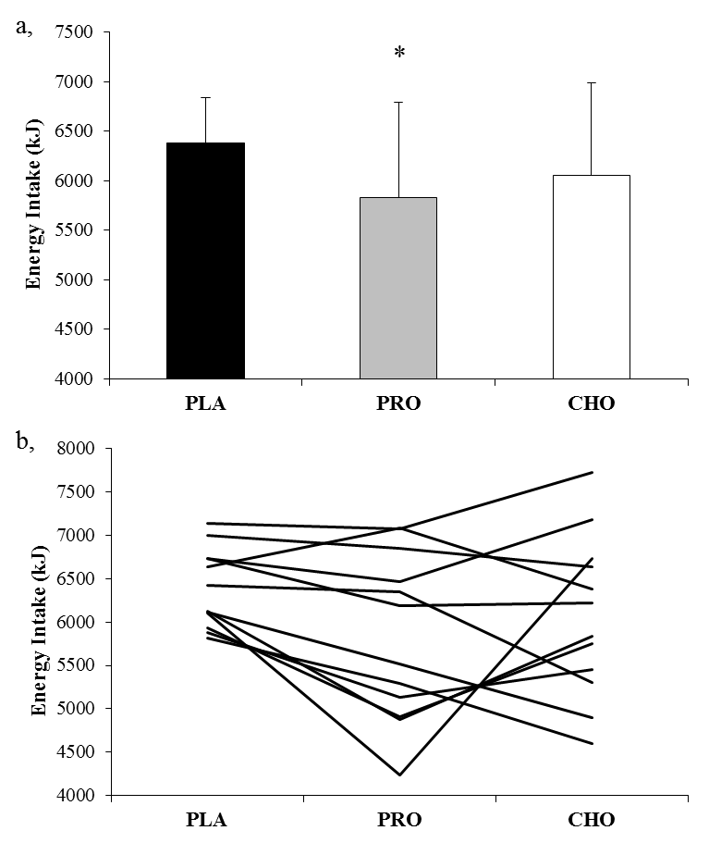

Figure 1. (a) Mean energy intake at the ad-libitum test meal (kJ) and (b) subjects individual

energy intakes (kJ) during each trial Values are means, with vertical error bars representing standard deviation.* Significantly different from PLA (P<0.05)
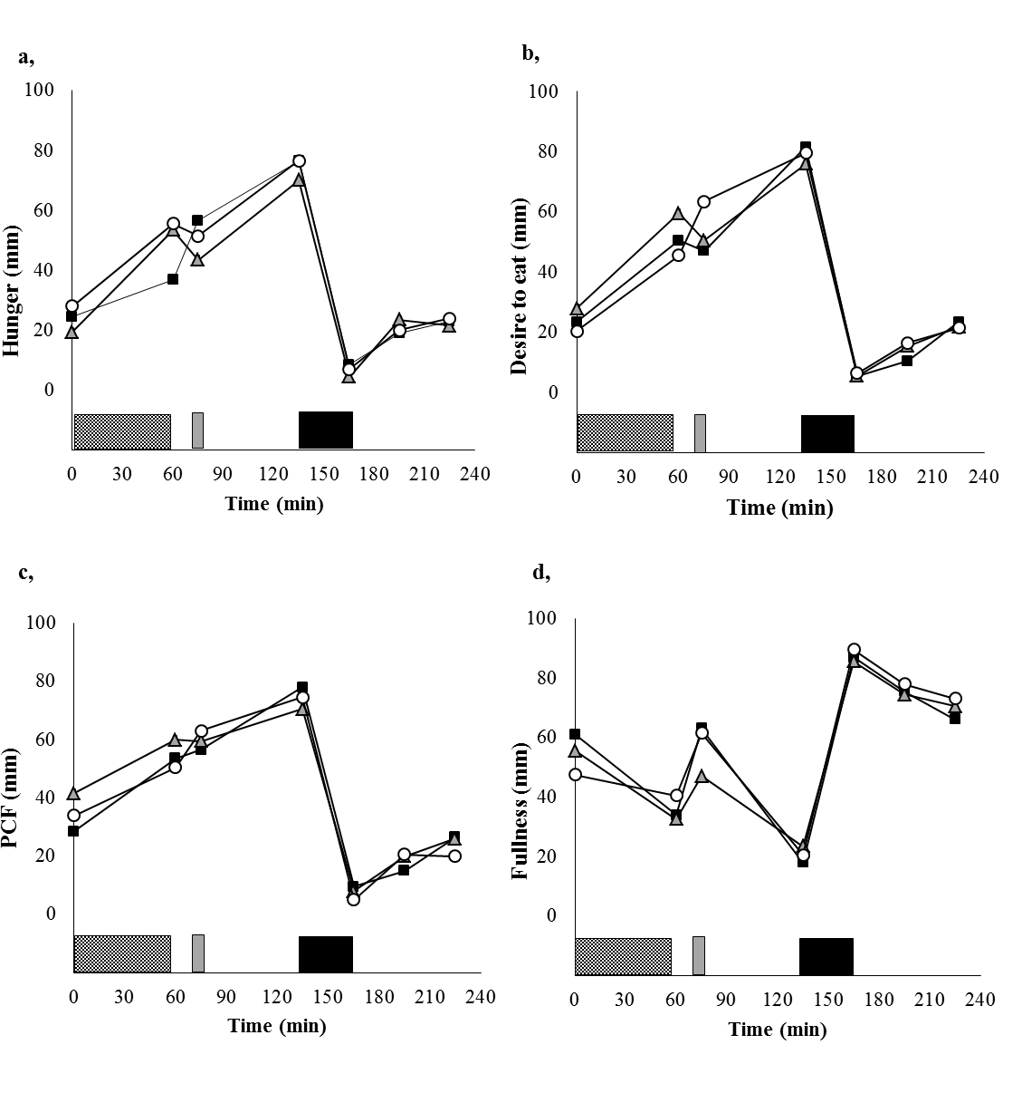
Figure 2. Subjective feelings of hunger (a), desire to eat (b), prospective food consumption (c), and fullness (d) after consuming the placebo (■), protein ( ) and carbohydrate (○)
drinks. Hatched shaded rectangle represents exercise, grey rectangle represents ingestion of the post-exercise recovery drink, and black rectangle represents the ad-libitum buffet meal. Data points are medians. All subjective measures of appetite showed a main effect of time (P<0.01)

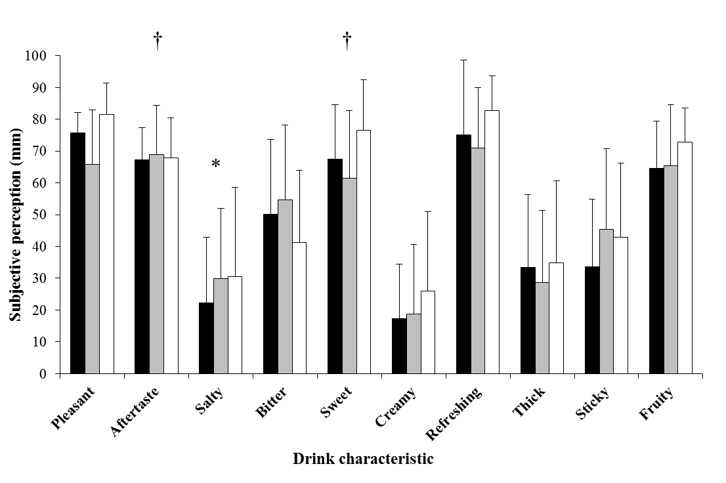

Figure 3. Subjective perceptions of test drinks (mm): PLA (■), PRO (■) and CHO (□). Subjective perceptions of salty, sweet, creamy, refreshing and thick were non-normally distributed, however all values presented are means, with vertical error bars representing standard deviation for consistency. * significantly different from PLA (P<0.05). † significantly different from CHO (P<0.05).

Discussion
The aim of this investigation was to examine whether post-exercise drink composition would affect energy intake at an ad-libitum lunch served 60 minutes after drink ingestion (i.e. 75 min post-exercise). The primary finding from this study was that energy intake was suppressed by approximately 9% (575 kJ) after consumption of a 6% whey protein isolate drink compared to a low energy placebo. These results suggest that consuming a protein containing drink after exercise might be an effective method of reducing energy intake at a subsequent meal compared to a low energy placebo drink.

Protein intake immediately after exercise potentiates the exercise-induced stimulation of myofibrillar and mitochondrial protein synthesis (Wilkinson et al., 2008). Furthermore, whey protein seems to induce a greater muscle protein synthetic response compared to casein or soy (Tang, Moore, Kujbida, Tarnopolsky, & Phillips, 2009), which is likely due to differences in postprandial absorption kinetics (Boirie et al., 1997). In the present study, 30 g of whey protein was provided, which has been shown to be within the optimal range to maximise the protein synthetic response (Moore et al., 2009; Witard et al. 2014). However, from a weight management perspective, the additional energy ingested in a post-exercise drink may compromise the energy deficit induced by the exercise session if the energy consumed is not compensated for at the next feeding opportunity. Results of the present study suggest that protein can be added to a post-exercise recovery drink without affecting gross energy intake. In addition to the effects of protein on satiety, protein also has an increased thermogenic effect compared to carbohydrate or fat (Feinman and Fine, 2004), and consequently post-exercise protein ingestion might further decrease energy balance by increasing energy expenditure, although this was not measured in the current investigation.
There is increasing evidence that acute protein feeding at rest may enhance satiety (Hill & Blundell, 1986; Stubbs et al., 1996) and reduce energy intake at a subsequent meal (Poppitt et al., 1998; Porrini et al., 1997; Araya et al., 2000) compared to isoenergetic carbohydrate and fat meals. Although this effect is less conclusive when energy is provided in liquid form, several studies have demonstrated a suppression of appetite and energy intake when high protein drinks are provided at rest, compared to water and carbohydrate drinks (Bertenshaw et al., 2008; Bertenshaw et al., 2009; Astbury et al., 2010; Dove et al., 2009). Bertenshaw et al. (2008) found that a 300 ml drink enriched with 37.7 g of protein (50% of total energy) reduced energy intake after an interval of both 30 and 120 min compared to an isoenergetic high carbohydrate drink containing 1.7 g of protein (2% of total energy) or a low energy placebo. Similarly, Astbury et al. (2010) found that the addition of protein to mixed macronutrient 400 ml pre-load drinks reduced subsequent energy intake after 90 min compared to an energy free placebo although systematically increasing pre-load protein intake did not further reduce energy intake until a very high protein content of 50.4 g (50% of total energy) was achieved. Blinding subjects to drinks with such disparate macronutrient contents can prove difficult, and in both of these investigations, subjects reported protein containing drinks to be thicker and/or creamier than low protein or placebo control drinks

which may have influenced energy intake (Bertenshaw, Lluch, & Yeomans, 2013), as well as the expected satiety of the drink (McCrickerd, Chambers, Brunstrom, & Yeomans, 2012).
Despite several studies reporting a decrease in energy intake following ingestion of protein containing drinks, this is not a universal finding. Poppitt et al. (2011) reported that low energy (<350 kJ) 500 ml whey protein enriched water drinks (5-20 g) did not decrease energy intake compared to an energy free placebo, although subjects reported increased fullness, satisfaction and decreased hunger after consumption of the protein drinks compared to the placebo drink. Much of the disparity within the liquid pre-load literature could be attributed to methodological differences, such as pre-load to meal time interval (Poppitt et al., 2011), volume of pre-load provided (Almiron-Roig & Drewnowski, 2003), sensory characteristics of the drinks (Bertenshaw et al., 2013), or protein source (Anderson & Moore, 2004). In the study of Poppitt et al. (2011), the time between ingesting the pre-load and the ad-libitum meal was 120 min which may be too long to observe a difference between drinks of such low energy density (<0.7 kJ·ml⁻¹). Based on recent findings, the average time interval for voluntary meal requests occurs ~80 min after the cessation of exercise (King, Wasse, & Stensel, 2012). Therefore, in the current study, a 500 ml pre-load with a pre-load to meal time interval of 60 min was utilised (75 min after exercise), along with a more energy dense drink (1.06 kJ·ml⁻¹) formulated to supply 30 g of protein (6%) to ensure maximal stimulation of muscle protein synthesis (Moore et al., 2009; Witard et al. 2014). Findings from the current study were that energy intake was reduced after protein ingestion at the subsequent meal by approximately 575 kJ representing a mean decrease of 9% compared to the placebo trial intake. However, there was no difference in energy intake after ingestion of the 6% protein compared to the isoenergetic carbohydrate drink, and was not different after ingestion of the carbohydrate and placebo drinks in the current study. When energy consumed in the post exercise drink was considered, total mean energy intake over each of the trials was reduced during PRO (6359 ± 960 kJ) compared to PLA (6431 ± 492 kJ) and CHO (6640 ± 901 kJ) although there were no significant differences between any of the trials (P=0.383). The exercise protocol of this study was conducted in the post-prandial state and it is unclear whether the same effect would be observed if exercise was performed in the fasted state. However, based on these results, the addition of protein to post exercise drinks might not increase energy intake at the next feeding opportunity and the consumption of protein after exercise may incur other benefits such as stimulating myofibrillar and mitochondrial protein

synthesis (Wilkinson et al., 2008) or enhancing the recovery of muscular force production (Cockburn, Hayes, French, Stevenson, & St Claire Gibson, 2008).
No blood parameters were measured in the present investigation making the mechanisms behind the observed appetite suppression after protein administration difficult to elucidate. Bowen and colleagues (Bowen et al., 2006a; Bowen, Noakes, & Clifton, 2006b) have studied the effects of protein intake on appetite regulatory hormone profiles and have shown that lower post-prandial plasma concentrations of ghrelin as well as higher concentrations of satiety hormones glucagon-like peptide-1 (GLP-1) and cholecystokinin (CCK) are present up to 3 h after protein ingestion compared to glucose ingestion. It is possible that the reduction in energy intake observed after protein ingestion during the current study was caused by alterations in gut peptide profiles, with protein stimulating an increase in satiety hormones (e.g. GLP-1 and CCK) and a reduction in appetite stimulatory hormones (e.g. ghrelin) compared to ingestion of a low energy placebo control. However, alterations in appetite hormone profiles do not always accurately predict energy intake (Bowen et al., 2007).
Recent research has highlighted the impact of sensory characteristics of drinks on subsequent energy intake. Bertenshaw et al. (2013) observed that when a high carbohydrate drink is artificially thickened, ad-libitum energy intake was reduced compared to a high protein drink. The authors suggested that energy intake was primarily governed through the hedonic qualities of the pre-load, with drinks that are described by subjects as being particularly thick or creamy, typically inducing higher feelings of satiety and reducing ad-libitum energy intake at a subsequent meal. When reviewing the literature, several studies that have observed differences in energy intake between protein and carbohydrate drinks have also provided drinks that would be expected to differ hedonically (skimmed milk vs. fruit juice) (Dove et al., 2009), or subjects have identified differences in the sensory characteristics of the drinks (i.e. thickness and/or creaminess) (Bertenshaw et al., 2008; Bertenshaw et al., 2009; Astbury et al., 2010). Oreosensory cues have been shown to elicit hormonal changes related to appetite control (Teff, 2006, 2010), as well as enhance fullness and expected satiety of a drink (McCrickerd et al., 2012). Therefore, insufficient blinding of experimental drinks may result in sensory differences that confound any potential effects of macronutrient composition on appetite and subsequent energy intake. In the current study, an acidified whey protein isolate was utilised, which assimilates well in solution, and resulted in no differences in thickness or creaminess reported by participants between any of the experimental drinks (Figure 3). In turn, this may have attenuated the subjective perception of satiety which has

been commonly observed after protein ingestion (Bertenshaw et al., 2008; Bertenshaw et al., 2009; Astbury et al., 2010; Poppitt et al., 2011; Dove et al., 2009), as there were no differences in hunger, fullness, prospective food consumption or desire to eat between trials in the current study. This may also help to explain why no difference was observed in ad- libitum energy intake after ingestion of the protein or carbohydrate drinks in the present study, despite several studies observing greater energy intake after carbohydrate ingestion compared to protein (Bertenshaw et al., 2008; Bertenshaw et al., 2009; Astbury et al., 2010; Dove et al., 2009).
The consumption of protein and carbohydrate drinks is particularly common after exercise but the interaction between exercise and post-exercise macronutrient intake on appetite has not been well studied. Liquid protein feeding at rest has often been reported to suppress appetite and energy intake relative to carbohydrate (Bertenshaw et al., 2008; Bertenshaw et al., 2009; Astbury et al., 2010; Dove et al., 2009), although this was not observed during the current investigation. The mechanisms behind these findings are not entirely clear, but could conceivably be due to the exercise protocol of the current study having a greater effect on appetite and energy intake than the macronutrient content of the post-exercise drinks. Forty minutes of high intensity interval cycling has been shown to reduce muscle glycogen concentration by approximately 50% (Stepto, Martin, Fallon, & Hawley, 2001). Although the degree of glycogen depletion would have been expected to be less severe after exercise in the current study, the perturbation in glycogen homeostasis may have influenced energy intake (and therefore carbohydrate intake) in order to promote glycogen resynthesis and restore glycogen balance (Hopkins, Jeukendrup, King, & Blundell, 2011). This may have counteracted some of the satiating properties of the post-exercise protein drink culminating in no difference in energy intake between the carbohydrate and protein trials. However, other investigations have found no differences in energy intake between steady state exercise, intermittent exercise and resting conditions, where disparate states of glycogen homeostasis might be expected to influence energy intake significantly (Deighton, Karra, Batterham, & Stensel, 2013).
Inter subject variability for energy intake appeared to be greater during the carbohydrate and protein trials compared to the placebo trial (Figure 1b). The reason for this is not clear, but might be due to differences in participant’s habitual intakes of these nutrients. Indeed, a study by Long, Jeffcoat, and Millward (2000) found that individuals who consumed a high protein diet habitually were less sensitive to the satiating properties of a high protein meal compared

to habitual low protein consumers. Likewise, we could speculate that a similar response may exist in subjects who consume a high carbohydrate diet habitually or perhaps regularly ingest high carbohydrate drinks in particular. Habitual dietary intakes were not collected as part of the current study and therefore these hypotheses remains speculative based on these results.
In conclusion, the present study found that a whey protein isolate drink consumed 10 minutes after exercise reduced energy intake at a subsequent meal compared to a low energy placebo drink. This suppression of food intake was not observed after ingestion of a carbohydrate drink. Matching the sensory characteristics of the drinks may explain why no difference in subjective appetite and food intake was observed between carbohydrate and protein drinks. Protein ingestion immediately after exercise may enhance the adaptive response of skeletal muscle by increasing myofibrillar and mitochondrial protein synthesis, and findings from the present study suggest that this might be possible without affecting gross energy intake, relative to a low energy/ energy free drink.

References

Almiron-Roig, E., & Drewnowski, A. (2003) Hunger, thirst, and energy intakes following consumption of caloric beverages. Physiology & Behavior, 79(4), 767-773.

Anderson, G.H., & Moore, S.E. (2004) Dietary proteins in the regulation of food intake and body weight in humans. The Journal of Nutrition, 134(4), 974S-979S.

Araya, H., Hills, J., Alvina, M., & Vera, G. (2000) Short-term satiety in preschool children: a comparison between high protein meal and a high complex carbohydrate meal. International Journal of Food Science & Nutrition, 51(2), 119-124.

Astbury, N.M., Stevenson, E.J., Morris, P., Taylor, M.A., & Macdonald, I.A. (2010) Dose– response effect of a whey protein preload on within-day energy intake in lean subjects. British Journal of Nutrition, 104(12), 1858-1867.

Bartlett, J.D., Close, G.L., MacLaren, D.P., Gregson, W., Drust, B., & Morton, J.P. (2011) High-intensity interval running is perceived to be more enjoyable than moderate- intensity continuous exercise: implications for exercise adherence. Journal of Sports Science, 29, 547-553.

Bertenshaw, E.J., Lluch, A., & Yeomans, M.R. (2008) Satiating effects of protein but not carbohydrate consumed in a between-meal beverage context. Physiology & Behavior, 93(3), 427-436.

Bertenshaw, E.J., Lluch, A., & Yeomans, M.R. (2009) Dose-dependent effects of beverage protein content upon short-term intake. Appetite, 52(3), 580-587.

Bertenshaw, E.J., Lluch, A., & Yeomans, M.R. (2013) Perceived thickness and creaminess modulates the short-term satiating effects of high-protein drinks. British Journal of Nutrition, 110(3), 578-586.

Blundell, J.E., Stubbs, R.J., Hughes, D.A., Whybrow, S., & King, N.A. (2003) Cross talk between physical activity and appetite control: does physical activity stimulate appetite? Proceedings of the Nutrition Society, 62, 651-661.

Boirie, Y., Dangin, M., Gachon, P., Vasson, M., Maubois, J., & Beaufrère, B. (1997) Slow and fast dietary proteins differently modulate postprandial protein accretion. Procedings of the National Academy of Sciences, 94(26), 14930-14935.

Borg, G. (1973) Perceived exertion: a note on" history" and methods. Medicine & Science in Sports & Exercise, 5(2), 90-93.

Bowen, J., Noakes, M., Trenerry, C., & Clifton, P.M. (2006) Energy intake, ghrelin, and cholecystokinin after different carbohydrate and protein preloads in overweight men. Journal of Clinical Endocrinology & Metabolism, 91(4), 1477-1483.

Bowen, J., Noakes, M., & Clifton, P.M. (2006) Appetite regulatory hormone responses to various dietary proteins differ by body mass index status despite similar reductions in ad libitum energy intake. Journal of Clinical Endocrinology & Metabolism, 91(8), 2913-2919.

Bowen, J., Noakes, M., & Clifton, P.M. (2007) Appetite hormones and energy intake in obese men after consumption of fructose, glucose and whey protein beverages. International Journal of Obesity, 31(11), 1696-1703.

Cockburn, E., Hayes, P.R., French, D.N., Stevenson, E., & St Clair Gibson, A. (2008) Acute milk-based protein-CHO supplementation attenuates exercise-induced muscle damage. Applied Physiology, Nutrition, & Metabolism, 33(4), 775-783.

Dansinger, M.L., Gleason, J.A., Griffith, J.L., Selker, H.P., & Schaefer, E.J. (2005) Comparison of the Atkins, Ornish, Weight Watchers, and Zone diets for weight loss and heart disease risk reduction. JAMA: The Journal of the American Medical Association, 293(1), 43-53.

Deighton, K., Karra, E., Batterham, R.L., & Stensel, D.J. (2013) Appetite, energy intake and PYY3-36 responses to energy-matched continuous exercise and submaximal high intensity exercise. Applied Physiology, Nutrition, & Metabolism, 38(9), 947-952.

Dove, E.R., Hodgson, J.M., Puddey, I.B., Beilin, L.J., Lee, Y.P., & Mori, T.A. (2009) Skim milk compared with a fruit drink acutely reduces appetite and energy intake in overweight men and women. American Journal of Clinical Nutrition, 90(1), 70-75.

Feinman, R.D., & Fine, E.J. (2004) “A calorie is a calorie” violates the second law of thermodynamics. Nutrition Journal,3(9).

Finucane, M.M., Stevens, G.A., Cowan, M.J., Danaei, G., Lin, J.K., Paciorek, C.J., et al. (2011) National, regional, and global trends in body-mass index since 1980: systematic analysis of health examination surveys and epidemiological studies with 960 country- years and 9.1 million participants. The Lancet, 378(9785), 31-40.

Franz, M.J., VanWormer, J.J., Crain, A.L., Boucher, J.L., Histon, T., Caplan, W., et al. (2007) Weight-loss outcomes: a systematic review and meta-analysis of weight-loss clinical trials with a minimum 1-year follow-up. Journal of American Dietary Association, 107(10), 1755-1767.

Gibala, M.J., Little, J.P., MacDonald, M.J., & Hawley, J.A. (2012) Physiological adaptations to low-volume, high-intensity interval training in health and disease. Journal of Physiology, 590, 1077-1084.

Hall, W., Millward, D., Long, S., & Morgan, L. (2003) Casein and whey exert different effects on plasma amino acid profiles, gastrointestinal hormone secretion and appetite. British Journal of Nutrition, 89(2), 239-248.

Harper, A., James, A., Flint, A., & Astrup, A. (2007) Increased satiety after intake of a chocolate milk drink compared with a carbonated beverage, but no difference in subsequent ad libitum lunch intake. British Journal of Nutrition, 97(3), 579-583.

Hill, A.J., & Blundell, J.E. (1986) Macronutrients and satiety: the effects of a high-protein or high-carbohydrate meal on subjective motivation to eat and food preferences. Nutrition & Behavior, 3, 133-144.

Hopkins, M., Jeukendrup, A., King, N.A., & Blundell, J.E. (2011) The relationship between substrate metabolism, exercise and appetite control. Sports Medicine, 41(6), 507-521.

Hubert, P., King, N., & Blundell, J. (1998) Uncoupling the effects of energy expenditure and energy intake: appetite response to short-term energy deficit induced by meal omission and physical activity. Appetite, 31(1), 9-19.

James, L. (2012) Milk protein and the restoration of fluid balance after exercise. Medicine Sport Science, 59, 120-126.

King, J.A., Wasse, L.K., Ewens, J., Crystallis, K., Emmanuel, J., & Batterham, R.L.(2011) Differential acylated ghrelin, Peptide YY3–36, appetite, and food intake responses to equivalent energy deficits created by exercise and food restriction. Journal of Clinical Endocrinology & Metabolism, 96(4), 1114-1121.

King, J.A., Wasse, L.K., & Stensel, D.J. (2012) Acute exercise increases feeding latency in healthy normal weight young males but does not alter energy intake. Appetite, 61(1), 45-51.

Leidy, H.J., Carnell, N.S., Mattes, R.D., & Campbell, W.W. (2007) Higher protein intake preserves lean mass and satiety with weight loss in pre-obese and obese women. Obesity, 15(2), 421-429.

Long, S., Jeffcoat, A., & Millward, D. (2000) Effect of habitual dietary-protein intake on appetite and satiety. Appetite, 35(1), 79-88.

Malik, V.S., Willett, W.C., & Hu, F.B. (2013) Global obesity: trends, risk factors and policy implications. Nature Reviews Endocrinology, 9(1), 13-27

McCrickerd, K., Chambers, L., Brunstrom, J.M., & Yeomans, M.R. (2012) Subtle changes in the flavour and texture of a drink enhance expectations of satiety. Flavour, 1(1), 20-30.

Mifflin, M.D., St Jeor, S., Hill, L.A., Scott, B.J., Daugherty, S.A., & Koh, Y. (1990) A new predictive equation for resting energy expenditure in healthy individuals. American Journal of Clinical Nutrition, 51(2), 241-247.

Moore, D.R., Robinson, M.J., Fry, J.L., Tang, J.E., Glover, E.I., Wilkinson, S.B., et al. (2009) Ingested protein dose response of muscle and albumin protein synthesis after resistance exercise in young men. American Journal of Clinical Nutrition, 89(1), 161- 168.

Nose, H., Mack, G.W., Shi, X., & Nadel, E.R. (1988) Role of osmolality and plasma volume during rehydration in humans. Journal of Applied Physiology, 65(1), 325-331.

Poppitt, S.D., McCormack, D., & Buffenstein, R. (1998) Short-term effects of macronutrient preloads on appetite and energy intake in lean women. Physiology & Behavior, 64(3), 279-285.

Poppitt, S.D., Proctor, J., McGill, A., Wiessing, K.R., Falk, S., Xin, L., et al. (2011) Low- dose whey protein-enriched water beverages alter satiety in a study of overweight women. Appetite, 56(2), 456-464.

Porrini, M., Santangelo, A., Crovetti, R., Riso, P., Testolin, G., & Blundell, J. (1997) Weight, protein, fat, and timing of preloads affect food intake. Physiology & Behavior, 62(3), 563-570.

Shirreffs, S.M., Taylor, A.J., Leiper, J.B., & Maughan, R.J. (1996) Post-exercise rehydration in man: effects of volume consumed and drink sodium content. Medicine & Science in Sports & Exercise, 28(10), 1260-1271.

Stepto, N.K., Martin, D.T., Fallon, K.E., & Hawley, J.A. (2001) Metabolic demands of intense aerobic interval training in competitive cyclists. Medicine & Science in Sports & Exercise, 33(2), 303-310.

Stubbs, R.J., van Wyk, M.C., Johnstone, A.M., & Harbron, C.G. (1996) Breakfasts high in protein, fat or carbohydrate: effect on within-day appetite and energy balance. European Journal of Clinical Nutrition, 50(7), 409-417.

Stunkard, A.J., & Messick, S. (1985) The three-factor eating questionnaire to measure dietary restraint, disinhibition and hunger. Journal of Psychosomatic Research, 29(1), 71-83.

Tang, J.E., Moore, D.R., Kujbida, G.W., Tarnopolsky, M.A., & Phillips, S.M. (2009) Ingestion of whey hydrolysate, casein, or soy protein isolate: effects on mixed muscle protein synthesis at rest and following resistance exercise in young men. Journal of Applied Physiology, 107(3), 987-992.

Teff K.L. (2006) Learning hunger: conditioned anticipatory ghrelin responses in energy homeostasis. Endocrinology, 147(1), 20-22.

Teff, K.L. (2010) Cephalic phase pancreatic polypeptide responses to liquid and solid stimuli in humans. Physiology & Behavior, 99(3), 317-323.

Wilkinson, S.B., Phillips, S.M., Atherton, P.J., Patel, R., Yarasheski, K.E., Tarnopolski, M.A., et al. (2008) Differential effects of resistance and endurance exercise in the fed

state on signaling molecule phosphorylation and protein synthesis in human muscle.

Journal of Physiology, 586(15), 3701-3717.

Witard, O.C., Jackman, S.R., Bleen, L., Smith, K., Selby, A., & Tipton, K.D. (2014) Myofibrillar muscle protein synthesis rates subsequent to a meal in response to increasing doses of whey protein at rest and after resistance exercise. American Journal of Clinical Nutrition, 99(1), 86-95.

Appendix B

INFORMED CONSENT FORM
(to be completed after Participant Information Sheet has been read)

The purpose and details of this study have been explained to me. I understand that this study is designed to further scientific knowledge and that all procedures have been approved by the Loughborough University Ethical Approvals (Human Participants) Sub-Committee.

I have read and understood the information sheet and this consent form. I have had an opportunity to ask questions about my participation.
I understand that I am under no obligation to take part in the study.

I understand that I have the right to withdraw from this study at any stage for any reason, and that I will not be required to explain my reasons for withdrawing.

I understand that all the information I provide will be treated in strict confidence and will be kept anonymous and confidential to the researchers unless (under the statutory obligations of the agencies which the researchers are working with), it is judged that confidentiality will have to be breached for the safety of the participant or others.

I agree to participate in this study.

Your name

Your signature

Signature of investigator

Date

Appendix C

Health Screen Questionnaire for Study Volunteers

As a volunteer participating in a research study, it is important that you are currently in good health and have had no significant medical problems in the past. This is (i) to ensure your own continuing well-being and (ii) to avoid the possibility of individual health issues confounding study outcomes.

If you have a blood-borne virus, or think that you may have one, please do not take part in this research.

Please complete this brief questionnaire to confirm your fitness to participate:

- At present, do you have any health problem for which you are:

(a) | on medication, prescribed or otherwise ............ | Yes |  | No
(b) | attending your general practitioner ................... | Yes |  | No
(c) | on a hospital waiting list ................................... | Yes |  | No

- In the past two years, have you had any illness which required you to:

(a) | consult your GP................................................ | Yes |  | No
(b) | attend a hospital outpatient department ........... | Yes |  | No
(c) | be admitted to hospital .................................... | Yes |  | No

- Have you ever had any of the following:

(a) | Convulsions/epilepsy ........................................ | Yes |  | No
(b) | Asthma ............................................................. | Yes |  | No
(c) | Eczema ............................................................ | Yes |  | No
(d) | Diabetes ........................................................... | Yes |  | No
(e) | A blood disorder ............................................... | Yes |  | No

(f) | Head injury ....................................................... | Yes |  | No
(g) | Digestive problems ........................................... | Yes |  | No
(h) | Heart problems ................................................. | Yes |  | No
(i) | Problems with bones or joints ........................ | Yes |  | No
(j) | Disturbance of balance/coordination ................ | Yes |  | No
(k) | Numbness in hands or feet ............................... | Yes |  | No
(l) | Disturbance of vision ........................................ | Yes |  | No
(m) | Ear / hearing problems ..................................... | Yes |  | No
(n) | Thyroid problems ............................................. | Yes |  | No
(o) | Kidney or liver problems ................................... | Yes |  | No
(p) | Allergy to nuts .................................................. | Yes |  | No

- Has any, otherwise healthy, member of your family under the age of 35 died suddenly during or soon after exercise?
Yes No

If YES to any question, please describe briefly if you wish (eg to confirm problem was/is short-lived, insignificant or well controlled.)
...................................................................................................................................................
...................................................................................................................................................
................

- Allergy Information

(a) | are you allergic to any food products? | Yes |  | No
(b) | are you allergic to any medicines? | Yes |  | No
(c) | are you allergic to plasters? | Yes |  | No

If YES to any of the above, please provide additional information on the allergy
……………………………………………………………………………………………………………
…………………..

- Additional questions for female participants

(a) | are your periods normal/regular? ..................... | Yes |  | No
(b) | are you on “the pill”? ......................................... | Yes |  | No
(c) | could you be pregnant? .................................. | Yes |  | No
(d) | are you taking hormone replacement therapy (HRT)? | Yes |  | No

- Please provide contact details of a suitable person for us to contact in the event of any incident or emergency.

Name: ……………………………………………………………………………………

Telephone Number:……...………………………………………………………………

Work Home Mobile

Relationship to Participant:...……………………………………………………………

- Are you currently involved in any other research studies at the University or elsewhere?

 | Yes |  | No

If yes, please provide details of the study
………………………………………………………………………………………………………
………………………………………………………………………………………………………
………………

Appendix D

Physical Activity Questionnaire

During one week, how many times on average do you spend doing the following kinds of exercise FOR MORE THAN 15 MINUTES?

  - Strenuous exercise (heart beats rapidly)

For example; running, jogging, squash, hockey, football, rugby, vigorous swimming, vigorous long distance cycling

times per week.

  - Moderate exercise (not exhausting)

For example; fast walking, tennis, casual cycling, badminton, casual swimming, dancing

times per week.

  - Mild exercise (minimal effort)

For example; yoga, archery, fishing, bowling, golf, casual walking

times per week.

Appendix E

THREE-FACTOR EATING QUESTIONNAIRE

Part 1: Please answer true or false

When I smell a sizzling steak or see a juicy piece of meat, I find it very difficult to keep from eating, even if I have just finished a meal.
True □ False □

I usually eat too much at social occasions, like parties and picnics.

True □ False □

I am usually so hungry that I eat more than three times per day.

True □ False □

When I have eaten my quota of calories, I am usually good about not eating any more.
True □ False □

Dieting is so hard for me because I just get too hungry

True □ False □

I deliberately take small helpings as a means of controlling my weight.

True □ False □

Sometimes things just taste so good that I keep eating even when I am no longer hungry.
True □ False □

Since I am often hungry, I sometimes wish that while I am eating, an expert would tell me that I have had enough or that I can have something more to eat.

- When I feel anxious, I find myself eating.

True □ False □

Life is too short to worry about dieting.

True □ False □

Since my weight goes up and down, I have gone on reducing diets more than once.
True □ False □

I often feel so hungry that I just have to eat something

True □ False □

When I am with someone who is overeating, I usually overeat too.

True □ False □

I have a pretty good idea of the number of calories in common food.

True □ False □

Sometimes when I start eating, I just can’t seem to stop.

True □ False □

It is not difficult for me to leave something on my plate.

True □ False □

At certain times of the day, I get hungry because I have gotten used to eating then.
True □ False □

While on a diet, if I eat food that is not allowed, I consciously eat less for a period of time to make up for it.

- Being with someone who is eating often makes me hungry enough to eat also.

True □ False □

When I feel blue, I often overeat.

True □ False □

I enjoy eating too much to spoil it by counting calories or watching my weight.

True □ False □

When I see a real delicacy, I often get so hungry that I have to eat right away.

True □ False □

I often stop eating when I am not really full as a conscious means of limiting the amount that I eat.
True □ False □

I get so hungry that my stomach often seems like a bottomless pit.

True □ False □

My weight has hardly changed at all in the last ten years.

True □ False □

I am always hungry so it is hard for me to stop eating before I finish the food on my plate.
True □ False □

When I feel lonely, I console myself by eating.

True □ False □

I consciously hold back at meals in order not to gain weight.

True □ False □

I sometimes get very hungry late in the evening or at night.

True □ False □

I eat anything I want, anytime I want.

True □ False □

Without even thinking about it, I take a long time to eat.

True □ False □

I count calories as a conscious means of controlling my weight.

True □ False □

I do not eat some foods because they make me fat.

True □ False □

I am always hungry enough to eat at any time

True □ False □

I pay a great deal of attention to changes in my figure.

True □ False □

While on a diet, if I eat food that is not allowed, I often then splurge and eat other high calorie food.
True □ False □

Part 2: Please answer the following questions by circling the number with the response that is appropriate to you.

How often are you dieting in a conscious effort to control your weight?

1 (rarely) 2 (sometimes) 3 (usually) 4 (always)

Would a weight fluctuation of 5 lbs. affect the way you live your life?

1 (not at all) 2 (slightly) 3 (moderately) 4 (very much)

How often do you feel hungry?

1 2 3 4

(only at meal times) (sometimes between meals) (often between meals) (almost always)

Do your feelings of guilt about overeating help you control your food intake?

1 (never) 2 (rarely) 3 (often) 4 (always)

How difficult would it be for you to stop eating halfway through dinner and not eat for the next few hours?
1 (easy) 2 (slightly difficult) 3 (moderately difficult) 4 (very difficult)

How conscious are you of what you are eating?

1 (not at all) 2 (slightly) 3 (moderately) 4 (extremely)

How frequently do you avoid ‘stocking up’ on tempting foods?

1 (almost never) 2 (seldom) 3 (usually) 4 (almost always)

How likely are you to shop for low calorie foods?

1 (unlikely) 2 (slightly unlikely) 3 (moderately likely) 4 (very likely)

Do you eat sensibly in front of others and splurge alone?

1 (never) 2 (rarely) 3 (often) 4 (always)

How likely are you to consciously eat slowly in order to cut down on how much you eat?
1 (unlikely) 2 (slightly likely) 3 (moderately likely) 4 (very likely)

How frequently do you skip desert because you are no longer hungry?

1 (unlikely) 2 (seldom) 3 (at least once a week) 4 (almost every day)

How likely are you to consciously eat less than you want?

1 (unlikely) 2 (slightly likely) 3 (moderately likely) 4 (very likely)

Do you go on eating binges though you are not hungry?

1 (never) 2 (rarely) 3 (sometimes) 4 (at least once a week)

On a scale of 0 to 5, where 0 means no restraint in eating (eating whatever you want, whenever you want it) and 5 means total restraint (constantly limiting food intake and never ‘giving in’), what number would you give yourself?

0
Eat whatever you want, whenever you want it 1
Usually eat whatever you want, whenever you want it 2
Often eat whatever you want, whenever you want it 3
Often limit food intake, but often ‘give in’ 4
Usually limit food intake, rarely ‘give in’ 5
Constantly limiting food intake, never ‘give in’

To what extent does this statement describe your eating behaviour? ‘I start dieting in the morning, but because of any number of things that happen during the day, by evening I have given up and eat what I want, promising myself to start dieting again tomorrow.’
1 2 3 4

(not like me) (little like me) (pretty good description of me) (describes me perfectly)

Scoring

One point is given for each item in Part 1 and for each item (numbered question) in Part 2. The correct answer for the true/false items is described below. In part 1, an ‘incorrect’ response results in zero point being added to that factor. ‘Correct’ answers receive one point. The direction of the question in Part 2 is determined by splitting the responses at the middle. If the item is labelled ‘+’, those responses above the middle are given a zero. Vice versa for those with a ‘-‘. For example, scoring 3 or 4 on the first item of Part 2 (no. 37) would receive one point. Anyone scoring 1 or 2 would receive a zero.
Key:

Question number | Correct Answer | Score | Factor concerning
1 | True |  | DH
2 | True |  | DH
3 | True |  | H
4 | True |  | DR
5 | True |  | H
6 | True |  | DR
7 | True |  | DH
8 | True |  | H
9 | True |  | DH
10 | True |  | DR
11 | False |  | DH
12 | True |  | H
13 | True |  | DH
14 | True |  | DR
15 | True |  | DH
16 | False |  | DH
17 | True |  | H
18 | True |  | DR
19 | True |  | H
20 | True |  | DH
21 | False |  | DR

22 | True |  | H
23 | True |  | DR
24 | True |  | H
25 | False |  | DH
26 | True |  | H
27 | True |  | DH
28 | True |  | DR
29 | True |  | H
30 | False |  | DR
31 | False |  | DH
32 | True |  | DR
33 | True |  | DR
34 | True |  | H
35 | True |  | DR
36 | True |  | DH
37 | + |  | DR
38 | + |  | DR
39 | + |  | H
40 | + |  | DR
41 | + |  | H
42 | + |  | DR
43 | + |  | DR
44 | + |  | DR
45 | + |  | DH
46 | + |  | DR
47 | - |  | H
48 | + |  | DR
49 | + |  | DH
50 | + |  | DR
51 | + |  | DH

 | Tally | Score | Boundaries
Dietary restraint (DR) |  |  | 0-10 low  11-13 high  14-21 clinical
Dietary disinhibition (DH) |  |  | 0-8 low  9-11 high  12-16 clinical
Hunger (H) |  |  | 0-7 low  8-10 high  11-14 clinical

Source

Stunkard AJ, Messick SM. The three-factor eating questionnaire to measure dietary restraint, disinhibition and hunger. Journal of psychometric research. 1985. 29(1): 71-83
King JA, Wasse LK, Stensel D. Acute exercise increases feeding latency in healthy normal weight young males but does not alter energy intake. Appetite. 2013. 61: 45-51

Appendix F

List of Study Foods

Diets will be formulated and foods will be supplied during the study so therefore we would like to know whether there are any foods that you may be ALERGIC to or have a particular DISLIKE for. Please indicate in the table below:

Food | Allergy (Yes/No) | Level of preference (1-5) 1=enjoy eating  5=will not eat | Additional Comments
Rice Crispies
Milk
Orange Juice
White Bread
Mayonnaise
Chicken
Lettuce
Tomato
Red Pepper
Cookies
Balsamic Vinegar
Strawberry Yoghurt
Chewee Cereal Bar
Pasta
Tomato Sauce
Olive Oil
Ready Salted Crisps
Strawberry Jam
Apple
Banana
Brown Bread
Ham

Tuna
Butter
Porridge
Orange Squash
Blackcurrant Squash
Summer Fruits
Squash

Appendix G

Q1
Subjective Feeling Questionnaire

How hungry do you feel?

Not at all hungry
Extremely hungry

How full do you feel?
Not full at all
Extremely full

How strong is your desire to eat?
No desire at all
Extremely strong

How much food do you think you could eat?
Non at all
A lot

How nauseated do you feel now?

Not at all nauseas
Extremely nauseas

Appendix H Multi-item lunch meals
Chapter VI | Chapter VII | Chapter VIII
Food choices
Salted crisps | Salted Crisps | Salted Crisps
Salted Crisps | Royal Gala Apples | Royal Gala Apples
Nutrigrain Elevensies Raisin | Clementine’s | Clementine’s
Nutrigrain Elevensies Choc  Chip | White Bread | White Bread
Royal Gala Apples | Brown Bread | Brown Bread
Banana | Sliced Ham | Sliced Ham
White Bread | Sliced Chicken | Sliced Chicken
Brown Bread | Tuna | Tuna
Sliced Ham | Lettuce | Lettuce
Sliced Chicken | Tomato | Tomato
Tuna | Mayonnaise | Mayonnaise
Grated Cheese | Spreadable Butter | Spreadable Butter
Sliced Tomato | Choc Chip Cookies | Choc Chip Cookies
Sliced Cucumber | Yoghurt | Yoghurt
Mayonnaise |  | Cheese
Spreadable Butter
Margarine
Bourbon Biscuits
Custard Cream Biscuits
Choc Chip Cookies
Drink choices
Water | Water | Water
Orange Squash | Orange Squash | Orange Squash
Blackcurrant and Apple  Squash | Blackcurrant and Apple  Squash | Blackcurrant and Apple  Squash
Summer Fruits Squash | Summer Fruits Squash | Summer Fruits Squash

Appendix I Pasta meals
Chapter IV
Ingredient | Amount (g)
Pasta | 500
Tomato Sauce | 375
Olive Oil | 50
Cheese | 156
Nutritional Information (per 100 g)
Carbohydrate | 25 g (53 %)
Protein | 7 g (14 %)
Fat | 7 g (33 %)
Energy | 801 ± 4 kJ

Chapter VII and VIII
Ingredient | Amount (g)
Pasta | 500
Tomato Sauce | 490
Olive Oil | 40
Nutritional Information (per 100 g)
Carbohydrate | 26 g (70 %)
Protein | 4 g (12 %)
Fat | 3 g (18 %)
Energy | 627 ± 11 kJ

Appendix A
Ingredient | Amount (g)
Pasta | 500
Tomato Sauce | 490
Olive Oil | 40
Cheese | 156
Nutritional Information (per 100 g)
Carbohydrate | 25 g (53 %)
Protein | 6 g (14 %)
Fat | 7 g (33 %)
Energy | 787 ± 10 kJ

Appendix J Porridge meal
Chapter VII
Ingredient | Amount (g)
Porridge Oats | 500
Semi-skimmed milk | 375
Nutritional Information (per 100 g)
Carbohydrate | 16 g (61 %)
Protein | 4 g (17 %)
Fat | 3 g (22 %)
Energy | 440 ± 5 kJ

Appendix K

Food and Activity Record

Subject no.:
Trial:
Date:

To ensure that the same conditions are present before each trial, we ask that you complete this food and physical activity diary for the 48 h period before your first trial. We also ask that you then repeat this in the 48 h before each subsequent trial. PLEASE REFRAIN FROM ALCOHOL AND STRENUOUS EXERCISE IN THIS PERIOD.

- Please describe each item of food and drink as fully as possible – type of food, cooking method, weight etc.
- Also please weigh/measure and list all drinks you consume in the 48 hours.
- You should not consume any food or drink other than what is supplied in the morning before each laboratory visit
Guidelines for use of the food record diary

- Please weigh all the food on the scales provided by placing your plate on the scales, pressing the ‘zero’ button, and then loading on the item of food. If the meal consists of several items then ‘zero’ the scales before each and record the weights. For example:
  - Put plate/bowl on the scales
  - Zero scales
  - Load first item e.g. meat – 125g shown
  - Record in the booklet
  - Zero scales
  - Load on another item e.g. potatoes – 150g shown
  - Record in booklet

Repeat stages 5-7 until you have completed your meal

- If eating out you will have to either (a) ask for an empty plate so that you can transfer each item to the new plate while you record the weight or (b) weigh the complete meal and eat each item separately and re-weigh the plate after each item so that you can work out the weight by the difference

- Some food types come in standard weights and in packets with information printed on the label, e.g. crisps, yoghurt, Mars bar, can of drink etc. So these are easy to record.
- Record only one food item on each line of the diary
- Describe each item as fully as possible. See example on the next page.
- Describe the method of cooking – boiled, roast, fried, grilled
- Indicate whether skins are eaten
- Please record all food in grams
- Remember to record cups of tea and coffee together with any milk or sugar added
- To record a commonly consumed item throughout the day more easily (e.g. tub of butter, packet of sugar), weigh the item at the start of the day and at the end of the day to obtain the total weight consumed. HOWEVER IF YOU LIVE IN SHARED ACCOMODATION MAKE SURE NOBODY ELSE USES YOUR ITEM OF FOOD
- For very light ingredients please use common household measures. i.e. ½ teaspoon of salt, sugar, herbs, spices, coffee etc.
- You may weigh ingredients raw or cooked e.g. pasta/rice but please indicate which you have done.

SOME EXAMPLES OF THE DETAILS REQUIRED ABOUT EACH FOOD OR DRINK EATEN ARE GIVEN ON THE NEXT PAGE

Operation of the scales

- The scales give a digital reading of the food type in grams. They can be ‘zeroed’ by pressing the ‘0’ button on the front. You can switch the scales on by pressing the ‘on/off’ button on the front.
- Place on an even firm surface before turning on, and leave for a few seconds to balance before placing anything on them. Scales will read 0g when they are balanced, and after this you can begin to add food to the scales. Ensure that scales are steady before recording a weight.
- Scales will turn off when left for a short period untouched. They can also be turned off by holding the ‘on/off’ button for a short time.

Example of food diary

Time | Description of food | Weight of food | Weight of food  left over
8.30am | Kellogs Cornflakes | 40g | 0g
 | Semi-skimmed milk | 200g | 0g
 | 1 slice of toast, Hovis, granary | 50g | 0g
 | Butter, Country Life, no added  salt | 10g | 0g
11.00am | Coffee, Nescafe decaffeinated,  granules | 180g | 0g
 | Whole milk | 17g | 0g
 | Kit-Kat biscuit, 2 fingers | 35g | 0g
1.12pm | Tesco sandwich: |  | 0g
 | White bread, 2 medium slices | 100g | 0g
 | Butter on bread | 20g | 0g
 | Grated cheese | 40g | 0g
 | 3 tomato slices | 10g | 0g
 | 1 can of diet coke, Coca Cola | 330g | 50g
6.00pm | Grilled lean lamb chop | 150g | 20g
 | Boiled new potatoes in skins | 250g | 43g
 | Processed peas, Cross and  Blackwell | 100g | 22g
 | 1 banana | 30g | 0g
 | 1 glass of orange juice,  Tropicana, no bits | 148g | 0g
10.00pm | Tea, PG tips | 40g | 0g
 | Semi-skimmed milk | 200g | 0g
 | 4 biscuits, McVities, chocolate  digestive | 50g | 0g

Example physical activity diary

Time | Activity | Intensity | Duration
9.00am | Cycle to university | Low | 20 min
7.00pm | Walk the dog | Low | 30 min
Please record all your physical activity over the 48 h standardisation period in the table on the next page. PLEASE REFRAIN FROM ANY STRENUOUS ACTIVTY DURING THIS TIME.

Food Diary – Day 1 – Date……………………………..

Time | Description of food | Weight of food | Weight left over

Physical activity diary – Day 1

Time | Type | Duration | Intensity

Food Diary – Day 2 – Date………………………………………

Time | Description of food | Weight of food | Weight left over

Physical activity diary – Day 2

Time | Type | Duration | Intensity

