**The appliance of prefabricated cement soil slabs processed with a hydrophobisator for the construction of auto-roads**

**S.P. Sannikov, S.A. Kujukov, A.V. Zamjatin, А.А. Zhigajlov**

ФГБОУ ВО “ Tyumen Industrial University “

Tyumen, Russia

[sannikovsp@tyuiu.ru](mailto:sannikovsp@tyuiu.ru), [kujukovsa@tyuiu.ru](mailto:kujukovsa@tyuiu.ru), [zamjatinav@tyuiu.ru](mailto:zamjatinav@tyuiu.ru), zhigajlovaa@tyuiu.ru

***Annotation.* The paper presents a complex method for increasing water resistance and reducing crack formation by using a prefabricated foundation of cement soil slabs with surface processing with a hydrophobizing material on basis of organosilicon compounds. Theoretical, laboratory and full-scale experimental studies were made. The object of the study is cement slabs made in the form, with a surface processing with a hydrophobizing material. Theoretical studies are based on the substantiation of the geometric parameters of the slab in order to exclude the probability of its destruction under its own weight during building and installation works. The result of the first stage of laboratory studies is the determination of the optimum composition of cement soil mixture in order to achieve a grade of strength M20. At the second stage, the effectiveness of the influence of hydrophobizing materials "Tiprom U" and "Penetron-Admix" on water absorption and compressive strength of cement soil was determined. The final stage of the research was a full-scale experiment. In the factory environment, cement soil slabs were manufactured in metal molds. Based on the results of the research, conclusions about the effectiveness of this complex method were made. The use of cement soil slabs allows reducing crack formation, as well as to work all year round due to manufacturing and processing of slabs in the factory environment.**

***Key words:* road revetment, cement soil foundations, slab, hydrophobizator, water absorption, crack formation.**

Introduction

In recent years, the fleet of vehicles has significantly increased and modified in Russia, which is connected with the availability of car purchases. As main reasons it is necessary to note the expanded crediting and various target programs. As part of the traffic flow, trucks with large payloads and significant axleloading appeared. The increase in intensity and the change in the composition of the flow require new approaches in the design and calculation of road revetment for auto-roads, as well as the use of new high-strength and durable materials, including cement soil foundations, in the structures.

The road is a complex engineering structure, which includes many elements, the main of which are the road bed and road revetment. It is the road revetment that is the element on which condition the uninterrupted year-round transport connection depends. Unfortunately, in recent years, the applied constructions of road revetment cannot be called diverse, especially the foundations.

For building the road revetment foundations stone materials (ballast, gravel) are mainly used. The lack of stone material on the territory of many regions makes it necessary to transport ballast from neighboring areas by rail and then reload into dump trucks. This is the main reason for a significant rise in the cost of construction, as well as a decrease in the pace of production. One of the solutions to this problem is the replacement of imported stone materials with reinforced soils [1, 2].

To strengthen the soil can be used a large number of materials based on mineral (cement, lime, ash), organic binders (bitumen, bitumen emulsion), synthetic polymer compounds (stabilizers, polymer additives), production waste (sludges). Complex, electrochemical and thermal strengthening is also known. [3, 4, 5, 6, 7, 8, 9, 10, 11, 12].

The choice of the method of strengthening depends on many factors, including the type of soil, the area of construction, and the technology of production.

The most common is the installation of foundations from cement soil. Cement soil is a composite material obtained during the hardening of the optimum ratio of soil, cement and water.

There are two ways to build a cement soil foundation. The first one is based on the preparation of the mixture directly on the construction site by mixing with a milling cutter or recycler, and the second one is the preparation of the mixture in a soil mixing plant. The quality of mixing of the mixture according to the second method is much higher, which affects the strength of the construct in use.

To ensure the durability of the construction of roads revetment with a base of cement soil foundation, it is necessary to correctly select the initial materials (soil and stabilizer) and their dosages for further preparation of the mixture in the installation.

A significant disadvantage of cement soil foundation when you are working in a structure is low water resistance and durability, as well as susceptibility to crack formation [13, 14, 15, 16]. The main cause of these defects is the increased porosity of the material, and the complex natural-climatic and soil-geological conditions.

As methods to increase water resistance, it should be noted: the laying of the base material "in a cage"; use of modified cement soil; installation of a roll waterproofing; application of waterproofing mastics, bitumen-latex emulsions, chemical elements, carbomide resins, petroleum products, microsilica. The method of reducing crack formation is the installation of expansion joints. All these methods have a number of significant disadvantages [17, 18, 19].

Objects and methods of research

To improve the water resistance, as well as reduce crack formation, a comprehensive method is proposed. It is the use of a prefabricated foundation of cement soil slabs with surface processing with a hydrophobizing material based on organosilicon compounds.

The slab consists of upper and lower contours, as well as beveled faces at an angle of 450. The beveled faces ensure that each subsequent plate is supported on the previous one, which results in a uniform transfer of the load to the underlying layers.

The processing of slabs with a water repellent allows reducing water absorption due to the formation of a water repellent film on the surface of the products, and the production of slabs in the factory conditions - to produce a cement soil foundation at negative temperatures.

To confirm the effectiveness of this method, theoretical, laboratory and field studies were made.

Theoretical research

Theoretical studies are based on the substantiation of the geometric parameters of the slab in order to exclude the probability of its destruction under its own weight during construction and installation works. As a estimated scheme, a scheme was adopted with the application of a concentrated load in the center of the slab.

The working capacity of the slab during the ascent is estimated by the assurance factor:

$К_{з}=\frac{М_{доп}}{М_{max}}$, (1)

where *Мдоп* – permissible moment, arising when the slab is raised, kN * m;

*Мmax* – maximum moment, kN * m.

To ensure additional design reliability, the assurance factor should be at least 1.3 to avoid destruction in the event of possible errors in the calculations and the technology for manufacturing the slabs.

When performing calculations, the thickness of the slab was assigned with reference to the recommended thickness of the bases of road revetment. The width of the slab was assigned to the multiple width of the base of road revetment.

The density of the product used in the calculations is taken from the results of laboratory studies [12, 17, 19].

Based on the results of calculations, it was found that, taking into account traffic intensity and loads for auto-roads, it is recommended to use slabs with dimensions of 0.75x1.0 m, 0.75x1.5 m with a tensile strengthin at bending 400 kN / m2 (grade of strength M20) ; for sidewalks and bicycle paths 0,75х0,75 m and 0,75х1,0 m with tensile strength at bending 200 kN / m2 (grade on strength M10) [20].

Laboratory research

To confirm the theoretical studies at the Department of Auto-road and Aerodromes, works on the production of cement soil slabs grade M20 with improved properties, consisting of three stages were carried out.

The purpose of the first stage of the research was to determine the optimum composition of cement soil mortar to achieve a grade of strength M20. For this purpose, the composition of the cement-soil mixture was selected by molding the samples of four series [21]. The first series - samples with 6% content of cement from the mass of the soil; the second - 8%; the third - 10%; the fourth - 12%. As a soil, fine homogeneous sand was used with the following characteristics: maximum density - 1687 kg / m3, with an optimum humidity of 12.2%. Samples were made on a small instrument of the standard inspissations UnionDORNIAS. Tests of the samples were made after 28 days from the moment of their manufacture.

The results of the tests showed that the required grade corresponds to samples of the second and third series with 8 and 10% cement content. For further studies, the cement content was taken as 10%, since with a cement content of 8%, the strength of the samples is close to the lowest value corresponding to the M20 grade, and with a minor technology violation, the claimed grade may not be achieved (Picture 1).

Picture 1. Dependence of compressive strength on cement content

At the next stage of the studies, works were carried out to confirm the effectiveness of hydrophobizing materials, such as a liquid hydrophobizer based on organosilicon compounds "Tiprom U" and a dry additive "Penetron-Admix". As a result, 4 series of samples with a cement content of 10% were molded. The first series - control samples (without treatment with hydrophobizators); the second - with volumetric application of Penetron-Admix (10% of cement mass); the third - with the processing of "Tiprom U"; the fourth - with a complex application of Penetron-Admix (10% of the mass of cement) and treatment with Tiprom U. In accordance with the technical recommendations developed by manufacturers of hydrophobizated additives, the time for maintaining the samples in a liquid hudrophobizator is 3 seconds [22]. To evaluate the effect of hydrophobizing additives, the samples were tested for strength. Water absorption was determined in accordance with GOST [23].

The results of the tests showed that samples of the third series possess the lowest value of water absorption, while corresponding to the brand strength (picure 2). The greatest compressive strength is typical for the fourth series, but the water absorption in such samples is 1.59% more than in the third series. The latter is due to the fact that the entering of Penetron-Admix has practically no effect on water absorption and, with the comlex effect of hydrophobic materials, reduces the effectiveness of the operation of Tiprom U.

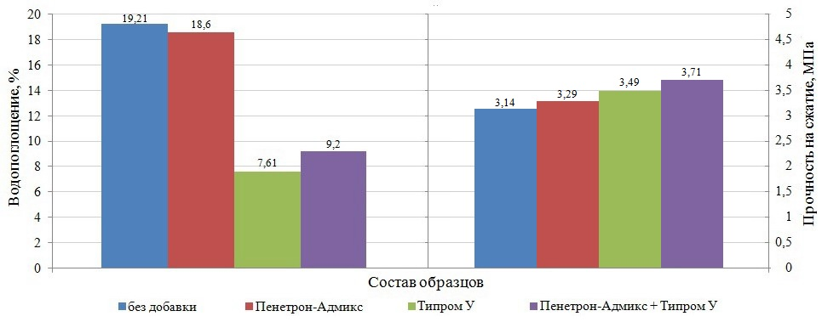

Picture 2. Dependence of water absorption and compressive strength on the composition of samples

Full-scale experiment

In August 2017, in order to confirm laboratory tests, a full-scale experiment (the third stage) was carried out at the production facility of the JSC "TODEP" DRSU-4. At the factory metal molds with dimensions of 0.75x1.00x0.18 (BхLхh, m) were manufactured. The composition of the mixture was adopted in accordance with the prescription, justified by laboratory tests. Preparation of the mixture was carried out in a gravity-type concrete mixing machine with a volume of 0,5м3. In total, three slabs were made.

The technology for the production of slabs included: preparation of the mixture, laying the mixture into a mold followed by compaction with a vibrating board, forms removal, processing of slabs with a hydrophobizator using a sprayer (Picture 3). To ensure a set of grade strength after processing, the slabs were closed with a film and held for 28 days.

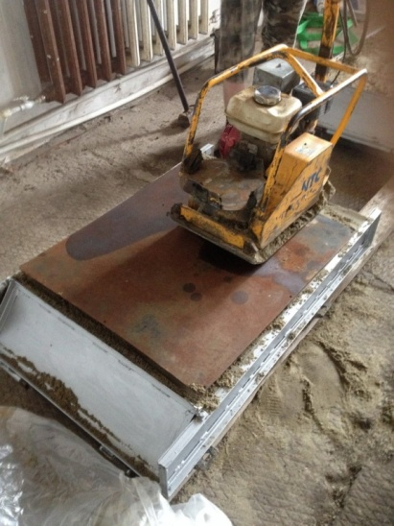 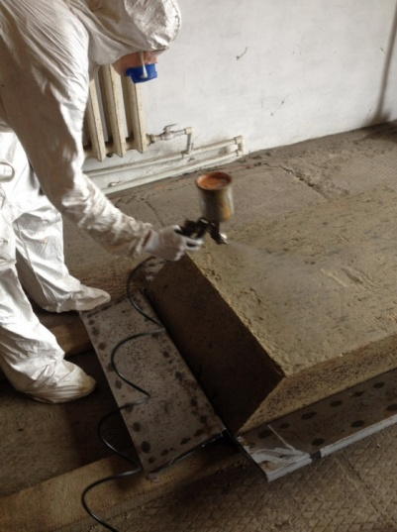

a) b)

Picture 3. Manufacturing of slabs

a) compaction of the mixture in the form; b) slab processing with a hudrophobizator.

After reaching the specified age, the external state of the plates was assessed and markings were made in accordance with the design scheme. Two metal supporting structures from below were installed, axially from above an equilateral corner was fixed on which a weighing device with manometer was placed. A jack was placed on the upper stop of the weighing device. To ensure uniform transmission of the load, the jack was rested against the support beam (picture 4). The whole process of testing was accompanied by video fixing. The load transfer to the slab was continued until lateral distortion. The values ​​of the destructive load were 15.0; 13.8; 14.3 kN. The average value of the flexural strength was 0.43 MPa, which corresponds to the M20 grade.

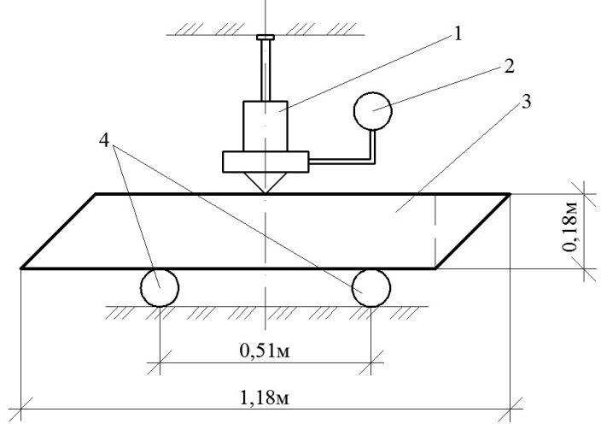

Picture 4. General view of the loading scheme for testing the slabs

1 – the jack; 2 – a weighing device with manometer; 3 – slab; 4 – metal supporting structures.

From each plate, sample cubes were selected for the subsequent determination of compressive strength and water absorption.

The results of the tests showed that the most compressive strenght have sample-cubes, treated with a hydrophobizator (3.27 MPa, which is 1.12 times more than in untreated samples). The maximum decrease in water absorption was marked on the samples-cubes treated with a hydrophobizator (from 19.89 to 9.54%, which is 2.08 times less than in the control samples) (picture 5).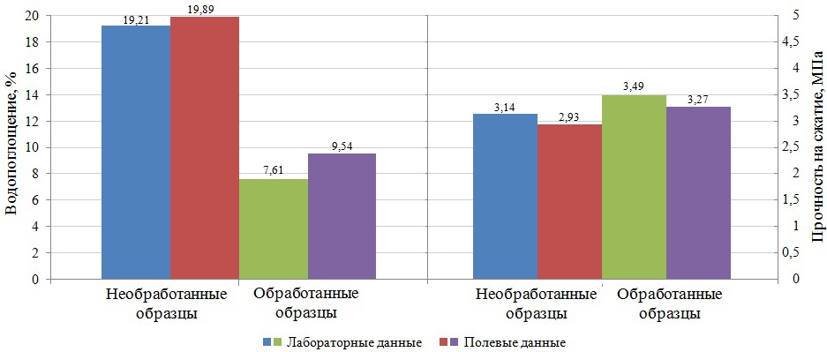

Picture. 5. Results of laboratory tests and full-scale experiment

When comparing the results of laboratory and full-scale studies, the deviations in water absorption were 0.68-1.93%, in compressive strength 6.73-7.16%. Deviations from laboratory data are due to the conditions for the manufacture of samples.

The test results of the slabs confirmed their applicability for the construction of foundations and additional layers of road revetment for auto-roads, sidewalks and bicycle paths in accordance with the requirements of the normative literature.

Conclusion

Analyzing the results of theoretical, laboratory studies, full-scale experiment, we can draw the following conclusions:

* Ensuring the water resistance of road structures with a cement soil foundation is an essential goal in the design and construction of auto-roads;
* A complex method for increasing water resistance and reducing crack resistance is proposed due to the use of a prefabricated foundation of cement soil slabs with surface treatment with a hydrophobizing material;
* calculations have been made, which allow to substantiate the geometrical parameters of slabs;
* laboratory studies have been performed, which allow to determine the composition of the mixture for the slabs;
* approbation of the proposed complex method for the manufacture and testing of cement soil slubs.

It is determined that:

* the processing of slabs with the hudrophobizator "Tiprom U" increases the water resistance of cement soil slabs by 2-2.5 times without significant change in strength;
* The use of assembly cement soil foundation, treated with a hydrophobizator, will allow to reduce crack formation, as well as to work all year round due to manufacturing and processing of slabs in the factory conditions.

Literature

1. Безрук В.М. Укрепление грунтов. / В.М. Безрук. – Москва: Изд-во “Транспорт“, 1965. – 340 с.

2. Безрук В.М. Укрепление грунтов в дорожном и аэродромном строительстве. / В.М. Безрук. – Москва: Транспорт, 1971. – 247 с.

3. Balabanov V.B. Comparative Analysis of the Principal Characteristics of Microsilica Obtained from Silicon Manufacture Wastes and Used in Concrete Production Technologies / V.B. Balabanov, K. N. Putsenko // IOP Conference Series: Materials Science and Engineering: IOP Publishing Ltd. - Chelyabinsk, 2017. – 262 (2017) 012011.

4. Ulrikh D. V. Soil-cement of Normal Hardening on the Basis of the Argillaceous Raw Material and Copper Ore Processing of Waste in Eco-geology and Construction / D. V. Ulrikh, M. D. Butakova // Procedia Engineering Сер. "2nd International Conference on Industrial Engineering ICIE, 2016 (Chelyabinsk, 19-20 мая 2016). – Chelyabinsk, 2016. – P. 1510-1515.

5.[Mavliev L.](https://elibrary.ru/author_items.asp?refid=467675163&fam=Mavliev&init=L) Road soil cement with complex additives based on organosilicon compounds and electrolytes / L. Mavliev, P. Bulanov, E. [Vdovin, V. [Zaharov,](https://elibrary.ru/author_items.asp?refid=467675163&fam=Zaharov&init=V) A. Gimazov](https://elibrary.ru/author_items.asp?refid=467675163&fam=Vdovin&init=E) // ZKG: ZEMENT -KALK-GIPS INTERNATIONAL. – 2016. – vol. 69, №9. – P. 49-54.

6. Балабанов В.Б. Опыт применения добавок микро- и наносилики из отходов кремниевого производства в бетонных технологиях / В.Б. Балабанов, К.Н. Пуценко, Д. Мункхтувшин // Научный журнал “Известия вузов. Инвестиции. Строительство. Недвижимость“. – 2017. – 7 том, №3(22). – С.107-115.

7. Траутваин А.И. [Оценка эффективности применения стабилизаторов серии “Чим-сто“ в грунтах, укрепленных неорганическими вяжущими](https://elibrary.ru/item.asp?id=32340449) / А.И. Траутваин, А.Е. Акимов, Е.А. Яковлев, В.Б. Черногиль, А.Г. Лукашук // [Вестник Белгородского государственного технологического университета им. В.Г. Шухова](https://elibrary.ru/contents.asp?issueid=2187532). – 2017. – [№12](https://elibrary.ru/contents.asp?issueid=2187532&selid=32340449). – С. 6-13.

8. Ядыкина В.В. [Перспективы использования полимерных стабилизаторов при укреплении грунтов в дорожном строительстве](https://elibrary.ru/item.asp?id=23901249) / В.В. Ядыкина, А.М. Гридчин, Р.О. Антонова // [Эффективные строительные композиты](https://elibrary.ru/item.asp?id=23900719): материалы научно-практической конференции к 85-летию заслуженного деятеля науки РФ, академика РААСН, доктора технических наук Баженова Юрия Михайловича (Белгород, 02-03 апреля 2015 г.). – Белгород, 2015. – С. 767-770.

9. Сигачев Н.П. Дорожные цементогрунты на основе золошлаковых отходов Забайкальского края, модифицированные полимерной добавкой / Н.П. Сигачев, Н.А. [Коновалова,](https://elibrary.ru/author_items.asp?refid=328054333&fam=%D0%9A%D0%BE%D0%BD%D0%BE%D0%B2%D0%B0%D0%BB%D0%BE%D0%B2%D0%B0&init=%D0%9D+%D0%90) П.П. [Панков](https://elibrary.ru/author_items.asp?refid=328054333&fam=%D0%9F%D0%B0%D0%BD%D0%BA%D0%BE%D0%B2&init=%D0%9F+%D0%9F), Н.С. [Ефименко](https://elibrary.ru/author_items.asp?refid=328054333&fam=%D0%95%D1%84%D0%B8%D0%BC%D0%B5%D0%BD%D0%BA%D0%BE&init=%D0%9D+%D0%A1), Д.А. Григорьев // [Вестник забайкальского государственного университета](https://elibrary.ru/contents.asp?titleid=35678). – 2015. – №7(122). – С. 28-36.

10. Рамазанов А.А. [Грунтобетон в закладке фундамента](https://elibrary.ru/item.asp?id=23502345) / А.А. Рамазанов, А.Д. Бадаева, Е.Б. Ланин, Т.А. Алнашаш // [Строительство уникальных зданий и сооружений](https://elibrary.ru/contents.asp?issueid=1393518). – 2015. – [№ 3(30)](https://elibrary.ru/contents.asp?issueid=1393518&selid=23502345). – С. 111-128.

11. Панков П.П. [Использование стабилизирующих добавок в составах цементогрунтов, модифицированных отходами теплоэнергетики](https://elibrary.ru/item.asp?id=30725884) / П.П. Панков, Н.А. [Коновалова,](https://elibrary.ru/author_items.asp?refid=328054333&fam=%D0%9A%D0%BE%D0%BD%D0%BE%D0%B2%D0%B0%D0%BB%D0%BE%D0%B2%D0%B0&init=%D0%9D+%D0%90) О.Н. Дабижа // [Современные наукоемкие технологии](https://elibrary.ru/contents.asp?issueid=1908387). – 2017. – [№11](https://elibrary.ru/contents.asp?issueid=1908387&selid=30725884). – С. 52-57.

12. Санников С.П. Влияние материалов серии “Типром“ и “Пенетрон“ на свойства цементогрунта, применяемого в дорожном строительстве / С.П. Санников, А.А. Жигайлов, В.С. Андреев // Научно-технический вестник Поволжья. – 2015. – №1. – С. 132–134.

13. Тюленев А.О. Анализ наличия и распространения на юге Тюменской области грунтов, пригодных для дорожного строительства / А.О. Тюленев, А.В. Замятин // Новые технологии – нефтегазовому региону: материалы международной научно-практической конференции (Тюмень, 24-28 апреля 2017 г.). – Тюмень, 2017. – С. 339-341.

14. [Вдовин Е.А.](https://elibrary.ru/author_items.asp?refid=369056552&fam=%D0%92%D0%B4%D0%BE%D0%B2%D0%B8%D0%BD&init=%D0%95+%D0%90) Исследование долговечности модифицированного цементогрунта дорожного назначения / Е.А. Вдовин, Л.Ф. Мавлиев // [Промышленное и гражданское строительство](https://elibrary.ru/contents.asp?titleid=7969). – 2014. – №11. – С. 76-79.

15. Коновалова Н.А. [Повышение качества дорожного цементогрунтана основе золошлаковых отходов забайкальского края введением стабилизирующих добавок](https://elibrary.ru/item.asp?id=26416226) / Н.А. Коновалова, П.П. Панков, Д.В. Бесполитов, А.Г. Коновалов, А.И. Кожуховский // [Транспортная инфраструктура Сибирского региона](https://elibrary.ru/contents.asp?issueid=1594692). – 2016. – Т.1. – С. 152-155.

16. Анненкова А.В. Анализ причин снижения эксплуатационной надежности цементогрунта дорожного назначения и методов его модификации / А.В. Анненкова // Новые технологии – нефтегазовому региону: материалы международной научно-практической конференции (Тюмень, 24-28 апреля 2017 г.). – Тюмень, 2017. – С. 223-226.

17. Санников С.П. Оценка комплексного влияния нагрузки при уплотнении и материала “Типром У“ на свойства цементогрунта / С.П. Санников, С.А. Куюков, А.А. Жигайлов // Актуальные проблемы архитектуры, строительства, энергоэффективности и экологии – 2016: сборник материалов международной научно-практической конференции (Тюмень, 27-29 апреля 2016 г.). – Тюмень, 2016. – С. 144–149.

18. Сигачев Н.П. [Эффективность использования золошлаковых отходов забайкальского края в производстве дорожных цементогрунтов](https://elibrary.ru/item.asp?id=24833267) / Н.П. Сигачев, Н.А. Коновалова, В.И. Коннов, П.П. Панков, Н.С. Ефименко // [Экология и промышленность России](https://elibrary.ru/contents.asp?issueid=1512895). – 2015. – [№11](https://elibrary.ru/contents.asp?issueid=1512895&selid=24833267). – С. 24-27.

19. Жигайлов А.А. Обоснование геометрических параметров цементогрунтовой плиты / А.А. Жигайлов // Новые технологии – нефтегазовому региону: материалы международной научно-практической конференции (Тюмень, 24-28 апреля 2017 г.). – Тюмень, 2017. – С. 243-247.

20. ГОСТ 23558-94. Смеси щебеночно-гравийно-песчаные и грунты, обработанные неорганическими вяжущими материалами, для дорожного и аэродромного строительства. Технические условия. – Москва: ФГУП “СоюздорНИИ“, 1995. – 10 с.

21. Налимов В.В. Статистические методы планирования экстремальных экспериментов / В.В. Налимов, Н.А. Чернова. – Москва: Наука, 1965. – 341 с.

22. Технические рекомендации по кремнийорганической гидрофобизации зданий и сооружений, а также по предварительной их очистке от загрязнений. Введен взамен изд. 3-е. – Москва: ПО “САЗИ“, 2014. – 27 с.

23. ГОСТ 12730.3-78. Бетоны. Метод определения водопоглощения. – Москва: Стандартинформ, 2007. – 7 с.