IB:247 Improving process performance

Final assignment

---------

Word count: 2496

**Introduction**

This essay will analyse how the restaurant business industry has adapted to process changes due to COVID-19, the examples will be fine dining restaurants in Mayfair, London that served Peruvian cuisine only at the restaurants before the lockdown happened. The restaurant industry has changed its operational process to adjust to lockdown measures, hence, the only way of enjoying a meal by fine dining restaurant is to order food home. This paper will describe the process of dining at the restaurant before the pandemic and after it would also illustrate Key Performance Indicators for the as-is process, analyse key issues with the original model, introduce a new process by using process mapping. Furthermore, it will discuss the logistics that may have informed the process change using techniques and finally will critically evaluate the ‘to-be’ process.

**How COVID-19 affected businesses**

COVID-19 was and still is an external shock that affected the globe and changed people’s lives forever. Many businesses, especially in the service sector, have redesigned the way business operates to follow the measures imposed by the WHO, such as social distancing to help to flatten the epidemic curve (Hansen, 2020). The reason why the service industry had to think on re-designing the process completely is that their customer cannot buy their products as used to by walking into a restaurant and contacting the waiter and other employees, nowadays, many countries are lockdown including the UK. Therefore, Mayfair Restaurants in London, such as Coya Mayfair, Hide, and others had to introduce takeaways to continue working (Evening Standard, 2020).

Typically fine dining restaurants do not deliver food, as their brand image is concerned with exclusiveness and high price setting, additionally, it is not that simple to book a table in the restaurants like Coya, you must reserve a table for Friday, a week in advance, to enjoy the Peruvian cuisine. However, the restaurant business has to adjust to the changing environment and lockdown measures. In Hong Kong, the restaurants operate as they used to but new safety measures implemented at protecting customers by installing the small booths lining between the tables (Time, n.d.). However, in London, restaurants are closed for serving customers, therefore the only way to sell the product and generate revenue was to introduce takeaways, for the restaurants that did not practice it before (Tan, 2020).

**The ‘as-is’ process**

The ‘as-is’ process is described by process mapping which is a useful tool to illustrate the business process through workflow diagrams and supporting text, it is a convenient tool in visualising an intricate process (Damelio, 2019). Before the outbreak of COVID-19, to make a reservation, a customer should have done in advance through an online reservation or a call. The process map is built for the occasion when a customer makes a reservation call, the reason why online booking was not added because it allows a customer to choose from available options as the unavailable booking times are not an option on the website of a restaurant or Opentable.co.uk. The process is split into 2 because there is a time frame between booking a table and walking into a restaurant on the day. The Booking process is illustrated in Figure 1 and the main part of the ‘as-is’ process is illustrated in Figure 2.

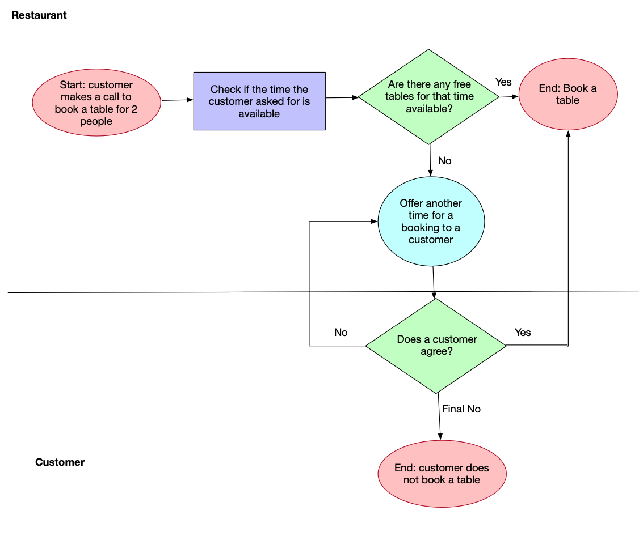

Figure 1: 'As-is' process part 1

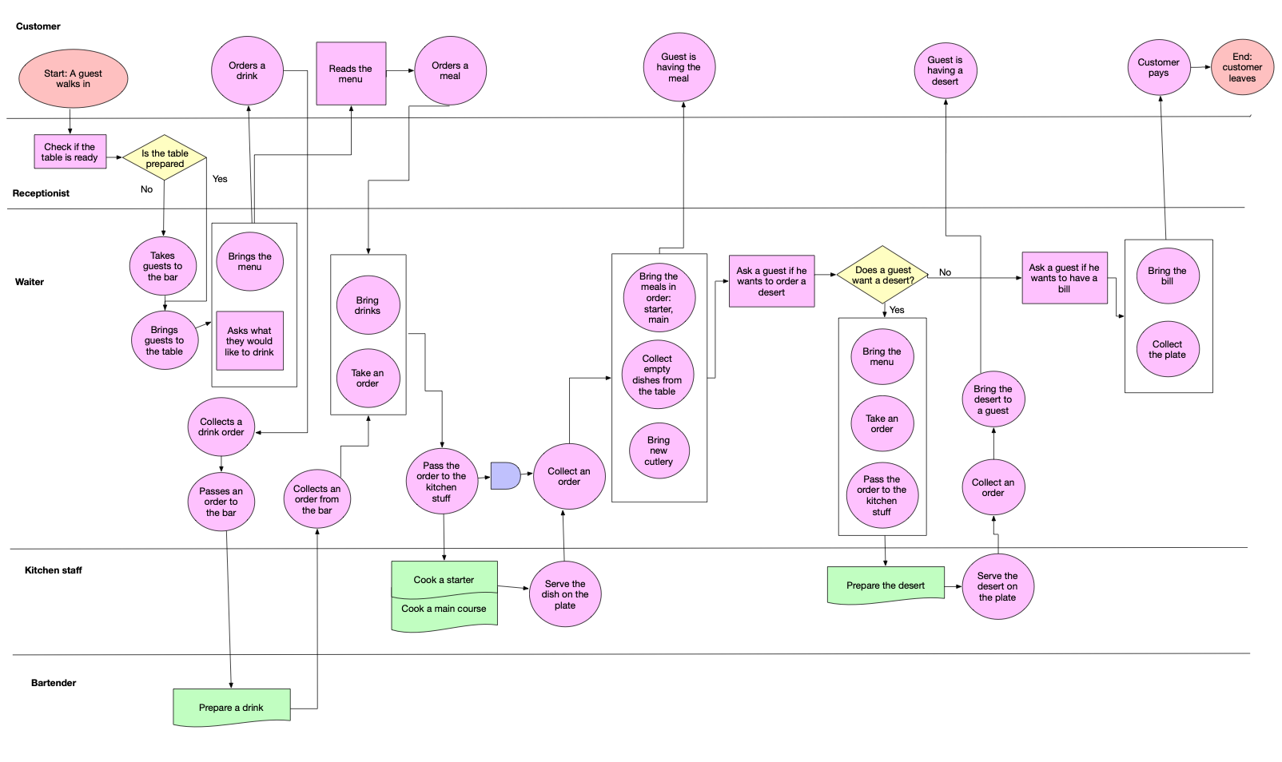

Figure 2: As-is process part 2

The process starts with customers entering the restaurant and being greeted by the receptionist, who requests for the name and checks the reservation time. If the reserved table is not set for guests, they are conveyed to the bar for an aperitif, as the table is set, guests are brought to the table and given a menu. However, if the table is ready, guests are accompanied to the table with the menu offered and guests are asked if they would like to order drinks. After a couple of minutes, a waiter appears to ask for the drinks guests would like to order. After some time, the waiter comes asking for orders with ordered drinks. Then, after the order is made, the kitchen receives orders and prepares them in the menu order. Then, the dishes are served to begin with starters. After guests are done with the mains, a waiter comes around and asks guests if they would like to have a dessert if customers don’t want to, the waiter asks if the bill should be brought, if not, he brings the menu, collects an order, passes an order to the kitchen, collects it and serves it to guests. Finally, the waiter asks if he should bring the bill, brings the bill, customers pay the bill and leave the restaurant.

**Key Performance Indicators and Objectives for the ‘as-is’ process**

The Key Performance Indicators (KPIs) and objectives are a measure of businesses’ successes at achieving its objectives using quantifiable and qualifiable indicators (Jahangirian et al., 2017). The choice for KPIs should meet the criteria of parsimony, feasibly, relevance, simplicity and reliability. In the restaurant, the KPIs could be different for each part of the process. For the kitchen, KPIs are the cost of goods sold, menu item profit and demand, production time per dish, food wasted per food purchased (Pezzini, n.d.). Another important part of the business is the frontline, which is an interaction with the customers, it is important because restaurant’s success depends on customer’s satisfaction, hence to do so, it is crucial to identify what customer values in the service and interpret it into KPIs.

In this case, I would adopt a customer approach, because in the restaurant business customer is the main stakeholder, hence would choose KPIs from customer’s and identify what is important for them. The 5P model is used to measure performance by evaluating at least 5 performance objectives, and it is constructed by using the description of the restaurant on their website and from my own experience from dining at Coya Mayfair. To make it clearer, we could use the 5P model to combine all the KPIs and see the overall picture of how the business performs (Figure 3 and 4).

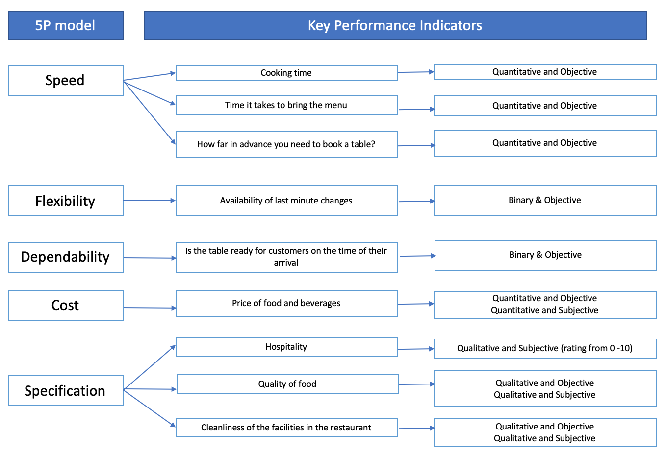

Figure 3: 5P Model KPIs

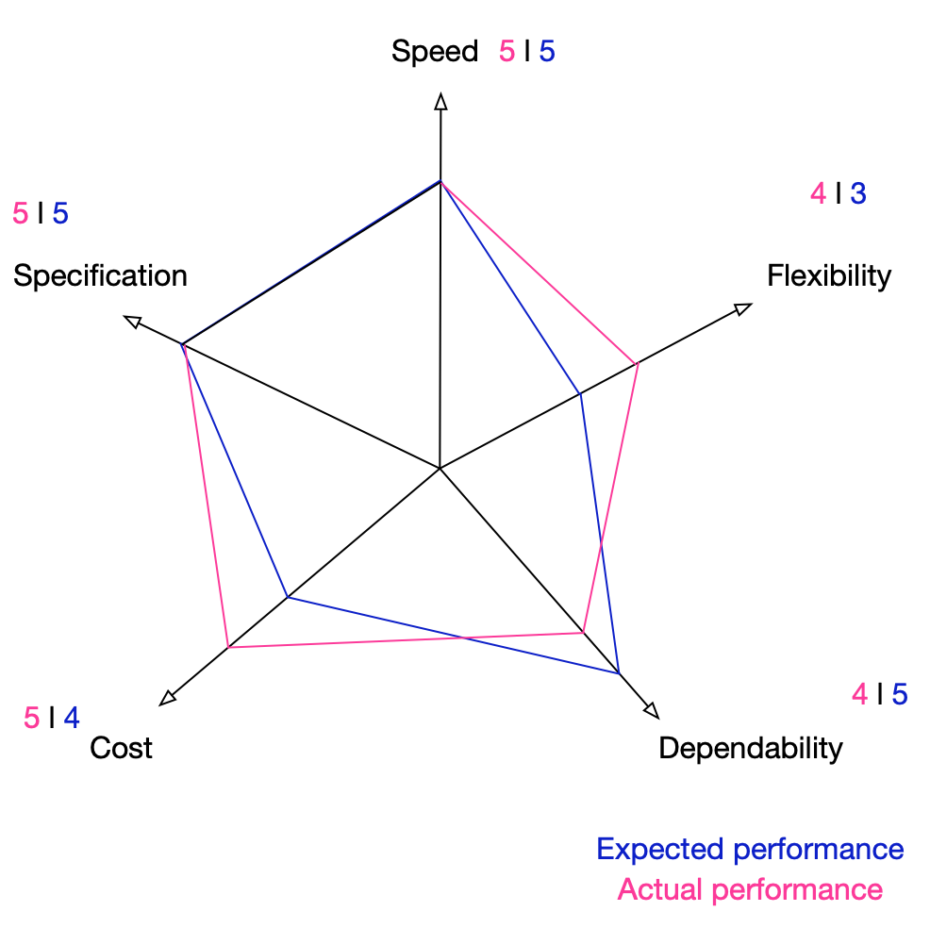

Figure 4: 5P model KPIs performance

The 5P model shows what are the key objectives of performance but it does not inform about which indicators should be improved and why therefore Marilla and James (1977) Importance-Performance Matrix will be applied (Figure 5). Placing the KPIs according to my perception is using a customer-centric approach, hence still relevant. Dependability is in the possible over skill section, however, if there will be less concentration on dependability, there will be a lot of complaints about waiting time at the restaurant. Flexibility could have been improved, by having some margin of free tables that could be booked in the last minute, the cost could be also changed, however, prices are high because it is fine-dining, hence, the decision should be made according to the profitability and the demand. If the firm needs to generate revenue, it might reduce prices to increase demand, hence increasing sales.

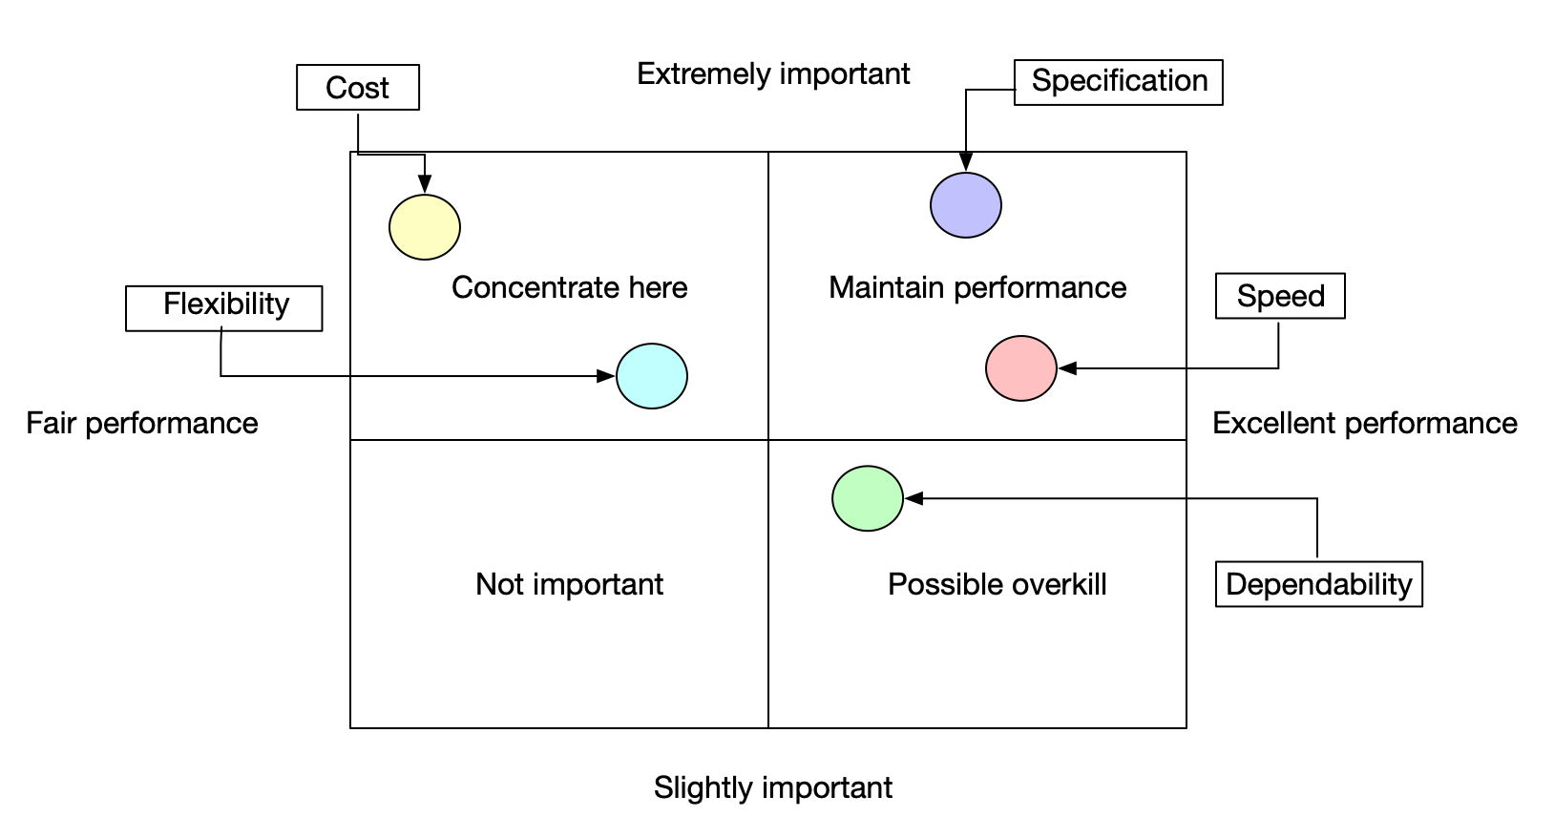

Figure 5: Marilla and James Importance-Performance Matrix (1977)

**Key issues with the ‘as-is’ process**

The possible issue with the as-is process is a failure to satisfy customer’s needs and wants, hence using the Ishikawa diagram, we could identify primary and secondary causes of the failure. Moreover, after identifying key issues with the process, we could improve the existing process to achieve customer satisfaction. Customer dissatisfaction could arise from five primary causes: cost, food, staff, the venue and time. To identify possible causes, the Ishikawa diagram is used and illustrated in Figure 6.

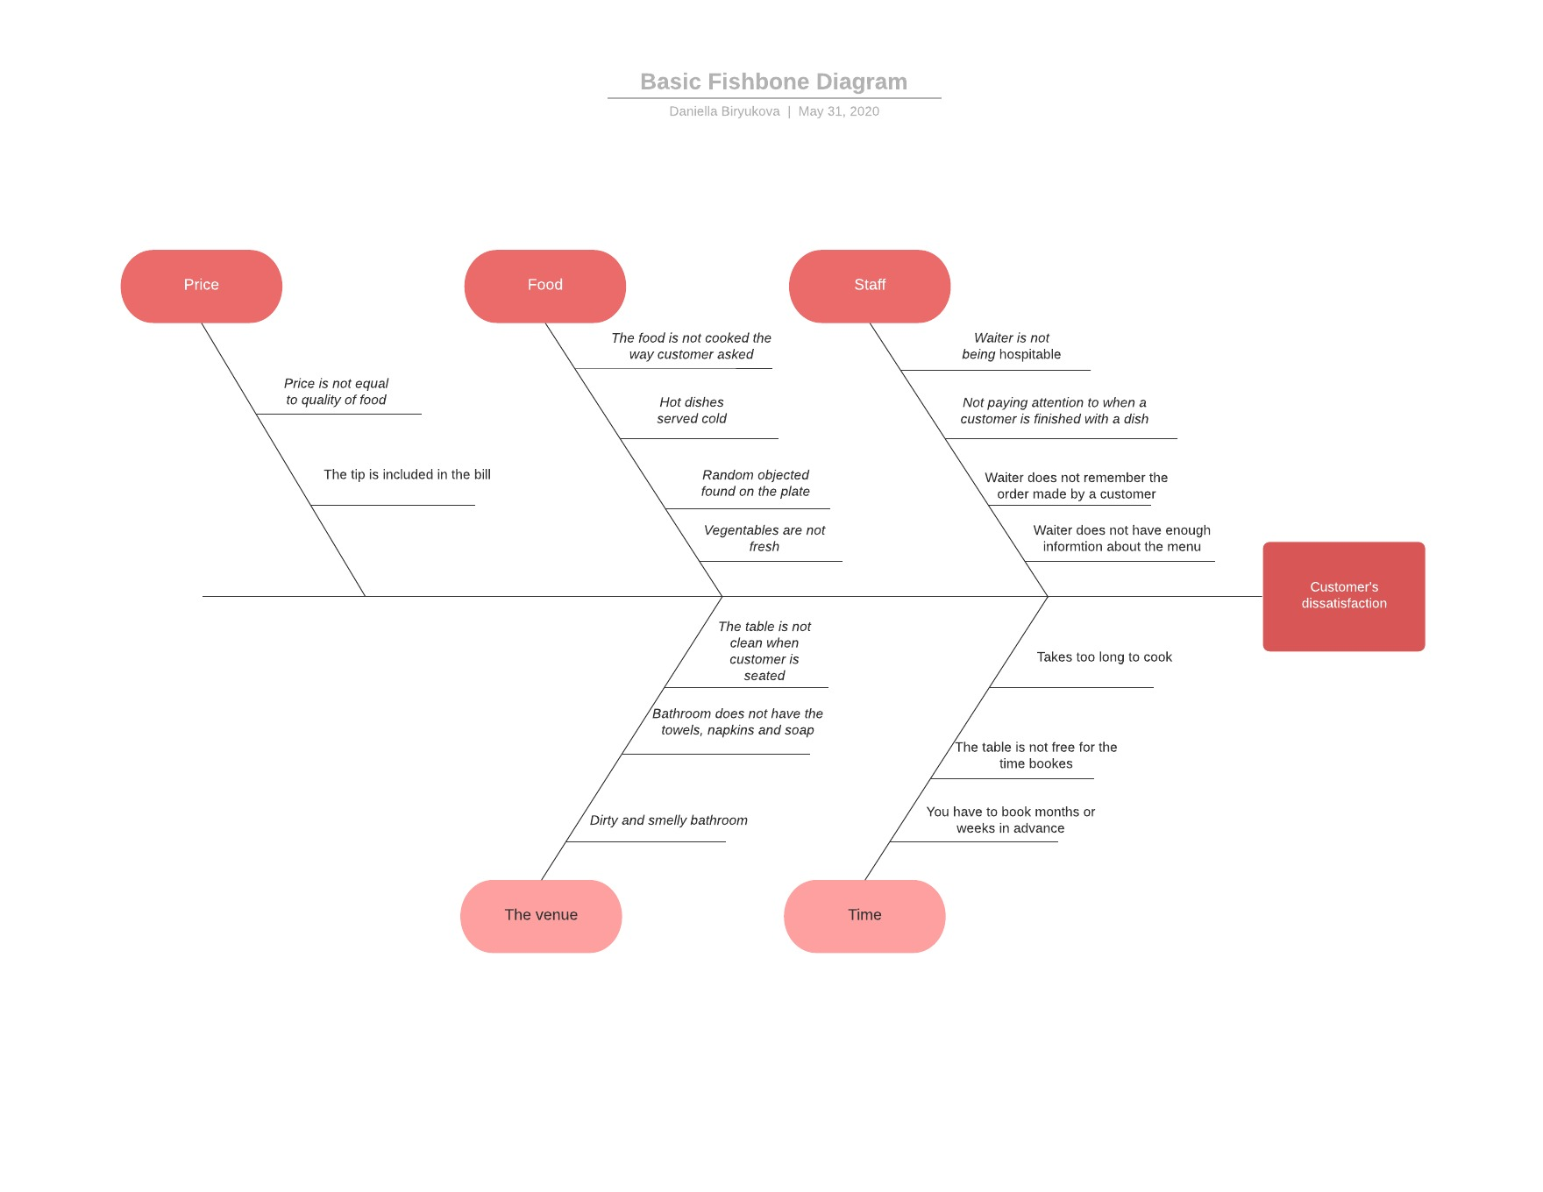

Figure 6: Ishikawa diagram

From the diagram, it could be said that the potential causes of customer’s dissatisfaction could all be improved. The food could be managed by carefully selecting the ingredients, increasing headcount in the kitchen to increase efficiency and have more supervision to avoid mistakes, staff could be trained to the level that all the secondary causes eliminated, the venue could be refurbished and again, more staff could be employed to ensure the cleanliness of the restaurant, the time could be improved by learning how to make the cooking process faster and perhaps open another restaurant to satisfy the demand. However, the price is a subjective measure, because of fine-tuning means that the prices will be much higher than in an average restaurant, but if the quality of food is not outstanding the price-to-quality ration would bring us back to the primary issue with food, hence increasing the quality of dishes.

**‘To be’ process**

As was mentioned before, COVID- 19 has changed the way businesses operate, especially restaurant businesses, as they cannot sell their ’product’ as before, hence the only solution is takeaway. The new processes eliminate the first ‘as-is’ process of booking a table, it only allows to experience fine dining by ordering the food home, through online applications. The KPIs would also change in this case, by including a KPI of the speed of delivering food, as well as eliminate KPIs regarding the service quality at the restaurant and most importantly, creating Health and Safety KPI that ensures that staff is protected and no infection is spread, by contaminating food. A new process is illustrated in Figure 7.

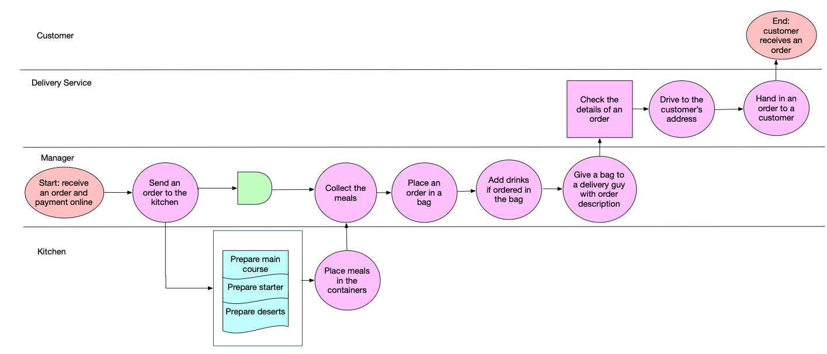

Figure 7: 'To-be' process

In the new process, the order is received online, then placed in the kitchen, the kitchen prepares orders at the same time by distributing tasks across the kitchen staff. Then, the order is packed in the food containers and placed in the bag with the drinks ordered. The bag is given to the delivery guy, who checks the order details, commutes to the address in the order and gives it to customers. In the ‘to-be’ model, a new stakeholder is added - the delivery service who is responsible to bring the order from the restaurant to the customer. The delivery services Coya Mayfair uses are Supper London, Uber Eats and Deliveroo (COYA, n.d.).

**How the process was changed and why?**

When restaurant redesigned their process, perhaps they have used benchmarking from those restaurants that delivered food before the crisis and adopted a similar strategy. Benchmarking is a reference point to which other phenomena are compared, however, in this case, the restaurant would use a mix of benchmarking and BPR heuristics since the structure of one restaurant cannot fully be copied from another due to different managerial structures, service values and their goal (Maylor, 2010). BPR heuristics is rethinking of existing processes through critical analysis and this is exactly what happened in this case (Hammer and Champy, 1993). Due to new circumstances, customers cannot be served as they used to, which raises a question of how the business should operate, hence, the new process should be designed in such way that it meets business objectives of selling Peruvian cuisine at high costs and generating enough revenue to cover fixed and variable costs of the restaurant.

In most cases, BPR and TQM are both customer-centric but in this case, apart from satisfying customers, the costs should also be reduced while keeping the quality of food the same. The first step is to optimise resources which impose costs, hence, to lay off waiters and receptionists that are no longer needed to interact with guests. Heuristics are illustrated in Table 1. The second step is to identify which tasks should be specialised, by giving more attention to the cooking process and reduce time by not waiting when a guest finishes dishes and start preparing a desert, in the new process, it all will be cooked in order without delays and by delegating different cooking parts to kitchen staff. The third step is automation, this is related to the way customer makes an order, the menu is listed online with the description of each option which increases the efficiency of interaction between a restaurant and customer as all the information available on one web page, and customers only need to place an online order and pay without interacting with the waiter and waiting at the bar until the table is ready for guests. The fourth step is task addition, as the customers are staying at home, the restaurant needs a third party to be responsible for the delivery, hence by cooperating with the delivery service. In the future, the process is perhaps would not go to the way it was described in the ‘as-is’ process as people would always keep in mind the safety and be aware of chances of catching the virus. Many businesses would also not reopen because of the financial losses unless a government would supply them with funds to rehabilitate from the crisis.

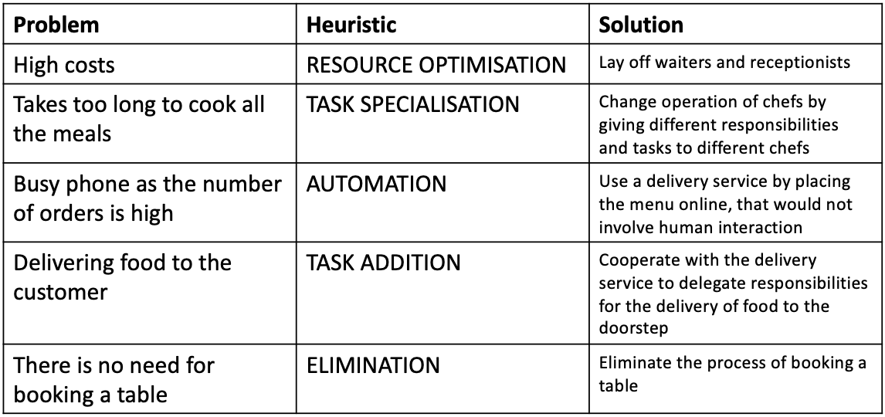

Table 1: Heuristics

**Evaluation of the ‘to-be’ process**

The to-be process is an adequate solution to new law regulations and lockdown. The customers are not able to be served inside the restaurant, the only solution is to introduce takeaways. However, as the government pulled down the restrictions of lockdown, the restaurants will be re-open in July and proposed measures could be applied then (Coghlan, 2020). For the relaxed restrictions, the restaurant should learn from its Eastern colleagues in Hong Kong and how they adapted to the changing policies. The restaurants are open but for a guest to sit in the restaurant and have a meal, a whole procedure needs to be carried out. At the entrance, guests declare that they have not been tested positive for COVID-19, did not leave Hong Kong, did not contact anyone with symptoms and sign the form supporting that, then, using contactless thermometers the temperature is measured, and only then are taken to the table that is 6 feet away from the nearest table (Hanbury, n.d.). Additionally, there are disposable bags for the face masks, hand sanitizers and wipes placed on the table for customers to disinfect hands and store the masks (ibid.). Another possible solution that I have thought myself that would allow minimising contact between employees and customers is to order by using an app on the iPad and before using, customers should sanitise hands and an iPad.

In the future, the process is perhaps would not go to the way it was described in the ‘as-is’ process as people would always keep in mind the safety and be aware of chances of catching the virus. Many businesses would also not reopen because of the financial losses unless a government would supply them with funds to rehabilitate from the crisis.

To conclude, the global pandemic has affected the restaurant industry in such a way that fine dining restaurants had to re-engineer the process operation, by using BPR heuristics and benchmarking. The process of booking a table and waiting for days, and sometimes for weeks to enjoy the Peruvian cuisine, however, the new model eliminates this stage of the process due to lockdown restrictions and introduces takeaways. The new process is an adequate solution, however, in July the government will relax restrictions and restaurants will be able to open doors, and in this case, the restaurant should adopt strategies by colleagues from Hong Kong.

Reference list

1. Coghlan, A. (2020). *Boris Johnson ‘Optimistic’ Restaurants Could Open Earlier Than He Previously Thought*. [online] Eater London. Available at: <https://london.eater.com/2020/5/28/21272947/boris-johnson-liaison-committee-pubs-restaurants-reopening> [Accessed: 31/05/2020].
2. COYA. (n.d.). *COYA at Home | Peruvian Food Delivery London | Fine Dining Delivered To You*. [online] Available at: https://www.coyarestaurant.com/london-delivery/ [Accessed: 31/05/2020].
3. Damelio, R. (2019). Basics Of Process Mapping. S.L.: Crc Press.
4. Evening Standard. (2020). *The best London restaurants newly offering delivery amid coronavirus*. [online] Available at: <https://www.standard.co.uk/go/london/restaurants/best-new-delivery-restaurants-london-coronavirus-a4393086.html>. [Accessed: 31/05/2020].
5. **Hammer,** M. & Champy, J. (1993). *Reengineering the Corporation: A Manifesto for Business Revolution*, Harper Business.
6. Hanbury, M. (n.d.). *This Hong Kong restaurant group created a manual about how to handle the pandemic, and it’s become a blueprint guide for restaurateurs around the world*. [online] Business Insider. Available at: <https://www.businessinsider.com/hong-kong-restaurant-chain-covid-19-playbook-global-hit-2020-5> . [Accessed: 31/05/2020].
7. Hansen, J. (2020). *Tracking London Restaurants’ Response to Coronavirus*. [online] Eater London. Available at: <https://london.eater.com/2020/3/16/21181466/coronavirus-uk-latest-london-restaurant-bar-closures-measures> . [Accessed: 31/05/2020].
8. Jahangirian, M., Taylor, S.J.E., Young, T. and Robinson, S. (2017). Key performance indicators for successful simulation projects. *Journal of the Operational Research Society*, 68(7), pp.747–765.
9. Maylor, H. (2010) *Project Management* Harlow: Pearson
10. Martilla, J.A. and James, J.C. (1977). ImportancePerformance Analysis. *Journal of Marketing*, [online] 41(1), pp.77–79. Available at: https://www.jstor.org/stable/1250495 [Accessed: 31/05/2020].
11. Tan, V. (2020). *To Survive Coronavirus, Restaurants Can Never Go Back to ‘Normal.’* [online] Eater London. Available at: <https://london.eater.com/2020/4/21/21228609/coronavirus-restaurants-lockdown-social-distancing-eating-out>. [Accessed: 31/05/2020].
12. Time. (n.d.). *Hong Kong Restaurants Are Going to Great Lengths to Protect Diners From Coronavirus. Here’s What They Could Teach the U.S*. [online] Available at: https://time.com/5838636/restaurants-coronavirus-safety-hong-kong/ [Accessed: 31/05/2020].