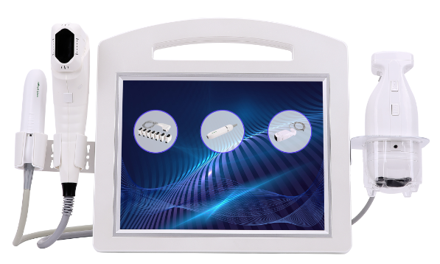

**THREE-IN-ONE**

**(Liposonic+** **4D+Radar Carving)**

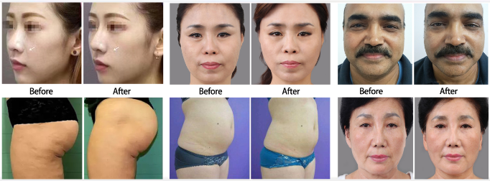

Before using the instrument, please read this manual carefully and strictly follow the instructions in the manual to operate it.

**Preface**

Dear users:

Welcome to use our company's latest products (Radar Carving + 4D multi-row+Liposonic) :**3 in 1 beauty instrument**.，It is a multi-row fixed-point + 360 ° non dead corner+ custom point technology.

**4D** muti-row and radar carving are more authoritative and higher-end anti-aging system instrument after the continuous thermage 、ultrasonic beauty machine,which replaces various effects of traditional facial anti-aging wrinkle surgery - including face-lifting, removing double chin, lifting firmness, removing wrinkles, tightening the skin, etc. It completely solve the problem of aging and sagging on the face and body parts, and recreate the contours to restore the youth!Compared with previous single-line technology ,the effects is more durable.

**Liposonic** is a local fat-dissolving instrument used for obesity caused by fat accumulation in the waist, abdomen, back, hands, legs, buttocks.It’s different from traditional methods of reducing weight. It pays more attention to non-invasive local fat elimination rather than replacing liposuction, but provides a safer solution than traditional liposuction.

This technology is non-invasive, no bleeding, no operation, no scars, no trauma with high safety, it don’t affect the normal life and work.

**One、Instrument Overview**

Our new latest product 3 in 1 beauty instrument can achieve five perfect effects of lifting, firming, wrinkling, reducing fat and sculpting. It’s the most advanced non-invasive high-energy focused ultrasound technology in the United States, penetrate deeply and generate nearly 10000 condensation points, precisely acting on the skin's SMAS layer and fat layer to generate heat energy to break and dissolve fat cells, stimulating the fascia layer to immediately contract and a large number of new collagen reorganization ,which build a new collagen fiber network, and enhance the elasticity of the skin from the bottom layer（ Self repair mechanism is safer).It’s the safest and most effective way to treat facial aging, sagging, obesity and vaginal sagging in the beauty industry;The four-in-one magical facial wrinkle removal, lifting firmness, improving breast, reducing body fat, Shaping body and other effects have been recognized by the authorities in the beauty industry, known as the miracle of eternal youth!

**Two、Mechanism function**

**4D and radar carving** use the cartridges with different depths (face 1.5, 3.0, 4.5mm) to focus the accurate energy on the epidermis layer, collagen layer and fascia layer;4.5mm is positioned on the subcutaneous fascia layer, and the fascia layer at the focus produces protein solidification reaction, so as to generate tension around the freezing point, playing the role of pulling the growth of muscle in the fascia layer to achieve the best effect of shaping, lifting and tightening;3.0mm acts on the collagen layer under the skin to stimulate the collagen regeneration and recombination. The newly generated collagen can gradually tighten and enhance the skin from the inside, and recover the elasticity;Aiming at the problem of facial relaxation and sagging, such as the formation of wrinkles.the whole part is pulled up in a single operation to achieve the overall contour lifting and tightening.In addition, the cartridges with different depths are used to treat obesity and chest, locate the body fat layer, tighten the skin and dissolve fat.Radar carving uses a fine cartridge in the way of rubbing and looping ,and the operation is fine and 360° without dead angle, so that the concentrated energy can reach each part evenly to make it get a better effect.

**Liposonic** use the body cartridges with different depths (0.6cm, 0.8cm, 1.0cm, 1.3cm, 1.6cm), transforms into 65-70 degree heat energy to break and dissolve fat cells by focusing ultrasonic.The intelligent positioning system locates the required fat cells, quickly crushes and dissolves large granular fat cells to reduces the amount of fat, while stimulating collagen contraction and proliferation,and quickly filling the gaps that appear after the fat is ablated.After treatment, the skin surface is thin and not wrinkled, and it will not cause damage to the epidermis, blood vessels, nerves and muscle tissues. The crushed fat will be excreted from the body as the body metabolizes.It works at once.It permanently destroys subcutaneous fat, directly reduces the amount of fat without rebounding.One hour course of treatment can reduce the average body circumference by 2-6cm, which can show multiple effects of reducing fat, tightening skin and shaping. For local obesity, it needs 1-3 times to achieve the desired effect.

**Three、Technology Advantage**

1、A variety of treatment heads, according to different skin depths, choose different cartridges, which can act on a variety of parts, such as the face, neck, chest, arms (butterfly sleeves), hips, legs, abdomen, etc.

2、The radar carving operation is 360 ° without dead angle, and can be adjusted to hit 1-9 dots in a second. The operation is free of dead angle, fast, evenly distributed and painless.

3、Radar Carving Machine with the way of rubbing and rolling operate finely 360 ° without dead angles, and the concentrated energy can be evenly achieved at each part to obtain better results.

4、4D and liposonic can switch between fast mode or slow mode.

5、4D can be adjusted arbitrarily from 1 to 12 lines, 12 lines have 300 points, which greatly shortens the operation time to make the energy points acting on the skin more uniform with best effect.

6、The energy is controllable, and the corresponding parameters can be adjusted according to the skin depth, so the operation is safer and more guaranteed.

7、The effect of tightening and shaping can be seen immediately after treatment, which can last for at least 18-24 months at a time, and achieve negative growth for skin age once a year.

8、Focused ultrasound has a certain selectivity, which can focus energy on specific areas, such as: fat layer, fascia layer, dermis layer, epidermal layer；Precise operation does not hurt the surrounding tissues, the energy is slightly over the epidermis, the surface is non-invasive, and the safety performance is high to ensure the customer is painless and comfortable.

9、No injection, no surgery, non-invasive, and does not affect normal life and work.

10、Liposonic adopts a circular custom contour output system. The treatment head emits 24 energy lines in the treatment area. The 24 energy lines in a single shot have 576 focus points, which accurately and completely crushes the amount of fat. The fat tissue is destroyed immediately during the treatment, and the body circumference is reduced by 2-6cm immediately after the treatment. After fat metabolism is completed within 8-12 weeks, the effect is more good.

11、In a single treatment, Liposonic can permanently destroy the subcutaneous fat, directly reducing the number of fat,and the damaged fat cells will never return, and can maintain a long-term slim good figure.

**Four、Installation**

1、Insert the corresponding handle wire into the corresponding socket on the host and fix the screws（install at the hole position, then lock the handle）；Then plug the power cord into the power socket and connect it to the power supply line which is suitable for the voltage within the normal working range of the instrument.

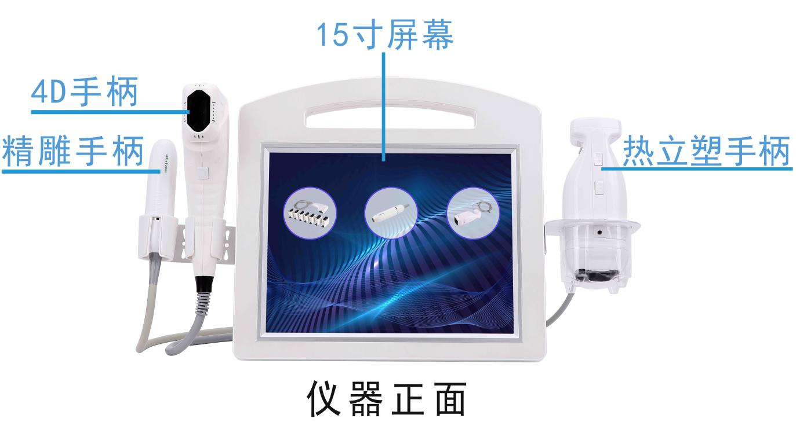

15 inch screen

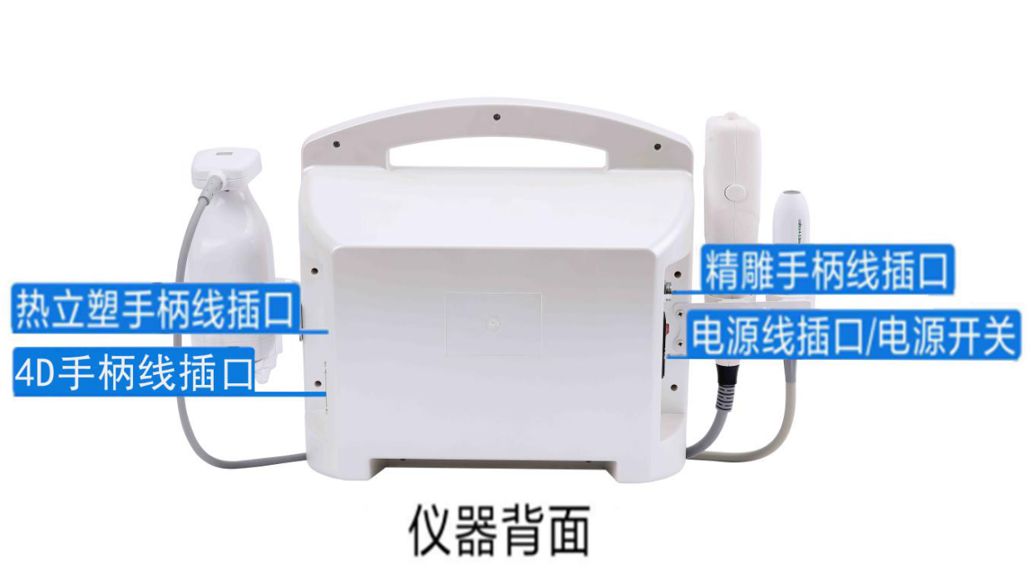

Back of the instrument

Power cord socket

Handle socket of 4D

Handle socket of radar carving

Handle socket of liposonic

Front of the instrument

Radar carving handle

4D handle

Liposonic handle

15 inch screen

2、Installation of 4D cartridge as follow:

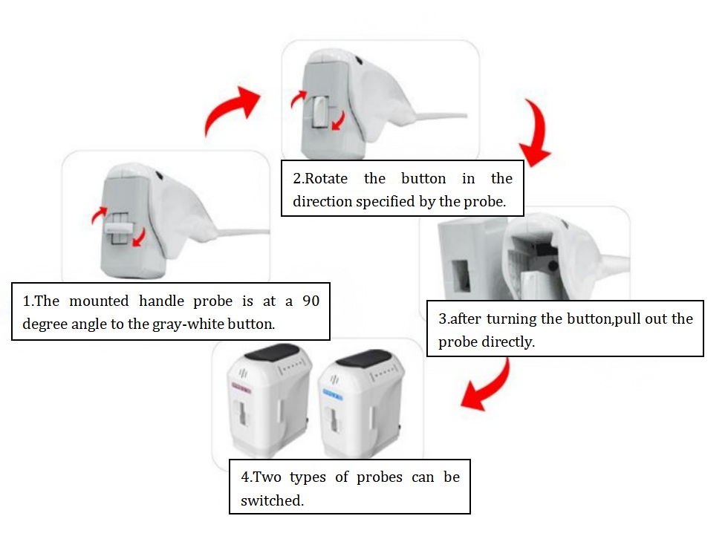

3、Installation of radar carving cartridge as follow:

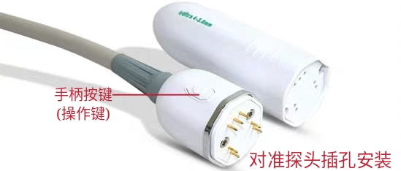

Handle operation buttons

Alignment with the socket of the cartridge

4、The installation of the liposonic cartridge:

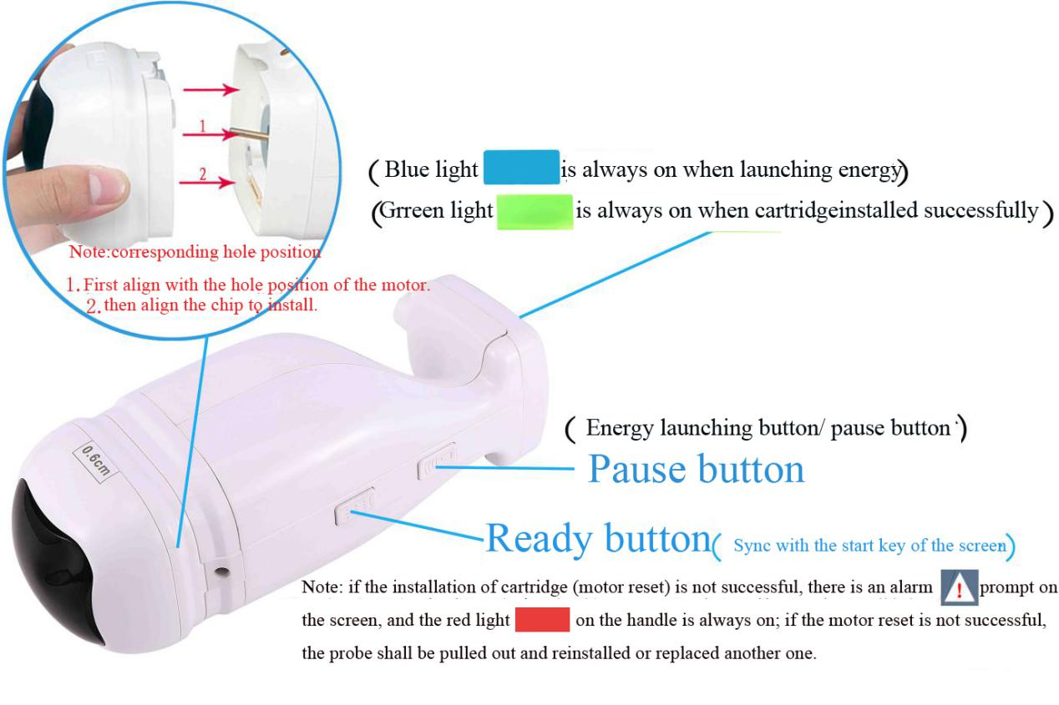

**There are total 7 standard cartridges：**4D facial head: 3.0mm, 4.5mm; Liposonic body head :0.8cm、1.3cm;Radar Carving head:1.5mm、3.0mm、4.5mm;

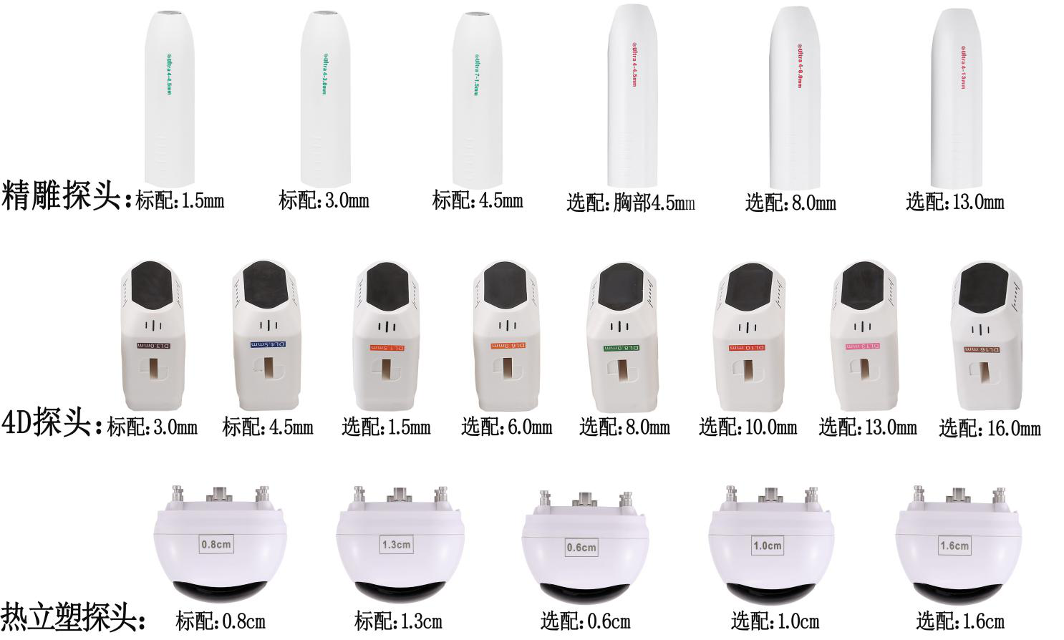You can choose the corresponding cartridge to treat the body parts according to your needs:Remarks: S:standard O:optional

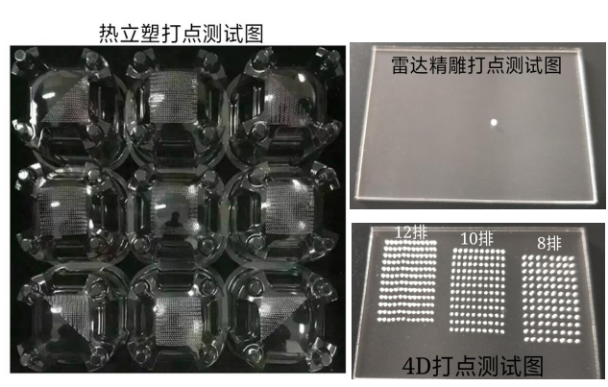

10 rows

8 rows

12 rows

Dot test chart of 4D

Dot test chart of radar carving

Dot test chart of liposonic

**4D cartridges:** 3.0mm(s) 4.5mm(s) 1.5mm(o) 6.0mm(o) 8.0mm(o) 10.0mm(o) 13.0mm(o) 16.0mm

**Radar carving cartridges:** 1.5mm(s) 3.0mm(s) 4.5mm(s) 4.5mm(chest,o) 8.0mm(o) 13.0mm(o)

**Liposonic cartridges:** 0.8mm(s) 1.3mm(s) 0.6mm(o) 1.0cm(o) 1.6cm(o)

**Five、Interface introduction** 1、**Start-up**

Please check whether the connection of the instrument is normal,and press the power switch of the host, the machine will start up and the boot interface appears as following picture.



After clicking the boot interface, it automatically enters into the professional work interface as following picture.

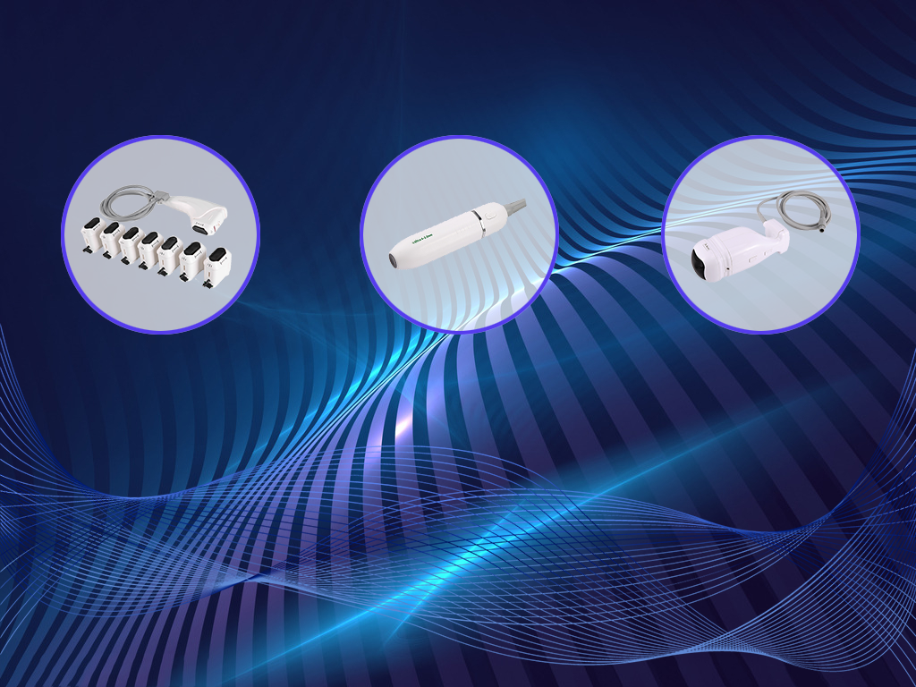

Operation interface of 4D

Operation interface of liposonic

Operation interface of radar carving

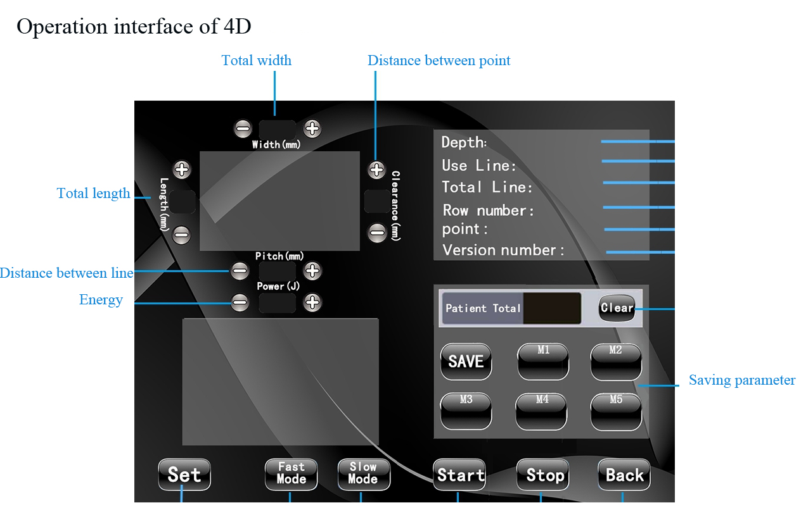

2、**4D multi-row operation interface**

【Width(mm)】represents the total width of the energy region;

【Length(mm)】represents the total length of the energy region of the ultrasonic beauty instrument;

【Clearance(mm)】represents the distance between the freezing point in each line of the energy region；

【Pitch(mm)】represents the distance between each line in the energy region;

【Power(J)】represents energy; click【-】（decrease）【+】（increase）adjust the size ；

【Patient Total】represents the number of points recorded for treatment; Click【Clear】clear treatment points;Click【Start】the instrument start working; click【Stop】the instrument stops working;

【M1】－【M5】represents the choice of parameter storage mode or recall parameters;and then click【SAVE】Save parameter storage; click【Back】represents return;

【Fast Mode】represents fast mode；【Slow Mode】represents slow mode;

【Depth】:Display the identified cartridge;【Use Line】:Total number of cartridges;【Total Line】:Remaining number of cartridge;

【Row number】:Display energy rows (1-12 rows);

【Point】:Display the number of energy points ;

【Version number】:Version

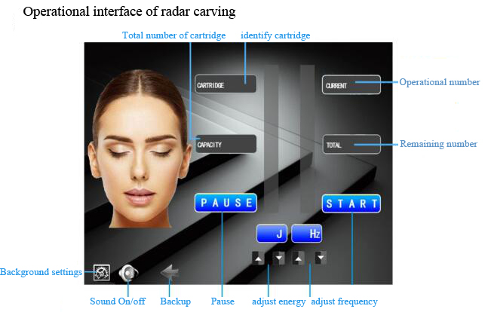

3、Operation interface of radar carving：

【CARTRIDGE】displays the depth of the identified cartridge.

【CURRENT】represents the number of recorded treatments.

【CAPACITY】display the total number of cartridges.

【TOTAL】display the remaining number of cartridges.

【J】represents energy(1-8J)，click【▲】increase，【▼】decrease，adjust the amount of energy.

【Hz】represents frequency of energy output is slow and fast(1-9Hz)，

click【▲】（increase），【▼】（decrease），adjust the speed of the energy output frequency.click【START】,the instrument will start working; click【PAUSE】,the instrument will stops working.

click【**←**】represents to back to the selection interface.

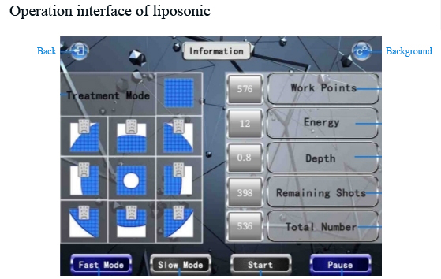

4、Operation interface of liposonic：

【Treatment mode】represents the pattern of the energy emission output of the liposonic cartridge.The operating mode can only be selected when the instrument is in the suspended state，576 output points in full style【C:\Users\Administrator\Desktop\1578017275(1).png1578017275(1)】，If the side fat is less than 25 mm, select the style here

【C:\Users\Administrator\Desktop\1578017300(1).png1578017300(1) C:\Users\Administrator\Desktop\1578017496(1).png1578017496(1) C:\Users\Administrator\Desktop\1578017350(1).png1578017350(1) C:\Users\Administrator\Desktop\1578017533(1).png1578017533(1)】for 300 output points, special style icon at the navel【C:\Users\Administrator\Desktop\1578017384(1).png1578017384(1)】for 360 output points.

【Work points】represents number of points for current work，after starting work, the number of points will begin to count down. When the current work points is displayed as "0", the launch is completed.

【Energy】 display energy(1-20)， represents the intensity of the energy emitted by the focus point；

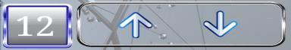Click position of energy numbers,Energy is an adjustment button,to increase【**↑**】,【**↓**】 to decrease，adjust the energy level.【Depth】displays the depth of the identified cartridge.

【Remaining Shots】display the number of remaining rounds.

【Total number】displays the total number of rounds.

【Fast mode】represents fast mode.【Slow mode】represents slow mode.

Click【Start】,instrument will start working.click【Pause】,instrument will stop working.

Save the value of tightness

**Six、Instrument instructions**

**1、Use range and operating energy parameters**

**--The usage range of 4D cartridge and the recommended operating parameters ：**

【Width】：8-11mm 【Pitch】：1.3-1.8mm 【Clearance】：1.5- 2.0mm

**1.5mm cartridge** ：Neck / double chin / jaw / cheek /forehead

【Power(J)】：0.4J

**3.0mm cartridge** ：Neck / double chin / jaw / cheek【Power(J)】：0.6J

**4.5mm cartridge** ：Neck / double chin / jaw / cheek 【Power(J)】：0.6J

**6.0mm cartridge** ：Chest 【Power(J)】：0.8J

**8.0mm cartridge** ：Abdomen 【Power(J)】：1.0J

**10.0mm cartridge**：Hand/leg 【Power(J)】：1.0J

**13.0 mm cartridge**：Hand/leg/hip 【Power(J)】：1.2 J

**16.0 mm cartridge**：Hand/leg/hip 【Power(J)】：1.2J

**--The usage range of Radar Carving cartridge and the recommended operating parameters：**

Hz(Frequency)：6-8Hz ， J(Energy)：4-6J  
**1.5mm cartridge**:Neck / double chin / jaw / cheek / forehead.   
**3.0mm cartridge**:Neck / double chin / jaw / cheek .

**4.5mm cartridge**:Neck / double chin / jaw / cheek, **4.5mm cartridge:**Chest.

**8.0mm cartridge**：Hand/leg/abdomen， **13.0mm cartridge**：Hand/leg/abdomen.

**--The usage range of liposonic cartridge and the recommended operating parameters：**

0.6cm cartridge: abdomen / hand / back / chest 【Energy】：03-10

0.8cm cartridge: abdomen / hand / back / chest 【Energy】：03-10

1.0cm cartridge: abdomen / leg / back 【Energy】：03-10

1.3cm cartridge: abdomen / leg / hip 【Energy】：03-10

1.6cm cartridge: abdomen / leg / hip 【Energy】：03-10

**▲**The above is the recommended energy value for each part of each cartridge’s operation.For shallower locations (such as forehead and crow's feet), the energy can start from the lowest. It is better to adjust the energy from low to high to the range that the experiencer can bear.（(If the guest can still afford it, it can be adjusted accordingly, so that the guest is suitable for non-tingling)

**2、4D&radar carving operation steps**

⑴Cleaning the face → Apply the product gel evenly to the area to be treated before the instrument is operated.  
⑵Face：First operate the 4.5mm cartridge, then operate the 3.0mm cartridge (synchronized 4.5 cartridge operated position), and finally operate the 1.5mm cartridge.(therefore, the operation of cartridge is from deep to shallow).

⑶Before the operation of the instrument , replace the required therapeutic head, and the energy is adjusted from low to high to the extent that the experience can withstand.

⑷**Operational steps of 4D instrument,**operate the position of the line (as shown below pictures).

--4D whole facial operation:the depth of each cartridge is 200-250 rounds;

--Then operate the dead corners of the face with Radar Carving (nasolabial), each cartridge operates about 800-1000 rounds.

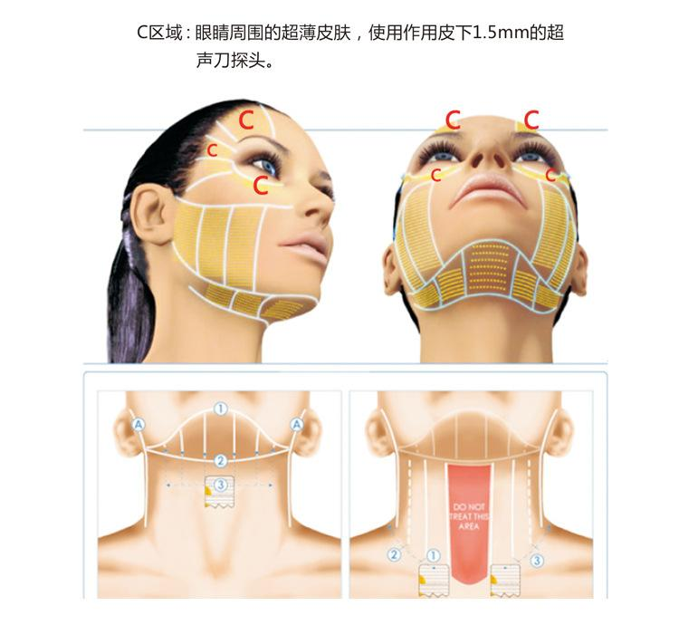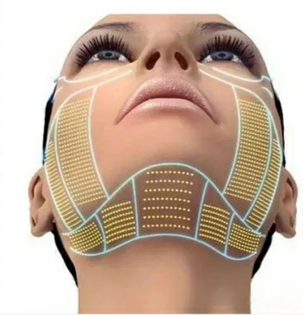

C zone: Ultra-thin skin around the eyes, using a subcutaneous 1.5mm ultrasonic cartridge.

**Operational exclusion zone：Avoid hairline, temples, eyes (eyeballs), Yintang, nose, upper lip, chin, larynx, aorta, and navel etc;**

The thyroid area around the neck cannot be operated；When treating the body, the places of the nerves and blood vessels pass through, please do not operate.The position of cesarean scar must be avoided.

⑸**Operational steps of Radar Carving**：The position of cheek is operated in a circle from the bottom to the top ,and the mandible is from the bottom to the top，(Don’t operate the position of the bone），nasolabial is operated in a circle from inside to outside along the cheek of apple.

--Note: 1 second operational position is about 5 mm, move the cartridge;Don’t stay for more than 2 seconds at the same part in the operation time.(Avoid eye area during operation).

⑹The therapeutic head should be kept flat on the skin, and the operation spacing should be arranged closely during the operation.

⑺During the operation, the experiencer should be constantly asked about the comfort level and the adjustment of energy level, so as to ensure that the experiencer can receive the experience in a pleasant state.

⑻Repeated intensive treatment at the problem site (2-3 times).  
⑼Please make sure the skin is moist during operation. If the medium is dry during operation, please reapply the gel.

⑽After operation, the face will be slightly red and feel hot, which is a normal phenomenon, and the face will be relatively dry.

⑾After the operation, clean off the gel and make a moisturizing mask for the customer.

⑿Such as: teeth or parts around the teeth, implant teeth, there may be a cold toothache. This can be done by inhaling to make the mouth bulge up or wrapping the teeth with gauze.

⒀Postoperative repair of nutrients - cell food and collagen for 1 to 6 months without interruption, the amount according to skin rehabilitation.

⒁Do not drink or eat spicy food after treatment, and do not wash your face with overheated water or supercooled water within a week.Do not do hot yoga, sauna, face steaming and facial massage (to avoid facial compression）Apply a mask every day within one week to hydrate, pay attention to sun protection, and do not use radio frequency or light instruments for treatment within one month.

⒂ 3-5 times a course of treatment, once every 2-3 months.

**3、Operation steps of liposonic**

⑴Pick up the fat in the skin care area with your hands, and judge whether the fat thickness is more than 1.0cm and whether it is suitable for liposonic operation. The corresponding therapeutic cartridge was selected according to different fat thickness.

|  |  |  |  |  |  |
| --- | --- | --- | --- | --- | --- |
| **Thickness of**  **fat** | above25mm | above23mm | above18mm | above14mm | above10mm |
| **Therapeutic cartridge** | 1.6cm | 1.3cm | 1.0cm | 0.8cm | 0.6cm |

⑵Cleaning skin;

⑶Taking photos before the operation, so you can compare them after treatment,generally measure the upper part, middle part and lower part of the umbilicus. The position of measurement is marked with a cosmetic pen and the measured size is registered, and the picture is taken.

⑷Using a cosmetic pen to mark the area to be treated for treatment ,apply gel on the treatment area.

⑸Entering into the operation interface of liposonic, adjust the energy intensity and working mode, and press the start button on the screen;

⑹When the instrument is in the ready state, the beautician press the cartridge against the skin, and then press the operation key on the handle, the current working count of the system will start to count down. The cartridge cannot be moved in the working launching state, and then move to the next position after the energy is launched! When the current working point is displayed as "0", it means that the launch is completed. (**The blue light is always on when launching energy**).

⑺If it’s necessary to pause during work, press the pause button on the handle to suspend the output of energy；If you press the pause key on the host screen, the instrument will stop working and the motor will reset.

⑻During the operation, the skin must be close to the surface without any gaps, and the gel should be fully uniform.

⑼During the operation, the user's comfort and energy level should be continuously asked to ensure that the user accepts the experience in a pleasant state.

⑽If the feeling of energy intensity is not enough can be added slowly, until the customer can accept it, the customer's feeling will have a slight tingling feeling or a slight heat feeling ,which is normal phenomenon.The slight redness of the skin after the operation is normal because of the heat generated by the fat cells at the bottom of the skin.

⑾After the operation, wipe the working handle and cartridge with soft cloth, and put them back to the working handle frame.

⑿Measure the size of the treated area and take pictures of the effect after the operation. Measure the upper, middle, and lower umbilicus. The measurement position should be the same as the position measured before the operation.

⒀Postoperative notes of liposonic：①Since the treatment is non-invasive, there is almost no recovery time, so daily activities can be resumed immediately.②After the operation, we should properly control the fat diet and drink more water and properly strengthen the exercise, and the effect will be more obvious. Don't eat spicy food.③Slight discomfort may be felt after the operation (such as redness, slight swelling, etc.), which can be eliminated within 2 to 3 days.With a single treatment for 1 hour, the maximum effect is seen within 8-12 weeks, which is also the time required for the body's natural metabolically damaged fat.

**Seven、Use precautions**

⑴Menstrual period, pregnant women or pregnant planners within a month should be cautious；

⑵The position of prosthesis and scar should be avoided;

⑶Injection of hyaluronic acid needs to wait for half a year before ultrasound treatment;

⑷Those patients should be used cautiously who has history of incomplete wound healing liver,or close to the treatment site where there is a large metal .

⑸Those patients should be used cautiously who with malignant tumors, hemophilia or severe bleeding, serious diseases, skin diseases and infectious diseases;

⑹Those patients should be used cautiously who has diabetes, hypertension, hyperthyroidism, asthma, heart disease, kidney disease, heart rhythm, implantable cardiac defibrillator, or other electromagnetic implantable medical devices, etc.

⑺Before using the instrument, clean the skin of the treatment site to prevent dirt from entering the skin with the ultrasound or preventing the penetration of ultrasound. Please remove all metal objects from your body before treatment to avoid unforeseen conditions that may affect the curative effect.

⑻It’s forbidden to operate without gel medium. It’s better to use the medium with a certain viscosity, which is conducive to the better fusion of ultrasound and skin, and to prevent the gap from causing reflection, which is not conducive to the better conduction of sound.

⑼Do not repeat too much for each treatment area, no more than 2 times to avoid skin redness and swelling.

⑽The degree of cartridge heat does not represent the size of the ultrasonic power output; small concentrations of liquids or drugs should not penetrate directly, otherwise it will easily cause dry skin.

**Eight、A&Q Common problems**

**A:Why do we put the Radar Carving Machine together with the 4D multi-row?**

Q:Because 4D multi-row can not be operated in many parts of the face, it can be said that there is no dead corner with the operation of radar line carving machine, the pain is reduced, and the effect is more obvious.

**A:Is there any pain when doing Radar Carving treatment?**

Q:The unique cartridge of radar carving is frictional treatment without any pain.Because the energy of the radar waves is transmitted deeply into the target, if the operation speed is slow and the customer feels pain after staying for a long time, the degree of pain varies from person to person. However, the radar-sculpted unique cartridge friction treatment does not cause any pain.

**A:How many rounds does it take if just using the Radar Carving Machine alone?**

Q:This depends on the areas that need to be addressed.For the whole facial treatment ,requires about 2500-3000 rounds of each depth cartridge, depending on the size of the client's therapeutic site to determine the number of rounds. Each cartridge is about 3,000 rounds in the body and about 2,500 rounds in the chest.

**A:When will the customer see the results? How long do they last?**

Q:Most clients can see the results immediately after the treatment is over. However, it mainly depends on the skin elasticity of the individual and the rebuilding process of collagen. Generally it will last for 1-3 years.

**A:How often? What's the reaction?**

Q:In order to maintain the long-term therapeutic effect, it is recommended to operate once every 2-3 months. It's possible to see a little redness after treatment and it will go away in a few hours.

**A:How often do the liposonic? How long will it take? Does it work?**

Q:Obese customers do it according to the course of treatment. For severe local obesity, it takes 1-3 times to achieve the desired effect, and do it every other month.For the relatively small body, liposonic can be made only once, and it just need to take an hour,that will reduce the local size by 2-6 cm;The clinical test results showed that up to 91.3% of the consumers improved their abdominal flatness significantly after treatment, and their waist circumference was 2 inches smaller on average. The body becomes slimmer and the waist curve returns to exquisite, which only needs 1 hour of treatment.

**A:Does the customer need a break?**

Q:No breaks. Customers can resume normal activities immediately.

**Nine、Common failures**

1、There is no display on the instrument interface. Please check if the power plug is not connected or the power switch is turned on.

2、The instrument is normal but there is no energy output or it is always on alarm. Please check if the handle cable is firmly connected to the host or the cartridge is installed in place.

**Ten、Instrument maintenance**

1、After using the instrument, please clean it with alcohol disinfection and keep it properly.

2、The plug with grounding pin must be used before use, and ensure that the power socket of the instrument is truly grounded.

3、Please make sure that the voltage of instrument is adapted. If the local power supply voltage is unstable, we recommend that the user increase the power matching power supply.

4、In order to ensure the therapeutic effect and normal service life of the instrument, please use the specified accessories provided or recommended by the original manufacturer.

5、Don’t place in a humid place or near a water source, and do not expose the instrument directly to the sun.

6、Don’t place the instrument close to a strong heat source as this may affect the life of the instrument and its normal use.

7、Please first remove all metal objects from your body to avoid unpredictable conditions and affect the efficacy.

8、In order to avoid contact failure, please pay attention to the skin contact with a certain degree of moisture, with water - based products or water to wipe it can achieve the desired effect.

9、When not in use, please turn off the power switch of the instrument, and ensure that the total power of the instrument is turned off after use to ensure the safety of the electrical products.

10、Using instruments or training instrument operators in strict accordance with instructions in the use manual.

**Eleven、Technical parameters and package size**

Product name：Three in one(Radar carving+4D multi-row+liposonic）

Input voltage：AC110V - 220V Fuse：5A

Output voltage：10-200W Weight：12kg(Don’t include the base)

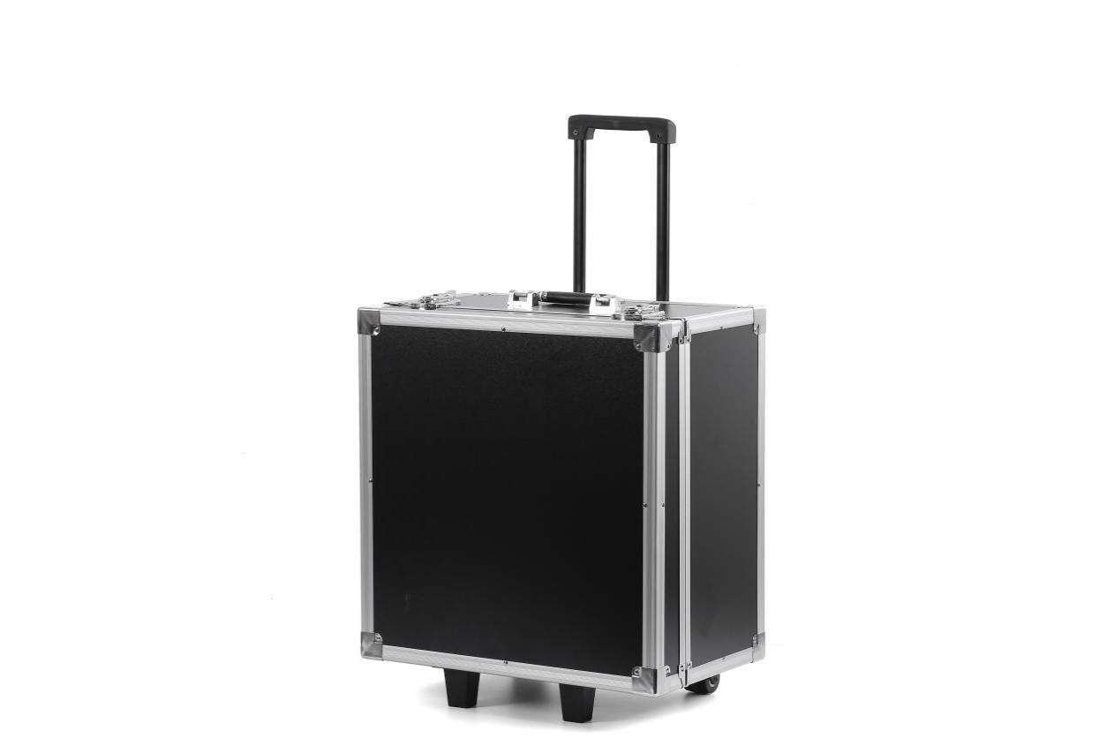Size of Air box：31×44×50cm