Title: The review of 888starz casino and its bonus models
Description: The 888starz casino review with unique bonus information included. What the process of registration at 888starz is and what the main features of the platform are.
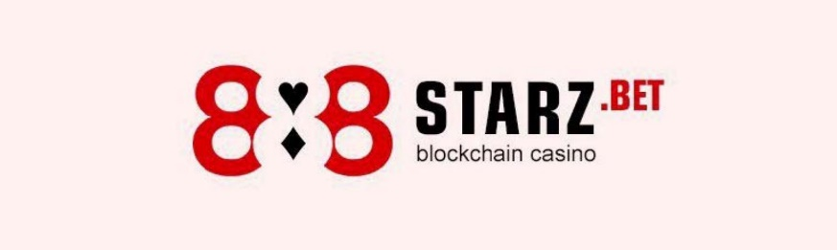
888starz - the first project of its kind with a unique dividend model that allows users to literally earn money by placing bets and enjoying the game. The hybrid social gaming platform skillfully combines a huge amount of entertainment content with blockchain technologies to guarantee transparency, honesty, anonymity and freedom to use it around the world. The full 888starz casino review can bring some definitely interesting information to the gamblers and developers of all scales. You can get more information about similar kinds of platforms through this link: https://top-casin.com/bookmakers/.
The main convictions of the platform
The 888starz team adheres to the principle of openness and transparency, because every 888token holder is essentially a shareholder of this platform. 888starz users are a whole community of people around the world who, through official channels on social networks, can communicate with each other, share opinions, advise, comment, discuss their questions regarding the project, help each other and receive answers directly from the 888starz team. The more satisfied and successful users there are, the more successful the project is, which means large dividend pools and payments to players who hold the tokens.
Interesting facts about 888 starz
The system in comparison is pretty new and has no analogues in the world. At the initial stage, it takes some time to figure out the details. So now and here you can see the list of most remarking features:
- A unique token-based player reward system that distributes the platform's income to players every 24 hours.
- More than 14 million US dollars paid for the time of the project's existence.
- Built-in support of connection with cryptocurrency wallets and Dapp browsers.
- Fast deposits in 26 different cryptocurrencies and comfortable withdrawals.
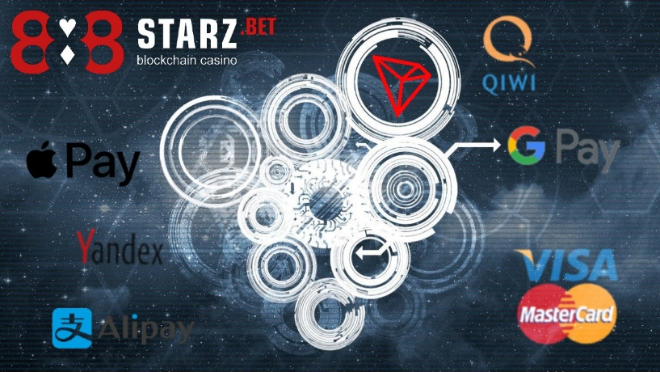
- Ability to recharge with fiat currencies through popular payment systems.
- Multi-lingual 24/7 support service in over 60 languages.
- Project 888starz is the winner of the prestigious developer accelerator Tron Foundation in 2019.
- Technical excellence and a wide range of games.
- The registration on 888starz is quick and easy to pass.
You don't have to think about which device to use the 888starz platform on. Just play and place bets on any device, and the platform adapts automatically. It is possible to choose from:
- 3500+ licensed slot games.
- Professional sports beech where you will find any sporting event.
- Bets made on cyber types of sports.
- Huge selection of world-famous manufacturers’ live games.
- Online poker games.
- Bingo, fishing, hunting lottery and more.
- Exclusive self-developed games with high win rate
- Game license and security
The only thing you want to think about while playing is entertainment. The platform takes care of the rest. The casino works only with licensed providers of gaming content, complies with all norms and requirements for online casinos, which is confirmed by a license issued by the Curacao International Gambling Commission (License #8048/JAZ2020-048). The players are ensured to get everything need to keep the data, bets and actions safe with SSL technology. Thus, the gamblers can be confident in the honesty and reliability of 888starz.
How to make money in this kind of casino
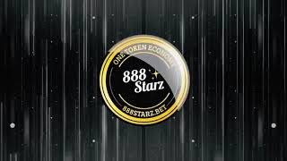
When making the bet, each user of the platform receives the project's unique tokens. They have the official designation and hold somewhat different functions than the usual ones. With them it makes almost no difference whether the player wins the game or loses it - the amount of tokens received in process depends only on the one factor: the bet size made by gambler and nothing more. Then the tokens are transferred to the player's account automatically and accumulated in real time.
After that all funds lost by players and received by the platform are stored in a special section called the "Reward Fund". Its system works in the reversed way - when gamblers lose, this fund increases, and vice-versa. According to the inherent mathematical percentage of retention in each game, the fund always grows over a long period of time. It is also distributed every twenty-four hours among all the players who have tokens accumulated on their account.
One of the peculiarities of the process is that the total token amount set across the platform is strictly limited. For that reason the difficulty of mining is constantly growing as the number of the occupied tokens increases instead. This fact boosts then the value of tokens, which are also traded on specialized exchange sources. In that interpretation, the token is presented as an analogue of a stock, which allows the holder to receive some income from the distribution of the proceeds of the platform in a passive way, and a crypto currency that has its own market value that allows it to be easily bought or sold.
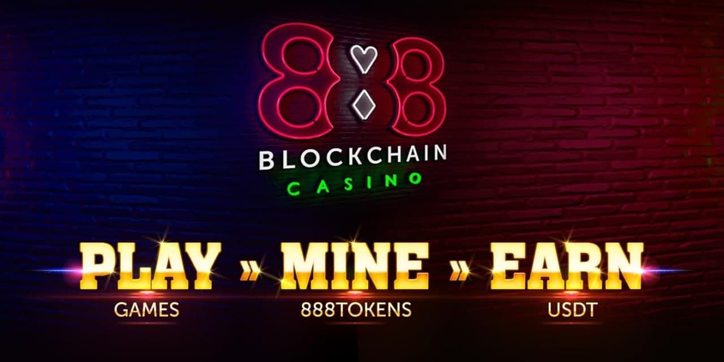
If the game for some reason has become boring for you, or other circumstances have appeared, then the tokens can also be placed on the player's personal account in the distribution of the Reward Fund. Soon, users can use the token as a game currency, as well as buy the desired goods.
Therefore, the player should remember that when playing on this kind of platform the gambler always stays in a winning state. After all, from the beginning of playing the token will automatically be transferred to your savings account and help to start receiving income.
Prohibited countries
You will not be able to access the website directly from the following countries: Italy, France, Israel, Poland, Spain, Slovakia, Belgium, Sweden, USA, Great Britain. For the convenience, you can use a chance to be provided with a free high-speed VPN that will solve the problem of accessing the platform from anywhere in the world, wherever you are.
24/7 customer support
Problems can arise in different situations, it is important to be able to solve them. No one else can do better than the well-prepared support team. The company and customer support will do its best to solve the problem in the most efficient and simple way possible.
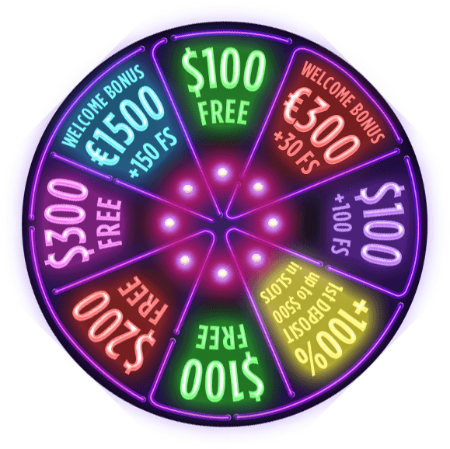
Bonuses
- 100% bonus deposit up to €100
- Welcome package provided with up to €1500 + 150 fs
- Weekly bonus for activity
- Bonus granted for a series of lost bets
To get to know more platforms with similar kinds of bonuses, you can visit https://top-casin.com/66-1xbet.html review.

