Olymp Trade Review

Wanting to find a good and honest broker, you gradually come across scammers. Oddly enough, some fake sites have a very good reputation due to honest work in the past, but the situation changes over time.

Olymp Trade broker is very popular because of the abundance of good advertising. Before trying to earn money on this platform, it is worth analyzing in detail all the features of its work.

What is Olymp Trade?

Olymp Trade is a popular platform for trading various currencies, cryptomonets, resources and items. The main advantage of the broker is a single wallet for performing all available operations. Without wasting time on transferring funds between wallets, you can perform many different operations from one account. For example, when playing on the price of gold, you can trade cryptomonets.

Is it possible to use Olymp Trade in India

|  |  |
| --- | --- |
| Parameter | Meter |
| *TRUST* | *7.5/10* |
| *COMMISSIONS AND FEES* | *8.0/10* |
| *CUSTOMER SERVICE* | *8.0/10* |
| *PLATFORM & TOOLS* | *7.5/10* |
| *PRODUCT PORTFOLIO* | *8.0/10* |

If there is an external regulation, the broker is allowed to use. In other words, if financial transactions are monitored from the outside, which helps to comply with the rules of trading and prevent violations that lead to deception of users, then the platform is available for trading.

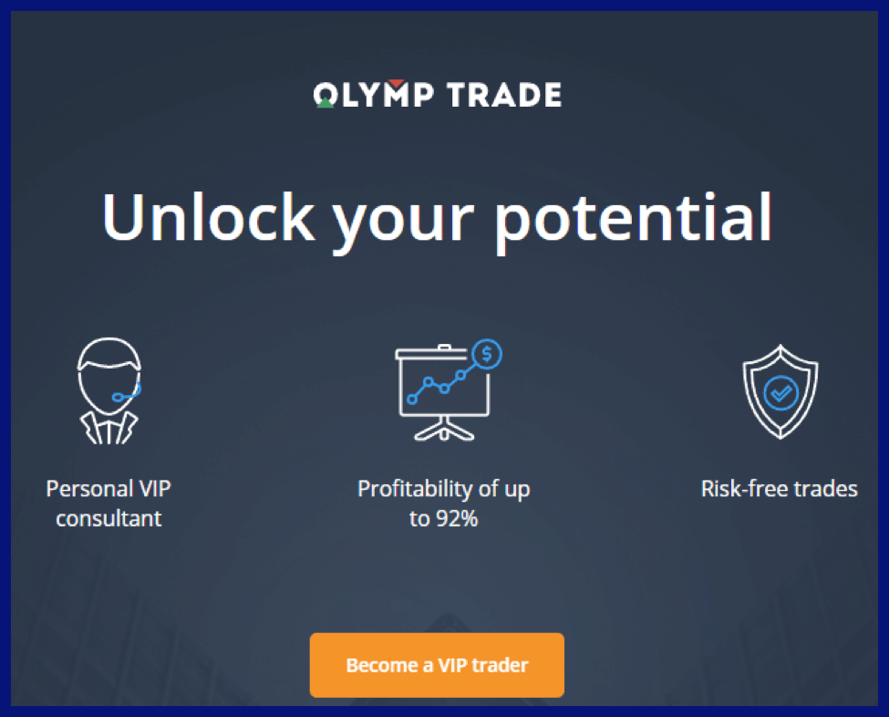

The International Financial Commission is the controller for the Olymp Trade platform. The company has been issued a certificate of assignment of category "A", which proves the conditions for completely safe operations. If there is a violation of the user's rights and funds are withdrawn from his account, the platform will pay compensation. The funds in the insurance fund are designed for a maximum payout of 20 thousand euros.

In case of violation of any of the conditions for issuing a security certificate, the license immediately ceases to exist. The work of Olymp Trade would not be possible in case of violations due to its popularity. To maintain the positions, the platform administration monitors the implementation of all prescribed rules.

As evidence of the possibility of using Olymp Trade for trading in India, we can consider the following facts:

• There is a contact person independent of the organization.

* Monitoring and regulation of financial transactions from the outside.

* The possibility of compensating risks from the insurance fund.

* Certified proven trading technology.

How to register an account in Olymp Trade

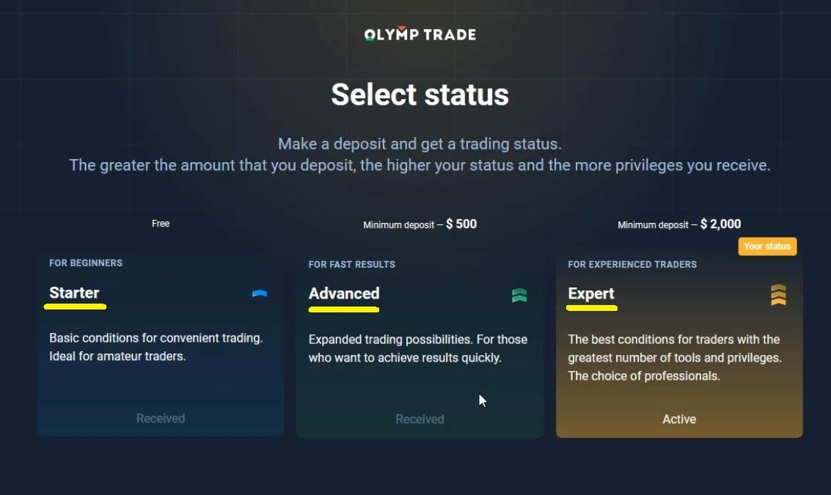

To create an account on the Olymp Trade platform, you need to go through simple operations:

1. Enter the user's data in the provided form to start registration.

2. An email containing a confirmation link is sent to the specified email address, which you need to click on in order to register further.

3. The user's entered phone number is confirmed by means of a call or SMS with a code.

4. The profile is filled in with real personal data. So it will be possible to confirm the involvement in the account in a force majeure situation by presenting documents.

5. When transferring at least $ 10 to the account account, it is possible to get started.

The difference between trading for real money and a demo account

Account types

|  |  |
| --- | --- |
| Basic account | You will be provided with strategies, indicators and educational materials which are available for everyone. |
| VIP account | You will have even more benefits, starting from personal analyst to secret strategies and increased profitability. |

To gain experience and prepare for trading in real currency, you can use the service of a demo account, for the security of your own funds.

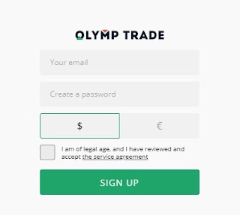

When creating a demo account, all the procedures coincide with the real one, the only thing is that the virtual currency is credited, not the real one. This is a good opportunity to try out the strategy on a demonstrative account and, with luck, repeat it on a real one. Of course, virtual currency cannot be withdrawn.

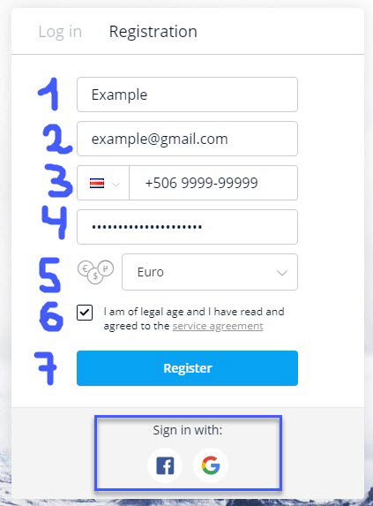

When working out a strategy on a demo account, all the conditions coincide with reality, due to this, all well-thought-out successful strategies will work on repeating from this profile.

Types of accounts available for traders from India

For traders, there are three variations of accounts with different characteristics and requirements:

* Starter-an account for beginners who want to try to learn trading. It is equipped with 12 levels and basic tools for market analysis. The advantages of more professional profiles are not provided, but they are not loaded.

* Advanced – the minimum initial deposit of $ 500 to get the status. The main advantage is the speed of analytics, which allows you to monitor transactions almost in real time.

* Expert – the highest level of the account, requires an investment of at least $ 2000 to the account. Provides special tools for market control. Suitable for professional traders.

Is it safe to use OlympTrade

Olymp Trade is a reliable platform for trading, this is confirmed by several facts about the protection of the platform. Part of the list:

* Modern means of protecting accounts with two-factor user authentication.

• All funds on the user's balance are available for debiting and use at any time, since the broker does not use the traders ' resources for its own purposes.

* Withdrawal and replenishment of the account are regulated, so that the transfer methods achieve a minimum commission.

* Resources are stored in different banks in Europe, which guarantees the safety of funds in case of unforeseen circumstances.

What can I trade in India through OlympTrade



The platform combines the possibility of trading on Forex and using binary options through a single account. This opens up the following possibilities to users:

Olymp Trade allows you to trade from one account at once on Forex and using options with a binary device. This allows the user to do the following:

* Turnover of transactions around the clock.

• You can trade world currencies, cryptomonets, raw materials, indices, ETFs and shares of corporations and enterprises at once.

• The opening period of transactions is variable - from a long to a minimum period of time.

• Under successful circumstances, each binary option transaction can bring income up to 92 euros.

* A fixed time for conducting transactions is possible.

* About 200 world markets are available for traders to work on one platform.

How to use Olymp Trade

To start working with the disclosure of all the possibilities, you should go to the website or use a special mobile application. Even a beginner will understand how the main functions of the system work. The analysis of tasks related to trading is also available for use.

A demo account will help you understand the structure of the site. To select a strategy for increasing resources, built-in functions will help, for example, a graph will help track fluctuations in the value of a particular resource or currency. This will allow you to choose the best time to buy and sell it. Well-analyzed information on the market will allow you to build the right course for earnings.

Tools to help traders

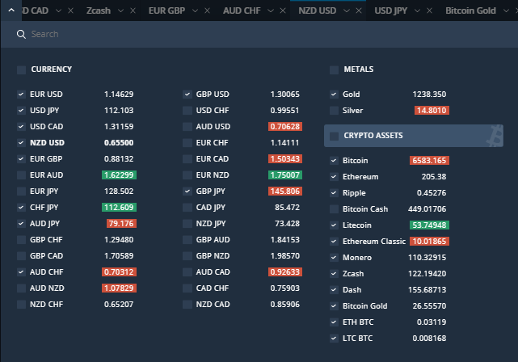

More than 20 assistants have been developed to improve the work of traders on the Olymp Trade platform. By studying as many tools as possible, you can speed up the process of tracking information and analyzing market dynamics. All incoming information can affect the market, therefore, it should be viewed. Charts and collected news will help in this matter.

By clicking on the chart near the graphs, you can view the parameters or change them. This is possible on the website and in the official application. Many add-ons for tools have been thought out for users, and when opening a premium account, the possibility of a trading call opens up.

Step-by-step Guide to Forex trading via Olymp Trade

Forex is a convenient market for trading through Olymp Trade. To work correctly on the site, you need to follow a simple algorithm for successful trading. When all the points are fulfilled, the benefit will come with the correct forecast.

1. Initially, you need to select the market from the proposed list, through which the trade will take place.

2.A qualitative analysis of the forecast is carried out using graphs and diagrams for clarity.

3. The amount of investment in currency, raw materials or securities is determined.

4. The labels are set, according to which the trades will be closed for possible profit.

5. A transaction is opened, after which it is necessary to continue monitoring the situation.

6. Depending on the changes in the exchange rate, the transaction can be closed ahead of time to make a profit or minimize losses, or wait for the automatic completion after the time has elapsed.

Fixed-time transactions

A popular method, but with great risks, depending on the correctness of the forecast, the profit may be significant, or it may go to a loss. A convenient way for high-quality calculations.

The basis is the prediction of which way the cost ratio chart will go. To make a deal, you need to perform the following steps:

1. The asset is selected, on the ratio of the exchange rate of which the forecast will be built.

2. The analysis of the situation for the last time is performed to assume how great is the chance of growth or fall of the chart.

3. The closing time of the transaction is selected. You can install it yourself using the options available in the interface.

4. Select whether the course chart will go up or down with the selected ratio.

5. When the time comes, the bet either wins and brings income, or is completely lost.

How to top up your account in India

To understand the possibility of adding funds to your account, you should refer to a specialized page, since funds may change depending on the position of the state. The minimum payment is $ 10.

Among the most popular options available in most cases, the following can be distinguished:

Bank cards of international payment systems with no limit on making payments on the Internet.

Bitcoin, as the most popular cryptocurrency, with automatic conversion to dollars.

Fasapay, Webmoney, Skrill, Neteller and other intermediaries that allow you to use local payment instruments for a small percentage.

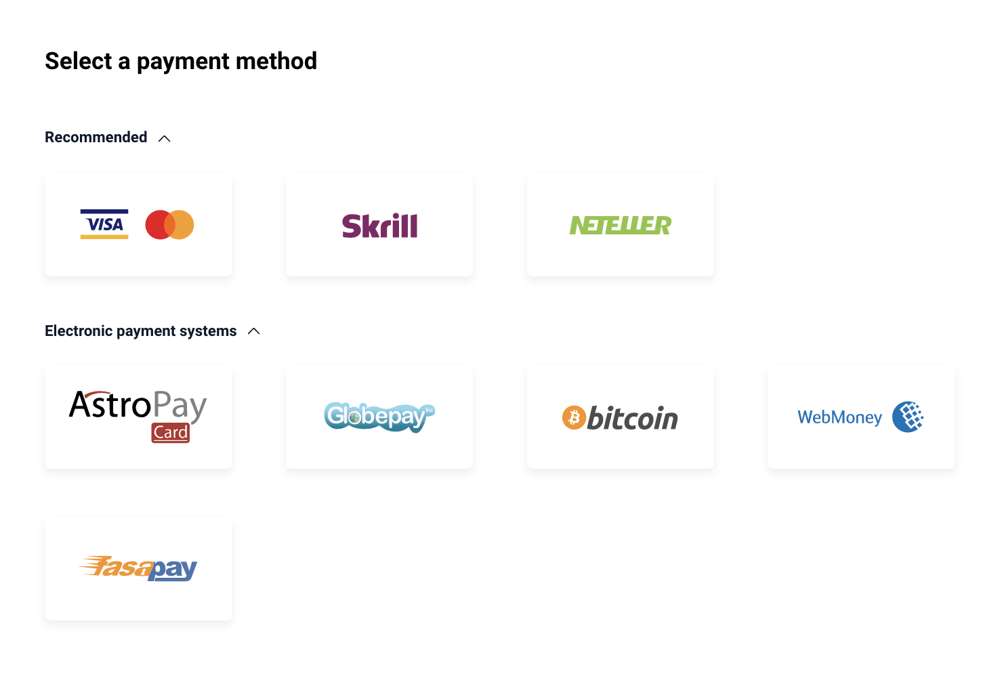

The broker himself does not charge a commission for replenishing his own account when choosing any of the proposed payment methods.

How to withdraw the earned money

To withdraw funds, you can choose any convenient method from the same list as for adding funds to your account. It takes from 3 hours to 3 days on average to withdraw any amount of at least $ 10, depending on the payment method. It is worth noting that, as with the replenishment of the wallet, the broker does not charge a commission from the user, which is very convenient for work.

Bonuses for traders from India from Olymp Trade

When registering and making the first deposit to the account, any trader will receive a bonus in the amount equivalent to the deposited budget. Therefore, at the first transfer, the bonus is issued the same amount that the user put on the account. This bonus is issued once as a welcome gift, therefore, the larger the first payment, the more you can increase your capital at future auctions.

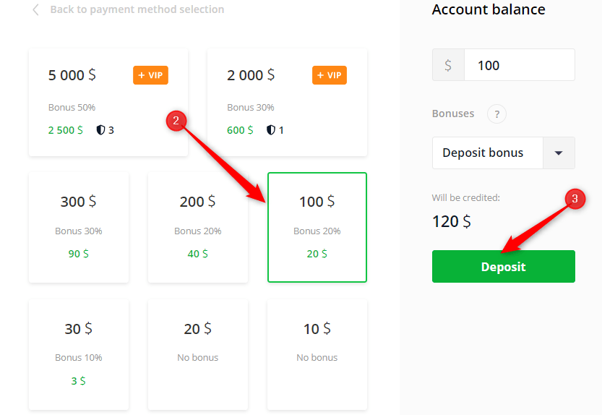

Rules for receiving bonuses

Bonuses are credited immediately to a separate account, from which they can be disposed of during trading. You will not be able to withdraw them immediately after receiving them, they can only be used in transactions, after which they will return with a successful strategy, when they can already be withdrawn without problems. This system is designed to control the abuse of shares by traders to increase their wealth. After a successful transaction, the money is transferred to a regular account without restrictions from Olymp Trade.

Mobile Trading App

To improve the quality of work of traders from all over the world, Olymp Trade has developed an official mobile application for working from anywhere in the world. The system is fully thought out and is freely available.

After downloading it for free in any store pre-installed on your smartphone, you need to log in to your account. To start trading, you must log in in accordance with the registration rules.

The device of the application is as close as possible to the site. The interface is easy to understand, and all the helper tools are available. This is well thought out for traders who are far from home, but do not quit their jobs.

There are no system failures in the application, unlike the site in a mobile browser. This contributes to investing at the right moment without problems in the broker's organization.

Customer Support

Since the bidding is conducted around the clock, all users can also ask for help 24/7, using one of the available communication channels. You can choose from a chat with employees, a phone call or an email. Technical support communicates in eight common languages, and Olymp Trade is constantly trying to expand their list so that all traders are more comfortable solving any disputable situations and technical problems.

|  |  |  |  |
| --- | --- | --- | --- |
| Support working time | Languages | Options | Contact |
| 24/7 | Multy languages | Chat  Phone call  Email  Contact form | [support-ru@olymptrade.com](mailto:support-ru@olymptrade.com)  +35620341634 |

All trades are held 24/7 it is necessary to provide support for all users also around the clock. Olymp Trade does it well. Employees can be contacted in 8 common languages via chat, call or email.

It is not difficult to get an answer, since a large number of employees work in the state at the same time and the operator quickly copes with solving the client's question. When receiving a premium level, it is possible to communicate with a personal assistant. You can contact him at any time of the day or night without waiting in line.

Reviews from traders about the Olymp Trade platform

Traders who have worked at Olymp Trade speak very well about the broker. This is the merit of a good development and a responsible team. Support is always ready to answer important questions and help, and the site and the app work like clockwork.

If there are negative comments, it is mainly due to the blocking of profiles due to a violation of the order. In order to avoid troubles and support proceedings, it is worth reading the list of Olymp Trade rules before registering.

Pros and cons of the broker

Among the main positive aspects of the Olymp Trade trading platform are the following:

Long-term presence on the market with a large number of positive reviews.

The presence of a certificate certifying the full fulfillment of any obligations to users.

Quick withdrawal of earned money using a variety of payment systems, and moreover without additional commission.

The ability to make a deposit using several methods available in any country, including India.

The presence of a demo account for training and honing your own skills without risk.

A constantly working support service, ready to solve any issue in the shortest possible time.

The ability to learn using the built-in hints to the available tools.

Trading in a huge number of directions at once, connecting to any world markets using the same account.

A convenient terminal interface that you can understand even without having special skills.

The ability to independently set the expiration date of the transaction, and not choose from the proposed options.

Adjust the timeframes on the charts in accordance with your own preferences to build a more accurate forecast.

The presence of an informative soundtrack both on the website and in the application, which allows you to make a decision on a particular transaction in time to minimize your risks and losses.

The ability to change the color scheme of the terminal depending on the conditions in which it is more comfortable to work.

Such an impressive list of positive aspects makes Olymp Trade one of the best brokers available. However, it also has a number of disadvantages that should also be taken into account before starting cooperation. Their list includes:

The need to withdraw money to the same source from which they were entered into the balance to avoid additional proceedings with the support service.

There is no way to restore the balance of the demo account if it was completely lost as a result of unsuccessful experiments.

The Personal manager is available only to users who have received the highest premium status.

Long-term deals are not available for all positions presented in the terminal.

Some traders consider the presence of a sound accompaniment superfluous. However, it is easy to disable it by regular means.

Similar resources for trading

Among similar resources offering trading opportunities with approximately the same conditions, the following can be distinguished:

Binomo. It requires a simultaneous deposit of at least $ 250, and also sets the minimum bet threshold of $ 5 against $ 10 and $ 1 at Olymp Trade. However, it is a reliable resource with a long working time.

Binary.com. One of the first platforms for trading using the binary options betting method. Unfortunately, it does not offer other opportunities like Olymp Trade. But the minimum deposit is only 5 dollars.

Iq Option. A fairly young company with a security certificate. According to the conditions and quality of work, it is the closest option to Olymp Trade and can well be used as a replacement.

Conclusion

A reliable and honest broker-Olymp Trade offers good trading conditions and data security. Traders can worry about funds only if the forecast is incorrect, but it will not work to lose money without explaining the reason. Olymp Trade is a very good platform for trading and working.

For traders of any level, there are useful tools and special opportunities for safe work. No wonder the platform is so popular all over the world.