**Is Binany safe to trade in India**

Binany **is one of the safest brokers. It works in many countries, including Asian ones, for example, India.**

Binany is one of the safest brokers. It works in many countries, including Asian ones, for example, India.

In order to work with clients from most countries, the company has opened several subsidiaries in different countries, where it has received certificates from

* the Malta Financial Services Authority.
* The Financial Services Commission of Vanuatu.
* The Financial Services Commission of the British Virgin Islands.
* The Financial Services Department of Labuan.

Terms of trade and tariffs

* The minimum deposit is $5. Other important conditions:
* The minimum bet is $0.35;
* the maximum yield is more than 100% on classic contracts and up to 3900% on other contracts;
* trading instruments — currency pairs, stock indices, commodities, synthetic assets of our own design.
* expiration-from five ticks to a year.

**About Binany**

Binany offers 11 types of transactions. Most of them are designed for gambling on synthetic assets. There are five types of contracts available for trading standard instruments.

Raising/Fall. The standard version of trading. To make money, the speculator must determine whether the asset price will be higher or lower at expiration compared to the opening quote.

Rules for winning on options Increase/Fall

Higher/Lower. The trader sets a barrier and decides whether the price will be higher or lower at the time of closing.

Rules for winning on deals Above/Below

Touch/There is no touch. The speculator will have to predict whether the quote will touch the set price level at any time during the open transaction period.

Rules for winning on Touch options/No touch

It Will End Inside/Out. The trader will earn money if he guesses where the option will close: inside the exposed corridor or outside its borders.

The rules for winning contracts Will end Inside/Outside

It Will Remain Inside/Out. It differs from the previous type in that you need to predict whether quotes will go outside the corridor at any time before expiration.

The rules of winning on transactions Will remain inside/outside

Options for gambling:

Asian-the last quote should be higher or lower than the average during the opening of the transaction.

Digital — to make a profit, you must specify the last digit of the price at the time of expiration: it will be even or odd, it will close above or below the last decimal quote.

Reset call / Reset put — where the value will be at the time of closing relative to the Reset value, which is formed after the opening of the transaction.

Lookback-the trader earns or loses the difference between the maximum and the close, the maximum and the minimum, or the close and the minimum.

Largest / smallest tick — it is necessary to guess whether the tick at the time of the transaction will be the largest or the smallest among the next five.

Only up/down — how many ticks in a row the asset will rise or fall.

**Is Binany Legit or is it another scam**

Gaming options, according to binany review, are riskier than classic ones. It is impossible to predict their outcome: no analysis method works on tick contracts. Therefore, it is not recommended to place bets of more than 1% of the account balance.

At the weekend, speculators can only trade gaming contracts for synthetic indices. Standard trading of currency and other familiar assets is available on weekdays, when the world financial markets are working.

**Regulation and safety of funds**

All clients of binany and binany app have one account type available. Therefore, regardless of the deposit size, the trading conditions are the same for all traders.

The broker has an informative website. The data on the company, working tools, deposit and withdrawal methods, regulation are indicated.

**Registration and verification**

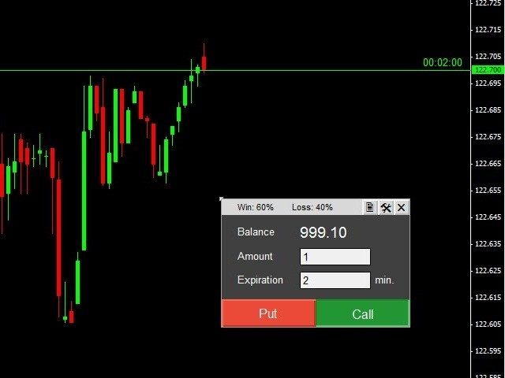

The entrance to the trading platform is available after registration. To do this, you need to specify an email on the site, click on the link from the received email and come up with a password.Traders are not provided with bonuses. An unlimited virtual account for $10,000 is opened after registration. The demo allows you to use all the functions of the platform, so you can fully test its operation. The virtual account balance is offered to be restored if there is less than $1000 left on the account.

**How Binany trading platform works in India**

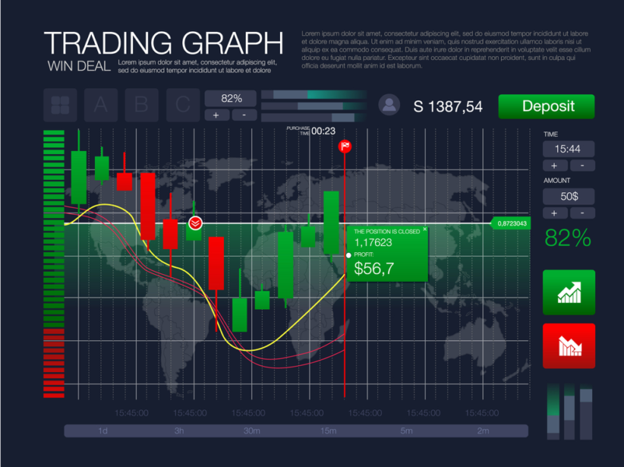

The answer to the question is binany safe is positive. There are two working tools on the site: SmartTrader and WebTrader with almost the same functions. The difference between WebTrader is the ability to add and rearrange elements: charts, control panels, trade history.

Elements of the WebTrader platform

* The control panel. It is used to select an asset, an option type, and entry conditions. All transaction parameters are clear and easy to configure.
* Platform Control Panel
* Chart. The broker has a functional window with quotes with everything necessary for technical analysis. Main features:
* saving templates so that you don't have to configure the terminal again every time after logging in;
* five types of charts: Japanese candlesticks, bars, line, points, curve;
* horizontal and vertical lines for graphical analysis;
* asset comparison function.

SmartTradercan be downloaded to a computer running Windows or macOS.

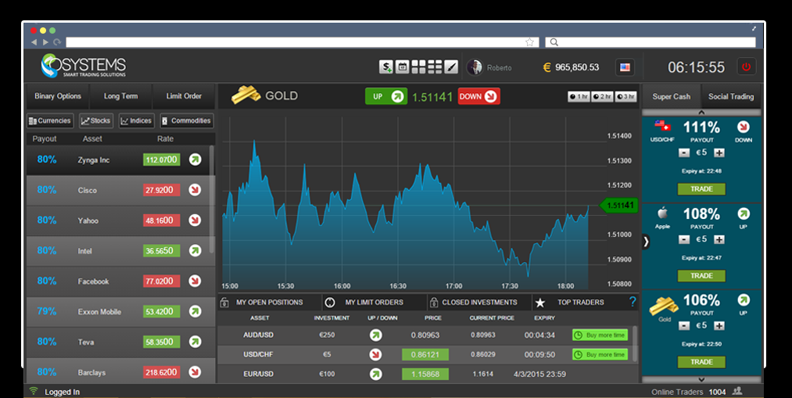

There are more than a hundred technical indicators of binany trading on the broker's platform: for tracking market volatility and pace, recognizing candlestick patterns, statistical functions, and price transformation. All the tools are customizable and can be used together.

The website states that the company has one of the best systems for generating quotes. A slight difference in prices with other suppliers is possible during periods of low liquidity and simply because due to the decentralization of the Forex currency exchange, assets are not traded with a fixed value worldwide.

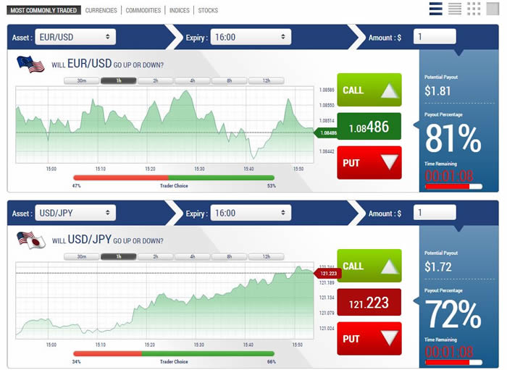

**Binanyassets**

The broker offers four types of assets:

* currency pairs: basic and cross-rates (secondary);
* stock indexes of Australia, Asia, Europe, America;
* commodities: gold, silver, palladium, oil;
* Synthetic tools are unique assets that simulate the movement of the real market.

**Currencies**

According to binany reviews, Currency pairs are divided into the following categories: The main pairs include the most popular world currency pairs. Secondary pairs are less liquid currency pairs. Exotic pairs that include one major currency (which is not USD) against the currency of a developing country. Example: GBP/HKD.

**Raw materials**

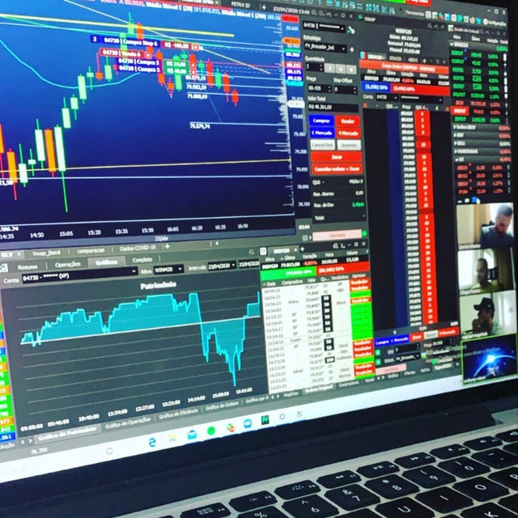

Commodity trading, despite its greater proximity to the final consumer, does not have the same popularity or intensity of trading. As a result, an erroneous impression is created of less liquidity (and, accordingly, profitability) of this asset. Let us explain that raw materials, in the binary options market, are understood as energy resources, metals or food resources. In a word, everything that the global industry needs to work on a daily basis.

**Stock**

The Company does not create a market for investments, securities, derivatives or speculation among or between clients. Each financial contract purchased by the client through this website is an individual agreement between this client and the Company and is not a security, and is not subject to transfer, exchange or assignment to or with any third party.

**Exchange indices**

Synthetic exchange indices from Binany.com -these are synthetic assets that simulate real market volatility and are available for trading 24/7. The indexes are based on a cryptographic random number generator, the accuracy of which is verified by an independent third party. Synthetic indexes provide exclusive access to various types of contracts.

**How to start trading on the platform**

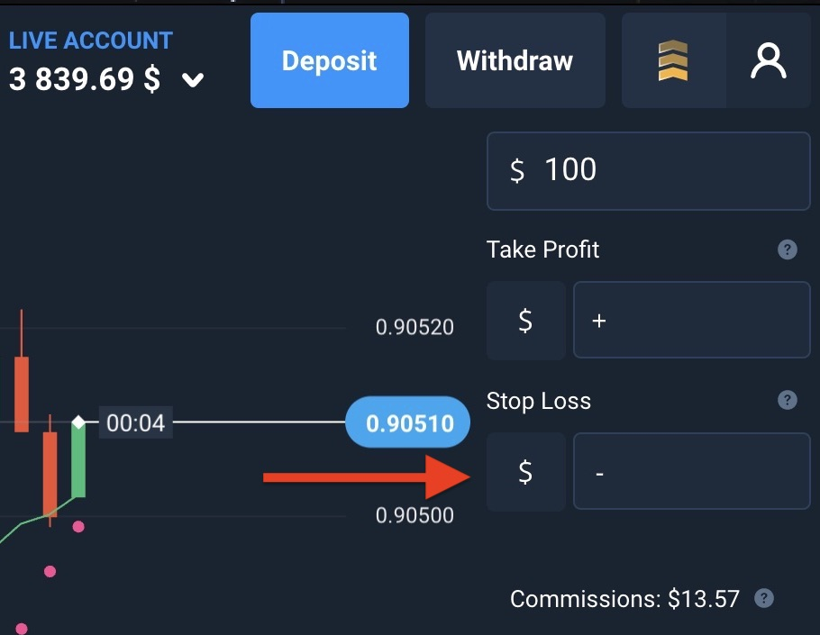

If you are a novice trader who wants to earn money in the financial markets, first you need to decide exactly how you intend to earn. You can trade inside the day or come after work, make a couple of transactions in the evening, you can also work like a scalper, making transactions lasting for several hours. In any of these cases, there is a specific work.

**Choose an Asset**

The asset should be clear to you specifically. Open the chart and look at it. If you feel that you understand and know how to make money here, then this is what you need. All the tools have their own special features. Of course, for the most part they are all similar to each other, but there are also differences. Many traders enter this into their trading system.

**Selecttheamountofthetransaction**

On average, traders who are responsible for trading on the stock exchange "raise" the amounts that make up about 20% of the funds they have invested in trading. Even very successful traders rarely reach 40%. Accordingly, the earnings will depend on the size of your investments.

**Time**

If you are engaged in scalping and do not rise above the five-minute timeframe, you should use no more than two assets in this case.. By trading more assets, your attention will dissipate, which will cause problems in trading.

Do your trades last for 3-6 hours, and do you trade within a day? You should use 3-4 assets. If your trades are delayed for weeks, you can use 5-6 instruments in trading. On transactions that last for months, you can also trade ten assets.

**Up and down**

Prices on the stock exchange are constantly moving up and down. If there is no pronounced movement up or down, then the trade develops sideways (with small zigzags within the "corridor"), which is called a flat. After it, the price can go anywhere, so experienced traders usually take a wait-and-see position. ... The price moves with small fluctuations and the "correct" trend will have a structure similar to steps (if you draw horizontal lines along the highs or lows of each wave). ... Investing and trading on world stock exchanges.

**Binany withdrawals and deposits for Indian traders**

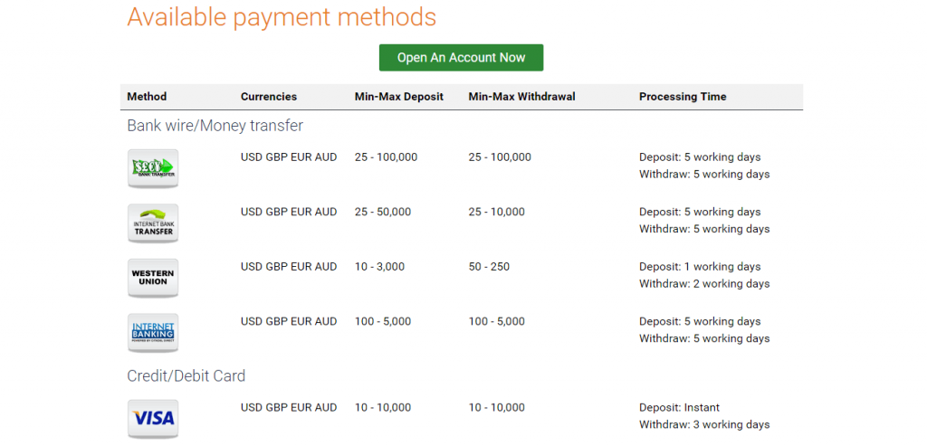

More than 20 payment systems are available to replenish the account: money and bank transfers, cards, electronic and cryptocurrency wallets.There are no commissions for input and output. All withdrawal requests are processed within one business day.

**Supported banking options**

A trader can withdraw money from his trading balance on:

• bank details

• cryptocurrency wallet

* electronic money of many payment systems

In the case of a fiat account, only electronic wallets and international payment systems will be available to the trader for both replenishment and debiting.

**Feesandlimits**

Fees and limits can vary, it depends on the way of money withdrawal chosen by the client. According to the clients’ reviews, the fee is quite insignificant, and it’s the advantage of the online broker.

**Binany promo codes and bonus offers**

Bonuses during registration and the first replenishment of the account with brokers reach 100-20% of the amount. This means that when making a small deposit with binany promo code, a trader can get a large base for earnings. But we must remember that it will not be possible to simply withdraw these funds. It should be "worked out", having earned a few more. Only after increasing the deposit, you can be given the opportunity to withdraw bonus money. Just obtain a binany promo code 2021.

**Customer support**

The broker does not have a chat with support. You can contact the manager via email or by leaving a ticket on the website. The consultant will respond within 24 hours. Faster support answers by phone, in English.

**Binany App review**

Full-fledged trading from smartphones and tablets is available through the browser, according to Binany app review. The quality of the platform on mobile devices is in no way inferior to the computer version. In the mobile application, the company teaches clients to trade using different strategies, does not talk about working with indicators, news, charts. Getting acquainted with the work of a speculator is reduced to explaining the principles of binary options trading from Binary, describing the types of contracts and available financial markets.

**Pros and cons of the broker**

Advantages:

* reliability and control of multiple regulators;
* maximum yield of 100% on standard transactions;
* the minimum deposit is $5;
* more than 10 ways to top up your account;
* 11 types of options.

Disadvantages:

* long feedback from support;
* lack of analytics.

**Binany reviews from traders**

Sometimes clients complain about problems with withdrawing funds and possible manipulations with quotes. The company transfers money to Mastercard and Maestro cards to traders from the UK. Customers from other countries can only use Visa. Not everyone takes this into account, so they face problems when translating.

**What to do if scammed**

If you have become the scam’s victim, please call the Binany technical support as soon as possible. Tell the consultant about your situation, and you will receive help. Also, you can apply to the police.

**Binany trading platform alternatives**

At the moment, there are few trading platforms in India. Thus, Binany can be the best one. It has gained a huge popularity due to convenience of money withdrawal and a big possibility of gaining the money.

Wrappingthingsup

Binany binary options broker is a platform proven by time, traders and regulators. She legally works in the EU and India, from where dubious offices have been leaving in recent years. If a trader knows how to make money on the market, no one will interfere with him.

|  |  |
| --- | --- |
| Number of options | 49 |
| Profit up to | 85% |
| Minimum investment | 1$ |
| Technical support | 24/7 |
| Payment systems | Neteller, Paypel, Perfect Money |

Frequently asked questions

Is Binany a scam? No, it is not. It is a safe and convenient online trading company.

How does Binany trading platform work in India? To start trading in India, you should register your personal account. Then, You will be able to trade.

How do I start trading on Binany? First, choose the object you want to trade, it can be raw materials, stocks or different couples of currencies. Then, study the basics of trade and choose the sum of your first transaction.

Which banking options are supported at Binany? You can withdraw your money to your card, electronic wallet or a bank account. There are many options.

