# IQ Option Review. How to trade online

It is one of the simplest brokers for the starters, The main values of the company are connected with Western business ideology, conditions are suitable for experienced traders and for novice traders. 24 hours technical support is available to the clients.

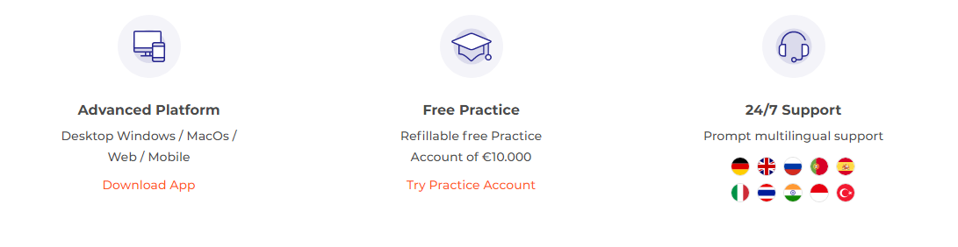

**What is IQ option**

Some users ask what is IQ option. It is a licensed company for trading online, well-known is most countries of the world.

|  |  |
| --- | --- |
| The year of foundation | 2013 |
| Available assets | Stocks, options, indices, goods, forex, cryptocurrencies |
| Trading platform | Web platform, online application |
| Minimal deposit | 10 USD |
| Official website | www.iqoption.com |

Company details

The list of the company's services is taken from the official website:

* A training program for beginners.
* A convenient trading platform.
* More than 500 assets for trading, binary options, digital options.
* OTS-trading.
* Tournaments.

**Is Iq Option Legit**

Not al the users are sure is iq option legit. The trading platform is regulated by the company from the Seychelles, the license number is 247/14, the license was issued at Cyprus. Thus, the company’s activities are legit.

Licensing and regulations

In 2014 the company has obtained a license in order to protect its clients. If something goes wrong, the trader can complain to the regulator and initiate an arbitration process. If the company goes bankrupt, the trader will get maximum 20,000 euros from his lost investments.

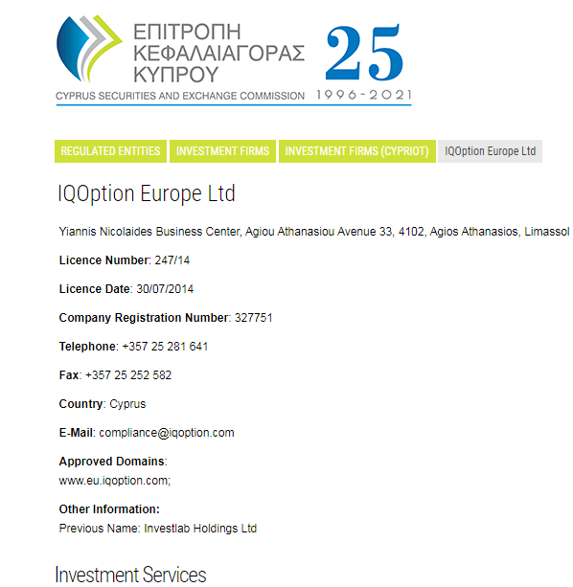

**Is Iq Option safe**

The question is iq option safe is quite frequent. IQ Option is a secure platform. It is used by 30 million traders all over the world, and great attention is paid at the safety.

Funds management

The company has a license with the number 247/14. So, it corresponds to the safety requirements and standards. It is registered in the British FCA Agency and French Regafi Agency.

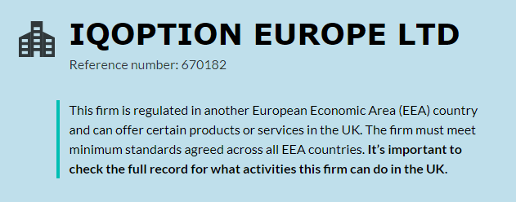

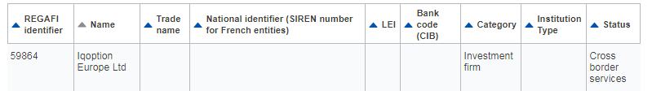

Account safety

The platform is secure, SSL technology is used for personal data protection. Encryption protocols are strong. Moreover, there is a firewall for personal data safety.

**Iq Option Registration process**

First, download the app to your pc. Then, create a personal account with a password and a login. Then you should make a deposit for trading.

Go to the Sign Up Page

You should visit official page of the broker, then sign in, find the button “Register” and enter your personal information, including e-mail address for confirmation.

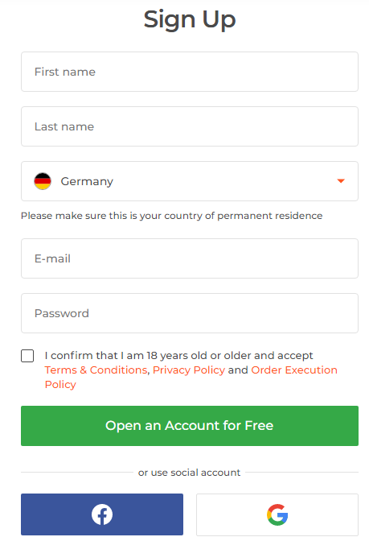

Verify your Email Address

If you don’t see the confirmation letter to your e-mail, then check the SPAM folder, the letter may be there.. If the email is not received, you should send the email verification request again. Probably, there were failures on the server.

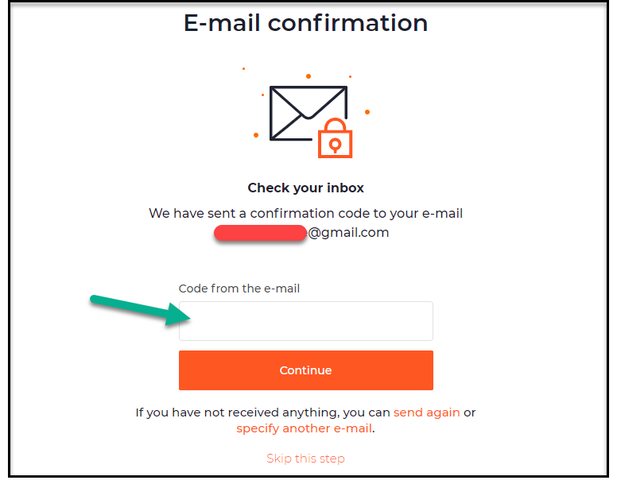

Verify Your Phone Number

When entering a phone number, you must specify the country and city code. You also need to make sure that the phone to which the specified number is registered is turned on, because a message with a verification code will be sent to it. You need to enter this code in the appropriate field, and the phone number will be automatically verified.

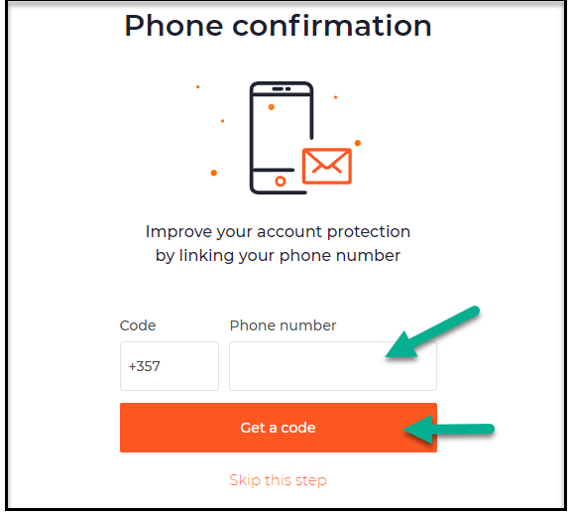

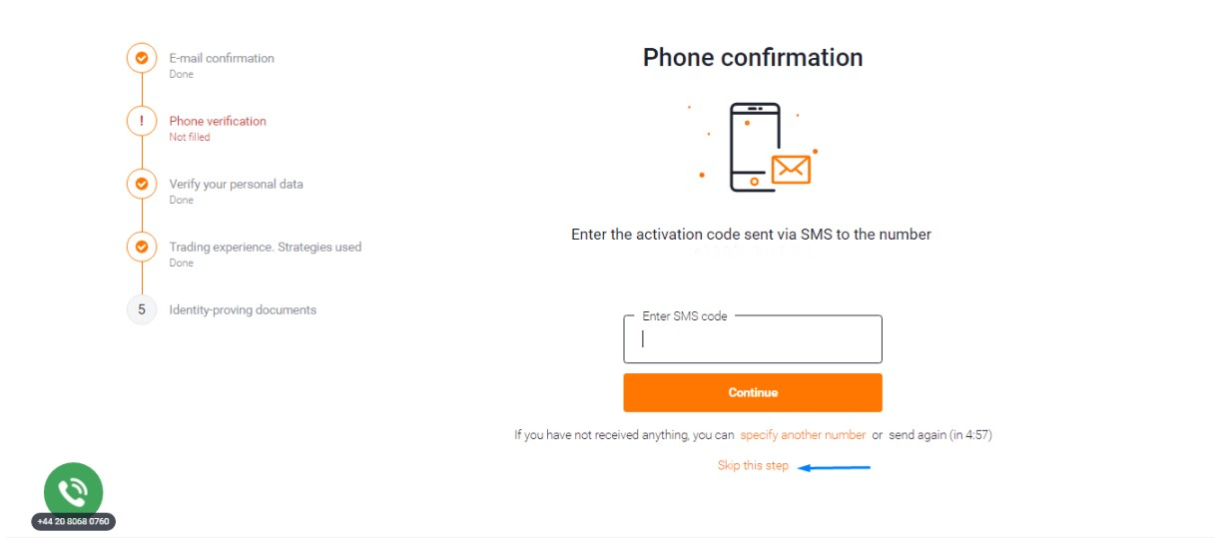

Complete Your Account Profile

The profile specifies the data and iq option login that the user entered during registration. Additionally, you can specify your wishes regarding trading. For example, a user can indicate that he wants to trade only raw materials or only stocks, and also choose the status of a beginner or a professional.

Start Trading

The cost of real contracts of iq option vs olymp trade starts from$1. The clients can use binary contracts and turbo contracts. In binary contracts, expiration time can be changed in increments of five minutes, and in turbo contracts it can be changed in increments of fifteen minutes.

**Iq Option App for Mobile Trading**

The mobile application iq option app is in the top of the Google Play Market for the query "binary options", and even if you look for competitive brokers, IQ Option will still flash on your screens sooner or later. After a quick installation of the application, you can either log in under your account, or create a new one, while you do not need any authorization or registration to trade on a demo account, which is very convenient.

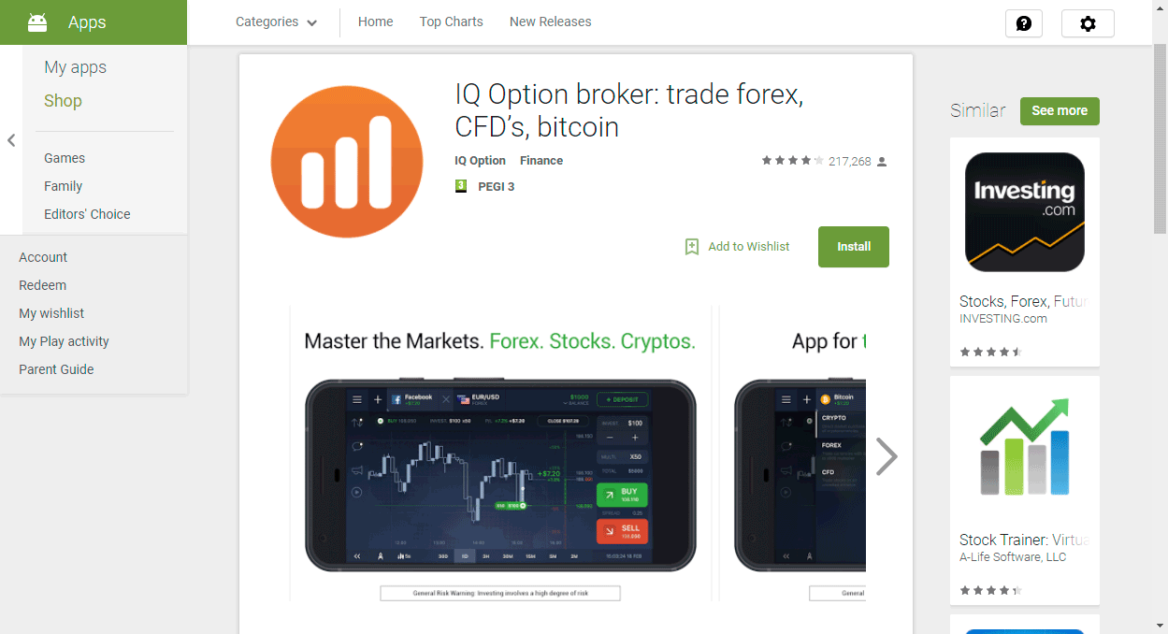

App Overview

The design of the trading platform for mobile devices is very pleasant and convenient to use. Everything is clear, while the versatility of the application pleases. You can change the display of the chart (4 types), as well as add indicators to the chart (4 pieces), or add auxiliary lines for technical analysis of trading. That is, IQ Option managed to make an identical trading platform for mobile devices, on which trading is practically no different from trading on a computer.

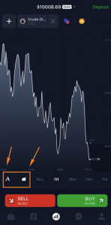

How to Trade with the App

Users often ask how to trade in iq option. If you want to trade with real money, then the minimum deposit in IQ Option is only $10, and the minimum bet size is $1. In addition, you can insure part of the amount (from 1 to 30%) in case of a failed transaction, which is very convenient for reinsurance for beginners, so as not to lose the entire bet amount if you lose. There are 23 currency pairs available in the demo account, and to access all other assets (there are more than 90 of them), you need to open a full-fledged account. The trading platform is very responsive and does not slow down even when opening several transactions in a row. All open transactions can be observed in a separate window, while the total income is updated in real time, depending on the movement of the asset.

**What can you trade on IqOption**

At the time of writing, the list of assets of Aikyu option is as follows:

* 172 shares;
* 88 currency pairs on the Forex market;
* 54 options;
* 6 types of goods (oil and precious metals);
* 11 stock indexes;
* 21 ETF funds;
* 24 cryptocurrencies.

Trading on low-liquid assets may be temporarily suspended.

Currencies|Forex

Currencies such as euros, US dollars, British pounds, Swiss francs, Canadian and New Zealand dollars, and the Russian ruble are traded on the IQ Option market.

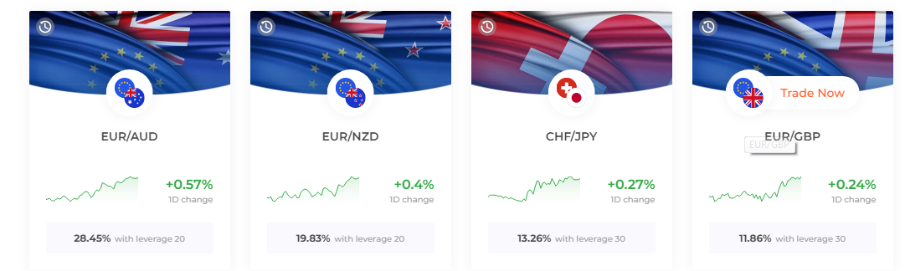

Commodities|Indices

The following types of raw materials are available:

* Gold, silver, platinum, palladium, aluminum, tin, zinc, copper.
* Brent oil, WTI oil, Urals oil, natural gas.
* Grain, soybeans, corn, cotton, sugar, coffee (arabica, robusta).

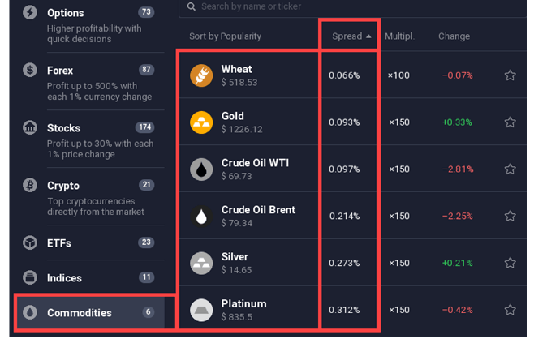

The most popular indexes are:

* The Dow Jones Index (Dow Jones). This stock index includes shares of 30 largest companies. By the way, this stock index is one of the first that were calculated and applied for trading.
* Next in popularity is the S&P 500 index (Standard&Poor's). As the name suggests, 500 is the number of companies included in this stock index. This option is the most suitable for trading for novice traders. The reason is the rather high liquidity and volatility of the instrument. In addition, the S&P 500 does not react so sharply to price spikes of individual companies due to the large number of shares used in the calculation of the index.
* NASDAQ 100 index-it includes the 100 largest companies whose shares are traded on the exchange of the same name.

Binary options

Binary options trading is a very uncertain way to make money with a high risk of losses, however, like all options for working in the financial markets. Price movements on the platforms are unpredictable, they depend on many factors: the mass mood of traders, the policies of major players. Therefore, measure your financial capabilities and chances of earning.

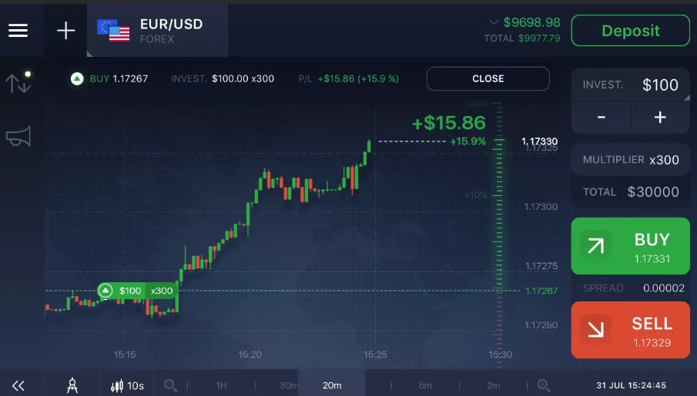

CFD

OTC assets, which include CFDs, are issued for any type of underlying asset, if the pricing and settlement conditions are clear to both parties (the seller and the buyer).

As a rule, CFDs on shares of well-known brands are in demand. Quotes and codes of instruments (tickers) coincide in the trading terminals of Forex brokers and the exchanges on which these securities placed during the IPO are traded.

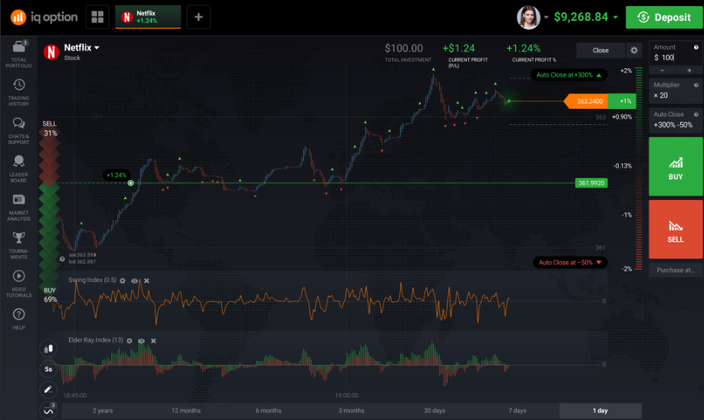

Cryptocurrencies

All types of cryptocurrencies are available.

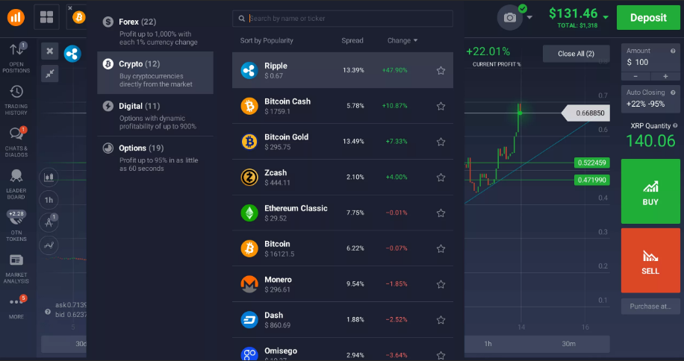

Experts recommend following certain trading strategies on the cryptocurrency exchange.

* The "pips" strategy. It is important to have time to close the transaction after reaching the set profit size of several pips (points). In a short time, a trader enters into a significant number of transactions, which are then instantly closed.
* The "arbitration" strategy. A trader buys cryptocurrency on one exchange and resells it on another, earning on the difference in exchange rates.
* The "statistical arbitrage" strategy. The meaning of this strategy is somewhat similar to "arbitration", but the scheme of work is more complicated and requires professional skills, as well as the ability to make a deposit of thousands of dollars. On the other hand, it is “static arbitrage " that brings a tangible profit from the price difference.

ETF

The fees associated with trading ETFs are lower and are usually offset by a decrease in the price of the ETF. In addition, you only pay the broker for opening and closing a position, and these commissions are the same as the costs associated with trading stocks.

Another advantage is the ease of choosing a suitable ETF. Compared to stock analysis, ETF analysis is much simpler. When investing in stocks, a large number of variables must be taken into account.

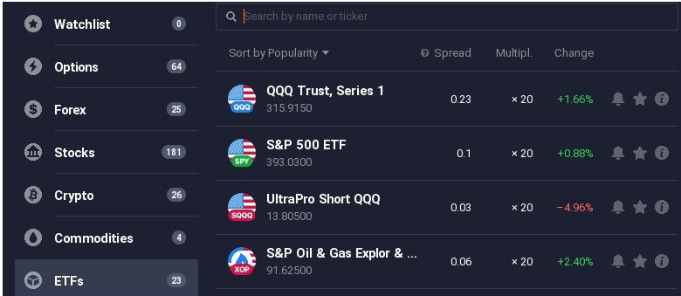

**How to use Iq Option**

You can use the trading platform on your pc or via your smart phone, because the mobile app is available. The interface for all clients is unified. If you start trading on your pc, later you can continue trading on your smart phone without any problems.

Trading hours

Some contracts of OTC type can be available even on Sunday and on Saturday. Other contracts are available from Monday to Friday, in the work hours of real exchange.

Risk/Profit Ratio

The broker's platform generates several target quotes. When the short-range is reached, the yield is standard. But the further the price goes in the right direction, the higher the profit.

Spreads & Commission

The broker such commissions, as:

* Various kinds of spreads;
* Commission of 2.9%;
* Fee for an inactive account.

Chart Types and Indications for analysis

You can use the broker’s terminal in a browser, like separate program or a mobile app. Anyway, you we’ll be given all necessary tools for analytical work, including the most common types of charts.

**How to Deposit Money in Iq Option**

To replenish the account, you can use plastic or virtual cards, the system of electronic money and wallets for cryptocurrencies. Also, bank transfer is available.

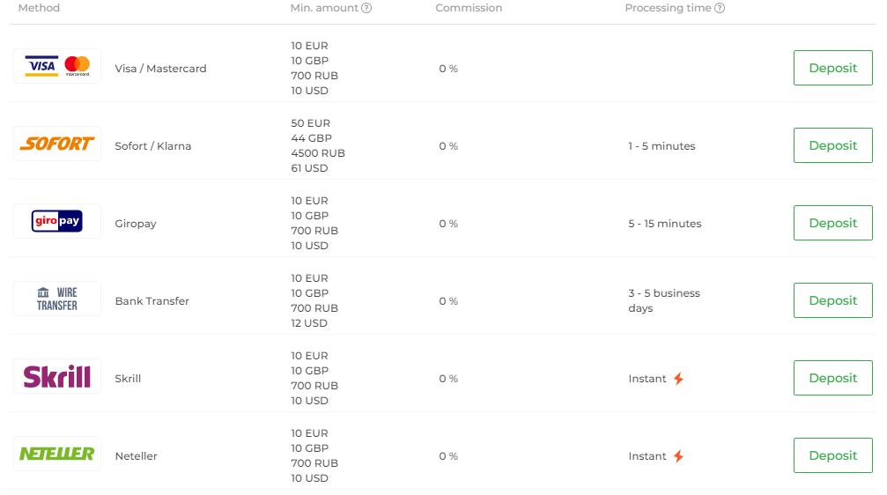

Supported banking methods

You can choose any bakning method. But remember that different banks have different conditions and, maybe. Different fees for money transfer.

Deposit process

Minimal deposit is ten American dollars. You don’t have to pay any fees for your deposit. Nevertheless, if your preferable way of payment is a bank transfer, you may pay commission to the bank.

Fees and limits

The minimum sum of the money to be withdrawn is 2 dollars. For withdrawal of money, you should provide your ID card, your passport, some bank statements for the identity confirmation. Within a day, all applications will be processed. But a bank transfer can take more time.

**Demo account Vs. Real money trading**

For an unlimited period, you can get a demo account. It is used for practicing your trading skills and for training. There is also a deposit on your demo account, and the trader can replenish it while training.

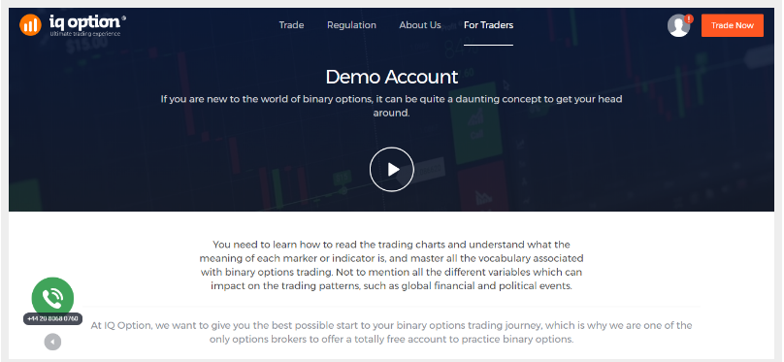

**Iq Option trading step by step**

To start trading, you must have a minimum deposit of 10 dollars. Then, more than 70 assets become available to you. Moreover, you are welcome to take part in trading competitions and tournaments.

Choose the market you want to trade

You can trade such securities, as CFD, crypto currencies, and electronic transfers. Moreover, it is possible to speculate on the assets’ price. Choose any, and then start trading. It’s really simple.

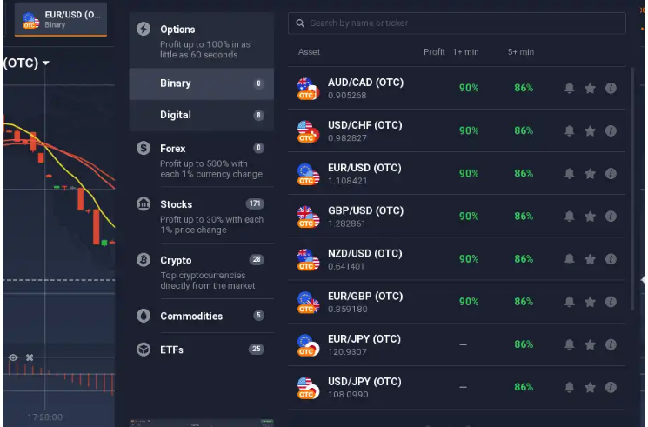

Make a forecast and analysis of the chart

Features of the trading terminal:

* four types of charts: line, candles, bars and heiken-ashi;
* graphical tools for analysis: segments, rays, horizontal and vertical lines, Fibonacci levels;
* the opportunity to sell an option ahead of time with a smaller profit or loss;
* displaying up to nine graphs on the screen;
* widgets that make it easier to make decisions about opening deals: the mood of other traders, news and trading volumes.

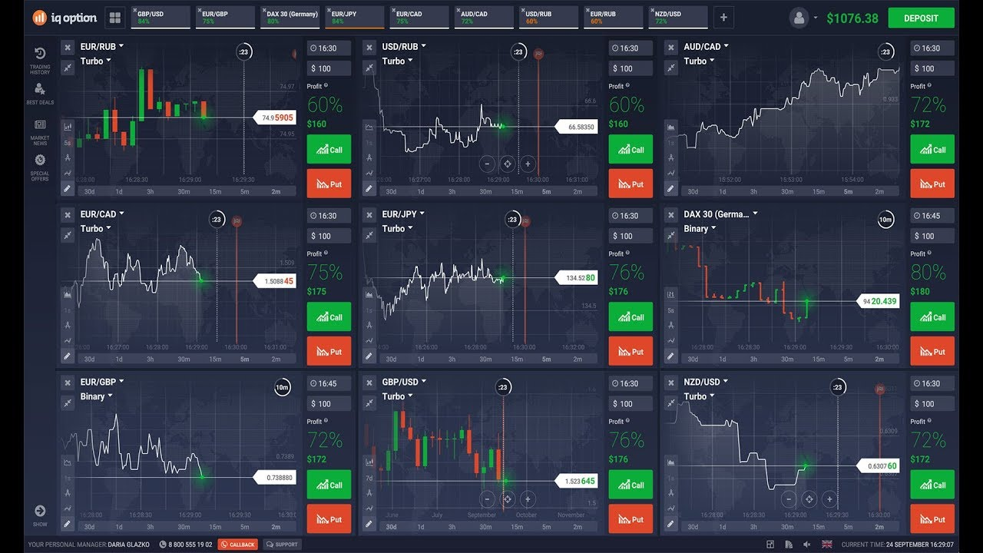

Choose the amount you want to invest

The starting capital depends on the following factors:

* Opportunities of the trader. With a salary of $500 (in the absence of other financial income), it is hardly worth risking $5000 at the start;
* Broker's Requirements;
* Expected income. The principle is simple – 10% of income from $ 100 and from $ 1000 will vary greatly in amount.

Set the Stop-loss and Take-profit

For long and short positions, stop losses are set in opposite directions relative to the entry point. The take profit is set in a mirror relative to the stop loss. If you have opened a purchase transaction, then take profit should be set above the market entry point. If you have a sale transaction open, then take profit should be placed below the entry point.

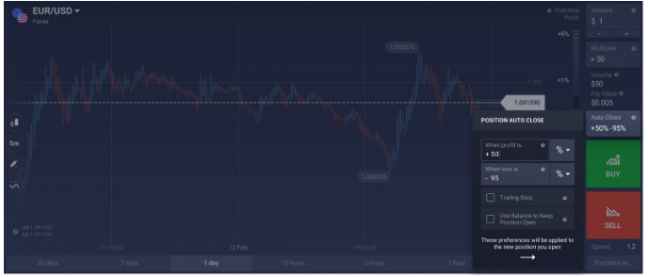

Start trading

There are 20+ technical analysis indicators available in the trading terminal: trend indicators, oscillators, volatility and volume indicators. Tool settings can be saved to templates, which save time on preparing a schedule in the future. The history of quotations is available to each client. It helps to track the accuracy of open transactions, test strategies and make sure that the company does not draw prices. By default, the history is available for the last week. The archive for a longer period is provided after contacting support.



Close the trade whenever you want

Close the position after the expiration of the time allotted for its existence. If the logic of opening a position assumed its relevance for a specific time period, then you should not contradict it. It is not necessary to hold a position until the end for reasons of only hoping for its profitability.

**Helpful trading tools**

There are many charting tools for the development of trading strategies. For example, you can freely use lines and candlesticks to get maximum profit.

Support for cryptocurrency

The platform has a set of special functions for cryptocurrency support. More than 100 developers all over the world are controlling and improving cryptocurrency support, in order to achieve maximum safety.

Trade cancellation

Along with the usual Stop Loss, there is also a more cunning tool for automatically exiting the market with minimal losses – Trailing Stop.

The essence of the trailing operation is to automatically move the Stop Loss up after the price by a fixed number of points each time, if the market has gone in your direction and the profit is growing. No one knows what will happen next, at any moment all the profit can melt, and it is also unwise to close a deal when the profit continues to grow.

Pending trade tool

It is quite a rare tool. It can be used in order to prevent you from losses or establish a desired profit level. The pending trade tool is somehow similar to MetaTrader 4, but there are also some differences.

**How to withdraw money from Iq option**

If you have struggled with forex brokers before, you will find relief with IQ Optiontrading.The procedure of money withdrawal is really simple. A wide range of withdrawal tools is supported.

Supported methods

The range of supported methods is wide. You can choose any of them by changing the settings in your personal account after the registration. This option is available to everybody.

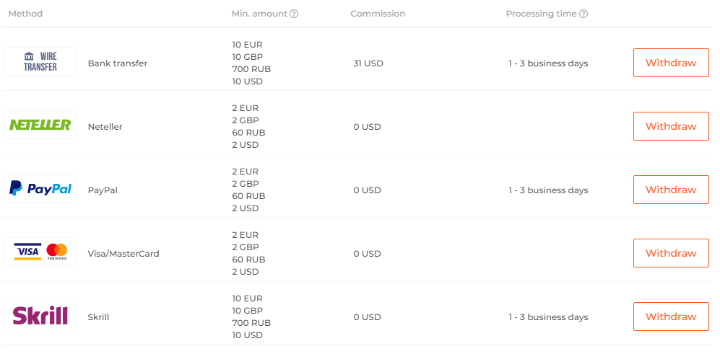

Withdrawal step by step

In order to withdraw funds, you must enter your profile, find and select money withdrawal, and then choose the withdrawal method you prefer. After that, just follow the instructions, and you will get your money.

Fees and limits

The withdrawal fee depends on the payment system operator. The time to withdraw funds may also vary. In general, users claim that the restrictions are very insignificant.

**About Binomo Bonus offers for Indian traders**

Minimal sum for trading is 10 USA dollars. If you want to withdraw money, the application will be processed in 3 days. You can withdraw from 10 dollars to one million dollars. You can also get bonus for the deposit.

Welcome Bonus

If you replenish your account for three thousand dollars, a VIP status with a welcome bonus will be granted to you, including personal management and regular trading signals’distribution. Also, all the contracts will be available to you.

First deposit bonus

The first deposit bonus cannot be withdrawn from IQ Option binary options. It can only be used for further trading. If you do not use it for a long time, it is automatically canceled.

Bonus terms and conditions

To receive bonuses constantly, you need to purchase the VIP status. There is increased profitability for VIP clients, such traders have the opportunity to earn more from each transaction they make.

**Customer support**

The service of customer support is safe and reliable. You can contact with the consultants via e-mail, social network or the telephone. If you call to the technical support. You’ll have to weight 10 minutes in average. In some countries there isn’t any fee for telephone calls.

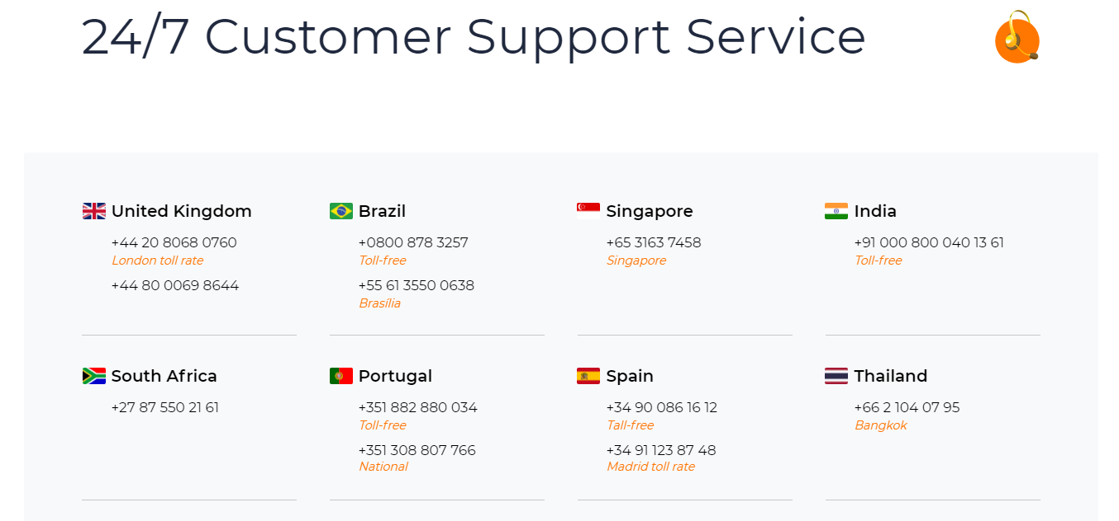

**Iq option reviews from the traders**

The traders say that this broker is safe and reliable, with a high level of services. The interface is simple and easy to understand, also there are many options that will help you to improve the trading process.

**Pros and cons of the broker**

It is very simple to use the broker’s services, the design and registration are unified. Also, you can use a demo account. However, the choice of expiration dates is limited, and you can’t use some tools round-the-clock.

**Iq option trading platform alternatives**

This trading platform is very efficient and quite popular. The main benefit is that the trader’s wishes are always taken into consideration.

**Iq option review final thoughts**

To sum up, the platform is good, but some traders don’t like limitations in the choice of expiration dated. Nevertheless, this broker will help you to gain a good experience of trading.