The benefits of moving company in San Jose
United Pro Moving Services is the company that was found in San Diego in 2005. For the recent years, it has gained a huge popularity among the clients in San Diego and other cities where the company is represented. We, as a moving company in San Jose, have a huge network of companies that are ready to help you in moving to other cities. Our aim is to provide the best moving services to our customers, both residential and industrial. We organize moving services for the companies and individuals, the cost of our services may vary.
We have the whole staff of movers, they are the experts with the high level of professional skills. Our staff is always ready to help you during the moving. Our experts are and consultants are skillful and competent. The aim of our company is to provide the highest level of satisfaction for our clients, and our motto is high quality and a high degree of reliability. According to the reviews of our customers, moving with our company is always reliable, quick and convenient. Our consultants have licenses for professional activities connected with moving, and we provide the whole range of insurance services for our clients. With us, San Jose moving company, you can be sure that your moving will be OK, we will help you to save your time and your nerves.

Activities of San Jose moving company
The moving activities of our company are based on a scientific approach to moving, and we use individual approach to different furniture and equipment that must be moved. We have gained a huge experience in moving, and all our works have been successful. Moving is always a stressful activity, but we will help you to get rid of an unnecessary stress, due to our scientific and high-competent approach. We, as a moving company San Jose California, will help you to overcome all difficulties that are usually connected with the moving.
We provide services connected with both long-distance and short-distance moving, you can choose any service you like. For example, we can move you from San Diego to such cities, as:
- Oregon;
- New York;
- Florida.
We will take a professional care about your personal belongings during the process of movement.
Also, different kinds of storage facilities are provided to our clients. With us, you can order the storage facility for your furniture, equipment or other valuable objects. The temperature in our storage facilities is regulated, it depends on the special character of your personal belongings. For example, if you need to store products, we can provide you low temperature of the storage during moving help in San Jose.

Services of moving company in San Jose California
We provide a wide range of commercial services, and the rates are quite affordable. In the rating of commercial moving services, we have occupied one of the first places recently. We provide the services of commercial moving for such complicated objects, as offices, department stores or warehouses. We guarantee the safety of your goods and documents during the moving. And we really appreciate your trust.
We provide a wide range of additional services that will make the moving process much quicker and more convenient. For example, nobody likes packing the boxes while moving. We have a special packing service. Our professional staff will help you to pack up the objects for moving with the highest level of safety. This service of moving house in San Jose has already gained a huge popularity among the movers.
Some people who want to save the money think that moving on their own is much better than addressing the moving company. However, it is wrong to think so. It is much better and more efficient to use our services then to manage on your own or to ask your friends for help with moving. We have a wide range of benefits.

Moving help in San Jose for you
First, our services are not expensive, and our work is based on the principle “all included”. If you are moving on your own, you must pay for different kinds of services, for example, for hiring the movers, and for the car that will drive you to your new house. But here you pay only at once. You pay to our movers, and they take care about everything, they are responsible of package, equipment and transportation, and it is very convenient for you. You needn’t to pay extra money for additional services that are not included into the basic package of services. Everything in the moving company in San Jose is included.
Moreover, our services are the safest. When you lift some heavy things, you can influence your health badly. For example, not everyone is able to lift a sofa or a table. But our movers are the experts, they lift heavy things without any damage to the health, and you won’t be responsible or liable.
Also, our moving company will help you to save the time. Without us, you can spend several weeks for moving, you will lose an opportunity to go out, to meet with friends and relatives and even to work because of moving. With our company, you will spend one day for moving, and it will help you to save a lot of time. It’s really valuable because time is money.

Enjoy moving house in San Jose
Moving with San Jose moving company is quite peaceful. It is always a great stress to pack the things, to arrange the transport and to move, but our experts will help you to avoid unnecessary stress and to stay calm. With us, you will enjoy moving, and this is a really rare thing.
Our competent and experienced staff is divided into teams, and the team usually includes three or four people, the number of people included depends on the difficulty of work. To contact with us and to order the moving, you must call to our consulting center or to fill in the form in our website, and we will soon call your beck. Our experts will consult you and tell you an approximate price of your moving. Don’t hesitate to work with our company because we use a responsible approach to the moving. And be ready to recommend us to your friends and relatives who are also moving to another house or even another city.
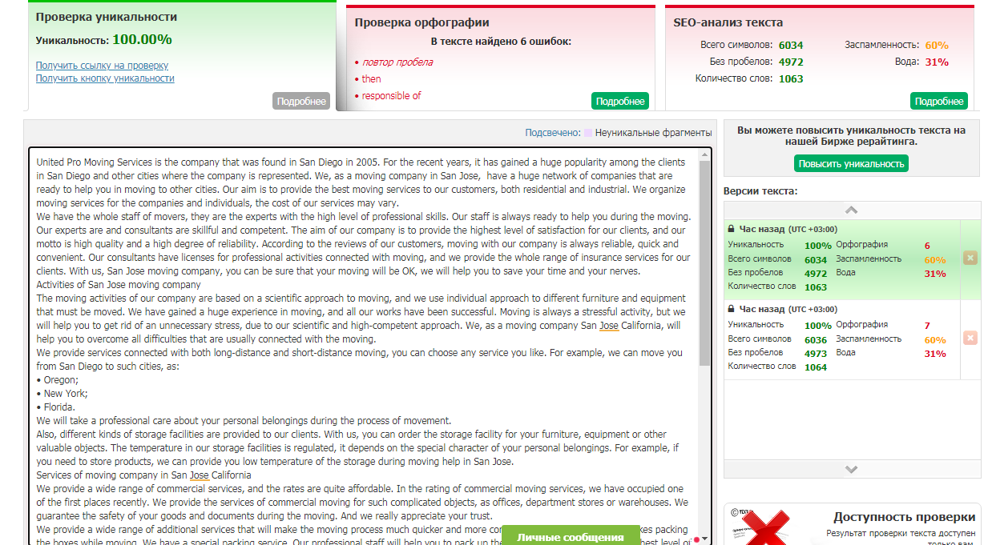

Benefits of local moving company San Jose CA
Nobody likes moving, even if it’s moving at the local level, because moving takes a lot of time, it is connected with stress and disruption. But we can find an easy solution of this problem, just call to the United Pro Moving Services company. Our company local moving company San Jose CA is located in California, and we are always ready to provide you the services for local moving. The team of our company includes competent professionals and experts in moving. Our experts:
- Have a professional education;
- Are really reliable and trustworthy;
- Take a great care about your personal belongings on every stage of the moving, from packing the things up to transporting them.

Services of local movers San Jose CA
We, as local movers San Jose CA, have been working more than 10 years, that’s why we guarantee you a perfect moving, without any stress or problems. We help people who are moving from their studio flats or offices. We guarantee that all your personal belongings will be delivered to the new place on time and without any damage, even the minor damage. Also, we have special experts in packing, they can arrive to your house with their packing supplies for packing your personal belongings. This service is really popular.
For local moving, we have special facilities for storing your personal things during the process of moving, Our aim is to provide the highest quality of local movement services, in order to satisfy the clients’ needs during San Jose local moving.

Additional services of San Jose local moving
During the process of local moving with a cheap local mover, it is often a difficult task to lift heavy furniture. But, if our experts are responsible for this job, it won’t be difficult any more. Just call us and describe the list of furniture that must be moved. We are always ready to move safely your cabinets, beds, heavy tables and wardrobes. Moreover, the services of unpacking and crating are provided for those who are moving with their furniture. Special storage facilities of local moving company near me can be provided for the furniture, the temperature and humidity there can be changed, according to the needs of your furniture.
With us, you won’t be stressed during the local moving. Local moving will take just a few hours, the precise time depends on the volume of work for our experts. According to the reviews of our clients, we make local moving safe and help you to avoid stress that is always associated with moving activities during local moving help.

Packing and unpacking in local moving company near me
Such services, as packing, unpacking and crating are extremely popular. For example, if you are living in a big house, the packing can take about two weeks, that’s a huge amount of time. Our company will save your time and the cost of a local move. Just order the services of packing, unpacking and crating. These services are provided by a team of real experts. Your things will be safe and well-packed, and you will stay calm during the moving. It’s really great because moving always makes people anxious.
Considering local moving, we work according to the all-included policy, so you needn’t to pay for a wide range of extra services, and it is really convenient and cheap. Our company will help you to save both time and money during the moving. Moreover, you will avoid inevitable stress caused by the very fact of moving. And you will save money, just remember how much do movers cost for a local move.

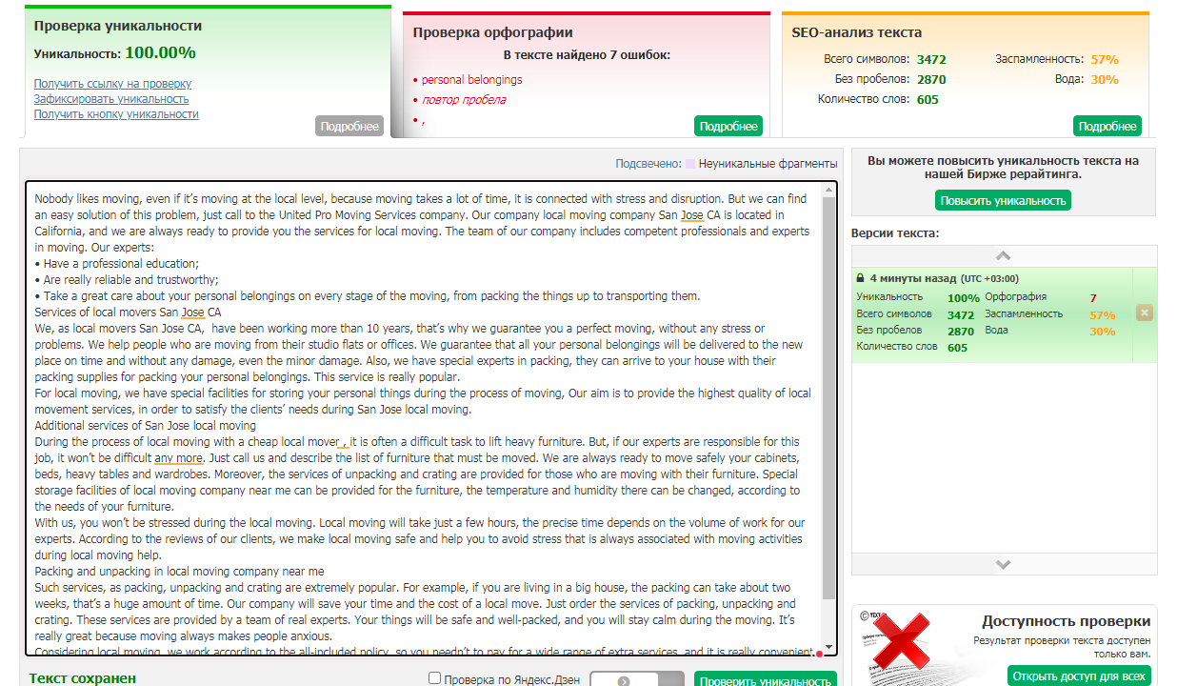

San Jose long distance moving in California
Our company is located in San Diego, California, it has been working for a long time and providing the services of long distance moving. Our services have a high quality and they are quite cheap, you will enjoy moving from one city to another one, and it doesn’t depend on the length of the distance. Due to the skills of our staff, we will provide you quick and comfortable long distance moving. Your things can be transported any time by San Jose long distance moving, the time depends on your preferences. We provide safe and quick transporting of any luggage. The car for transporting your things won’t be late. When you are making the order, we will fix in the agreement the information about our service transport.

Advantages of long distance movers San Jose
The benefits of our company are:
- Experienced staff;
- Safe and quick transportation;
- A wide range of additional services;
- The work according to all-included system.
We, as long distance movers San Jose, can transport any luggage, such as heavy furniture or building materials, computers, musical instrument, food products and water. Due to the provision of storage facilities, your items will stay safe and undamaged during the moving from San Jose to long beach distance. We can change air temperature and humidity in our storage facilities, in order to store products, water or furniture.

The best long distance moving company
Our staff, as the best long distance moving company, has a big experience of lifting and carrying the heavy things, and it is really important when you move to a long distance, for example, from one city to another one. Fragile items are packed free of charge before the moving and then they are carefully unpacked. Moreover, crating services are available, their price is included into the price of the whole moving.
If you want to move to another city with your home or with your office, the best solution is to address our company, the best moving company for long distance. We have a wide range of affordable prices, the price depends on the volume and difficulty of work. A system of discounts is provided to our clients, in order to increase the clients’ loyalty.

How to use the services of the best moving company for long distance
In order to discuss all the details, just call to our company or fill in the form on our website. Our consultants will help you to calculate the price of moving, according to the special features of your house or office. We accept different methods of payment, for example, credit cards, electronic accounts or web money. Our company, as a long distance mover near me, values your trust. We have experience of moving the people from San Diego to other US cities, and the clients say that moving with our company is calm, without any stress.

Commercial services of long distance mover near me
We also provide commercial services for those who want to move their office, a small shop or a big department store. In this case, we guarantee the safety of your documents and products, just use our storage facilities. We make the process of moving well-organized and efficient, moving with our company will take just a few hours. However, if you are planning to move on your own, without a moving company long distance, be ready that moving can take several days. During these days, you will lose an opportunity to go out with friends, to relax or even to work.
We are always ready to provide premium services for our clients. We know that a long-distance moving is a responsible and stressful work. Thus, be ready to make moving easier with us. The services of our company, a long distance moving company San Jose, have the highest quality. WE will make your moving the most enjoyable experience.
