

Guarantees Program About us Price Recommendations Feedback



By nature (или EstestvOM в случае имени нарицательного)



Online Marathon   
«Healing by Nature»

Gradual process initiation of the body’s detox via dietary structure changings and implementation of the corporal practice.

Consultation Join us

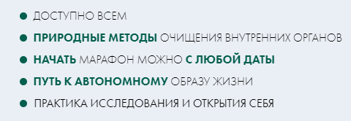

Available for everyone

* Natural methods for the innards detox are used
* You can join the marathon whenever you want
* Discover the path to the autonomous lifestyle
* Practice for self-discovery and self-reflection



Dear friends, we insistently ask you to read all the above-given information on the website attentively. If you have any questions, do not hesitate to ask our tutors for the consultation.

Click to download «Recommendations and precautions»

Home page

Who will benefit  
  
Guarantees  
  
Program  
  
  
About the «Detox days»

About us

Price

Recommendations

FAQ  
  
Feedback  
  
Useful articles

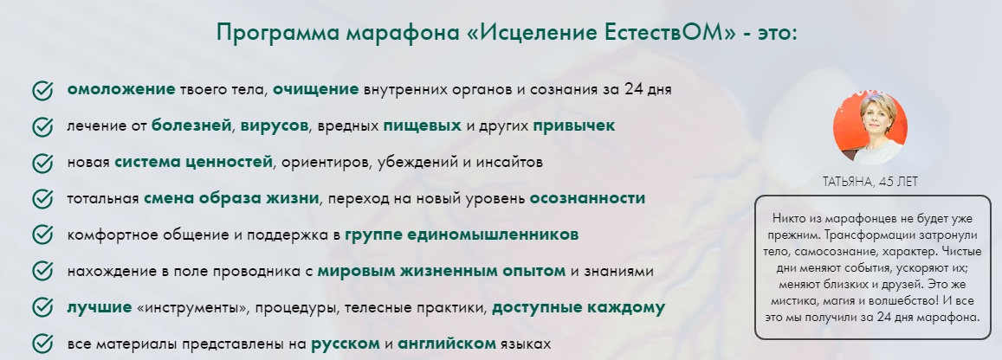

«Healing by nature» marathon program stands for:

* Your body rejuvenation, innards and mental detox within 24 days
* Healing of diseases, viruses, unhealthy nutrition and other harmful habits
* Adoption of the new system of values, life orientations, personal beliefs and insights
* Total lifestyle changing, a quantum leap to the new level of self-understanding
* Supportive and comfortable communication within the group of like-minded people
* Co-work with a guide with an enormous life experience and knowledge
* The best «tools», procedures, corporal practices, available for everyone
* All materials are given in Russian and English languages

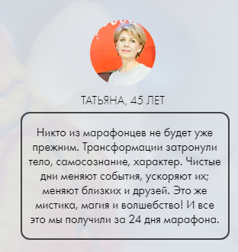

Tatiana, 45 years old

None of the marathon participants will be the same. The full transformation included body, mental and personal traits changes. Detox days probably change happenings, accelerate them; they change our friends and relatives. This is a real mysticism, magic and wizardry! All that positive changes we have gained within 24 days of the marathon.

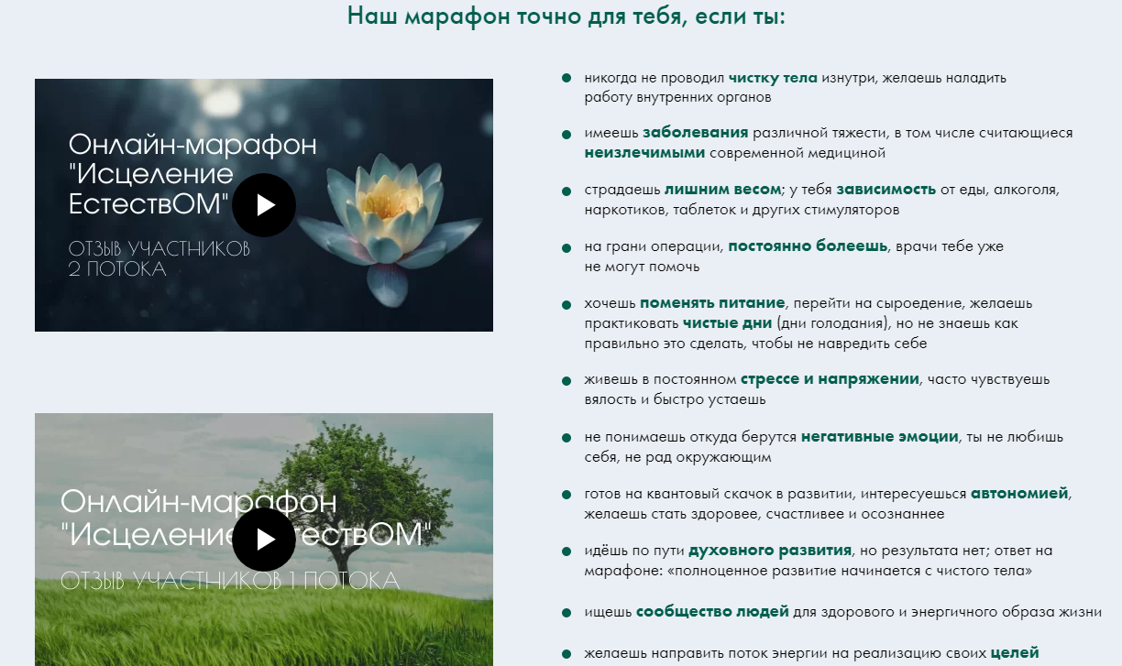

Our marathon is exactly for you, if:

* You had never experienced corporal detox inside and want to fix the inners performance
* You have diseases of varying severity, including incurable ones by the modern medicine
* If you suffer from obesity, food, alcohol, drugs, pills and other stimulators addiction
* You are about to have a surgery, you are constantly sick and doctors are no longer able to help you
* You want to change your diet, switch to a raw food diet, you want to practice detox days (famine days), but you do not know how to do it correctly so as not to harm yourself
* You experience everyday stress and external pressure, feel weakness and get tired easily
* You can’t explain where the negative emotions came from, you don’t love yourself anymore, and even you’re not friendly with surroundings
* You are ready for a quantum step in your self-development, you are interested in autonomy, want to become healthier, happier and more self-conscious
* You choose the path of mental development, but there is no result; you will probably discover the answer during the marathon, because «comprehensive development begins with a clean body»
* Is you are looking for a group of people for joining and supporting healthy and active lifestyle
* You want to direct your energy flow to fulfill and achieve your own goals

«Healing by nature» online marathon

Feedback from participants of the second stream

«Healing by nature» online marathon   
Feedback from participants of the first stream  




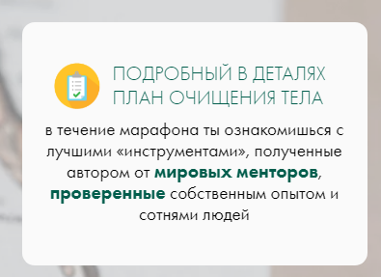We guarantee you a colossal amount of opportunities for self-changing

Detailed body cleansing plan  
  
During the marathon, you will discover all the best «tools» collected by our author from the worldwide famous mentors, these «tools» were tested by the author of the marathon himself and by a hundreds of people.

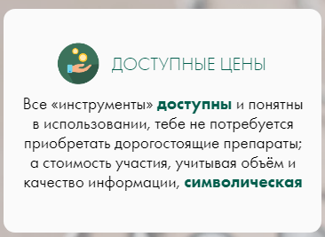Moderate prices

All the «tools» are available and easy to use, you don’t need to purchase expensive medicine; by the way, the participation cost is symbolic, comparing it with the amount and quality of information that you will get.

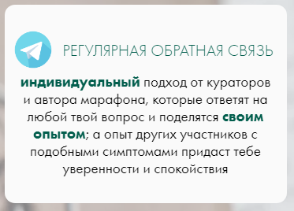  
  
Constant feedback  
You will be treated with an individual approach from tutors and the author of the marathon, they will answer any of your questions and share with you their personal experience; besides, the experience of other participants with the same symptoms will boost your self-confidence and calm you down.

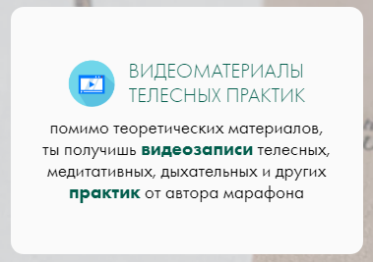

Corporal practices video materials

Despite theoretical materials, you will also get video materials of the corporal, meditative, breathing and other kinds of practices from the author of the marathon.

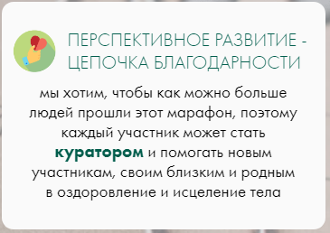  
Advanced development causes a chain of the attitude

We want to invite to join this marathon as many people as possible, that is why any of participants can become a tutor and help new participants, their surroundings and relatives to enhance their health and heal their bodies.

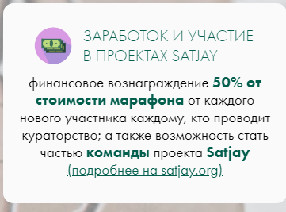   
  
Money earning and participation in SATJAY projects

You can get 50% from the marathon cost from every new participant to everyone who conducts supervision as a tutor, in addition, there is also an opportunity to become a member of our project Satjay team.  
(more on satjay.org)

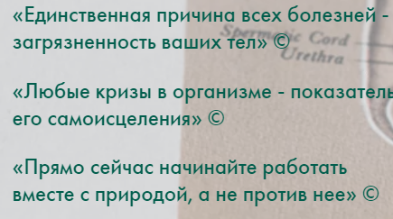« The only one reason of all diseases is the pollution of your bodies»

«Any crises appearing in the body are the indicators of his self-healing»

«Start working right now together with nature, but not against it»



«Healing by nature» online marathon

Feedback from participant of the first stream  
Results, health state and further path

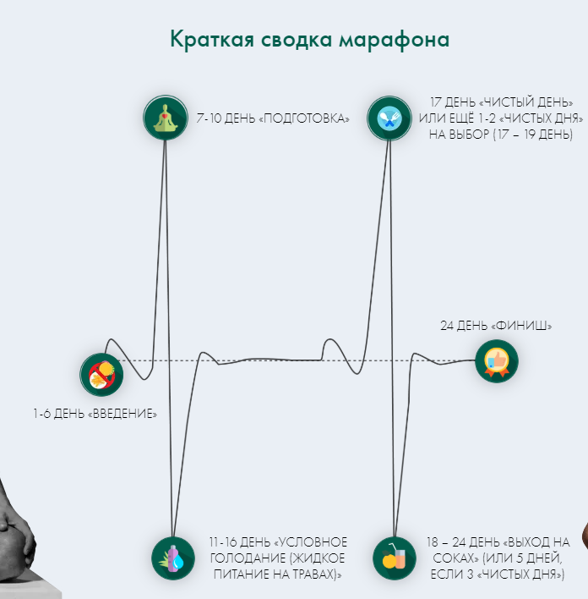Day 1-6 «Initiation»

Day 7-10 «Preparations»

Day 11-16 «Deemed famine (Liquid herbage nutrition)»

Day 17 «Detox day» or 1-2 «Detox days» at your choice (day 17-19)

Day 18-24 «Detox quitting on juices» (or 5 day if you had 3 «Detox days»)

Day 24 «Finish»

How is the marathon going?

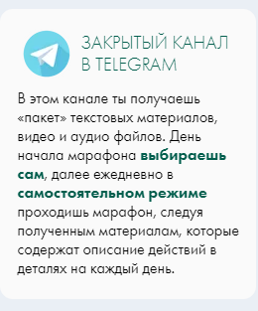Private Telegram channel

Here you receive a «pack» of text materials, video and audio files. The first day of the marathon beginning is up to you, then, you go through a marathon every day by yourself, following the materials received, which contain a description of actions in detail for each day.

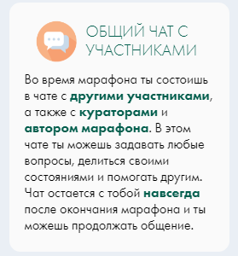

Conjoint chat with participants

During the marathon you join the special chat with other participants, in addition there also will be the author of the marathon and tutors. Here you can ask whatever you want to, share your state of health and help others. Even after the finish of the marathon you can continue to communicate with other participants.

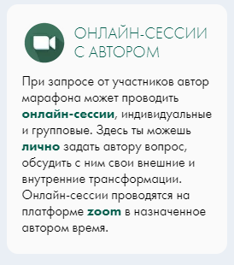   
  
Online sessions with the author of the marathon

If there is a demand from the participants, the author of the marathon can hold sessions, they can be individual or group ones. Here you can personally ask the marathon’s author any questions, discuss with him your external and internal transformations. Online sessions are held on the Zoom online platform, the author chooses the meeting’s time.

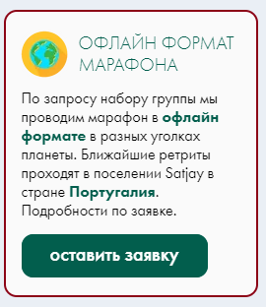Offline marathon format

If there is a demand from a group, we conduct an offline marathon in different parts of the world. The next retreats will take place in the Satjay settlement in Portugal. Details are on the application.

Submit a request



What does the «Detox day» term stands for and why do we need them?

Obligatory for reading

We provide open access to 1 of the marathon files, where you can get acquainted in detail with what "dry fasting" is, or in other words, "Detox days", "Nutrition pause".

Download bonus

Nutritive break is one of the most ancient methods of invigoration.

Mahatma Gandhi said, that famine opened him the way to the inner, mental world.

Many outstanding ancient doctors, such as Hippocrates, Ibn Sina, Paracelsus used food refusal methods for the treatment of a wide range of diseases.

Japanese medicine professor Koda Mitsuo claims, that weekly one-day food refusal is an extremely effective method, which allows us to regain previously lost health state in a year.

The beginning and the termination of such a state of self should be gradual, but the period of famine may reach weeks or even months of practice.



Nutrition pause medical results

* Изображение выглядит как текст

  Автоматически созданное описаниеDuring the famine, sweating practically stops — the skin turns from an "excretor" into an "absorber"
* Vision ability improves, so there is no need to wear glasses and contact lenses anymore
* The heavy smell from the mouth disappears, the breath becomes clean, odorless, and the morning bitterness in the mouth goes away
* Due to the active cell renewal, a person gets younger by 10 or even 15 years
* Increased or decreased blood pressure after dry fasting returns to normal rates
* Intuition increases greatly, a person begins to feel pathological or therapeutic energy zones
* Those who experiences famine regularly, notice their will development, they are able to decide reasonably and then they act with firm determination
* Изображение выглядит как текст

  Автоматически созданное описаниеImmunity to colds and endurance to cold increases
* The yellow plaque on the teeth disappears, teeth become whiter and stronger, and they sit harder in the gums
* A chronic runny nose heals completely
* Hair loss stops, and silver hair regains its former color
* Insomnia disappears and a strong healthy sleep restores, snoring passes, gnashing of teeth goes away
* Sometimes telepathic abilities open up, people begin to understand each other without words
* Awakens a sense of how much water and food the body really needs

The author of the marathon

Ilya Satjay- parapsychologist, yogi, alchemist, guide.

«During last 7 years I have healed many of my drawbacks with the power of nature, by changing my lifestyle and way of thinking, having passed the path of awakening from shamanism and yoga techniques to the path of Bretarianism. »

Within 24 days I will lead you through healing by nature to the good state of health, directing you to the body detox on the cell level from the unnecessary information.  
Here you can get familiar with me and my activities closer:



«Self-healing and detoxing is not the easiest way, however, this is exactly what your body really needs»

make an appointment for a consultation

The author of the marathon about his own way and bretarianism (видео)



The cost of the marathon

* Изображение выглядит как текст

  Автоматически созданное описаниеDetailed instructions and recommendations
* Additional video-, audio- and text materials
* Raw food menu with video recipes
* Self-check diary
* Recordings of corporal and breathing practices
* Zoom meetings with the author of the marathon
* Community of like-minded people
* Regular support from the tutors and the author of the marathon in the chat

«Healing by nature» online marathon

Feedback from the participant of the ___ stream

Meat refusal, impressions from the marathon

Date: you can choose yourself

Type: online

Price: 7500 rubles

Join

If there is the reason you do not have an opportunity to pay for the marathon, please contact with us by [info@satjay.org](mailto:info@satjay.org) and write «I want to join the marathon», and our tutor will contact you back.

Tools

To complete the marathon successfully you need to purchase a set of "tools".

You can find the list and links for ordering "tools" by clicking the button below.

These are special herbals, oils and high-quality medicine stuff, tested by our own experience, they are inexpensive and affordable.

Needed «tools» can be replaced by another antiparasitic bitter herbs, oils, etc. First you better consult with the author or tutors of the marathon.

Download file



Please do not try to complete the marathon by your own! Lack of knowledge of some nuances may cause adverse consequences. At our marathon, we will provide all the necessary information so you can easily and safely walk through this path.

Recommendations and precautions

Obligatory for reading

While passing a wellness marathon, people with certain diseases need to adhere to special recommendations. Be sure to read them carefully and refer to them as needed throughout the marathon.

Download file

You know yourself, your body, that is why you take all the responsibility yourself.

Approach the marathon responsibly. And if you can't do all the tasks, you don't need to get upset and, moreover, put excessive effort into it.

All the instructions are just recommendations. They should be completed by your desire and, and, most importantly, according with your state of health.

Doing them even by 50%, at the end of the marathon you will be satisfied with your appearance, inner state and physical well-being. Recommendations can be adjusted to your life schedule and current opportunities. Move at your own pace!

Everyone can achieve their own goals by the time which satisfies and suits their bodies!

Frequently asked questions

Will a marathon suit me if I have never practiced famine?

Of course, our marathon is a universal way of a soft transition to short-term famine, which will suit everyone.

I don't understand how exactly nutrition is connected with the development of mindfulness?

You will get acquainted with this topic in the materials of the marathon. Shortly, all the energy of the body, which was previously used in large quantities for the implementation of digestive processes, will now be directed to the development of mindfulness.

What if I have many diseases? Is it possible to join and complete the marathon?

Depending on the deseases. Read the file "recommendations and precautions". Marathon is contraindicated only for pregnant women and people suffering from severe mental illnesses. If any ailments arise during the marathon, report them to us, we will be able to tell you how to get rid of them by natural methods and how to cope with crises (stages of intensive detox of the body).

I want to complete the marathon but I’m afraid I can’t cope it without food, what should I do?

You can do it. The marathon program is designed so that you will pass the "detox days" without fear and with joy. And this exactly means that there is enough internal motivation for everything!

I practice famine from time to time, will the marathon be benefit for me?  
Yes, if you want to go through a deeper practice of the body detox. Our marathon is based on famine, but we also practice days on herbs, juices, etc.

Can I share the marathon materials with my relatives or surroundings?

Sharing of the materials of marathon to third parties, to put it mildly, is incorrect. This can lead to questions and unexpected situations from the side of the new participant. It is necessary to participate in the marathon under the guidance of tutors or the author of the marathon in a chat for participants.

  
  
Feedback from participants

Ann

36 years old, Dmitrovgrad

I will begin my review with immense gratitude to its creators! Guys, you truly heal people by giving them youth, beauty, self-confidence and self-love, and what could be more important than it?! I want to share with you with my results. I am 36 years old, two children, intolerant of diets (I have always been oppressed by diet restrictions), but nevertheless I have successfully kept Great Lent for more than 20 years (7 weeks without animal products).

Over the past 10 years, my cherished dream was to see the first digit 6 on the scales. In March 2021, I weighed 79.6 kg, during the spring Lent I have lost 5 kg, and during the Marathon another 5 kg! But what is most interesting, after the Marathon, already on a new nutrition, applying new knowledge, my weight continued to decrease, and reached 68 kg. This is my most comfortable weight.

It's been six months since the Marathon, and I haven't recovered at all. The kilograms I was happy to part with (12 kg since the beginning of the year) inspired external transformations, and now those who have not seen me for more than six months hardly recognize me).

I got rid of FOOD addiction, at the end of the Marathon I easily and comfortably went out for 3 detox days (without food), and now, although I have returned to my usualdiet, I can easily arrange a famine day for myself.

The marathon teaches a reasonable approach, what, how, when and in what quantity you needto eat, drink, or not eat, who needs it). Here everyone is guaranteed to getan invaluable experience, a new self, both inside and out! I recommend this course of detoxification, rejuvenation and wellness to absolutely everyone! Starting with all-eaters (like me), and ending with those, who aspires tobretarianism! Once again, a low bow for your invaluable work, wonderful Marathon creators! I wish you all the best Health, Love, success in everything, well-being and harmony in all spheres of life!

Eugene

32 years old, Lisbon

I was really touched by the idea of the marathon, the people and the results they showed. I decided to go further with my own marathon based on Ilya's materials. I clearly saw all my weaknesses and where to put effort now. Ilya, thank you very much for lighting this fire inside me. He began to show the direction that I had been looking for a very long time.

Thanks. Hugging everyone.

Natalia

36 years old, Dmitrovgrad

Sasha, thank you so much for inviting me to this marathon! I was very glad to complete it under the guidance of a wonderful bright man Ilya, glad to be surrounded by interesting people, glad to discover a new me, glad to be in the same energy stream with you!

Special thanks to Ilya for this magical marathon. I am absolutely sure everyone needs it, no matter at what stage a person is, what he is looking for, what he exactly needs. Here everyone will find their own path.

Good luck and love to all! I'm not saying goodbye!

Tigran

59 years old, Vladikavkaz

Guys, I did it all. I mean three dry days. I respect myself so much now! If someone had told me before the marathon that it was so cool, I wouldn't have believed it. I could have gone further, but I clearly didn't have enough energy for worldly fuss. As a result, it took 13 kg of weight and some new life interests began to appear in my life. I can state a certain transformation of consciousness. I think that everything is in the process. I want to thank all the guys who shared their experience here and of course Ilya!

Vera

55 years old, Vyazniki

Friends! I invite you to virtually stay next to very interesting and talented people and go through your marathon «Healing by Nature»! No, no, you don't have to look after the chakras and worry about prana. Only really useful practical knowledge: cool, professional and confident! Support for all 24 days! The result is full, slender, beautiful! Lightness in the body (switching to cascade nutrition) and clarity in the psyche. To prolong youth, it is not necessary to run to a plastic surgeon and drink medicines by handfuls, you just need to reach a new level of perception and a MARATHON will HELP YOU! Ilya, Alexander! You are doing important and eco-friendly work! I sincerely wish that your sources of inspiration do not run out, goodness and prosperity to you!!! Hug!

Stanislav

31 years old, Moscow

It feels like I am a little bit closer to the love and the warm of God. Thanks for this marathon!

More feedbacks

Aryuna

30 years old, Moscow

I feel so active! Wow! So much energy, I plan to do a lot of things today! Have a magical day, friends! I hug everyone!

Victoria

39 years old, Electrostal

Thanks for the marathon! He opened a window for me into a world I never dreamed of. So far, I'm studying, watching, practicing. Many thanks to Ilya for not just telling me what to do, he gives direction and information so that everyone can choose their own path to the body detox that they need! It is not easy, but easier than it seems!

Reaching a new level of life is only in your hands! Full spiritual development begins with a healthy and clean body!

Consultation join healing



By nature

Contacts



Address

Moscow, Pavlovksaya str., 18-257

Information

Personal Data Processing Policy