Handbags
Item | Description
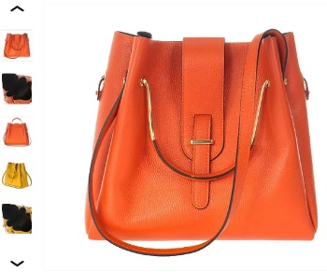 | Tara  Stylish Tara tote bag features a contrasting combination of classic rectangular shape and soft leather texture. The roomy model, complete with functional shoulder straps, is the perfect companion for the woman who loves comfort.
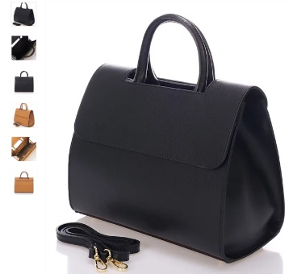 | Gabriella  This model from the brand new collection easily contains everything you need for every day. An elegant leather accessory, complete with a textured flap, epitomizes contemporary chic. The comfortable shoulder strap allows the bag to be carried as you wish.
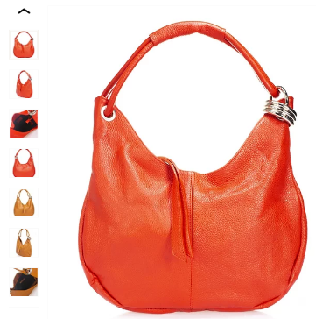 | Lilly  Lily's bag is made of soft, pleasant leather. Double handles add versatility to this adorable model and make it comfortable for everyday use. Sparkling silver hardware rounds off this sophisticated design.
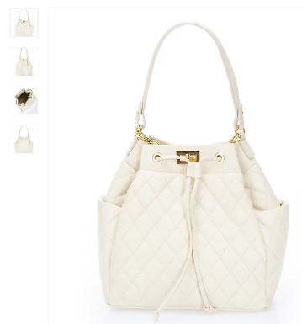 | Delphine  The Delphine bag is your best wardrobe investment. Full of elegance, it will supplement any of your outfits. Capacious and durable, it is easy to care for. Deep inside, it may easily replace a small backpack and serve as an elegant everyday accessory.
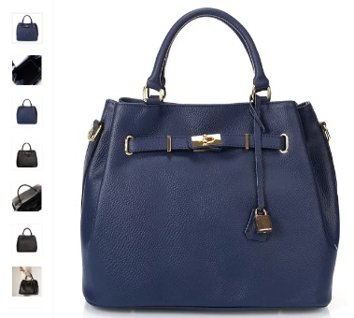 | Jeanne  Jeanne model is decorated with a pendant of the main color of the bag and contrasting accessories. The bag is a gorgeous piece of exceptional quality and is suitable for the office and the special occasion usage. This model can be worn in the hand or on the shoulder and can be combined with other products of our brand.
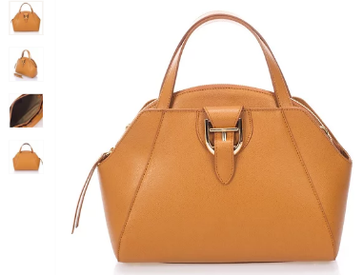 | Sophia  A graceful medium accessory made of smooth leather with a rich tone and characteristic texture. Timeless design features classic details such as a lock, comfortable short handles and gold fittings. The detachable shoulder strap allows the bag to be carried on the shoulder or over the shoulder.
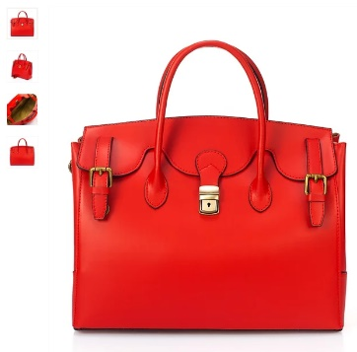 | Alice  The model made of genuine leather will be appreciated by businesswomen. It goes well with elegant dresses, looks great in an ensemble with classic jeans and a T-shirt. Delicate taste, elegance and brightness characterize the owner of such a tote bag.
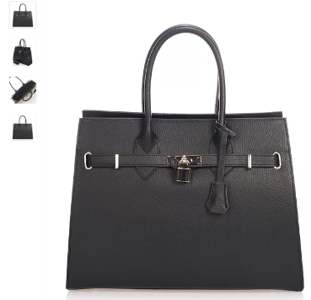 | Sonia  Finding the perfect bag for your daily needs is hard to find, but lucky you to see this model! The versatile black color, the convenient storage compartments and the stylish front lock make this bag your best friend.
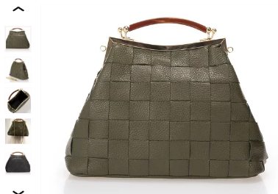 | Simone  This elegant mid-size accessory features a striking, sculptural silhouette and roomy, functional design. The classic handle will be comfortable for everyday wear, and the additional shoulder chain strap will decorate your evening look and make it unforgettable.
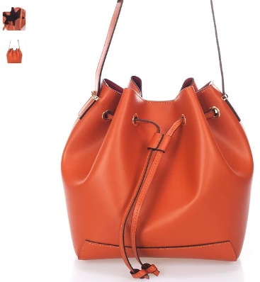 | Angelica  Bucket-bag is a fashionable necessity for every modern woman. A secure drawstring, woven handle and long shoulder strap make it easy to carry on. The bag combines trendy shape, practicality and color that perfectly matches fashionable looks.
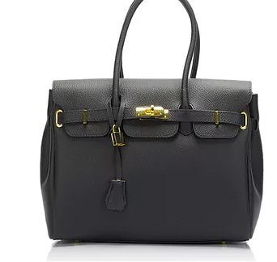 | Nicole  Feminine Nicole bag made of luxurious leather is the epitome of sophisticated urban chic. This sophisticated accessory is complemented by stunning details in a classic style: a metal lock, contrasting hardware and decorative leather ties. The functional handles make the Nicole bag your favorite accessory.
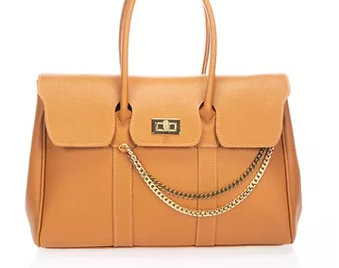 | Carole  This genuine leather model, decorated with scrumptious chain-shaped elements in the front, will accommodate all the little things you need. The small tote bag, made in the best traditions of classy everyday handbags, can be carried in the hand or on the shoulder.

Cross body bags
Item | Description
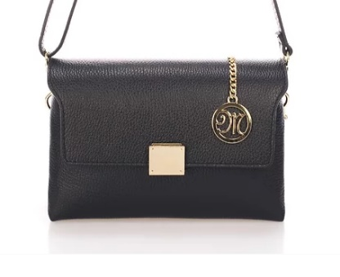 | Anna  Sophisticated compact bag of modern design made of black leather. Refined details such as the gold-colored hardware and pendant embodies our vision of contemporary elegance and beauty.
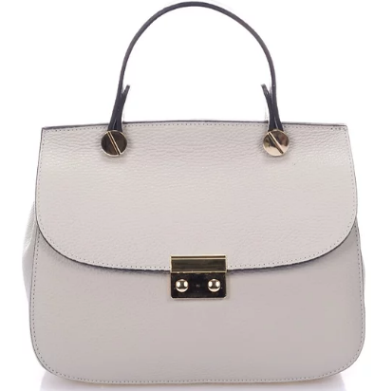 | Sarah  Comfortable handles complement this charming everyday model. Trendy colors will serve as a bright accent in your look. The wide detachable shoulder strap allows the accessory to be worn over the shoulder or in a cross-body style. Thanks to the capacity of the bag, all the necessary little things will always be at hand.
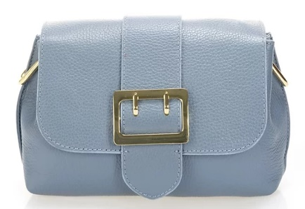 | Kate  Kate bag has a striking and laconic design. It is made of luxurious smooth glossy light blue leather. The modern style model has a magnetic flap. The ideal accessory for an evening look is complemented by a detachable shoulder strap. The bag can be carried as over the shoulder bag or as a clutch.
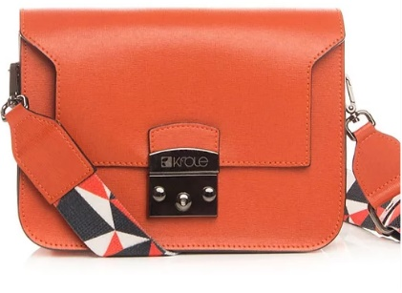 | Samantha  Our brand new bag with a shoulder strap with geometric patterns will perfectly highlight your personality and become your best friend. The medium bag can be carried in hand, over the shoulder or cross-body and can be paired with a day or evening wardrobe.
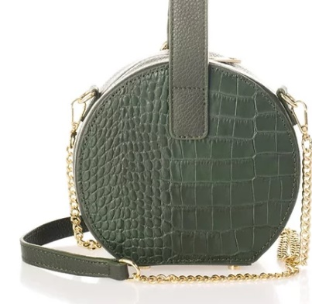 | Natalia  The Natalia bag embodies a classic vision of sophistication and beauty. It is an elegant, timeless yet contemporary masterpiece. The eye-catching shape of the bag and crocodile leather will definitely set you apart from the crowd.
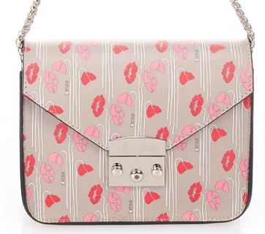 | Jessica  The small size model is perfect for every day. The model features signature design elements: geometric flap and stylish print. Feminine colors and unusual print will accentuate the image and add a bright element to it.
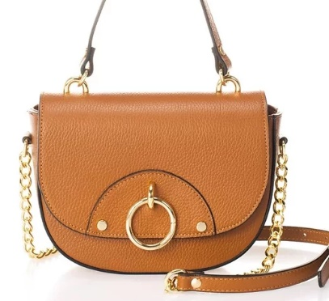 | Maria  A graceful gold-colored chain, gold fittings and an unusual shape are the keys to the success of this model's design. The model, complete with functional compartments, perfectly accommodates important accessories.
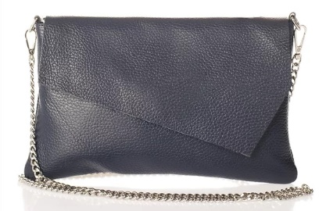 | Jessica  Spectacular roomy bag allows you to keep all the necessary accessories close at hand and goes well with day and night looks. This model will perfectly fit into the office dress code, and will also look perfect in relaxed urban looks.

Backpacks
Item | Description
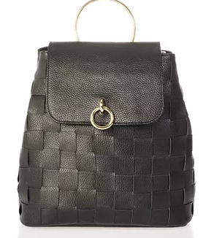 | Emilie  This elegant Emily backpack is crafted in woven leather with a comfortable carry handle and dual shoulder straps. The lightweight model, ideal for a modern look, holds all the essentials. Shiny hardware emphasizes the beauty of this accessory.
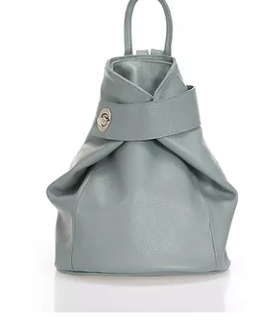 | Anais  The unusual shape of this backpack will surely attract attention. The color range of this model contains colors that suit any, even the most unusual image. The extraordinary clasp of this accessory will become your love at the first sight.
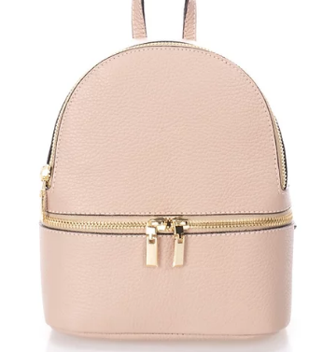 | Jennifer  Jennifer trendy mid-size backpack features a sleek silhouette. The roomy model is complemented by golden fittings. Comfortable handle and adjustable shoulder straps allow you to alternate between style variations. An external zip pocket completes the functional design.
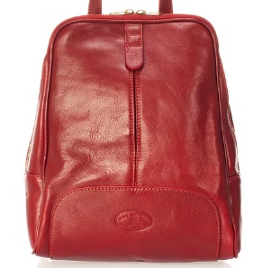 | Caissie  The stylish women Caissie backpack made of genuine leather will complement the image of any modern girl. The Cassie backpack is presented in a stylish, minimalist design, and the bright color will add contrast to your look. You definitely need to choose this one!
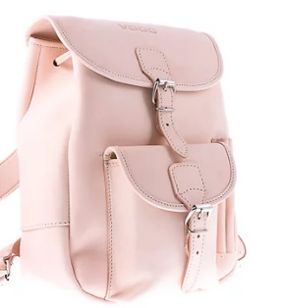 | Vintage  The new Vintage backpack combines modern character with classic elegance. The model is made of genuine leather and decorated with pockets that instantly attract attention and are suitable for small things. The model is small in size with adjustable padded shoulder straps, which can be worn on the arm, on the shoulder or on the back.
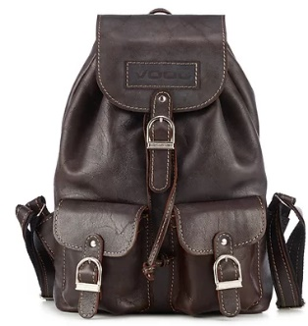 | Retro  The middle-sized accessory with adjustable shoulder straps complements the look in many stylish variations. The practical model, decorated with patch pockets, easily accommodates a smartphone and other little things for every day. A reliable main section of the backpack will protect all the most valuable belongings.
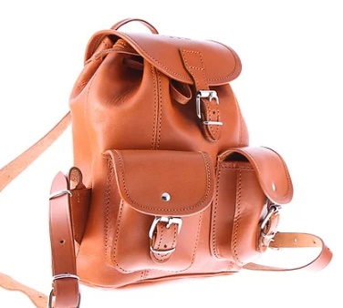 | Vintage  The vintage model with patch front pockets can hold all the things you need during the day. High-quality material, large volume of the backpack and comfortable handles are exactly what you need!
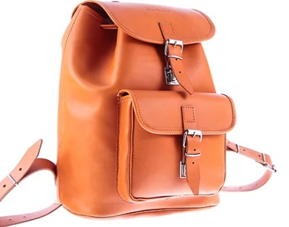 | Vintage  This roomy backpack will be your new friend. High quality tailoring, straight lines and classic shape will make this backpack your daily must. Do not hesitate and be the lucky one who can own it.

Business bags
Item | Description
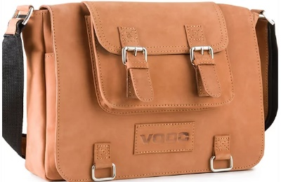 | Crazy Horse  Classic A4 leather bag with wide functionality will be your best friend at work and outside the office. Genuine leather, laconic design and high-quality workmanship are the reasons why you need it. Convenience, comfort and functionality are three words that describe this bag.
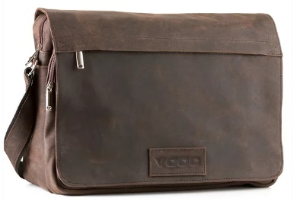 | Urban  This casual business bag is suitable for both men and women. The adjustable shoulder strap and the comfortable shape of the bag make it easy to put your things in and out. The large volume inside will allow you to take everything you need.
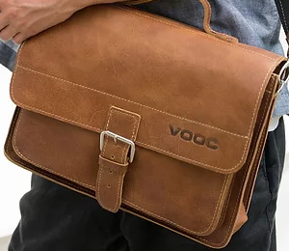 | Satchel with a strap  Our "Satchel with a strap" model is a must-have for the modern businessperson. Sewing from soft high-quality fabric allows the product to retain its original appearance. Basic colors allow this bag to harmoniously fit into any look.
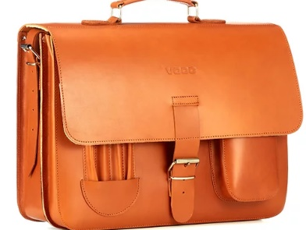 | Vintage briefcase  This classic full-featured unisex leather bag is exactly what you were looking for. The functionality of the accessory is achieved due to the many well-thought-out and convenient compartments and it perfectly fit the whole design of the product. laconic design and the highest quality will serve the owner of this bag for a long time.
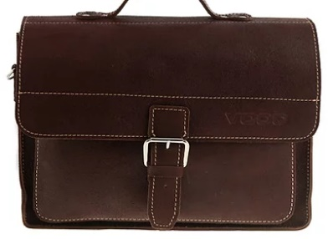 | Satchel with a strap  Universal accessory in multi-colored leather with external pockets, ideal for A4 documents and laptop. The wide, removable, smooth leather shoulder strap allows you to carry the bag in a variety of styles.

