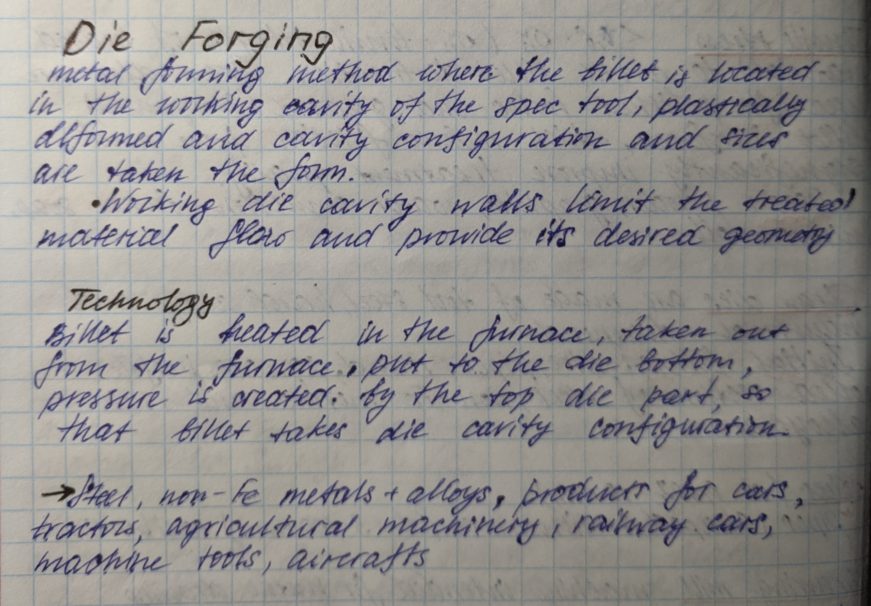Die Forging
Metal forging method where the billet is located in the working cavity of the spec. tool, plastically deformed and cavity configuration and sizes are taken the form.
Working die cavity walls limit the treated material flaw and provide its desired geometry.

Technology
Billet is heated in the furnace, taken out from the furnace, put to the die bottom, pressure is created by the top die part, so that billet takes die cavity configuration.

Steel, non-Fe metals +alloys, products for cars, tractors, agricultural machinery, railway cars, machine tools, aircrafts.

