# Aleo

Web services use our data in exchange for accessible functions, and it is a generally known fact. Privacy and security are becoming more critical and less attainable day by day.

And what is more important, web services enter new aspects of our lives, asking for more and more personal information. Now developers must think about data control to achieve clients’ trust. Aleo offers a solution.

## The Era of Privacy Is Coming

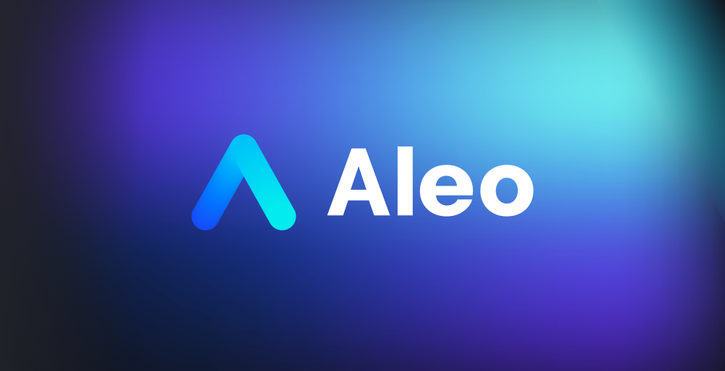

Aleo is a 2022 project for developers who take data privacy with due attention. It is a coding platform that allows the creation of entirely private, scalable, and cost-effective applications. Aleo developers aim to build a concept of personal web data, which is not available now.

To create an account anywhere, a user must provide quite a long list of data. It includes contact information, login, password, etc. While applying Aleo, companies and web services will still check it, but they won’t see and take advantage of it.

## Zero-Knowledge Approach Is the Key

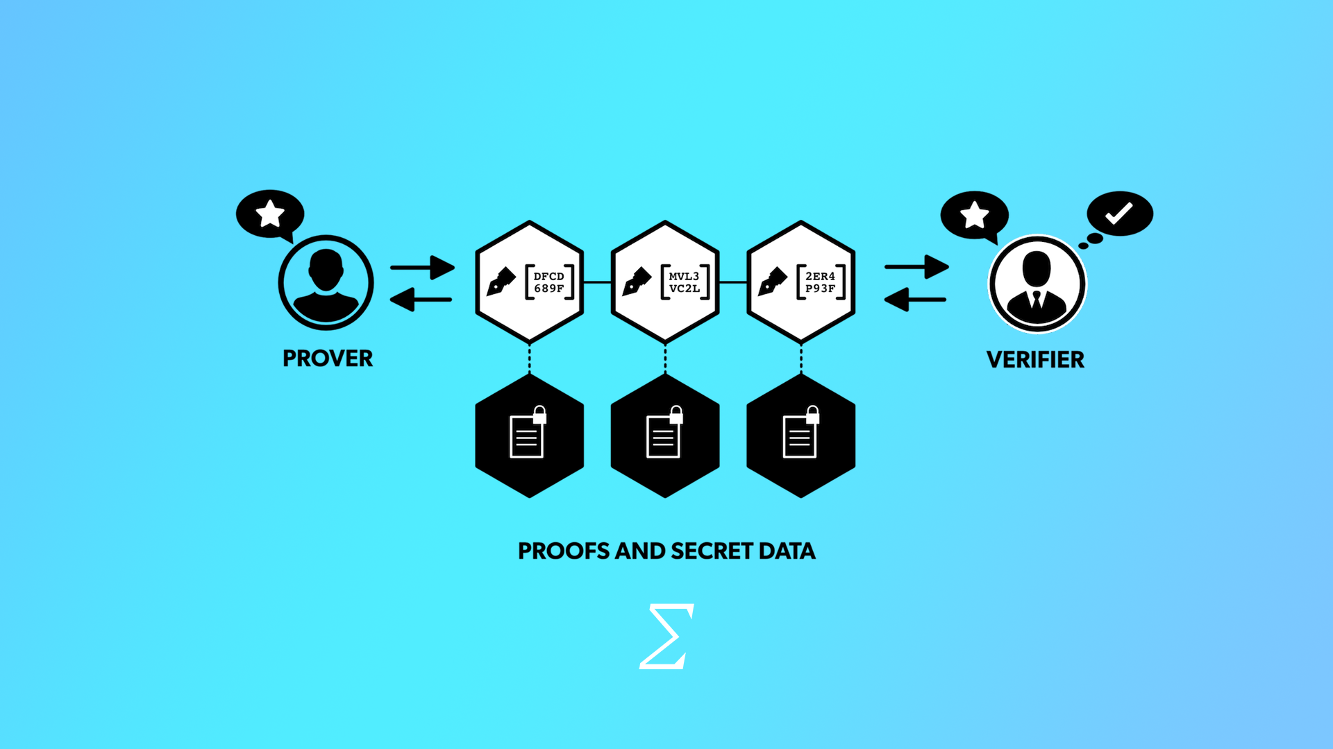

The algorithm we described above is available with zero-knowledge cryptography. It is a cryptographic protocol in which one party (the prover) establishes to the other party (the verifier) ​​that something is true without revealing its validity. This approach ensures that neither the verifier nor any party observing the transaction learns why the assertion is true. This is a summary of how Aleo works.

### Benefits for Users

* With the ability to simply hash a password on the device, a user doesn’t have to send it to a web service. It lowers the chances of data leaks and account hacking.
* Aleo puts the power back in the hands of users, not the corporate interests that control it. Only you define your digital personality and choose what to share and with who.

### Benefits for Web-Services

* While a service doesn’t handle the data, it doesn’t risk compromising it, so the legal responsibility becomes significantly more accessible than ever before.
* With the privacy-by-default principle, access control overhead becomes lower due to safety measures and another level of data breaches control.

### Benefits for Developers

* Aleo is moving the execution of intelligent contracts off-chain to enable a wide range of decentralized applications that are entirely private and can scale to thousands of transactions per second.
* Like Ethereum, it provides a new level of flexibility but with a more scalable architecture. Miners should only check transactions instead of re-running them every new time.
* Aleo is creating a new programming language called Leo, specified for writing private and zero-knowledge services. Now a playground is running, and everyone can have a try.

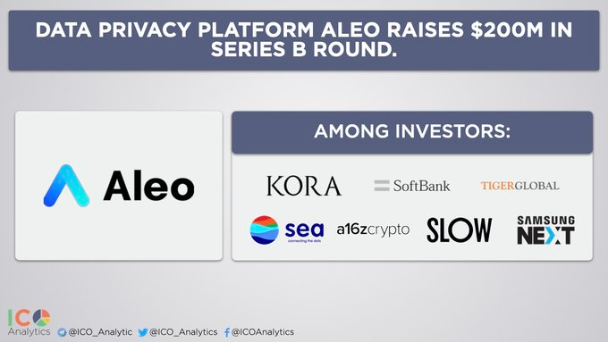

Our platform has grabbed the attention of professionals in cryptography. Famous funds like Polychain Capital, Coinbase, and Galaxy Digital provided $28 billion for development. February 7th, another $200 million was raised from SoftBank and a16z.

To support the brand, you can take part in an ambassador program. We will include active participants in the pre-whitelist at the public sale and provide tokens. Join the Aleo ecosystem and see how the field of web-dev will change.

<https://text.ru/antiplagiat/620b5c8aaf120>

<https://glvrd.ru/s/6atbnA/>

<https://pastenow.ru/b8a548b195715b47c7dfe0695b5fe39f>