ID 1
Summery: User can't select Spanish when clicking "Select Language" button
Severity: Trivial
Priority: Low
Type: localization
Assigned: assign 11
System/Environment: Windows 10, Google Chrome V.94.0.460681(oficiale version), 64 bit.
Precondition: Open site lifecell.ua

Steps:
1.Hover over the "Language Selection" button
2.Select Spanish language to understand the site

Expected result: Spanish is in the "Language Selection" menu
Actual result: Spanish is missing from the "Select Language" menu

Attachment:
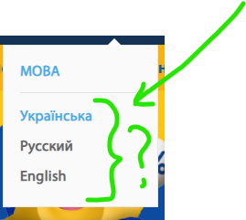

ID 2
Summery: When pressing the "Business" button, the opening panel flickers (open / close) with an interval of 3 seconds
Severity: Trivial
Priority: Low
Type: localization
Assigned: assign 12
System/Environment: Windows 10, Google Chrome V.94.0.460681(oficiale version), 64 bit.
Precondition: Open site lifecell.ua

Steps:
1.Hover over the "Business" button
2.Click on the "Business" button to stabilize the open panel

Expected result: The open panel "Selecting the type of Business" will function stably
Actual result: The open panel "Select the type of Business" opens / closes with an interval of 3 seconds
Attachment:

ID 3
Summery: "My lifecell" button is loading slowly (20 seconds after site activation)
Severity: Trivial
Priority: Low
Type: localization
Assigned: assign 11
System/Environment: Windows 10, Google Chrome V.94.0.460681(oficiale version), 64 bit.
Precondition: Open site lifecell.ua

Steps:
1.Hover over the "My lifecell" button

Expected result: The "My lifecell" button loads quickly, like all the buttons in the Main Menu Bar
Actual result: "My lifecell" button is loading slowly (more than 20 seconds)
Attachment:
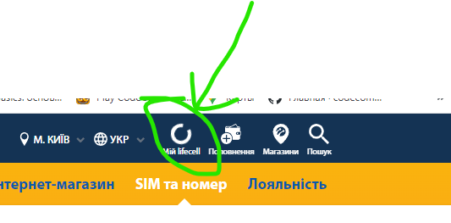

ID 4
Summery: The User cannot return to the lifecell.ua Homepage after he has gone to the page https://my.lifecell.ua/
Severity: Minor
Priority: Low
Type: localization
Assigned: assign 11
System/Environment: Windows 10, Google Chrome V.94.0.460681(officiale version), 64 bit.
Precondition: Open site lifecell.ua

Steps:
1.Press the "My lifecell" button on the Main Menu Bar
2.Press the "My lifecell" button in the opened window
3.Press the button symbolizing the Home Page

Expected result:
Should return to the lifecell.ua page
Actual result: page https://my.lifecell.ua is just being updated
Attachment:

ID 5
Summery:
When the User enters the duplicated code +38, the "Confirm" button is activated
Severity: Minor
Priority: Low
Type: localization
Assigned: assign 11
System/Environment: Windows 10, Google Chrome V.94.0.460681(oficiale version), 64 bit.
Precondition: Open authorization page: https://auth.lifecell.ua
Steps:
1.Enter number +380633595422 for authorization

Expected result: The "Confirm" button is not activated (grey color)

Actual result: The "Confirm" button is activated (yellow color)

Attachment:

