## Report on training and risk assessment in the Madanur guest house

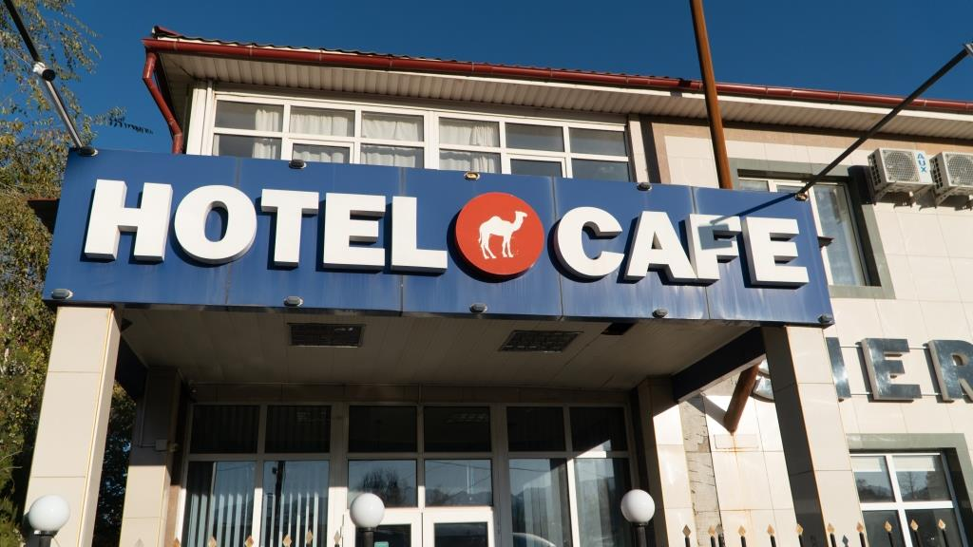

## About the guest house

Madanur guest house stands out from other objects for its size and activity. Despite the fact that the guest house has only 15 rooms, business activity is significantly higher than in similar guest houses. This is probably due to the presence of a conference hall and a coffee shop Sierra, which is popular in Bishkek, in Karakol-the only one. Madanur was built and launched in 2006 and since then has been successfully operating in the market with an average annual load of 50%, receiving more than 3400 tourists a year. The guest house has 15 rooms with a total capacity of 30 people. The main partners of Madanur guest house are tour companies such as Ak-Sai, Novi nomad, Kyrgyz Concept, CAT, Travel Land", Travel Experts, who brings tourists from Western Europe, the Middle East and Japan. High seasons are the months from May to September and from December to February, in the off-season March-April and October-November, the number of tourists falls significantly. The total number of employees is 10, the head is Madina Balakhisheva.

* 1. The existing risk management system at the guest house

The area is well fenced and lit. Video surveillance cameras are available. Access to the rooms is possible with individual keys.

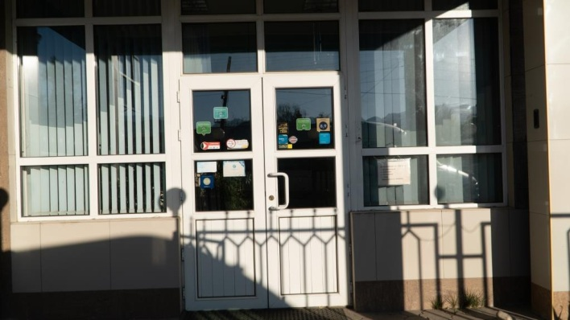 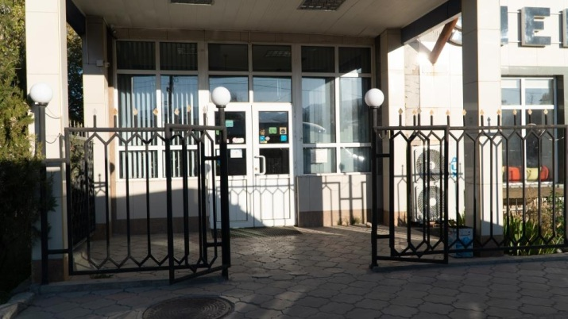

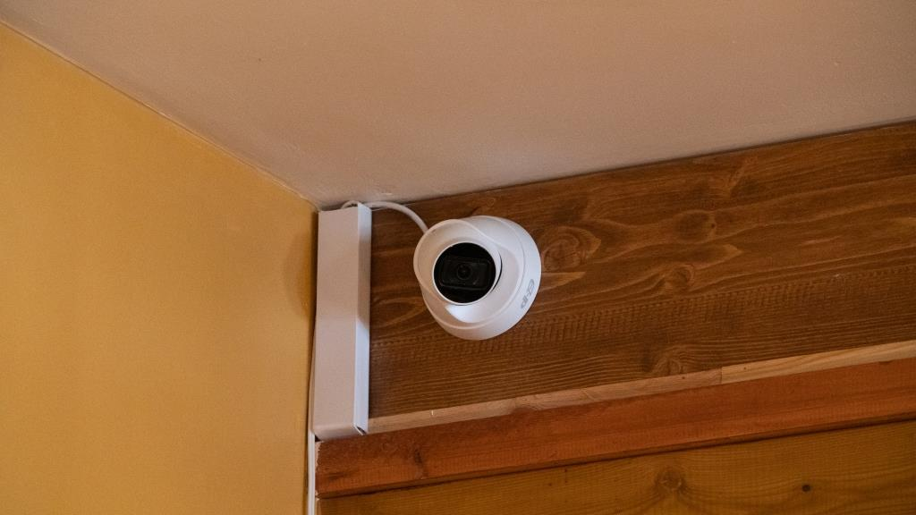 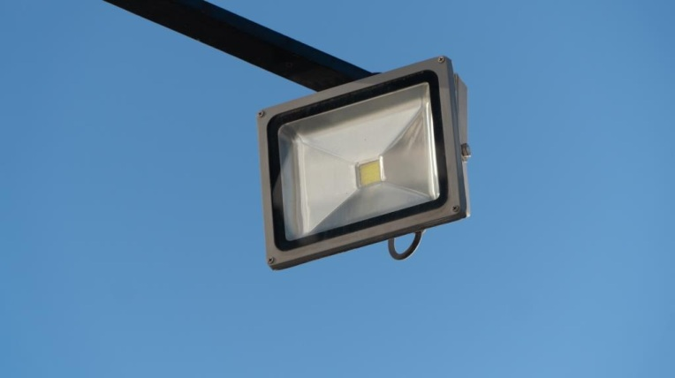

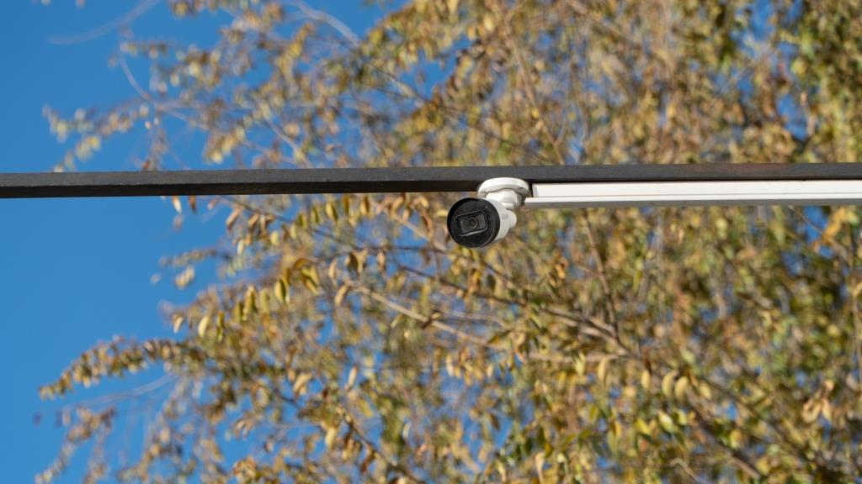 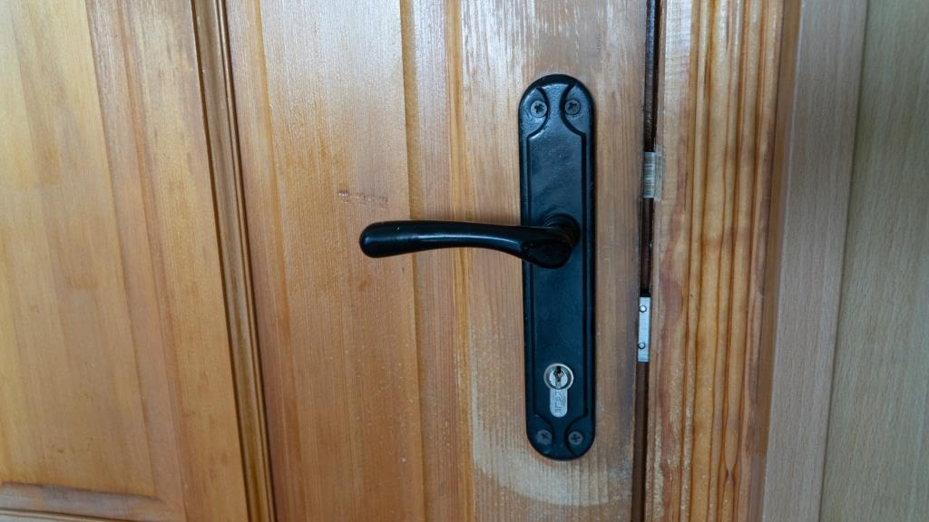

Fire safety is provided at a fairly good level. There are fire extinguishers, temperature sensors, warning signs "Do not smoke", fire alarm and fire escape.

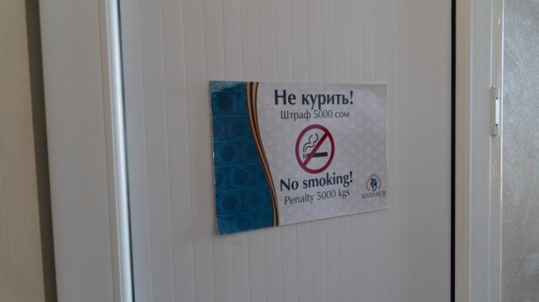 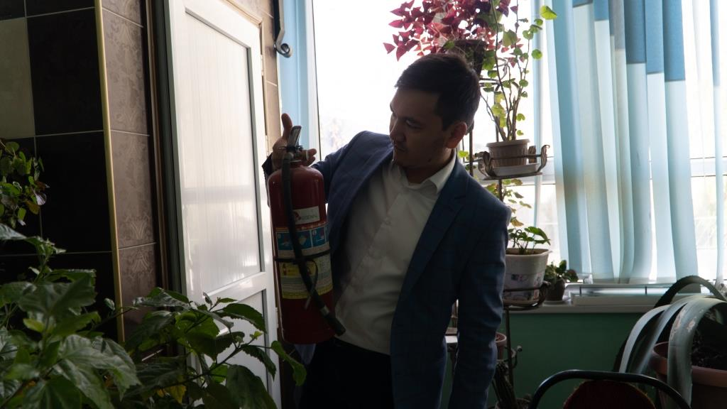

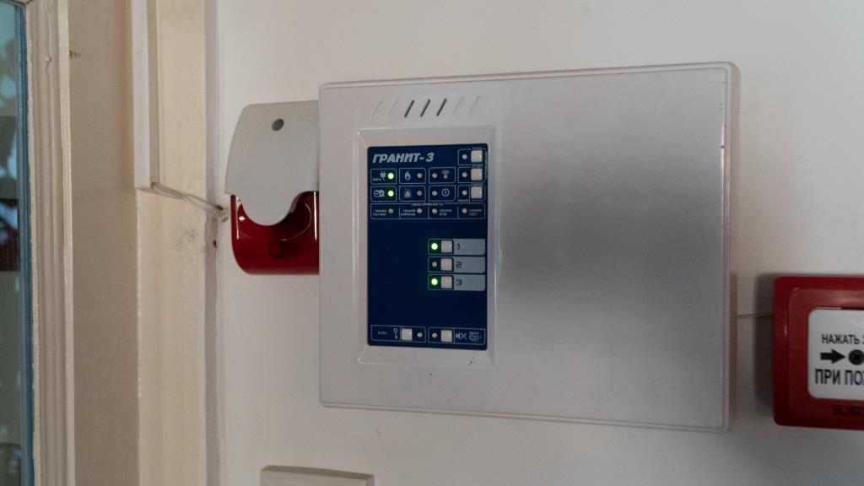 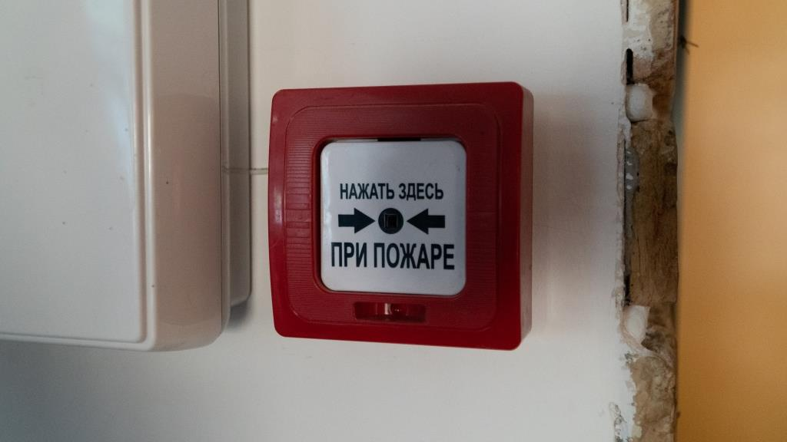

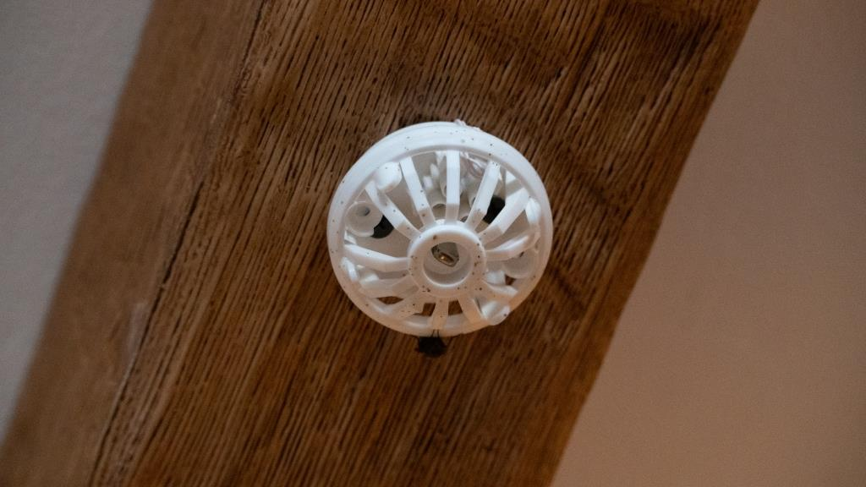 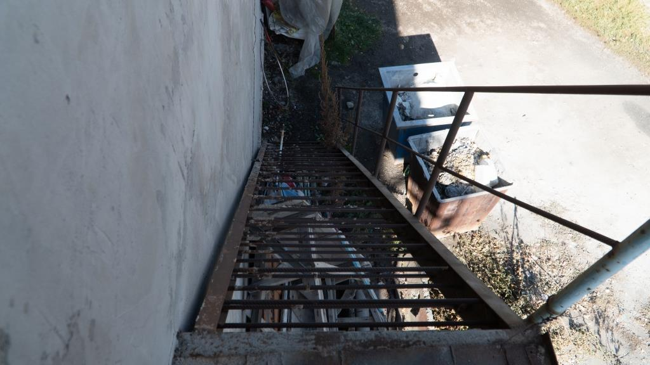

In terms of food safety, Madanur guest house complies with the basic requirements.

Products in refrigerators are maintained in separate containers, banks, packages. Boards are marked.

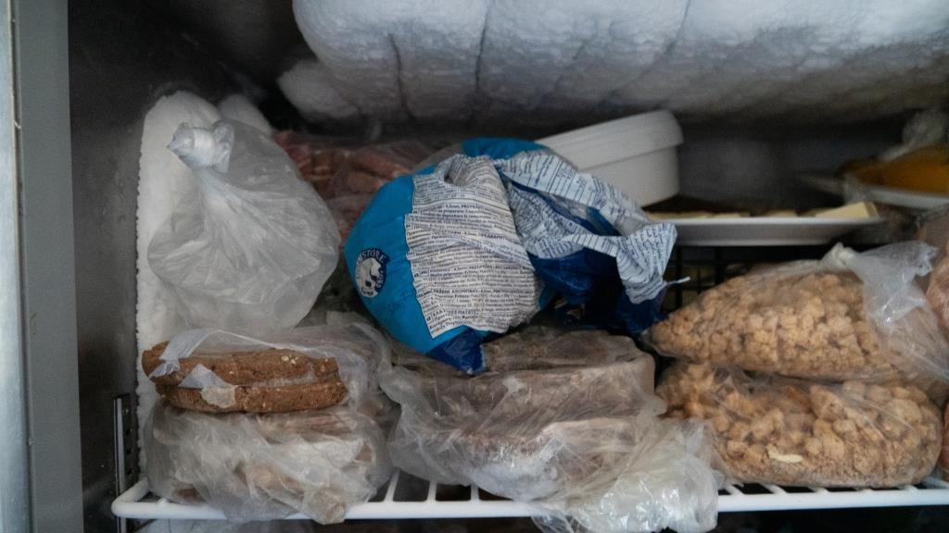 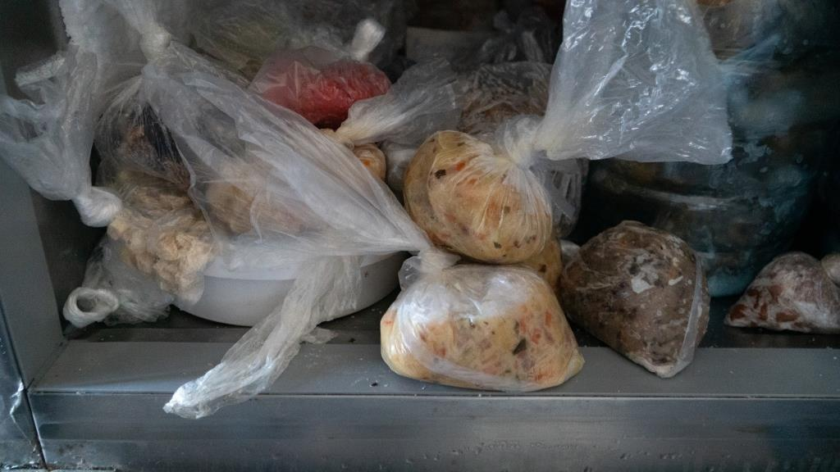

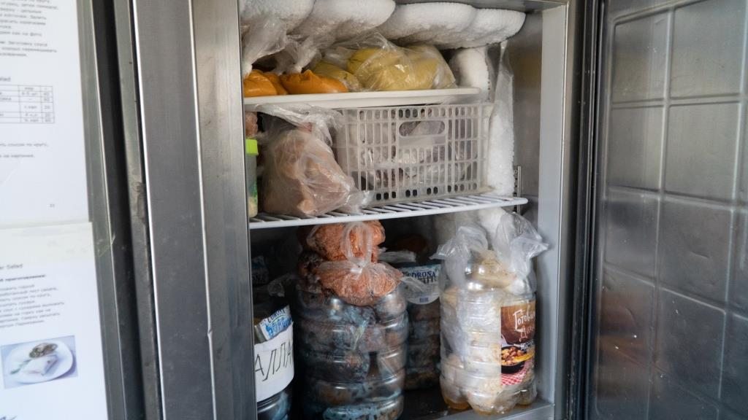 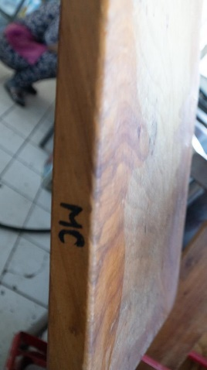

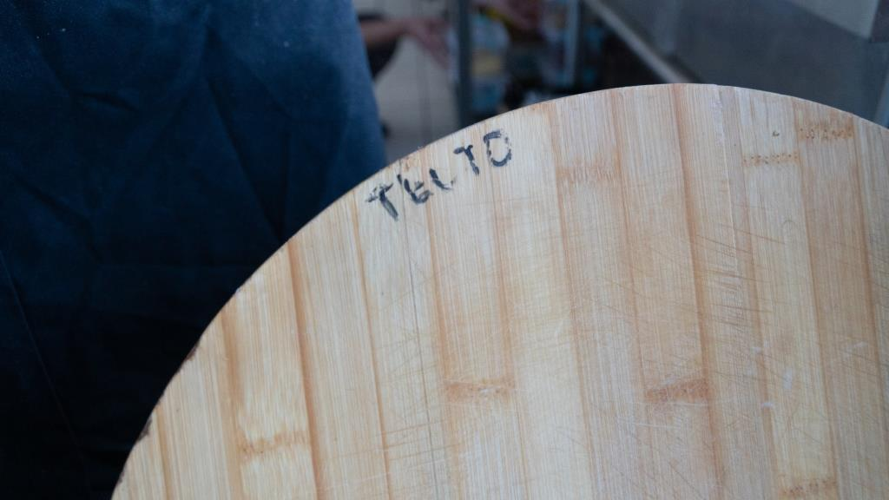 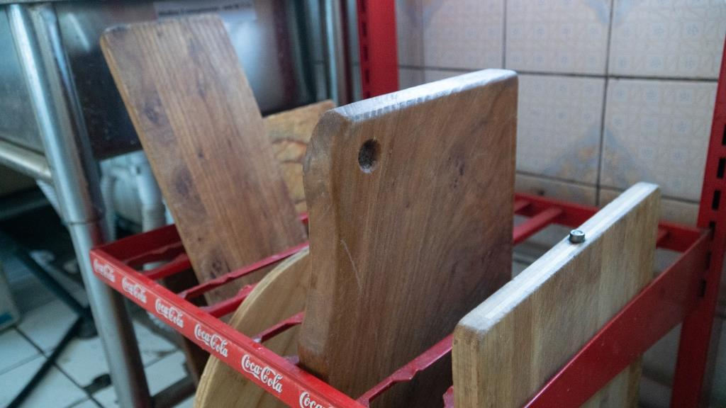

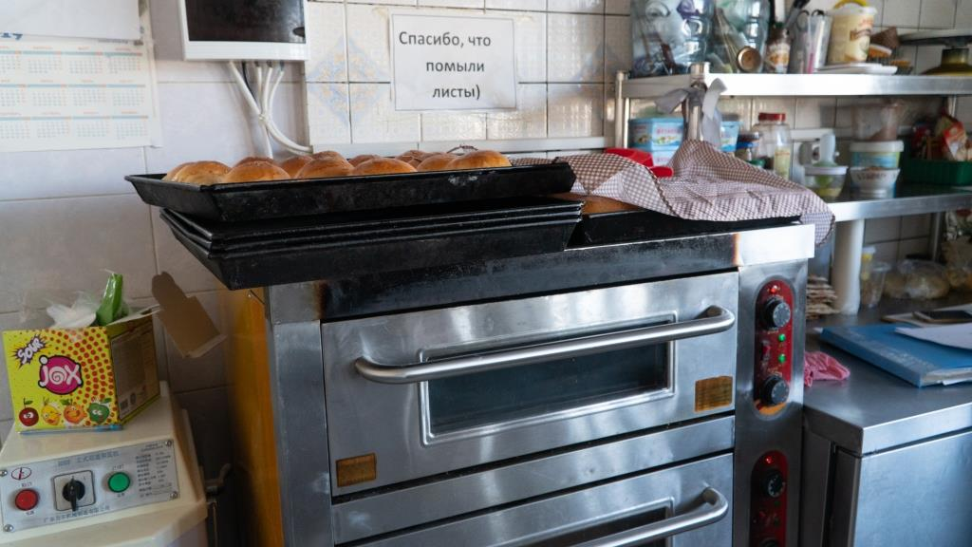 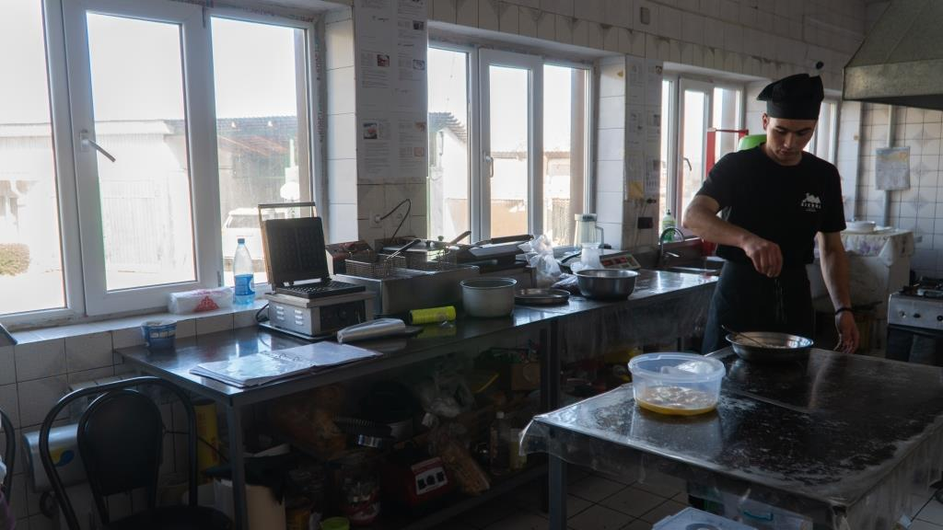

Hygiene in Madanur guest house is provided at a fairly satisfactory level. Clean linen is stored separately in dry and bright rooms. There is a liquid soap and a paper towel in shared bathrooms. Cleaning materials are used for washing and disinfection. They have washing and drying machines.

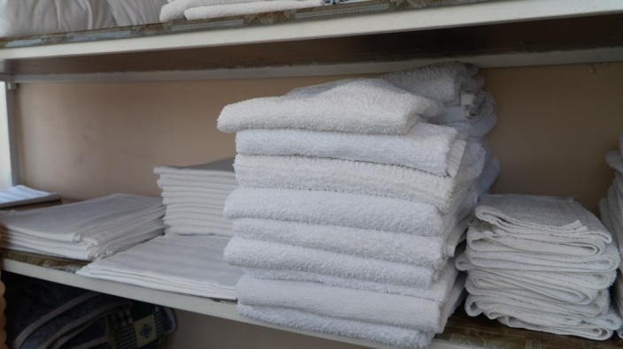 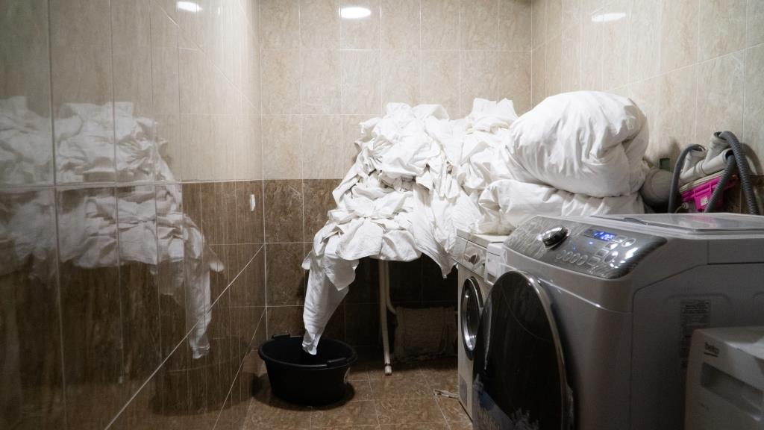

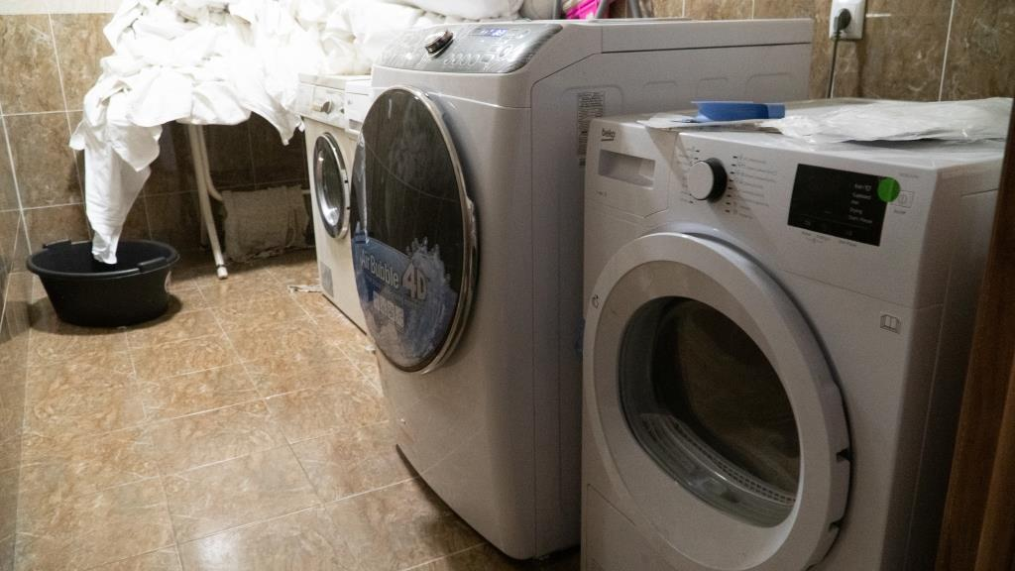 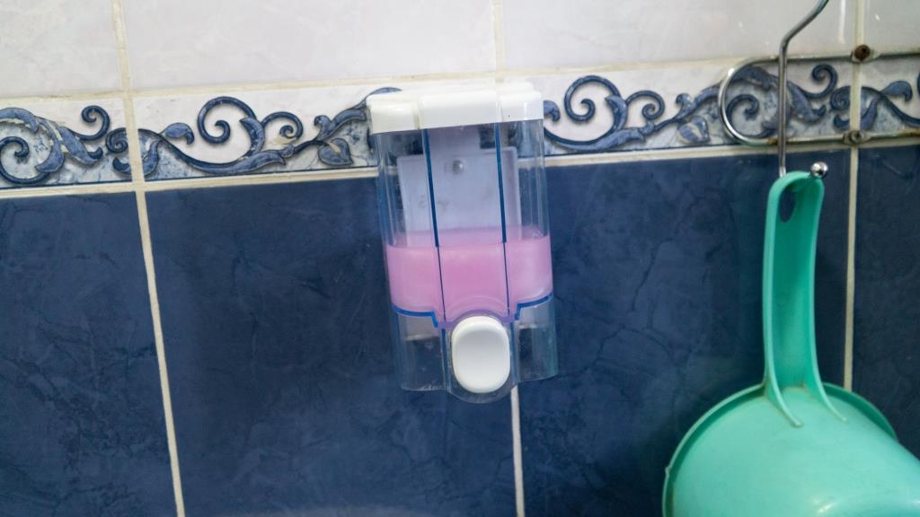

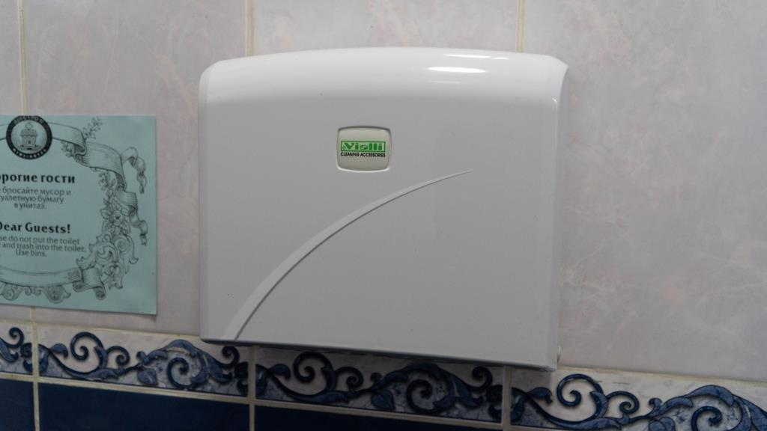 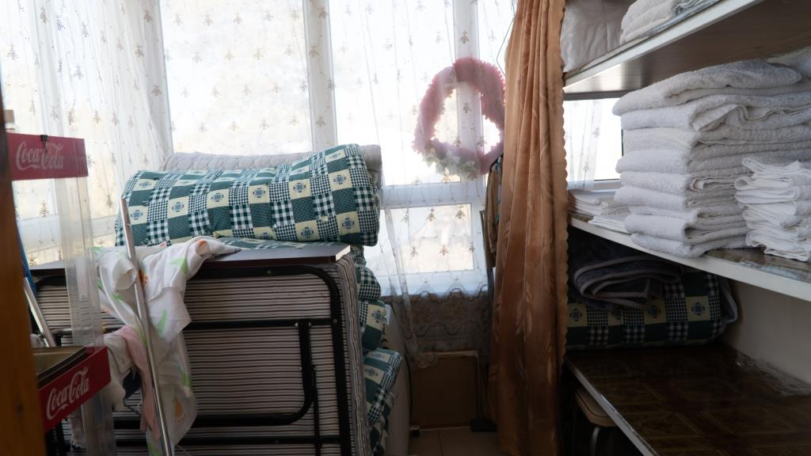

Unfortunately, the guest house doesn’t have an infrastructure in accommodating people with disabilities.

* 1. Identified deficiencies and recommendations

Madanur guest house needs to check if all fire extinguishers are ready for use. Some fire extinguishers should be refilled. It is necessary to develop and hang evacuation plans in each room and in the common area. "EXIT" signs must be hung above each exit. Purchase gas masks. Mark all products in the kitchen. Sign an agreement for deratization and disinsection services. Require medical books from employees. Complete the first aid kit.