## Want to become stronger?

It is not a secret that sport is an integral part of people's lives. Today we have a huge choice variety from gymnastics or gym to boxing or MMA. What is MMA? What I will learn there? Where to join?

Firstly, MMA- mixed martial arts, is a relatively new kind of sport afront of boxing. The first MMA performance was in 1993, called “UFC 1”. In Ukraine, the 2010 captured the first funs when the first competitions were organized. It was the groundbreaking time for this new baked sport, era MMA began.

I have been a member of the leading MMA club in Lviv “MMA Center Lviv”,for 2 years. Here is why I keep training here and why I recommend it.

Why our club?

## Our goals:

One of our coaches, also the first master of sports in the Lviv region is Ruslan Telibalev. He conquered this title after winning the bronze in the lightest weight “56 kg”, in the Czech Republic.

Our members won loads of medals and rewards on regional competitions, Ukraine cups and world cups that you can see in the profile of the club on Instagram.

## Trainers:

Oleg Gritsyuk- the main coach, developer of “MMA Centre Lviv” and a great person. He has been connected to MMA for 10 years already and his goal is to raise a strong and healthy generation.

Ruslan Telibaev, mentioned above, the pupil of Oleg and trainer of the youth group.

Vadim Knishevich and Roman Gritsina, both trainers of morning group, and both replace Ruslan or Oleg in an emergency case.

## The location:

## The location- Lviv, Klepaivska 39a Street, on the fourth floor. There in the park you will see a huge building ”Sports centre”(on the picture below), where the guarder will direct you.

## . https://lh5.googleusercontent.com/p/AF1QipPag54F3aKePG5DgFDqIFMnu4N_rILdst-Pq1Yn=w600-h650-p-k-no

## The gym:

The huge space, the floor covered with a mat, the walls isolated so that fighters do not run into a sharp edge and hurt themselves. An additional workout gym, for which any club could only dream. The workout gym, punching bags, dumbbells and barbells to makes the training varied and more efficient. A fresh shower after training will chill you up, and if you are not sweating enough, the sauna is waiting for you.

. 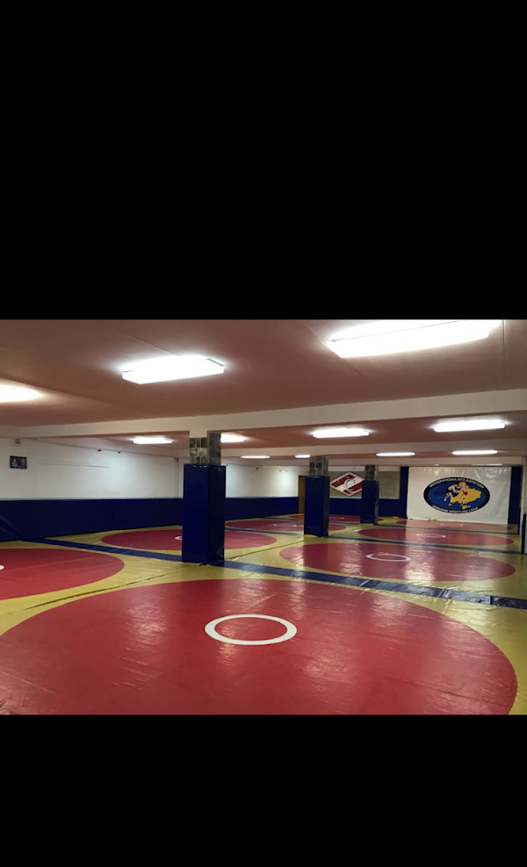

## The schedule:

## The young group, for children up to 16 y. o. at 7 pm every Tuesday, Thursday and 2 pm every Saturday.

## The older group, from 16 y. o. at 8 pm every Monday Wednesday and Friday.

## The first free training will introduce us and our activity, to you.

## Personal training. It is a training one per one, where coach’s attention is only yours. To make an appointment, contact the trainer on Instagram or the phone numbers (below), but take a note, they are busy, so hurry up.

## Contacts:

1. Email- [*************@gmail.com](mailto:*************@gmail.com)
2. Phone number: +380 9********
3. Instagram:

* Club: @mma_*******
* Coaches: @o******, @v******, @r*******, @r*******

## Payment:

* Evening groups: 700 UAH
* Morning groups: 400 UAH
* Personal training: coordinate with the coach.

## Choose us:

Our coaches will find out your calisthenics level and make a suitable program for you. Oleg always says, the level of preparation is not important, whether you are a newbie or experienced, in our gym you will increase your progress.

No contender can provide such a service and opportunities for a sports career as “MMA Center Lviv” do. Our team provides loads of opportunities to challenge yourself on competitions not only in MMA but in other kinds of sports, from kickboxing to Jiu-Jitsu. 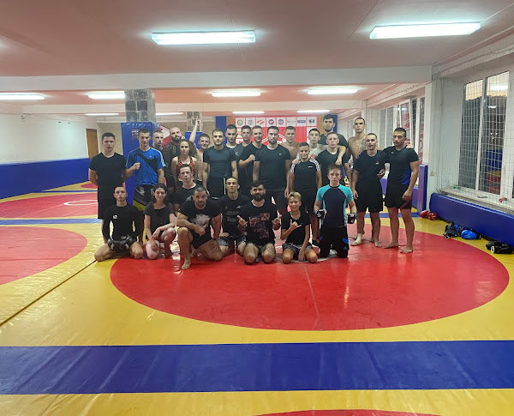

## Benefits:

* Strength

Do you feel weak, do not like your body and want to become stronger? We will help you to take control of your body.

* Mental health

Playing sports strengthens mentality. MMA is a tough one and if you decided to challenge it, the demons in your head have no chance.

* New friends

The gym is one of the best places to meet new people, true friends and get relationships. Training and competitions, emotions like adrenaline, agitation, and happiness, connect people for their entire life.

## **My story:**

I joined the club in December 2020. The new people, coach and a new sport for me made me worried but curious about what I was going to experience there. The team changed my life, presented me with true friends, and the competition experience has built my body and mind.