## Introduction:

“The strongest survives” the strongest become precisely thanks to training at MMA Center Lviv.

MMA- mixed martial arts, is a relatively new kind of sport afront of boxing. The first MMA performance was in 1993, called “UFC 1”. In Ukraine, the 2010 captured the first funs when the first competitions were organized. It was the groundbreaking time for this new baked sport, era MMA began.

## Trainers:

Oleg Gritsyuk- the main coach, developer of “MMA Center Lviv”.

Ruslan Telibaev- the pupil of Oleg and trainer of the youth group.

Vadim Knishevich and Roman Gritsina- the pupils of Oleg and trainers of the morning group.

## The location:

## Lviv, Klepaivska 39a Street, on the fourth floor.

## There in the park you will see a building “Sports center” (on the picture below).

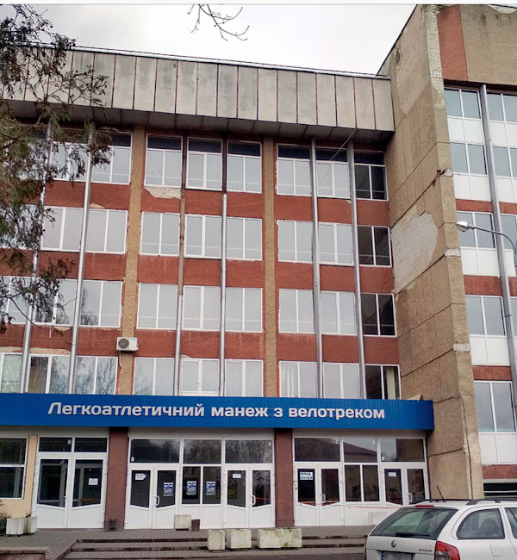

## The gym:

A few things I must know about our gym:

The spacy gym and сovered with mat walls and floor make the training process convenient and safe.

An additional workout gym and punching bags.

A shower and a sauna to your service.

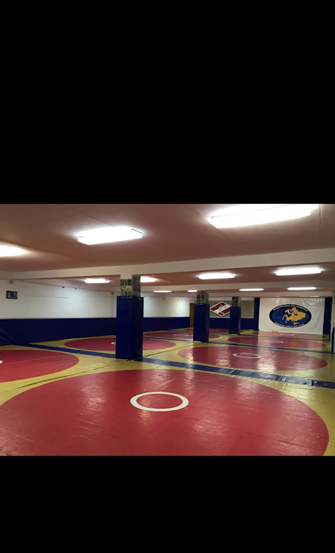

## The schedule:

The young group, up to 16 y. o. at 7 pm on Tuesdays and Thursdays; at 2 pm on Saturdays. (2hours)

The adult group, from 16 y. o. at 8 pm on Mondays Wednesdays and Fridays. (2 hours)

The morning group, without age restrictions, on Mondays-Saturdays; at 8 am (1 hour)

The first training free, so you could find out if you like it.

To try a personal training, contact us by phone number or in Instagram (contacts below)

## Contacts:

Email- [*************@gmail.com](mailto:*************@gmail.com)

Phone number: +380 9********

Instagram:

Club: @mma_*******

Coaches: @o******, @v******, @r*******, @r*******

## Payment:

Evening groups: 700 UAH

Morning groups: 400 UAH

Personal training: coordinate with the coach.

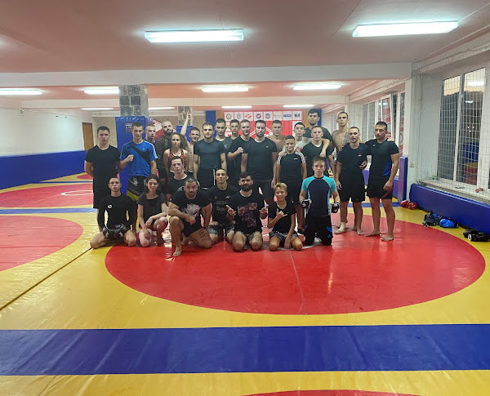

## Choose us:

Our club is more than ten years in MMA, our experience and goals are in history of this sport in Ukraine.

Oleg always says, the level of preparation is not important, whether you are a newbie or experienced, in our gym you will increase your progress.

“MMA Center Lviv” will promote your career as a sportsman.

Challenge yourself, join us.