- Introduction
- Description
- Important information
- Indications for use
- Appropriate wound types
- Contraindications
- Warnings
- Precautions
- VUTS introduction
- Additional precautions
- Precautions specific to Weisuc Device
- Mechanism of product
- Package content and configuration list
- Technical parameter
- Weisuc Modes
- Dressing changes
- Delivering the right pressure level
- Physician orders
- Pressure settings
- Application environment
- Basic operation
- Running alarm
- Transportation
- Storage requirements
- Service life and warranty period

Introduction
Weisuc has a well-established product and treatment portfolio that cover all major aspects of the treatment of a wide range of wound types. It is a recognised principle that wounds are treated throughout the healing process and require different treatments at each stage of the process. Weisuc offers the Vacuum Urgent Therapy System (VUTS) as part of a complete range of wound care products that can be used throughout the patient's journey to recovery. The key to selecting a product to use at each stage of the continuum is to identify the obstacles to recovery and the treatment goals to address these problems.

VUTS is widely used as a standard treatment for patients with both acute and chronic wounds. Various formats are now available, and as the wound progresses along the continuum, switching from one format to another may be the most appropriate course.

VUTS has been shown to be cost-effective when used correctly. Being aware of when VUTS is most appropriate and when alternative therapies may be more applicable helps to maintain efficient use of resources while not negatively impacting wound outcomes.

Vacuum urgent therapy system includes the application of controlled levels of sub-atmospheric (negative) pressure to the wound. The systems described in this manual consist of a suction pump to create negative pressure and various wound dressing kits to deliver therapy to the wound site. The benefits of VUTS in advancing wound healing go far beyond drainage management. Investigations have demonstrated that VUTS improves granulation tissue formation, can reduce bacterial burden, protects against the external environment, helps to maintain moisture balance in the wound bed and can reduce the frequency of dressing changes.
Always study and follow all applicable user manuals, product inserts, instructions for use, safety information and reference guides for use, operation and application of the product.

Description
Weisuc VUTS devices are designed to provide therapy to a closed environment over a wound, in order to evacuate exudate from the wound site to a disposable canister, which may promote wound healing via removal of fluids, including irrigation and body fluids, wound exudate and infectious materials.
Important information
Monitor the patient, the device and the dressing carefully and frequently to determine if there is evidence of bleeding, exudate accumulation (congestion), infection, maceration or loss of negative pressure wound therapy. The frequency should be determined by the physician based on the individual patient and wound characteristics.
Warning: Monitor patients carefully for signs of bleeding that may lead to interruption of therapy and haemodynamic instability. If these symptoms are present, discontinue therapy immediately, take appropriate measures to control bleeding and contact the treating physician.
Indications for use
The Weisuc System is indicated for patients who would benefit from a suction device (negative pressure) as it may promote wound healing via removal of fluids, body fluids, wound exudate and infectious materials.
Appropriate wound types include:
- Traumatic
- Chronic
- Ulcers (such as pressure or diabetic)
- Sub-acute and dehisced wounds
- Acute
- Partial thickness burns
- Flaps and grafts
Contraindications
The use of the Weisuc System is contraindicated in the presence of:
• Necrotic tissue with eschar
• Untreated osteomyelitis
• Malignancy in wounds (with exception of palliative care to enhance quality of life)
• Exposed arteries, veins, organs or nerves
• Non-enteric and unexplored fistulas
• Anastomotic sites
Warnings
- Carefully monitor patients for signs of bleeding, which may lead to interruption in therapy and hemodynamic instability. If such symptoms are observed, immediately discontinue therapy, take appropriate measures to control bleeding, and contact the treating clinician.
- Patients suffering from difficult hemostasis or who are receiving anticoagulant therapy have an increased risk of bleeding. During therapy, avoid using hemostatic products that, if disrupted, may increase the risk of bleeding.
- Do not use directly on exposed blood vessels or organs. Sharp edges such as bone fragments must be covered or removed prior to initiating therapy, due to risk of puncturing organs or blood vessels drawn closer under the action of negative pressure.
- VUTS has not been studied on pediatric patients. Patient size and weight should be considered when prescribing the device.
- Foam or gauze must not be tightly packed or forced into any wound area. Over-packing may interfere with distribution of VUTS evenly across the wound. This may decrease the ability of the wound to properly contract and permit exudate to remain in the wound. Do not place foam into blind or unexplored tunnels
- In the event that defibrillation is required, disconnect the device from wound dressing prior to defibrillation. Remove wound dressing only if its location will interfere with defibrillation.
- Device is not MRI compatible. Do not bring the device into the MRI suite. Prior to entering the MRI suite, disconnect the device from the dressing. Dressing can remain intact on the patient.
- Device is unsuitable for use in areas where there is danger of explosion (eg, hyperbaric oxygen unit).
- When operating, transporting or disposing of devices and accessories, there is risk of infectious liquids being aspirated or contamination of device assembly through incorrect use. Universal precautions should be observed whenever working with potentially contaminated components or equipment. Device and canister kits are provided non-sterile and should not be placed within a sterile field.
Precautions
More frequent device and wound dressing monitoring should be taken for patients who are or may be:
  - Suffering from infected blood vessels
  - Receiving anticoagulant therapy or platelet aggregation inhibitors, in addition to patients with intrinsic coagulation problems such as low platelet counts
  - Actively bleeding or have friable blood vessels or organs
  - Suffering from abnormal wound hemostasis
  - Untreated for malnutrition
  - Noncompliant or combative
  - Suffering from wounds in close proximity to blood vessels or friable fascia
When monitoring patients for delivery of therapy, ensure wound dressing is free of air leaks, fully compressed and firm to the touch.
As a condition of use, the device should only be used by qualified and authorized personnel. Users must have necessary knowledge of the specific medical application for which VUTS is being used.

VUTS introduction —
- If an occlusion occurs on the wound side, the dressing may lose its tightness or there may be a pooling, without activating the alarm. Viscous, purulent or serous-bloody drainage may contribute to the occlusion of the dressing. Regular monitoring of the device and dressing is necessary to ensure complete therapy and removal of the exudate. Ensure that the wound dressing is free of air leaks, fully compressed and firm to the touch during any active therapy.
- Underlying structures such as bones, tendons, ligaments and nerves should be covered with natural tissue or a layer of non-adhesive dressing before the VUTS is applied to provide protection and minimize the risk of damage from direct contact with the dressing.
- To minimize the risk of bradycardia, do not place VUTS in close to the vagus nerve.
- If a patient with a spinal cord injury experiences autonomic dysreflexia, stop using VUTS and seek medical attention immediately.
- When treating enteric fistulas, do not apply a VUTS dressing in direct contact with the open bowel. Cover the wound bed, including the fistulous opening, with non-adhesive gauze or one layer of gauze moistened with a physiological solution. Monitor the patient's fluid levels closely during treatment.
- Avoid using circular dressings, except in cases of oedema or profuse discharge from the extremities, when this technique may be necessary to maintain tightness. Consider using multiple dressings to minimize the risk of reduced distal circulation. Assess distal pulses regularly and discontinue therapy if changes in circulation are detected.
- As VUTS is not intended as a direct treatment for infection, seek immediate medical attention if signs of systemic infection or progressive infection in the wound area are detected.
- If more than one piece of foam or gauze is required to fill the wound profile, count and record the number of pieces so that when the dressing is changed, all pieces can be removed to minimize the risk of delay and possible infection.
- VUTS should remain for the entire duration of treatment. The length of time for which the patient may be disconnected from the device is a clinical decision based on individual patient and wound characteristics. Factors such as wound location, volume of drainage, integrity of the dressing seal, assessment of bacterial burden and risk of infection to the patient must be considered.
- Do not use a dressing kit with broken or damaged packaging.
- There is a risk of tissue ingrowth when using VUTS. Tissue ingrowth can be minimised by reducing the therapeutic pressure, using a wound contact layer or increasing the frequency of dressing changes.
- Using VUTS should not be painful. If the patient reports discomfort, consider reducing pressure and using a wound contact layer. Pressure setting is a clinical decision based on individual patient and wound characteristics. Factors such as wound location, drainage volume and dressing integrity must be considered.
- Monitor the device and wound condition regularly during therapy to ensure therapeutic treatment and patient comfort.
- The patient should disconnect from the device during bathing or showering by protecting the end of the Weisuc Soft Port tube with a tethering cap. Before resuming therapy, ensure that the aeration disc next to the Quick Click connector is free of moisture to ensure proper operation of the alarm and prevent interruption of therapy.
- If liquid has penetrated into the device, discontinue use and return it to an authorised retailer for servicing.
- CT scans and X-rays may interfere with some electronic medical devices. If possible, move the device out of the range of X-rays or the scanner.
- Use caution if the device is used in the presence of a flammable mixture of anaesthetic with air or with oxygen or nitrous oxide.

Additional precautions:
Electrical power can only be removed by disconnecting the power cord or AC power adaptor. Take care in positioning the device to allow access to the cord receptacle.
If the power cord or power source is damaged, wires are frayed or exposed, do not use the power cord. Contact a Weisuc representative for a replacement cord or power source.
Canister kits are single-use devices. Do not reuse.

Precautions specific to Weisuc Device
The Weisuc System Pump is only to be used with authorized components. Use of any other products has not been proven safe and effective with the Weisuc System .
In the event of heavy or viscous drainage with sediment or when blood is present, regular monitoring and more frequent dressing changes may be required to reduce the risk of interruption of therapy, maceration, infection, and ensure proper exudate removal.
For patients with high risk of bleeding, use a 450 mL canister. Ensure the 450mL canister viewing window is checked frequently for signs of bleeding.

Mechanism of product
With the help of a negative pressure pump exhausting air, the negative pressure will be produced in VUTS drainage bottles and wounds so as to have a condition of negative pressure to treat the wound.
The device could generate continuous or dynamic negative pressure and form a condition of negative pressure in accordance with the requirements of the setting in the wound. In the end, the mechanism of negative pressure on the wound will ultimately promote wound healing.
Package content and configuration list

Package content of Weisuc device consists of:
- VUTS device
- dedicated adapter
- strap for use as a hand-held device
- user manual.

Technical parameter
The performance indicators for the Weisuc device are referred to as follows:
1.Adjustable range of negative pressure:-50~-500mmHg.
2.Accuracy of stable negative pressure: Between 50~500mmHg，the absolute error between actual measurement value and set value should be less than or equal to ±5mmHg.
3.Noise due to normal work: shouldn’t exceed 40dB.
4.Battery lifetime: Up to 25 hours
5.Ultimate negative pressure: Shouldn’t exceed 505mmHg.
6.Free-air flow:shouldn’t exceed 6L/min.
7.Parameters of drainage bottle:
7.1.Maximum allowable negative pressure of drainage bottle:500mmHg;
7.2.Sealing:when the negative pressure in the drainage bottle is 500±10mmHg，seal the bottle, after 3 min measure the negative pressure in the bottle and leakage of negative pressure should be controlled within 20mmHg.
7.3.Volume: the drainage bottle can be loaded with an exudate that is not less than 90% of the standard capacity.
7.4.Stop overflowing:during use, the exudate in the drainage cannot be absorbed into the negative pressure pump.
8.Display function:
8.1.The monitor of the negative pressure device should display the value of the negative pressure and the unit is mmHg.
8.2.During the treatment, the monitor of the negative pressure device should graphically display the leaking rate.
9.Warning function:The device can give an alarm if there is leakage, low battery level and blocking.

Weisuc Modes
The device can be delivered to the wound bed using 3 modes of delivery; Continuous, Dynamic or Intermittent.
  - Continuous: Pressure is applied constantly
  - Dynamic: Pressure is repeatedly switched on and off alternating between 0 and set pressure
  - Intermittent: Pressure is varied between two levels (set pressure and low pressure) maintaining a negative pressure environment throughout the therapy.
NOTE! INTERMITTENT therapy is not recommended for:
- Highly exudating wounds
- Wounds with tunnels
- Wounds in difficult areas where maintaining a seal is problematic
- Patients who experience pain during intermittent therapy

Dressing changes

- Foam dressings should be changed every 48 to 72 hours after initial application of therapy. If no leak is present and the patient is comfortable, dressing changes should occur no less than 3 times per week.
- Gauze dressings should be changed 48 hours after initial application of therapy. If no leak is present and the patient is comfortable, dressing changes should occur 2-3 times per week.
- In the event of heavy or viscous drainage, drainage with sediment, or when blood is present, regular monitoring and more frequent dressing changes may be required.
- When dressing a wound involving difficult to seal anatomy or exposure to external moisture, frequent inspection of dressing is recommended to ensure a seal is maintained. Ensure wound dressing is fully compressed and firm to the touch.
- Ensure all wound filler material placed in the wound has been removed before redressing the wound. If foam dressing adheres to the wound, apply normal saline to the wound dressing and let it set for 15-30 minutes before gently removing the foam. Appropriately discard used wound dressings observing your institution’s protocol for medical waste handling.
- As with all adhesive products, apply and remove dressing carefully from sensitive or fragile skin to avoid skin stripping, especially after frequent dressing changes. Use of skin sealant may assist with protection of periwound skin.
- Monitor patient for any signs of local or systemic infection. Infected wounds may require more frequent dressing changes. If there are any signs of systemic infection or advancing infection at the wounded area, contact the treating clinician immediately.
- If the Weisuc Device activates a complete blockage alarm, inspect the dressing and canister tubing for any blockage. If a blockage cannot be identified or resolved, replace the device canister first, then remove the dressing and Weisuc Soft Port, replacing as necessary.
NOTE: Negative pressure wound therapy should remain on for the duration of treatment. If the patient must be disconnected, the ends of the Weisuc Soft Port and canister tubing should be protected using a tethered cap. The length of time a patient may be disconnected from the device is a clinical decision based on individual characteristics of the patient and wound. Factors to consider include location of wound, volume of drainage, integrity of the dressing seal, assessment of bacterial burden and patient’s risk of infection.

Delivering the right pressure level
With respect to pressure levels, an independent Weisuc Expert Panel recently convened to develop evidence based recommendations describing the use of the device.
They recommend that Weisuc device be used within a therapeutic range of -40mHg to -150mmHg. The recommended pressure settings for Weisuc VUTS devices fall within this range.

Continuous versus Intermittent therapy:
An additional aspect of pressure setting is the choice between Continuous and Intermittent delivery of pressure. Intermittent therapy involves the cyclical release and reapplication of pressure. The Weisuc delivers Intermittent/variable therapy at: High therapy -25 to -200mmHg at high cycle times of 3, 5, 8, 10 minutes.
Low therapy 0 to -180mmHg at low cycle times: 3, 5, 8, 10 minutes. The Weisuc setting should be determined by the prescribing clinician and tailored to the individual wound for optimal effects.
Considerations for use of Intermittent or Variable therapy
It is recommended that all patients remain on Continuous therapy for the first 48 hours.
- Intermittent therapy is not recommended for:
- Highly exudating wounds
- Wounds with tunnels
- Wounds in difficult areas where maintaining a seal is problematic.
During the off period, if the wound has large volumes of exudate, there may be a tendency for the exudate to leak out and break the adhesive film seal.
NOTE: In patients who would benefit from Intermittent or Variable therapy but who experience wound pain, please select the Variable option.
Pain during the application of Weisuc may be experienced more frequently during the on
and off cycle of Intermittent therapy. Less pain is experienced with Variable therapy.
NOTE: Most effective delivery of Variable pressure is thought to occur when pressure cycles between a “high” level of pressure within the therapeutic range of -40mmHg to -120mmHg)
to a “low” pressure of below the therapeutic range (i.e. below -40mmHg).

Consideration for use of Continuous therapy
- Continuous therapy is generally recommended for the first 48 hours, with patients at increased risk of bleeding, highly exudating wounds, fresh flaps and grafts, and wounds with acute enteric fistula.
- Continuous therapy is also recommended in wounds with tunneling and undermining.
Physician orders
Prior to placement of the Weisuc Device, the healthcare professional treating the wound must assess how best to use the system for an individual wound. It is important to carefully assess the wound and the patient to ensure clinical indications for Weisuc are met.

All treatment orders should include:
- Size and/or wound measurements
- Weisuc wound dressing kit type
- Vacuum settings (recommended therapeutic range is 40-120mmHg)
- Frequency of dressing changes
- Adjunctive dressings

Pressure settings
General guidelines:
The guidelines on therapy settings in this booklet are general recommendations. Vary the pressure settings to optimize therapy based on the treatment goals for the patient and clinical judgment.
NOTE: Recommended pressure range for the Weisuc VUTS Systems is 40mmHg to 120mmHg.
- If a patient experiences discomfort, it may help to reduce the pressure level.
- An increase in the pressure may be necessary according to size of wound, viscosity of exudate, amount of exudate and clinical judgment of desired wound outcomes.
- Anatomical location and tissue pliability may also influence pressure level utilized.
- Outside the recommended optimal therapeutic pressure range of 40–120mmHg, the broader operating range of 25–200mmHg is provided to support clinical discretion on pressure set-point. The device will display the therapy set point.

Application environment

The device could be expectedly used in the following normal working environment
a) Temperature:5°C-35°C
b) Humidity:≤80% R.H

Basic operations
1.Installation of the power supply
Connect the power output plug of the power adapter to the power socket on the back of the device

2. Install/uninstall the canister
Note: Do not forget to use the special canister and drain tube from Weisuc.
Please follow the requirements of this manual as any unintended use may result in a safety risk.
1. Install Weisuc canister:
Push the canister with your hand, when the sound of “Click” is heard, the installation of the canister is completed.

2. Uninstall canister:
Press the button on the top of the device, grasp the canister with your other hand and pull it to remove the drain bottle.

3.Operation
ON:
Press the button for 1,5 seconds, the device will be switched on.
Warning: if the device is not operated after being switched on, it will be automatically switched off after 5 minutes.
OFF:
Press the button for about 3 seconds, and the unit will be switched off.

4.Display operation

4-1.Set/start the continuous therapy.

After switching the device on, it will automatically switch to the main settings interface within a few seconds.

On the main setting interface select “Continuous Therapy”, enter the setting interface of Continuous Therapy.
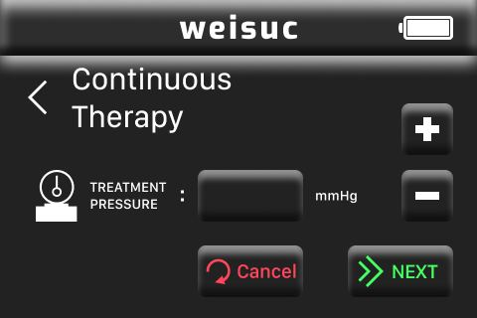

Click“+”or“-”on the continuous therapy setting interface to adjust the pressure value of continuous pressure therapy. The adjustment step is 25mmHg. The maximum value is 225mmHg and the minimum value is 50mmHg.

Click the value display box on the continuous treatment setting interface to input the keyboard, and use the method of the keyboard box to set the treatment pressure value, the negative pressure value is an integer and the system default value is 125mmHg.
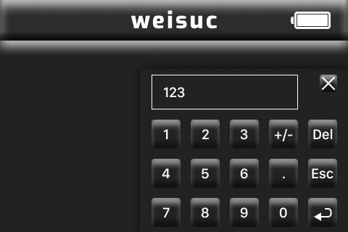
When using the keyboard to input, if it exceeds the maximum and falls below the minimum value, it will display a cross-border reminder. After adjusting the value of negative pressure, click the key ‘Enter’ and then return to the main interface. Click the key “Submit” to enter the continuous therapy interface. If you click “Cancel”,the system default value as 125mmHg will be restored.

In the continuous pressure therapy interface, click the set to input the pressure value and time of the current mode arbitrarily, and click "Cancel" on the setting interface to restore the system default value. Click the continuous therapy interface, and it will start continuous therapy.

In this interface, it shows the cumulative treatment time. Start the treatment, Start treatment, start timing (display time accuracy is min, hour value is up to 999, minute value is up to 59), stop treatment, and time is cleared. Click the back button on the startup interface to return to the previous setting page. Click the key “Locking” to lock the working state that can prevent accidental touch.
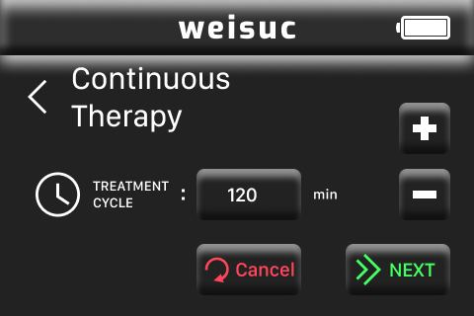

Click “unlock” to enter the unlock interface.
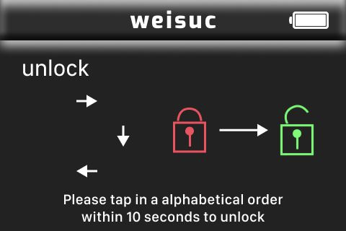
To unlock, please click the keys following alphabetical order within 10 seconds. If there is no operation within 10 seconds, it will automatically exit the unlock interface. If you do not follow the sequence of taps, the unlock failure prompt will pop up, and then exit the unlock interface.
Unlock failure interface
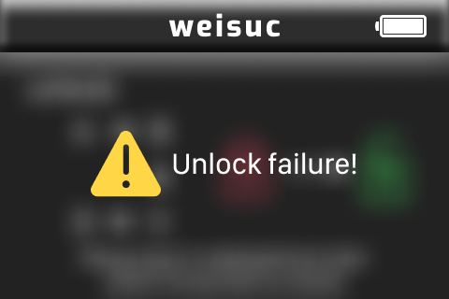

After unlocking，click to pause or end this treatment.
4-2.Setting/starting dynamic therapy.
After starting the device, click “setting” on the continuous therapy interface to enter the main setting interface. On the main setting interface, select “DYNAMIC THERAPY” to enter the dynamic therapy interface 1.
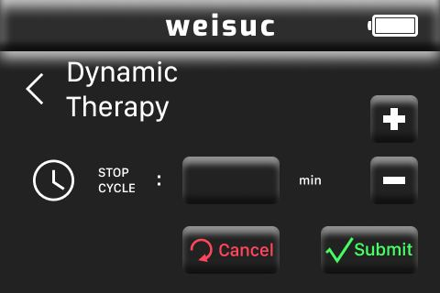

Click“+”or“-”on the dynamic therapy setting interface 1 to adjust the pressure value of dynamic therapy, the adjustment step is 25mmHg. The maximum value is 225mmHg and the minimum value is 50mmHg. Or click the value display box on the dynamic therapy setting interface to pop up the keyboard, and use the input method of the keyboard to set the therapy pressure value, the negative pressure value is an integer, such as:

When using the keyboard to input, if it exceeds the maximum value and falls below the minimum value, the keyboard display box will display an out-of-bounds reminder. After adjusting the pressure value, click the return button to return to the main interface, and click the "next" button to enter the dynamic therapy setting interface 2. If you click "Cancel", the system default value of 125mmHg will be restored.
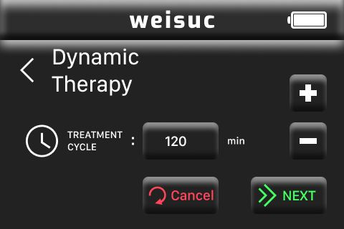

Click "+" or "-" on the dynamic therapy setting interface 2 to adjust the cycle of dynamic pressure therapy, and the adjustment step is 2 minutes. The maximum value is 98min and the minimum value is 2min. Or click the value display box on the dynamic treatment setting interface to pop up the keyboard, and use the keyboard input method to set the treatment period. The time period is limited to an even number.
When using the keyboard to input, if it exceeds the maximum value and falls below the minimum value, the keyboard display box will display an out-of-bounds reminder. After adjusting the treatment period, press the return key to return to the previous setting page. Click the "Submit" button to enter the dynamic pressure therapy mode interface. If you click "Cancel", the system default value of 10min will be restored.
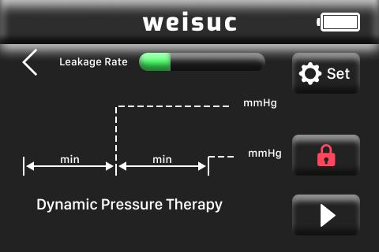

In the dynamic pressure therapy mode interface, click the set to enter the parameter setting interface, you can set the pressure value and time of the current mode arbitrarily, and click "Cancel" on the setting interface to restore the system default value. Click the back button to return to the previous setting interface. Click the start button in the dynamic pressure therapy mode interface to start dynamic pressure therapy.

Click the return button on the startup interface to return to the previous setting interface. Click the“lock” button to lock the current working state in order to prevent accidental touch.
Click the button “UNLOCK” to enter the UNLOCK interface.
To unlock, please touch in alphabetical order within 10 seconds. If there is no operation within 10 seconds, it will automatically exit the unlock interface; if you do not follow the sequence, it will pop up an unlock failure prompt, and then exit the unlock interface.

After unlocking, click the button to end the therapy operation.

4-3. Set and start Intermission therapy.
In the main setting interface, click the "INTERMISSION THERAPY" button to enter the intermission therapy interface.
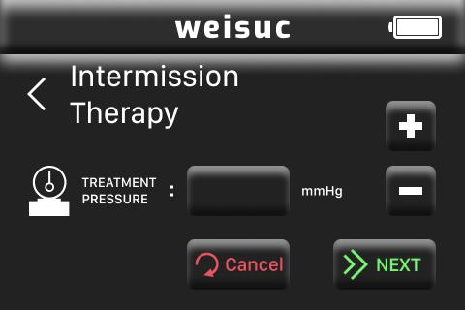

Click "+" or "-" on the intermission therapy setting interface 1 to adjust the pressure value of intermission pressure therapy, and the adjustment step is 25mmHg. The maximum value is 225mmHg and the minimum value is 50mmHg. And also click on the value display box on the intermittent therapy setting interface 1 to pop up the keyboard, and use the keyboard input to set the therapy pressure value, and the negative pressure value is an integer, such as:
When using the keyboard to input, if it exceeds the maximum value and falls below the minimum value, the keyboard display box will display an out-of-bounds reminder. After adjusting the pressure value, click the return button to return to the main interface, and click the "next" button to enter the intermission therapy setting interface 2. If you click "Cancel", the system default value of 125mmHg will be restored.

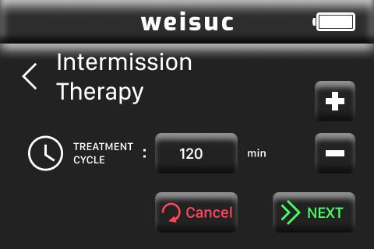
Click "+" or "-" on the setting interface 2 to adjust the therapy time, and the adjustment step is 1 min. The maximum value is 99min, and the minimum value is 1min. You can also click on the value display box on the intermission treatment setting interface 2 to pop up the keyboard, and use the keyboard to set the treatment time, and the setting value is an integer. The keyboard input interface is shown in the figure below.

When using the keyboard to input, if it exceeds the maximum value and falls below the minimum value, the keyboard display box will display an out-of-bounds reminder. After adjusting the treatment time, click the back button to return to the previous setting page. Click the "Next" button to enter the intermission pressure therapy mode interface 3. If you click "Cancel", the system default value of 5min will be restored.
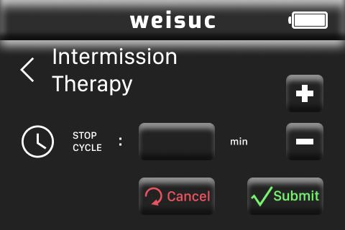

Click "+" or "-" on the intermission therapy setting interface 3 to adjust the stop time of intermission therapy, and the step length is 1min. The maximum value is 99min and the minimum value is 1min. Or click the value display box on the intermission therapy setting interface 3 to pop up a keyboard, and use the keyboard to set the stop time, and the set value is an integer. The keyboard input interface is shown in the figure below.
When using the keyboard to input, if it exceeds the maximum value and falls below the minimum value, the keyboard display box will display an out-of-bounds reminder. After adjusting the stop time, click the return button to return to the previous setting page, and click the "Submit" button to enter the intermission pressure therapy mode interface. If you click "Cancel", the system default value of 2min will be restored.

In the intermission pressure therapy mode interface, click Set to enter the parameter setting interface. The pressure value and time of the current mode can be set arbitrarily, and the system default value will be restored by clicking "Cancel" on the setting interface. Click the back button to return to the previous setting interface. Click the start button to start intermission pressure therapy.

Click the return button in the startup interface to return to the previous setting interface, and click "lock" to lock the current working state to prevent accidental touch.
Click "Unlock" to enter the unlock interface.
Please touch in alphabetical order to unlock within 10 seconds. If there is no operation within 10 seconds, it will automatically exit the unlock interface; if you do not follow the sequence, it will pop up an unlock failure prompt, and then exit the unlock interface.
After unlocking, click the button to end the therapy.

4-4.Low charge alarm.
When the system charge is too low, the therapy unit's LCD screen will display a warning that the battery charge is too low, accompanied by an audible alarm. As shown below. At this time the power adaptor should be connected to the therapy unit to charge the therapy unit.
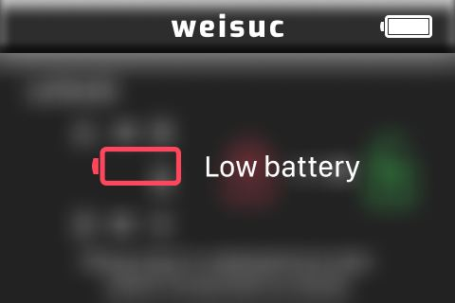

4-5.Alarm for blocked pipes.

When the device is operating in continuous treatment mode or in dynamic treatment mode, the tubing is blocked and a tubing blockage warning appears on the LCD display, accompanied by an audible alarm. As shown below. At this time treatment must be paused and the location of the pipeline blockage must be found and repaired before the unit is restarted.
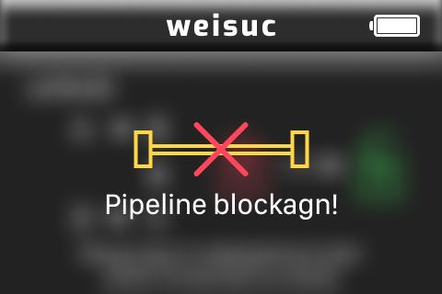

4-6.Air leakage alarm.
When the unit is operating in continuous treatment mode or in dynamic treatment mode, an air leak occurs in the pipework and an air leak warning appears on the LCD display with an audible alarm. At this time it is necessary to suspend treatment, locate and repair the air leak in the pipework before restarting the unit.
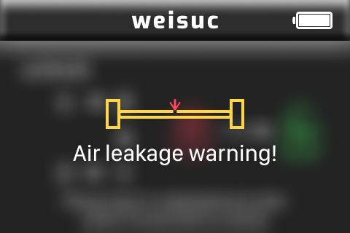

4-7.Tightness.
When the treatment device is operating in continuous treatment mode or in dynamic treatment mode, it will monitor the air leakage from the pipeline in real time and display it on the LCD screen. If it shows the speed during ""and"",it means that the tightness of the pipework is in good condition. If it shows speed during ""and"" means that the tightness of the piping is not good, in this situation the tightness of the piping should be checked.

5. Charging.
Use the special charger to charge the cleaning device. Connect the charger plug to the treatment unit for charging and the LCD display will show an icon that the treatment unit is charging.

Use the special charger to charge the cleaning device. Connect the charger plug to the treatment unit for charging and the LCD display will show an icon that the treatment unit is charging.

At this time the device will issue an audio signal. When using the device without the adapter you may notice that the internal battery of the device gradually decreases in charge until a low battery alarm appears.

When the unit detects that there may be a blockage in the system pipework once treatment has started, or when the liquid in the drain bottle is full and the overflow protection is triggered, the unit will stop working and issue a blockage alarm.

When the unit is in operation, squeeze the drain tube connected to the unit and the unit will give a blockage alarm for 1 minute.

Attention:When the dynamic negative pressure alarm is blocked due to the overflow protection, you can press the return key to return to the main interface of the device, and replace the dynamic negative pressure drainage bottle, and then restart the device operation.
After the alarm occurs, the user can cancel the alarm sound by pressing the "set" key and return to the system working interface where the treatment stops.

Running alarm
During the use of the device, a low battery alarm, blockage alarm, and air leak alarm may happen. The alarm level is medium and the alarm volume is not less than 50dB.
Transportation
1.Avoid vibration, collision, knock, and drop during transportation of this device.
2. The device should be kept at room temperature and pressure during transportation, and avoid exposure to sunlight.
3.The equipment cannot be transported with high-concentration volatile corrosive gases, liquids, etc. during transportation.

Storage requirements
- Storage temperature: -10°C~50°C
- Storage humidity: 5%~85% R.H
- Atmospheric pressure: 700hPa~1060hPa
- Other non-corrosive gases, good ventilation.

Service life and warranty period
The service life of this Weisuc device is 2 years. See the label attached to the back of the product for the production date.
This product is guaranteed for the whole machine (two years) from the date of leaving the factory. For after-sales service contact information, see product after-sales service information.

