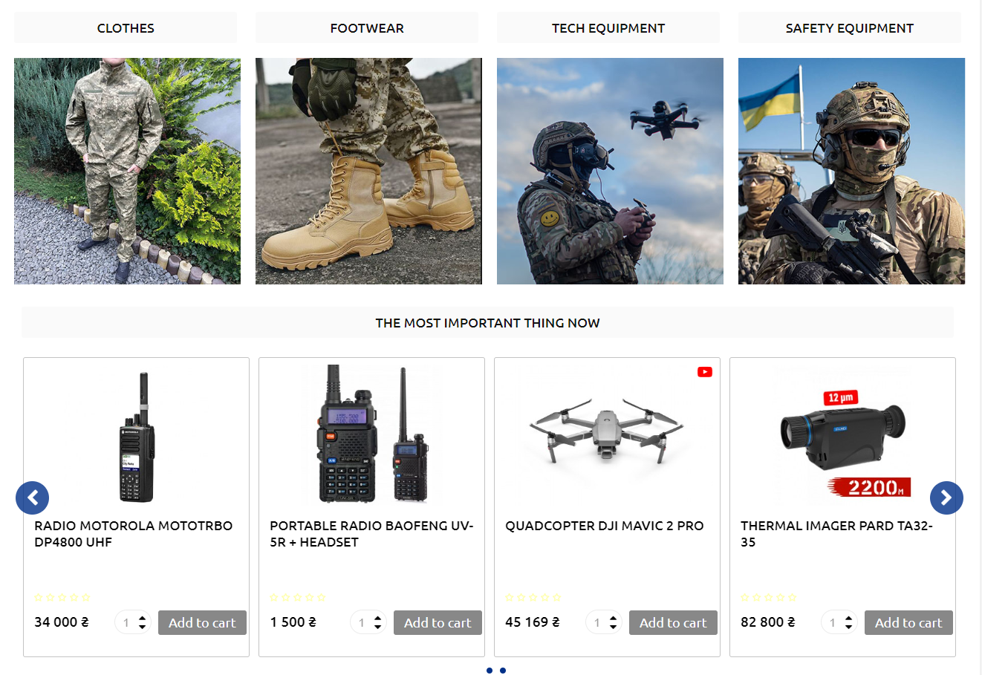

INTERNET SHOP “EURO SHOP KHARKIV”

IDEA AND BACKGROUND OF CREATION OF ONLINE-SHOP

Since the Revolution of Dignity, creation and growth of organization Euro-Kharkiv was started.

In 2014, 14th of September, tent EVERYTHING FOR THE VICTORY was settled on Freedom Area (Ploshad` Svobody).

His goal was to incarnate requirements of Euromaidan in Kharkiv, but war, instead of ending by our victory, was only getting bigger.

Tent turned to volunteer distribution point and info center. People would give help to tent, weave camouflage nets, or just talk to each other. After 24th of February, 2022, work for volunteer group got bigger, because of war.

This online shop is a growth of our volunteer activity, and goal of this shop to power up our activities and give an opportunity to everyone who wish to help our fighters to defend Ukraine independence.

How does a regular online store works? You find a product that you need, pay for it, and wait for a delivery. But our shop is special. It was created to**get our defenders and military must-need products** – clothes, shoes, armory, tech and medicine.

It’s also really easy for Ukrainians, who wants to help our army, but don’t have an opportunity to buy those things by themselves and deliver it to military bases. And not only for them: people from around the whole world can help Ukraine. And this help will be most appreciated. In our shop you can find stuff, that will be irreplaceable during military service.

ASSORTMENT OF “EURO SHOP KHARKIV”

1. **Clothes and Shoes**. Comfortable good-quality uniform is not a luxury but a must-need.

2. **Safety Equipment.** Our army definitely can’t live without tactical gloves, body armor or knee pads.

3. **Tech Equipment**. Radio, quadrocopters, thermal imager, scopes etc. Our defenders need to have an “extra-eye” and an “extra-ear”, and also stay in touch.

4. **Medicine**. There’s nothing you can do on a war without medicine and first-aid kit.

5. **Food**. Our army needs a high-quality and healthy food.

New options and updates of assortment will eventually grow. Stay tuned!

HOW “EURO SHOP KHARKIV” WORKS?

Very simple. Military ordering stuff they need, for example, shoes, equipment, or medicine. We’re sending those orders to our data-base and publishing the request on our site. You can pay for it, and then we will send this money to sellers, and getting everything, that our military has ordered. This will not only help our defenders, but you will also make a good thing with maximum practicality and effectivity.

And you can buy some of those things for yourself too. Especially if you don’t have much time and opportunities to go to the store by yourself. If you are a military and you want to pay for a product, we can also take your order. You are going to receive all things you need and we will deliver it to any place it needs to be. If you are not a military, you can also buy everything you want from our assortment here.