Monobank credit card with cashback: how to order, rates, terms and reviews.

Hello, my dear friends! Today, everyone is faced with a choice - which bank to prefer, how to quickly draw up a card, which to choose a credit card, which is better visa or MasterCard? The first question to ask yourself is, do you really need a credit card?

If you do decide that you need a credit card, consider the offers of different banks. Of the huge selection of banks in Ukraine, I would prefer Monobank.

What is a Mono card?

Why Monobank card? I will answer you. Monobank is among the bank products of Universal Bank (UniversalBank). The Monobank card can really be obtained instantly without leaving the house, being anywhere, having only a phone. Now meeting with a representative of the bank is not necessary. Monobank works on favorable terms for the client. The Bank offers a large selection of cards, as they say, for every taste and color. People are most interested in cashback, installments and interest rates on loans.

The monobank is becoming increasingly popular among young people. Young people like minimalist design, gift stickers, convenient mobile application, cashback when shopping - and other modern things. They are also attracted by the format: «bank without a bank», where the bank is placed in a smartphone and gives you an incredible number of opportunities. For example, replenish a mobile account, transfer money from a card to a card, replenish the card and all this is free and no fees.

Credit card Monocard from Monobank

Monobank has many interesting payment cards. But in this review below we will talk more about one of the most common - black card.

Rates and conditions on the map

Let me in more detail tell you about the terms of the "black" card from Mono Bank:

International Payment System Card - Mastercard/ Visa

Free registration and maintenance

Free delivery of cards by courier : Kiev, Dnepr, Odessa, Kharkov, Lviv and Zaporozhye.

Cashback up to 20% on certain categories of purchases

Commission for the withdrawal of own funds 0.5% in any ATM in Ukraine.

The real annual interest rate on the card is 44.12% per annum

Monthly loan commission 3.1%

Credit rate for grace period 0.00001%

Penalty for overdue payment From 1 to 30 days - 50 UAH. from 31 to 90 days - 100 UAH. from 91 to 120 (210) days - calculated by the formula: 100 UAH. + 6.2% of the total

arrears arising on the first day of the relevant calendar month. The rate is 0.00001% per annum.

Mandatory monthly payment of 4% of the debt (not less than UAH 100, but not more than the balance of the debt)

Lack of commissions and transparent tariffs make the single bank card one of the best credit cards in the Ukrainian market.

Pros and cons

Every product has both positive and negative sides. Let me tell you in more detail what I have noticed in writing this review.

+

-

1. The best tariffs on the Ukrainian market

2 Adequate exchange rate when paying in currency

3. No commission for replenishment

4. No commission for public utilities

5. Cashback

6. Interest on fund balance - 7

7. Convenient application.

8. Minimalist design

1. No payment by smartphone

2. Transaction volumes and balances of the virtual map

Many Ukrainian banks offer quite favorable terms of lending. As you can see, the best rates for banking services in Ukraine managed to offer the clients of the team of Monobank. Special analysis claims that it is most profitable to order a map from them.

Cashback

So we got to the thing that our readers are most interested in - cashback. What is cashback in simple words? Here everything is very simple - it is a cash back. Monthly you need to choose two categories for which will be

return up to 20% when paying with a mono card. It can be a purchase of goods, payment for petrol station, visit to the beauty salon, payment for a taxi and much more.

The credited money comes to the account instantly after the settlement of the card in the category. Minimum amount , which can be cashed from 100 to 500 UAH per month.

How to Order a Monocard

Any citizen of Ukraine at the age of 14 can order a Monocard. To issue a Monobank card it is enough to take a smartphone, regardless of whether you have an android or iOS from Apple. The app is available in both the Play Market and the Apple Store.

Hurry up to join the registration and become one of the first lucky players to appreciate the benefits of a state-of-the-art monobank card.

Order a map now and get 50 UAH!

In Google Play or Apple, download and install the Monobank app. The first thing the application offered to draw a map. The process took me 10 minutes. Download the app on your smartphone and fill out the questionnaire, honestly and truthfully answering questions.

Here is the list of documents for obtaining a single bank card:

Passport

INN

Help from work (optional)

Additional documents to increase credit limit (optional)

* Now the single bank card can also be obtained with the application «DIY» + PIK of Ukraine

As in any other Ukrainian banks, to open an account you need to provide documents: passport of a citizen of Ukraine, INN. Even in the most innovative banks you will have to visit the branch.

With Monobank Universal Bank you will not need to do this. Instead of visiting the bank branch, the client is asked to take photos of the documents. This process is a bit painstaking, as the application itself focuses and takes a snapshot of your document if it is correctly placed on the screen.

How is the registration going?

In order to register, you need to do the following:

Enter a valid phone number. It will come with a text with a confirmation code.

Enter the numbers from the message into the app.

Take a picture of the passport and send it. The bank sets certain requirements for the photos. So, you can not upload finished photos. You need to take a picture through the app. By the way, the same requirement is everywhere where you need a remote registration on your passport. This allows you to confirm that the passport is in your hands, and the photo is not included

corrections. Given that the bank issues, including credit cards, the requirement is reasonable. No one’s gonna be happy to hear that an online loan was made in his name.

Take a photo with a passport in your hands, a sheet with the date on the photo and the inscription Monobank. It is necessary to do on the main camera - the photo should not be mirror.

Answer some questions, and the registration will be over. Remember, with the bank always have to be honest. If you enter incorrect data, you will be blocked from the account. In fact, they are needed to set the credit limit on the card. If you are not interested, and plan to use as a debit - this moment can be skipped.

Next, choose how to get a Monobank card. There are two options:

Go to the nearest partner bank branch or point of issue;

Wait for the courier.

As soon as Monobank confirms all your information, you can safely order a single bank card. In this case, no paper forms and questionnaires.

You can issue a Mono card in any convenient for you place where there is access to the Internet.

How to use the card from Monobank

The universality of the map is confirmed by the fact that it can be used both on the territory of Ukraine and abroad. Thanks to the international payment system MasterCard, payments can be made contactlessly.

Replenishment

New clients of Monobank often have a question: how to replenish the card if the bank branches do not exist? The answer is very simple: go to the application Monobank, on the main page select the item «Add to your card».

You will be given the main ways of replenishment:

From another card. The easiest way. If you have the cards of other banks, you can quickly perform the operation of recharging the Monobank card. To do this, you will need to enter the card data, specify the amount of the transfer and confirm the transaction. Note that some banks charge a commission.

Cash replenishment. The screen will show a map of the nearest terminals or Ibox, which are partners of the mobile bank. On the map you can see a detailed schedule of work.

According to the details in Ukraine. This method is somewhat worse than previous ones, since the money is credited within 3 days. In addition, for such a transfer is removed additional fee.

According to the details from abroad. The method is not very profitable. Used most often for people who work abroad. The details are determined by the currency used for the transfer. The amount of the commission is determined by the bank.

Click here. This method involves creating a link, opening which you can replenish your card. You can send such a link using Telegram, Viber, Facebook Messenger messengers.

All these methods are located in the app itself and you can use them at any time.

Cash withdrawal

The question how you can withdraw money from the Monobank without a commission people ask quite often - cashing funds in mobile banks has a certain specificity. No branches, no ATMs, how do you get your blood money?

In principle, you can withdraw money from the Monobank card in any ATM in Ukraine, but the commission in some cases will be, in others - no. If the bank whose ATM you decided to use is not a partner, you will have to pay an additional interest. The ATMs of partners - Universal Bank and A-bank do not take it.

In addition, all banks, partner or not, set limits on withdrawals in ATMs. They are different, most often - 1000 UAH.

It is impossible to withdraw money Monobank without a commission - Mono himself always charges a certain percentage. You have to pay 0.5% for your own funds and a full 4% if you are talking about credit. Monobank loans are recommended to be used only for non-cash payments, paying in shops, at stations, gas stations or on the Internet.

As already mentioned, in the branches and ATMs of Universal Bank and A-Bank nothing is charged from the amount, but Monobank will have to pay interest.

It is also possible to cash out funds through the Universal Bank, A-bank and TASkombank. The withdrawal of money from the Monobank card is possible only in the branches of these three financial institutions, and Tambank will take an additional payment for the operation - 0.5%.

Realizing that such conditions are not pleasing, the bank offers to put the funds on deposit. It seems to mean that deposit interest more than compensates for unavoidable losses if it is necessary to pay cash. But the deposit is a little different topic, for an emergency withdrawal this option is not suitable.

Reviews about the "black" card of the Monobank

After analyzing the bank’s customer reviews, I realized that I made the right choice for myself. Although there are negative reviews among them, but as they say, you will not please everyone.

Other Bank Products

Monobank offers its clients a wide range of payment debit and credit cards. All of them differ from each other different conditions and different bargaining chips.

Now in mono very popular are the following cards:

Black card - the most popular card that will be useful almost every day: money transfer, replenishment of mobile, payment for utilities - all transactions are absolutely free;

White card - will work if you need bank plastic most often for cash transfer. The card is issued free of charge. It is debit, that is, it has no credit line;

Children’s card - payment plastic for users from 6 to 16 years. This product is not fully self-contained, the card has the option of parental control. In addition, the card holder mobile application has a special design;

Platinum card - available on the basis of Mastercard and VISA, which implies a lot of privileges and no restrictions. Be the holder of such a card is a great opportunity to save on expenses in travel;

Iron Card - also available on popular Mastercard and VISA systems, guarantees its holder an exclusive status and a high level of filling and care.

Personal card - gives users the opportunity to increase the available amount of the credit limit and to use money without additional commission during the 62 days of the grace period. When using the card there is no service fee,there is no need to visit the bank to open the credit limit.

Virtual card - is intended, first of all, for safe, fast payments in the Internet. The only difference between such a card and ordinary plastic - it exists only in electronic form. Since the card is virtual, it is only digital, but if you tie it to an electronic wallet, you can pay for purchases in ordinary stores. But you can’t cash a card like that.

If the first three cards from the list to get in the Monobank is quite simple, then the cards "Platinum " and "Iron" are issued only to selected customers.

Conclusion

And so, to sum up. Monobank is quite popular and convenient. Draw a card easily and quickly. The bank’s customers receive advantageous rates, can pay bills, draw up installments, use cashback. Users can use a loan or open a deposit. The bank has good technical support and plenty of opportunities.

As you can see, the mono card has a rather big prospects in the future. More and more people prefer the Monobank card, and the bank itself.

I have told you in detail about Monobank cards, and about the bank itself. I think you will have no problem with the choice. I wish you all a good cashback and a great mood. See you soon!

Monobank credit card with cashback: how to order, rates, terms and reviews.

Hello, my dear friends! Today, everyone is faced with a choice - which bank to prefer, how to quickly draw up a card, which to choose a credit card, which is better visa or MasterCard? The first question to ask yourself is, do you really need a credit card?

If you do decide that you need a credit card, consider the offers of different banks. Of the huge selection of banks in Ukraine, I would prefer Monobank.

What is a Mono card?

Why Monobank card? I will answer you. Monobank is among the bank products of Universal Bank (UniversalBank). The Monobank card can really be obtained instantly without leaving the house, being anywhere, having only a phone. Now meeting with a representative of the bank is not necessary. Monobank works on favorable terms for the client. The Bank offers a large selection of cards, as they say, for every taste and color. People are most interested in cashback, installments and interest rates on loans.

The monobank is becoming increasingly popular among young people. Young people like minimalist design, gift stickers, convenient mobile application, cashback when shopping - and other modern things. They are also attracted by the format: «bank without a bank», where the bank is placed in a smartphone and gives you an incredible number of opportunities. For example, replenish a mobile account, transfer money from a card to a card, replenish the card and all this is free and no fees.

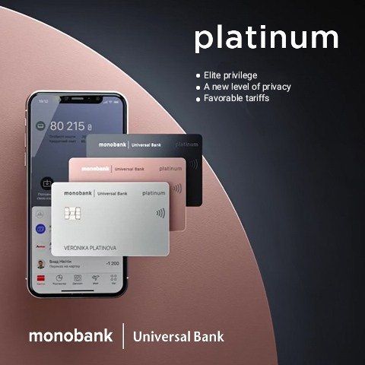

Credit card Monocard from Monobank

Monobank has many interesting payment cards. But in this review below we will talk more about one of the most common - black card.

Rates and conditions on the map

Let me in more detail tell you about the terms of the "black" card from Mono Bank:

International Payment System Card - Mastercard/ Visa

Free registration and maintenance

Free delivery of cards by courier : Kiev, Dnepr, Odessa, Kharkov, Lviv and Zaporozhye.

Cashback up to 20% on certain categories of purchases

Commission for the withdrawal of own funds 0.5% in any ATM in Ukraine.

The real annual interest rate on the card is 44.12% per annum

Monthly loan commission 3.1%

Credit rate for grace period 0.00001%

Penalty for overdue payment From 1 to 30 days - 50 UAH. from 31 to 90 days - 100 UAH. from 91 to 120 (210) days - calculated by the formula: 100 UAH. + 6.2% of the total debt incurred on the first day of the relevant calendar month. The rate is 0.00001% per annum.

Mandatory monthly payment of 4% of the debt (not less than UAH 100, but not more than the balance of the debt)

Lack of commissions and transparent tariffs make the single bank card one of the best credit cards in the Ukrainian market.

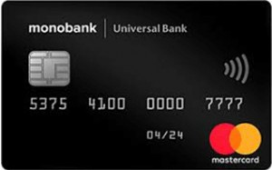

Every product has both positive and negative sides. Let me tell you in more detail what I have noticed in writing this review.

|  |  |
| --- | --- |
| + | - |
| 1. The best tariffs on the Ukrainian market  2 A1. The best tariffs on the Ukrainian market  dequate exchange rate when paying in currency  3. No commission for replenishment  4. No commission for public utilities  5. Cashback  6. Interest on fund balance - 7  7. Convenient application.  8. Minimalist design | 1. No payment by smartphone  2. Transaction volumes and balances of the virtual map |
|  |  |

Many Ukrainian banks offer quite favorable terms of lending. As you can see, the best rates for banking services in Ukraine managed to offer the clients of the team of Monobank. Special analysis claims that it is most profitable to order a map from them.

Cashback

So we got to the thing that our readers are most interested in - cashback. What is cashback in simple words? Here everything is very simple - it is a cash back. Every month you need to choose two categories on which will return up to 20% when paying with a mono card. It can be the purchase of goods, payment for petrol station, visit to the beauty salon, payment for taxi and much more.

The credited money comes to the account instantly after the settlement of the card in the category. Minimum amount , which can be cashed from 100 to 500 UAH per month.

How to Order a Monocard

Any citizen of Ukraine at the age of 14 can order a Monocard. To issue a Monobank card it is enough to take a smartphone, regardless of whether you have an android or iOS from Apple. The app is available in both the Play Market and the Apple Store.

Hurry up to join the registration and become one of the first lucky players to appreciate the benefits of a state-of-the-art monobank card.

Order a map now and get 50 UAH!

In Google Play or Apple, download and install the Monobank app. The first thing the application offered to draw a map. The process took me 10 minutes. Download the app on your smartphone and fill out the questionnaire, honestly and truthfully answering questions.

Here is the list of documents for obtaining a single bank card:

Passport

INN

Help from work (optional)

Additional documents to increase credit limit (optional)

* Now the single bank card can also be obtained with the application «DIY» + PIK of Ukraine

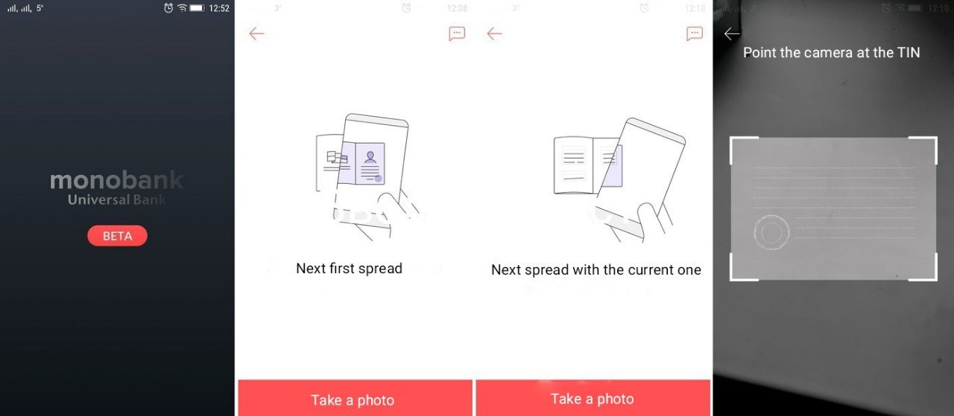

In order to register, you need to do the following:

Enter a valid phone number. It will come with a text with a confirmation code.

Enter the numbers from the message into the app.

Take a picture of the passport and send it. The bank sets certain requirements for the photos. So, you can not upload finished photos. You need to take a picture through the app. By the way, the same requirement is everywhere where you need a remote registration on your passport. This allows you to confirm that your passport is in your hands, and the photo is not corrected. Given that the bank issues, including credit cards - the requirement is reasonable. No one will be happy to learn that in his name was received online loan.

Take a photo with a passport in your hands, a sheet with the date on the photo and the inscription Monobank. It is necessary to do on the main camera - the photo should not be mirror.

Answer some questions, and the registration will be over. Remember, with the bank always have to be honest. If you enter incorrect data, you will be blocked from the account. In fact, they are needed to set the credit limit on the card. If you are not interested, and plan to use as a debit - this moment can be skipped.

Next, choose how to get a Monobank card. There are two options:

Go to the nearest partner bank branch or point of issue;

Wait for the courier.

As soon as Monobank confirms all your information, you can safely order a single bank card. In this case, no paper forms and questionnaires.

You can issue a Mono card in any convenient for you place where there is access to the Internet.

How to use the card from Monobank

The universality of the map is confirmed by the fact that it can be used both on the territory of Ukraine and abroad. Thanks to the international payment system MasterCard, payments can be made contactlessly.

Replenishment

New clients of Monobank often have a question: how to replenish the card if the bank branches do not exist? The answer is very simple: go to the application Monobank, on the main page select the item «Add to your card».

You will be given the main ways of replenishment:

From another card. The easiest way. If you have the cards of other banks, you can quickly perform the operation of recharging the Monobank card. To do this, you will need to enter the card data, specify the amount of the transfer and confirm the transaction. Note that some banks charge a commission.

Cash replenishment. The screen will show a map of the nearest terminals or Ibox, which are partners of the mobile bank. On the map you can see a detailed schedule of work.

According to the details in Ukraine. This method is somewhat worse than previous ones, since the money is credited within 3 days. In addition, for such a transfer is removed additional fee.

According to the details from abroad. The method is not very profitable. Used most often for people who work abroad. The details are determined by the currency used for the transfer. The amount of the commission is determined by the bank.

Click here. This method involves creating a link, opening which you can replenish your card. You can send such a link using Telegram, Viber, Facebook Messenger messengers.

All these methods are located in the app itself and you can use them at any time.

Cash withdrawal

The question how you can withdraw money from the Monobank without a commission people ask quite often - cashing funds in mobile banks has a certain specificity. No branches, no ATMs, how do you get your blood money?

In principle, you can withdraw money from the Monobank card in any ATM in Ukraine, but the commission in some cases will be, in others - no. If the bank whose ATM you decided to use is not a partner, you will have to pay an additional interest. The ATMs of partners - Universal Bank and A-bank do not take it.

In addition, all banks, partner or not, set limits on withdrawals in ATMs. They are different, most often - 1000 UAH.

It is impossible to withdraw money Monobank without a commission - Mono himself always charges a certain percentage. You have to pay 0.5% for your own funds and a full 4% if you are talking about credit. Monobank loans are recommended to be used only for non-cash payments, paying in shops, at stations, gas stations or on the Internet.

As already mentioned, in the branches and ATMs of Universal Bank and A-Bank nothing is charged from the amount, but Monobank will have to pay interest.

It is also possible to cash out funds through the Universal Bank, A-bank and TASkombank. The withdrawal of money from the Monobank card is possible only in the branches of these three financial institutions, and Tambank will take an additional payment for the operation - 0.5%.

Realizing that such conditions are not pleasing, the bank offers to put the funds on deposit. It seems to mean that deposit interest more than compensates for unavoidable losses if it is necessary to pay cash. But the deposit is a little different topic, for an emergency withdrawal this option is not suitable.

Reviews about the "black" card of the Monobank

After analyzing the bank’s customer reviews, I realized that I made the right choice for myself. Although there are negative reviews among them, but as they say, you will not please everyon

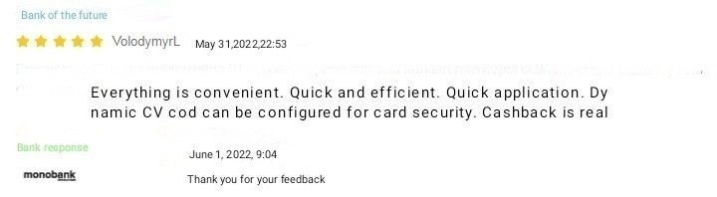

Other Bank Products

Monobank offers its clients a wide range of payment debit and credit cards. All of them differ from each other different conditions and different bargaining chips.

Now in mono very popular are the following cards:

Black card - the most popular card that will be useful almost every day: money transfer, replenishment of mobile, payment for utilities - all transactions are absolutely free;

White card - will work if you need bank plastic most often for cash transfer. The card is issued free of charge. It is debit, that is, it has no credit line;

Children’s card - payment plastic for users from 6 to 16 years. This product is not fully self-contained, the card has the option of parental control. In addition, the card holder mobile application has a special design;

Platinum card - available on the basis of Mastercard and VISA, which implies a lot of privileges and no restrictions. Be the holder of such a card is a great opportunity to save on expenses in travel;

Iron Card - also available on popular Mastercard and VISA systems, guarantees its holder an exclusive status and a high level of filling and care.

Personal card - gives users the opportunity to increase the available amount of the credit limit and to use money without additional commission during the 62 days of the grace period. When using the card there is no service fee,there is no need to visit the bank to open the credit limit.

Virtual card - is intended, first of all, for safe, fast payments in the Internet. The only difference between such a card and ordinary plastic - it exists only in electronic form. Since the card is virtual, it is only digital, but if you tie it to an electronic wallet, you can pay for purchases in ordinary stores. But you can’t cash a card like that.

If the first three cards from the list to get in the Monobank is quite simple, then the cards "Platinum " and "Iron" are issued only to selected customers.

Conclusion

And so, to sum up. Monobank is quite popular and convenient. Draw a card easily and quickly. The bank’s customers receive advantageous rates, can pay bills, draw up installments, use cashback. Users can use a loan or open a deposit. The bank has good technical support and plenty of opportunities.

As you can see, the mono card has a rather big prospects in the future. More and more people prefer the Monobank card, and the bank itself.

I have told you in detail about Monobank cards, and about the bank itself. I think you will have no problem with the choice. I wish you all a good cashback and a great mood. See you soon!

