3. METHODOLOGY AND RESULTS OF INTERPRETATION OF THE WELL SURVEY DATA (WSD). IMITATION OF ELASTIC PROPERTIES OF ROCKS
In this work, aimed at examining and forecasting of lithologic structure and reservoir features of deposits of the Veyak formation of Lower Silurian (S₁vk), the results of interpretation of the well survey (WS) were used with the purpose to assess the major volumetric data of the surveyed bed, and also together with the seismic data for calibration of seismic signal, to construct low-frequency geological model, to establish correlation between elastic properties of rocks, obtained based on seismic survey data and petrophysical rock properties.
In order to resolve the assigned tasks in coordination with the Client, the methodologies and petrophysical functions mentioned in the reports [20, 22] were used as well as those obtained within the scope of this work; besides that, original algorithms, aimed at subsequent utilisation of results of petrophysical interpretation relating the tasks of seismic inversion.
With the purpose to verify the obtained results of the well survey data and to interpret them geologically in an adequate way, the information obtained from the core material (lithologic description, quantitative definitions of petrophysical properties on samples, etc) were widely used, as well as well testing data.

3.1. Petrophysical properties of productive deposits of S₁vk
Filtration-capacitive, water-retentive, elastic, electric and other reservoir features of the surveyed bed were examined, mainly in complex analytical laboratory of TP NITz. Information on the scope of survey of petrophysical properties, used in this work are tabulated below (Table 3.1).

3.1.1. Petrophysical links for productive deposits of S₁vk
Results of assessment of reservoir features of the surveyed deposits were used with the idea to generalize all the existing information relating the core and to construct generalized petrophysical links.

3.1.1.1. Filtration-capacitive and water-retentive features
Fig. 3.1 gives comparison of coefficients of open porosity (К_{п, откр.}) and absolute gas permeability (К_{пр}).

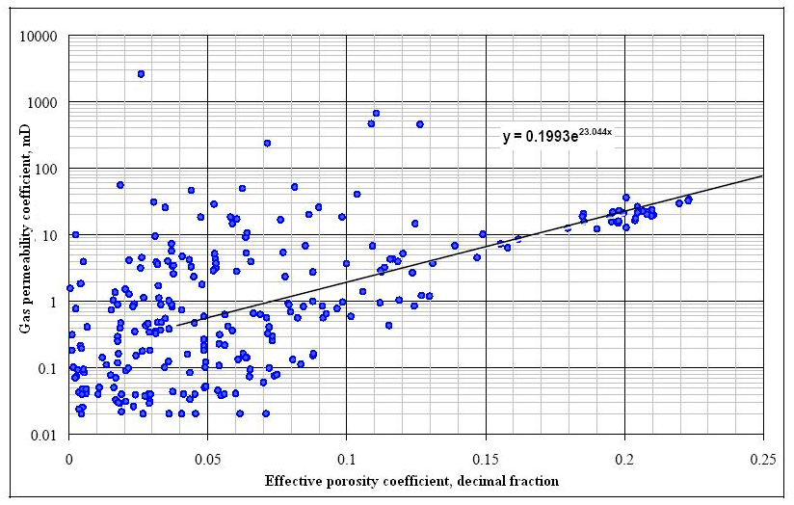
Fig. 3.1. Comparison of coefficients of open porosity (К_{п, откр}) and absolute gas permeability (К_{пр})
As seen in Fig. 3.1, statistically significant correlation between К_{п, откр} and К_{пр} is virtually non-existent and that proves the prevalence of complex type reservoirs (i.e. porous-fractured, porous-fractured-vuggy).
One could note substantial effect of fractures not only within the range of low values of porosity, but also within the range of high (up to 13%) values. Intergranular type of reservoir has developed essentially in the region of high porosity values, i.e. more than 13%, where one could trace linear link between the porosity coefficient and permeability. It is possible to recommend the obtained link for subsequent calculations only for reservoirs with prevalence of porous components. The rate of boundary value of open porosity, adopted in previous works as equal to 7% at boundary value of К_{пр}, equal to 1 mD does not contradict the obtained correlation of К_{пр}=f(К_{п}), but reflects only properties of the rock matrix.

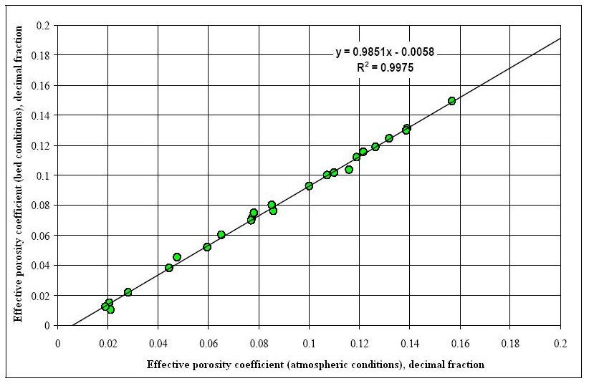
Fig. 3.2. Comparison of open porosity coefficient, obtained in atmospheric (К_{п, откр. атм}) and reservoir conditions (К_{п, откр. пласт})

