PrivatBank: its services and opportunities

Today there are a large number of banks and to choose one of them is not so easy so we suggest you read about PrivatBank and make the right choice.So, we will talk about one of the largest banks in Ukraine. In our article you will read:

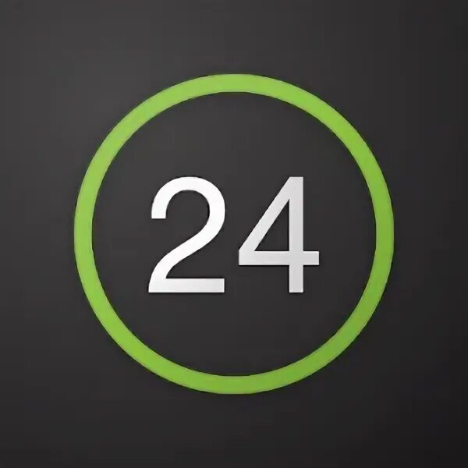
- What is PrivatBank?
- Privat 24
- -Getting a plastic card
- Junior card
- Credit Card
- Terms & Tariffs
- Bank Products
- Reviews and customer opinions
What is PrivatBank?
PrivatBank - the largest and most reliable bank in Ukraine, occupies the 1st place in the top of the most profitable banks, as well as the 16th place in the rating of the largest banks in Europe. It was the first bank in Ukraine to connect Apple Pay.

This bank has an incredible lot of advantages, but we list the most important ones
1. Convenient application for everyone to master.
2.Payment of public utilities in the comfort of your home
3.Contactless payment with any smartphone model.
4. More than 4 000 branches all over Ukraine
5. Reliable payment system

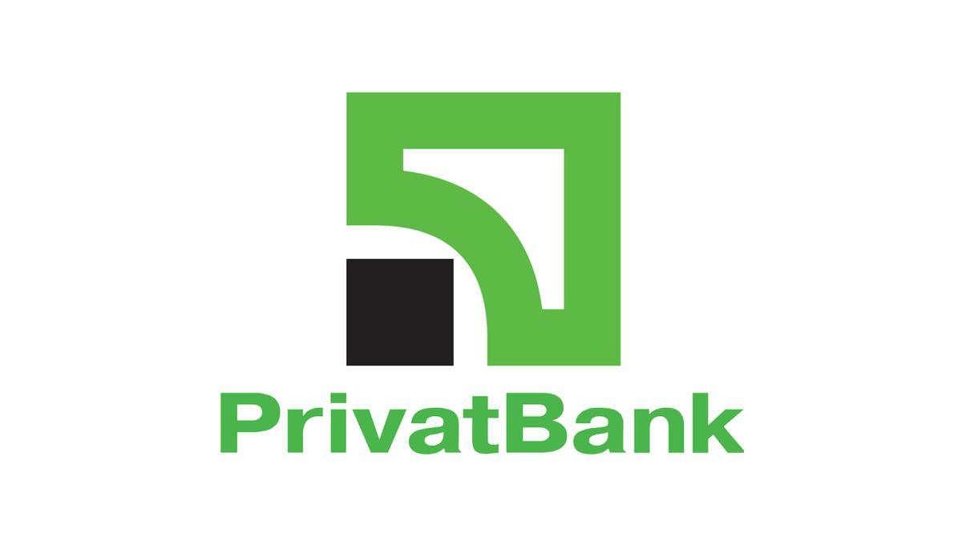
PrivatBank was registered in 1992 and since then it holds leading positions by all key financial indicators. It is easy to use by clients of absolutely any age category, including children (we will tell you about the junior card later). The bank offers many opportunities among which: deposit and credit products, cash management services, interbank operations, securities operations, documentary operations, acquiring services, payment cards and payroll projects.

Privat 24

Privat 24 is the official service of PrivatBank.The service is also suitable for business, both small and large, and allows you to receive payments for the online store with the security of payments, notification of incoming payments and many other functions at any time and in any place.Privat 24 customers have long understood and appreciated the convenience of such a service. With its help, you can always be aware of your accounts. It allows paying utility bills, transferring money from card to card, both to your own and other people's cards, replenishing internet and cell phone bills, buying various tickets, paying for purchases on the internet and performing many other operations.There is no need to go to the bank or look for a terminal, just choose the repayment page in the site menu, choose your financial or credit organization and by the number of credit contract and payer's name make the payment. You can create a payment template in your personal office and you won't need to fill in the form every time.

Registration
To register on the site is very simple, you only need to perform a few actions:
Step 1. Go to the site Privat24 and click on <Register>.
Step 2. You will automatically be redirected to the registration page. Enter the necessary data.
Step 3. If all the data you entered in the previous form was correct, you will receive a password on your phone number. Enter this password into the form and click "Continue". That's it, the registration is completed! Now you can use Privat24 without any limits.

That's how in just 3 steps you can register on the site. Now we will tell you how to register in the application:
Step 1. Download Privat24.
Step 2. Click on "Register" button, which is situated under the login and password input window
Step 3. Then enter your login and cell phone number, which will be used to login into the system
Step 4. Confirm the operation by receiving a call or entering the single-use password from SMS-notification
Step 5.Confirm the registration by entering the PIN-code of PrivatBank payment card on the virtual keyboard
Step 6. Write and enter the password consisting of letters and digits, at least six symbols (maximum 15)
Step 7 Specify a valid e-mail address
If you agree with the terms and conditions of using banking services, please tick the appropriate box. Already done! Now you can use all application services.

Getting a plastic card

Where and how do I get a plastic card? Let's first understand why you need one
The bank cards are used for non-cash payments, including via the Internet, as well as for cash withdrawal or account replenishment via ATM or cash point
And unlike mono-bank, cash can be withdrawn from the PrivatBank card at absolutely any ATM.

How to get a card in Privat24

Authorize in Privat24;

In the "Wallet" menu press "Add" and select "Digital card";

Choose the type of card you want to get ("Credit" or "Debit"), payment system and currency;

You will see your new card in your wallet within 10 minutes.

The card can be ordered with delivery, or you can pick it up at the bank branch. It also has a variety of beautiful designs. For example, it can be a card with strawberries, with shopping, or just colored.

Junior card
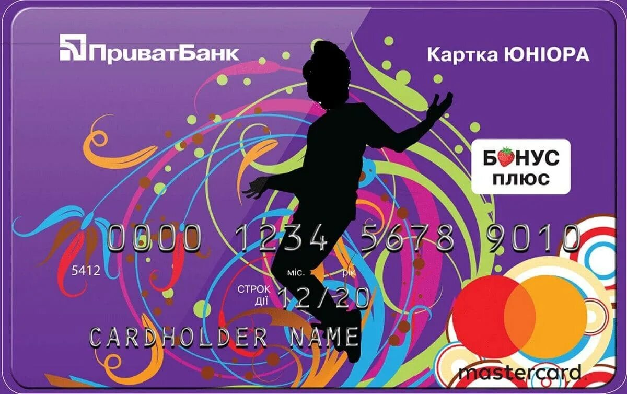
JuniorBank from PrivatBank is a real way to teach your child how to use banking services. What is especially important is that the cardholder will understand that he/she is already quite an adult and responsible person. After all, the Junior card has the same functions as an adult's card.

In order to keep the adult-child from getting carried away with active shopping, there is a limit credit. If the child spends all his funds, the bank will credit the purchase up to 300 hryvnias.

The grace period is the same as for the other cards - 55 calendar days. The main thing is that the credit card has all functional peculiarities like its "adult" analogue. In addition, it gives its holder the following privileges:

The balance of your own funds accrues interest of 10% per annum.

Free service and issue, with the connection SMS - banking.

Information on all financial transactions comes not only to the phone of a young user, but also to one of the parents.

Zero commission for the purchase of goods in Internet-stores.

The following documents will be required for registration:

- The child's birth certificate.
- The accompanying parent's passport.
- Cell phone of a young client of PrivatBank.

Bank employees will hand over a standard contract for reading and signing. After its execution the card is issued. It is possible to order a credit card on the official web-site of PrivatBank.

