PrivatBank: its services and opportunities
Today there is a large number of banks and to choose one of them is not so easy so we suggest you read about PrivatBank and make the right choice. So, we will talk about one of the largest banks in Ukraine. In our article you will read:
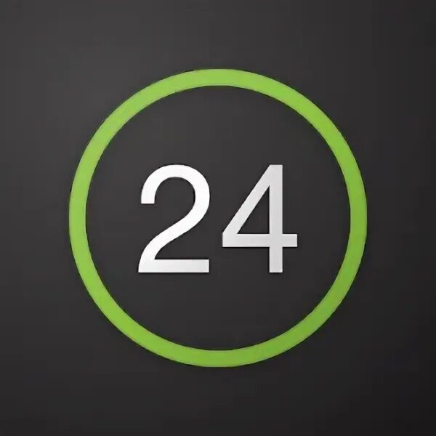
- What is PrivatBank?
- Privat24
- Getting a plastic card
- Junior card

What is PrivatBank?
PrivatBank - the largest and most reliable bank in Ukraine, occupies the 1st place in the top of the most profitable banks, as well as the 16th place in the rating of the largest banks in Europe. It was the first bank in Ukraine to connect Apple Pay.
The advantages of this bank are incredibly numerous, but we will list the most important ones:
1. A user-friendly application that everyone can master.
2. Payments for utility bills in the comfort of your home.
3. Contactless payment with any smartphone model .
4. More than 4 000 branches all over Ukraine.
5. Reliable payment system
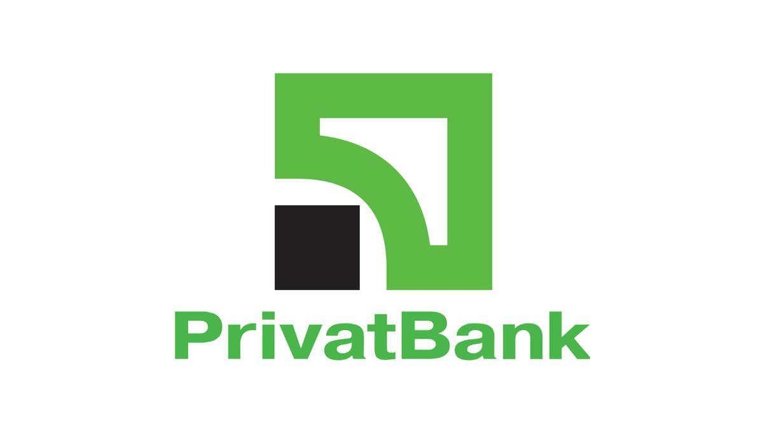
PrivatBank was registered in 1992 and has been leading in all key financial indicators ever since. It is easy to use by clients of absolutely any age category, including children (we will tell you about the junior card later). The bank offers many opportunities among which: deposit and credit products, cash management services, interbank operations, securities operations, documentary operations, acquiring services, payment cards and payroll projects.

Privat24
Privat 24 is the official service of PrivatBank. The service is also suitable for business, both small and large, and allows you to accept payments for your online store with payment security, notification of incoming payments and many other functions at any time and in any place. The clients of Privat24 understood and appreciated the convenience of this service long ago. With its help, you can always be aware of your accounts. It allows paying utility bills, transferring money from card to card, as well as to other people's cards, replenishing internet and cell phone bills, buying various tickets, paying for Internet purchases and performing many other operations. You don't have to go to the bank or look for a terminal, just choose the page of credit repayment in the site menu, choose your financial or credit organization and use the number of credit agreement and the name of the payer to make a payment. You can create a payment template in your account and will not need to fill in the form every time.
Registration
To register on the site is very simple, you only need to perform a few actions:
Step 1. Go to Privat24 website and click on <Register> button
Step 2. You will be automatically redirected to the registration page. Enter the necessary data.
Step 3. If all the data you entered in the previous form was correct, a password will be sent to your phone number. Enter this password into the form and click "Continue". That's it, the registration is completed! Now you can use Privat24 without any limits.
That's how you can register on the site in just three steps. Now we will tell you how to register in the application:
Step 1: Download the Privat24 app.
Step 2. Press the "Registration" button, which is located under the login and password input boxes.
Step 3. Enter login and cell phone number you will use for login.
Step 4. Confirm the operation by receiving a call or entering the one-time password from the SMS-notification.
Step 5.Confirm the registration by entering the PIN-code of PrivatBank card on the virtual keyboard
Step 6. Write and enter the password consisting of minimum six symbols (maximum 15), consisting of letters and digits
Step 7. Write a valid e-mail address
If you agree with the terms and conditions of using banking services, please tick the appropriate box. Already! Now you can use all application services.
Obtaining a plastic card
Where and how do I get a plastic card? Let's first understand why you need one
The bank cards are used for non-cash payments, including via the Internet, as well as for cash withdrawal or account replenishment via ATM or cash point.
And unlike mono-bank, cash can be withdrawn from the PrivatBank card at absolutely any ATM.
How to get a card in Privat24 on your own
Authorize in Privat24;
Click "Add" in the "Wallet" menu and select "Digital card";
Select the type of card you want to issue ("Credit" or "Debit"), the payment system and currency;
You will see your new card in your wallet within 10 minutes.
The card can be ordered with delivery, or you can pick it up at a bank branch. It also has a variety of beautiful designs. For example, it can be a card with strawberries, with shopping, or just colored.
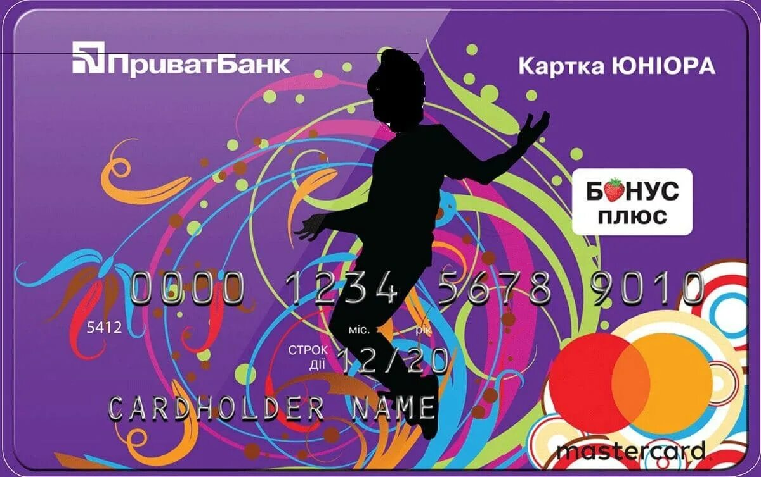
Junior card
JuniorBank from PrivatBank is a real way to teach your child how to use banking services. What is especially important is that the cardholder will understand that he/she is already quite an adult and responsible person. After all, the Junior card has the same functions as those of an adult user.
In order to prevent the adult-child from getting carried away with active shopping, there is a limit loan. If the child spends all his funds, the bank credits the purchase for an amount not exceeding 300 hryvnias.
The grace period is the same as for the other cards - 55 calendar days. The main thing is that the credit card has all functional peculiarities like its "adult" analogue. Besides it gives to its owner the following privileges:
Interest is accrued on the balance of own funds at the rate of 10% per annum.
Free service and issuance, with the connection of SMS - banking.
Information about all financial transactions comes not only to the phone of a young user, but also to one of the parents.
Zero commission when purchasing goods in Internet-stores.
You will need to have the following documents:
- The child's birth certificate.
- Civil passport of accompanying parent.
- Cell phone of the young client of PrivatBank.
Bank employees will give you a standard agreement to read and sign. After its execution the card is issued. It is possible to order a credit card on the official web-site of PrivatBank.

