**PrivatBank: its services and opportunities**

**Today there is a large number of banks and it is not easy to choose one of them, so we suggest you read about PrivatBank and make the right choice.** So, we will talk about one of the largest banks in Ukraine. In our article you will read:

* 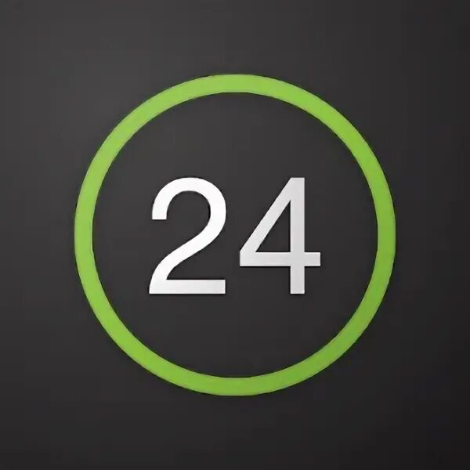What is PrivatBank?
* Privat24
* Getting a plastic card
* Junior card
* Credit Card
* Terms and rates
* Banking products
* Comments and opinions

**What is PrivatBank?**

**PrivatBank** - the largest and most reliable bank in Ukraine, occupies the 1st place in the top of the most profitable banks, as well as the 16th place in the rating of the largest banks in Europe. It was the first bank in Ukraine to connect Apple Pay.

The advantages of this bank are incredibly numerous, but we will list the most important ones

1. Convenient application which can be mastered by anyone

2. Payments for utility bills in the comfort of your home

3. Contactless payment with any smartphone model

4. More than 4 000 branches all over Ukraine

5. Reliable payment system

PrivatBank was registered in 1992 and has been leading in all key financial indicators ever since. It is easy to use by clients of absolutely any age category, including children (we will tell you about the junior card later). The bank offers many opportunities among which: deposit and credit products, cash management services, interbank operations, securities operations, documentary operations, acquiring services, payment cards and payroll projects.

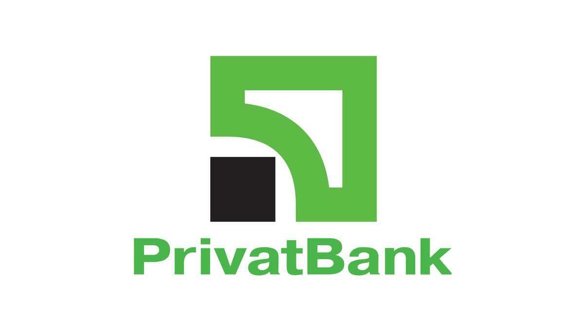

**Privat 24**

Privat 24 is the official service of PrivatBank. This service is also suitable for business, both small and big, and allows you to receive payments for your online store with payment security, notification of incoming payments and many other functions at any time and in any place.Privat24 clients have long understood and appreciated the convenience of this service. With its help, you can always be aware of your accounts. It allows paying utility bills, transferring money from card to card, both to your own and other people's cards, replenishing internet and cell phone bills, buying various tickets, paying for purchases on the internet and performing many other operations.There is no need to go to the bank or look for a terminal, just choose the repayment page in the site menu, choose your financial or credit organization and by the number of credit contract and payer's name make the payment. You can create a payment template in your personal office and you won't need to fill in the form every time.

**Registration**

To register on the site is very simple, you only need to perform a few actions:

Step 1. Go to the site Privat24 and click on "Registration".

Step 2. You will automatically be redirected to the registration page. Enter the necessary data.

Step 3. If all the data you entered in the previous form was correct, you will receive a password on your phone number. Enter this password into the form and click "Continue". That's it, the registration is completed! Now you can use Privat24 without any limits.

That's how you can register on the site in just 3 steps. Now we will tell you how to register in the application:

Step 1. Download the Privat24 application.

Step 2. Press the button "Registration", which is located under the windows for username and password input.

Step 3. Then enter your login and cell phone number, which will be used to login into the system.

Step 4. Confirm the operation by receiving a call or entering a one-time password from the SMS-notification.

Step 5.Confirm the registration by entering the PIN-code of PrivatBank card on the virtual keyboard.

Step 6 Devise and enter a password consisting of minimum six symbols (maximum 15), consisting of letters and digits.

Step 7. Enter a valid e-mail address.

Step 8. Agree with the terms and conditions of using banking services, by ticking the appropriate checkbox. Already done! Now you can use all application services.

**Getting a plastic card**

Where and how to get a plastic card? Let's first understand why you need one.

The bank cards are used for non-cash payments, including via the Internet, as well as for cash withdrawal or account replenishment via ATM or cash point

And unlike mono-bank, cash can be withdrawn from the PrivatBank card at absolutely any ATM.

**How to get a card in Privat24**

Authorize in Privat24;

In the "Wallet" menu press "Add" and select "Digital card";

Select the type of card you want ("Credit" or "Debit"), payment system and currency;

You will see the new card in your wallet within 10 minutes.

The card can be ordered with delivery, or you can pick it up at a bank branch. It also comes in a variety of beautiful designs. For example, it can be a strawberry card, a shopping card, or just a colorful card.

**Junior card**

JuniorBank from PrivatBank is a real way to teach your child to use banking services and facilities. Especially important is the fact that the cardholder will understand that he/she is already quite an adult and responsible person. After all, the Junior card has the same functions as those of an adult user.

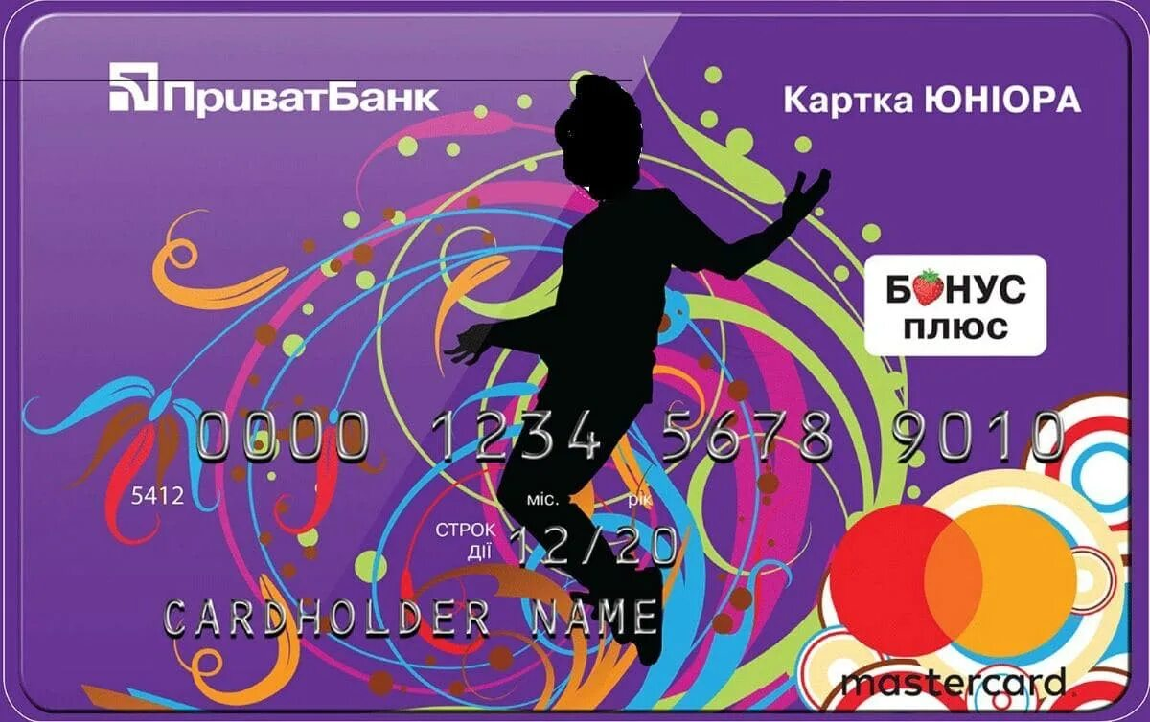In order to prevent the adult-child from getting carried away with active shopping, there is a limit loan. If the child spends all his funds, the bank credits the purchase for an amount not exceeding 300 hryvnias.

The grace period is the same as for other cards - 55 calendar days. The main thing is that the credit card has all the functional features of its "adult" counterpart. In addition, it gives its owner the following privileges:

Interest is accrued on the balance of own funds at the rate of 10% per annum.

Free service and issue, with the connection of SMS - banking.

Information about all financial transactions comes not only to the phone of the young user, but also to one of the parents.

Zero commission for purchasing goods from online stores.

You will need to have the following documents to apply:

- The child's birth certificate.

- Civil passport of accompanying parent.

- Cell phone of the young client of PrivatBank.

Bank employees will hand over a standard contract for reading and signing. After its execution the card is issued. It is possible to order a credit card on the official web-site of PrivatBank.

**Credit Card**

One of the best credit cards with tens of millions of satisfied users.

A person facing the problem of choosing a credit card for the first time may experience serious difficulties because of the huge number of offers in the market of banking products. The task can be significantly narrowed if you familiarize yourself with the terms and conditions of one of the best credit cards.

What are the advantages of PrivatBank "Universalna" credit card?

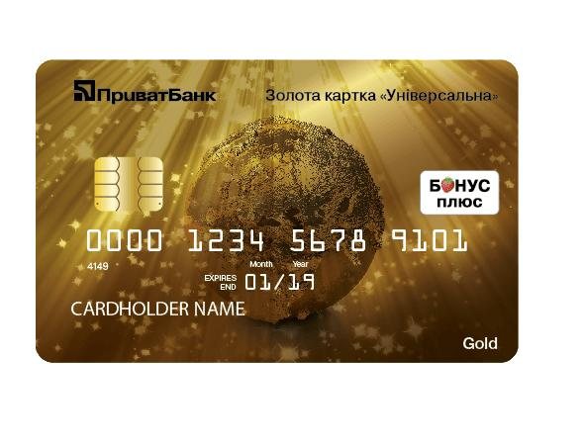Free registration and service.

10% per annum.

Excellent online banking.

Pin code change.

SMS banking.

Bonus Plus.

Check lottery.

0% credit period.

Access to Privat24 internet banking.

**"Universal Gold**

Universal Gold" card

With the Gold credit card you can use both your own money on the card and credit funds. Your relatives, friends or partners can transfer money to this card. Funds on "Universalnaya Gold" card, both personal and credit ones, are available to you everywhere in the world at any time.

The higher the level, the more services the bank provides with the card, but at the same time the cost of servicing Premium level cards is more expensive for the client. So in essence Gold card is the same payment instrument as a usual one but with additional advantages.