**PrivatBank: its services and opportunities**

Today there is a large number of banks and to choose one of them is not so easy so we suggest you read about PrivatBank and make the right choice.So, we will talk about one of the largest banks in Ukraine. In our article you will read:

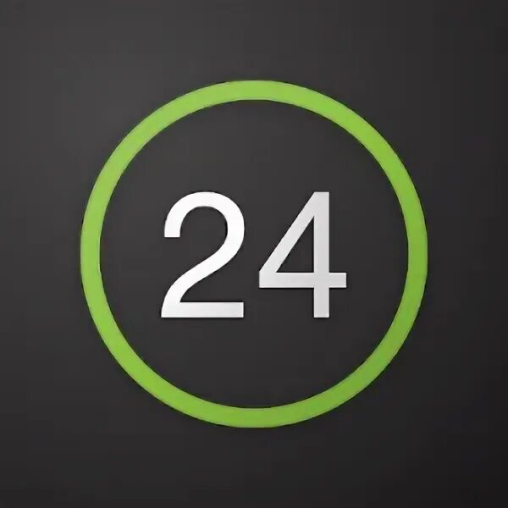• What is PrivatBank?

• Privat24

• Getting a plastic card

• Junior card

• Credit Card

• Terms & Conditions and Fees

• Bank products

• Customer reviews and opinions

***What is PrivatBank?***

**PrivatBank** - the largest and most reliable bank in Ukraine, occupies the 1st place in the top of the most profitable banks, as well as the 16th place in the rating of the largest banks in Europe. It was the first bank in Ukraine to connect Apple Pay.

**The advantages of this bank are incredibly numerous, but we will list the main ones:**

1. A handy application that anyone can master

2. Paying utility bills without leaving home

3. Contactless payment from any smartphone model

4. More than 4 000 branches all over Ukraine

5. Reliable payment system

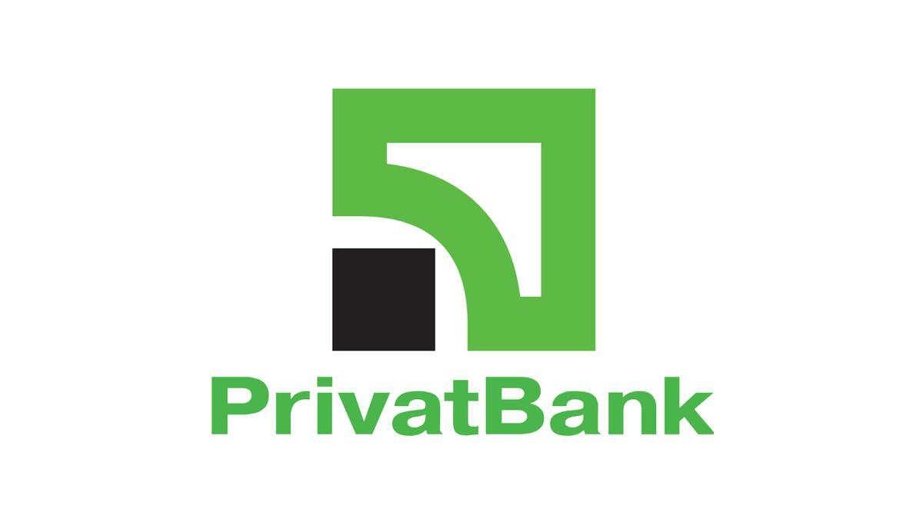 PrivatBank was registered in 1992 and has been leading in all key financial indicators ever since. It is easy to use by clients of absolutely any age category, including children (we will tell you about the junior card later). The bank offers many opportunities among which: deposit and credit products, cash management services, interbank operations, securities operations, documentary operations, acquiring services, payment cards and payroll projects.

***Privat24***

Privat 24 is the official service of PrivatBank.The service is also suitable for businesses, both small and large, and allows you to accept payments for an online store with payment security, notification of received payments and many other functions at any time and in any place.Privat 24 customers have long understood and appreciated the convenience of such a service. With its help, you can always be aware of your bills. It allows paying utility bills, transferring money from card to card, both to your own and others' cards, replenishing internet and cell phone bills, buying various tickets, paying for Internet purchases and performing many other operations.No need to go to the bank or look for a terminal, just select the repayment page in the site menu, choose your financial or credit organization and make payment by the number of credit contract and payer name. You can create a template of payment in your personal cabinet, and you won't need to fill in the form every time.

***Registration***

Registering on the site is very easy, you only need to perform a few actions:

Step 1. Go to the website [Privat24](https://www.privat24.ua/) and click on <Register>.

Step 2. You will automatically be taken to the registration page. Enter the necessary information.

Step 3. If all the information you entered in the previous form was correct, a password will be sent to your phone number. Enter this password into the form and click "Continue". That's all, registration is completed! Now you can use Privat24 without any limits.

That's how in just 3 steps you can register on the site. Now we will tell you how to register in the application:

Step 1. Download App [Privat24](https://privatbank.ua/apps/privat-24)

Step 2. Click the "Register" button, which is located under the login and password input boxes

Step 3. Next, enter your username and the cell phone that will be used to log in

Step 4. Confirm the operation by receiving a call or by entering the one-time password from the SMS-notification

Step 5. Confirm registration by entering PIN-code of PrivatBank card on the virtual keyboard

Step 6. Make up and enter a password of at least six characters (maximum 15), consisting of letters and numbers

Step 7. Enter a valid e-mail address (e-mail)

Step 8. Agree with the terms and conditions of banking services by clicking the appropriate checkbox. Finished! Now you can use all services of the application.

***Getting a plastic card***

Where and how do I get a plastic card? Let's first understand why you need one at all

Bank cards are used for non-cash payments, including via the Internet, as well as for cash withdrawals or replenishments through ATMs or cash points

And unlike Monobank, you can withdraw cash from a PrivatBank card at absolutely any ATM.

***How to apply for a card in Privat24***

Authorize in Privat24;

In the "Wallet" menu, click "Add" and select "Digital Card";

Select the type of card you plan to issue ("Credit" or "Debit"), the payment system and currency;

You will see the new card in your wallet within 10 minutes.

The card can be ordered with delivery, or picked up at the bank branch. It also has a variety of beautiful designs. For example, it can be a card with strawberries, with shopping, or simply colored.

***Junior card***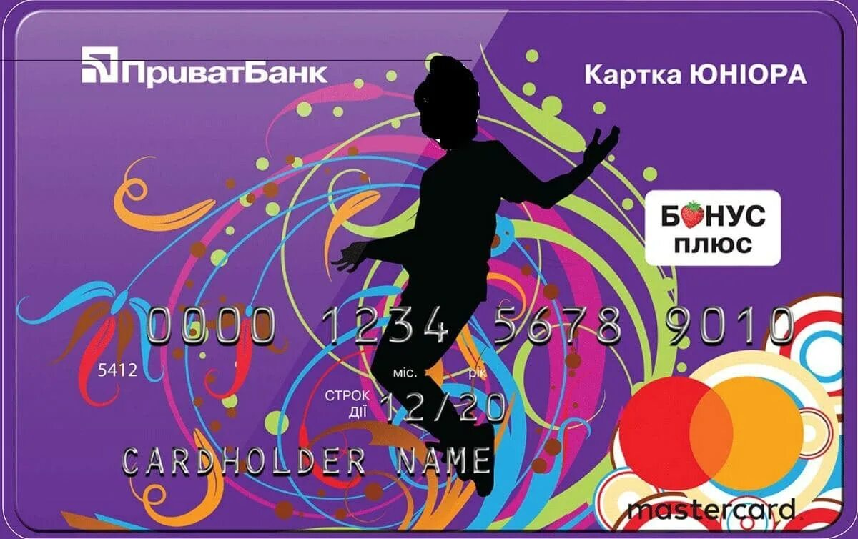

JuniorBank from PrivatBank is a real way to teach your child how to use banking services. What is especially important is that the cardholder will understand that he/she is already quite an adult and responsible person. After all, the Junior card has the same functions as those of an adult user.

In order to keep the adult-child from getting carried away with active shopping there is limited credit. If the child has spent all his money, the bank credits the purchase for an amount not exceeding 300 hryvnia

The grace period is the same as for other cards - 55 calendar days. The main thing is that the credit card has all the functional features of its "adult" counterpart. In addition, it gives its owner the following privileges:

Interest is accrued on the balance of own funds at the rate of 10% annual.

Free service and issue, with the connection SMS - banking.

Information about all financial transactions comes not only to the phone of the young user, but also one of the parents.

Zero commission for purchasing goods from online stores.

For registration you will need to have the following documents:

* The child's birth certificate.
* The civil passport of the accompanying parent.
* Cell phone of a young PrivatBank client.

Bank employees will give you a standard agreement to read and sign. After its execution the card is issued. It is possible to order a credit card on the official web-site of PrivatBank.

***Credit Card***

One of the best credit cards with tens of millions of satisfied users.

A person facing the problem of choosing a credit card for the first time may experience serious difficulties because of the huge number of offers in the market of banking products. The task can be significantly narrowed if you familiarize yourself with the terms and conditions of one of the best credit cards.

What are the advantages of PrivatBank "Universalna" credit card?

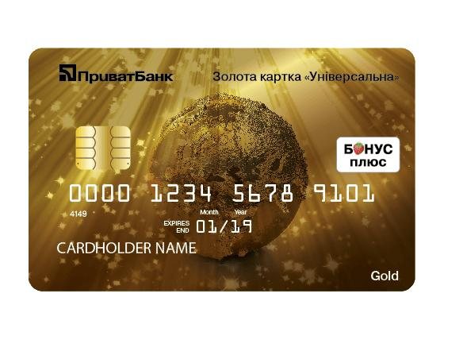Free registration and service

10% per annum

Great online banking

Changing a pin code

SMS banking

Bonus Plus

Lottery check raffle

Credit period at 0%

Access to Privat24 online banking

<Universal Gold>

Universal Gold card

With a Gold credit card, you can use your own money on the card as well as credit funds. Your relatives, acquaintances or partners can transfer money to this card. Funds on the card "Universalnaya Gold" both personal and credit are available to you anywhere in the world at any time of the day or night.

The higher the level, the more services the bank provides with the card, but at the same time the cost of servicing premium cards is more expensive for the client. That is, in fact, the Gold card is the same payment instrument as the usual one, only with additional benefits.

***Other services***

**Human Resources Security**

PrivatBank is ready to offer its corporate clients a new solution for personnel security. PrivatBank managed in a short time to minimize the risk of fraud among its employees. If you also want to protect your business from such a problem, contact the bank's specialists, they know how to do it.

**OSHA policies**

OCCLI is a policy of Compulsory Motor Third Party Liability Insurance. The policy provides indemnification of damages to victims of traffic accidents on the territory of Ukraine, in case of damage to property, life and health.

**PayPass sticker**

The latest technology makes it possible to make purchases without contact with paper money. To pay for a transaction, you need to bring a PayPass sticker to the reader installed at the cash register.

**Deposit PrivatBank**

It is a profitable investment of money, a guarantee of its safety and an opportunity to receive additional income with absolutely no effort at all. First of all, the client will not only keep his money, but also receive additional profit in the form of accrued interest.

**Savings service "Money Box"**

As a rule, when the time comes to save the planned funds, the need to spend them immediately arises. "PrivatBank offers you to save money without noticing it.

**Payment in installments. No overpayments**

Nowadays, more and more often people are faced with such a problem as overpayment. Various companies are vying with each other to offer their supposedly unbelievable conditions and as a result, they do not meet your expectations. That is why PrivatBank will provide you with payment in installments without overpayments.

***Bank products***

**Pension card**

"PrivatBank offers seniors favorable conditions for receiving pensions. It is very convenient to visit a bank branch only once, without having to waste time on a trip to the Pension Fund.

**The "Universalna" name card**

"PrivatBank offers its clients to open an additional payment card with photo. Universalna name card with photo is supplemented with a special chip with high security level, so it is impossible to forge it, because your name and surname are indicated and there is a photo on the card.

**Mini Map**

"PrivatBank offers its clients to get the MiniCard. PrivatBank Mini Card is a stylish accessory and a practical international class card for making various payments.

***Reviews***

Today we told you about perspectives, conveniences, and advantages of PrivatBank. In conclusion we offer you to read some feedback from bank's clients.

