PrivatBank: its services and opportunities
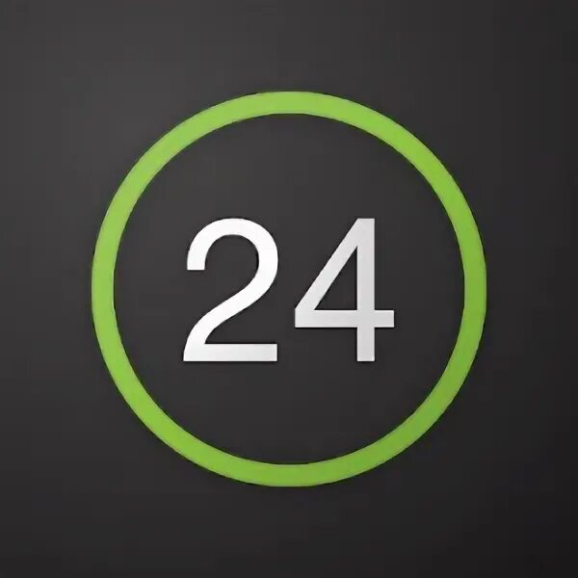
Today there is a large number of banks and to choose one of them is not easy so we suggest you to read about PrivatBank and make the right choice.So, we will talk about one of the largest banks in Ukraine. In our article you will read:
- What is PrivatBank?
- Privat24
-Getting a plastic card
- Junior card
- Credit Card
- Terms & Tariffs
- Bank products
- Our Customers' Reviews
What is PrivatBank ?
PrivatBank is the largest and most reliable bank in Ukraine. It occupies the 1st place in the top of the most profitable banks, as well as the 16th place in the rating of the largest banks in Europe. The first one in Ukraine hooked up Apple Pay.

This bank has many advantages, but we list the most important ones

1. Convenient application for those who want to use it..

2. Paying for utilities in the comfort of your own home;

3. Contactless payment with any smartphone model. 4.

4. More than 4 000 branches all over Ukraine

5. Reliable payment system

PrivatBank was registered in 1992 and since then it holds leading positions in all key financial indicators. It is easy to use by customers of absolutely any age category, including children (we will tell you about the junior bank card later). The bank offers many possibilities among which are: deposit and loan products, cash management, interbank operations, securities operations, documentary operations, acquiring services, payment cards and payroll projects.

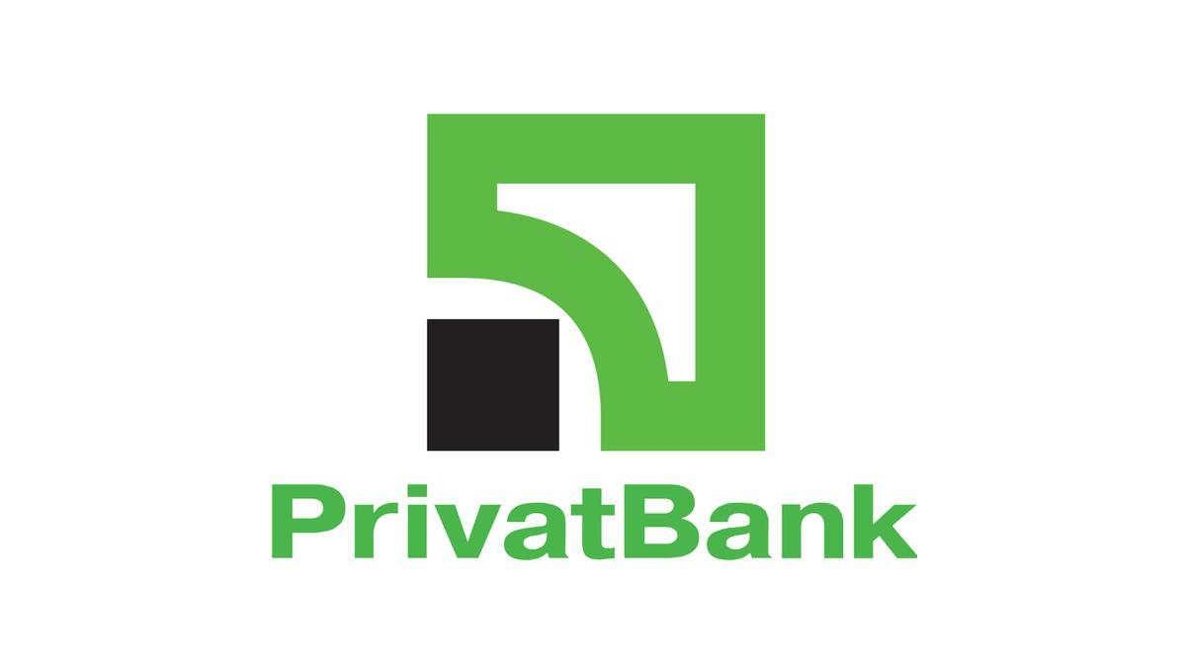

Privat24
Privat24 is the official service of PrivatBank.The service is also suitable for businesses, both small and large, allowing you to accept payments for an online shop with payment security, notification of incoming payments and many other features at any time and in any place.Privat24 customers have long understood and appreciated the convenience of such a service. With its help, you can always be aware of your accounts. It allows you to pay utility bills, transfer money from card to card, both to your own and other people's cards, replenish Internet and mobile phone bills, buy various tickets, pay for Internet purchases and perform many other operations.No need to go to the bank or look for a terminal, just choose in the site menu the repayment page, choose your financial or credit organization and by the number of credit agreement and the name of payer make the payment. You can create a payment template in your personal cabinet, so you don't have to fill in the form every time.
Registration
Registration on our website Privat24 very simple, you have to do several steps:
Step 1: Visit the site Privat24 and click on <Register>.
Step 2. You will be automatically redirected to the registration page. Please enter necessary data.
Step 3. If all the data you entered in the previous form is correct, you will receive a password on your phone number. Enter this password into the form and click on "Continue". That is all, registration completed! Now you can use Privat24 without any limits.
That is how in just 3 steps you can register on the website. Now we will tell you how to register in the application:
Step 1. Download Privat24 app.
Step 2: Click on "Register" button which will be located under the login and password input window
Step 3. Enter your username and mobile number you will be using to login into the system.
Step 4 Confirm the operation by receiving a call or entering a one-time password from SMS-notification
Step 5.Confirm the registration by entering the PIN code of PrivatBank payment card on the virtual keyboard
Step 6. Write and enter the password composed of at least six symbols (maximum 15), as well as digits
Step 7 Enter a valid e-mail address
Step 8. agree with the terms and conditions of using banking services, by clicking on the respective checkbox. Already done! Now you can use all the services of the application.

Getting a plastic card
Where and how do I get a plastic card? Let's first understand why you need one
Bank cards are used for non-cash payments, including via the Internet.
For cash withdrawals or top-ups at ATMs or cash withdrawal points.
Unlike Monobank, you can withdraw cash from a PrivatBank card at any ATM or cash point.
ATM

How to open a card in Privat24?

Authorize in Privat24;
In the "Wallet" menu, press "Add" and select "Digital Card";

Choose the type of the card you are going to issue ("Credit" or "Debit"), payment system and currency;

You will see your new card in your wallet within 10 minutes.

The card can be ordered with delivery, or you can pick it up at the bank branch. You can also get the card in different beautiful designs. For example it can be a card with strawberries.
simply coloured.

Junior card

JuniorBank from PrivatBank - is a real way to teach the child to use banking services. Especially important is the fact that the cardholder will see that he/she is already an adult and responsible person. The Junior bankcard has the same Junior Velcro card has the same functions as adult one.

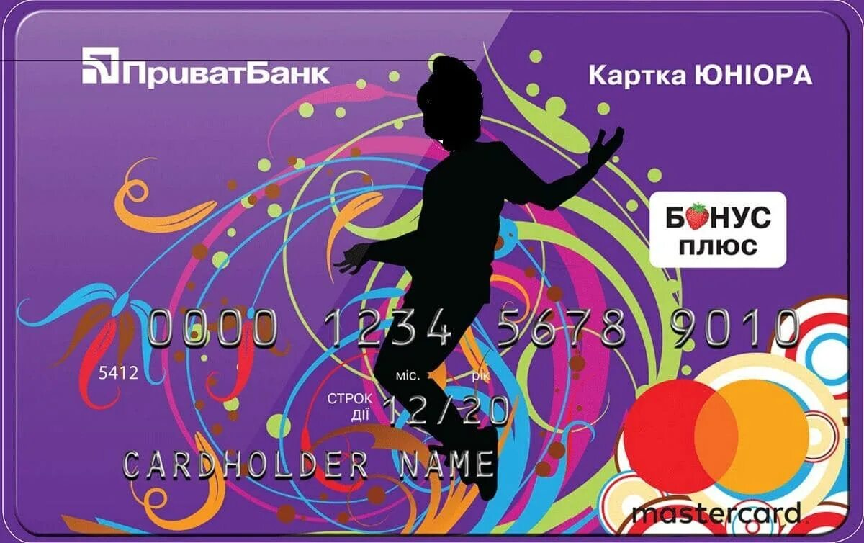
There is a credit limit to prevent your child from getting carried away with active shopping.
If the child spends all of his/her funds, the bank will credit the purchase up to 300 hryvnias.
astercard
The grace period is the same as for the other cards - 55 calendar days.
The main thing is that the card has all functional features like its "adult" counterpart. Except that it provides its holder with the following
privileges.

The equity balance bears interest at 10% per annum.

Free of charge servicing and issue, with connection to SMS – banking

All financial transactions are reported not only to the phone of a young
of the user but also of a parent

