United States Patent n9i

Midden

[S4) COFFEE GRINDER
[75] Inventor: William E. Midden, Springfield, Ill. [73) Assignee: Buan•O•Matic Corporntion,
Springfield, Ill.
(21] Appl. No.: 562,757
[22] Filcd: Aag. 3, 1990
[5l] Int. G.• .............................................. B02C 19 m
[52] US. Cl. ....
241/i46 J1 258 241/
[58] Field of Senrch ’241/ltXl,’101.4, 246,
241/248, 258, 259.1, 261.2, 261.3
[56] References Clted
U.S. PATENT DOCUMENTS
2,852,202 9/1958 Ditting et al. l/1(D X
2,900,140 8/1959 Schuhmann et al. /liXi X
3,6l0,$40 10/1971 Krolopp et al. /13 X
4,023,737 5/1977 Leider et al. 241/261.3
4,039,153 8/1977 Hoffman /261.2 X
4,605,175 8/1986 Weber /261.2 X
4,607,622 8/1986 Zimmcmam ::.:::::::: ¥#1/31 X
USO35201474A
liii Patent Number: 5,201,474

[45j Date of Patent: Apr. 13, 1993

FOREIGN PATENT DOCUMENTS
501028 2/1951 Belgium 241/246
2444152 3/1976 Fed. Rep. of Gerınany 2J1/261.2
1165865 10/1958 Fmncc 241/246
l3fi6775 2/1973 United Kingdom 2J1/261.2
Primary Examiner—Mark Rosenbaum
Assistant Examiner-Frames Chin
Attorney, Agent, or Finn—Trex1er, Bushnell, t3ian oz
& Blackstone

A coffee grinder comprises a bin for holding a supply of coffee beans to be ground, a grinding assctribly for re- ceiving beans from the bin and grinding the same to a desired grind size, and a collection receptacle for re- ceiving the ground coffee from the grinding assembly. The grinding asscriibly comprises blades for cutting the beans to a relatively uniform size, which blades are configured and located for feeding the cut beans in an auger-like fashion to burrs. The burrs are configured and arranged for grinding the beans to a desired grind sise and for delivering the same to the collection recep- tacle, such that the beans make a single pass through a grinding path comprising the blades and the burrs.

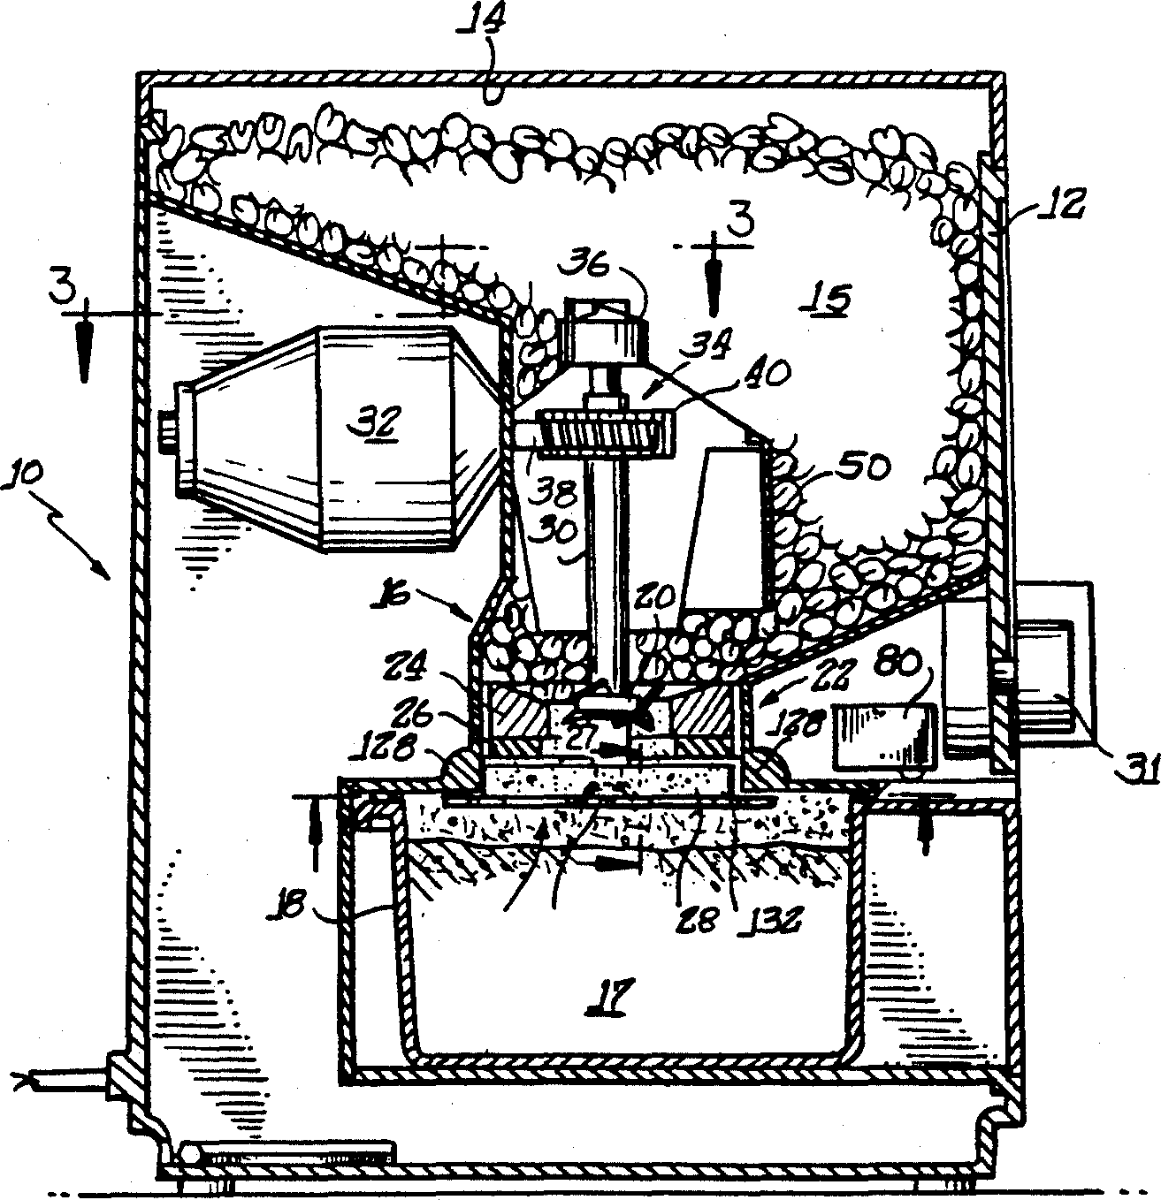
28
f8
27

U.S. Patent a,*. ia, 1993 Sheet 1 of 7 Ôș201,474
FIG.I

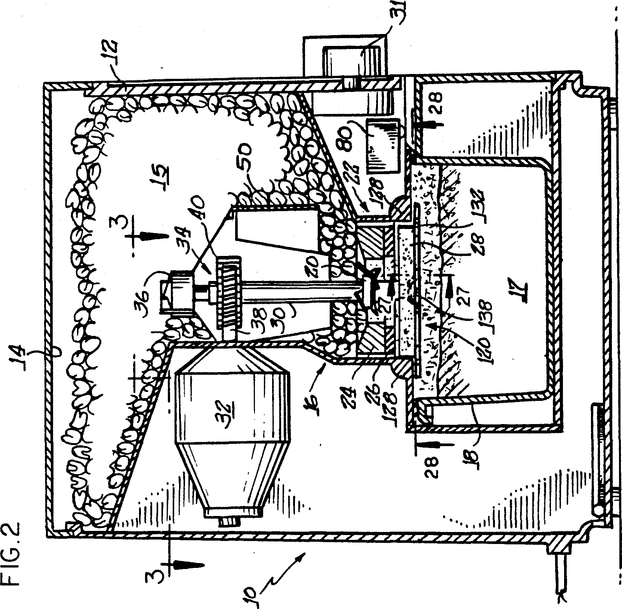

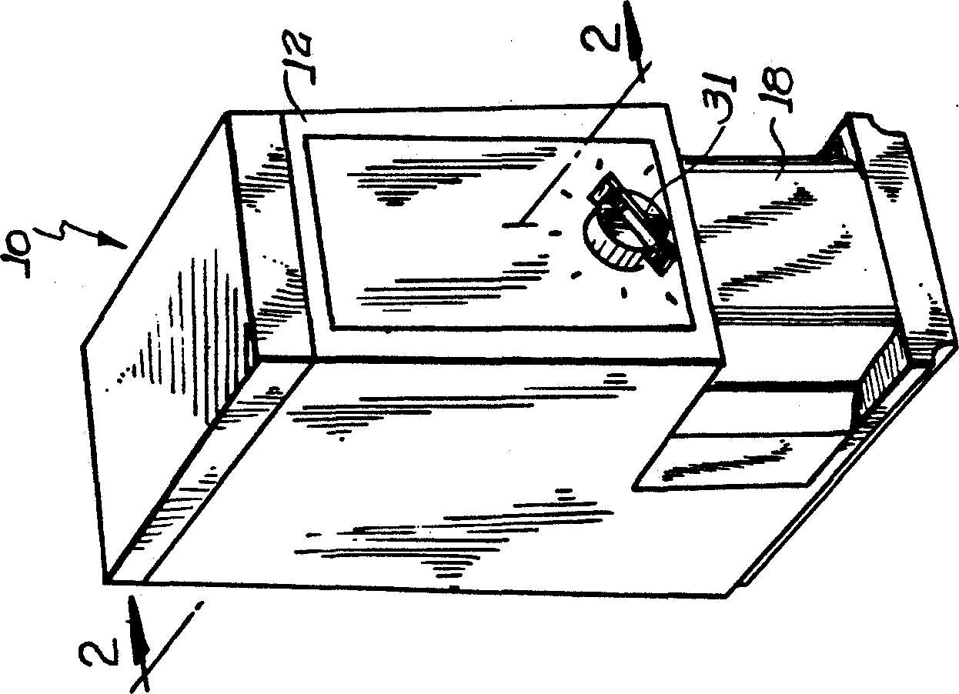

U.S. Patent a»*. it, 1993 Sheet 2 of 7 5,201,474
FI 6S.

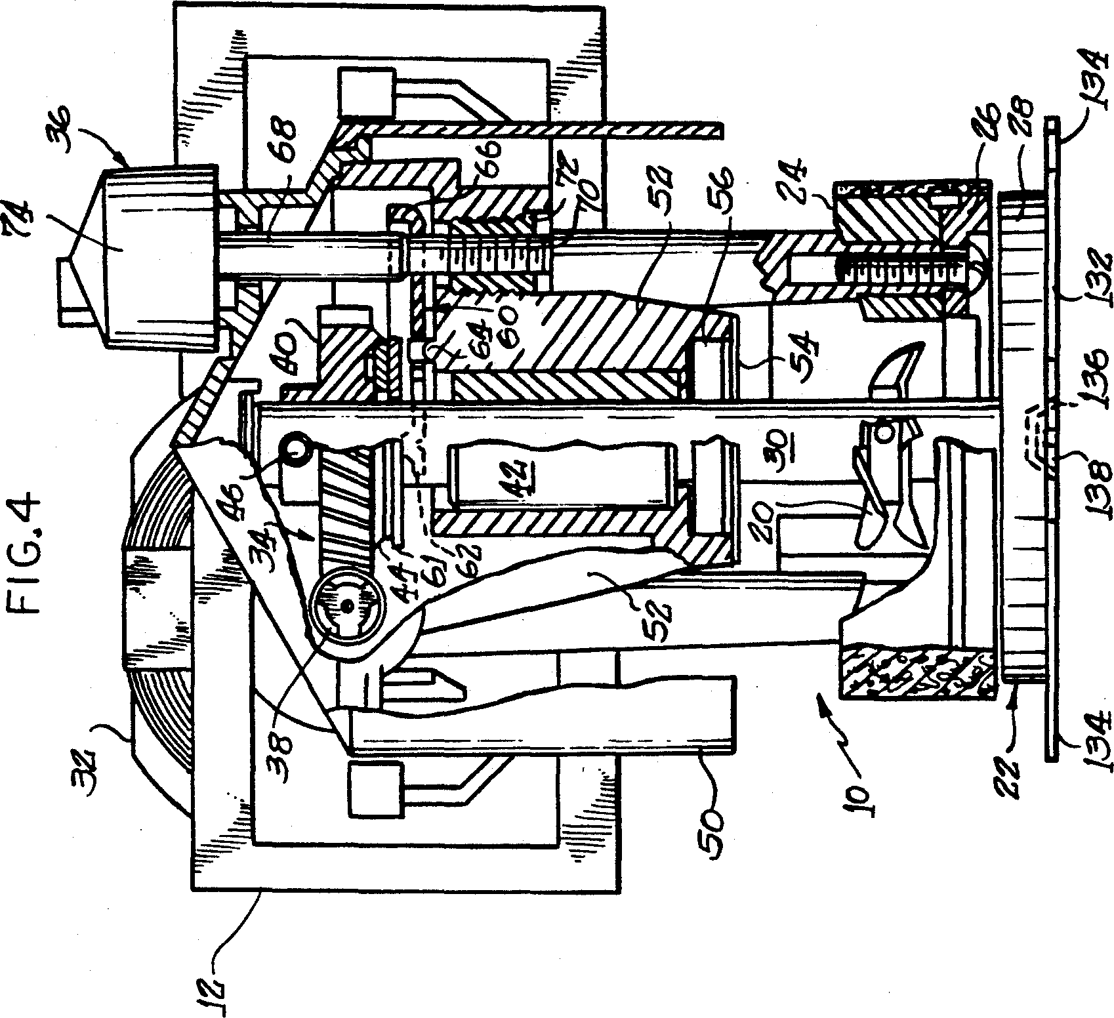

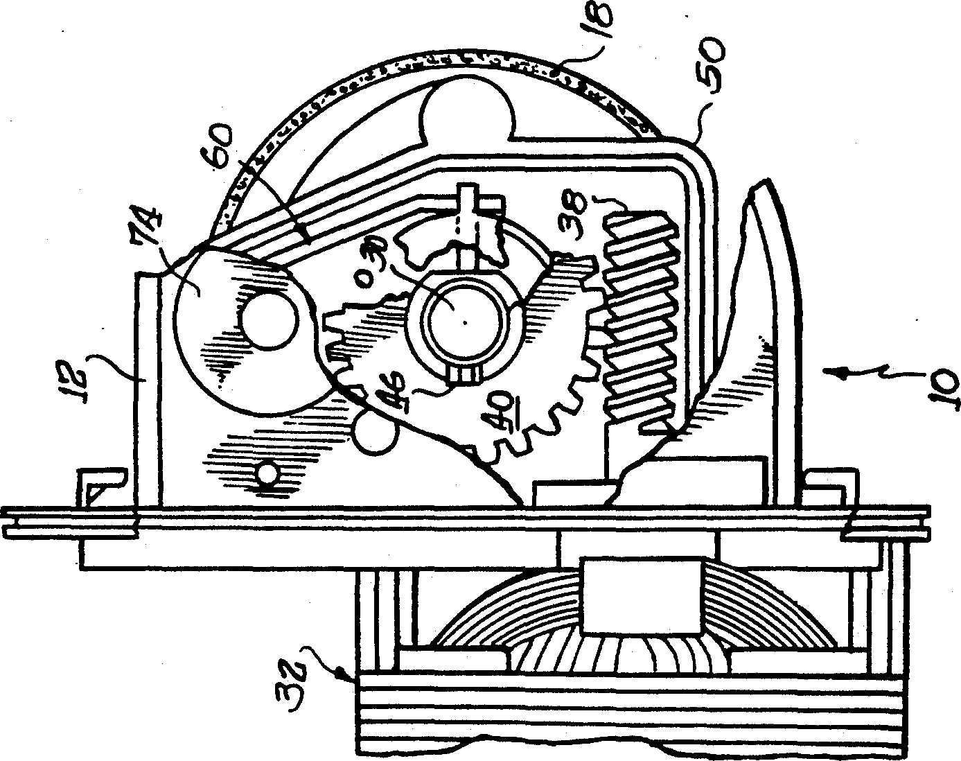

6

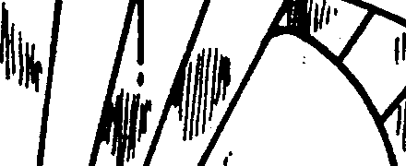
FIG. 5

J0Ë

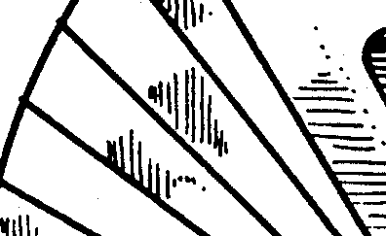

a4


7“ ’* 7
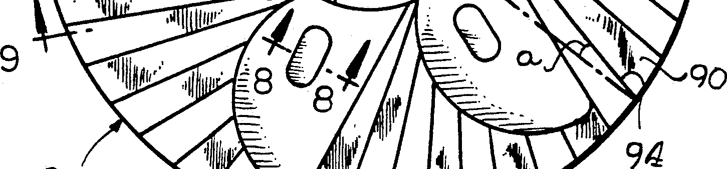
9 ll•

6

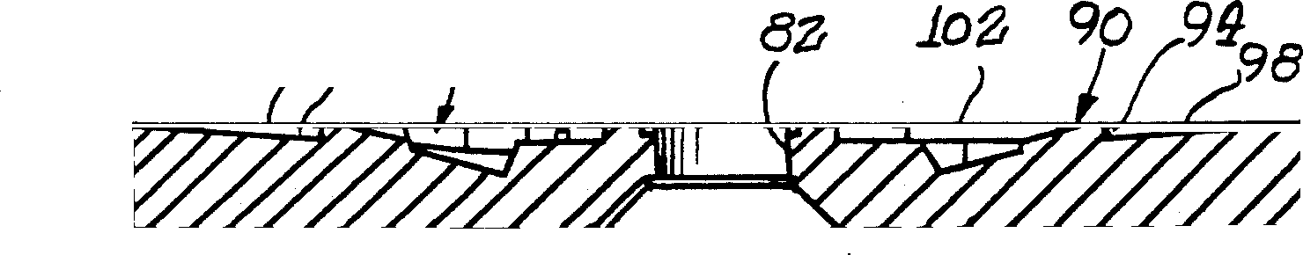
FIG. 6 ,q•,» •¡•

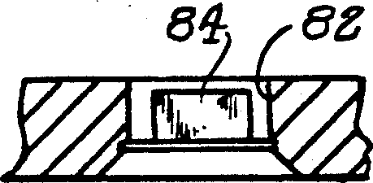
.Fł G.7

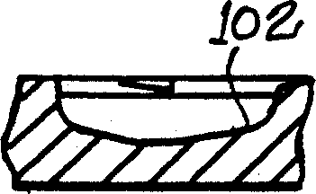
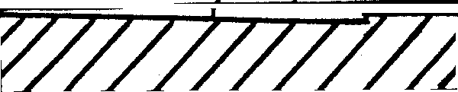FI G.8
FI G. 9

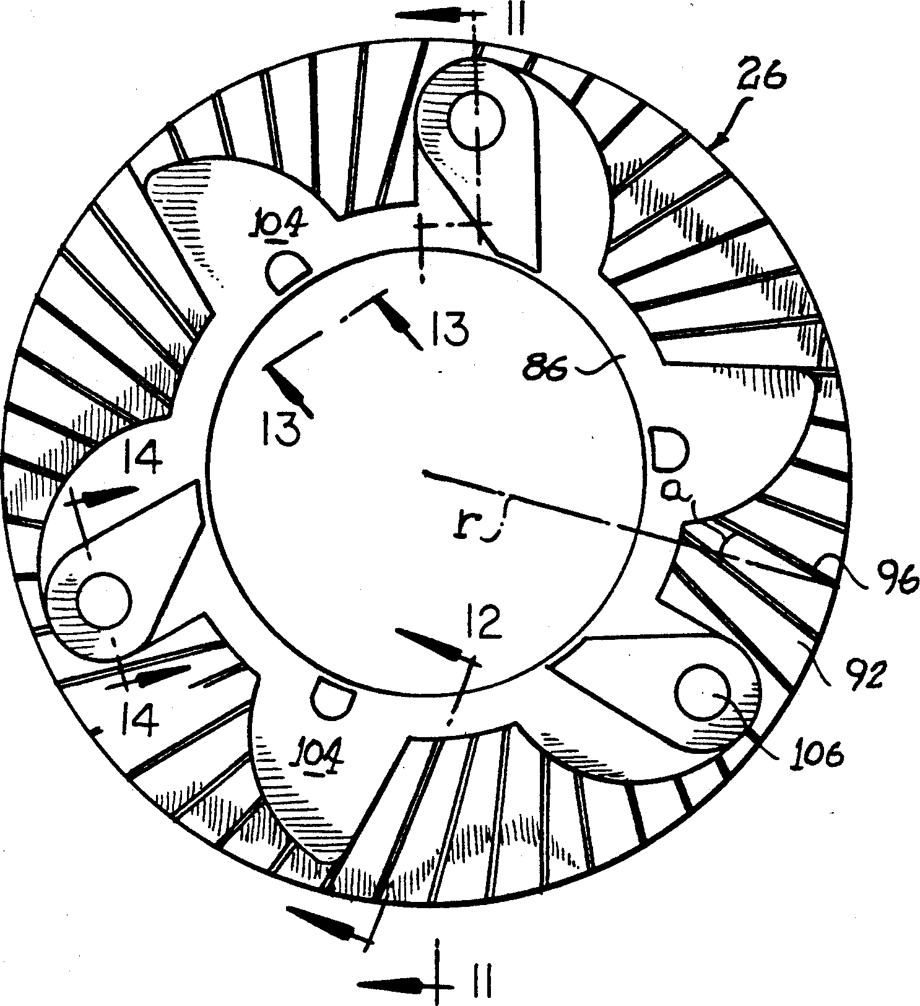
FIG.10
f2
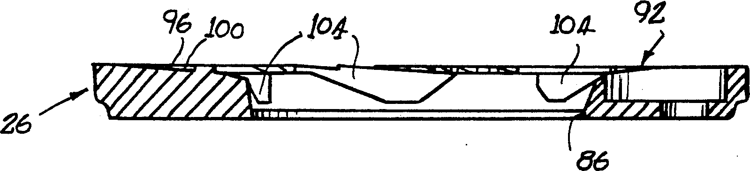
FIG. I I

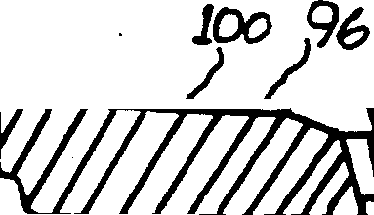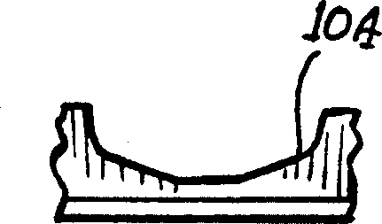FIG. I2
FIG. I3

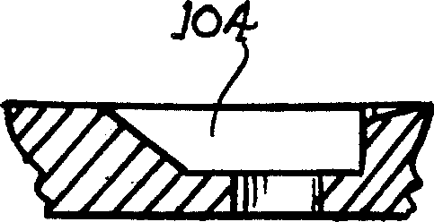
FI G.14

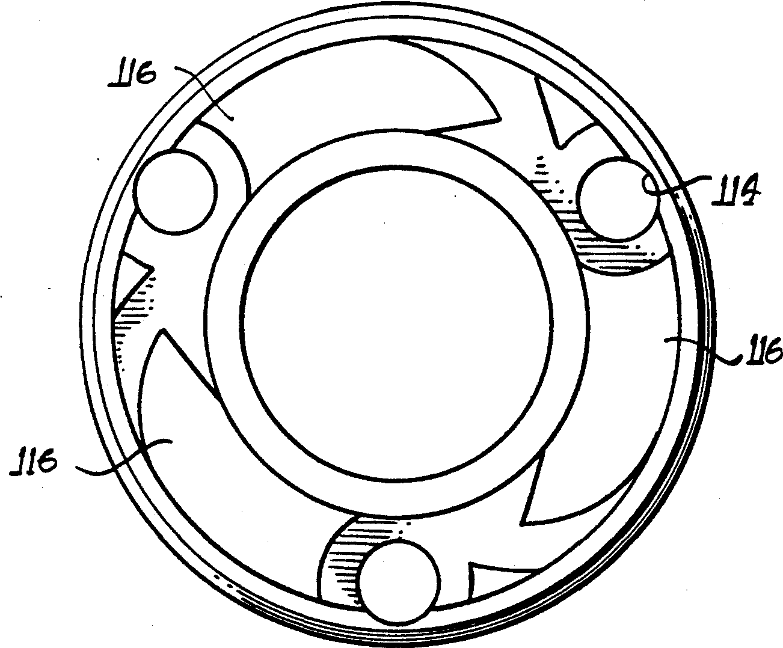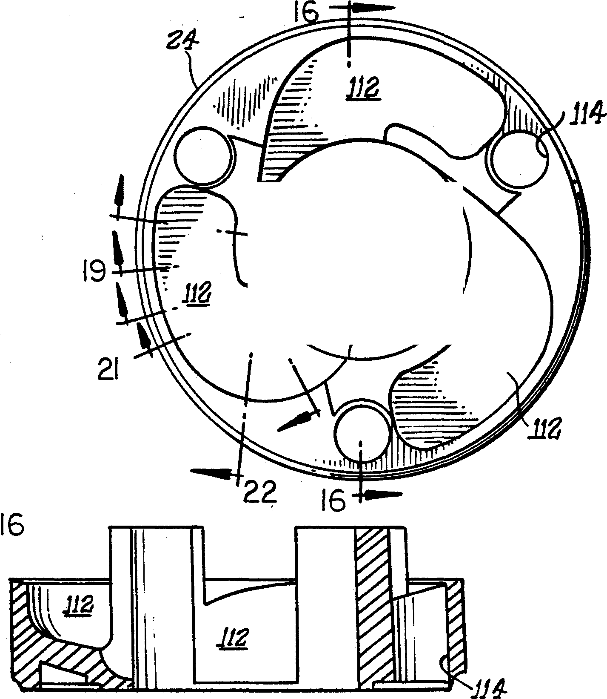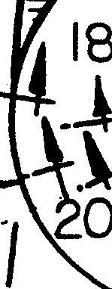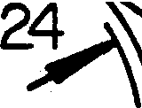FI G.
FIG.15
18
..Z 19
20
.Ś2I,22,23
24
ź3
FIG I7

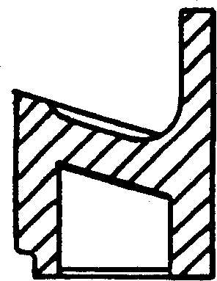
FIG.18

Fl 6. 19
FIG.20

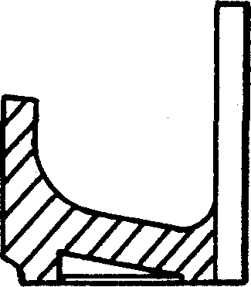
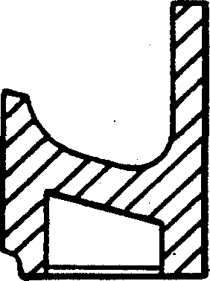
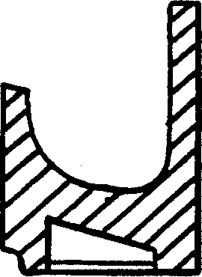
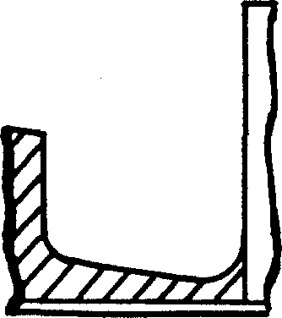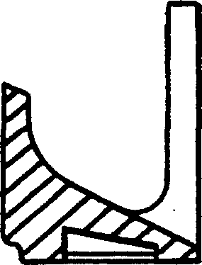FIG.22
FI 6.23
FIG.2I

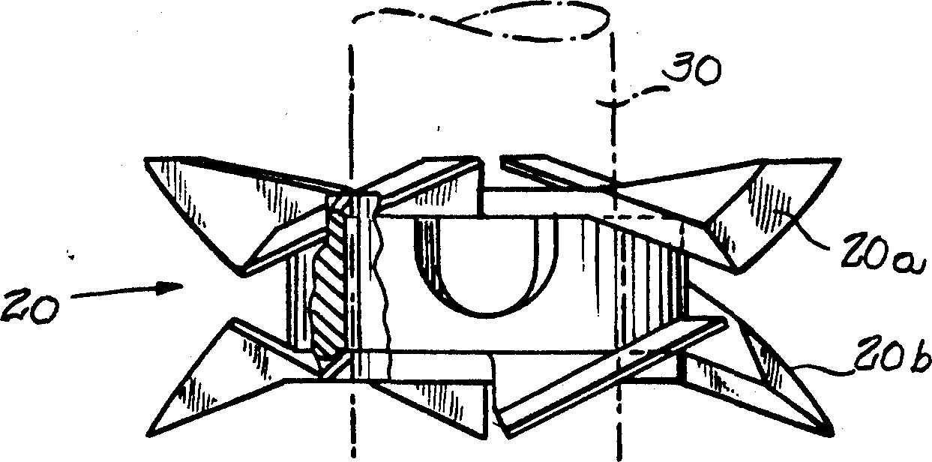FI
6.25
FIG.24

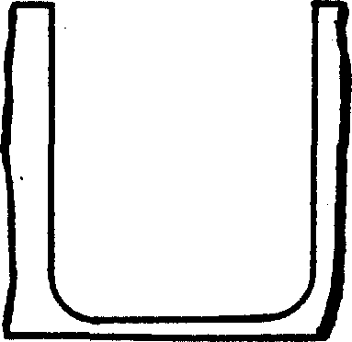

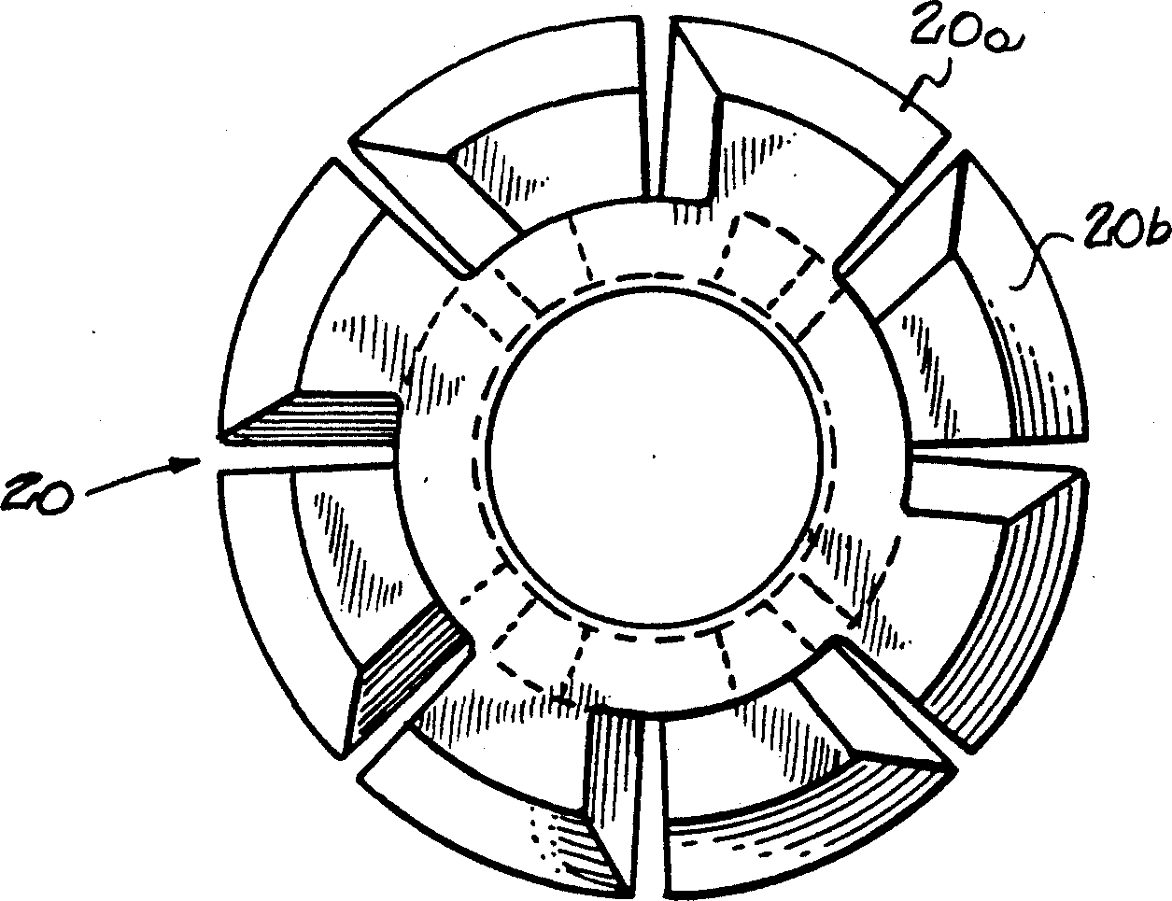
FI 6. 26

U.S. Patent A,*. 13, 1993 Sheet 7 of 7 5,201,474

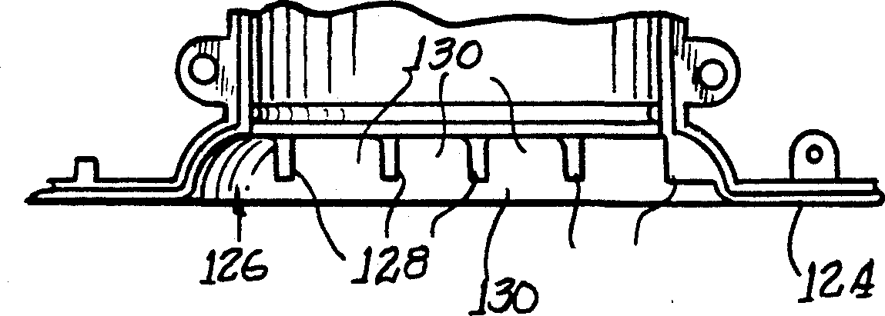FIG.27

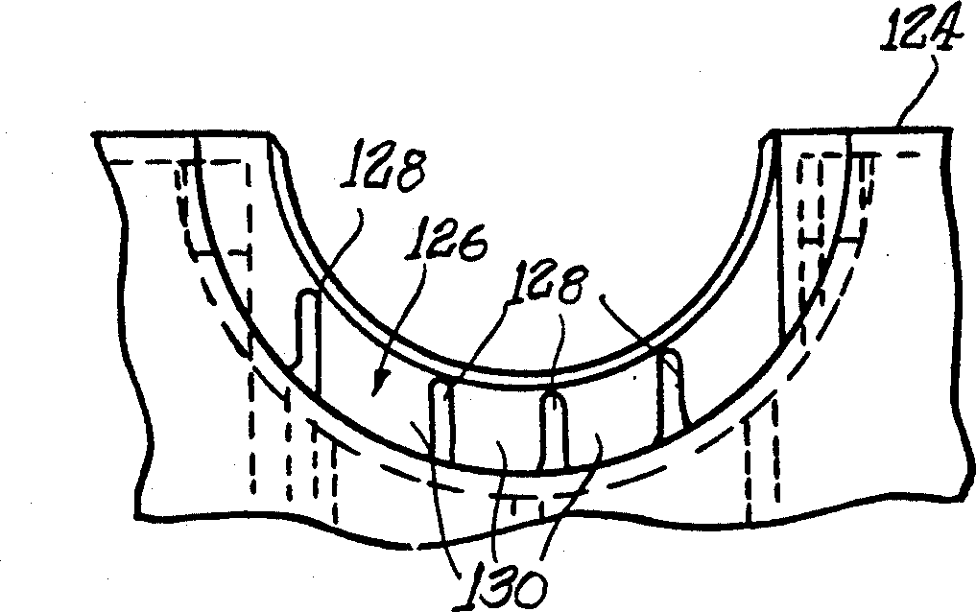
FIG.28

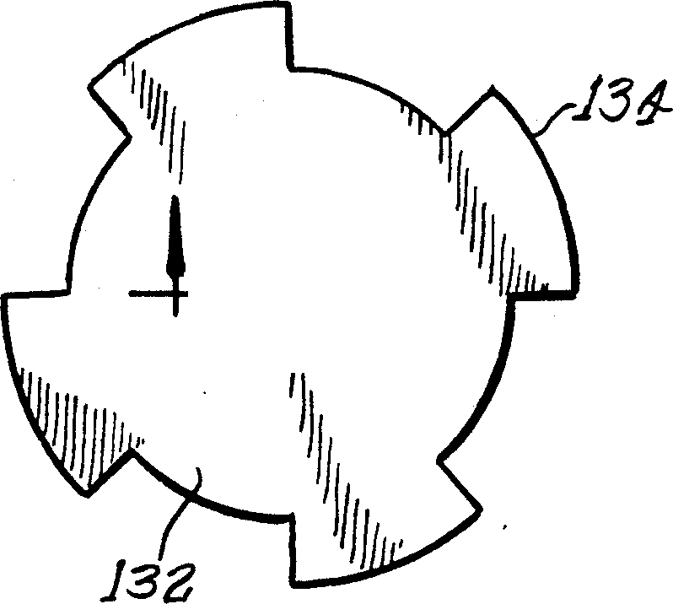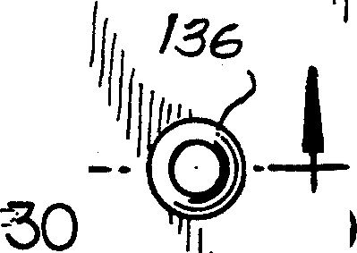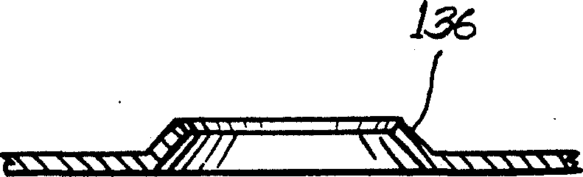FI G.29
FIG. 30

COFFEE GRINDER
quent burning of the beans can adverscly affect their flavor.
As an additional matter, inany home market machines

BACKGROUND OF THE INVENTION - are difficult to effectively clean, and allow excessive This application is directed to improvements in coffeg chaff and ground coffee to build up in the grinding areas grinders. More particularly, this application is directed 8fid inechdiliSTDS. This chaff and ground coffee can, of to improvements for coffee grinders for the home mar- course, deteriorate and become stale over time, and thus ket. cooipromise the llavor of freshly ground coffec being

Generally speaking, coffee grinders for the home must be relatively simple and reliable in operation, a yet durable and reasonably maintenance free. These goals must be accomplished within strict budgetary considerations, making it possible to design, assemble and market a coffct grinder at a price suitable for home use.
10
Generally speaking, a number of problems must be overcome in properly grinding coffee. Initially, differ- ent types of coffee and different types of coffee brewing
processed through the grinder.
OBJECTS AND SUMMARY OF THE

INVENTION
Accordingly, it is an object of the present inventiòn to provide a novel and improved coffee grinder which overcomes the problems noted hereinabove, and yet is capable of being economically produced for the home uiarket.
A related object is to make a coffee grinder in accor-

methods require different grind sizes of the coffee. 20 dancc with the foregoing which is highly reliable in

While commercially ground coffee is available in sev- eral grinds, many consumers prefer the flavor of freshly ground beans. Moreover, many coffee lovers mix a number of different beans to obtain a desired flavor blend.
Coffee lovers know that coffee begins to lose flavor and aroma as soon as it is ground. In fact, roasted bean coffee has a shelf life approximately much longer than preground coffee.
In general, the finer the grind of the coffee, the
operation and has a long and relatively oiaintenance- free service life.
A coffee grinder in accordance with the invention comprises bin means for holding a supply of coffee
23 beans to be ground; grinding means for receiving the beans from the bin means and grinding them to a desired grind size, and collection receptacle means for receiv-
ing the ground coffee from said grinding means; wherein said 8rinding means comprises blade means for

greater the surface area exposed to water during brew- 30 cutting the beans to a relatively uniform size; said blade

ing and the more rapid the rate of flavor extraction. A coarse grind exposes less surface and is therefore more appropriate for longer brewing cycles. On the other hand, a grind too fine tends to result in a more bitter
means being configured and located for feeding the cut
- beans in an auger-like fashion to the burr means; said burr means including means for grinding the beans to a desired grind size and for delivering the same to said

flavor. Generally speaking then, the correct coffee 35 collection receptacle means, such that said beans make

grind is one that permits the water to pass through the coffee grounds in the correct amount of time with the minimum amount of sediment.
The grinding of coffee requires a grinding apparatus which has sufficient power to fully grind the coffee to desired size, and yet does not bruise, burn or abrade the coffee bean. That is, the coffee bean should ideally pass through the grinder relatively rapidly, and be quickly and efficiently ground to the desired finished size. Un- fortunately, many coffee grinding machines presently on the market for home use fail to achieve these ends reliably.
45
Many of these home coffee grinders utilize blades or so-called burrs to grind the coffee. However, most of these machines utilize a rotary action of the blades or burrs and, in order to apply sufficient force to the beans, utilize relatively high rotational speeds. For example, typical home machines on the market utilize rotatioiiâi
t single pass through a grinding patii com prisin g said blade means and said burr means.
BRtEP DESCRIPTION OF THE DRAWINGS
The features of the present invention which are be- lieved to be novel are set forth with particularity in the appended claims. The organization and manner of the operation of the invention, together with further objects and advantages thereof may best be understood by ref- erence to the following description, taken in connection with the accompanying drawing in which like reference numerals identify like elements, and in which:
FIG. 1 is a perspective view of a coffee grinder in accordance with the invention;
FIG. 2 is an enlarged, sectional view taken generally in the plane of the line M2 of FIG. 1;
FIG. 3 is a partial sectional view taken generally nlong the line 3-3 of FIG. 2;

motor speeds of anywhere from 20,tXD rpm to as high as s FIG. 4 is a side elevational view of the coffee grinder

29,5tD rpm. These rotational speeds, together with the types and sizes of blades and/or burrs used in these u:machines, produce an effective blade or burr speed (surface feet per minute) of anywhere from on the order
of 9,2fD sfpm to as high as 17,RD sfpm. A few machines
of FIGS. 1-3, partially broken away and partially in section;
FIG. S is a plan view of a rotatable burr member of the coffee grinder of the invention;

do utilize lower motor shaft speeds and/or effectivey UG. 6 is a sectional view taken generally along the

blade or other cutting surface speeds. However, we have found none of the prior home market grinders able to achieve grinds to CBC (Coffee Brewing Council) specifications.
line of FIG. 5;
FiGS. 7, 8 and 9 are partial sectional views taken generally along the corresponding lines 7—7, and 9—9 of FIG. $;

The relatively high rotational speeds of most grinders 65 FIG. 10 is a plan view of a stationary burr member of

tend to crush and abrade the beans in such a way that considerable heat builds up and burning of the beans occurs during grinding. Such heat build-up and subsc-
the grinder of the invention;
FIG. 11 is a sectional view taken generally along the line 11—11 of FIG. 10;

FIGS. 12, 13 and 14 are partial sectional views taken both the rotatable and stationary burrs, and at a locatiofl
generally along lines 12—12, 1M13 and lMl4 of which is axially spaced somewhat thereabove.
FIG. 10; The metering ring 24 is also generally annular in form FIG. 15 is a top plan view of a metering member of having a similar inner diameter to the respective burrs the coffee grinder of the invention; $ 26, 28 such that the blades 20 are also substantially FIG. 16 is a sectional view taken generally along the centered relative to the metering ring 24, and such that Me 1M16 of FIG. 15; all of these elements are substantially coaxially aligned FIG. 17 is a bottom plan view of the metering mem- relative to the axis of the shaft 30. As will be more fully her of FIGS. 15 and 16; described presently, a burr adjustment means 36 is Also FIGS. 18-24 are respective partial sectional views 10 provided for adjusting the axial spacing or gap between taken along the corresponding sectional lines indicated the rotatable burr 28 and stationary burr 26 to vary the
on FIG. 15; grind size of the coffee obtained thereby as desired.
FIG. 25 is a side elevation of a blade assembly of the In the illustrated embodiment, the gear reduction coffee grinder of the invention; means 34 comprises a worm gear 38 and a mating gear FIG. 26 is a plan view of the blade assembly of FIG. l$ 40. As illustrated, the worm gear is mounted to be ro- 2S; tab by the shaft of the motor 32 and the mating gear is FIG. 2J is an enlarged side elevation illustrating one nonrotatably affixed to the drive shaft 30. A control half of two substantially identical shroud halves which such as an adjustable timer 31 may be used to operate
surround the grinding assembly and a dechaffing struc- the motor 32.
ture; 20 As best viewed in FIG. 4, the drive shaft 30 is FIG. 28 is a plan view of the structure shown in FIG. mounted to a series of bearings including an elongate 27; axial bearing J2 about a mid-portion thereof, and a FIG. 29 is a plan view of a dechaifmg blade member; thrust bearing 44 about an upper portion thereof which FIG. 30 is a partiâi sectional view taken generally supports the gear 60, which is in turn pinned to the shaft along the line 30-34 of FIG. 29. 2$ 30 by a spring pin 6. A bean shield or shroud member

DETAILED DESCRIPTION OF THE ILLUSTRATED EMBODIMENT
Referring now to the drawings and initially to FIGS.
SO circumferentially surrounds and directs beans around the assembly comprising the shaft and 8ear reduction drive, so as to direct beans downwardly around these components and into the metering ring 26. An internal

1—6, a coffee grinder in accordance with the invention is 30 housing component or member 52 surroundingly en-

designated generally by the reference numeral 10. The coffee grinder 10 includes a case or housing fi2 within which is defined a bin or hopper 14 for holding a supply of coffee beans 15 to be ground. A grinding means or assembly designated generally by reference numeral 16 receives the beans 15 from the bin 14, grinds the beans to a desired size, and delivers the ground coffee 17 to a collection receptacle 18.
In accordance with the invention, the grinding means or assembly includes blade means 20 for initially grind- ing or cutting the beans to a relatively uniform interme- diate size. The blade means are configured and located within a grinder for feeding the cut beans in an auger- like fashion to a burr assembly or burr means 22 there-
gages and supports the bearing 42 and terminates in a 'sealing arrangement comprising an annular washer S4 and a sealing felt 56 which seals off the drive assembly from the bean receptacle and grinding areas of the appa- ratus.
In the illustrated embodiment, the burr adjusting means for regulating the size of the gap between the burrs 26 and 28 comprises means for axially adjusting the position of the thrust bearing 44. This assembly includes an elongate lever 60 which has one end thereof split in a yoke-like fashion for engaging an cared washer 6l which in turn engages the bearing 44 from below, to either side of the shaft 30 as indicated by reference numeral 62. A mid point of the lever is fulcrumed on the

below. The burr means or assembly 22 is configured for 45 housing portion 52 as indicated generally at reference

grinding the beans to the desired grind size and for delivering the same to the collection receptacle 18. The arrangement of the bin 34, blades 20, burrs 22 and recep- tacle 18 is such that the coffee beans make a single pass through a grinding path comprising both the blades and the burrs as they are ground to desired size for delivery to the receptacle 18.
Additional metering means in the form of a generally nnnular metering ring 24 is located in surrounding rela- tion to the blades 20 for metering and directing the beans into the blades 20. The burr means 22 will be seen to comprise a generally annular stationary burr member 26 and a similar, generally rotatable annular rotatable burr 28. The blades 20 and rotatable burr 28 are carried upon a common shaft 30 which is opcratively coupled to a motor 32 for rotation through a gear reduction drive 34. The stationary burr and rotatable burr nre formed such that the coffee is ground therebetwecn and discharged into the collection receptacle substantially
numeral 64. A:n opposite end 66 of the lever is coupled to an elongate threaded adjustment shaft 68 which is threaded for bidirectional axial movement along an axis generally parallel to the axis of the drive shaft 30. The threaded shaft 68 has an externally threaded lower end 70 which extends into a similarly threaded support 72 to accomplish generally bidirectional axial movement of the shaft 68 when it is rotated by an outwardly extend- ing control knob 7J, which is nonrotatably nffiied to the shaft 68.
Hence, the gap between the burrs 26 and 28 can be adjusted within predetermined limits by rotation of the knob 74 which causes bidirectional movement of shaft 68, Mcruming of lever 60 and corresponding axial movemmt of the thrust bearing 44 which carries with it the gear 40 and shaft 30.
In connection with operation of the motor 32, an additional sensing means, such as a small electrical switch 80 is provided for detecting when the collection

about a 360’ circumference; that is, about the outer 65 receptacle fi8 has been removed from the grinder hous-

circumference of the rotatable burr 28. The mounting of the blades 20 and rotatable burr 28 to shaft 30 also serves to substantially center the blades 20 relative to
ing 12. The switch TO is wired in circuit for preventing operation of the motor 32 when the collection recepta- cle 18 is removed.

5 Œ
Referring now to the remaining drawings, further are primarily a result of the manufacturing process for
details of the rotary and stationary burrs 28, 26, of the forming these sloping areøs 112 within the æCtßring guide ring 24 and of the blades 20 are illustrated. Refer- ring 2d.
ring initially to FIGS. 5-9, it will be seen that the rotary Referring to FIGS. 2J and 26, the blades 20 will be burr 28 is a substantially annular, disc-like member hav- 5 seen to comprise substantially identical ønd oppositely ing a central through opening 82 for mounting an end facing blade members or portions 20ø and 20ó. As men- part of the drive shaft 30 thereto. Preferably this open- tioned, these blade portions are configured such that the ing 82 has one or more flats b4 for securing the shaft blades initially receive and partially grind or reduce the thereto in nonrotatable fashion. coffee beans fed thereto from the metering ring 2ł, and Referring now also to FIGS. 10-14. The stationary 10 feed these initially ground or reduced beans in a augur- burr 2£ is also a generally annular, disc-like member like fashion to the final cutting burrs 26, 28. It will be having a central through opening 86 through which noted that as viewed in the top plan views of the blades shaft â0 frœly extends. Both the rotatabłe and mtion- 20 and of the rotatable burr 2ß, illustrated respecõvely ary burrs have facing, substantially annular coffee in FIGS. 26 and 5, the rotation thereof by the drive grinding faces, 9ti, 92 which are formed in a similar and l6 shaft 30 will be in a counterclockwise direcdon. Prefer- complementary fashion as illustrated in respective ably, the motor and gear reduction drive are arranged FIGS. 5-9 and 10-14. In particular, each of these faces to operate the drive shaft for rotating the blades and 90, 92 has a plurality of elongate teeth 94, 96 which are rotatable burr at a speed of substantially on the order of formed at least partially thereacross, and which eztend 2ŒØ rpm. The motor speed is on the order of I9ŒD rpm ncross the annular face at an angle a relative to its rødius 10 and the gear,ratio about 9.66 in the exemplary embodi-
R, r. In the illustrated embodiment, the angle of each of ment described herem.
these teeth 96, 96 to the radius across its respective Referring now to PIGS. 27 through 30, in accor- nnnular face is substantially on the order of 14ᵉ. dance with a preferred feature of the invention, a de- It will be noted that when the faces 90 and 92 are chatting means or assembly 120 is provided (see also brought together in face-tœfacc relatioii øs illustrated in 25 FIGS. 2 and 4). This dechafFmg assembly 120 generally FIGS. 2 and 4, for example, that the respective teeth prevents chaff from the grinding operation from enter- and grooves will be angled oppositeły, such that a scis- ing and possibly clogging portions of the grinder appa- sors-like cutting action is achieved tberebetween. ratus. The dechaffmg assembly thereby essentially de- Moreover, øs best viewed in FIGS. 9 and 12, each of chaffs the apparatus and causes the chaff to remain with these teeth defines a corresponding groove 98, lŒi 30 the ground beans as the same travel from the burr as- which grooves generally increase in depth as they ex- sembly into the receptacle 18. We have found that ab- tend inwardly from outer peripheries of respective an- . sent such a dœhaffing means, there is a tendency for the nular faces 9O, 92 toward the centers thereof. Advanta- chaff to develop a static charge and migrate into various
geously, we have found that the increasing depth of the areas of the apparatus in øn undesirable manner. grooves 98, 100 tends to force the beans radially out- 35 Referring now more particularly to FIGS. 2, I ønd
wardly as the cutting progresses and as their size gradu- 27-30, the dechafFmg means 120 includes a shroud ally decreases from the size at which they are intro- member or portion 122 which is preferably formed øs a duced to the burrs to the desired finished grind size. pair of substantially identical shroud halves, one such The burrs also include a plurality of recesses or pock- half 124 being illustrated in FIGS. 27 ønd 28. The ets fi02, 104 which are generally blade-like in plan. 40 shroud 122 defines a generally annular open area 126 These pockets 102, 104 are also preferably shaped, lo- which generally circumferentially surrounds the grind- cated and configured to receive the beans as initially cut ing assembly and in particular the rotatable burr 28. by the blades 20 and to uniformly distribute and urge This annuiar open area or volume 126 generally permits the beans outwardly and into the areas between the the ground beans to exit circumferentially or pcripher- teeth and grooves for the final cutting or grinding 45 ally of the rotatable burr 28 and enter the collection thereof to their desired final size. Stationary burr 26 also receptacle 18 therebelow. In order to assure that the defines respective through openings 106 for receiving chaff remains with the ground beans, the shroud 124 is fasteners for mounting the same in stationary fashion to provided with a plurality of small divider wall members the grinder structure. Preferably each of the burrs 26, 28 128 which extønd into the area 126 and divide it into a
is a chrome-type tool steel. S0 number of separate zones fi30.
Referring now to FIGS. lS-24, further details of the Referring also to FIGS. 29 and 30, a cooperaäve metering ring 24 are illustrated. It will be seen that the dechafFmg blade member 132 is mounted, as best ring 24 comprises a generally annular body having a viewed in FIG. 4, to a bottom surface of the rotatable central through opening 110 within which the blades 20 burr 28 surface of the rotatable burr 28. The dechaffing are located in the assembled grinder. Generally speak- 55 blødc 132 is a generally circular disk-like member hav- ing, the depth of opening 110 is such that the blades will ing a plurality of projecting angularly spaced segments be located fully therewithin (sec FIGS. 2 and I) and 134. These projecting segments 1S4 are generally equi- such that the beans will be fed to the blades exclusively nngularly spaced ønd of equal angular extent. The angu- through a plurality of downwardly and inwar,d1y slop- lar extent of the projections 134 is such that they tend to ing guide trough or chute-like areas 112 formed in the 6o cover one or more of the zones 130 as the blade rotates metering ring 24. Tàese areas fi12 open inwardly and relańve to the shroud 124 thus momentarüy stopping or downwardly of the metering ring øs best viewed in preventing flow of the beans and chaff therethrough. FIGS. 15 and 16. Three through mounting apertures The dechaffing blade will be seen to include a some- 1fi4 are also formed in the metering ring. At the bottom what recessed central area or portion 13d to facilitate surface of the metering ring shown in FIG. 17, addi- 6S mounting of the same dirccUy against the facing surface tional recesses 116 are illustrated. These recesses 116 of the rotatable burr 28 and for in turn mountin8 both extend generally in a circumferential direction and have the rotatable burr 28 and the dechafFing blade 136 to the slopes corresponding to those of the surfaces 112, and shaft 30, as best viewed in FIGS. 2 and 4.

7 8
While particular embodiments of the invention have S. A coffee grinder according to claim 1 wherein said been shown and described in detail, it will be obvious to blade means is substantially centered relative to the those skilled in the art that changes and modifications of rotatable and stationary burrs, and is spaced axially the present invention, in its various aspects, man m thereabove.
made without departing from the invention in its 5 6. A coffee grinder according to claim S and further

broader aspects, some of which changes and modifica- tions being matters of routine engineering or design, and others being apparent only after study. As such, the scope of the invention should not be limited by the particular embodiment and specific construction de- 10 scribed herein but should be defined by the appended claims and equivalents thereof. Accordingly, the arm in the appended claims is to cover all such changes and modifications as fall within the true spirit and scope of the invention. 15
The invention is claimed as follows:
- A coffee grinder comprising: bin means for holding a supply of coffee beans to be ground; grinding means for receiving said beans from said bin means and grind-
including metering means comprising a substantially annular metering ring located in surrounding relation to aaid blsde means and generally coaxial with and in alignment with said annular rotatable and stationary

- A coffee grinder ancording to claim 1 and further including drive means for rotating said blade means and said rotatable burr oicans and comprising a motor and a gear reduction drive operatively coupled intcrmediate eaid motor and both said blade means and said rotatable burr means.
- A coffec grinder according to claim 7 æid further including a common drive shaft æounting both said
blade means and said rotatable burr for rotation in uni-

ing the beans to a desired grind sine, and collection rcccptacle means for receiving the ground coffee from said grinding means; wherein said grinding means com- prises blade means and burr means, said blade means being configured and located for cutting the beans to a
20 son and whùrein said gear reduction means comprises a worm gear couplet to said motor, and a mating gear coupled to said drive shaft.
- A coffee grinder according to claim 7 and further

predetermined sine and for feeding the cut beans in an 25 including sensor means for sensing the absence of said

auger-like fashion to said burr means; said burr means including means for grinding the cut beans to a dnsired grind size and for delivering ground beans to said col- lection receptacle means, such that said beans made a single pass through a grinding path comprising said 30 blade means and said burr means; wherein said burr
collection receptacle and for preventing operation of said motor when said collection reccptacle is absent.
- A grinding apparatus for a coffee grinder com- prising: burr means, blade means for cutting coffec bcans to a predeterœined size; said blade means being configured for feeding the eut beans in an auger-like

means comprise a rotatable burr and a stationary burr spaced apart therefrom to defme a gap therebetween; wherein said rotatable burr and said stationary burr are
- fashion to said burr means; and burr means including
means for grinding the beans to a desired grind size and for delivering ground beans directly to a collection

substantially annular in form whereby the coffee is 35 reccptacle, such that said beans make a single pass

ground and discharged to said collection reccptacle substantially about 360’; wiierein said rotatable and stationary burrs have facing, substantially annular cof- fee-grinding faces defining radü, and wherein said faces contain a plurality of elongate teeth extending at least partially across said annular faces at an angie to the radü thereof, the teeth of said stationary burr extending at an angie opposite the teeth of said rotatable burr when said annular faces are in face-to-face relation for achieving a
through a grinding path comprising said blade zneans and said burr oieans; wbercin said burr means comprise a rotatable burr and a stationary burr spaccd apart therefrom to defme a gap therebetween; wherein said rotatable burr and said stationary burr and substantially annular in form whereby the coffee is ground and dis- charged to said collection reccptacle substantially about 360s; and wherein said rotatable and stationary burrs
have facing, substantially annular coffce-grinding faces

scissors-like action therebctween, and further including 45 defining radü, and wherein said faces contain a plurality

dechalfing means located adjacent said burr means for substantially retaining chaff with the ground beans and for substantially preventing chaff from accumulating in other portions of said coffee grindcr.
  - A coffec minder according to claim 1 and further including metering means for directing said beans through said blade means and said burr means.
  - A coffec minder according to claim 1 and further including burr edjustment means for adjusting the sizc of said gap between said rotatable burr and said station- wy burr to vary the grind sizc as desired.
  - Apparatus according to claim 1 wherein said de- chafFmg means comprises a shroud member surround- ing said burr means and having a generally annular cécumferential open area for delivering ground beans gcncralïy la a radiaJJy outward direcöoo fzoza about a pcripheray of said burr means; a plurality of divider oiczaben projcctiag into said anaular area for dividïag the same into a plurality of separate zones, and a gener-
of elongate tœth extending at least partially across said aiuiular faces at an angle to the radü thereof, the tecth of said stationary burr extending at an angle opposite the teeth of said rotatable burr when said faces are in face- to-face alignment for achieving a scissors-like action therebetween, and drive tneans for rotating said blade mcans and said rotatable burr uieaos and comprising a motor and a gear reduction drive opcratively coupled intermediate said motor and both said blade ineans and said rotatable burr means, and a common drive shaft mounting both said blade ineans and said rotatable burr for rotation in unison and wherein said gear reduction æeans comprises a worm gear coupled to said motor, and a mating gear coupled to said drive shaft, und burr adjusting means for regulating the sizn of the gap bc• tween the rotatable and ststionary burrs to vary the grind size ns desircd, said burr adjusting means compris- m g bearing means mounting said drive shaft for bidirec-

ally circular disk-like dechaffing member having a plu- 65 tional axial moyennant, lever means for adjusting the

rality of radially outwardly projecting portions for al- ternately blocking and opening said plurality of zones defined by said divider means.
axial height of said bearing means to obtain the desired gap, and control ineans for bidirectionally moving said lever ineans to adjust said shaft.

- Apparatus according to claim 10 and further in- operatively coupled intermediatc said motor and both cluding metering means for directing said beans said blade means and said rotatable burr means, and a through said blade means and said burr means. common drive shaft mounting both said blade ztieans
- Apparatus according to claim 10 and further in- and said rotatable burr for rotation in unison and cluding burr adjustment means for adjusting the sine of f wherein said gear reduction means comprises a worm aard gap between said rotatable burr and said stationary gear coupled to said motor, and a tnating gear coupled burr to vary the grind size as desired. to said drive shaft, and burr ndjusting means for regulat-
- Apparatus according to claim 10 wherein said ing the size of the gap between the rotatable end station- control means comprises an elongate threaded shaft ary burrs to vary the grind sizc ns desired, said burr uiounted for bidirectional threaded movemcnt along an 10 adjusting means comprising bcaring means mounting axis generally transversc of said lever means, and yoke said drive shaft for bidirectiooal anial movement, lever means coupling one end of said lever to said control means for adjusting the axiai height of said bearing shaft, an opposite end of said lever being positioned to means to obtain the desired gap, and control means for bear against said bearing means, and fulcrum means for bidirectiooally moving said lever means to adjust said said lever intermediate said ends thereof. 15 straft.
II. Apparatus according to claim 10 wherein aard 17. A coffee minder according to claim 16 wherein blade means is substantially centered relative to the said control means comprises an elongate thrcaded shaft rotatable and stationary burrs, and is spaced axially inounted for bidirectional threaded movement along an thereabove. axis generally transverse to said lever means, and yoke
- Apparatus according to claim 14 and further in- 20 means coupling one end of said lever to said control cluding metering means comprising a substantially an- shaft, an opposite end of said lever being positioned to nular metering ring located in surrounding relation to bear against said bcaring means, and fulcrum means for said blade means and generally coanial with and in said lever intermediate said ends thereof.
alignment with said annular rotatable and stationary 18. A coffee grinder comprising: bin means for hoId- burrs, and spaced thereabove. 25 ing a supply of coffee beans to be ground; grinding
- A coffee grinder comprising: bin means for ho1d- means for receiving said beans from said bin means and ing a supply of coffee beans to be ground; grinding grinding the beans to a dcsired grind size, and collection means for receiving said beans from said bin means and receptacle means for receiving the ground coffee from grinding the beans to a desired grind size, and collection said grinding means; wherein said grinding means com- receptacle means for receiving the ground coffee from 30 prises blade means and burr means, said blade means said grinding means; wherein said grinding means com- being configured and located for cutting the beans to a prises blade means and burr means, said blade means . predetermined size and for feeding the cut beans in an being configured and located for cutting the beans to a auger-like fashion to said burr means; said burr means predetermined size and for feeding the cut beans in an including means for grinding the cut beans to a desired auger-like fashion to said burr means; said burr means 35 grind size and for delivering ground beans to said col- including means for grinding the cut beans to a desired lection receptacle means, such that said beans make a grind size and for delivering ground beans to said col- single pass through a grinding path comprising said lection receptacle means, such that said beans made a blade means and said burr means; and further including single pass through a grinding path comprising said dechafFmg means located adjaccnt said burr means for blade means and said burr means; wherein said burr 40 substantially retaining chaff with the ground beans and means couiprise a rotatable burr and a stationary burr for substantially preventing chaff from accumulating in spaccd apart therefrom to define a gap therebctween; other portions of said coffee grinder; and wherein said wherein said rotatable burr and said stationary burr are dechafFmg means coinpriscs a shroud member sur- substantially annular in form whereby the coffee is rounding said burr means and having a generally annu- ground and discharged to said collection receptacle 4i lar circumferentiai open area for delivering ground substantially about 360’; wherein said rotatable and beans generally in a radially outward direction from stationary burrs have facing, substantially annular cof- about a periphery of said burr means; a plurality of fee-grinding faces defining radü, and wherein said faces divider members projecting into said annular area for contain a plurality of elongate teeth extending at least dividing the same into a plurality of separate zones, and partially across said annuiar faces at an angie to the radü 50 a generally circular disk-like dechafFing member tbereof, the teeth of said stationary burr extending at an mounted for rotation in unison with said blade inrans angie opposite the teeth of said rotatable burr when said and having a plurality of radially outwardly projecting annular faces are in face-to-face relation for achieving a portions located and configured for altematcly bloeding scissors-like action therebetween, and drive means for and opening said plurality of zones defined by said di- rotating said blade means and said rotatable burr means SS vider means as said disk-like member rotates.
und comprising a motor and a gear reduction drive • • • • •

65

