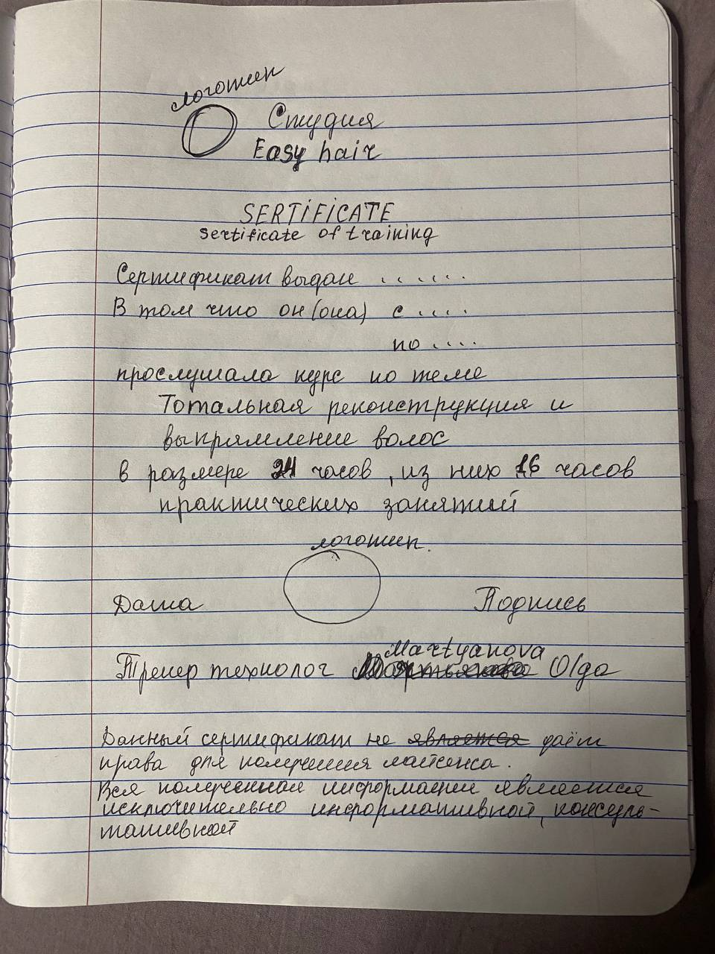

Easy hair studio

**Certificate**

Certificate of training

The certificate is issued _______________

That he/she from_______

to _________

Took a course on:

**«Total reconstruction and hair straightening»**

24 hours, including 16 hours of practical training

Date _________ Signature _________

Trainer technologist Martyanova Olga

This certificate does not entitle you to obtain a license.

All information received is extremely informative, consultative.