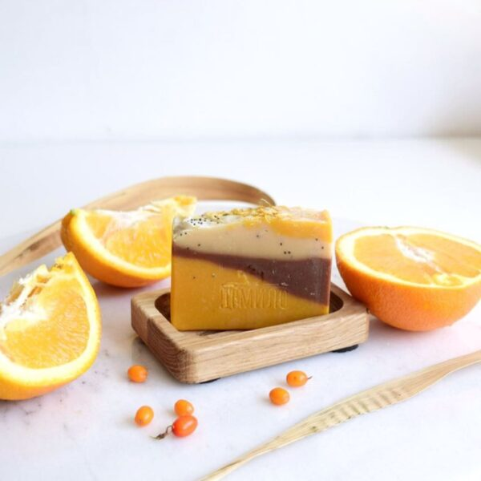

Introducing our handmade soap, infused with the invigorating scent of fresh oranges! Made with natural ingredients, our soap gently cleanses and moisturizes your skin, leaving you feeling refreshed and rejuvenated. The citrusy aroma of orange provides a burst of energy and is known for its uplifting properties. Indulge in the luxurious lather and let the scent of orange invigorate your senses. Perfect for those who love natural, handcrafted products that are gentle on the skin. Try it today and experience the difference!

