Kemei Professional Hair Clipper KM-1990 Review https://www.aliexpress.com/item/1005005058409255.html
The story

After the breakdown of my previous clipper, it took quite a long time to find a new one, because I take every purchase seriously and think through all the details. I searched a lot of sites to find a new, unique machine, and still managed to find the perfect one.

The Professional Hair Clipper KM-1990 from Kemei turned out to be such an ideal option. I bought it at a New Year's sale on AliExpress, and it cost me twenty dollars, which is very cheap for a professional clipper.

Hair Clipper KM-1990 Review

The trimmer arrived a month after ordering, a bit long, but the important thing is that it arrived at all. The box was a little damaged in the corner, but it did not affect the device itself.

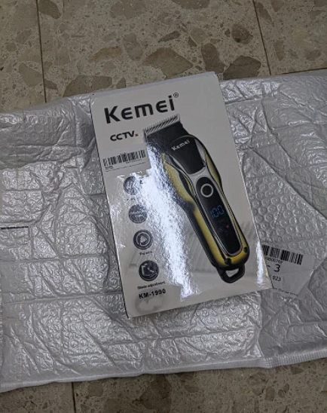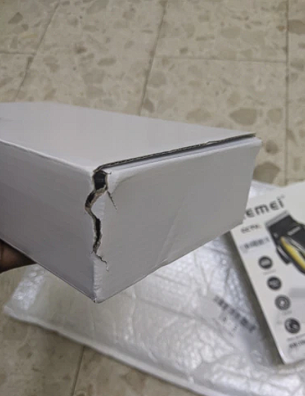

The device itself was quite small, which is great, because the convenient shape fits comfortably in your hand, thereby providing a comfortable work for the craftsman. Therefore, it is only a pleasure to work with this trimmer.

The housing is very sturdy, and the knives are sharp. The noise that the machine makes is very quiet, and does not cause discomfort.

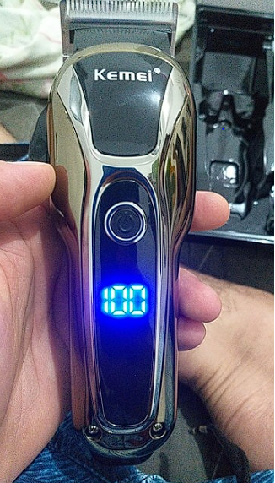
Package Included:

- Hair clipper (gold color);
- Excellent quality USB charging cable, very durable and quite long;
- Six guide combs in different lengths (1mm/2mm/3mm/4mm/5mm/6mm);
- One brush to clean the hair from the machine. (quite small, and the hairs themselves are hard);
- Instructions for use;
- Oil for lubrication;
- A small comb of excellent quality.

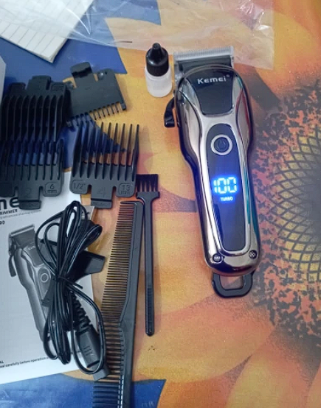

Technical specifications

- Brand: Kemei;
- Model: KM-1990;
- Power and voltage: 10W, AC 110-240V;
- Battery Type: 500mAh Li-ion battery;
- Charging time: 1.5 hours (very fast, especially when you consider that you can cut hair and charge at the same time);
- Operating time: 120 minutes (enough time for the whole family to get a haircut and still have a charge);
Net weight of the machine: approximately 138 grams;
- Machine size: 15cm * 4.1cm (fits perfectly in the hand, which is very convenient);
- Material of the machine: ABS-plastic (the main thing is not to drop, because it can easily crack).
LCD Display

A big plus is that the trimmer is equipped with a smart LCD display, which is designed to show the remaining battery charge. It greatly simplifies the operation and maintenance of the electric machine, thereby you will no longer forget to charge your machine.

USB Charging

Charging the trimmer is done by connecting it to the USB cord, it takes an hour and a half to fully charge it, but it discharges in two hours, which is very good. It also supports plug on play technology, because of this, to discharge it completely, you have to try very hard.

High performance can be achieved at any convenient location, but for best results, it is worth letting the trimmer dry out a bit naturally before cutting.

Engine and speed modes

The smooth curved handle is more comfortable to hold and the design of the hair clipper head itself is easy to clean. Hair does not clog the cutting head, and in turn the high-quality motors do not make any noise during operation. This allows you to enjoy the shaving process in peace of mind, and there are three speeds that allow you to control the speed of cutting yourself.

Conclusions
If you take into account all of the above, it is an excellent device for its money, from the pluses I can highlight the fact that it has an excellent shape and light weight, so it does not cause any discomfort. It has a fast charge, and discharges - on the contrary, for a long time, it is very quiet. The price does not bite.
Disadvantages particularly and did not notice, as for home use is an excellent option for its money.

