Wahl Magic Clip Cordless Hair Clipper
https://www.aliexpress.com/item/1005004991753508.html

The Story
More than once I've had the thought of buying a wonderful Hair Clipper that could replace my two trimmers and add comfort to my haircuts. I've been on the lookout for the right trimmer for a long time. I looked at different brands, consulted with colleagues, read a lot of reviews and characteristics of different machines, but for a long time I could not find the one that would fall into my heart.

Because I needed a machine that could perfectly perform the necessary functions, and so when I studied the Magic Clip Cordless, created by the American manufacturer Wahl, I had no doubt that it was exactly what I needed.
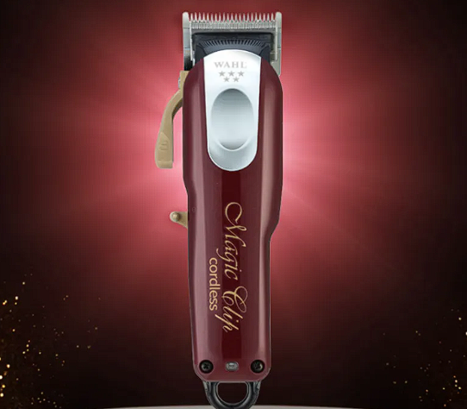

I dismissed the idea of another American brand, a Wahl counterpart, and started looking for a store that had this machine in stock.

The machine was at the peak of its popularity, but was not on sale in many stores. So, I decided to look for it on AliExpress, where I ordered it.

Wahl is an American brand that is popular with barbers all over the world. I've seen many videos on the Internet of how barbers make quality, stylish haircuts with this machine, as well as training videos on how to cut a cool fade with just one Magic machine. On top of that, the machine was battery operated, which in turn is much more convenient than working with a corded machine.

The seller said that the package will arrive within two weeks, but either the post office has delayed, or lost somewhere, but had to wait a month, which is not particularly critical.
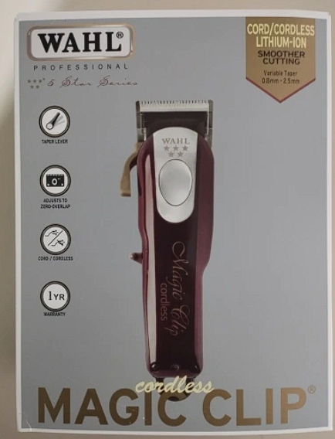

Package Included:
- Hair clipper
- Battery charger
- 8 plastic cutting attachments
- Protective cap for blade assembly
- Oil for blade lubrication
- Scrubbing brush for removing hair from the blade unit

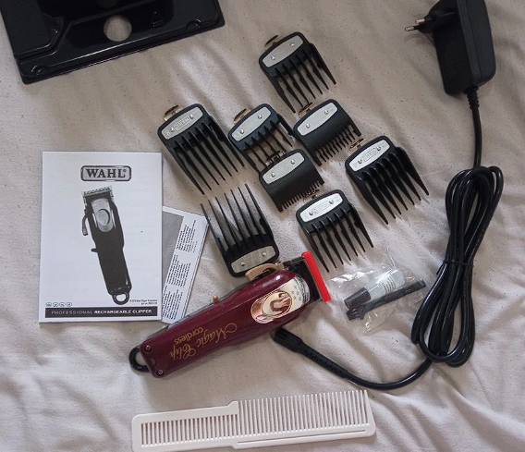
Wahl Hair Clipper Color Pro Cordless review
The Wahl Magic Clip Cordless combination power tool is designed for even fade or finish cuts. The cordless clipper comes with a double-row blade assembly.
The geometry of the blade is made with Crunch technology and is different from other cutting units. When you cut, you hear a characteristic "crunch", which gives more control over the cut, and the transitions are homogeneous.
The knife is made of a carbon-enriched steel alloy that gives hardness. The chrome finish reduces the risk of corrosion when cutting wet hair.
The machine is lightweight and very comfortable in the hand. The properly made body and lightweight makes my hand much less tired compared to the machines I've had before.
Knife section
The knife block is made with a double row of teeth, so that the cut can be made "clean" the first time. This saves a lot of time, which is important.
The cutting length can be continuously adjusted from 0.8 to 2.5 mm with the side lever on the body. Eight sturdy metal attachment nozzles are included before the machine. If you cut using combs, you can cut up to 25mm. The slightly rounded tips of the teeth don't traumatize sensitive skin, easily pass through the hair and don't leave any layers. They are fastened to the blade with a single movement and hold firmly during cutting.
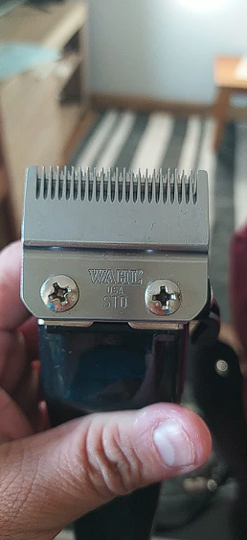
Battery
The built-in lithium-ion battery can run continuously for up to an hour and a half. It takes up to two hours to fully charge the battery. You don't have to wait until the battery is fully discharged to recharge. The machine can be plugged in at any time. For example, during breaks or to finish a haircut if the battery runs out.

Motor
Inside the machine is a rotary motor with overheat protection that runs at 5,500 rpm. The motor runs quietly without disturbing you when you cut your hair. The motor handles stiff or thick hair effortlessly.
During my time using this machine, I have never once felt it get hot, even with long cuts.

Wahl Hair Clipper Color Pro Cordless review
The trigger lever is located on the left side of the machine in a convenient place and is activated with the thumb of the right hand.
Slightly above the switch-on lever, there is a lever for adjusting the blade assembly, to change the length of the cut. The adjustment lever is very smooth, capable of adjusting the cut by 0.1 mm.
The knife is sharp, it is immediately obvious that the steel is of high quality and expensive. On the knife block you can discern a double row of teeth.
At the bottom of the body there is a charging indicator light. When the machine is on charge, the indicator light is blue. When the battery is fully charged it goes out, also at the end of the machine, in the continuation of the body is a plastic loop, designed to hang the machine on a hook.
For the mains cable, in general, a separate plus, because its length is as much as two meters, which is very convenient for use while it is plugged in.
The nozzles are made of quality material, the hair when cutting "is not magnetic" and they are very easy to slide on the hair and scalp. Each nozzle has metal inserts indicating the length, and the tips are rounded so as not to traumatize the skin. There are also metal hooks that snap firmly into place behind the blade assembly of the machine, providing a great hold on the nozzle, it will never fall off the machine during cutting.
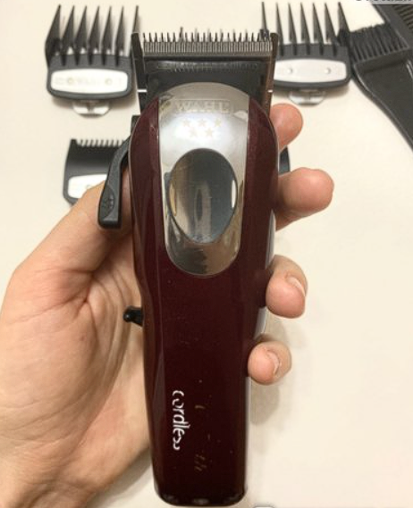
Wahl Machine Care

After each cut, I clean the blade assembly with the brush that comes with it. Once every two days, I oil the blade and turn it on so that the oil is evenly distributed throughout the blade assembly.
In all the time I've used it, I've taken the machine apart only once, thinking about cleaning the inside, but it turns out it's made in such a way that hair doesn't get in there. And for cleaning the knives, a brush is quite enough, or you can buy a special spray and not to complicate your life
The advantages of this machine

- The knife is sharp, makes a quality cut the first time, does not leave "antennas", does not pull a thick, thick hair.
- The sharp knife does not traumatize the skin when cutting hair to zero.
- The knife block moves very smoothly, thanks to it, you can make a nice transition from zero, and it does not require several machines, as before.
- The quality of the cuts is also noticeably improved, not only can you clearly build the length of the cut, but you can use non-standard attachments (1.5 mm and 4 mm) for a smoother transition, which are included.
- The nozzles are made of a material that does not create static electricity, perfectly held on the blade assembly.
- Reduced cutting time as the machine cuts better than my past ones and I don't have to waste time like with others.
- Since it is cordless, the cord doesn't get tangled or in the way while cutting.
- Comfortable body, light weight - all this makes the process of hair cutting a pleasant experience for the craftsman.
Disadvantages of this unit

The only drawback is that the plug of the power cord after a while began to poorly hold in the slot machine, but otherwise nothing unnecessary.

Conclusion

Wahl Magic Clip Cordless hair clipper is a quality and professional product. In the work is very convenient. Each item in the package is of good quality, and made without defects. When using the nozzles, I have dropped them many times, but they are still in excellent condition, the teeth are not broken, not worn out and also cling well to the knife block of the machine.

Working with this machine is a pleasure and comfort, so if you are looking for a good option for long-term use, the Wahl Magic Clip Cordless Hair Clipper will be a great choice for you, which you will not regret.

