VGR Trimmer Review
https://www.aliexpress.com/item/1005005181885931.html
Sales on AliExpress, truly amazing, because for little money you can find a truly valuable product. One of them is the VGR Trimmer for men.
I found it by chance and at first did not even think about buying, because I have a good analogue, but after some thought, I decided to buy something newer, and I was right. A big plus is the cheapness, as for a professional machine.
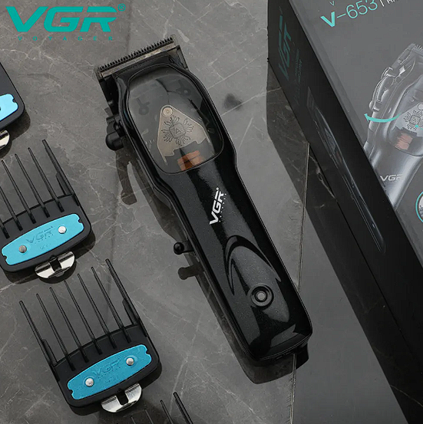
I didn't have to wait long for the parcel, three weeks passed since I ordered it, and now I have it in my hands. I have been using it for a couple of days, so I have already managed to notice the pros and cons.
The package includes:
- Hair clipper.
- Metal guide combs 4 pieces, each with different length (3/6/9/12 millimeters)
- Good quality USB cable for charging the machine
- Cleaning brush for cleaning the hair residue on the comb
- Oil for machine lubrication
- Charging base
- Instructions for use.
The machine arrived in a special air pocket that protected it from damage.
Special thanks for the base for charging, very useful, because when you cut sometimes need to remove the trimmer, and put it on the table is not always a good solution, and here you can gently put, and at the same hour to recharge, thereby trimmer almost does not lose energy, and for one approach can cut a lot longer than specified in the instructions.
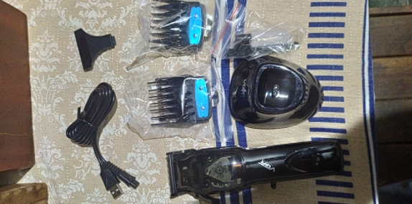
For its low price, the trimmer has excellent performance, and also performs its functions perfectly and without fuss:
- A huge plus can be added only for the DLC coated blades, which are made of high quality stainless steel, with a self-sharpening design that allows you to maintain a long time sharpness ensuring high efficiency and precision shearing.
- Adjustable cone switch that makes it easy to adjust the length of the cut without the use of guide combs (0.8 to 2.0 millimeters).
- 2500 mAh lithium-ion battery, fast rechargeable with USB cable, you can charge the trimmer whenever and wherever you want.
- Four guide combs of different lengths (3-6-9-12 millimeters), with which you can easily control the length of the trimmer.
- Also, the trimmer is equipped with technologies that make it easy to work with it, namely: R-angle blade technology to protect the skin, fitting technology to reduce friction, effective noise reduction.
Powerful motor, magnetic motor with 9000 beats per minute, optimized for increased power, efficiency and performance.
The manual is written in different languages, which is very convenient, the sheet itself is quite dense, all printed neatly and clearly, without any spots. There is also a note that this trimmer can be used in both wired and wireless mode. The charging cable is long, as much as 1.5 meters.
Now let's look at the blade, the "comb" is very small, but the blades cut well, not "chew" and not "chew" like some machines for a similar price. The blade of the machine is not removable, on the one hand this is bad, but on the other hand it is more simple and reliable design, after cutting the mustache I have no problems with cleaning the machine from the hair.
There is a clear charging indicator, glowing red while charging and blue when charging is complete, everything is simple and clear, but the indicator itself does not glare in the eyes if you look at it from any angle, seemingly a small thing, but well-thought-out.
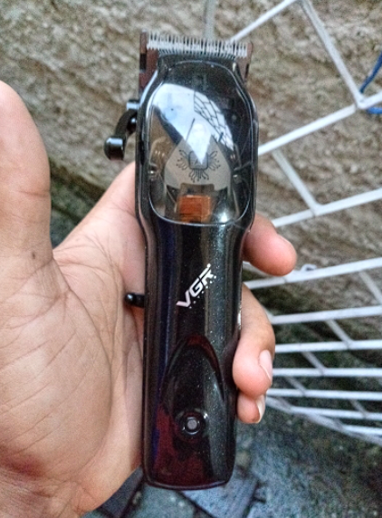
To sum it all up, the VGR Trimmer is a great option for beginning hairdressers who are not particularly wealthy. For a small price, it has great features and the same great equipment. Despite the fact that it came into my hands by accident, I will use it with pleasure.

