XIAOMI MIJIA Hair Clippers Review
With even minimal haircutting skills, you can already shoulder the bulk of the work of getting your hair in order. And even if we do not touch the subject of saving time and money, you can trim bangs, give a beard an appropriate look and even remove hair from places where it should not be - all this can be done at home at any time and with all the convenience, without visiting a barbershop. Especially because you don't need expensive professional hair clippers at home, so MIJIA Hair Clippers, which you can order on AliExpress (https://www.aliexpress.com/item/1005005059842518.html), fits as well as it does.
The characteristics of this machine are very attractive:
- The machine blades are made of titanium alloy and ceramic, an aerospace material that is expensive and durable.
- 3 original combs. 14 length adjustment modes, you can trim your hair without worries.
- Anti-corrosion coating, long use period, no need to replace the blades often.
- Battery 2200 mAh, 180 minutes of run time.
- Low noise, and even in high-speed mode with 6200 rpm, the noise does not exceed the 50 dB mark.
- The edge is round, which is very comfortable and does not hurt the skin.
- IPX7 waterproof, supports full body shearing.
The car came packed in an ordinary cardboard box, which was divided into sections for accessories.
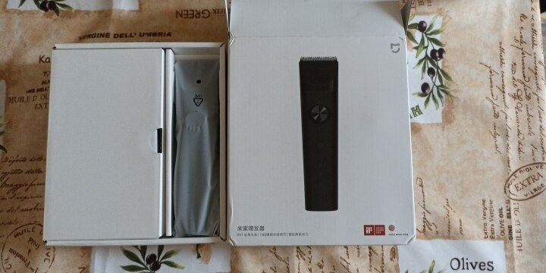

In addition to the machine itself, there were 3 more attachments - for filing, as well as for short and long hair, in addition to the attachments and a clip to fix the hair, a brush for cleaning, cloth cape and a cord to recharge the battery.

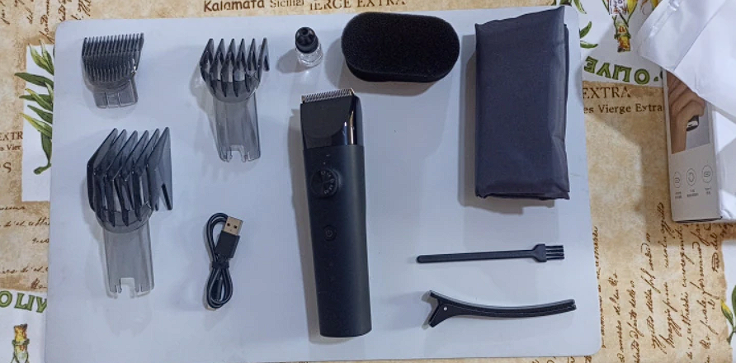

The MIJIA Hair Clippers are a great option for long hair, because the machine comes with plastic combs that are attached to the head of the machine and a special regulator allows you to smoothly and gently change the length of your hair. The heads are firmly fixed and do not pop out. This loom uses a motor-slider system.
If we talk about the length, without attachments the machine can change the length of the hair - from 0.5 mm to 1.7, but using the attachments, you can adjust the length from 3 to 41 mm, just a fabulous range. For such adjustments are responsible for two plastic nozzles that are inserted in a special slot in the machine, their installation is very easy and simple. It is only necessary to insert them until they snap into place. After that, using a special motor, this nozzle can be extended to the desired length. The first nozzle can be adjusted from 3 mm to 21 mm, and the second nozzle already from 23 to 41 mm. The value that is currently used can be seen on the back of the nozzle. It all works very well, except that while cutting thick and long hair, you will need to shake them out of the nozzle if you need to shorten the length. After all, when they start to accumulate in large quantities, it can be more difficult to adjust, but this is not particularly critical in the home environment.
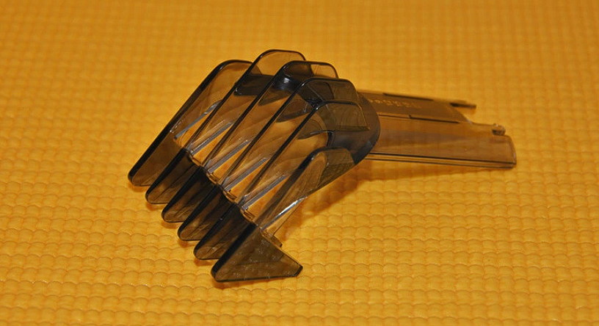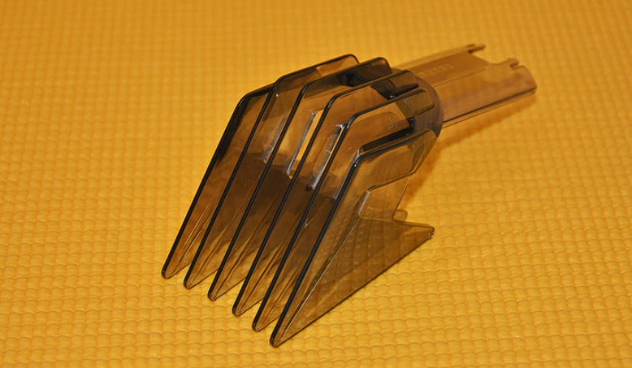
Nozzle from 3 to 21 mm Nozzle from 23 to 41 mm
Both nozzles are made of a nice transparent plastic, have six teeth and look quite sturdy. The teeth are quite thick and will last a long time, they also glide well on the skin, and the big nozzle has a slight concavity, so even a little discomfort is not felt. But the slit where the nozzles are inserted sometimes gets clogged with hair, so it is advisable to blow them out when replacing them.

Also, there was a third nozzle in the kit, but it is different in that the length cannot be adjusted, because it does not even snap into the socket, like the previous two. It is used for filleting hair. The teeth of this tool are made in much the same way as on the filing scissors. However, it takes a little skill to use it because filing is a little different from a standard cut, but with a little practice, you'll be fine.
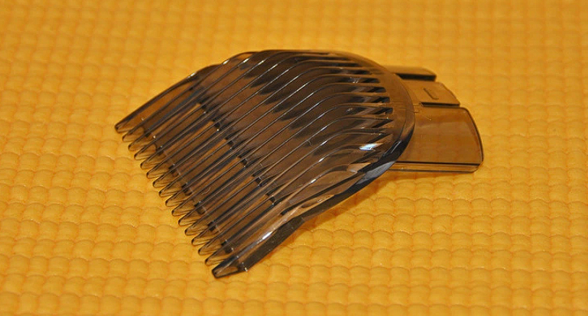

The volume of the battery in this machine, - 2200 mAh. Xiaomi company says that a full charge of the battery is enough for 180 uninterrupted work, but during the time of use, has not once discharged. A full charge is two and a half hours. A big plus is that the machine can work during recharging without any problems.
In the head of the machine, a ceramic blade with a titanium coating is used. Generally speaking, it is accepted that the ceramic cutting system is the perfect and most advanced solution. Such knives can keep their sharpness for a long time, as well as they are hypoallergenic and do not overheat during work. The machine cuts hair like butter and the head does not pull the hair, so there is not even the slightest difficulty.
The machine needs to be cleaned and lubricated regularly, and the instructions describe the points where you need to apply silicone from time to time. In order not to forget to monitor the machine, it has a special LED indicator that will remind you when the machine will consume too much current. In addition, there are 2 more LEDs on the case, one lights up when the machine is on and the other signals the depletion of the battery and its current status during recharging.
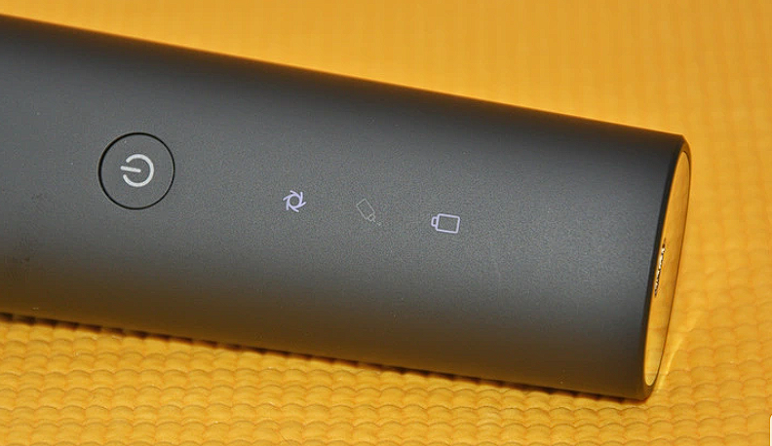
The case is designed in the form of a straight cylinder, which is slightly flattened and no curves, for some this may be a plus, for some it is a minus. The case is fully waterproof according to IPX7 standards, without any worries, you can use it under a ball of water, at a depth of up to 1 meter, for half an hour. Because of this, you can use the machine while in the shower, and the chance of missing it is minimal, because the case is coated with an anti-slip coating. Also, in addition to this, the head of the machine itself has its own regulator, with which you can set the cutting length from 0.5 mm to 1.7. This is very convenient, because for people with rashes on the face, it is important not to traumatize the rash.
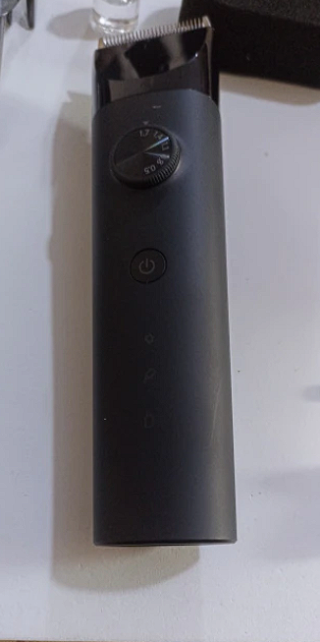
In summary, the MIJIA Hair Clippers from Xiaomi are an excellent choice for home use. It cuts without any inconvenience or discomfort, and does not cause pain by tugging your hair. Everything works great and the production is top-notch, in addition with the most convenient mechanism to adjust the length of the cut. It's a great machine that doesn't require much experience to cut.
You can buy it at the same AliExpress https://www.aliexpress.com/item/1005005059842518.html.

