Xiaomi ENCHEN Hair Trimmer Review
I have been visiting AliExpress for a long time in search of interesting products, which does not always succeed, but this time the visit was very successful, because I came across an excellent hair trimmer. Without any hesitation, I decided to order it for me and my wife, and I have not regretted it. I did not have to wait long, within 3 weeks of ordering it was in my hands. After two weeks of use, I can appreciate it.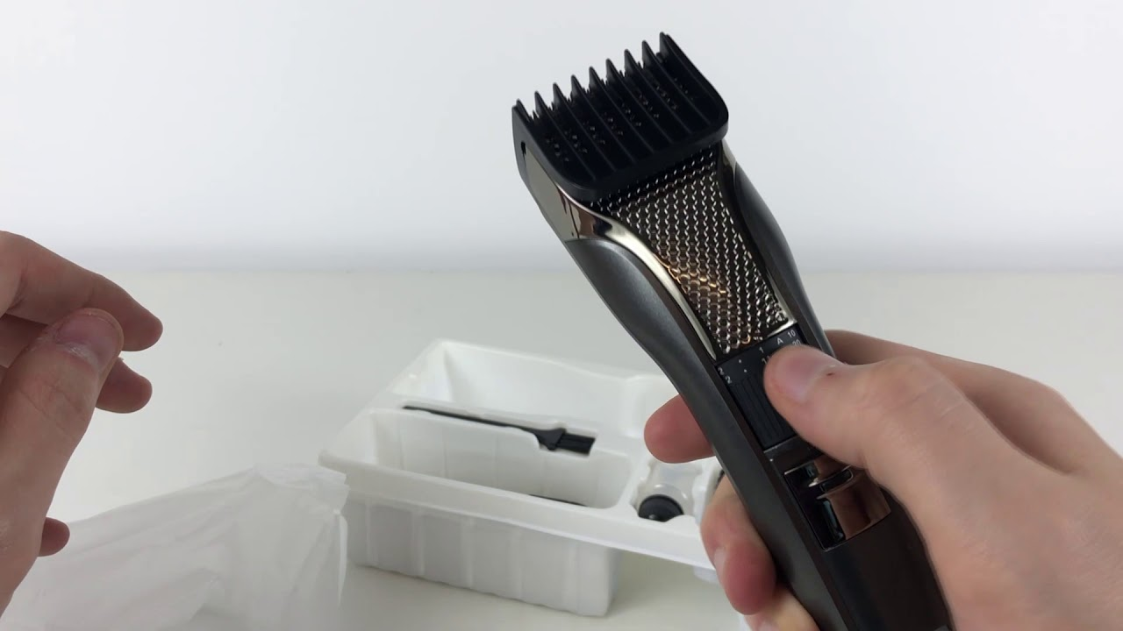
According to the characteristics it is quite a good option, namely:
- There is no age restriction on its use, as it is suitable for both adults and children.
- It has a slide switch
- Step can be adjusted from 0.7 to 21 millimeters
- Ceramic blades with high hardness
- Trimmer works in 2 speeds - standard 4500 rpm, and turbo 5800 rpm
- Working time in standalone mode is 90 minutes, and charging to 100% in rapid mode occurs in one hour.
- Noise level reaches 55 dB
- Charging via USB with built-in Type-C port
It was created by Xiaomi, which boasts excellent performance for little money.

The trimmer comes in this package:
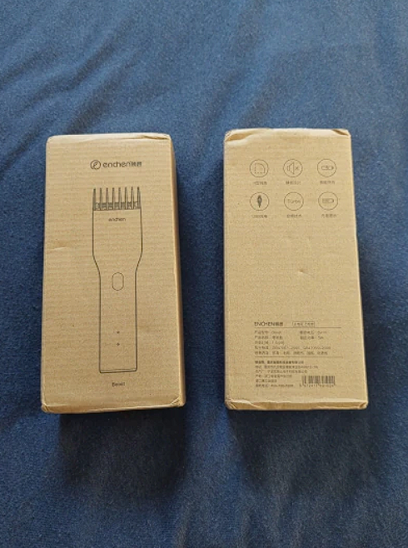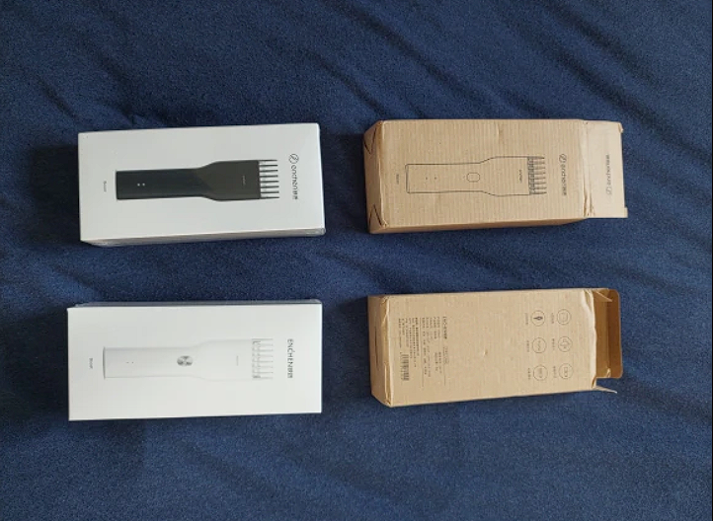
The package includes the trimmer itself, along with a brush to clean the hair, instructions (a pity that only in Chinese), a cord to recharge, and oil for lubrication:
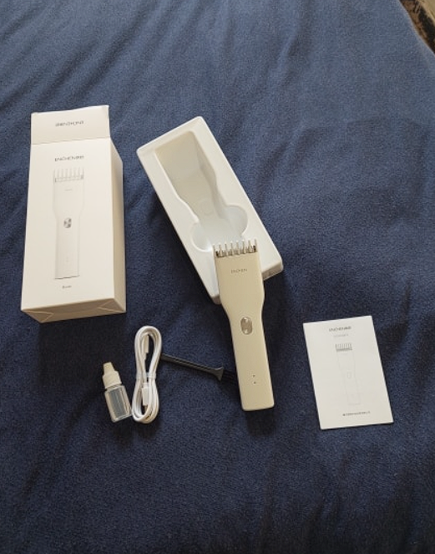

If we describe in detail each item in the set, then:
The brush to clean the hair from the trimmer, is small in size and has thick lint that is also stiff.
Type-C cord for recharging the trimmer, made well and quite tight.
The oil for lubricating the knives is transparent in color and thick in consistency, but one disadvantage is that the oil itself has a pronounced, specific smell of machine oil. To trimmer served not one year, he needs to regularly lubricate the knives, after shearing, in order to grease requires cleaning of the knives with a brush, then put a drop of oil on the knives themselves and turn on the machine for half a minute, to spread it in the oil, then turn off the machine and wipe the blade dry to remove excess oil.
The instructions are in Chinese.
The trimmer itself is made of thick plastic. It is pleasant to the touch, also the workmanship in general is good. Each detail fits perfectly to each other. On the front panel is a power button, which has two modes. The main mode is 4500 rpm which you can turn on by pushing the button and also the turbo mode that has 5800 rpm and is turned on by holding down the power button. Under the button are two LEDs showing the battery charge.
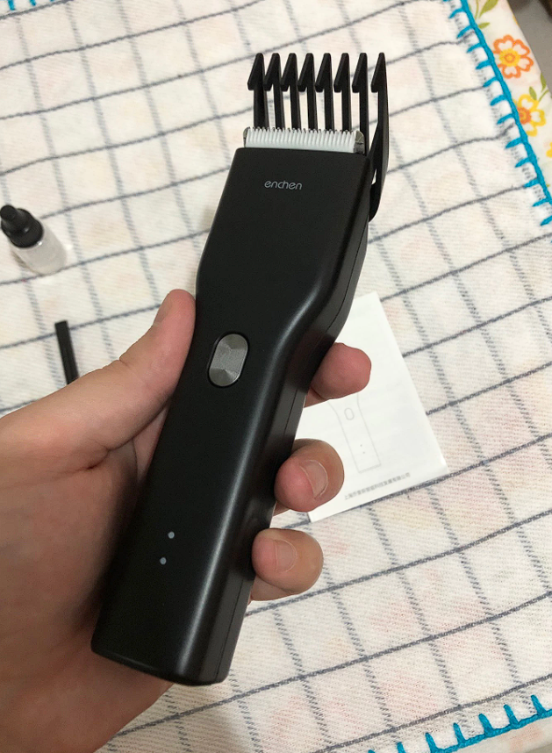

There is nothing on the sides of the trimmer, but on the back side there is a plastic hair cutting height adjuster, also it has a scale in millimeters. This adjustment is perfect for trimming. If you don't need the regulator, you can remove it without unnecessary fuss.

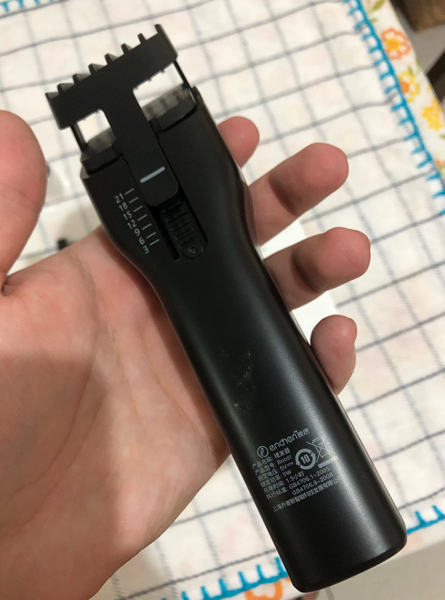
When you remove the regulator, you can see that the trimmer blade is indeed ceramic. But only the upper one, because the lower one is stationary and made of metal. It is desirable not to drop the machine, because the ceramic is easily broken, but at the same time the ceramic will not blunt as quickly and will not corrode as the metal.
At the very bottom of the trimmer there is a charging port for the battery. It takes about 90 minutes on average to fully charge. On a full charge, the trimmer can easily run for 60 minutes in turbo mode, and 90 minutes in standard mode. However, when the charge drops to 20%, the trimmer begins to noticeably lose its power, so it is worth watching the charge.
The trimmer has no protection against moisture, which can sometimes have a bad effect on its work, in some cases, protection is just necessary.
After using this trimmer for a couple of weeks, was pleasantly surprised for a small money, the thing was very useful. For people who have a lot of hair, the trimmer can be a salvation, copes well with coarse and fine hair, to all this we should add that the blade does not cling to the skin when shaving, and does not cause discomfort. As a general consumer ENCHEN Hair Trimmer from the company Xiaomi, is an excellent option for little money.

