Automation in logistics: Big opportunity, bigger uncertainty
As e-commerce volumes soar, many logistics and parcel companies hope that automation is the answer. But as this second article in our series on disruption explains, things are not so simple.
The history of logistics is also a history of automation, from the steam engine to the forklift to today’s robotic pickers and packers. So today’s fevered interest in new machinery, after a lull of several years, has plenty of precedents.
Many trends are thrusting automation toward the top of the logistics CEO’s agenda, not least these three: a growing shortage of labor, an explosion in demand from online retailers, and some intriguing technical advances. Put it all together, and McKinsey Global Institute estimates that the transportation-and-warehousing industry has the third-highest automation potential of any sector1 . Contract logistics and parcel companies (which, for sake of convenience, we will call simply “logistics companies”) particularly stand to benefit. (Automation is also on the table at other transport companies, such as trucking companies and port operators).
Yet for all the excitement, most logistics companies have not yet taken the plunge. For every force pushing companies to automate, countervailing factors suggest they should go slowly. We see five reasons companies are hesitating: the unusual competitive dynamics of e-commerce, a lack of clarity about which technologies will triumph, problems obtaining the new gizmos, uncertainties arising from shippers’ new omnichannel-distribution schemes, and an asymmetry between the length of contracts with shippers and the much-longer lifetimes of automation equipment and distribution centers.
This is the second in a series of five articles on disruption in transport and logistics. In the first, we examined the implications of autonomous trucks. Automation is no less potent a force. In this article, we will review the reasons automation is coming to the fore, examine the five factors that are hindering investment, and lay out strategies that can position contract logistics companies to prepare for an uncertain future.
Three cheers for automation
At first blush, more automation seems like the answer to three problems facing contract logistics companies.
Start with a shortage of workers. It’s no secret that, at least in the United States, labor markets have tightened. Unemployment rates are at a 50-year low, and wages are increasing. Some of the largest e-commerce facilities currently require 2,000 to 3,000 full-time equivalents, an order of magnitude more than traditional distribution centers employ, and need to add even more workers during the holiday peak season, when labor is most scarce.
While many of the jobs that might be automated are currently difficult to fill, that’s not to say that automation will have no effect on the workforce: it will, and companies must reckon with the significant costs to their employees and communities. In 2017, the US Bureau of Labor Statistics estimated that nearly four million Americans work in warehouses as supervisors, material handlers, or packers. That’s almost 3 percent of the total labor force; collectively, they earn more than $100 billion in annual wages. Automation won’t make all these workers redundant, of course, and many can be reassigned to new jobs that involve collaborating with and maintaining the new machines. But if even a portion of these jobs are lost, it will still represent significant upheaval.
E-commerce, the second trend, is remaking the entire logistics industry. The inexorable rise of online sales is well documented. In the United States, for example, growth has averaged 15 percent annually over the past decade, and the range of goods has expanded dramatically. That’s been good for logistics companies. We estimate that, out of every $100 in e-commerce sales, these companies (or e-tailers’ in-house logistics units) are collecting $12 to $20, a massive increase from the $3 to $5 spent on logistics in a typical brick-and-mortar-retail operation. (It’s important to note that, in our estimate, e-tailers are saving $12 to $16 out of every $100 of sales versus their brick-and-mortar competitors, which explains why their economics work so well.)
But even as logistics companies have benefited from burgeoning volume, the business is not without its challenges. Many B2B networks are struggling to adapt to B2B2C. Many large logistics companies fulfill e-commerce orders by carving out a corner of warehouses designed for B2B operations. And some logistics companies have at times been willing to use e-commerce as a loss leader to add business to their transport divisions. But as volume expands, all such arrangements are coming under immense strain. Here, too, automation seems to be an answer.
There’s a third reason for heightened interest: automation technology has come a long way. Ocado Retail’s new fully automated warehouse has demonstrated the potential of several new technologies—as seen by a big YouTube audience. Other companies, such as CommonSense Robotics (CommonSense), GreyOrange, and XPO Logistics, are rolling out intriguing new offerings.
These three trends make it seem like more investment in automation is a layup. Indeed, many are finding success with it. Some companies’ new automated pallet-handling systems cut shipment-processing time by 50 percent. And DHL International (DHL) has built almost 100 automated parcel-delivery bases across Germany to reduce manual handling and sorting by delivery personnel.

Automation technologies to watch
Warehouse automation technologies can be broadly categorized into devices that assist the movement of goods and those that improve their handling. In the first group, we’ve already seen automated guided vehicles (AGVs) that move cases and pallets. New twists are the equipment and software needed to retrofit standard forklifts and make them autonomous. The new gear can be switched on whenever needed—peak seasonal shifts, say—and the forklift can remain manual when demand is slower. Other recent technologies include swarm robots (most famously, Amazon’s Kiva robots) that move shelves with goods to picking stations and advanced conveyors that can move goods in any direction. Advanced automated storage/retrieval systems (AS/RSs) store goods in large racks, with robotic shuttles moving in three dimensions on rails attached to the structure.
New handling devices automate the picking, sorting, and palletizing of goods. Picking systems typically include a robotic arm with sensors that can determine the shape and structure of an object, then grasp it. Some devices remain fixed and have goods brought to them (often by AGVs). Others travel to the goods and retrieve and move them at once. Magazino’s new TORU cube is an example of the latter.
With the e-commerce boom, efficient sorting has become increasingly important, particularly in parcel operations. Advanced conveyor systems use scanners that can pick up bar codes on any side of a package to determine the appropriate action. Autonomous palletizers use robotic arms to build pallets from individual units and cases, often using advanced analytics to determine the optimal placement for each box.
Beyond the machines that mimic human hands and arms, other innovations will improve the productivity of people in warehouses. Drones are already in use in the warehouse for inventory management and outside the four walls for yard management. We expect to see much greater adoption of drones for these uses. Exoskeletons augment human motion with mechanical power through gloves or additional support for legs. The systems feature electric motors that augment the person’s own strength to allow them to move more goods (for example, heavier items) or move goods more easily and safely.
In fact, if you squint hard enough, an entirely new logistics paradigm is coming into view (Exhibit 1). Many operations could be automated by 2030, as artificial intelligence takes over the many repetitive activities that logistics companies perform. We expect to see fully automated high-rack warehouses, with autonomous vehicles navigating the aisles. Managers with augmented-reality goggles will be able to “see” the entire operation, helping them coordinate both people and robots. Warehouse-management systems will keep track of inventory in real time, ensuring it is matched to the ordering system. 3-D printers will crank out spare parts made to order.
Exhibit 1
A new logistics paradigm is emerging.
10 prominent technologies that could remake warehouse operations
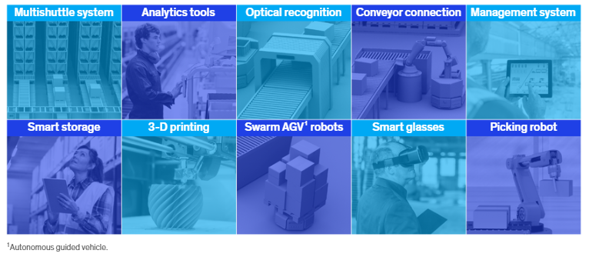

Five reasons for hesitation
Logistics companies are intrigued by the potential of automation but wary of the risks. Accordingly, they are investing conservatively. McKinsey research estimates investment in warehouse automation will grow the slowest in logistics, at about 3 to 5 percent per year to 2025. That’s about half the rate of logistics companies’ customers, such as retail and automotive (6 to 8 percent) and pharmaceuticals (8 to 10 percent).
Five issues are holding the sector back. Two are the flip sides of the forces (e-commerce and technological advance) that are motivating the renewed interest in automation. Also clouding the outlook are purchasing problems, the potential for change in the omnichannel supply chain, and the risks associated with short-term contracts.
Frenemies and ‘coopetition’
To capture the large e-commerce-growth opportunity, any logistics company must meet two fundamental requirements: speed and variety. Think same-day delivery of any of a million SKUs. To deal with that, more automation in picking, packing, and sorting seems like an easy investment call. But the unusual dynamics between logistics companies and e-commerce customers hold many logistics companies back. The risk manifests in a few ways. One is that e-commerce companies have a lot of buying power; if they do not like a logistics company’s offer, they can easily shift their business to competitors. That tends to keep prices low and may keep logistics companies from making an adequate return on a big investment in automation.
Another wrinkle is that most large e-commerce companies, such as Amazon and JD.com, have built their own logistics capabilities. Indeed, we estimate that if Amazon’s logistics unit were a separate company, it would be the fifth-largest third-party-logistics company in the world. To be sure, working with these companies can present challenges for shippers. The online giants, with their superior data and extraordinary scale, can readily offer white-label products that undercut their shipping customers’ offerings.2 But many thousands of shippers find the benefits outweigh the risks. The online giants deploy their in-house logistics first in the most lucrative niches, such as parcel delivery in dense urban areas, while slowly expanding into other areas. As that happens, they threaten to shunt logistics companies toward low-margin services, which may not justify an investment in automation. The moves by big e-commerce companies to build more warehouses in the last mile, and offer same-day as well as instant delivery, are a potent step in that direction, and logistics companies will have to carefully monitor the pace of change.
A particular challenge of serving e-commerce companies is that demand is very spiky, easily doubling around Christmas or Singles’ Day. On Singles’ Day 2017, Cainiao, Alibaba’s logistics arm, processed 812 million orders, eight times more than on a typical day. If logistics companies are to fulfill customer expectations during peaks, they will have significant spare capacity for three-quarters of the year. And if they do not build sufficient capacity for peaks, e-commerce giants have further incentive to build their own capabilities, as Amazon did after the 2013 Christmas season.
Technology racing ahead
We combed the industry and found more than 50 technologies that could further automate some part of the supply chain, including many in logistics (Exhibit 2). All are much more than a twinkle in some technologist’s eye, but none are yet in widespread use. The question that confronts logistics companies (and warehouse companies) is simple enough: Which ones will take off to yield the greatest return on investment?

Exhibit 2
Dozens of logistics technologies are under development.
Logistics-technology development
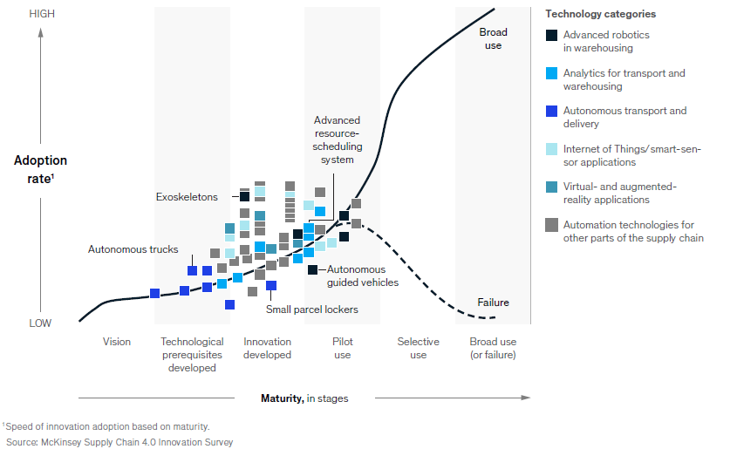

Finding answers is much more difficult, of course (see sidebar “Automation technologies to watch” for our thoughts on the first few horses out of the gate). No one wants to buy technology that becomes obsolete shortly after acquisition. Not only would that leave a company less efficient than competitors that made better choices, but it would also leave it worse off than those competitors that made no investment at all. The cost of removing and replacing equipment, much of it not fully depreciated, would put unlucky investors in a deep hole.
Purchasing woes
Even if a logistics company makes a great choice about the automation equipment to buy, it can run into another problem. The leading warehouse-automation manufacturers have enjoyed strong revenue growth of 15 to 20 percent annually since 2014. At many, order books are now full. In 2017, the order book at Vanderlande Industries reached an all-time high. Our conversations with many would-be buyers, especially at parcel companies, suggest that manufacturers operating at full capacity cannot even provide them with quotes.
Part of the problem is that the manufacturers are not yet at scale. Many companies, including the market leaders, are focused on a narrow range of technologies and solutions. That may change: the industry is in turmoil, with significant M&A activity underway. Notably, large technology conglomerates are investing in automation start-ups. For example, in 2015, Siemens took a 50 percent stake in Magazino, a start-up that builds automated picking robots. Once the dust has settled, some larger companies that are better able to meet demand may emerge. Then again, such companies will also have stronger pricing power.
A related issue is some confusion at logistics companies about which advanced equipment they truly need. Often the equipment on the purchase order is “overspec’d,” or more expensive than it might have been. We have seen purchase prices for the same equipment vary by as much as 50 percent.
Rapid change in shippers’ distribution networks
Brick-and-mortar retailers are reacting to the e-commerce onslaught in part by evolving their distribution networks into omnichannel systems in which consumers can purchase and receive items through any channel. They might purchase online and take deliveries at home, the classic e-commerce model. Increasingly, they can order online and pick up in stores. Or they might purchase in-store and receive shipments at home, an option that menswear company Bonobos and other companies offer. And of course, they can still go to the store and walk out with their purchases. On top of that, consumers demand ever faster delivery, which requires more local storage capacity, further driving complexity. Building a supply chain to support an omnichannel system is highly complex (Exhibit 3).

Exhibit 3
To fulfill omnichannel orders, shippers are redesigning their supply chain.
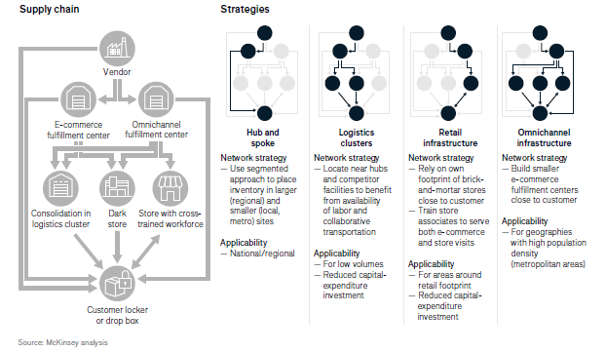

With all this complexity comes a lot of uncertainty: Where should new fulfillment centers be built? What share of B2C orders should they accommodate? And perhaps the biggest question: How much and what kind of automation are ideal? Shippers are asking the same sorts of questions.
Too-short contracts
Most logistics contracts run for about three years, sometimes longer. That’s much shorter than in the past. Shippers have tried to cut costs by more frequent tendering and have sought greater flexibility to respond to rapid changes in customer demand. The trend has exerted significant pressure on logistics companies. Because they typically develop sites with a particular customer in mind, they need to calculate carefully the investment required to add a new customer. With a significant initial investment required, logistics contracts are often not profitable for two years. That leaves only a year or so of profit before renegotiations begin. Big investments in automation would push the break-even point back further, leaving logistics companies at even greater risk that a customer would change providers, which would leave the facility empty and automation equipment unutilized while the third-party-logistics company searches for a new customer.
In the future, contract planning might get even more difficult. E-commerce requires dense networks, especially in urban areas. But no single customer has the scale to support a full-scale network. Logistics companies must therefore build fulfillment centers and purchase automation technology before demand is known, let alone contracted.
Strategy under uncertainty
In these murky waters, what should contract logistics companies do? As the previous discussion illustrates, there is no single automation strategy that guarantees a company will thrive. In the following sections, we offer some guidance that we hope can start the thinking process.
Contract logistics
The big changes we’ve discussed—the simultaneous rise of e-commerce, omnichannel supply chains, and new automation technologies—present contract logistics with a great opportunity to sharpen its value proposition, which has historically relied on one of two factors:
- Superior services. To meet the needs of small shippers, which typically lack the capabilities or scale to set up and manage complex fulfillment, contract logistics companies offer heavily customized services, such as differentiated packing, effective returns management, and high-speed fulfillment.
- Efficiency through scale. By serving multiple customers, contract logistics companies build the scale and expertise needed for warehouse efficiency—for example, shift planning during peak hours and seasons. For many shippers, large and small, these capabilities were the key reason they outsourced their warehousing.
In our view, automation is not (yet) very helpful in delivering value-added services, which are often quite complex. Consider what happens when a worker checks whether a returned pair of sneakers is ready to be reshipped. Reliably unpacking the shipment (customers often use whatever they can get their hands on, such as supermarket plastic bags), recognizing the condition of the returned item, and then selecting the correct next processing step is not a job easily performed by a robot.
However, a lot of automation equipment is well suited to drive efficiency, the first factor, in three ways. Start with the jobs of putting away and picking, especially of high-velocity items. Automation can reduce the dependency on an ever-tightening labor market. Second, automation can enable higher throughput in a smaller space. Given the tight market for warehousing real estate, especially near city centers, the business case for automation is improving significantly. Large manufacturers and start-ups such as CommonSense have identified this advantage of automation as a core value driver. And of course, automation can help during peak times. Business cases for automation often rely on average throughput, or the base load. Even on those terms, automation can succeed, but it means that a lot of equipment sits idle much of the year, as it is only used for one or two shifts a day. During peak times, this idle capacity can easily be unlocked through a third shift without adding large numbers of part-time warehouse employees—who are harder to find during Christmas season, for example. From an efficiency standpoint, automation has a lot going for it right now.
So how can contract logistics players make the most of this opportunity? With specialized equipment proliferating—more than 20 logistics activities could soon see mechanized help—almost every logistics customer now needs guidance in picking the optimal equipment for its purposes, procuring it, fitting it into the warehouse layout, training workers on it, and maintaining it. With contract logistics companies’ scale and experience, they can meet the need and become true partners to their customers, offering expertise, better rates of procurement, and deep operating knowledge. But to get there, logistics companies must do two things:
- Be at the forefront of understanding and deploying automation (for example, by partnering with automation providers to test new equipment). Scale will help with this requirement, especially in segments that use specific types of equipment (for example, to handle small items or returns).
- Get sharp on the marketing strategy, including a definition of the market segments they can serve well, discipline in targeting clients in these segments, and clear communication of the value proposition to them. With the rise of equipment comes a greater need for companies to specialize in activities common to a given industry, as most machinery is not as versatile as human labor. It will become tougher to serve every client out of the same warehouse setup. Contract logistics players need to shape and communicate a clear benefit for each customer industry.
Delivering the best service at the lowest cost in a given market segment will create a strong value proposition. The expertise gained by doing this well may also help to mitigate some of the contract issues: the deep relationships formed by becoming a true partner and adviser will likely also lead to stable contracts that can accommodate longer payoff periods. Some customers will still leave, of course, but when they do, the logistics company’s expertise and market-leading role should attract replacements, lowering the risk of equipment obsolescence. Therefore, logistics companies should avoid equipment that is specific to only one customer if that customer is not willing to help shoulder the burden.
Yet superior expertise and support may not be enough to make all contracts profitable over their duration. Contract logistics companies should also get smart about pricing. The power of incentives, such as adding attractive terms to extend contracts or penalties if contracts are terminated before customized equipment is paid off, is not to be underestimated.
Parcels
For parcel companies, the strategic considerations are a little simpler. Increasing demand is a given, as are rising requirements for speed and reliability. Considered that way, there can be little question that parcel companies need to automate. And in fact, many already have. DHL invested about €750 million in its German parcel network, and United Parcel Service (UPS) has announced a long-term plan to invest even more.
But within that imperative, parcel companies face some subtler questions:
What kind of equipment should be installed? Parcel companies around the world have two choices. One is to install large equipment that can handle the vast majority of parcels, say those up to 120 by 60 by 60 centimeters. This approach puts a high value on flexibility to accommodate a wide mix of parcels. Other companies have focused on equipment designed for smaller items, as e-commerce fulfillment features lightweight (less than 5 kilograms) items that are typically smaller than a shoebox. This kind of equipment is less flexible, as it cannot handle the large items, but it is significantly cheaper to install and often even to operate.
To decide, companies must review two pieces of data: the historical mix of parcel sizes and the growth rate of each size. If the data do not yield a definitive answer, it may make sense to create a flexible base capacity of large equipment and then add smaller sorters to accommodate e-commerce peaks.
Which process steps should be automated? The most obvious candidate is sorting in the hub. The labor-cost savings, especially in the developed world, make this a relatively clear case. Unloading and loading in the hubs are more complicated. Over the past five years, more equipment for these activities has been developed. Some providers say their gear can increase the productivity of one employee to more than 3,000 items unloaded per hour, from the previous 700 to 1,000 items per hour. In our experience, however, this equipment often struggles with the different shapes and especially the packaging of today’s e-commerce parcels. Plastic bags are the worst nightmare of many parcel-hub engineers.
When it comes to automation of loading, large parcels are the villain. Just imagine a 50-pound sack of dog food landing on a small, delicate box of LEGO toys. The child who receives the latter will not be happy with its condition. For smaller items, automation has been in place for years, but reviews are mixed. Parcel companies are well advised to ask manufacturers to showcase their solution with the company’s parcel mix.
Apart from hubs, some parcel companies, such as DHL, have started to automate delivery bases. Key advantages of this model are more sorting “depth”—that is, less manual sorting—and easier same-day deliveries that are fulfilled close to a city and then just sorted to the route in the delivery base. Automating in this way allows a company to outcompete some low-cost services offered by rivals.
How much capacity should be installed? E-commerce growth, and the volatility of its volumes, make this a vexed question. Many companies seem to have chosen not to overinvest in growth. The US operations of FedEx and UPS, and Japan’s Yamato Holdings, are only slowly expanding capacity. There are two reasons, which we raised previously, for being cautious and not rushing to capture all the growth: e-commerce players such as Alibaba and Amazon are investing in their own delivery systems, and e-commerce volumes tend to be low margin. Instead of focusing on investing in growth, many players are trying to get more out of their existing automation equipment—for instance, by introducing new products with different speeds that allow for sorting through the entire day. This will initially postpone the question of installing new capacity, but ultimately, all parcel companies need to find the right balance between yield and growth.
Despite the uncertainty, logistics companies can make informed decisions. We hope this article offers clarity on a complex situation, and together with the series of papers of which this is a part, provides logistics executives with a useful perspective on how their industry is changing—and how they can change ahead of it.

