PrivatBank: its services and capabilities
Today there are a lot of banks and choose one of them is not so easy.
So, we will talk about one of the largest banks in Ukraine. In our article you will read:
• What is a PrivatBank;
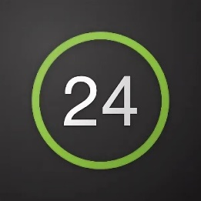
• Priva 24;
• A plastic card;
• Card juniors;
• A credit card;
• conditions and tariffs;
• Products of the bank;
• Customer reviews and opinions

What is a PrivatBank?
PrivatBank - The largest and most reliable bank in Ukraine, ranks 1st among the most profitable banks and 16th among the largest banks in Europe. The first in Ukraine connected Apple Pay.
The pros of this bank are incredibly many, but we will list the most basic:
1. Convenient application that will master everyone;
2. Payment of utilities without leaving the house;
3. Contactless payment from any smartphone model;
4. More than 4,000 branches throughout Ukraine;
5. Reliable payment system
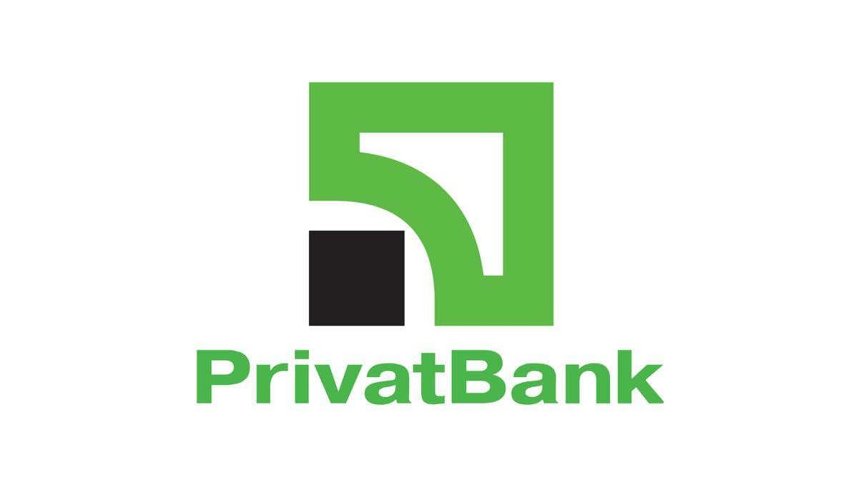
The PrivatBank was registered in 1992 and has since been in the leading position in all key financial indicators. It is easy to use by customers of absolutely any age category including children ( we will tell you about the junior card later). The Bank provides many opportunities including: deposit and credit products, payment and cash services, interbank transactions, securities transactions, documentary operations, acquisition services, pre-paid cards and salary projects.
Privat 24
Privat 24 is the official service of PrivatBank.The service is suitable for business, both small and large, allows you to accept payments for the online store with security payments, notification of payments and many other functions at any time and anywhere.
Private 24 customers have long understood and appreciated the convenience of this service.
With its help, you can always be aware of the business on their accounts. It allows you to pay for utilities, transfer money from card to card, both to your own and to other people’s cards, replenish Internet and mobile bills, buy various tickets, pay for purchases on the Internet and many other operations.
Do not need to go to the bank or look for a terminal, it is enough to choose in the menu of the site page repayment of credits, choose your financial or credit organization and on the number of the credit agreement and the name of the payer to make the payment. You can create a payment template in your account and will not need to fill in the form every time.

Registration
Registering on the site is very simple, you just need to perform several actions :
- Step 1. Go to the site Private 24 and click on the button <Registration>.
- Step 2. Automatically you enter the registration page. Enter the required data.
- Step 3.If all the data you entered in the previous form were correct, your phone number will receive a password.
Enter this password into the form and click “Continue”. All, registration is complete! Now you can use Private without restrictions.
In just 3 steps you can register on the site. Now we will tell you how to register in the app :
- Step 1. Download the Private 24 app.
- Step 2. Press the «Register» button, which is located under the login and password windows
- Step 3.Next, enter the login and mobile phone that will be used to log in.
- Step 4.Confirm the operation by receiving a call or entering a one-time password from an SMS-notification.
- Step 5.Confirm registration by entering PIN code of PrivatBank card on the virtual keyboard
- Step 6. Invent and enter a password of at least six characters (maximum 15) consisting of letters and numbers.
- Step 7.Enter a valid email address (e-mail).
- Step 8. Agree to the terms and conditions of banking services by clicking on the appropriate check box. Done! Now you can use all the services of the application.

A plastic card
Where and how to get a plastic card? Let’s first understand why it is necessary. Bank cards are used for cashless payments, including through the Internet, as well as for withdrawing cash or replenishing an account through an ATM or cash point. And unlike monobank, cash from PrivatBank can be withdrawn in absolutely any an ATM.
How to draw your own card in Privat24.
- Log in to Privat24;
- In the menu «Wallet» click «Add» and select «Digital card»;
- Choose the card type you plan to issue («Credit» or «Debit»), payment system and currency;
You will see a new card in your wallet within 10 minutes. The card can be ordered with delivery, or pick up in the bank branch. It also has various beautiful designs. For example, it can be a card with strawberries, with shopping or simply colored.
Junior card
JuniorBank from PrivatBank is a real way to teach your child to use banking services and services. It is especially important that the cardholder will realize that he is already old enough and responsible. After all, the Junior card has the same functions as an adult user.
In order to adult-baby not engaged in active shopping there is a limited credit. If the child has spent all its funds, the bank credits the purchase in the amount of not more than 300 hryvnia.
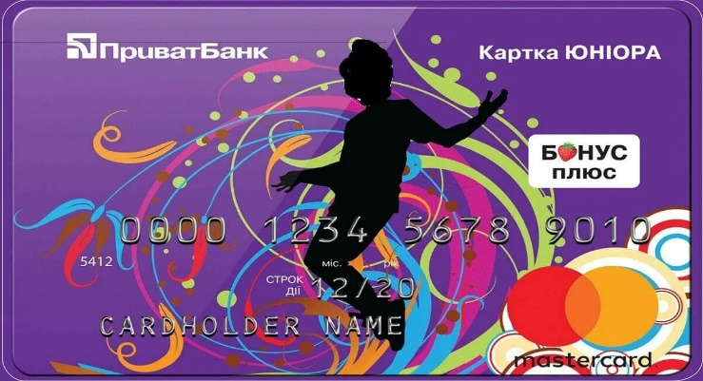
The grace period is the same as for other cards - 55 calendar days. The main thing is that the credit card has all the functional features, as well as its «adult» analogue. In addition, it gives its owner the following privileges:. On the balance of its own funds accrued interest of 10% per annum. Free service and release, with SMS connection - banking.
Information about all financial transactions comes not only to the phone of a young user, but also to one of the parents. Zero commission when buying goods in online stores.. For registration you will need to have such documents:

- The birth certificate of the child;
- The civil passport of the accompanying parent;
- Mobile phone of young customer Privat Bank;
The bank staff will give a standard contract for reading and signing. After it is issued card. Credit card can be ordered on PrivatBank’s official website.
Credit card
One of the best credit cards, with tens of millions of satisfied customers. The first person to face the problem of choosing a credit card can experience serious difficulties due to the huge number of offers on the market of banking products. The task can be significantly reduced if you read the terms on one of the best credit cards.
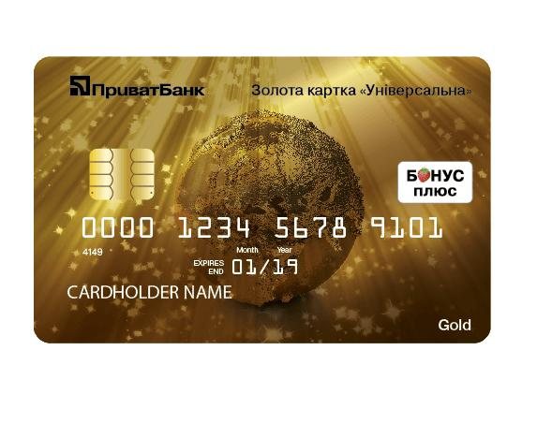
Advantages of credit card PrivatBank "Universal":
- Free registration and maintenance.
- 10% per annum.
- Excellent internet banking.
- Change of pin code.
- Sms-banking.
- Bonus plus.
- Lottery on check.
- Credit period under 0%.
- Access to internet banking Privat 24

Universal Gold card
With a Gold credit card you can use both your own money on the card and credit facilities. Your relatives, acquaintances or partners can transfer money to this card. Money on the «Universal Gold» card as personal and credit available to you anywhere in the world at any time of the day. The higher the level, the more services the bank provides together with the card, but at the same time the service cost premium cards for the client is more expensive. That is, in essence, Gold-card is the same payment instrument as usual, only with additional advantages.

Other services
Personnel security.
PrivatBank is ready to offer to corporate clients a new solution to ensure personnel security of the enterprise. Privat Bank managed to minimize the risk of fraud among its employees in a short time. If you also want to protect your business from this problem, contact the bank’s experts, they know how to do it.
Policy CCLIP
CCLIP is Compulsory Car Liability Insurance Policy. The policy provides compensation for damage suffered in an accident on the territory of Ukraine, in case of damage to property, life and health.
Sticker PayPass
The latest technology allows you to make purchases without contact with paper money. To make the transaction payment, you need to attach the PayPass sticker to the reader installed on the cashier.
Deposit PrivatBank
This is a profitable investment of money, a guarantee of their safety and the opportunity to receive additional income absolutely without effort. First of all, the customer will not only keep his money, but also receive additional profit in the form of accrued interest.

Services through “ Piggy bank”
As a rule, when the time comes to put aside planned funds - immediately there is a need to spend them. «Privatbank» offers you to save money without noticing it.

Payment in instalments. No overpayment
Nowadays, more and more people face the problem of overpayment. Various companies in a hurry offer their allegedly incredible conditions and as a result do not realize your expectations. Therefore PrivatBank will provide you with payment in instalments without overpayment.

Product of the bank
Pension card.
«PrivatBank» offers the elderly favorable conditions for receiving pensions. Very convenient but,will have to visit the bank branch only once without the need to spend time on a trip to the Pension Fund.
Personal card
"Universal". «PrivatBank» offers its customers to open an additional payment card with a photo. Name card Universal with a photo is supplemented with a special chip with a high level of security, so it is impossible to fake it because on the map you are listed with your name and a photo.
Mini Card.
«PrivatBank» offers its customers to receive MiniKARTU. Mini PrivatBank card is a stylish accessory and a practical international-class card for various payments.

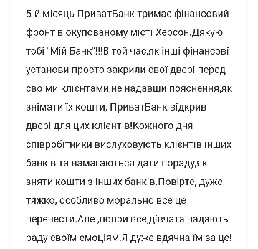
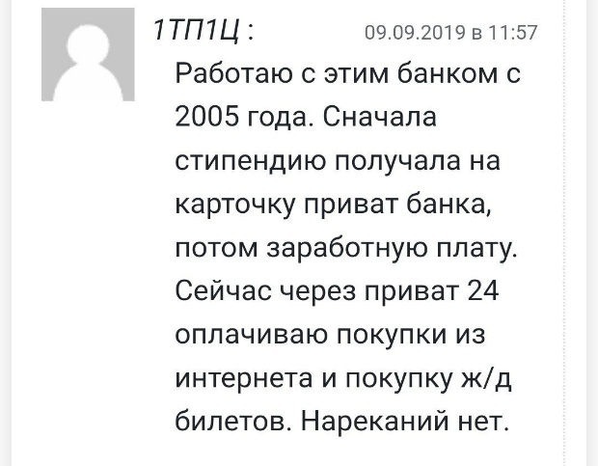
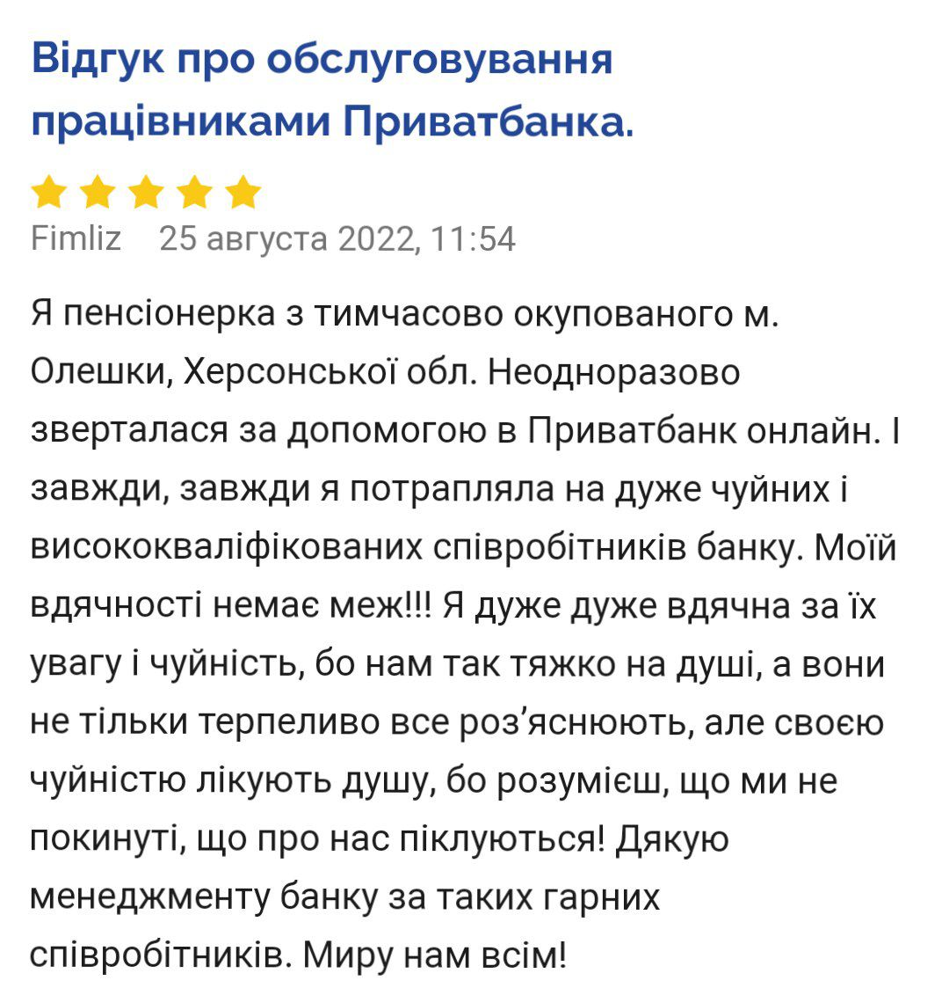
Reviews. Today we told you about the prospects, facilities and benefits of PrivatBank. In conclusion, we would like to read some reviews from the bank’s clients.

