

**ООО «АгроМосква»**

Business plan

Greenhouse complex

2 hectares

**Московская область – Орехово-Зуево**

**2023**

**Moscow Region, Orekhovo-Zuevo - 2023**

Table of contents

1. Memorandum of Confidentiality 6

2. Project Summary 7

2.1. Project summary information 7

2.2. Brief description of the project 8

2.3. Unique selling proposition 9

2.4. Key project indicators 10

2.5. Main objectives of the project 12

3. Information about the project initiator 13

3.1. Company Information 13

3.1.1. General information about the company: 13

3.1.2. Data on the reliability of the company and the risks of cooperation: 13

3.1.3. "Tree of connections" by founder and managing persons: 14

3.1.4. Financial (accounting) statements: 15

3.1.5. Permitted activities of the company: 16

3.2. Information about the company's leader 16

4. An enlarged analysis of the market 17

4.1. Enlarged overview of the Russian vegetable market 17

4.1.1. General situation on the Russian tomato and cucumber market 17

4.1.2. Market size of greenhouse tomatoes and cucumbers 18

4.1.3. Gross harvest of vegetables in protected areas 19

4.1.4. Overview of key trends in the wholesale market 20

Overview of key trends in the wholesale market 20

4.1.5. Overview of production facilities 22

4.1.6. Leading regions in the production of greenhouse vegetables (RF) 23

4.1.7. Export potential of the market 24

4.1.8. Expected market trends 26

4.2. An enlarged overview of the Russian market of greenhouse complexes 27

4.2.1. General information about the Russian greenhouse market 27

4.2.2. Summary analysis of the state of the industry 28

4.2.3. Industry Outcomes 2020-2022. 29

4.2.4. Assessing the dependence of the industry on imported seed 29

4.2.5. Estimating the shortage of consumables for the industry 30

4.2.6. Prospects for changes in the assortment matrix 31

4.2.7. Industry forecast 31

5. Organizational plan of the project 33

5.1. Business process description 33

5.2. Land plot 33

5.3. Documentation and design 34

5.4. Main structures of the greenhouse complex 34

5.4.1. Description of the facilities of the greenhouse complex. 38

5.4.2. Description of building structures and engineering systems 40

5.4.3. The system of ventilation of greenhouses 41

5.4.4. Thermal protection and light-reflecting curtain screen system (curtain system) 42

5.4.5. Greenhouse heating system 43

5.4.6. Drip irrigation system with nodes for preparation and supply of mineral fertilizer solution 44

5.4.7. System of plant feeding with carbon dioxide (СО2) 46

5.4.8. Roof cooling system 47

5.4.9. The system of electrodynamic illumination of plants 48

5.4.10. Automated control system microclimate and mineral nutrition of plants 49

5.5. Organization of water supply 52

5.6. Organization of electricity and heat supply 56

5.7. Purchase of seeds 61

5.8. Fertilizers used 64

5.8.1. Nitrogen fertilizers 65

5.8.2. Liquid nitrogen fertilizers 65

5.8.3. Phosphate fertilizers 66

5.8.4. Potassium fertilizers 67

5.8.5. Complex fertilizers 68

5.8.6. Microfertilizers 69

5.8.7. Boron-containing fertilizers 70

5.8.8. Manganese fertilizers 70

5.8.9. Copper-containing fertilizers 71

5.8.10. Molybdenum fertilizers 71

5.8.11. Zinc fertilizer 71

5.9. Arrangement of additional supplemental light for the plants 71

5.10. Quality assurance of finished products 80

5.11. Personnel information 81

5.12. Harvesting stage 82

5.13. Organization of sales of finished products 82

5.14. Logistics solutions 83

5.15. Project Implementation Plan-Schedule 84

5.16. Structural decomposition of the work plan 85

5.17. Climatic features of the project area 89

5.17.1. Data on maximum sunny months 89

5.17.2. Data on weather conditions 89

5.17.3. Average temperature data (graph) 90

5.17.4. Average humidity data 91

5.17.5. The wind rose of the area 91

5.17.6. Snow and wind loads 92

5.18. Environmental features of the project 93

6. Marketing plan 100

6.1. Overall marketing strategy 100

6.2. Planned ATL - events: 101

6.3. Planned BTL - events: 101

7. Financial plan 103

7.1. Start date and estimated duration of the project 103

7.2. Project currency, inflation rate, inflation accounting 103

7.3. Parameters of taxes 104

7.4. Calculated discount rates 104

7.5. Project starting balance 105

7.6. Data on projected sales 106

Schedule: Planned sales 106

7.7. Raw materials and material costs 107

7.8. Project personnel costs 108

7.9. Data on operating expenses 109

7.10. Data on planned investments 110

7.11. Data on availability of equity capital 111

7.12. Data on planned loans and credits 111

7.13. Data on tax payments 112

7.14. Profit and loss statement 112

7.15. Statement of cash flows (direct) 113

Graph: Cash balance at the end of the period 114

7.16. Forecast balance of the company 114

7.17. Calculation of project efficiency for the company (FCFF) 115

Graph: Payback for the company (FCFF) 115

7.18. Calculation of project efficiency for shareholders (FCFE) 115

Graph: Payback for the company (FCFE) 116

7.19. Calculation of debt indicators 116

7.20. Calculation of efficiency for the bank (CFADS) 116

Graph: Payback for the bank (CFADS) 117

7.21. Calculated estimate of business value 117

7.22. Calculation of profitability and turnover 118

7.23. Calculation of the budgetary efficiency of the project 119

8. Sensitivity analysis of the project 120

8.1. Sensitivity of the Net Present Value (NPV) parameter 120

8.1.1. Sensitivity of NPV of the project to sales volume: 120

8.1.2. Sensitivity of NPV of the project to sales prices: 120

8.1.3. Sensitivity of NPV of the project to the costs of raw materials: 121

8.1.4. Sensitivity of NPV of the project to personnel costs: 121

8.1.5. Sensitivity of NPV of the project to operating costs: 122

8.1.6. Sensitivity of NPV of the project to investment costs: 122

8.2. 8.2 Sensitivity of the Internal Rate of Return (IRR) parameter 122

8.2.1. Sensitivity of project IRR to sales volumes: 123

8.2.2. Sensitivity of project IRR to sales prices: 123

8.2.3. Sensitivity of the IRR of the project to the costs of raw materials: 124

8.2.4. Project IRR sensitivity to personnel costs: 124

8.2.5. Sensitivity of project IRR to operating costs: 125

8.2.6. Sensitivity of project IRR to investment costs: 125

8.3. Sensitivity of the Discounted Payback Period Parameter (DPBP) 125

8.3.1. DPBP project sensitivity to sales volumes: 126

8.3.2. DPBP project sensitivity to sales prices: 126

8.3.3. DPBP project sensitivity to raw material costs: 127

8.3.4. DPBP project sensitivity to personnel costs: 127

8.3.5. DPBP project sensitivity to operating costs: 128

8.3.6. DPBP project sensitivity to investment costs: 128

8.4. Conclusions on sensitivity analysis 129

9. Risk analysis 129

9.1. SWOT analysis of the project 129

10. Conclusion on the project 130

11. Contact information 130

# Memorandum of Confidentiality

This project business plan is submitted for consideration on a confidential basis solely for the purpose of making a decision on the financing of this project and may not be used for copying or any other purposes, as well as to transfer to third parties. By accepting this business plan for consideration, the recipient assumes responsibility and guarantees the return of this copy to the project initiator at the address indicated, if he/she does not intend to participate in the financing of this project.

All data, estimates, plans, suggestions and conclusions given on this project, concerning its potential profitability, sales volumes, costs, rate of return and its future level, are based on the agreed opinions of the entire team of project development participants.

This document contains confidential information, which is the property of LLC "AgroMoscow". It is intended only for persons who received it with the consent of the owner of the information. It is prohibited to copy or disclose the information contained in the business plan without the written consent of the owner.

The data presented in the business plan is a trade secret.

* It is forbidden to disseminate the information contained in the business plan without the consent of the copyright holder.
* It is forbidden to copy the business plan, as well as parts of it.
* It is forbidden to transfer the business plan to third parties without the consent of the copyright holder.
* It is prohibited to use the information contained in the business plan for any purpose other than familiarization.

In the event of a refusal to invest, this business plan shall be returned to the copyright holder or destroyed.

The receiving party shall be liable in accordance with the applicable laws of the Russian Federation for the disclosure of Confidential Information.

The Receiving Party's liability is limited to the amount of actual, documented damage incurred by the Disclosing Party as a result of the Receiving Party's actions.

# 2. Project Summary

# 2.1. Project summary information

Below is the basic information on the project to conduct a rapid analysis of the attractiveness of investment:

**6,5 %**

**4.8 years**

**150 million rubles.**

**4.8 years**

**93.6 million rubles.**

**31,3 %**

**162 million rubles.**

The total amount of funding needed to implement the project is: 161 606 995 rubles.

The initiator of the project makes investments in the project in the amount of 7% of the necessary financing: 11 600 000 rubles.

The amount of attracted financing is: 150,006,995 rubles.

Estimated term of attraction of borrowed financing is: 4.8 years.

Due to the fact that this project is a project in the field of agriculture and food is taken into account a preferential credit rate of: 6,5%.

Estimated term of credit money use: 4.8 years.

Estimated debt coverage ratio (DSCR): 1,3.

The total amount of accrued interest on the loan: 31,879,119 rubles.

Total discounted payback period of the project: 3.4 years.

Simple payback period of the project (PBP): 4.8 years

Internal rate of return of the project (IRR): 31,3%

Modified rate of return (MIRR): 26,3%

Rate of return on discounted costs (PI): 1.6 times

The cost of business for the calculation period: 541,796,610 rubles

Coefficient P/E (price/profit): 4,0

EV/EBITDA ratio (value of the company/profit before taxes): 5,0

The ratio of equity to attracted financing of the project:

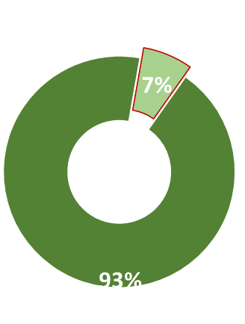

**7 %**

**93 %**

**RAISED FINANCING**

**OWN FUNDING**

The total cost of the project initiator, taking into account previously incurred costs and expenses of future periods will amount to 11.6 million rubles. This amounts to 7% of project financing.

## 2.2. Brief description of the project

**Project Name:**

Construction of a 20,000-square-meter greenhouse facility for growing vegetable crops (tomatoes, cucumbers) by AgroMoskva LLC in the Moscow Region.

**Project initiator**:

OOO AgroMoscow

OGR: 1170571011885

**Project Location:**

Russian Federation, Moscow Region, Orekhovo-Zuevo District, Likino-Dulevo Urban District, north of Lyakhovo village.

The project is located near the border of the Moscow and Vladimir regions.

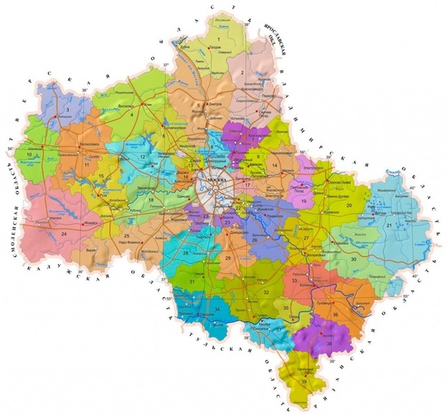

**Organizational and legal form of project implementation:**

Limited Liability Company.

**Manager:**

General Director - Ibragim Ibragimov Hajimusaevich

**The essence of the project:**

On the leased land area of 11.5 hectares on an area of 2 hectares is planned to build a modern greenhouse complex for year-round agricultural production with a total area of 20 000 sq.m.

As the main products planned cultivation of the following crops: cucumbers, tomatoes. The planned annual yield of tomatoes is 600 tons, at the same time cucumbers - 720 tons.

Connection of industrial greenhouses to the water, gas and electricity supply networks will provide a continuous cycle of production of finished products without reference to the climatic seasons. This will level out the seasonal fluctuations in prices for this type of products, ensuring the sale of products during the high price season.

Careful selection of seed material, the use of high-class personnel, the use of the right additives and fertilizers, the use of translucent greenhouse structures and the organization of artificial light supplementation will ensure the high quality of finished products. High taste qualities will ensure the stability of sales and the ability to maintain the estimated level of selling prices.

The project has an important social significance. Its implementation will create an additional supply of fresh cucumbers and tomatoes for the residents of Moscow and Vladimir regions. In addition, the project implementation will create more than 100 additional jobs and provide additional tax revenues to the regional and federal budgets.

**Project type:**

New construction, construction and installation work, purchase and installation of equipment.

**The way to achieve the goal**:

Receiving an investment loan for the creation of new agricultural production, reducing production costs, increasing production volumes.

**Variant of the appearance of the object**:

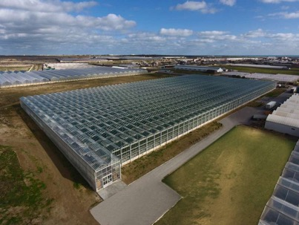

## 2.3. Unique selling proposition

The project does not have a single pronounced unique selling proposition.

However, some individual business solutions for different stages of the business process together form the uniqueness of the entire project and form its competitive advantage.

First, when selecting a greenhouse project, the main emphasis is on the project of the Russian manufacturer with elements of a complete set of production in China - this reduces the investment costs.

Secondly, the most advanced foreign and domestic technology greenhouses generation 5 and 5 + are taken as a basis for the project development. This allows for high quality products and consistently high yields.

Thirdly, ready accumulated customer base allows to ensure stable sales of finished products at estimated prices of the project.

## 2.4. Key project indicators

Information about the amount of investment, revenue, net profit, and cash of the project:

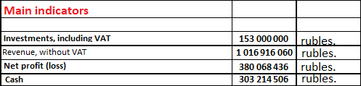

According to calculations, the project requires direct investment of 153 million rubles.

The expected net profit on an accrual basis over the seven estimated years of the project will be more than 1 billion rubles.

Information about the parameters of attracted financing (own and borrowed funds - absolute values and proportion):

The initiator of the project plans to invest in it its own funds about 11.6 million rubles, which will be 7% of the necessary funding. The amount of borrowed funds will be about 150 million rubles.

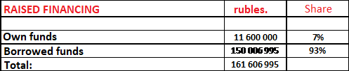 The total amount of investment in the project, taking into account the costs of its investment phase will be. 161,606,995 rubles.

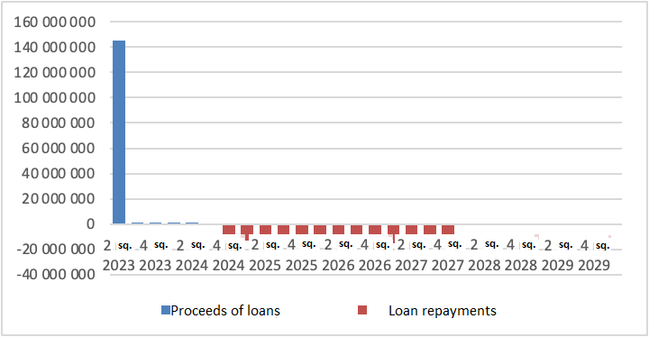Schedule of credit receipt and repayment (quarterly):

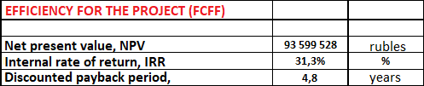 Calculation of project efficiency for the company (FCFF):

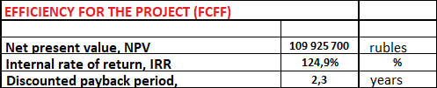 Calculation of project efficiency for shareholders (FCFЕ):

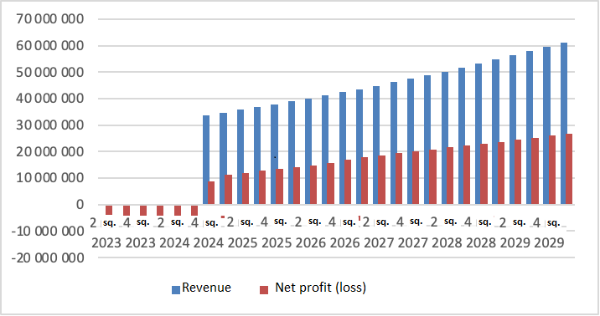 Revenue/net profit graph (quarterly):

Completion of the investment phase and launch of production is planned for the 4th quarter of 2024. The production cycle implies a one-step output of 100% volume of finished products. Further growth of revenues and net profit in monetary terms is due to the inclusion of appreciation due to inflation in the calculations (estimated value of 12% per annum).

## 2.5. Main objectives of the project



# 3. Information about the project initiator

# 3.1. Company Information

The initiator of the project is LLC "AgroMoscow".

### 3.1.1. General information about the company:

### 3.1.2. Data on the reliability of the company and the risks of cooperation:

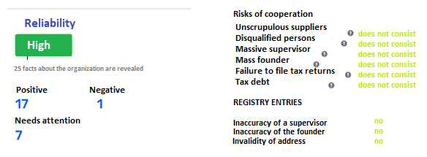

The reliability of the company is assessed by independent counterparty review services as high. Risks of cooperation were not detected.

### 3.1.3. "Tree of connections" by founder and managing persons:

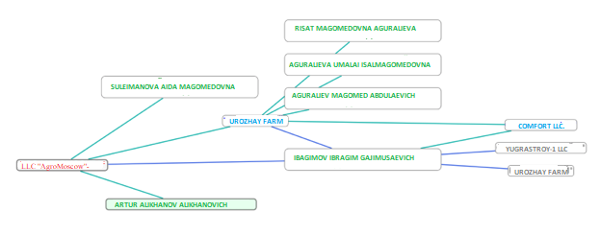

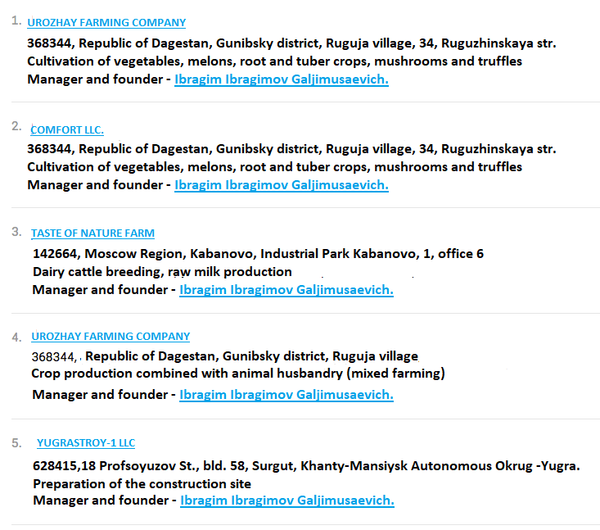

### 3.1.4. Financial (accounting) statements:

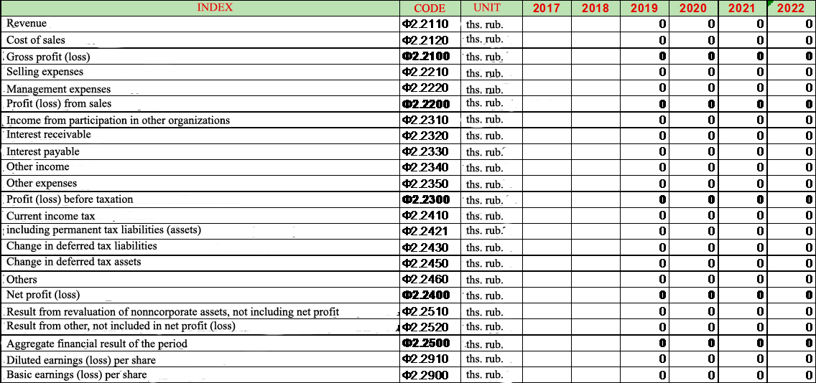

The company has not carried out any operating activities since 2017. The company's fixed assets with a book value of 58,879,000 rubles are unfinished construction projects in the Republic of Dagestan.

### 3.1.5. Permitted activities of the company:

|  |  |
| --- | --- |
| Code | Permitted activity |
| 01.13 | **Growing vegetables, gourds, root and tuber crops, mushrooms and truffles?** |
| 01.25 | **Cultivation of other fruit trees, shrubs and nuts** |
| 01.30 | **Growing seedlings** |
| 01.41 | Dairy cattle breeding, raw milk production |
| 01.42 | Breeding of other cattle and buffalo breeds, semen production |
| 01.45.1 | Breeding sheep and goats |
| 01.49 | Breeding other animals |
| 01.50 | Mixed farming |
| 46.31 | Wholesale trade in fruits and vegetables |
| 46.31.11 | Wholesale trade in fresh potatoes |
| 46.32 | Wholesale trade in meat and meat products |
| 46.32.3 | Wholesale canned meat and poultry |
| 46.33 | Wholesale trade in dairy products, eggs and edible oils and fats |
| 46.38.21 | Wholesale trade in homogenized food products, children's and dietary food |
| 46.42 | Wholesale trade in clothing and footwear |
| 46.90 | Wholesale non-specialized trade |
| 47.19 | Other retail trade in non-specialized stores |
| 47.21 | Retail sales of fruits and vegetables in specialized stores |
| 47.22 | Retail trade in meat and meat products in specialized stores |
| 47.23 | Retail sales of fish, crustaceans and mollusks in specialized stores |
| 47.29.36 | Retail sales of homogenized food products, children's and dietary food in specialized stores |
| 47.78 | Other retail trade in specialized stores |

Permitted activities of the company correspond to the declared project.

## 3.2. Information about the company's leader

**Ibragim Ibragim Hajimusaevich**

Education as a civil engineer.

* 2001-2005 worked for an agricultural company as a brigadier in Makhachkala
* 2007 to 2009 worked as the head of OOO "Yugrastroy-1", Surgut
* 2015-present: Head of the "Urozhay" farm in Makhachkala (Republic of Dagestan)
* 2015-present: Head of LLC "AgroMoskva" Orekhovo-Zuevo (Moscow Region).

Before the start of the project, he made a number of business trips to the regions of Russia, as well as to Azerbaijan, Turkey and Iran to get acquainted with the best practices in greenhouse farms of these countries.

The topics of equipment selection, technology, agricultural and business processes, market trends, enterprise economics were studied.

# 4. An enlarged analysis of the market

## 4.1. Enlarged overview of the Russian vegetable market

### 4.1.1. General situation on the Russian tomato and cucumber market

According to estimates by BusinesStat, the gross tomato harvest in Russia increased by 13.5% from 2.66 to 3.02 million tons in 2017-2022. According to the method of cultivation, tomatoes are classified into those grown in open field or indoors. The gross yield of tomatoes grown in open ground increased by 6.1 percent (from 1.96 to 2.08 million tomatoes) and indoors by 34.3 percent (from 0.70 to 0.94 million tomatoes).

The driver of vegetable growing in Russia was the process of rapid import substitution amid the imposed sanctions. The state actively stimulated agrarians and farmers by providing them with comprehensive support to improve their business: compensation of incurred costs for the implementation of investment projects and the granting of soft loans. In addition, there was a wide application of agricultural technologies, mineral fertilizers and pesticides in the cultivation of vegetables. As a result, market participants were able to increase production and the range of cultivated tomatoes.

In 2020-2021 the gross harvest of tomatoes in Russia decreased by 2.6%: from 3.02 to 2.94 million tons. The coronavirus pandemic led to a drop in demand for produce, the introduction of new sanitary standards for production, as well as a decrease in the profitability of many vegetable-growing enterprises. The situation was exacerbated by adverse weather conditions. As a result, the gross harvest of tomatoes grown in the open field fell to 1.96 million tons by the end of the period (by 5.8% compared to 2019).

At the same time, the gross yield of tomatoes grown indoors in 2020-2021 showed a slowdown in growth rates. Against the background of market saturation, tougher competition, higher electricity and gas tariffs, there was a reduction in investment in greenhouse vegetable production. At the end of 2021, the gross yield of tomatoes grown in open fields in Russia was 0.98 million tons, which exceeded the level of 2019 by only 4.3%.

In 2016-2019, sales of cucumbers and gherkins in Russia increased by 15%: from 0.74 to 0.85 million tons. The growth in sales was influenced by the acceleration of the pace of life, leading some consumers to abandon growing cucumbers and gherkins in favor of buying them in stores. The continued relatively low prices also contributed to the increase in sales volumes. In 2016-2019, the average retail price growth rate for cucumbers was lower than the average inflation rate due to the growing number of producers and the increasing level of competition in the industry. The market attracted investors due to the state support of greenhouse vegetable production, which involves reimbursement of part of capital costs and soft investment loans.

In 2020, the real income of Russians decreased significantly under the influence of the economic crisis and restrictions imposed due to the coronavirus pandemic. This led to a 6.6% decrease in sales of cucumbers and gherkins compared to 2019 (down to 0.8 million tons). With lower incomes, people bought fewer cucumbers, reallocating spending to cheaper products. In addition, 2020 saw a decline in the country's population due to both increased mortality from the pandemic and the departure of some migrants to their home countries. A larger market decline was avoided by a short-term food rush at the beginning of the quarantine in the spring of 2020.

### 4.1.2. Market size of greenhouse tomatoes and cucumbers

According to the Food Security Doctrine of the Russian Federation, the level of self-sufficiency in vegetables in the country should be at least 90% for each category. The greenhouse cucumber market actually reached this mark back in 2019. Nevertheless, production in the country continues to grow, which negatively affects the selling prices of products in the summer and autumn period. The country's export potential in terms of this crop is obviously growing. At the same time, the current "sanction" realities do not allow it to be sold in full. According to the Federal Customs Service, in recent years, Ukraine and Belarus accounted for more than 90% of cucumber shipments, while other export destinations have not been worked out and implemented.

The conditional capacity of the market of greenhouse cucumbers in 2022, according to ICAR estimates, was 899 thousand tons, and the level of self-sufficiency in culture - 95%. Most likely, at the end of the year, there will be reductions in foreign trade. According to ICAR, the volume of imported products in the market was about 43.6 thousand tons (-21% compared to the previous year), and the volume of export operations will decrease from 31.9 to 30 thousand tons.

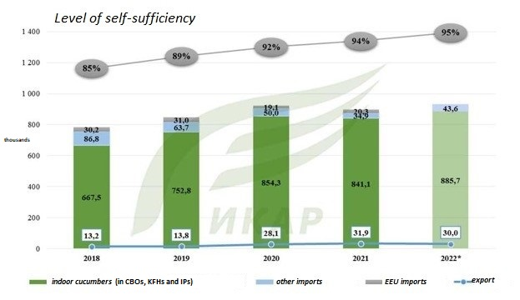

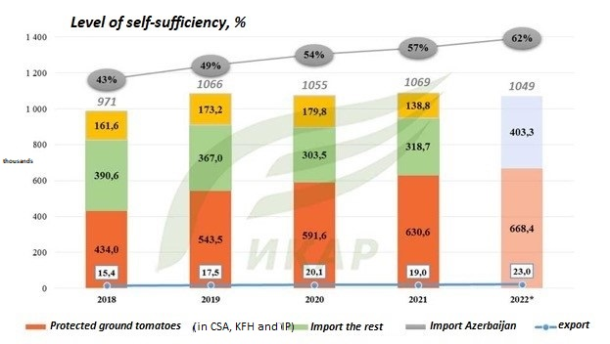According to experts, the level of self-sufficiency in tomatoes is still lagging behind the target values: this year the indicator will add 5ppt and amount to 62%. The tomato market is still dependent on imports during the off-season, and they continue to have a significant impact on the market situation in this period. According to ICAR, the volume of imported products in the country in the outgoing year will decrease by about 12% to 403 thousand tons, which will be the lowest value in recent years. The total market volume for 2022 is 1,554 thousand tons.

### 4.1.3. Gross harvest of vegetables in protected areas

According to the results of the year, the greenhouse industry expects a new production record. ICAR estimates the harvest in 2022 at 1.602 million tons of vegetables, which is more than the previous year by 5.6%.

In the structure of production is not expected to radical changes. Thus, the production of greenhouse cucumbers is estimated at 885.7 thousand tons (+5.3% over the previous year), tomatoes - at 668.4 thousand tons (+6%). Production of "other" crops (greens, eggplants and peppers) will reach 48.5 thousand tons.

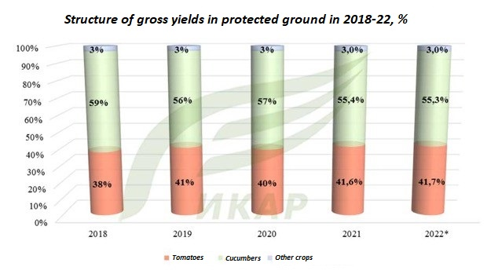

### 4.1.4. Overview of key trends in the wholesale market

### Overview of key trends in the wholesale market

The race for gross yields this year has become more clearly visible in the greenhouse cucumber market. Let's consider the situation on the example of short-fruited and medium-fruited smooth cucumbers. Let's return to the thesis about the growth of domestic cucumber production in the country.

When it comes to the market of short-fruited cucumbers, the average price tag in 2022 was 126 rubles/kg and far exceeded the previous years - 118 and 99 rubles/kg in 2021 and 2020, respectively.

The most striking growth was observed at the beginning and end of the year (winter period). Price levels for this crop were the highest in the last few years, which clearly indicates a reduction in the harvest of this crop in greenhouses. From January till the first half of March the average value of the wholesale price for this crop amounted to 214 rubles/kg and was 5% higher than during the same period of 2021 and 27% higher than in 2020.

Since the beginning of November there is a similar situation in the market - the average selling price on the wholesale markets amounted to 206 rubles/kg. This is the maximum price tag for similar periods of previous years.

For example, in 2019 it was 146 rubles/kg (-60 rubles to the current figure). Obviously, the varieties of this type of cucumber have a relatively lower yield per hectare than the widespread "meva".

In fact, producers began to allocate less and less area for its planting, and grow it not for sale on the free market, but rather as an assortment position for network contracts for sale in prepackaged form. This can be explained by the fact that this sales channel and method greatly increases the profitability of its sales.

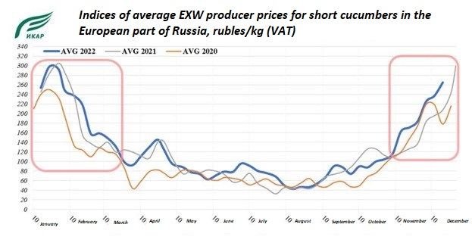

The oversaturation of the market of medium-fruited smooth cucumbers is evidenced by their annual "failures" during the hot period of the year. Once again, the situations recorded on the market in 2022 were a confirmation of this.

In the period from mid-May to the first decade of August, the market saw price swings: down, up, down.

In the second half of May, the working wholesale price tag was down to 20 rubles/kg, while in 2020 and 2021 it started from 55-60 rubles/kg.

Rather indicative situation was observed in the market during this period: wholesalers were "overstuffed" with this type of cucumber, producers - with carry-over stocks, networks were reducing the number of trades on the deficit.

In the first decade of August this story was repeated again, with a small exception - at that time, the working wholesale price tag in some regions began from 5 rubles / kg. and, at best, reached 10 rubles / kg throughout the market.

With the onset of November, the average level of selling prices accelerated above the level of previous years, and by the end of the month reached 138 rubles/kg against 94 rubles in 2020-21.

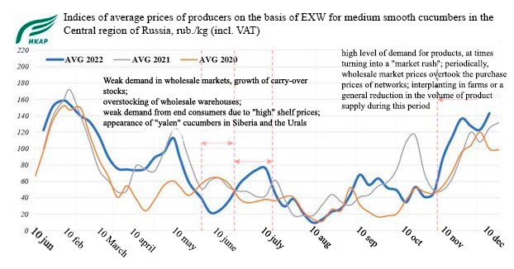

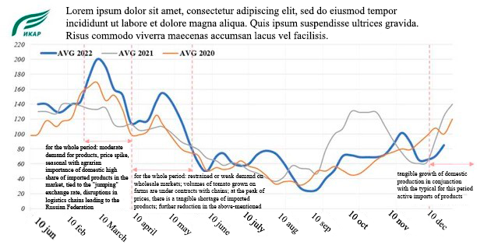According to statistics, the tomato market is far from saturation, and imports coming to the market in the off-season period actually continue to "dictate" the conditions of its functioning. The beginning of the USE and the ensuing weakening of the ruble against the dollar, disruption of the regularity of supply of imported products greatly destabilized the wholesale market of tomatoes in terms of selling prices. In the period from late February to mid-May the level of selling prices on the market reached the highest values for the last few years. At the same time, the accompanying surge of market activity was not observed. At its peak (early March), working wholesale prices for round red tomatoes started from 200 rubles/kg. As the situation and the exchange rate stabilized, the price situation in the market entered more or less as usual. All other recorded deviations (summer period) were tied to agronomic and climatic components - change of turnover in farms and weather conditions affecting not only the yield in greenhouses, but also the supply of open field products to markets.

### 4.1.5. Overview of production facilities

The beginning of 2022 was a difficult test for producers of vegetables of protected ground - in the conditions of new realities and disruption of supply chains the production costs increased, there were failures with the supply of means of production. Despite this, at the end of the year there was an increase in production capacity in the sector.

According to ICAR estimates, last year the production capacity in the sector increased by at least 280 hectares of new high-tech greenhouses. Thus, by the end of the year, the area of winter greenhouses in agricultural holdings in Russia reached 3.4 thousand hectares. The key role was played by the largest companies on the market - GK ROST and Ekokultura. The most active expansion of areas was recorded in the Central, Volga and North Caucasian districts.

Despite the positive aspects of the ongoing expansion of the sector, it has a downside. Increasing competition in the market "squeezes" out of it the players who are the least adapted to the existing realities. Outdated production technologies that have not been modernized in time, irrelevant marketing or sales policies - these are some of the points due to which manufacturers "lose" profitability or, for example, no longer cope with the loan burden...

### 4.1.6. Leading regions in the production of greenhouse vegetables (RF)

In 2022, domestic producers produced a record number of greenhouse products - 1.5 million tons. At the beginning of December in the protected ground harvested 1.43 million tons.

According to the Ministry of Agriculture of the Russian Federation, the production of greenhouse vegetables increased by 6.7% compared to the same period last year. Including cucumbers harvest is 886,4 thousand tons (+5,3%), and tomatoes - 668,4 thousand tons (+6%).

The leading regions in greenhouse vegetable production in the 2022 season are:

* Lipetsk,
* Moscow,
* Volgogradskaya,
* Kaluzhskaya,
* Belgorodskaya,
* Novosibirsk region,
* Republics of Karachay-Cherkessia and Tatarstan,
* Stavropol Krai and Krasnodar Krai.

### 4.1.7. Export potential of the market

In the first three quarters of 2022 Russia exported 12.2 thousand tons of fresh cucumber. Imports for 9 months so far exceeded exports and amounted to 34 thousand tons. The main market during the reporting period remained Belarus, which imported 9.9 thousand tons of Russian cucumbers. In the second half of 2022 Russia became almost completely independent of imported cucumbers. The cucumber market was completely saturated, and Russian cucumber went to foreign markets.

What is most surprising is that Russian cucumber, at a wholesale price of 60-80 rubles, turned out to be super-competitive. And the world market turned out to be practically limitless, with another 2 million tons of cucumbers that could be sold there. At the moment, the main global cucumber importer is the United States. In second place is Germany, and in third place is Britain.

Russia is one of the world's top three producers of cucumbers (China, Iran, Russia):

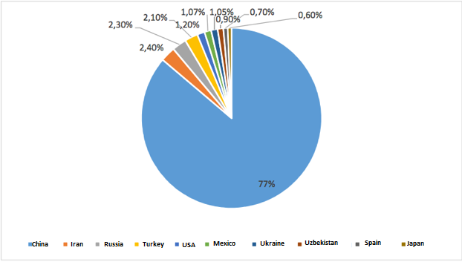

The world's leading exporters of cucumbers and gherkins are Mexico, Spain and the Netherlands, annually exporting more than 60% of the global share of fresh vegetables. Mexico's share of the global market of cucumbers and gherkins is 26.4% of global exports of this type of vegetables. In second place is Spain with a share of 24.1%. The Netherlands has a share of 13.2%.

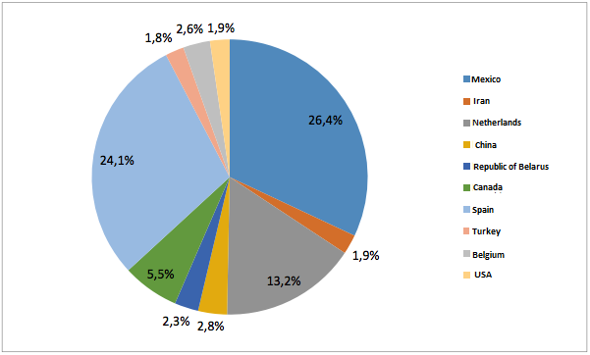

The largest importer of cucumbers and gherkins is the United States, which accounts for more than 30% of total imports of vegetables. About 18% is imported by Germany. The share of UK imports of cucumbers and gherkins is just over 6%.

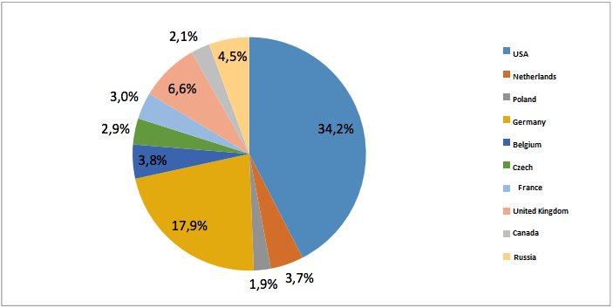

Thus, Russia still has export potential for cucumbers to the world markets. Sanctions imposed on Russia are a barrier to this. Finding a mechanism to bypass the sanctions regime provides additional opportunities to ensure sales of finished products in markets with high solvency.

### 4.1.8. Expected market trends

According to the results of this year, the Russian production of greenhouse products may increase by 4-8%. The growth rate of gross yields of vegetables grown in protected ground is now somewhat more modest than in the first years of development of the sector.

But this situation is logical: the market is more and more saturated with goods of own production, and it is no longer necessary to bet on increasing the volume. Now companies are working more on expanding the assortment and increasing business efficiency. However, new greenhouses are also being built: up to 150 hectares may be commissioned in 2023.

Last year, most greenhouse enterprises finished with positive financial results, unlike, for example, in 2020, although, of course, some companies went into deficit.

In 2022, the producers of vegetables in protected ground also felt good. During this year, high prices for greenhouse products were kept not only in retail, but also in wholesale. The trend for a significant increase in the price of vegetables emerged in the second half of 2021, and in the first half of 2022 even more accelerated, in the summer price growth slowed down, but their overall level has already become noticeably higher than in 2019-2021.

On average, in October-November, greenhouse products cost 3-5% more than in the same months a year earlier. Since December, prices will increase by at least another 20-25% - this is a typical seasonal phenomenon. Thus, companies are trying to recoup the growing winter costs of heating and electric lighting.

The price dynamics in 2022 reflected the macroeconomic situation. In late winter and early spring there was a sharp rise in commodity prices and inflation on the background of "consumer panic. With the arrival of the outdoor harvest on store shelves in summer and fall there was a decrease in the cost of greenhouse vegetables and greens. By the second half of autumn, with the arrival of more expensive greenhouse produce, vegetable prices began to rise again due to the seasonal factor. The cost of growing greenhouse products is also increasing due to higher tariffs for energy resources (gas, electricity), prices for seeds, substrates, packaging.

But the consumption of greenhouse vegetables in 2023 is expected to be lower than in the previous year. The population in Russia has been decreasing for several years in a row, an even more tangible factor will be the fact that a significant part of the target group of consumers of expensive greenhouse products during the off-season this year left our country. According to various estimates, it is from 400 thousand to 700 thousand people in the age of 30-40 years, who earn well, lived mostly in cities and consumed greenhouse vegetables year-round and regularly.

Instead of the displaced population, other social groups appeared in the country: refugees and migrants from different regions of Ukraine. But they are not the target audience of products grown in indoor areas, since the income of most of these people does not allow them to buy cucumbers or tomatoes for 350-500 rubles/kg in winter.

Thus, the downward trend in the consumption of greenhouse vegetables will be observed not only this year, but also next year.

The growth in demand for their products is not observed by the producers themselves. Vegetables are not a basic necessity, so when the solvency of the population decreases, their consumption decreases.

At the end of 2022, the demand for greenhouse products in Russia is likely to remain at last year's level, although consumption in many other countries is constantly increasing as the culture of healthy eating increases.

The dynamics of growth of Russian production of vegetables in protected areas in the future will also remain moderate. Combines will not be able to increase the harvest at the same rate as it increased in 2019-2021, if they want to maintain an acceptable profitability of the business. After all, the number of target customers is not growing yet, and they definitely will not significantly expand the consumption of greenhouse vegetables in the near future. For this to happen, it is necessary to lower prices, but it is quite problematic to do in the current economic situation, the cost of production has increased significantly.

To support the industry, the Ministry of Agriculture has developed a new program to increase the repayment period of long-term loans from 12 to 15 years. Some producers have already begun to use this opportunity. Cheap investment loans in the European part of Russia remain the most effective form of state support for new high-tech projects.

One of the important factors that determines the profitability of the industry is energy tariffs, which account for more than 50% of production costs.

Subsidizing of all greenhouse complexes that use the technology of extra lighting in the production of vegetables, especially for regions with 100% of the use of this technology, would be a significant help for the sector of closed ground. This would allow to partially compensate the increased energy costs and stabilize the prices of products. But so far, such a measure of support has been provided to the regions in a minimal amount.

## 4.2. An enlarged overview of the Russian market of greenhouse complexes

### 4.2.1. General information about the Russian greenhouse market

Greenhouse industry in Russia is in a growing trend: the area of farms is increasing, the range of cultivated crops is expanding, the equipment of greenhouse complexes is modernized, the qualification of scientific, industrial and technical personnel is growing.

In addition, there is a new competitive in the world market seed material of high-yield, quality, disease and pest tolerant vegetable crops for protected ground.

The main greenhouse crops in Russia remain tomato and cucumber. Cucumber accounts for about 74%, tomato - 25%, herbs, peppers and eggplant - 1% in the structure of crops grown in protected ground.

The share of protected ground vegetables lines up as follows:

The largest vegetable growing enterprise since 2018 is Agroindustrial Holding "ECO-Cultura". Operating greenhouse complexes are located in Stavropol Krai - 129.37 hectares, in Leningrad region - 17.5 hectares and Lipetsk region - 60.34 hectares. The main crops grown in the company's greenhouses are tomatoes, cucumbers and leaf lettuce. The holding also includes a vegetable packing facility and distribution centers in Stavropol Krai, Moscow and Leningrad Oblast.

In second place by the area of greenhouses is JSC "Agrocomplex "Yuzhny" - 144 hectares. Production is more than 45 thousand tons of vegetables per year. The greenhouse plant is located in the territory of Ust-Dzhegutinsky district of Karachaevo-Cherkessia.

The list of 111 greenhouse complexes in the Russian Federation is available at: [тепличныехозяйства.рф.](https://xn--80adiakejmtlg5adk4b3a3ezd.xn--p1ai/)

### 4.2.2. Summary analysis of the state of the industry

The stage of active construction of greenhouse complexes continues in Russia. Large holdings are planning to put into operation significant areas by the end of 2023: APH "Eco-culture" - more than 200 hectares, GK "Rost" - more than 70 hectares.

Modern trends that are now beginning to bring additional profits to greenhouse complexes: the opening of large garden centers, where flowers and vegetables are grown and immediately sold, as well as participation in the state program of reforestation through the cultivation of planting material of conifers in greenhouses. We can also note the successful import substitution of greenhouse equipment by Russian companies. Domestic manufacturers, for example, are able to supply automatic modular thermal power plants and water-heating hot tube three-way boilers.

According to FAOSTAT, Russia ranks second in the world in the consumption of cucumbers (1.7 million tons) and eighth in the consumption of tomatoes (3.5 million tons), while being only in the third and second top ten in per capita consumption.

At the same time our own production in our country is insufficient, last year Russia imported 460.22 and 55.2 thousand tons of cucumbers. However, the sanctions imposed against Russia have led to the impossibility of upgrading/expanding some technical facilities and the risk of banning the import of seeds, equipment and other components. Problems of arising risks for vegetable processors due to sanctions pressure and the withdrawal of large processing companies from the market are fixed.

According to the Federal State Budgetary Institution "Center for Agricultural Analysis" in Russia today there are 72 investment projects for the period 2021/2028 in the production of vegetables in greenhouses. 62% of the projects are already being implemented, the rest are planned for implementation. The planned total amount of investment projects for 2022-2024 is 45.2 billion rubles, including 1.7 billion rubles for the modernization of existing plants.

### 4.2.3. Industry Outcomes 2020-2022.

During the pandemic, especially in the first year, the sheltered-garden companies encountered difficulties in marketing products due to logistical constraints at the regional level. As a result, most of the crop was isolated from traditional marketing channels, and many companies had to engage in charity to sell it. Chain retailers severely limited the prices of producers in online bidding due to the reduced flow of end customers in stores in the first half of the year. Of course, the online format began to actively develop in 2020, but according to our estimates, this method of selling fresh vegetables directly from producers is only 1-2% of the total volume. In addition, this option is focused on local sales, and large producers usually practice a wide geography of supply. As a result, according to our calculations, about 35% of the leading enterprises ended 2020 with losses. In addition, there was a general decline in consumer demand in 2020. In large cities, the food culture has already reached a level where people are reluctant to refuse to buy vegetables or fruit, but during the pandemic they were forced to do so. As a result, this factor, along with logistical constraints, put a lot of pressure on the prices of producers and networks, not allowing them to grow. Thus, in the first half of 2020, the cost of sales was lower than in the same period of 2019. The price of less mature cucumbers decreased strongly, while for tomatoes it remained almost at the same level as the previous year. The increase began in the fall of 2020, and by the end of it the price parity was such that the average annual sales price for tomatoes in Russia increased by 1%, and for cucumbers decreased by 3%.

Last year was very successful for industrial greenhouse complexes and vegetable growers. Many logistical constraints were removed, and producers were able to significantly raise prices. Their increase was observed throughout 2021 and continued at the beginning of this year, and not only for the products of protected ground. Due to the well-known events, the situation did not return to a stable, gradual and small increase, but continued to develop in the spring of 2022. It should be noted that, starting from the fall of 2021 until the summer of 2022, the negative moment for the industry was the instability of the dollar exchange rate, because a significant part of consumables is purchased abroad.

### 4.2.4. Assessing the dependence of the industry on imported seed

Hybrids for light cultivation that give high yields and are suitable for intensive production are purchased from foreign suppliers. Usually they are known originators from the Netherlands, Germany and France. European breeding began to focus on this technology 30-40 years ago, while in Russia, of course, there was no such thing. Seed breeding is a science-intensive, complex and long payback period, and it is not easy to attract investors from scratch without strong state support. In recent years, Russia began to take steps to revive the industry and there are already worthy offers for both open and closed ground, but it is impossible to reach the world level in such a short time. Among domestic producers of seeds for protected ground, the company "Gavrish" occupies the leading position, including seeds of cucumbers and tomatoes for light cultivation.

Today, hybrids should not only be high-yielding and resistant to many diseases, but also have good shelf-life, marketable appearance, certain consumer characteristics. In the last 2-3 years a lot of attention has been paid to this, because these qualities are the basis of competition in the industry, because excellent results have already been achieved in terms of yield and other indicators. Today, the buyer votes with his wallet for the varieties or hybrids he likes best. Ten years ago the situation was different, and the range was very limited. For example, no one in our country grew small-fruited tomatoes, but now the supply from domestic producers exceeds imports. Over the years, the industry has not only increased the area and gross yield, yield and intensity of production, but also expanded varietal diversity and began to take into account consumer preferences. This is a fundamentally different level of business and market.

However, the capacity of Russian seed suppliers is still not enough to meet the needs of all greenhouses in Russia. In addition, the market requires diversity, including breeding solutions. For these reasons, the dependence of the domestic greenhouse industry on the world selection is quite high. In the next 2-3 years it will not be possible to change this situation.

In the fifth package of sanctions imposed by the EU against Russia, there is a clause banning the supply of planting material. This does not mean seeds, but primarily seedlings, such as ornamental trees, fruit trees, shrubs and perennial flowers. Within the greenhouse industry, the restriction hit flower producers hard, not vegetable producers. There is no direct ban on seeds for outdoor and indoor crops.

However, some companies that had a representative office in our country or traded directly from abroad are forced to refuse to work with Russian business because they are pressured by their governments and society. Also known events have affected the growth of prices, especially at the end of winter and spring, when the behavior of the exchange rate was unpredictable. Greenhouse complexes do not buy seeds a year in advance, but purchase them for a specific turnover. During that period, the cost of seed increased sharply, but now the situation has stabilized.

### 4.2.5. Estimating the shortage of consumables for the industry

In March and April, there were interruptions in the supply of equipment and other materials. Moreover, sometimes there were situations when companies could not receive paid goods on time due to logistical constraints. This problem has now practically been solved - bypass routes and new supply channels have been found. In addition, representative offices of foreign organizations continue to operate in Russia. In the greenhouse industry there is no obvious deficit of any items, as can be observed in open ground. Protected ground has a different approach to the operation of equipment: it is not necessary to renew boilers, fertilizer mixing devices or drip irrigation and supplementary lighting systems every season. Of course, consumables have to be replaced regularly, but over the past 10 years the country has had enough domestic companies that produce the necessary goods. Only protection products and entomophages are problematic in this area: the capacity of Russian companies is still insufficient to meet the demand. In general, the situation in the greenhouse industry is better than in some other areas of agriculture, although it is also characterized by an increase in business entropy.

### 4.2.6. Prospects for changes in the assortment matrix

Expansion of assortment matrix is one of the trends of further development of the industry. In Russia there are few enterprises specializing in the year-round cultivation of berry crops, although in such conditions it is possible to successfully engage in the production of garden strawberries, raspberries, blueberries, blackberries. Investments will be about the same as for a vegetable greenhouse. Such practice is not yet widespread due to poor agronomy in this direction and small number of qualified agronomists for berry crops in protected ground. Besides, berries in the world are usually grown in open ground or in conditionally closed, i.e. under light shelters, so for the year-round greenhouses there are few appropriate technologies.

Another promising direction is the cultivation of niche vegetable crops, such as peppers, eggplant, radish, some types of leafy and baby lettuces. There are no problems with these positions in the Moscow region, but in other regions they are still grown as the first experiments, although in practice the organization of production of leaf lettuces is the easiest and most profitable business in terms of production per kilogram compared to vegetables.

### 4.2.7. Industry forecast

In the coming years competition within the country will intensify. For producers it will be a more serious test than the confrontation with foreign suppliers, because the important role will play not the price, but the consumer qualities of products, the commercial appearance and the ability to work with distribution channels. Domestic competition will be a plus both for buyers, who will be given a wide range of vegetables at a reasonable cost, and for greenhouse complexes. They will get a powerful incentive to increase the efficiency of intensive production, to search for new varieties and types of products, meeting the requirements of the market, to optimize business processes inside the enterprise. Certainly, outdated greenhouses will have to be dismantled and new complexes will have to be built. According to experts, without competition producers will not be interested in such development, so we can say that it is a plus for the establishment of the industry as a whole and enterprises in particular.

In addition, the share of large enterprises and agricultural holdings in the total production of greenhouse vegetables will continue to increase. Now the main construction of new production areas is implemented by them. The leaders are Agroholding "ECO-culture", GK "ROST", GK "Gorkunov", GK "Greenhouses of Regions". The contribution of such organizations to the growth of gross yield will come not only from the construction, but also from the intensification of production. Their competitiveness will also increase, unlike small enterprises with old capacities. The latter will either have to radically change their business policy, or switch to another type of activity, for example, to the cultivation of annual plants for landscaping in protected ground.

Since the fall of 2021, almost all fresh vegetables have risen substantially in price, while the real income of the population continues to decline. Together, these two factors will lead to a decrease in consumer demand and a decrease in purchases, especially during periods of high prices. According to the results of last year, despite the difficult situation, consumption increased slightly, but in 2023, according to experts' calculations, it will fall by 4-5% in Russia.

Thanks to the intensification of production, the yield of major crops will continue to grow. In addition, the assortment matrix will expand by including niche species - colored tomatoes, small-fruited cucumbers, mini peppers and others. They are characterized by low productivity, but arouse more interest among consumers and have a different price level.

**In the last three years, a new trend has begun to emerge in the industry - the export of greenhouse products.** Now it accounts for only 2% of gross production. Buyers with a sufficiently large volume of purchases could be Mongolia, which has almost no greenhouses of its own, the Republic of Belarus, which has no production sites with light crops, and some European and Middle Eastern states. However, due to sanctions, logistical constraints, and problems with mutual settlements, producers should not expect to be able to easily sell their goods to another country.

In general, it can be noted that in the absence of severe bans on foreign supplies of seeds and plant protection products, the situation in the greenhouse industry is not bad, and the sanctions have not had such a strong impact on it as on crop and open field vegetable production. Moreover, in recent years, the direction of protected ground has shown positive dynamics of development, and this year it will remain. According to the results of 2022, the gross harvest is expected to increase due to the start of new greenhouses and increased yield due to optimization of agronomic and other processes at the enterprises. A more critical factor for the greenhouse industry now is the solvency of the population.

# 5. Organizational plan of the project

## 5.1. Business process description

The proposed project is a classic business process with the following cycle:

## Land plot

The project land has the following main characteristics:

* **Cadastral number**: 50:24:0000000:77260
* **Land category**: agricultural land
* **Type of permitted use**: cultivation of grain and other crops (in accordance with paragraph 17 of Article 39.8 of the Land Code of the Russian Federation, changing the type of permitted use of the land plot is not allowed).
* **Information about the rights to the land̆ plot**: state property is not delimited
* **Rental period**: 20 years

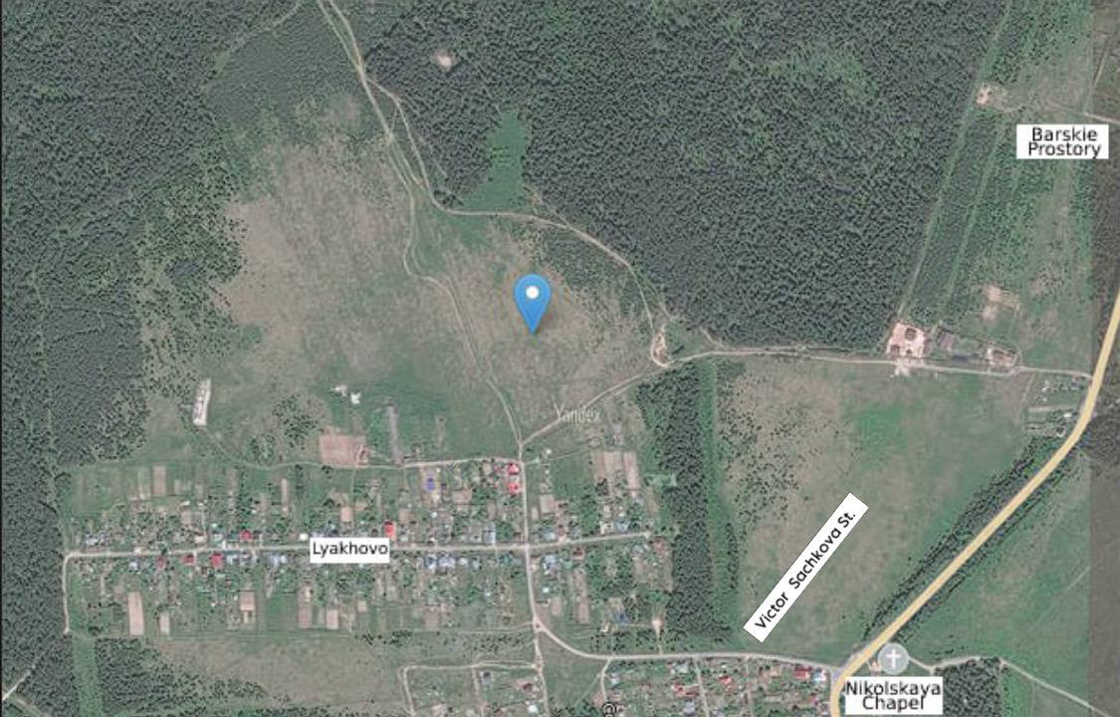

There are 286 plant species in the area of the village Lyakhovo. Of these, 21.33% are cultivated by humans, 36.01% are wild plants, and 42.66% are weeds. Pests of Orekhovo-Zuevsky district of Moscow region are represented by 166 types. Vegetation is prone to 106 diseases.

The soil map of Orekhovo-Zuevsky district is represented by 2 types of soil:

* Sod-podzolic – 65%;
* Histosolic Distric – 35%;

The project is located in the zone of sod-podzol soils. Sod-podzolic soils are a subtype of podzolic soils. They contain 3-7% of humus and are the most fertile among the podzolic soils.

## Documentation and design

To date, the necessary information and consulting activities have been conducted with representatives of local, regional and federal authorities, resource supplying organizations, suppliers of key equipment, construction companies, suppliers of raw materials and supplies for production.

Due to the rapidly changing macroeconomic situation, the full cycle of preparation of the initial permitting and project documentation at this stage of project development seems inexpedient.

These activities are planned to be carried out after obtaining approval for project financing.

Approximate term of preparation of necessary project permitting documentation is 6 months.

## Main structures of the greenhouse complex

The requirements for the design of greenhouse complexes are enshrined in the Handbook of updated methodological materials on the technological design of greenhouses, greenhouses, greenhouse complexes and breeding complexes.

[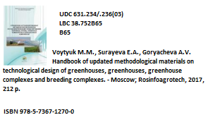](https://rosinformagrotech.ru/data/elektronnye-kopii-izdanij/rastenievodstvo/send/5-rastenievodstvo/1261-spravochnik-aktualizirovannykh-metodicheskikh-materialov-po-tekhnologicheskomu-proektirovaniyu-parnikov-teplits-teplichnykh-kombinatov-i-selektsionnykh-kompleksov-2017g)

The chosen method of growing vegetable crops in protected areas: on soils with combined (natural + artificial) light.

Vegetable crops are grown in three stages: seedlings, sprouts, adult crops. For each stage, compartments are provided, the area of which is taken by calculation. The compartments shall be equipped with engineering systems and technological equipment depending on the method of cultivation adopted.

Cultivation of seedlings and seedlings for greenhouses is provided with the use of cassettes and pots of various materials, peat blocks, cubes of mineral wool on multi-tier hydroponic installations or in one tier on the ground.

The territory of greenhouse complexes and plants is divided into the following functional areas: greenhouses area with a block of administrative and amenity buildings; machine repair area; storage area; container management area; area of preparation and storage of soil mixtures, manure, destruction of plant residues; energy area.

Vegetable and seedling-vegetable greenhouses of year-round use at latitudes 35-60 of northern latitude orient the roof ridges in the latitudinal direction, for seedling-vegetable greenhouses of spring and autumn use at latitudes 45-65 of northern latitude the meridional orientation is reasonable. In all zones, cultivation constructions should be placed on the slopes of southern orientation.

Buildings and structures of industrial and auxiliary purposes should be placed on the northern side of the cultivation constructions. Greenhouses should be located on the windward side in relation to the sources of pollution of their translucent fences.

Areas for the destruction of crop residues, manure storage facilities shall be placed on the leeward side relative to the greenhouses for winds of the prevailing direction for this area in the spring and autumn period, at the periphery of the site away from the paths of workers. Sites for the preparation of soil and storage of dusty materials (soil, compost, mineral wool substrates, peat, straw, sawdust, etc.) should be placed on the leeward side relative to the greenhouses and utility rooms.

Access roads and intrasite roads shall have a hard surface. The width of the roadway of the main production roads must be at least 6.0 m, driveways and entrances to the buildings shall be not less than 3.5 m wide.

The area of the territory of factories and complexes per 1 hectare of block greenhouses is taken 2.5 hectares, and hangar greenhouses - 3 hectares.

Bulk and natural soils, mineral and organic substances, and mineral fertilizer solutions are used to grow plants.

Bulk greenhouse soils - artificial soil mixes of complex composition are used in greenhouses of year-round use in the northern and central zones.

Natural greenhouse soils are used in greenhouses of year-round use in the southern zone and greenhouses of spring-autumn use. Greenhouse soils must be made at the rate of 2000-3000 tons per hectare.

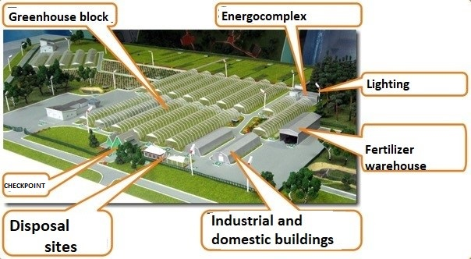 Principle scheme of the location of greenhouse complex facilities (variant):

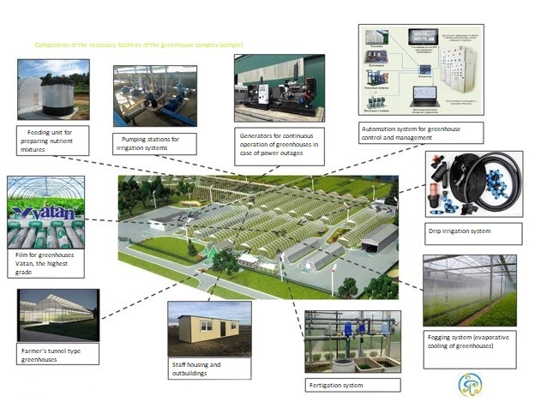 The composition of the necessary facilities of the greenhouse complex (option):

The area of the built-up area -2 ha (20 000 m²).

As part of the greenhouse complex will be the construction of the following buildings and structures:

- A block of greenhouses with a total production area of 1.8 ha, with a built-in seedling room, for growing vegetables (tomato, cucumber) and green crops (lettuce) with a seedling room;

- Production and household block with amenity rooms, sorting and packaging area and a warehouse - refrigerator;

- Heat and power station;

- Storage of emergency fuel of heat and power point;

- Building of the warehouse of fertilizers and agricultural materials, material warehouse;

- Repair and maintenance shop;

- Buildings of checkpoints.

The block of industrial greenhouses is divided by translucent partitions into separate climatic zones, which are combined with each other through the total volume of industrial and residential block. In the volume of production and household block there is a service area with technological equipment, living quarters for personnel and other auxiliary premises.

The adoption of this planning decision is due to the following factors:

1. Mutual isolation of greenhouse blocks allows to perform stage-by-stage construction works of blocks and engineering networks and systems, allocating start-up complexes in the total volume of the construction stage;

2. Mutual isolation of blocks, separate engineering-technological systems of cultivation, protection and mineral nutrition of plants - these factors exclude phytopathogenic influence between plants of different greenhouses;

3. When blocking greenhouses, the interblock partition is in the "warm" zone, which eliminates heat losses through the material of the partition fence, and allows you to save thermal energy for heating the blocks of greenhouses;

4. the total volume of the blocks of greenhouses for the production and household block allows to optimize:

* logistics of material flows (containers, harvested products, agricultural materials and fertilizers, etc.);
* movement of personnel;
* systems of automatic control of microclimate and mineral nutrition of plants;
* duplication of engineering and technological systems of mineral nutrition of plants by means of bypass lines.

As a part of the greenhouse complex, the following linear objects are to be constructed:

1. a water pipeline for technological, technical and household drinking water supply;

Routes of the storm water, domestic sewage and disposal lines of the surface water. 3;

3. 10 and 0.4 kV power supply lines;

4. the route of the gas supply;

5. The line of external electric lighting;

6. Intrasite roads, driveways and platforms;

7. Fencing of the greenhouse complex area.

There are two entrances to the territory of the mill, to separate traffic flows and optimize the movement of personnel from the gatehouse to the workplace, as well as in in keeping with requirements p.4.5 SNiP II-97-76 "General plans of agricultural enterprises" and p.3.14 SNiP II-89-80 "General plans of industrial enterprises.

The central entrance is equipped with a stationary checkpoint.

Intrasite roads and passages are made with hard surface. Pedestrian walkways with a hard surface are provided for the staff, and pedestrian zones are provided on the roadway.

Objects of greenhouse complex, according to the drawing 01.12.2008-GP-E "Plan of the complex facilities" are located within the boundaries of the land, which excludes the alienation for the needs of construction of the adjacent land.

### 5.4.1. Description of the facilities of the greenhouse complex.

**1. A block of greenhouses.**

Industrial multi-span greenhouse with a span width of 9.6 m, pitch of the struts 4 m, height of the struts 5 m is proposed. The greenhouse is a prefabricated half-timbered structure, assembled from steel and aluminum elements of full prefabrication, and consists structurally of load-bearing racks, trusses with parallel belts, runs, water trays (are the strength elements of the structure), self-running rafter elements of the roof, as well as stiffening elements.

This design has all necessary certificates for construction in this climatic region. Steel structures of greenhouses are made of closed profile, hot-dip galvanized according to the I class of galvanizing. End columns (columns) also serve as drainage pipes for storm water runoff from the roof of the greenhouse.

The foundation for this block of greenhouses is a pile cluster of bored reinforced concrete piles with a diameter of 400-500 mm, with a grid according to the geometric dimensions of the steel frame. The depth of the piles is calculated based on the soil, climatic and hydrogeological conditions of the construction site.

On the border of the external enclosing structures, on top of piles, a reinforced concrete plinth is arranged with a height of 400-600 mm. For this climatic region basement

perform insulated with nonhygroscopic insulation (polystyrene foam slabs) with a protective layer (plaster on the grid or corrugated steel galvanized sheet).

Intramural passageways and passageways - with concrete coating. It is proposed to grind the concrete with the further device of abrasion-resistant poured coating or painting.

Exterior enclosing structures of greenhouses - translucent. Roof fence is performed by filling the aluminum frame sheet glass thickness of 4 mm. Vertical fence is performed by filling the aluminum frame double sheet glass thickness of 4 mm, which improves the thermal characteristics of the building.

Cultivation trays are arranged on a leveled and compacted earthen base with sandy backfill, over which is laid a special synthetic fabric, to avoid weeds germination.

**2. The production and household block.**

The building is made of greenhouse structures, similar to the block of greenhouses, with the replacement of the vertical translucent fencing on the outer facades of the frame and cladding, insulated, with the device of windows, doors and gates. The roofing of the building is performed similarly to the roofing of the greenhouse block, with the replacement of sheet window glass for frosted glass. The floors of the building - concrete, insulated, with wear-resistant coating for industrial buildings or ceramic tiles.

The interior volume of the building is divided, depending on the fire requirements and functional purpose of the premises, by solid partitions or light fences into functional areas:

1. Zone of domestic premises;

2. Zone of administrative premises;

3. Zone of technological equipment;

4. Zone of operating and on-duty personnel premises;

5. Zone of auxiliary areas (to accommodate the premises for processing and sorting of products, storage of finished products, storage of small tools);

6. Zone of heat power equipment (heat power station).

Administrative and amenity rooms are carried out in the form of built-ins in the building of the production and household block. The enclosing structures of the buildings - walls and ceilings - shall comply with the requirements of Clause 1.25 SNiP 2.09.04 - 87 "Administrative and Residential Buildings". The internal space of the building is divided by partitions into separate rooms: administrative, domestic and sanitary technical rooms.

Zone of technological equipment is isolated from the rest of the premises by translucent partitions, eliminating the entry of dust, which may contain phytopathogenic inclusions, in the area in which the technological equipment for the preparation of mineral plant nutrition solutions, tank equipment for accumulation of clean water supply, etc. is located.

Zone of the premises for operational and duty personnel is arranged in the volume of the

zone of the premises of the operational and duty personnel is arranged within the area of technological equipment. Premises for the ACS and the work of operational and duty personnel are made in the form of built-ins in the volume of the building.

The auxiliary area is isolated from the other areas with light mesh

fencing.

The heat power equipment zone is isolated from the rest of the premises by a fire wall, which meets the fire safety requirements according to SNiP II-35-76 "Boiler Plants".

**3. Storage of emergency fuel of the heat and power station.**

Represents a metal tank with a volume of 48 m3 for liquid fuel storage.

It is installed openly on reinforced concrete supports. The tank is attached to

The tank is attached to the heat and power station, which is permitted according to item 11.51 SNiP II-35-76 "Boiler units".

The tank shall be equipped with pipelines for supplying to the burner devices of the heat and power station equipment, shut-off and safety valves and fencing to restrict access of people.

**4. The building of the warehouse of fertilizers, agricultural materials and material storage.**

The building is a typical quick-construction capital building made of light metal structures with sandwich-panel exterior envelopes and service rooms for warehouse employees.

Foundations of the building - point reinforced concrete, built under each pillar

steel frame, and tied with reinforced concrete rover. The floors in the building - concrete,

with the device of wear-resistant polymer coating.

The building is divided by capital partitions into two mutually isolated zones: a zone for storage of various agricultural materials (mineral fertilizers, means the area for the protection of plants from diseases and pests) and the area for the storage of inventory (mineral wool substrate, spare parts and equipment of technological systems, stop valves, etc.).

Immediately next to the building there is an area with a concrete surface and

a concrete paved area with a storage tank for washing mobile and portable equipment

plant protection equipment.

**5. The building of the checkpoint.**

It is a quickly erected building made of steel galvanized frame and sheeting, with exterior cladding of painted profiled galvanized steel sheet, with interior cladding of gypsum cardboard sheets.

The building foundation - shallow reinforced concrete slab. The floors of the building - insulated, with a coating of ceramic floor tiles. In the building is arranged by the entrance area, equipped with a turnstile, and the necessary rooms for staff.

### 5.4.2. Description of building structures and engineering systems

**Transparent fence system**

**(«Cold House»)**

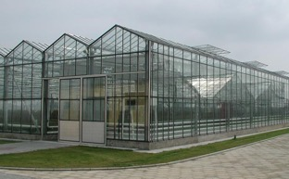«Cold House» is the basis of the greenhouse, which performs a number of functions, providing protection of plants under adverse climatic factors, creating a favorable microclimate for plants, installation and operation of engineering and technological systems, reliable operation of the structure as a whole for the entire period of service.

The basis of the construction is a frame of greenhouses with a span of 9.6 m and a column pitch of 4 m. The frame is assembled from steel galvanized structures. The height of the columns 5m. Lightweight steel structures are protected against corrosion by hot-dip galvanizing with coating thickness of 200 microns.

Covering the roof of a sheet of glass with a thickness of 4 mm. on aluminum spurs on rubber seals.

External enclosing structures of greenhouses are translucent. Roof fence is made by filling the aluminum frame with sheet glass 4mm thick. Side fence is performed by filling the aluminum frame with double sheet glass with a thickness of 4 mm or polycarbonate with a thickness of 6 - 8 mm.

On aluminum requests on rubber seals, which improves thermal performance.

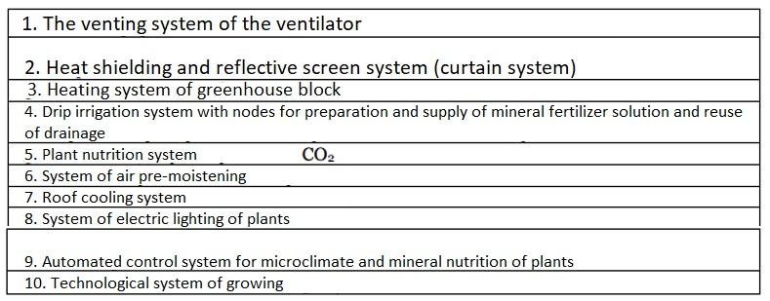Foundations - bored piles, precast concrete. Basement - monolithic reinforced concrete or prefabricated reinforced concrete rover.

Engineering and technological systems of the greenhouse:

### 5.4.3. The system of ventilation of greenhouses

Greenhouse ventilation is designed to provide natural air exchange of the enclosed volume of greenhouses with the outside space through the ventilation openings in the roof of translucent enclosure. The ventilation system is a rail-type ventilating system. All located on the roof ventilation slides open and close with a storm-proof mechanism. The opening is carried out automatically and remotely. The shutters are located in staggered order on both sides of the roof ridge.

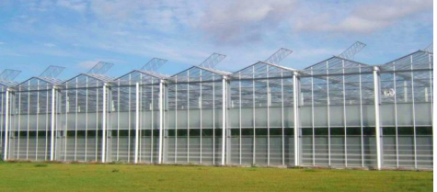This system allows for quality control of technological processes the greenhouse climate is maintained in the greenhouse. In all greenhouse compartments, the area of the opening transoms is up to 25% of the total area of the greenhouse roof. This area of ventilation openings allows the necessary volume of outside air to enter the greenhouse block to maintain optimal temperature parameters in the greenhouse. Angle of rise of the windows up to 50 degrees. Lift side

the air temperature, wind speed and direction, and precipitation are automatically adjusted depending on the air temperature, wind speed and direction. The system of ventilation of greenhouses consists of the following elements:

* transoms with connecting elements;
* rack and pinion mechanical fanlight drive;
* gearmotors for the mechanical drive of the fanlights;
* power supply and control system of electric drives.

Ventilation fanlights with connecting elements, as well as fanlight opening mechanisms are an integral part of the greenhouse frame, and at the same time, belong to engineering and technological systems that perform the functions of microclimate control. Opening of transoms is carried out by a rack-and-pinion type mechanism with a horizontal stroke. The design of a motor-driven window-opening mechanism ensures simultaneous raising or lowering of the windows over the entire area of each greenhouse compartment.

Each mechanism consists of rack and pinion gears mounted on the top chord

trusses in the central part of the greenhouse, with slats, the ends of which are connected to the tubular rods of the distribution shaft, assembled in one line along the entire length of the greenhouse section. When the gearmotor is turned on and the drive and distribution shafts are rotated by it, the slats of all rack reducers of the section simultaneously extend and move the rods, raising or lowering the roof shutters, turning them in the ridge sprocket. Each gearmotor serves the same name roof slopes: left and right.

The ventilation system is actuated automatically by an automated control system sensor or remotely by the operator.

### 5.4.4. Thermal protection and light-reflecting curtain screen system (curtain system)

Horizontal thermal protection and light-reflecting curtain screen system is designed to create shading in greenhouses during intensive (excessive) solar radiation in spring and summer, as well as to preserve heat at night and periods with the lowest outside temperatures. Horizontal shading is carried out by a cloth of polymer materials and provides almost complete overlap of the upper part of the greenhouse.

The shutter mechanism designs are made separately for each of the compartments of the greenhouse block. Each shutter design provides movement of the screen simultaneously in all bays from the motor, kinematically connected to the rack and pinion reducers, which move the bars and stretch the curtain screen in the plane of the upper girder belt. The curtain screen opens and closes as needed in automatic mode, at the signal of the automated climate control system or remotely by the operator.

The heat shielding and reflective curtain system consists of the following elements:

* Cable system of curtain screen fabric suspension;
* Gearboxes of cable system drive;
* Electric actuator control system;
* Curtain screen fabric.

The fabric of the curtain screen is a specially developed material. The combination of aluminum and transparent strips allows for both reflection and absorption of solar thermal energy. The result is a more favorable climate for plants and staff. During the day the screen is used to reduce the level of solar radiation penetrating the greenhouse, at night the screen is used to reduce the heat loss of the greenhouse to the environment. The flexibility of the material allows the screen to be folded in such a way that it does not shade the plants or obstruct the passage of light.

The back side of the curtain has a good ability to absorb the heat

energy coming from below. This fact allows the curtain to maintain a high temperature,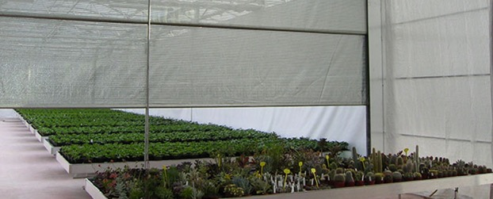 The curtain's back side never produces water droplets of condensation.

Vertical curtain screen - designed to reduce the intensity of light flux passing through the vertical translucent enclosing structures of greenhouses in order to avoid thermal burn of plants, as well as to reduce heat loss through the outer enclosing structures. It is a motor reducer in a tubular housing, which also serves as a spool for winding the curtain fabric.

The vertical curtain screen is controlled automatically or remotely by the operator.

### 5.4.5. Greenhouse heating system

Heating system is designed to maintain the temperature regime in the volume of the greenhouse in accordance with the technological requirements. The greenhouse is heated by means of a multi-circuit heating system. Designation of heating circuits:

Underfloor heating circuit - designed to provide snow melting in case of intensive precipitation.

The upper process heating circuit is designed to regulate the temperature conditions in the upper part of the greenhouse, preventing cold air from entering the plant area during sudden drops in ambient temperature and opening of the screen (creating a warm air "cushion" in the upper part of the greenhouse volume).

Lower technological heating circuit - Main regulating circuit. Designed to create a given thermal regime in the greenhouse. It is also used as a guide structures when moving carts for collecting products. Hot water with design temperature values in the range of 50 - 95 С is used as a coolant. The nominal values of the coolant parameters are 95/70 С.

The greenhouse heating system consists of the following elements:

* Main pipelines of heat pipelines;
* Heat carrier control unit (heat distributor);
* Pipelines of the lower technological heating circuit;
* Pipelines of under tray heating;
* Pipelines of upper technological heating;
* Control cabinets of electric drives of mixing valves and pumps.

The temperature parameters are set according to the requirements of agricultural technology in each greenhouse section independently. Distribution of coolant in the greenhouse heating system is carried out by means of temperature control units (distributors) by greenhouse unit compartments.

Temperature control by loops is performed by the automated microclimate control system.

Temperature control units - distributors are used to provide the required temperature of the heating medium in the heating circuits. Each node is connected to the main pipelines and serves the heating circuit in the greenhouse sections working independently. The control unit consists of a circulation pump, 4-way mixing valve, as well as piping binding, fittings and instrumentation.

### 5.4.6. Drip irrigation system with nodes for preparation and supply of mineral fertilizer solution

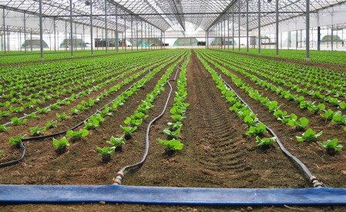Drip feeding system is designed to prepare and supply a nutrient solution of mineral fertilizers to plants grown on organic and inorganic substrates. The system allows you to carry out prepare a nutrient solution of the desired concentration and transport it to the root zones of each plant through the distribution network and droppers.

The use of drip-feeding system in the technological cycle of protected ground production allows optimal scheduling of irrigation during a day.

The system provides precise maintenance of the specified concentration of mineral fertilizers in the nutrient solution depending on the inflow of photosynthetic active radiation (PAR) in accordance with the control algorithm incorporated into the automatic control system (ACS) of microclimate and mineral nutrition of plants.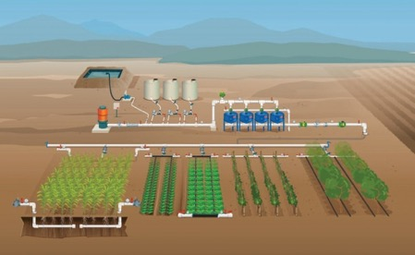

The equipment set for the drip-feeding system includes:

* nutrient solution preparation unit with mixer-dosing unit and drip irrigation pump group;
* distribution network of drip irrigation system with drip line and drip heads;
* tanks for water treatment and storage;
* installation of ultraviolet cleaning (quartz treatment) of drainage;
* tanks for collection and storage of drainage water.

Set of equipment is designed for automated preparation of mineral fertilizer nutrient solutions of a given concentration and temperature, as well as the implementation of the solution into the distribution network of drip irrigation system.

Mineral fertilizer solution preparation unit (solution unit) includes:

* mixer-dispenser
* drip irrigation pump group
* tanks for preparation and storage of uterine solutions

The main characteristics of the drip irrigation system are determined based on the layout of technological trays for growing products and the layout of the planting material.

Pipeline network of delivery and distribution of irrigation solution is a set of main pipelines laid in a greenhouse from nodes of preparation of solution to input into intra- greenhouse sectional distribution networks and from nodes of solenoid valves to distribution pipelines with capillary tubes and compensated drippers, i.e., plants are irrigated uniformly.

The complex of equipment for irrigation by sections is a system of intra-greenhouse solenoid valves installed on each the valve section is equipped with a bypass and controlled remotely to "open-close" irrigation by signals from the automated control system. Each valve section is equipped with a bypass. This bypass is used to clean the drip pipes and drip heads at full pump pressure. The valve sections are provided with PVC ball valves for the reduction group. Cleaning is accomplished by opening and/or closing these PVC ball valves

Drip lines (the number is determined by the location of technological trays in the span, PE pipe). Each compensated drip line supplying nutrient solution under each plant is equipped with a special silicone valve regulating the volume of the supplied nutrient solution and preventing "leaking" after the end of the solution supply.

The use of compensated droppers also ensures an even supply of solution throughout the drip lines, even after several years of operation. Drip lines are supplied complete with capillaries and capillary lines.

Flushing of the main distribution line is carried out using PVC pipes. These flushing pipes connect to the rainwater drainage system pipe along the side fence.

Irrigation is controlled automatically by an automated control system, depending on the external meteorological conditions and the microclimate parameters in the greenhouse.

Since from 15 to 25% of irrigation water volume, containing mineral salts not absorbed by plants, is removed from the greenhouse area into the drainage pipeline system with a storage tank, in addition, as a source of nutrient solution for production and technological needs it is provided to use the returned solution after plants irrigation from the drainage system.

Drainage solution before secondary use is subjected to biological disinfection on special disinfection unit by ultraviolet quartz irradiators on special unit, and is fed to the solution unit with automated control of concentration of residual mineral salts.

The UV drain cleaning system includes a control computer and a UV disinfection unit. The system provides disinfection of drainage water in the easiest and most effective way. Depending on the selected dose of UV radiation nematodes, molds, fungi and viruses are destroyed.

To store water reserves, necessary in the preparation of solutions, as well as to create a daily reserve are used special containers with a capacity of 30-50 m3. Tanks are installed in the service area of the greenhouse block and are round tanks, consisting of carefully centered hot-dip galvanized corrugated sheets with a double row of mounting holes for accuracy and ease of assembly. The inner lining consists of a 0.5 mm thick PVC sheet with a polyester fabric along the upper edge for strength. The dimensions of the tanks are determined with reference to the service area.

### 5.4.7. System of plant feeding with carbon dioxide (СО2)

In order to increase the yield and quality of the crops grown in the greenhouse, a system of plant feeding with carbon dioxide CO2, which is necessary to ensure the vital activity of plants.

Plant nutrition system structurally consists of devices for flue gas extraction from gas boilers with subsequent supply to the greenhouse by unpressurized pipelines of variable cross-section with condensate collection tanks.

Provide for two sources of CO2, using the same distribution network inside the greenhouse: waste (flue) gases boiler, which is the source of heat and liquefied carbon dioxide.

Extraction of carbon dioxide from the chimney of the boiler house is carried out using special equipment, which is a condenser with a built-in fan, metering device and waste gas control equipment.

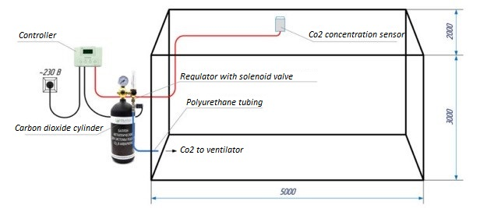Principle scheme of carbon dioxide feeding in the greenhouse:

**Evaporative humidification system**

Designed to create the necessary temperature and humidity conditions in the greenhouse. The high, medium or low-pressure air humidification systems are used.

The most effective is the high-pressure humidification system, which allows to cool the leaf surface of plants and humidify the air in greenhouses without formation of drops on the leaves. Control of system operation is made by ACS according to data of greenhouse sensors according to production task of agronomist.

The approximate composition of the distribution network of the high-pressure system has

the following parameters:

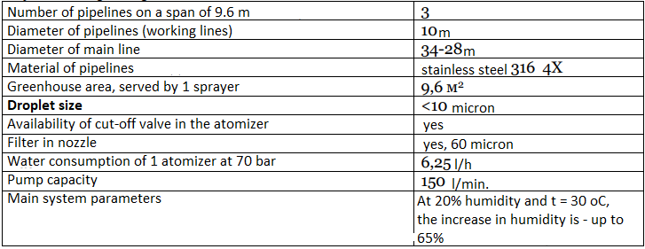

### 5.4.8. Roof cooling system

The roof cooling system is a device for spraying water on the roof of greenhouses during periods of high outside temperatures and excessive solar radiation to reduce the air temperature in them.

Structurally, the system consists of sprinklers (atomizers) with capacity up to 100 l/hour, electromagnetic valves for remote control of the system, pumps and piping. The system works as follows: it sprays for a few minutes, then the water evaporates from the roof naturally, lowering the temperature of the air in the greenhouse, and then the cycle repeats. The temperature is lowered by cooling the roof with cold water through special rotary nozzles.

The nozzles are attached to the top of the ridge profile next to the transom with special clips (clamps). The spraying range of the nozzle is approximately 10 m at an operating pressure of 2.5 atm. This spraying range ensures good overlap and coverage of the greenhouse roof area. The nozzles are connected to the supply pipeline with flexible polyethylene hoses, which are led through the roof surface near the ridge through holes drilled in the aluminum transom. The supply pipes are integrated into the steel structures of the greenhouses and run inside the supporting columns. The main pipeline approaching the greenhouse is a PVC pipe 90 mm in diameter, which is attached to the truss and runs along the central track.

A system of pumps and filters is located in the utility rooms, as the application of the roof irrigation system involves pre-treatment of water. This system is controlled automatically from the central climate computer according to the set parameters.

### 5.4.9. The system of electrodynamic illumination of plants

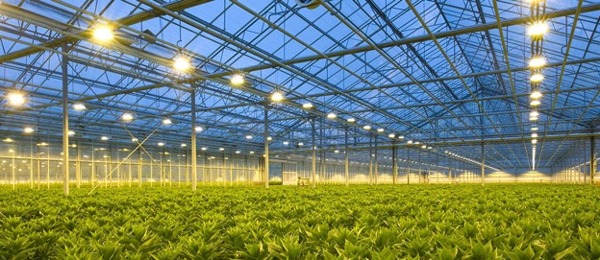 Light is one of the most important factors of the microclimate in greenhouses, affecting the yield of grown plants. Plant growth is determined by photosynthetic processes, for which light is the main source of energy. Therefore, the rate of plant growth and development is proportional to the level of light exposure.

The system of electric lighting of plants is designed to maintain the required level of illumination in lettuce and vegetable seedling growing compartments, taking into account the level of external solar radiation and time of day especially in the autumn-winter period. Practice has shown that the optimum regime is 10,000 lux/m² for 18-20 hours a day. The efficiency of electric dock lighting systems is determined by the spectral composition of light they emit; the level of illumination they provide; the coefficient of efficiency, which affects the operating costs.

The light from high-pressure sodium lamps is the closest for plants. Special lamps for greenhouse use are produced by: Philips (Holland), SYLVANIA Gmbh (Germany), Osram (Germany), General Electric (USA), Reflax (Russia). The most common are 400W and 600W lamps. Switching lamps and uniform lighting of plants are provided by lighting fixtures of appropriate capacity with ballasts. A distinction is made between lamps with electromagnetic control gear (CCG) and with electronic control gear (ECG).

Selection of lighting equipment is made taking into account the main factors: type of greenhouse, type of crops grown, standardized irradiation intensity, light zone, artificial component of the standardized irradiation, specific power at a given coefficient of efficiency of light source in the area of PAR, type of irradiation system and light source.

When placing fixtures in the greenhouse, the requirement for uniform illumination of plants and their mutual influence on other technological systems is also taken into account.

Special control panels PU including communication and safety equipment are used for control of electric dosing system, which provides distribution of electric power to groups of lights and switching on of lights in accordance with agricultural requirements.

To automate the control of dosing systems, dosing control panels are used which allow you to remotely or automatically switch on all or part of the dosing system according to the program.

In addition, the automatic microclimate control system allows you to change the time of switching on and intensity of dosing according to the season and duration of daylight.

### 5.4.10. Automated control system microclimate and mineral nutrition of plants

Functionally, the automatic control system of greenhouse microclimate and mineral nutrition is designed to maintain the set temperature and humidity in the greenhouse and substrate with plants (takes into account changes in external meteorological data), carbon dioxide (CO2) concentration, irradiation and plant nutrition regimes, as well as control of other parameters.

Maintenance of set parameters is provided by automatic control of heating system capacity, position of ventilation flaps, actuators of feeding system, irradiation, CO2 concentration and other engineering equipment.

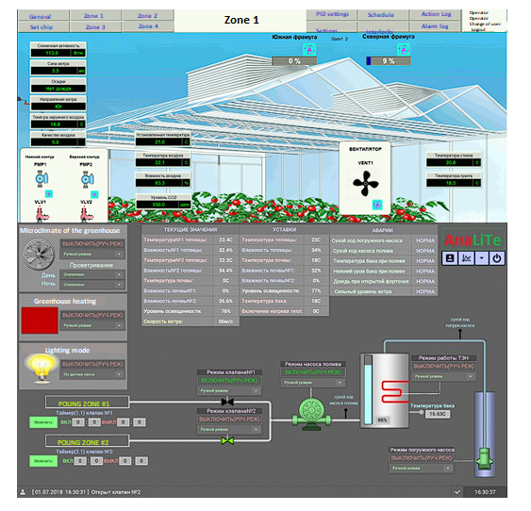 Example of greenhouse management program screens:

The ASU MMP performs the following information functions:

* data input from the weather station;
* collecting, processing and presenting information on PC screens and local consoles;
* creation of archives of process history data and their presentation in forms convenient for analysis (text, graphs, histograms, etc.).

The application of the ASU MMP provides:

* Increased yields due to flexible automatic maintenance of the required microclimate parameters;
* reduction of energy consumption;
* increasing the level of reliability and efficiency of the equipment;
* obtaining reliable and timely technological information;
* detection and issuance of signals on emergency (pre-emergency) situations.

Two-level structure with functions of automatic, remote and manual control of the main engineering and technological systems of the greenhouse is adopted as the basis of the automated control systems of technological processes in greenhouses.

Computer system is modular, architecture of which is specially designed for automation of microclimate and mineral nutrition in greenhouse complexes. The computer must take into account the individual characteristics of each specific project, including the mode of operation of the boiler room, heat point and other energy facilities, the basic climatic characteristics, as well as the mode of operation of all electrical installations and water quality control. The software allows the computer system to function efficiently and reliably, and effective management tools minimize energy costs.

IPC (Industrial Processor Computer)

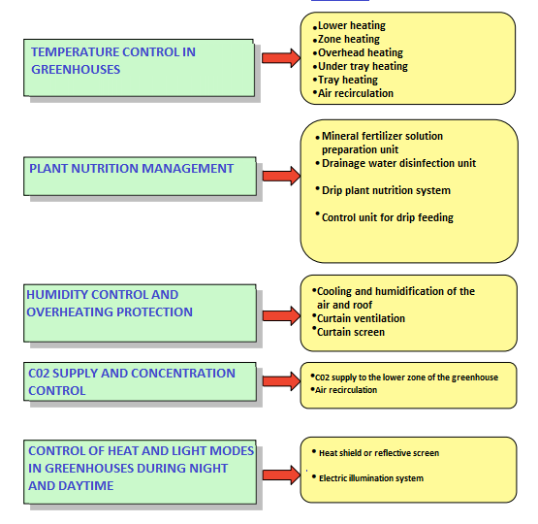The IPC is the central computer that controls the entire automatic production process. The IPC is equipped with Windows software.

The advantages of Windows software are ease of installation, simplicity of operation, and ease of maintenance. The IPC includes a network printer and a modem as standard. The modem is used for installing updates, maintenance and service management, while the network printing is used to connect the IPC with one or more UTP network control stations. Fujitsu Siemens PC - controller station located in the operator's room.

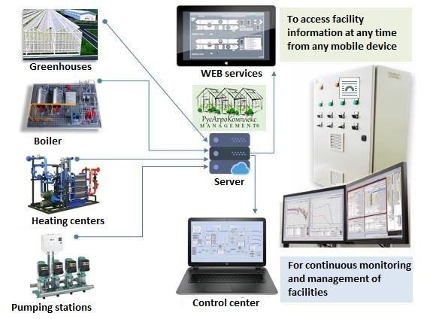

**Thus, to date, the main technologies of creating an agro-industrial greenhouse complex are fully developed and implemented in the market. During the construction, taking into account the current political and economic situation, preference will be given to the products and services of Russian companies, which will reduce the investment costs of the project without loss of quality.**

## Organization of water supply

Water supply of a greenhouse complex is planned to be carried out in the combined variant: by connection of a complex to the general centralized systems of water supply and construction of own wells.

Design water consumption for water supply of a greenhouse complex: 5,7 m3/h, 19,3 m3/day - domestic and drinking water supply (B1). 20.6 m3/h, 638.4 m3/day - production water supply (B2). Reservation of water supply and coverage of volumetric discharge is carried out by return water intake from rainwater storage ponds. Water supply of greenhouse complex is provided by artesian wells:

* domestic-potable water supply - two (2) wells with a capacity of 15 m3/h each;
* industrial and fire-fighting water supply - 4 (four) wells with a capacity of 20 m3/h each.

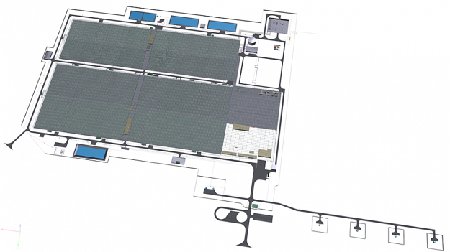 Approximate scheme of water supply for a greenhouse complex:

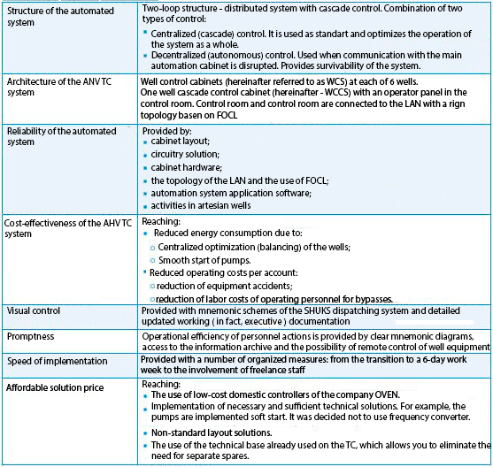 Model of the automation system for the outdoor water supply of a greenhouse complex:

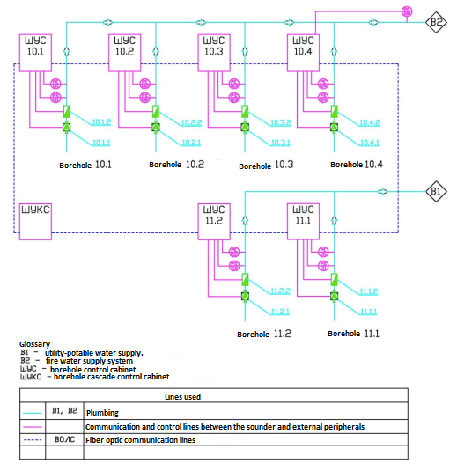Block diagram of the automation system of the outdoor water supply of a greenhouse complex:

In the issue of water supply it is proposed to implement a combined system that combines:

* centralized cascade control (SHUKS - well cascade control cabinet);
* autonomous operation of each cabinet (SHUS - well control cabinet) when there is no communication with the main cascade cabinet.

Normally, the SHUS operates in automatic cascade mode. Wells B1 (2 pcs.) form the first cascade, wells B2 (4 pcs.) - the second one.

The essence of the work of the cascades is as follows:

* The SHUKS constantly analyzes the situation and, if there is a lack of pressure for a certain time, a command to switch on a new pump is issued.
* In case of excess pressure, a command to switch off one running pump is issued. This mode can be considered as moving in steps. Pressure dropped, went up to the first stage (one pump switched on). Checked, pressure is still not enough - step up one more step (switch on second pump). Pressure is within the norm - stay on the current stage. Pressure became excessive - go down one step (switch off one pump).

The program that implements the cascade algorithm is built to solve several other problems:

* balancing the operation of cascades to include different pumps;
* preventing wells from becoming silted up;
* prevention of pump restarting, if not enough time has passed since stopping;
* automatic commissioning of a reserve pump (in case of an emergency stop of the main unit).

Since the cascade is controlled via the network, all cabinets (both SHUS and SHUKS) constantly analyze the network availability. In order to "fight for water supply survivability, in case of loss of communication, the SHUS automatically switches to the local mode and operates on the pressure sensor installed in the well, and the SHUS excludes the unavailable SHUS from the cascade. When communication is restored, well cascading is restored automatically.

Operating personnel can use the operator panel on the SHUKS to:

* monitor the sensor readings;
* Receive notifications about warnings and alarms and acknowledge them;
* view the archive of alarms and warnings log;
* control well status (working, paused after shutdown, ready for operation, emergency, in manual mode, etc.)
* monitor instantaneous flow rate of each working well;
* change settings and settings, remotely start and stop well pumps;
* receive information on technical accounting of produced water for each well.

Layout of outdoor well control cabinets:

The internal content of well control cabinets (PLC, power supply unit, soft starter, etc.) is strictly limited to the temperature limits within which it must function.

Also an important task of the cabinet is to protect the contents against external adverse factors (such as precipitation, electromagnetic pulses of lightning discharges, insects, dust, etc.).

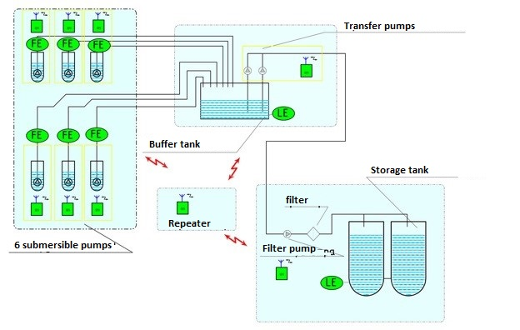 Schematic diagram of the water supply for a greenhouse complex:

## Organization of electricity and heat supply

By artificially creating optimal growth conditions in a greenhouse, we can grow vegetables, houseplants, flowers and seedlings all year round, even in places with a harsh climate. The industry of protected ground is industrial and high-tech, but also energy-intensive. In most farms in the structure of the cost of production the cost of energy reaches 50-60%.

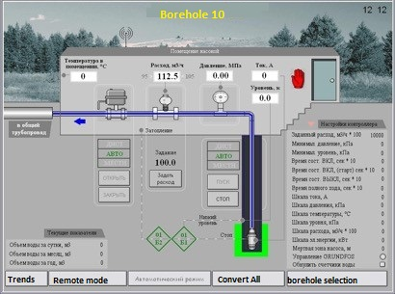The need to heat air in greenhouses, water for watering planted crops, soil requires enormous amounts of thermal energy especially at low temperatures ambient air.

Most domestic greenhouse farms use boilers to obtain heat, in which the primary energy carrier (gas, diesel fuel, coal, etc.) is burned only in order to obtain thermal energy for heating. As a rule, territorial power supply companies are the suppliers of electric power for power supply of technological equipment of greenhouses (pumping and ventilation equipment, refrigeration equipment, conveyors, etc.).

It is no secret that power lines and switching equipment over a long period of operation morally and technically obsolete. But even the high electricity tariffs, which in the past few years have increased at times, and, apparently, will continue to grow, do not give the owner of a greenhouse complex, that he at some point is not faced with a blackout farm. The prolonged absence of electricity and heat supply, and in the winter period enough 2 hours and, consequently, the inability to carry out technological processes can lead to the loss of crops, and eventually to the collapse of the greenhouses.

Experts know the facts confirming not quite mutually beneficial relations of greenhouse farms and power supply companies. So, some TGOs and ESKs today raise the question of signing a contract for the power supply of greenhouses for five years ahead, taking into account the hourly (!) Power limits. These requirements put greenhouse farms in a difficult situation - the energy consumption of greenhouses to a large extent depends on the ambient air temperature and weather, which even a month in advance cannot be predicted with a high degree of probability.

Plant growth is determined by photosynthesis, for which the main source of energy is light, and the rate of plant growth and development is proportional to the level of light exposure. Therefore, more and more Russian companies of the protected ground industry use supplementary lighting technologies especially in winter, spring and autumn periods when the low level of natural solar radiation is accompanied by a short daylight period.

It has been proven that using the right lighting technologies can double yields, extend the season, expand the range of crops, improve product quality and guarantee supply. It is worth noting that the limited supply on the agricultural market and relatively high prices in the fall-spring period make electric backlighting systems cost-effective. However, these systems require a significant amount of electrical energy (70 to 100 W per 1 m2 of area) to achieve illumination levels up to 6-7 KLK. Large yields are achieved with lighting of 20 KLK and above. Accordingly, this requires the installation of more lights and the use of more electrical energy. It is easy to calculate that the total power consumption of greenhouse facilities for dosing the light can be up to 10 MW.

In general, industry experts cite the following figures: energy consumption of 1 hectare of greenhouse is about 1 MW of electricity and 2 MW of heat. Taking into account the high specific cost of energy carriers in the price of products, a significant reduction in the cost of production and increase in profitability can be achieved only by reducing the "energy component".

Experts at the analysis of existing schemes of power supply of greenhouse farms offer an option of autonomous generation. Indeed, the own thermal power plant will not only eliminate or significantly reduce payments to electricity and heat supply companies, but also significantly increase the yield due to the beneficial use (CO2) of carbon dioxide (carbon dioxide), which is contained in large quantities in the exhaust gases. Below is a schematic diagram of the heating and 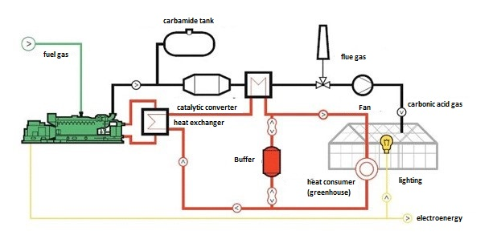power supply of an industrial greenhouse:

The technological process is as follows: the cogeneration unit generates electricity, in the heat-exchange equipment the heat of the exhaust gases, lubrication and cooling systems is transferred to the external circuit of the consumer. Simultaneously, the exhaust emits combustion products through the exhaust. The exhaust gases then undergo a purification process and nitrogen oxides are removed, then cooled in the heat exchanger to an acceptable temperature (up to approximately +50°C) and the condensate is removed. Using paddle turbofans, the gases are conveyed to the greenhouse CO2 supply system through piping (perforated PVC pipes or porous film sleeves) mixed with the greenhouse air and delivered directly to the plant bases. The ambient air contains about 350 volume fractions of carbon dioxide. For an active plant growth, depending on the type of plant, the greenhouse atmosphere must contain between 700 and 800 vol. fractions of CO2. In one hour, a 1MW mini-HPP at an average annual load of 75 per cent produces 372 cubic metres of carbon dioxide at normal pressure, with a CO2 content of 700 ppm. With this approach, the yield of a single greenhouse increases by about 30 to 40 percent.

The combined use of supplemental lighting technology and carbon dioxide enrichment leads to a yield increase of 2-2.5 times!

It is worth noting that the energy centers of greenhouse complexes are the most efficient solution for the organization of autonomous power supply and provide the fuel utilization factor (FUE) of the system at the level of 95-97%. Indeed, in addition to electrical and thermal energy, the greenhouse complex receives a source of carbon feed to the plants, which is necessary for the intensive process of photosynthesis. Electric energy is used to cover its own needs and artificial lighting of the greenhouse, and through the system of heat utilization the agro-complex is supplied with thermal energy.

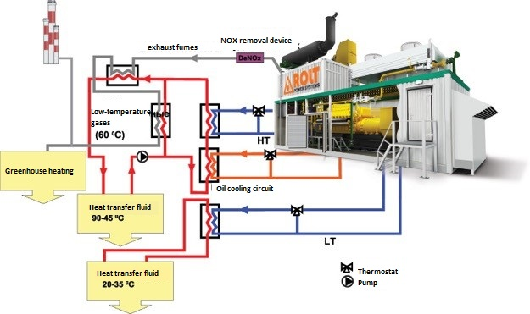Efficient power supply to agricultural complexes, according to experts, can be built on the basis of gas piston generator sets operating in cogeneration mode according to the scheme shown in the figure:

Moreover, the proposed scheme allows to use the heat of all circuits of GPU cooling. And with different temperature schedule. Organization of heating system with separation of heating circuits in practice shows its effectiveness in terms of saving heat and improving the temperature fields of the greenhouse.

Such schemes are widespread in European states - Belgium, Denmark, France, Spain, Great Britain, Portugal, and reached their culmination in greenhouse farms in the Netherlands. It is here that the many years of experience in the cultivation of flowers and vegetables have made this system unique, having no analogues in the world.

Both natural mains gas and biogas - a product of anaerobic decomposition of organic waste - can be used as fuel. In addition to heat recovery systems and complete switchgears 6.3 kV or 0.4 kV in the energy center of the agricultural complex must include a system of CO2 extraction from the flue gases.

The modular (container) design of the mini-CHP is the best way to meet the requirements of "greenhouse workers". It provides:

* short time for construction and installation and commissioning works;
* low requirements to the foundation;
* Simple integration of the modular mini-CHP into the electricity and heat supply system of the greenhouse enterprise;
* compact placement of modular mini-CHP in a limited area;
* Full compliance with the requirements of GOST and SNIP;
* scalability of the applied solution;
* high degree of automation, allowing the mini-CHP to work without the constant presence of service personnel;
* convenient integration of the mini-CHP monitoring and control system into the automated greenhouse management system.

The result of the modernization of production will be a significant increase in productivity of greenhouses, improving the reliability and quality of electricity and heat supply and, finally, significant savings in money by eliminating the services of suppliers of electricity and heat. In the case of the use of biogas will provide independence from fuel suppliers and an additional source of fertilizer.

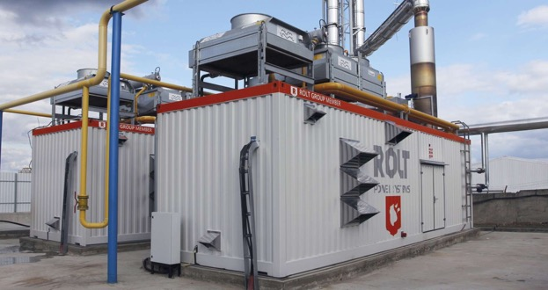 Example of the appearance of a mini-CHP for a greenhouse complex:

Under the proposed project, the use of mini-cogeneration plant is planned in parallel with the use of external power supply network of the complex.

If the site has already organized a complete external power supply and the mini-CHP is considered only as an event to reduce the cost of electricity, it is necessary to compare the cost of production and purchase of electricity.

At the average cost of purchasing electricity from the grid at 6.0 rubles including VAT per 1 kWh, the savings in the production of 1 kWh of electricity, taking into account the full utilization of heat is as follows:

Cost of electricity from grids - cost of generated electricity = 6.0 - 2.2 = 3.8 rubles per 1 kWh.

At even full capacity utilization per year, savings are made at a rate of:

Savings with each kWh * 8000 working hours per year * capacity = 3.8 * 8000 * 1001 = 30.43 million rubles per year

**Thus, during the construction of the planned greenhouse complex it is advisable to apply a combined scheme of electricity and heat supply, including both connection to fixed networks, and autonomous power and heat generating capacity.**

## Purchase of seeds

 The following species have been selected as the basic seeds for growing cucumbers:

**Professional Cucumber Seeds F1 Aurora**

Uniform ripeness of fruits. Crisp, dense, juicy flesh. Retains its properties on long-term storage after harvesting.

Description and characteristics of cucumber F1 Aurora

Parthenocarpic early-ripeninğ cucumber hybrid for growing in winter-spring rotation and in light-culture conditions on a high trellis with pruning.

* The plant is powerful, well-balanced - it has good growth vigor
* strong root system
* lateral sprouts determinant - female flowering
* 1-2 ovaries per node
* fruit length 18-20 cm
* average fruit mass - 180-210 grams
* color - dark green
* surface smooth, slightly ribbed - fruit shape – cylindrical

Resistant to:

* true powdery mildew
* leaf powdery mildew

Tolerant to:

* Cucumber mosaic virus

**Professional cucumber seeds F1 Anna**

A beautiful tasty cucumber. Fruits have an excellent appearance and have excellent taste qualities. Environmental plasticity, shade tolerance.

Winter-spring hybrid.

Description and characteristics of cucumber F1 Anna:

Parthenocarpic tuberous cucumber hybrid for early-spring and summer-autumn rotation.

* plant is very tall - medium foliage - female-type flowering - 1-2 ovaries in the node
* fruit length 12-14 cm
* average fruit weight 120-140 grams
* color dark green
* surface is heavily tuberose
* medium-sized tubercles
* fruit shape is oval-cylindrical

Moderately resistant to:

* true powdery mildew - root rot
* ascochytosis

**Professional cucumber seeds F1 Ermak from Gavrish**

A new hybrid of parthenocarpic smooth-fruited cucumber for growing in winter-spring rotation and light crop, excellent for high trellis cultivation with pruning. The fruits are uniform in weight and size.

Description and characteristics of cucumber F1 Ermak:

* The plant is powerful with intense growth,
* Root system powerful with high regenerative capacity,
* Shoots are weak,
* Lateral shoots are determinate
* Type of flowering female
* 1-2 ovaries per node
* Fruits are 18-20 cm long
* Weight 180-210g
* The shape of the fruit is cylindrical
* Color dark green
* Smooth, slightly ribbed surface, with attractive gloss

Cucumber F1 Ermak is tolerant to:

* True powdery mildew
* Root rot
* Peronosporosis
* Ascochytosis

 The following species have been chosen as the basic seeds for growing tomatoes:

**Professional tomato seeds F1 Ordyinka**

Description and characteristics of tomato F1 Ordyinka:

* Tomato medium late maturity (118 - 122 days from sprouting to the beginning of fruit ripening) is a highly productive indeterminant hybrid.
* Suitable for cultivation as a method of low-volume technology, and for growing on the ground.
* Recommended for cultivation in both the first and second turns.
* The plants are very tall, medium foliose.
* Leaf is grayish green, large, horizontally arranged or slightly drooping in the middle part of the plant.
* The first inflorescence is set above a 10-12 leaf, subsequent ones after 3 leaves.
* Inflorescence is simple, compact with 4-6 fruits of flat, round shape (fruit index 0.8-0.9).
* Fruit shape: rounded.

The F1 Ordyinka tomato hybrid is resistant to:

* tomato mosaic virus,
* cladosporiosis,
* fusarium wilt,
* verticillosis wilt
* nematode

**Professional tomato seeds F1 Arkaim**

Description and characteristics of the F1 Arkaim tomato:

* Ideal for light culture
* Resistant to powdery mildew
* Indeterminant hybrid
* For winter glazed greenhouses
* Highly technologically advanced hybrid
* 4-5 fruits per bunch
* Average fruit weight up to 300-350g
* Color bright red
* Fruits are multilocular

Tomato F1 Arkaim is resistant to:

* tomato mosaic virus,
* fusarium,
* cladosporiosis,
* verticillosis
* powdery mildew

**Professional tomato seeds F1 Armata**

Description and characteristics of tomato F1 Armata:

* interfering hybrid
* high fruit setting
* Semi-generative plant
* 7-8 fruits per bunch-fruit
* mass from 140 to 160 g
* bright red color
* plum-shaped

Tomato F1 Armata is resistant to:

* tomato mosaic virus
* cladosporiosis
* fusariosis
* verticillosis
* nematodes

## Fertilizers used

To ensure high yields and the quality of finished products, a necessary step in the production process is "top dressing" - the application of the necessary complexes of fertilizers according to certain schemes.

In addition, when growing vegetables in greenhouse conditions the vegetables are exposed to no less number of hazards compared to open ground. Artificial microclimate and the lack of natural regulating factors lead to the infection of plants with various diseases, so the search for effective control and protection measures remains relevant.

The chemical industry of the Russian Federation produces and supplies a wide range of mineral fertilizers to the domestic market.

Mineral fertilizers are industrial or fossil products that contain nutrients for plant growth and development and are used to increase soil fertility. Nutrients contained in the plant body in significant amounts (from hundredths to whole percentages) are called macronutrients - N, P, K, Ca, Mg, S.

Elements, the content of which in plants is expressed in thousands and hundreds of thousands of percent, are referred to trace elements - B, Mn, Cu, Zn, Co, Mo, Fe, and elements that are in even smaller amounts - to ultramicroelements.

Types of fertilizers - single-component: nitrogen, phosphorus and potassium; complex - complex, complex-mixed, mixed and fertilizers with trace elements. Among the types there are distinguished forms.

Fertilizer forms:

* nitrogen - nitrate, ammonium, ammonia, ammonium-nitrate, amide, liquid, slow-acting;
* phosphorous - soluble, semi-soluble, insoluble;
* Potassium - chloride-containing, sulfuric acid.

Taking into account the level of natural fertility of fields, other agricultural land, the production plan of agricultural enterprises, the availability of organic fertilizers, the size of the planned yields, as well as the further growth of agrochemical indicators of soil specialists calculate the annual need for fertilizers.

Non-hygroscopic (potassium chloride, ammonium sulfate, superphosphate) and low-hygroscopic fertilizers supplied to agriculture are shipped without packaging (in bulk). This allows to significantly reduce the cost of single packaging and fully mechanize the loading and unloading operations at all stages from the supplier plant - temporary storage (near-rail warehouses) - to their loading into the sowing machines and application to the fields.

Strong-hygroscopic fertilizers (nitrates) come in polyethylene or 5-6-layer bituminized bags weighing about 50 kg.

In recent years, companies supply in soft specialized containers, which in conditions of only about 50% availability in typical warehouses allows to dramatically reduce losses of mineral fertilizers, providing a high level of mechanization of loading and unloading operations with them.

There are soft multi-use containers (MC), made of rubber and cord, with a capacity of about 1.7 cubic meters. m (fertilizer weight - up to 2 tons); single-use containers (SUM) - made of polyethylene, with a capacity of about 1 cubic meter (fertilizer weight to 1 ton); and recyclable - of limited service life (MKO) - polyethylene fabric with polyethylene coating, its working volume up to 0.85 cubic meter, carrying capacity of about 1 ton of fertilizer weight.

Containers are stored in open areas (near the warehouse or directly in the field), stacked in 1-2 tiers. For loading and unloading works at the farm it is necessary to have a tractor loader-container truck or self-lift truck with a cantilever crane.

Urea, ammophos, diammophos, double superphosphate, potassium chloride, as well as nitrophos, nitrophoska, diammophoska and other granulated complex fertilizers are supplied in soft containers of IBC type. Plants-suppliers guarantee the quality of mineral fertilizers, defined by GOST (TU), as a rule, within 6 months from the date of production. Therefore, if there is a shortage of standard storage containers, one should not store fertilizers in excess of their annual requirement.

**Main types of fertilizers for greenhouse farming:**

### Nitrogen fertilizers

Characteristics of the main forms of nitrogen fertilizers

They all have a crystalline structure, they are characterised by high hygroscopicity. If stored for a long time in poor conditions, they moisten, lose their flowability and caking in clumps. Of the main range of nitrogen fertilizers calcium and ammonium nitrate are subject to high hygroscopicity and caking, ammonium sulfate and ammonium sulfate-sodium are the least subject to it.

To increase fluidity, reduce caking and improve the physical and mechanical properties, they are introduced organic (petroleum oils, fuchsins, fatty acids) or mineral (dolomites, phosphate) additives, which isolate the fertilizer particles and prevent caking. This is also facilitated by granulation.

Main types of nitrogen fertilizers:

**Ammonium nitrate NH4NO3** – GOST grade B contains not less than 34.4% of nitrogen. Its share of the produced is about 20% of nitrogen supply, and in the long term it will decrease slightly. It comes in 5-6-layer bituminized paper or polyethylene bags weighing up to 50 kg.

**Urea (carbamide) CO(NH2)2** for agriculture - grade B. It is the most concentrated dry nitrogen fertilizer - at least 46.2% of nitrogen. Agricultural enterprises receive it approximately 25% of all nitrogen fertilizers. It comes, as a rule, without packaging, and sometimes in five-ply paper bags (crystalline salt) or in polyethylene bags. In addition, urea can be supplied in a reusable soft container (MP) or a single use container (SUC).

**Ammonium sulfate (NH4)2SO4** according to GOST 9097-82 must contain not less than 21% of nitrogen. This fertilizer is produced in the amount of up to 2% of all nitrogen fertilizers. It is supplied in paper bituminized or polyethylene bags of 50 kg. Upon agreement with the customer, it is usually shipped in bulk.

**Calcium nitrate Ca (NO3)2** ТУ-2181-018-324964-45-00. The liquid, which comes in 60-liter polyethylene barrels, contains 8% nitrogen and 13% CaO.

**Sodium nitrate NaNO3** – is a relatively uncommon fertilizer. It contains at least 16% nitrogen. Comes in paper bituminized five-layer bags weighing about 50 kg.

### Liquid nitrogen fertilizers

Their advantage is low energy costs during production (evaporation, granulation are excluded), no single use of containers is required. It is possible to mechanize all the work - from delivery to application in the ground.

Liquid fertilizers give no less fertilizing effect than solid ones. Therefore, their energy factor is 2-2.5 times higher than that of ammonium nitrate or urea.

However, the use of liquid forms requires significant one-time costs for metal containers, machines for application. A higher "agronomic culture" is required, including the observance of safety at all stages of work. There is also a seasonality of supply - mainly in the warm period of the year.

Main types of liquid nitrogen fertilizers:

**Liquid (anhydrous) ammonia NH3**. It is promising, the most concentrated fertilizer, is about 10% of the supply. It contains 82.3% of nitrogen. It comes in sealed railway tanks of 50 cubic meters capacity, designed for high pressure (16-20 atmospheres). It corrodes non-ferrous metals (copper, zinc and their alloys), but is virtually neutral to ferrous metals and aluminum alloys.

**Ammonia water (aqueous ammonia) NH4OH** - one of the cheapest fertilizers. It comes in grades I and II with nitrogen content of 20.5% and 18.0%, respectively. It comes in sealed railway containers as a colorless or yellowish liquid with a pungent odor.

**UAN (urea-ammonia mix) NH4NO3+ CO(NH2)2 + H2O** – is a stable liquid fertilizer. According to the standards, it is a light-colored liquid (with yellowish or yellow-greenish tint), density 1.26-1.34 g/cm3, pH 6-7. It contains 28-32% nitrogen. It consists of melt (unevaporated solutions of ammonium nitrate - 38-42.7% and urea - 31-42%) with the addition of small amounts of ammonia (0.2-0.3%) and orthophosphoric acid (0.1-0.2% P2O5). Stored in containers of black metal, closed with a lid. Used as a basic fertilizer, but especially effective as an ordinary or foliar fertilizer.

### Phosphate fertilizers

General properties. Phosphate fertilizers are powder-like. They have a light gray (superphosphates, precipitate, thermophosphates) or dark (phosphate flour, phosphate slags). Even easily assimilable water-soluble phosphates (superphosphates) are little or almost insoluble in water. When wet, they are prone to caking (except for phosphate flour). All phosphates are stored in conventional warehouses. Workers must wear overalls and respirators when working with powdery fertilizers.

**Superphosphate powder simple Ca(H2PO4) · H2O + 2CaSO4· 2H2O.** In the range of phosphates has a small specific weight (up to 5%). It contains at least 19% of assimilable P2O5. Free acidity of the fertilizer (in terms of P2O5) should not exceed 5%. Comes in bulk.

**Granulated superphosphate plain Ca(H2PO4) · H2O + 2CaSO4 · 2H2O.** Contains at least 19% P2O5, free acidity should not exceed 2.5% P2O5. Comes in 4-5-layer bituminized paper bags weighing about 50 kg or in bulk.

**Dual (concentrated) superphosphate Ca(H2PO4)2 · H2O.** The output of this fertilizer is 25% phosphate, in the future will be reduced to 13%. Provision is made for "A" and "B" grades at a content of at least 46 and 43%, respectively water-soluble phosphorus available to plants, the free acidity of the fertilizer in terms of P2O5 should not exceed 2.5-5%. Comes unpackaged or in 5-ply paper bituminized (polyethylene) bags of about 50 kg, as well as in soft containers.

**Superfos,** or superphosphate-phosphate fertilizer (slow acting phosphate fertilizer), contains at least 38% available phosphorus, including 50-65% water-soluble phosphorus.

**Precipitate CaHPO4· 2H2O (fertilizer).** Contains at least 38% P2O5. Comes in 4-ply paper bags weighing about 35-50 kg. Production is limited.

**Phosphateslag 4СaO · P2O5 · CaSiO3** – a waste product of the steel industry. It contains not less than 8-10% P2O5.

**Monocalcium phosphate** (feed). Depending on the grade contains not less than 55 and 50% P2O5. It comes in 4-5-layer paper and polyethylene bags weighing about 50 kg. In terms of granulometric composition it is very similar to powdered superphosphate, but has a darker (dark gray) color, with a specific "superphosphate" smell. It contains practically no fluoride.

**Phosphate meal Ca3 (PO4)2.** Four varieties of phosphate meal are produced, the total phosphorus content per P2O5 which is as follows: highest grade - 30%, first - 25, second - 22, third - 19, with a fineness of grinding particles not exceeding 0.17 mm. As a rule, comes in bulk. It is allowed to supply this fertilizer with a content of 16% d. v.

### Potassium fertilizers

Potassium has multifaceted effects on plants, yields, and product quality. The more nitrogen is used, the higher is the need for it. In the last 8-10 years the provision of soils with available potassium decreased sharply, which led to a decrease in coefficients of nitrogen and phosphorus fertilizers, a drop in yields of forage and row crops. In intensive farming the balance of potassium should be positive or zero.

Basic Properties. Potash fertilizers have a well-defined crystallinity (except Kalimag, which is a powdery fertilizer). They are malogroskopic and in good storage is almost not traceable.

Solubility in water is significant: a liter of water at 0 ° C dissolves 283 g of potassium chloride or other fertilizer at 20 ° C - 563 g. The highest efficiency of potash fertilizers provide the main application on light and peaty soils.

**Potassium chloride КСI**– the main potassium fertilizer, the supply of which currently accounts for 80% of all potassium fertilizers. Depending on the production technology a number of grades of fertilizers are produced: grade "K" is obtained by crystallization from the solution, grade "F" - by flotation of potassium ores. Depending on the grades contains (at least): grade "K" - the highest grade - 62.5%; grade I - 62.0%; grade II - 60.0%; grade "F" - grade II - 60%, grade III - 58.1% K2O.

**Potassium salt mixed 40%, КСl + (mKCl · nNaCl)** TУ 6-13-77 contains 40% K2O, 20% NaO and 50% Cl. It is obtained by mixing flotation potassium chloride with sylvinite. A mixture of mottled crystals of small and medium size.

**Chlorcali-electrolyte КCI sprinkled with NaCI и MgCI2 (worked out**). ТУ48-10-40-76 provides for the production of crystalline salt of light gray color and pellets of the same color. Fertilizer grade "A" contains at least 45.5% K2O and up to 6% MgO; grade "B" - 31.6% K2O. Comes in 4-5-ply paper bags of about 50 kg or in bulk.

**Potassium sulfate К2SO4.** According to ТY 2184-044-00196368-95 contains at least 46% K2O. Comes in bulk.

**Calimagnesia K2SO4 ·MgSO4.** According to ТY 2184-022-32496445-00 The production of "A" and "B" grades with 28 and 25% K2O, respectively, is envisaged, as well as 9% of magnesium oxide. Chlorine must be no more than 15%. For exceeding this amount of chlorine is discounted from the wholesale price. Comes usually without tare.

**Kalimag K2SO4 · 2MgSO4 (potassium-magnesium concentrate)** ТY6-13-7-76. A granular non-tracking powder of gray or light gray color arriving in bulk. It contains at least 18.5% K2O and 9% MgO. It comes in granular and non-granular grades.

### Complex fertilizers

Their advantage over single-component macrofertilizers, containing only one main element, is a high content of the active substance (from 36 to 52% and higher), as well as better physical and mechanical properties.

Compared with single-component fertilizers they have less ballast and the constituent components are evenly distributed in the granule (molecule). Their use does not require additional costs for fertilizer mixing.

These fertilizers are supposed to include up to 26% of nitrogen, 50% of phosphorus and 24% of potassium, supplied in the form of mineral fertilizers. In the range of complex fertilizers the main specific weight of the supply is tuks with the ratio of the main elements (nitrogen, phosphorus and potassium) equal to 1:1:1; 1.5:1:1; 1:1.5:1; 1:1.5:1.5 and 1:1:0.5. These are nitrophoska, nitroammophoska, azofoska, carbammophoska - their specific weight accounts for over 45% of all complexes, of which about 22% account for forms with an equalized ratio of elements equal to 1:1:1. These trends of the range of complex fertilizers will remain, but in the future the share of forms with an equalized ratio of the main nutrients will increase to 36%. However, a large proportion falls on ammonium phosphate: ammophos, diammophos, ammophosphate, LCF and others with a wide ratio of nitrogen to phosphorus (1:5:0; 1:4:0; 1:3,5:0; 1:2,5:0), which now account for up to 35% of all complex fertilizers. In the future it is planned only a slight decrease in the supply of ammophos (1:4:0), but the specific weight with unequal ratio of the main nutrients in the supply will remain.

These fats are stored in a separate compartment, at receipt without packaging - in bulk up to 3-4 m high, when delivered in bags on pallets they are stacked crosswise in stacks of 20-25 bags.

**Ammophos NH4H2PO4.** The product is supplied in granular form (grade A) and in powder, non-granular form (grade B) - both contain 44-50% phosphorus and 10-12% nitrogen. It comes in bulk, less often in polyethylene bags or in soft containers. Due to the high content of the active substance (up to 56-64%) and good physical properties, it has an advantage over single-component fertilizers and fertilizer mixtures. The difference from superphosphate - noticeable crystallinity of the product. Grade "A" is advisable to use before sowing locally or in scattered form as a starter, row fertilizer. Grade "B" is used as the main fertilizer, as well as in the fertilization of crops of continuous sowing, for example, many summer grasses, natural forage lands.

**Diammophos (NH4)2HPO4**– similar to ammophos grades containing 18% nitrogen and 47% phosphorus. It is used in the same way as ammophos.

**Ammophosphate** – a new phosphate-nitrogen fertilizer produced with less consumption of sulfuric acid and energy resources, more rational use of the initial phosphate raw materials. There are grades: "A" - 46% P2O5, 7% of nitrogen and "B" - 39% P2O5, 5% of nitrogen. Phosphorus is about 60-70% of the total - water-soluble. The granules are dark gray, strong and aligned, they are mostly 3-4 mm in diameter and practically do not caked. Application is similar to that of ammophos.

**Potassium nitrate KNO3.** GOST 19790-74. Finely crystalline substance of white color, well soluble in water, not hygroscopic, not caking, contains 46% of K2O and 13.5% of nitrogen. It is supplied in polyethylene or paper bags.

Due to its excellent physical properties, potassium nitrate is suitable for mixed fertilizers as well as for direct application to the soil. The main application of this fertilizer is only possible in spring, it is used as a top-up. A valuable fertilizer for chlorine-sensitive crops. It is used mainly for vegetable crops, especially indoors.

**Ammonium metaphosphate NН4РО3** – contains 14% N and 32% P2O5. The fertilizer is insoluble in water. Therefore, the nutrients are not leached from the soil, but due to hydrolysis they gradually pass into a plant-accessible state. Mixtures prepared on metaphosphates have satisfactory physical properties. They are used for main application.

**Potassium metaphosphate (КРО3)**– chlorine-free concentrated fertilizer (60% P2O5 and 40% K2O), almost insoluble in water. Externally, it is a powder similar to potato starch. In experiments conducted in our area, it surpasses other phosphate fertilizers. It is promising for use in light and medium soils as the main fertilizer for chlorine-sensitive crops.

**Magnesium ammonium phosphate (phosphoammagnesia) МgNН4РО4 · Н2О.** A triple compound fertilizer containing 10.9% N, 45.7% available phosphorus and 25.9% magnesium. Nitrogen in this fertilizer is in a water-soluble form, while phosphorus and magnesium are in a citric-soluble form. Therefore, it can be regarded as a fertilizer of long-term action. It is expedient to use it on light sandy soils (where significant losses of nitrogen from soluble fertilizers are possible and where there is a deficit of magnesium) as a basic fertilizer for potatoes, root crops and vegetable crops. It is of interest for irrigated agriculture and greenhouses when growing vegetables on hydroponics.

**Ammonium polyphosphate.** It is produced by ammonation of polyphosphoric acids. Until recently, the production of superphosphate, ammonium phosphate was based on orthophosphoric acid - H3PO4, which contains no more than 54% P2O5. Polyphosphoric acids contain from 70 to 82% P2O5, which allows for more concentrated fertilizers (their general formula Hn + 2PnO3n + 1). Polyphosphoric acids are used to produce triple superphosphate (55% P2O5). Ammonium polyphosphate contains 13-15% N and 60-65% P2O5.

### Microfertilizers

Micronutrients such as boron, manganese, copper, molybdenum, zinc, cobalt and iodine are important in plant nutrition, yield formation and quality. Plants need trace elements in very small amounts. However, their deficiency, as well as their excess, disrupts the activity of the enzymatic apparatus and, consequently, the metabolism of the plant.

Micronutrients accelerate the processes of plant development, fertilization and fruiting, synthesis and movement of carbohydrates, protein and fat metabolism.

They are more often necessary on light soils of low fertility. However, when planning high yields, it is necessary to take into account that crops may have an increased need for certain micronutrients. Therefore, it is important to know the plants need each micronutrient and optimally meet it.

The appropriateness of their application is determined by agrochemical cartograms or the results of soil studies.

### Boron-containing fertilizers

**Granulated borosuperphosphate** – light gray granules containing 18.5-19.3% P2O5 and 1% boric acid (H3BO3).

**Double borosuperphosphate** contains 40-42% P2O5 and 1.5% boric acid.

Borosuperphosphates are used primarily for application in rows during planting at the rate of 0.5-1.5 kg of boron per 1 hectare. As a basic fertilizer 200-300 kg of boron per 1 hectare are applied.

**Boric acid** – a fine crystalline powder of white color. It contains 17% boron. Easily soluble in water.

**Bormagnesium fertilizer H3BO3 + MgSO4.** TU 113-12-151-84. There are "A", "B", "C", "D" grades containing 14, 17, 20 and 11% of boric and 15-20% magnesium oxide.

The powder is light gray color, odorless, insoluble in water. When hydrochloric acid is added, it acquires yellow-green color. It comes in bags.

**Boron-datolite fertilizer is produced from datolite rock (2СаО · В2О3 · 2SiO2 · 2Н2О)** by decomposition with sulfuric acid. As a result, boron is converted into a water-soluble form (H3BO3). This fertilizer contains about 2% boron or 12-13% boric acid.

### Manganese fertilizers

**Marganized superphosphate** – light gray pellets containing 1.0-2.0% manganese and 18.7-19.2% P2O5, obtained by adding 10-15% manganese sludge during granulation to conventional powdered superphosphate 10-15% manganese sludge. Marganized superphosphate (50 kg per 1 ha) is used for pre-sowing application. In addition to nitrogen, phosphorus and potassium, marganized nitrophosphate contains about 0.9% of manganese, which is well assimilated by plants. It can be used for main and pre-sowing applications.

**Manganese sulfate MnSO4 · 5H2O** – crystalline powder of pale pink color, well soluble in water and insoluble in alcohol, containing 19.9% Mn, used for pre-sowing treatment (wetting or powdering) of seeds (50-100 g per ton of seeds) and for foliar dressing (0.05% salt solution at a rate of 400-500 l/ha).

**Manganese sludge** – manganese production wastes with manganese content from 10 to 17%. They also contain about 20% of calcium and magnesium, 25-28% of silicic acid and a small amount of phosphorus.

Manganese slurry can be applied before sowing under the main tillage on the chow (300-400 kg/ha) or in the soil when fertilizing row crops (50-100 kg/ha).

### Copper-containing fertilizers

**Sulfuric copper CuSO4 · 5Н2О** – finely crystalline blue salt containing 25.4% of copper, well soluble in water. Copper sulfate can be used for foliar feeding and pre-sowing soaking of seeds. To fertilize 1 hectare of crops dissolved 200-300 g of copper sulfate in 300-400 liters of water. Salt consumption for pre-sowing treatment is 50-100 g per 1 kg of seeds.

**Pyritic pellets** are an industrial waste product of sulfuric acid production with a copper content of 0.3-0.7%.

### Molybdenum fertilizers

**Molybdenum ammonium NН4 МоО4 (ammonium molybdate)**. Contains at least 52% molybdenum. Comes in boxes of 2 to 5 kg. It is a white or pinkish crystalline salt with good solubility soluble in water.

**Molybdenum superphosphate simple and double** (0.1 and 0.2% molybdenum, respectively) and waste from the electrical lamp industry (0.3-0.4% molybdenum in water-soluble form).

**Molybdenum superphosphate** is introduced into the rows at sowing (with the usual dose of phosphorus 10-15 kg/ha, 50-75 g Mo per 1 ha is applied), and molybdenum-containing

industrial wastes are applied before sowing (0.5-1.5 kg Mo per 1 ha). The effectiveness of molybdenum increases with a good phosphorus-potassium background.

### Zinc fertilizer

**Sulfuric zinc ZnSO4 · 7Н2О** contains 25% of zinc and is a white crystalline powder, well soluble in water.

Zinc polymicrofertilizer (ZMP) is a slag waste from chemical plants.

**Thus, successful crop production requires the use of a wide range of chemical fertilizers. All necessary fertilizers are available on the Russian market in sufficient quantities.**

## Arrangement of additional supplemental light for the plants

The basic and most important property of plants is photosynthesis. The essence of photosynthesis is that plants use sunlight to convert water and carbon dioxide into oxygen and sugars (organics). That is, they convert solar energy into chemical energy. This property is used by humans in the cultivation of various plant crops.

Of course, the most favorable type of lighting for plants is natural lighting, which is characteristic of the habitat of the particular crop in question.

The only source of natural light is the sun. It emits light, some of which is dispersed in the atmosphere and creates diffuse radiation. In other words, we should distinguish between the light falling directly from the sun and the light from the "sky" - sunlight scattered by the atmosphere. In the shade, the properties of light also change due to partial and selective reflection or absorption of different spectral components. Natural light changes depending on the time of day, the state of the atmosphere, weather conditions and time of year. The main feature of natural lighting is the variability of intensity and spectral composition of its radiation, which is influenced by regular and random factors.

The nature of light is corpuscular-wave character. That is, light has the properties of a particle and electromagnetic wave at the same time. A particle of light, the photon, can have different frequencies of the electromagnetic wave v, the value of which determines the energy of the photon E:

Е=hѵ, where h = 6.63×10-34 J×sec. – Planck’s constant.

As a rule, light sources emit photons of different frequencies, which together form the spectrum of radiation of a given light source. For convenience, when considering the spectrum of visible light, we operate not with the frequency of the photon, but with its wavelength. In this case the wavelength is measured in nanometers. The range of photosynthetic active radiation (PAR - radiation that is assimilated by plants during photosynthesis) roughly coincides with the range of visible light. "Blue" photons have a shorter wavelength than "red" photons. That is, they have a higher frequency and more energy. The difference in energy at the boundaries of the FAR is almost two times the size.

Studies in the field of photosynthesis are based on the works of K.A. Timiryazev and on the photoelectric effect theory formulated by A. Einstein. According to these ideas, it was believed that the intensity of photosynthesis depends not on the amount of absorbed energy, but on the number of absorbed photons. As a consequence, it was concluded that the absorbed energy in the red part of the spectrum is used more efficiently, since the energy of "red" photons is much lower compared with that of "blue" photons. That is why abroad gained popularity a system for evaluating greenhouse light based on the measurement of photosynthetic photon flux (PFP), ie, the number of photons emitted by a light source per unit time in the part of the spectrum that is suitable for photosynthesis (400-700 nanometers (some estimates 320-750 nanometers)). In practice, the FFP level is measured in μmol/sec (1 mole = 6.023x1023).

In 2014, evidence was obtained that the mechanism of photosynthesis uses vibronic quantum coherence. The essence of this phenomenon is that the energy of absorbed photons is used by the plant with a very high efficiency close to 100%. This means that the energy of any photon ("blue" or "red") is used in full without losses. This in turn means that the intensity of photosynthesis still depends not so much on the number of absorbed photons, as on the amount of absorbed energy. Modern research indicates that plants use a complex molecular complex to capture light. Chlorophyll molecules and other light-absorbing antenna pigments are capable of capturing photons with different wavelengths from the whole range of the PAR. A special group should be singled out "green" photons, which are practically not absorbed due to almost complete reflection from the leaf surface.

Blue and red spectral components are necessary for the full growth of plants. The photosynthetic system of plants has a great flexibility in adapting to environmental conditions, including the spectral composition of the spectrum. But this adaptation comes at the expense of changing the biochemical structure. And if you try to greatly change the natural conditions of the crop, you may get a result that you did not expect. For example, "plastic" tomatoes or cucumbers without taste and smell. This result can be partly due to the use of high-pressure sodium lamps (HPLs).

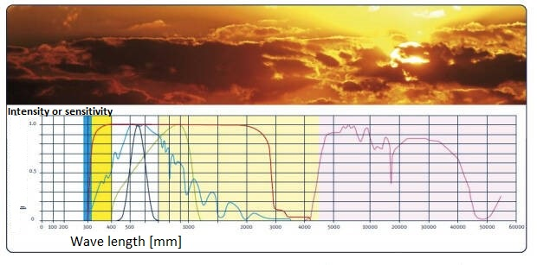Regular factors influencing the variability of natural light are the height of the sun above the horizon and geographic latitude. Random factors include the state of the atmosphere (clear, rain, fog, etc.) and the effects of light reflection and absorption from the ground and surrounding objects.

As the sun rises, the intensity of light and its color temperature increase. Shortwave rays of light (violet to green) are more refracted in the Earth's atmosphere than longwave rays (yellow and red). Therefore, the first and last rays of the sun are blue and green. Gas molecules and aerosols are responsible for most of the absorption of radiation.

Scattering of solar radiation on water droplets and ice crystals occurs in the entire spectral range. Molecules mainly scatter radiation at shorter wavelengths, while aerosols scatter radiation at longer wavelengths. This leads to an increase in the proportion of short-wavelength components (and, accordingly, to an increase in color temperature) as the sun moves toward the zenith.

The density of clouds, their height and location in relation to the sun, haze, fog, rain, and snow have a significant influence on the illumination of objects, contrast, and spectral characteristics of light. For example, in the presence of cumulonimbus clouds, illumination of unshaded objects illuminated by the sun increases by 25%, and illumination in the shadows increases by two and a half times.

The contrast of illumination decreases approximately twice in comparison with illumination in cloudless weather. When it is cloudy, there is a significant decrease in illumination and lighting contrast.

The spectral characteristics of natural radiation are given in the following table:

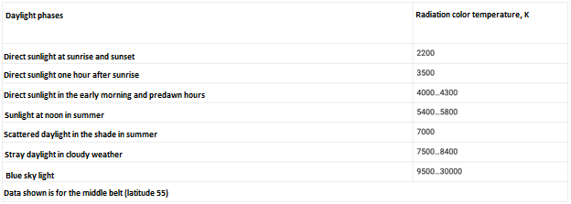

Example of the illumination of the Earth's surface in cloudless weather in different periods of the year and hours of the day, %:

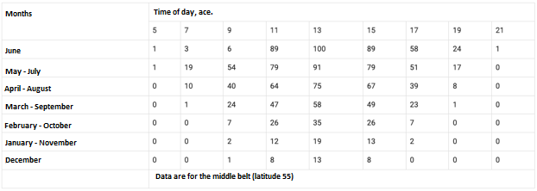

Example of the change of light and dark times of the day during the year:

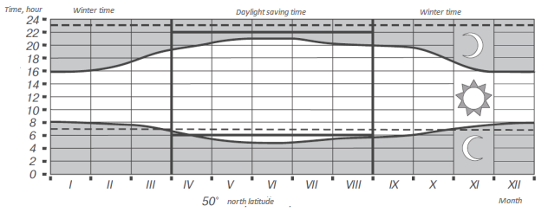

As can be seen from the above tables, depending on the time of the year, not only the duration of daylight hours, but also the diurnal level of PAR changes.

Temperature at the surface of the sun is about 5770 K. The power of energy radiated by our luminary is about 63 MW from each square meter of its surface, about 3.72x1020 MW in total. The energy density of solar radiation that reaches the Earth's atmosphere averages 1.367 kW/m2. This value is called the solar constant, whose fluctuations do not exceed 0.1%. Maximum radiation intensity is in the range from 400 to 800 nm (see Figure 5). The PAR accounts for about 50% of all solar radiation reaching the Earth's surface. On a cloudless day, the solar energy flux reaching the Earth's surface at local noon is usually in the range of 700 to 1300 W/m2 depending on the latitude, longitude, altitude above sea level, and time of year.

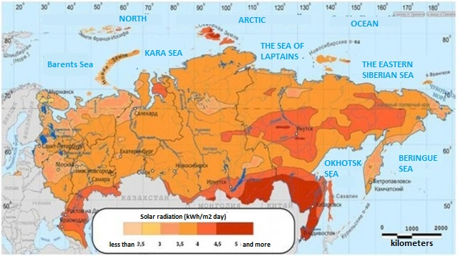Average solar radiation on the territory of Russia (from April to September):

**Evaluate the required level of extra light for greenhouse plants.**

It should be noted at the outset that the required level of extra light can cover the range from a few to several tens of watts per square meter in terms of PAR. It all depends on many factors inherent in the design of a particular greenhouse, the choice of practice of its use (seasonal or year-round cultivation, cultivated species and varieties of plants).

Determining parameters of illumination for photosynthesis are both power of radiation and duration of its exposure during a day (integral parameter - mol/m2/day (DLI) or kWh/m2×day (average solar radiation in the FAR area)).

A minimum level of irradiation is required to initiate photosynthesis. This level is not constant. It directly depends on the position of the compensation point.

The compensation point refers to the irradiance at which the photosynthetic and respiratory processes of the plant balance each other out. The position of the compensation point depends on many factors. In particular, there is a strong dependence on temperature.

There are optimal ranges of temperatures (daytime, nighttime, stage (in the sense of growth stages)), humidity, nutrition balance, atmosphere composition, etc. for each crop being grown.

In order to obtain a crop, it is necessary to provide a certain level of radiant productive energy (RPA) during the day (kWh/m2×day).

So, according to the results of studies by various organizations, we have the following results (for various reasons, the results are related to the use of the NLDS):

* **15-30 W/m2** – Low intensity of PAR (minimum permissible): vegetative organs grow, but full-grown generative organs are not formed.
* **40 W/m2** – According to the Giproniselprom Institute, such a PAR with a photoperiod of 14 hours (0.56 kWh/m2×day) is the optimal rate of irradiation in the greenhouse for the cultivation of seedlings.
* **65-90 W/m2** – on highly efficient phytocomplexes for year-round intensive production of plant products developed by the Agrophysical Institute, high yields are achieved. The developer reports that the plants can produce several harvests per year (tomato - 4, pepper - 3, cucumber - 4÷6, celery leaf, dill, parsley - 12÷14, leaf mustard - 16÷18, watercress - 20÷24). Products have high quality indicators on the content of vitamins, mineral elements and other food value characteristics. Its nitrate content is much lower than the established sanitary standards, there are no pesticides and other pollutants.
* **100 W/m2** – According to the developments of Giproniselprom Institute, such a PAR with a photoperiod of 16 hours (1.6 kWh/m2×day) is the optimal rate of irradiation in the greenhouse for growing to produce.
* **150-220 W/m2** – according to many sources, is considered the optimal PAR intensity at which the maximum accumulation of biomass per unit time is observed. Photosynthesis and growth are well balanced at photoperiod of 16 hours (2.4÷3.52 kWh/m2×day).
* **280-300 W/m2** – upper reasonable limit for the application of supplementary light. Depending on the method of artificial light control, the appropriate algorithm for switching off dormancy is implemented.
* **400 W/m2** (photoperiod 16h.-6.4 kWh/m2×day) and more - the saturated intensity of PAR, at which photosynthesis reaches the plateau of light saturation, i.e., the maximum photosynthesis. Plants become stunted.

In a year-round practice, photoperiodic lighting will definitely be required. The lighting installation will have to work in the dark and must fully provide a given level of photosynthesis.

It should be noted that in this situation, the choice of lighting power starts with the minimum required level, which does not depend on the geography of the greenhouse! On the geography will depend on the time of operation of the lighting installation in the annual cycle. The minimum required PAR level of a lighting installation should be considered 40 W/m2 (with a photoperiod of 16 hours - 0.64 kWh/m2×day, with 20 hours - 0.8 kWh/m2×day).

Until recently, it was believed that greenhouses should be located in the southern latitudes, and the products should be delivered with the help of well-functioning logistics. Now in Europe, thanks to advances in technology, this concept is being reconsidered in favor of placing greenhouses in close proximity to the potential consumer. In this case, products in the unambiguous sense arrive on the shelves literally from the "bed".

In Russia, with its vastness and limited logistical possibilities, this approach to the location of greenhouses is extremely relevant for many regions. Contrary to common misconceptions, almost the entire territory of Russia has a much higher level of irradiation than it might seem. Some northern territories in the warm half of the year have a level of natural light comparable to the south. Although due to differences in microclimate and terrain topography, an error in choosing the location of a greenhouse a hundred other kilometers away can lead to a significant reduction in the possible number of sunny days per year.

If irradiation is too intense, the rate of dark photosynthetic reactions may not keep up with the rate of light reactions. In this case you can try the practice of intermittent activation of extra light during the dark time of the day. In this case for more efficient use of light energy the duration of dark intervals should exceed the duration of light intervals. The effectiveness of this method is a scientifically proven fact.

The level of additional lighting capacity of 40 W/m2 allows you to implement a year-round cultivation of plants in greenhouses in almost all latitudes of Russia.

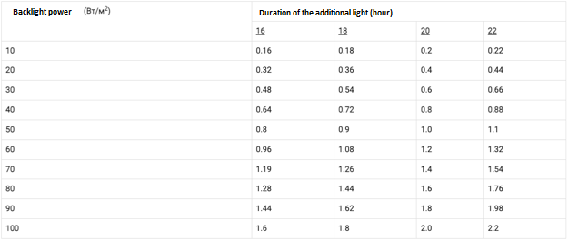 Total daily dose of supplementary light (kWh/m2/day):

**Automatic control of downdraft:**

Electric dosing is controlled by consoles, complete with communication and safety equipment. PU (control panels) distribute energy between groups of receivers and turn on the lights according to agricultural requirements. their number, as well as the number of light sources under the control of each device is calculated taking into account the need to solve the optimization problem, designed to minimize electricity losses.

Automation of the system is realized by placing control panels for dormitory lighting (SCHUD) on the territory of the object. Each greenhouse is equipped with its own control panel, which initiates the switching on of all the lamps present in the room, or only some of them. This administration can be centralized (commands for all low-voltage switchgears (LVDC) come from a single control point), remote (settings are set by the operator) or automatic (the algorithm of the controller is prescribed in the program).

Automated control systems (automated control systems) responsible for microclimate, which such boards are usually part of, are capable, among other things, depending on the current season of the year and, accordingly, on how many hours of daylight, change the time and intensity of dosing.

Artificial irradiation of crops is a system which includes control and power electric installations. They activate or deactivate consecutively in automatic or manual mode the lights of greenhouse block containing both electronic and electromagnetic ballasts.

As part of the intelligent complex there are two functional blocks.

The main one is the lighting control cabinet. This cabinet controls the operation of both the SCHD (stepper motors), and the group artificial light sources connected to its panel of illumination.

If automatic mode is selected, the climate computer acts as a source of commands. Analog or digital channels are used to organize data exchange between the computer and the panel and to transmit control signals. Communication between the cabinet and the control panel (and vice versa) is established through the Modbus protocol (RS-485 serial line).

The control panel is equipped with a programmable logic controller, which can be considered the main link in building the logic of the unit operation. The software is usually tailored to the specific system. To visualize the data, to enter parameters and manually adjust their values, the operator panel, mounted in the door of the enclosure of the switchgear and control unit, is used.

The second element is the switchboards. They receive power and distribute it to the group lines of artificial light sources. They provide local and remote modes of operation, and the commands are transmitted by the cabinet SHUO. NCU of this type have a built-in automatic protection (presented by time delay), excluding the repeated manual activation of receivers, classified as unauthorized. The function is implemented on the basis of a programmable relay placed in the panel.

Determination of the number of SHD for each greenhouse unit, their power and the quantitative composition of consumer groups powered by them is carried out at the stage of the complex development and is specified in the final version of the project.

**Additional lighting with LED lights**

LED lights have much higher efficiency, low heat dissipation and quality spectrum composition. This fundamental change in lighting installations allows for a more efficient way of supplementary lighting - continuous irradiation from morning to evening with less power combined with the maximum allowable photosynthetic period (see figure). The end result is to achieve the necessary level of DLI (Daily Light Integral) at a lower cost.

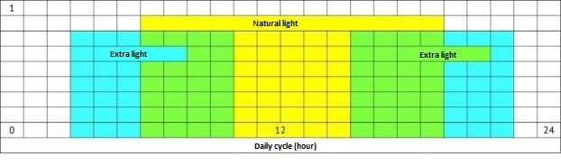 Schedule of additional lighting with LED lights:

LED lighting systems have much lower energy consumption compared to HPSL (high-pressure sodium lamps). This postulate, in turn, leads to the following conclusion: the use of LEDs significantly reduces the cost of the entire lighting installation. The quality of products in this case will compare favorably for the better.

The design of lighting fixtures allows for smooth adjustment of the level of radiation using various methods. However, a less costly and no less effective method of regulating the irradiance of plants is to modulate the period of artificial lighting in the daily cycle. It is possible to order fixtures with different spectra, which have different proportional composition of red, green and blue spectrum areas.

A variant of completing the complex with EL-008MT series greenhouse luminaires. This series includes fixtures with rated power from 60W to 240W.

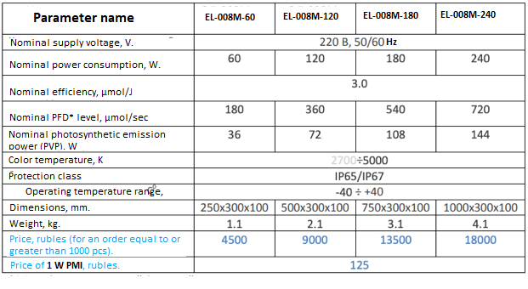 Technical and economic characteristics of EL-008M series luminaires:

When calculating the economic efficiency of LED installations, it is necessary to consider not only the price of lighting fixtures and energy savings due to lower power consumption of LEDs. The calculation should include the cost of generation (in particular, the cost of the gas turbine plant). This is true because LED installations consume significantly less power and, accordingly, the power of power generators is also required significantly less. Consideration of this fact leads to significant cost savings when deploying greenhouses from the zero cycle.

Let's carry out a comparative economic analysis of the four lighting installations using the following example. Initial parameters:

- total estimated area of 20 hectares. The size of standard sections 6.4m x 81m (518.4m2);

- obtaining electric and thermal energy by means of gas turbine unit. The cost of 5-15 MW installation is 50000 rub/kW, 20-30 MW - 40000 rub/kW. The net cost of 1 kW of electricity is 1.5 rubles;

- 1st installation: based on lighting fixtures with electronic control gear ZSP 64-600-002R/380V with lamps

lamp DNAZ super/Reflux S 600/400V. Served area by one lamp is 4.9 m2, power consumption - 630W, high CCT, the level of FFP of a new lamp is 1120 µmol/sec (228 µmol/m2/sec), efficiency - 1.77 µmol/J, the price is 7,774 rubles (including the price of the lamp 1809 rubles);

- 2nd unit: based on the LED lights EL-008M-240. Serviced area with one lamp is 4.9 m2, power consumption - 240 W, wide CCT, the level of FFP 720 µmol / sec (145 µmol/m2 / sec), efficiency - 3.0 µmol / J, the price - 18000 rubles;

- 3-rd installation: based on EL-008M-180 LED lighting fixtures. Serviced area with one lamp is 4.9 m2, power consumption is 180 W, wide CMP, the level of FFP 540 µmol / sec (110 µmol/m / sec), efficiency is 3.0 µmol / J, the price is 13500 rubles. The results of the analysis are shown in the table.

Comparative analysis of lighting systems:

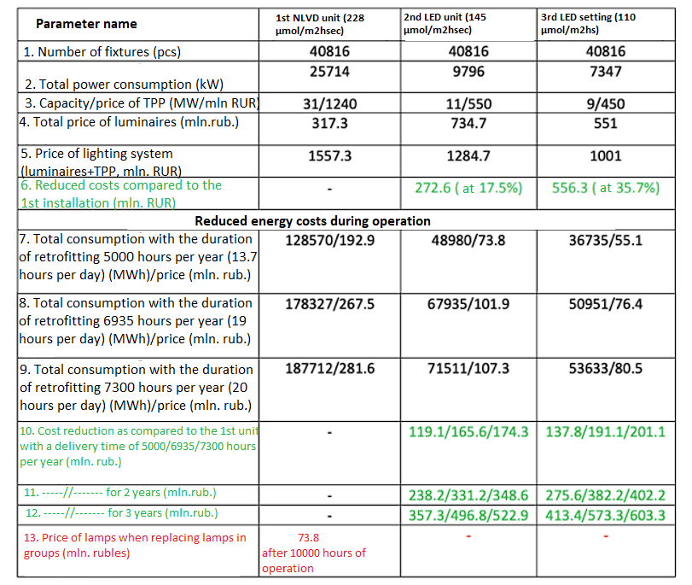

Explanation of the table:

- Line 1 specifies the number of lighting fixtures required to cover 20 hectares of greenhouses;

- Line 2 specifies the total power consumption of the luminaires, specified in line 1;

- line 3 specifies the required power of the electric installation and its price;

- line 4 contains the price of the luminaires indicated in line 1;

- Line 5 contains the total price of all luminaires and electric installation (p.4 + p.3);

- IMPORTANT: Line 6 specifies how much cheaper the LED installation is than the ULVD installation;

- Lines 7-9 contain information about the consumption of installations with different duration of dimming and price per year;

- Lines 10-12 contain information about the cost reduction when implementing LEDs for 1,2 and 3 years, respectively.

**Thus, for this project, it is advisable to apply a system of LED afterglow for growing vegetables in protected areas.**

## Quality assurance of finished products

The production process forms the basis of the quality assurance system. The entrepreneur can use this system to continually critically evaluate all details of production management and, if necessary, improve them. Quality assurance is an auxiliary means to provide assurance to business partners and end customers. A well-functioning quality assurance system enables all concluded contracts to be fulfilled.

In addition to the quality of the product itself, the system of comprehensive quality assurance also includes environmental protection and working conditions. These three components of the system are logically closely connected with greenhouse vegetable production. Organic crop production with biological control of diseases and pests and registration of chemical consumption belongs to the environmental protection, but it also leads to a better management of the crop protection. Without attention to good work organization and good working conditions it is not possible to organize the production process optimally.

## Personnel information

The total number of staff required to ensure the smooth operation of all divisions of the greenhouse complex will be 46 people.

Planned staffing of the greenhouse complex:

|  |  |  |  |  |
| --- | --- | --- | --- | --- |
| № п/п | Position | Quantity | Rate  (rubles) | Total  (rubles) |
| 1 | General Director | 1 | 150 000 | 150 000 |
| 2 | General accountant | 1 | 80 000 | 80 000 |
| 3 | Accountant | 1 | 50 000 | 80 000 |
| 4 | Head of Sales | 1 | 100 000 | 100 000 |
| 5 | Sales Manager | 1 | 80 000 | 80 000 |
| 6 | Advertising Specialist | 1 | 50 000 | 50 000 |
| 7 | Marketing Specialist | 1 | 30 000 | 30 000 |
| 8 | Agronomist | 1 | 50 000 | 50 000 |
| 9 | Workers | 20 | 40 000 | 800 000 |
| 10 | Electrician/Boiler house operator | 2 | 50 000 | 100 000 |
| 11 | Laboratory Technician | 1 | 40 000 | 40 000 |
| 12 | Utility workers | 4 | 40 000 | 160 000 |
| 13 | Cook | 1 | 45 000 | 45 000 |
| 14 | Cooks assistants / kitchen workers | 2 | 40 000 | 80 000 |
| 15 | Driver | 2 | 50 000 | 100 000 |
| 16 | Security Guard | 6 | 45 000 | 270 000 |
|  |  |  |  |  |
|  | **TOTAL:** | **46** |  | **1 645 000** |

For each greenhouse, separate employees are needed, mostly handymen. Their duties include working with seedlings, caring for plants, collecting and packing products in containers. The work schedule is in shifts. The greenhouse farm does not provide for weekends when the greenhouses are closed and do not need supervision.

The administrative building will need a director, sales department and accounting department.

The complex must be guarded at night, so there must be security specialists on staff.

Products must be delivered to customers if they do not have their own transport. For this purpose, we invite drivers on a six-day week with one day off.

## Harvesting stage

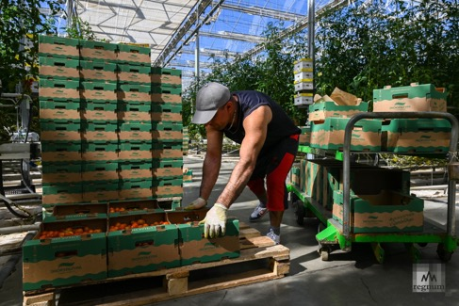 As the harvest matures, greenhouse workers (vegetable growers) manually collect the harvest and pack it in prepared cardboard containers.

As crops are harvested, finished products are stored in temporary warehouses at the greenhouse complex, from where they are self-delivered and finished products are delivered to consumers in our own vehicles.

Collection and presale storage of finished products is an important stage of the business process. Losses at this stage can be up to 10% of the harvested crop.

## Organization of sales of finished products

The task of selling finished products lies with the sales department of the greenhouse complex. The project provides for two sales managers under the guidance of a more experienced sales manager.

The introduction of incentive payments to employees of the sales department depending on the volume of products sold.

At the same time, the presence of a large base of potential consumers of the project initiator, most of whom express a desire to purchase finished products from the newly created greenhouse complex, allows you to confidently plan 100% sales of finished products.

## Logistics solutions

The logistics of the greenhouse complex is planned to be organized in three variants:

**Basic logistics option** finished products to the consumer - self-delivery of products from the warehouse of the greenhouse complex. In this case, the complex is only responsible for the loading of goods and registration of the necessary accompanying documentation.

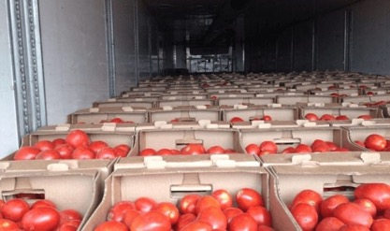 Practice shows that a significant part of potential consumers of finished products has its own capabilities to organize its transportation to the buyer.

**The second logistics option** is the option of engaging specialized carriers to transport finished products to the consumer. In this case, the area of responsibility of the complex expands, because to maintain the reputation of a reliable supplier, it will be forced to assume additional risks of transporting goods to the consumer with subsequent recourse to the carrier in case of force majeure.

When using this option in the logistics of greenhouse complex eliminates the need for the initial purchase and subsequent maintenance of its own fleet of trucks. There is also no need to maintain additional personnel - drivers. Such a solution allows you to reduce the initial investment and operating costs of the project.

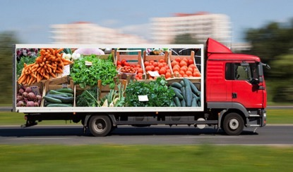 In case of using the second option of logistics, the buyer pays the cost of transport services of the carrier in addition to the cost of purchased finished products.

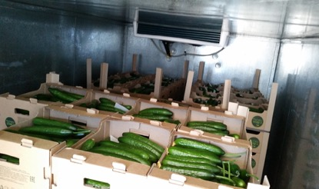 **The third option** delivery of products is the delivery of its own vehicles, the cost of procurement and maintenance of which are taken into account in the financial model of the project. When implementing the third option of logistics it is planned to use low-tonnage refrigerated vans.

In case of organization of delivery of finished goods to the consumer by vehicles of greenhouse complex, the buyer will be charged an additional delivery fee.

Such a comprehensive solution for the organization of transport logistics allows to cover all the logistics needs of finished products of the greenhouse complex with minimal costs.

## Project Implementation Plan-Schedule

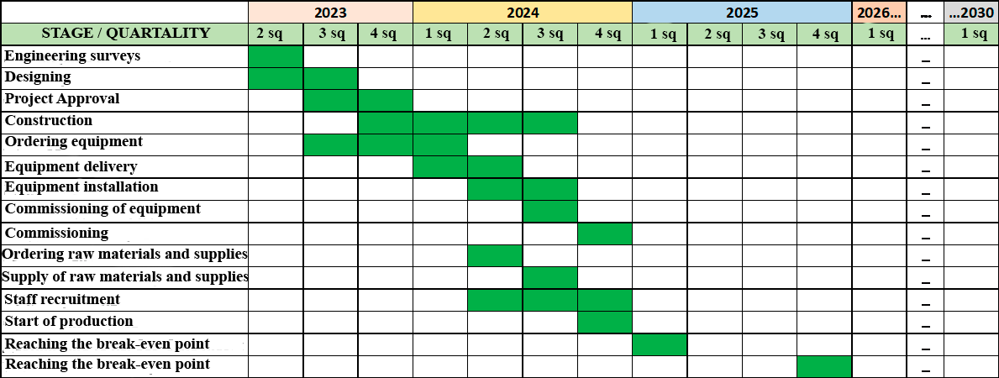 The project implementation schedule shows the chronology of the main stages of the project in a graphical form:

Engineering surveys are planned to be carried out in the 1st quarter of 2023. In parallel, the design processes for the elements of the project that do not require engineering surveys are being launched. The design phase continues for 2 quarters of 2023.

Selected construction elements such as site fencing, construction camp set-up, and preparation of in-situ networks during construction may be initiated in Q2 and Q3 2023, but the main construction phase will occur between Q4 2023 and Q3 2024.

The phases of ordering, delivery, installation and commissioning of the main equipment is planned to be carried out in parallel stages from the 3rd quarter of 2023 to the 3rd quarter of 2024. Up to the moment of putting the greenhouse complex into operation in the 4th quarter of 2024.

Raw materials and basic materials of production are planned to be ordered in advance in the 2nd quarter of 2024, than to ensure their delivery in the 3rd quarter of 2024 by the time of preparation to commissioning of the complex.

Hiring of personnel is planned in Q2, Q3, Q4 2024, gradually increasing the number of employees for training, skills, mastering of equipment and preparing the complex for normal operation.

The general start of production in the pilot-staff mode is planned to be implemented in Q4 20204.

Taking into consideration the receipt of advance payment for the finished product the breakeven point is planned to be reached in the 4th quarter of 2024 or in the 1st quarter of 2025 depending on the specific conditions of agreements with buyers of finished products and market conditions at that time.

Reaching the break-even point and return of attracted investments with payment of all interest for the use of funds is planned for the 4th quarter of 2025.

## Structural decomposition of the work plan

* + 1. **Preliminary stage** (at the preliminary stage, if necessary, an assessment of the land plot is carried out to meet a number of requirements for construction, such as the availability and amount of water, heat, energy and labor resources, as well as the specific relief of the landscape. This will not only significantly reduce the amount of capital investment, but also further reduce the cost of production, which is one of the key indicators in creating an effective business):
  1. Development of the Concept and making the decision to open the project
  2. Development of a Business Plan for the project

**WE ARE HERE**

* 1. Measures to attract investment resources to implement an investment construction project in a Russian credit institution
  2. Preparation of documentation for reimbursement of part of the cost of paying interest on the investment loan

1. **Pre-project preparation for construction**:
   1. Engineering and geodetic surveys (topographic survey) of the plot intended for the construction of a greenhouse complex
   2. Preparation of the package of initial permissive documents, including technical conditions for connection to engineering networks and communications, taking into account the requirements of regional legislation act
   3. Conducting engineering and geological surveys at the site construction
   4. Environmental engineering surveys, obtaining conclusions:

* on radiation safety;
* the presence of electromagnetic radiation (EMR);
* the content of heavy metals, radon and other hazardous substances in soils;
* background concentrations of harmful substances in the surface layer of the atmosphere (if necessary);
* levels of traffic noise and other sources (if required);
* the presence of sanitary protection zones
  1. Preparation of documentation for the organization of tenders for the supply of steel structures and technological equipment. Organization of tenders. Analysis of tender documents submitted by suppliers. Selection of suppliers.

1. **Designing**:
   1. Development and coordination with the customer of the basic schemes of growing and harvesting technology, engineering systems, cargo flow diagram, staffing and working conditions workers
   2. Development of the project at the stage "P" (including coordination with the Customer of principal solutions) as part of:
2. Explanatory note
3. Scheme of planning organization of the land plot
4. Architectural solutions
5. Structural and volumetric planning solutions (as part of Volumes III and IV on the objects of the complex)
6. Information on engineering equipment, on networks of engineering and technical support, list of engineering and technical measures, content of technological solutions:

* 0.4 kV power supply system
* Water supply system
* Sewage system
* Heat supply system
* Gas supply system
* Heating, ventilation and air conditioning system
* Communication networks
* Technological solutions

1. Construction organization project
2. Project for the organization of work on the demolition or dismantling of capital construction facilities
3. List of measures to protect the environment
4. Activities to ensure fire safety
5. Measures to ensure accessibility for people with disabilities
6. Engineering and technical measures for civil defence
7. Technological regulations for dealing with construction waste
8. Labor management and working conditions of employees. Production and enterprise management
9. Estimates for construction of capital construction objects
10. Energy Efficiency
    1. Approval by the Customer of the developed design documentation at the stage "project”
    2. Conducting approvals of developed design documentation with permitting organizations
    3. Organization of the state expertise and protection of the project documentation

3.6. Approval of the developed design documentation by the Customer

3.7. Development of the project at the "RD" stage

1. **Procurement of materials, building structures and equipment**
   1. Development, coordination and approval of the delivery schedule in accordance with the design specifications and the schedule of construction and installation works
   2. Contracting for imported building structures and technological equipment
   3. Contracting with a specialized company for the turnkey import of the equipment, including international freight, logistics, and application of economic customs regimes (if such services cannot be provided by the equipment supplier)
   4. Procurement and logistics of materials and equipment from Russian suppliers
   5. Incoming quality and quantity control, warehousing and accounting of materials, building structures and equipment delivered to the construction site.
2. **Stage of construction**
   1. Obtaining a warrant for preparatory work for construction
   2. Preparatory work for construction
      1. Notification of the commencement of construction activities to the state construction supervision authorities. Registration of the General work log
      2. Marking the construction site in situ, fixing of geodetic signs
      3. Erection of the temporary fencing and information boards
      4. Erection of temporary buildings and structures
      5. Temporary power supply, temporary water supply and sewage
      6. Cleaning of the area
      7. land remediation
      8. vertical leveling
      9. Construction of temporary roads and sites
      10. Preparation of documentation for the organization of tenders for construction and installation works. Organization of tenders. Analysis of tender documents submitted by contractors. Selection of contractors.
   3. Obtaining a construction permit
   4. Technical and author's supervision of the turnkey construction of the plant with utilities, facilities and industrial and amenity premises on construction stages, including continuous control over the execution of the executive documentation required to put the facility into operation
   5. Organization of construction and installation works for the turnkey construction of the plant with utilities, facilities and industrial and household premises (by construction stages)
      1. Construction of buildings and structures axes foundations for greenhouses and amenities
      2. Construction of basement for greenhouses and amenities.
      3. Construction and installation work on the greenhouse block (with sprouts section)
      4. Construction and installation work in the nursery
      5. Construction-assembly works on the industrial and household block №1 (service area and amenity rooms)
      6. Construction-assembly works on the heating and power block
      7. Construction and installation work on the administration and amenities building with a canteen
      8. Construction-assembly works on the fertilizers and agricultural materials warehouse
      9. Construction and installation works on the checkpoint with a gatehouse
      10. Arrangement of fencing of the territory
      11. Installation of external on-site utilities and communications
      12. Arrangement of external off-site utilities and communications
      13. Construction of permanent roads and sites
      14. Construction of disposal sites for solid household waste and vegetation residue
      15. Carrying out commissioning works, individual testing of engineering and technological systems and equipment
      16. Comprehensive operational tests with planting and training of personnel
      17. Landscaping
      18. Organization of work of the commission for acceptance of the Facility. Preparation of the commission report
   6. Obtaining of the conclusion of the State Construction Supervision about conformity of the constructed object to the requirements of the technical regulations and design documentation.
   7. Obtaining of a permit for commissioning of the object
   8. Registration of the constructed object with the state registration (organization of preparation of technical inventory passports, obtaining passports)
3. **Operation.**
   1. During the operational tests it is necessary to carry out a set of measures to prepare the object for operation:

* staffing and certification according to the staffing schedule;
* concluding contracts with organizations for the maintenance of external networks and communications;
* preparation of operational documentation (schedules, regulations, etc.)
  1. Organization of warranty service of equipment.
  2. Fulfillment of all requirements of the complex's maintenance personnel to the warranty equipment during the period of warranty operation.

## Climatic features of the project area

Weather statistics show that the warmest month in Orekhovo-Zuevsky District of Moscow Region is July, with an average temperature of +19.6°С. August is second (+18.4°C), while June is third (+18.2°C). Accordingly, the coldest month in the city is January. The average monthly temperature in January is only -6.9°C..

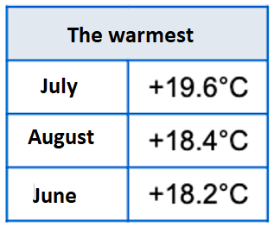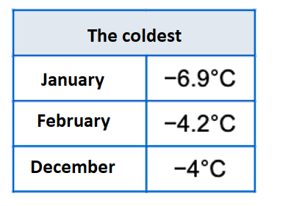

### Data on maximum sunny months

The sun shines the most in June. Thus, June is the sunniest month in the city.

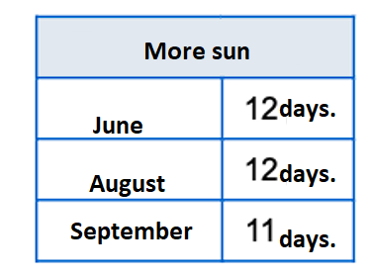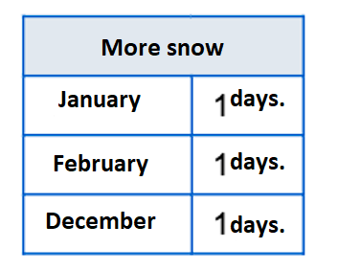

### 5.17.2. Data on weather conditions

Below is the weather table for Orekhovo-Zuevsky area by month. The table shows such parameters of district climate as average temperature by months, average humidity by months, average wind speed by months, number of sunny days by months, number of rainy days by months.

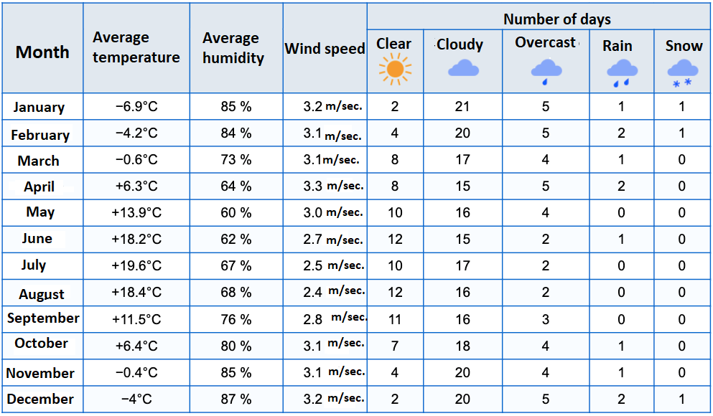

### 5.17.3. Average temperature data (graph)

The temperature in Orekhovo-Zuevsky area varies from -6.9°C to 19.6°C depending on the month. The minimum temperature is observed in January, the maximum temperature is usually in July.

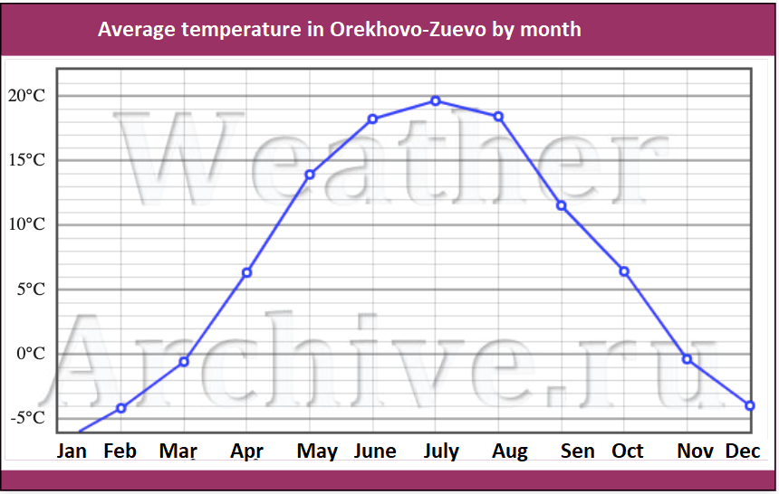 The average temperature in Orekhovo-Zuevsky District by month is shown below:

### 5.17.4. Average humidity data

The humidity in the region varies from 60% to 87% depending on the month. The minimum humidity is observed in May and the maximum humidity is in December.

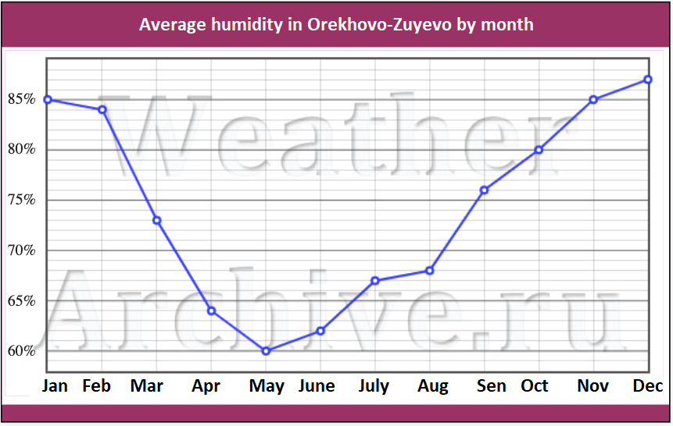 Average monthly humidity in Orekhovo-Zuevsky District by month is shown below:

### 5.17.5. The wind rose of the area

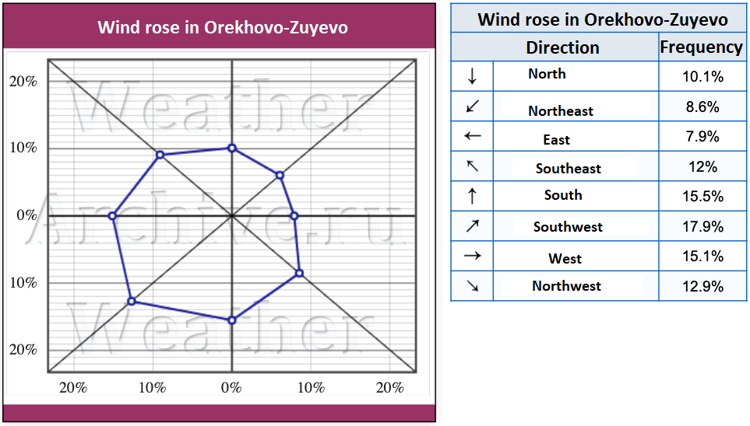 The wind rose (also called wind pattern or wind map) shows which winds prevail in the city in question.

The main wind direction is southwest (18%). In addition, the predominant wind directions are south (16%) and west (15%). The rarest wind in the area is easterly (8%).

### 5.17.6. Snow and wind loads

When constructing buildings and structures, it is necessary to take into account the factors of environmental impact on the construction object, as they have a significant impact on the strength and durability of structures during operation. The exact load from the weight of the snow cover can be established by the maps of SP 20.13330.2011 "Loads and Effects", enclosed in this Code of Practice.

The magnitude of the snow load on the roofs of structures made of metal construction can be calculated by the formula: s = so?, where so - a certain value of the weight of snow cover per square meter of horizontal ground surface, ? - the coefficient of transfer from the weight of snow cover of the ground to the snow load on the roof of hangars.

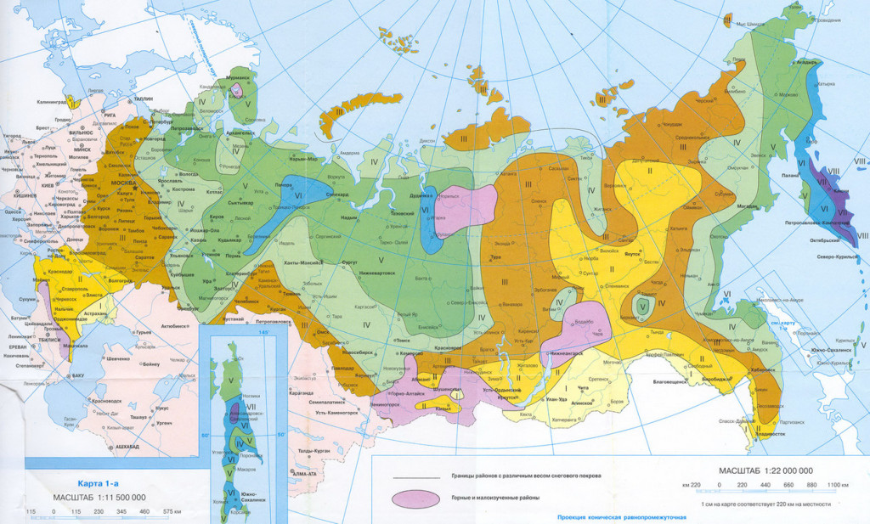 Map of snow areas in Russia:

The wind load on the structures is an aggregate of the normal pressure We influencing the outer surface of the hangar, the friction forces Wf directed tangentially to the outer surface and referred to the area of its horizontal or vertical projection and the normal pressure Wi directed to the inner surfaces of the hangar with permeable fences or open open openings. Or as the normal pressure Wx, Wy, due to the total resistance of the hangar in the direction of x and y axes and conditionally applied to the projection of the structure on the plane perpendicular to the corresponding axis.

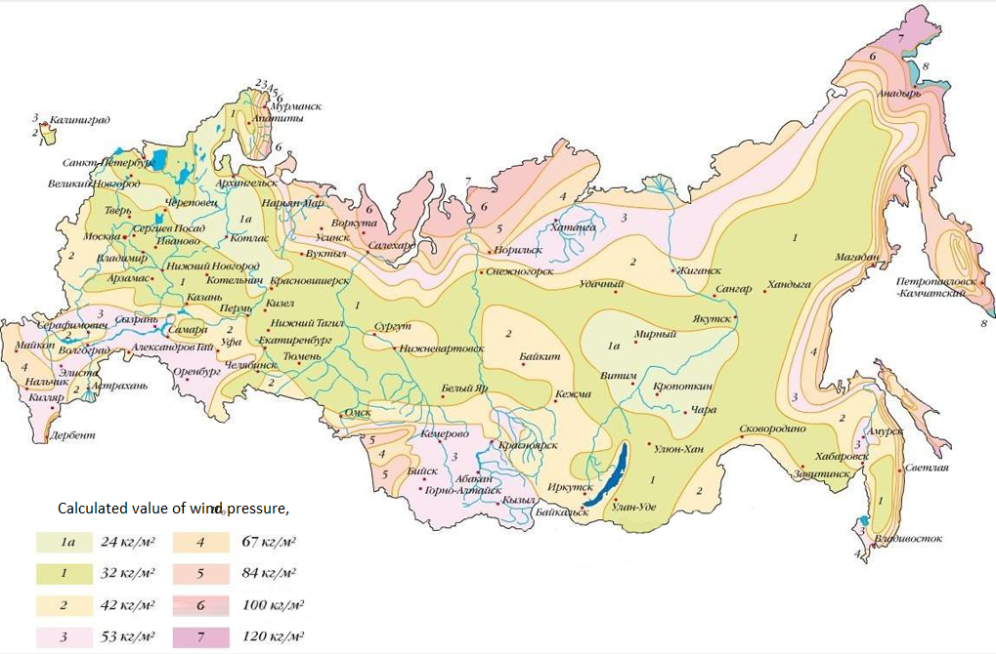 Map of windy areas in Russia:

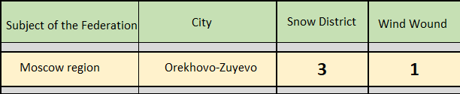The calculated value of the average component of the wind load on the structures w at height z above the ground surface should be calculated by the formula: w = wgk(z)c, where wg is the calculated value of wind pressure, k(z) is the coefficient taking into account the change in wind pressure by height z, c is the aerodynamic coefficient.

Thus, the proposed project is located in the snow zone 3 (third) category (with a load of 180 kg/m2) and wind zone 1 (first) category (with a load of 23 kg/m2).

## Environmental features of the project

Information about the environmental impact of the project, the project's compliance with environmental performance standards:

Greenhouse complex, as an object of industrial production, has sources of permanent and periodic negative impact on the environment in the production process:

* + 1. Emissions into the atmosphere from a heat and power plant (TPP) of a gas-fueled enterprise;
    2. Emissions to the atmosphere from on-site transport;
    3. Wastewater from the greenhouse complex;
    4. Fibrogenic dust emissions into the atmosphere;
    5. Dust emissions from transport movement along the intrasite roads and passages;
    6. Generation of industrial and domestic waste.
    7. The impact of the facility on the environment due to man-made accidents or force majeure circumstances (natural disasters):
* Spills of petroleum products from a destroyed fuel tank;
* Emissions into the atmosphere and onto the ground from destroyed lamps of the outdoor lighting system.

The basic principles of environmental protection allow for a certain impact of enterprises on the natural environment, based on the requirements in the field of environmental protection. At the same time, the reduction of the negative impact on the environment is achieved on the basis of the best advanced technologies, taking into account economic and social factors.

Characteristics of sources of environmental impact:

1. Emissions into the atmosphere from a heat and power plant (TPP) of a gas-fueled enterprise.

For the needs of heat and electricity supply of the greenhouse complex is proposed device of heat and power station on the gas-powered equipment. The main fuel for the heat and power station - natural gas, emergency fuel - diesel fuel.

In addition to generating thermal energy, gas-operated equipment TEP is a source of carbon dioxide in the exhaust gases, which is used to increase the concentration of CO2 in the volume of greenhouses needed for the vital activity of plants.

During the operation of thermal power equipment, waste gases containing some carbon monoxide (CO) and nitrogen oxides (NOx) are released into the atmosphere. The remaining substances contained in the exhaust gases: carbon dioxide and water - do not have a negative impact on the environment.

1. Sources of emissions are on-site and off-site trucks and cars equipped with internal combustion engines. In addition to exhaust gases, transport is a source of fuel and oil emissions.
2. Wastewater from the greenhouse complex:

* surface runoff water from the roof of greenhouses;
* surface runoff water from roads, driveways and lawns;
* industrial effluents;
* domestic wastewater.

Surface wastewater from the roof of greenhouses is not a source of negative impact on the environment, as it does not contain pollutants, and can be drained into open water bodies without pre-treatment.

Surface wastewater from roads, driveways and lawns contain some amounts of pollutants such as automobile oils, fuels, solid inorganic inclusions (dust, sand), rubber crumb from car tires.

Industrial effluents are subdivided into liquid industrial wastes generated during washing of chemical plant protection equipment, washing clothes of workers in the chemical plant protection workshop and irrigation solution not absorbed by plants (drainage). Household wastewater - contains human waste and detergents.

1. Emissions of fibrogenic dust into the atmosphere.

Dust is formed due to the destruction of granules or crystals of mineral fertilizers during their transportation, storage and application for the preparation of irrigation solutions of mineral plant nutrition. Sources of dust formation are the warehouse of fertilizers and agro-materials, and technological zone of preparation of irrigation solution.

1. Dust emissions from transport movement along the intrasite roads and passages. The movement of motor vehicles along the intrasite roads and driveways generates fine dust.
2. Industrial and domestic waste. The operation of the greenhouse complex generates industrial and domestic industrial waste. Industrial waste of the enterprise according to the source of its formation is subdivided into:

* Plant residues. Leaves and stems are removed during the greenhouse cultivation process when the plants are being formed. They are removed on a daily basis throughout the entire growing period. Mass formation of plant residues occurs when plants are rotated at intervals of one or two times a year. Plant residues are regarded as low-toxic waste, which is allowed to be stored in open areas.
* Substrate. For growing plants using the method of low-volume hydroponics a substrate of thin basalt fiber is used. The period of use of the substrate is 1 year. At the end of this period the substrate is replaced with a new one. The used substrate is taken to the landfill of industrial waste.
* Containers from mineral fertilizers and toxic chemicals. Fertilizers and pesticides in polyethylene bags, cans and canisters are stored in a separate warehouse of mineral fertilizers and agricultural materials. The containers released from pesticides are thoroughly cleaned and washed and further disposed as other solid waste (industrial waste).
* Lamps of lighting systems (including electric illumination systems). To provide year-round cultivation of green crops and growing seedlings of vegetable crops in the greenhouse complex a system of artificial electric lighting of plants by lighting fixtures with high-pressure sodium lamps is used. Fluorescent lamps are used for lighting administrative and production premises. For outdoor lighting of the greenhouse complex territory, it is assumed to use mercury lamps (DRL type). Waste fluorescent and mercury lamps, as well as lamps of the electric illumination system are a potential source of toxic substances in the environment, which determines the need for their selective collection and recycling.
* Glass of the external translucent fencing of greenhouses. When replacing broken glass in greenhouses, uncontaminated glass scrap is received as waste, which, as it is formed, is collected in metal containers or crates, and then, as other solid mineral waste (industrial waste), is disposed of at the landfill of industrial waste.
* Rubber fabric waste. The greenhouse heating system uses rubber-fabric hoses that connect the heating circuit registers to the distribution pipelines. Used rubber hoses, when replaced with new ones, go to waste as part of other solid waste (industrial waste), which is disposed of.
* Scrap of ferrous and non-ferrous metals. It is generated during replacement of worn-out sections of pipelines and replacement of defective shut-off valves. Due to the non-toxicity of this type of waste, it is allowed to be stored before being sent to a storage facility or recycled in open areas within the territory of the enterprise.
* Paint and varnish products. To paint the pipes of heating systems in the greenhouse complex pentaphthalic enamels are used, metal cans from under which are collected in containers and further disposed as waste paint products.
* Waste generated during the operation of on-site electric vehicles. It is assumed to use self-propelled electric vehicles (electric loaders and electric cars) for loading and unloading operations in greenhouses and on-site territory of the complex. Their operation generates the following types of waste:
  + when replacing worn tires, waste includes used tires with metal cords, which are stacked on an open area with a paved surface as they are generated. Worn tire tubes also go to waste. Vulcanization of tubes and adhesive works are not carried out at the company, if necessary, they are carried out at a specialized enterprise;
  + used batteries: Used batteries (without draining the electrolyte) are collected as they are generated on a hard surface in an isolated room, in the building of the material warehouse; Technical fluids, rubber products and parts are not replaced on the territory of the enterprise. The above-mentioned works are performed by specialized enterprises.
* Cloth wiping material containing oil is a fire hazard and should be stored in closed metal containers.
* Household waste. As a result of the activities of the company's employees, unsorted household waste (excluding bulky waste) is generated, which is collected in garbage cans, buckets, boxes installed in the household and industrial premises, then disposed of in containers at the site of solid household waste, from where it is taken to the landfill of solid household waste.

The hazard class of waste is determined by the degree of its possible harmful effect on the environment (OHS) through direct or indirect impact, and is determined by the "Federal classification catalog of waste", approved by the order of the Ministry of Natural Resources of Russia No. 786 of 02.12.2002.

**Measures to protect the environment during the operation of the enterprise:**

Federal law dated August 22, 2004 № 122-FZ "About environmental protection" defines that exploitation of enterprises and other objects, which directly or indirectly render negative influence on environment, is realized according to requirements in the field of environmental protection. At the same time, environmental protection measures, which are divided into design (technical and technological solutions to reduce the negative impact of production on the environment), and organizational and technical, carried out during the operation of the greenhouse complex should be provided.

Proposed design solutions and organizational and technical measures are presented for each source of negative impact on the environment:

1. Emissions into the atmosphere from the heat and power plant (TPP) of a gas-fueled enterprise:

For the heating needs of the greenhouse complex natural gas equipment is used, which can significantly improve sanitary and hygienic conditions in the enterprise and adjacent areas by eliminating the content of ash, soot, dust, sulfur dioxide in the air basin and reducing the nitrogen oxide content. In addition, the installation of devices for continuous monitoring of carbon monoxide (CO) and nitrogen oxides (NOx) in the TEP working area, with the alarm about exceeding the concentration thresholds established by GOST 12.1.005-88 and GN 2.2.5.686-98, must be provided by the project.

The height of chimneys should be calculated taking into account the dispersion of harmful substances in the volumes of MPE during the operation of thermal equipment with liquid fuel, taking into account the requirements of GOST 17.2.3.02.-78 "Nature Protection. Atmosphere. Rules for Establishing Permissible Emissions of Hazardous Substances by Industrial Enterprises".

1. Emissions to the atmosphere from on-site transport:

The general plan of the enterprise intrasite roads and driveways shall be provided in such a way as to minimize the movement of motor transport on the territory of the enterprise. Areas for parking of motor vehicles, loading and unloading and turning platforms in accordance with SNiP II-97-76 "General plans of agricultural enterprises" must be provided.

1. Wastewater from the greenhouse complex:
   1. Surface wastewater from the roof of greenhouses: Wastewater from the roofs of greenhouses is not a source of negative impact on the environment, so the design solutions for the treatment of water are not provided.
   2. Surface wastewater from roads, driveways and lawns. For discharging water into open water bodies, it is necessary to clean them from pollutants (oil products, solid particles). To do this you need to provide a separate outdoor sewer networks and surface-waste water treatment plant (type "Alta PSV" or "Ruchey"), equipped with sand trap, catching oil and water settling chambers before release to the terrain or in the open water body. The waste water containing chemical substances and suspended particles must meet the standards for discharge of treated water into fishery waters in accordance with SanPin 2.1.5.980-00 "Hygienic requirements for protection of surface waters". Wet sludge from the sand trap without intermediate storage is transported by special vehicles to treatment facilities. Collected oil products without intermediate storage are transported by special equipment either to an oil product regeneration facility, or to an oil product utilization (incineration) facility.
   3. Industrial effluents;

* Drainage runoff. The project provides low-volume technology of growing vegetable products, using drip irrigation system with the collection and recycling of drainage. Nutrient solution, not absorbed by plants, flows down the pipes into polyethylene containers buried in the corners of greenhouses, from where the pressure pipeline is fed into the container of untreated drainage solution. Further the solution is subjected to disinfection by ultraviolet cleaning unit (quartz treatment of solution), after that it is repeatedly supplied for irrigation. Application of drainage water recycling system allows to exclude nutrient solutions penetration to the relief and open water bodies, and to prevent the negative impact of effluents on the environment.
* Wastewater generated during washing of chemical protection devices, washing clothes of workers in the chemical protection of plants. There is a covered concrete platform for washing of chemical protection apparatuses directly near the warehouse. Runoff from the platform is carried out in a buried sealed container. The runoff from the washing equipment, in which the clothes of the workers of the chemical protection of plants are washed, is carried out into the same tank. The tank must be provided with waterproofing, excluding corrosion destruction of the walls and the subsequent infiltration of the liquid into the ground. To avoid overfilling of the tank it is necessary to provide an emergency overflow from the tank to the buffer tank. The tank capacity should be designed for twice the volume of effluent generated in one shift with the chemical treatment of the greenhouses. When the tank is full, the wastewater is transported by special vehicle to the landfill for neutralization of liquid industrial waste.
* Domestic wastewater. The project provides installation of biological wastewater treatment plant of "Biotal" type. The station is a complex of equipment: a reception chamber for detention of garbage and coarse impurities, SBR- reactors of water treatment, and a well of accumulation and chlorination of treated water before discharge. The operating principle of the station is the decomposition of organic matter by anaerobic bacteria with permanent barbotage aeration of activated sludge until its complete deactivation. The biological treatment plant consists of SBR reactors connected in series. Technology of the installation is arranged in such a way that treated wastewater, flowing from the first to the last SBR-reactor, undergoes a complete cycle of biological treatment in each of them. The return activated sludge, constantly circulating between the reactors, is divided into four streams: stabilized excess sludge is removed from the system into sludge bags, and sludge water returns to the reactors and passes through all stages of treatment. Old activated sludge is sent to the first SBR in the flow, younger activated sludge is sent to the second SBR, and sludge from the tertiary settling tank is sent to the intake chamber. Such circulation of sludge allows the plant to cope with incoming SPAW (synthetic surfactants), the appearance of which is associated with their use in everyday life as detergents, in concentrations corresponding to the domestic human activity. This achieves a step-by-step adaptation of the activated sludge microorganisms with a step-by-step dilution of treated wastewater with return, activated sludge in the course of their movement from the first to the third SBR reactor. Sludge is automatically fed into sludge bags and then removed mechanically (manually) with the subsequent possibility of its composting and use as a fertilizer or utilized according to the requirements of SNiP 2.04.03-85.

1. Emissions of fibrogenic dusts into the atmosphere. Dust sources shall be equipped with supply and exhaust ventilation systems, with indicators of air turnover multiplicity according to current construction and sanitary standards. At the air outlet to reduce the dust concentration in the air (up to 4 mg/m3) the dust separation chamber of labyrinth type is provided, with the exception of dust pick-up by the ascending air flow. Dust is deposited in a removable tray of the chamber.
2. Dust emissions from the movement of transport on the intrasite roads and passages. It is necessary to provide on the territory of the enterprise a post of mechanical cleaning of the wheels of on-site transport, equipped with devices for washing the wheels with water under high pressure.
3. Industrial and household waste generation:

In accordance with the "Federal Law on Environmental Protection" dated January 10, 2002 № 7-FZ production and consumption waste shall be collected, neutralized, transported, stored and buried, the conditions and methods of which shall be environmentally safe. When developing the section of the project "General Plan" it is necessary to provide sites for the collection and intermediate storage of domestic and industrial wastes. When organizing places of waste storage (accumulation), it is necessary to take measures to ensure environmental safety: consider the possibility of seasonal flooding of the site, location relative to the borders of water protection zones of open water bodies, location relative to the borders of sanitary and protective zones of environmental protection facilities and water supply sources. The equipment of storage sites must be designed with due regard for the class of hazard, physical and chemical properties, reactivity, generated waste and the requirements of relevant GOSTs and SNiPs (GOST 12.1.007-76 "Hazardous Substances. General Safety Requirements", Sanitary Norms SN-245-71). Waste storage sites should be equipped with turning areas for motor transport.

**Thus, the set of environmental protection measures envisaged by the project complies with all environmental regulations and standards. The use of modern environmental protection technologies allows to classify this greenhouse complex as an environmentally friendly enterprise.**

# Marketing plan

In the Russian Federation, as in the rest of the world, major cities play a key role in the economy. These markets are the most important for agricultural producers because they have a solvent demand and do not produce these products themselves.

At the same time, one of the problems for producers of fresh vegetables is the difficulty in accessing these markets. At a conference organized by The Clute Institute in Munich in 2014, a group of experts published a set of GAP (Good Agricultural Practices) on the marketing of vegetable products.

According to the conclusion of experts, the main channels through which agricultural products can reach consumers are presented in the diagram:

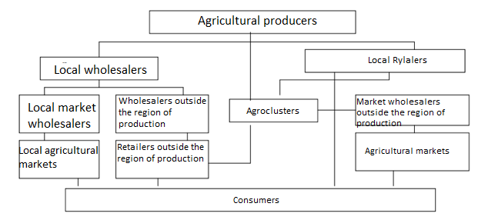

This scheme draws attention to the presence of agro-clusters - large complexes for trade and logistics of agricultural products. Their use makes it possible to effectively solve the problem of the output of the greenhouse complex to the territories located outside the region of production.

This sales technology is especially relevant for Russia.

## 6.1. Overall marketing strategy

**Target clientele of the project** – stores, markets, wholesale markets, small and large retail chains, agroclusters.

**Products** – tomatoes and cucumbers will be grown as part of the project.

**Pricing** – to forecast the level of prices and their changes during the year (seasonality of prices), statistical data of the Ministry of Agriculture of the Russian Federation for 2022 were used. According to the data obtained, the average annual selling price:

* Cucumbers - 100 rubles/kg
* Tomatoes - 70 rubles/kg.

Advertising and marketing activities are necessary for the company to present its products to the potential target audience, inform about the product line and pricing policy, as well as establishing contacts with major distributors and partners.

First and foremost the company plans to work with wholesale companies - the major players in the vegetable market of Russia and foreign markets, which have branched sales networks and distribution channels. However, sales will also take place with smaller wholesalers in the region and neighboring regions.

The company plans to enter into contractual relationships with large retail chains as well as individual stores to develop quantitative and qualitative distribution in such cities as: Moscow, Vladimir, Ryazan, Ivanovo, Nizhny Novgorod, Electrostal, Kolomna, Voskresensk and Sergiev Posad.

Further coverage is planned for the remaining single supermarkets, as well as those with smaller sales turnover.

Potential sales channels also include online sales websites of vegetable products.

In order to develop a successful marketing program, research work will be conducted to assess the market situation and its impact on the company on a number of indicators. Quarterly sales volumes will be analyzed and influencing factors will be established.

It is planned to follow market tendencies and foreign economic situation, macroeconomic situation in the country and prerequisites for development, sales volumes of similar products and competition level on the market.

The company is planning to enter an active advertising phase from the beginning of deliveries. Effective tools of marketing promotion will be the use of various Internet resources (the site, promotion by search engines), active advertising campaign in social networks, outdoor advertising, etc..

## 6.2. Planned ATL - events:

* Advertising on local radio
* Advertising in local print media
* Online advertising
* New website development
* Promotion on social media
* Outdoor advertising
* Vehicle advertising
* Brand enhancement
* Point of sale advertising
* Advertising in target directories

## 6.3. Planned BTL - events:

* Company PR (complex of events)
* Merchandising activities
* Loyalty program
* Participation in exhibitions/fairs
* Organization of product presentations
* Organization of open door days
* Sponsorship
* Organization of fish festivals
* Implementation of a modern CRM-system
* Distribution of promotional products

**Thus, a set of planned marketing activities will allow to closely monitor the market situation, build a recognizable brand with a high reputation among consumers, to compete effectively with producers of similar products and to ensure 100% sales of the crop..**

# Financial plan

The project financial plan provides for the financing of a set of planned activities, taking into account potential contingencies.

More detailed parameters of the financial plan are presented in the attached financial model of the project.

## Start date and estimated duration of the project

The project is scheduled to begin in April 2023.

Estimated planning horizon of the project: 7 years - 28 quarters - 84 months

For ease of reference, the estimated planning step is a quarter

## Project currency, inflation rate, inflation accounting

The Russian ruble is used as the main settlement currency of the project. This is due to the lack of plans in the project to conclude contracts of foreign economic activity, in particular on direct imports of equipment, raw materials and supplies.

The estimated level of inflation - 12% annually - was chosen taking into account the current and prospective macroeconomic situation.

Inflation is taken into account in full when calculating the parameters of sales, purchases of goods and materials, operating costs and personnel costs.

## Parameters of taxes

The project initiator company applies a special tax regime: SAT (Unified Agricultural Tax). This tax regime provides for the payment of the following types of taxes:

* Tax on income-expenses at the rate of 6%
* Social contributions

Companies under this tax regime are exempt from paying other taxes.

## Calculated discount rates

Discount rate for equity is assumed to be 20%

Discount rate for borrowed capital was assumed to be 15%

Weighted average WACC rate - 16,5%

Shares of equity and debt capital:

* 7% of own funds
* 93% of borrowed funds.

The discount rate for calculating budgetary efficiency - 15%.

## Project starting balance

The total current assets of the company-initiator at the beginning of the project are absent.

Total non-current assets amount to 59,875,000 rubles. This amount is estimated for the building under construction, which is on the balance sheet of the company.

The location of the construction-in-progress facility is the Republic of Dagestan.

The total value of net assets of the starting balance is 59,875,000 rubles.

At the moment the company is not engaged in operational activities.

This legal entity with such starting balance has been selected by the project initiator as a SPV-company - that is, its use is planned exclusively within the framework of this projectа.

## Data on projected sales

For the calculation adopted two main commodity items of finished products of the greenhouse complex: cucumbers and tomatoes. The estimated wholesale cost of 1 kilogram of cucumbers at the beginning of the project is 100 rubles (excluding VAT). The estimated wholesale cost of 1 kilogram of tomatoes at the beginning of the project is 70 rubles (excluding VAT).

The staff capacity of the greenhouse complex for the calculation period (quarter) is: 150 tons of tomatoes and 180 tons of cucumbers.

Availability of revenue in the 3rd quarter of 2024 (the last quarter of the investment phase of the project) can be explained by the planning of advance payments from buyers of products.

### Schedule: Planned sales

The growth of sales in monetary terms is due to the inflation rate of 12% per annum. Estimated volume of output of finished products for the calculation period remains unchanged.

**Graph: EBITDA**

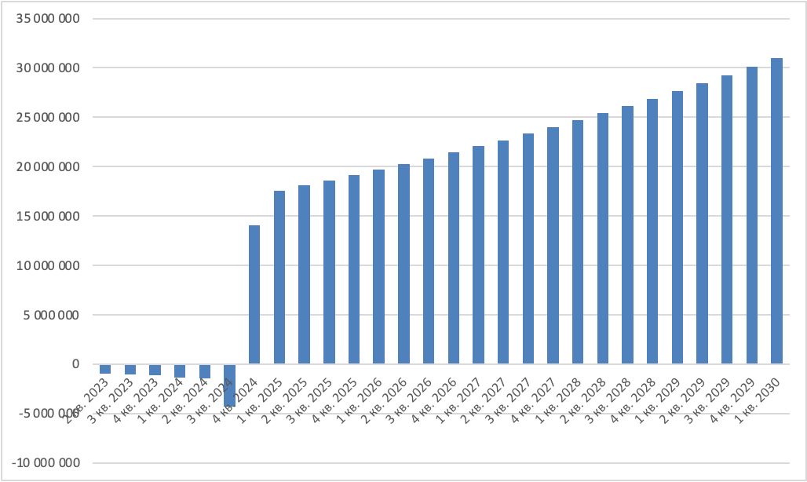(The company's profit before interest on loans, income tax and amortization of major intangible assets)

The company's profit growth is due to an inflation rate of 12% per annum.

## Raw materials and material costs

Seed consumption for plants is calculated based on the total amount of seeds needed by the greenhouse complex for the calculation period.

Consumption of seeds for the period (quarter) is: for tomatoes - 12500 units, for cucumbers - 13000 units. The average purchase price of seeds is: for tomatoes - 4 rubles / piece, for cucumbers - 2 rubles / piece.

The growth of purchasing prices over time and, accordingly, the growth of the total costs of raw materials in the profit and loss account is due to the inflation rate of 12%.

## Project personnel costs

The total estimated number of employees of the greenhouse complex is 106 people. From the very beginning of the investment phase of the project personnel costs are conditioned by the presence of the CEO and the chief accountant of the company. In the final period of the investment phase of the project the early recruitment of production and commercial staff begins - their number in this period reaches 23 people.

For more details on the project staff salary rates, see « Project Operational Plan - Personnel Information ».

## Data on operating expenses

The main items of operating costs of the project are gas and electricity supply.

The project plan includes a set of measures to reduce the costs of these items and prevent critical dependence of the project on the tariff supplying organizations.

The financial model of the project provides for contingencies.

## Data on planned investments

The main investment costs are planned for the 1st period of the investment phase of the project. This solution allows you to get the most favorable terms from suppliers, which reduces the investment capacity of the project and makes it more recoupable.

The size of the total investment in the project is: 153 000 000 rubles.

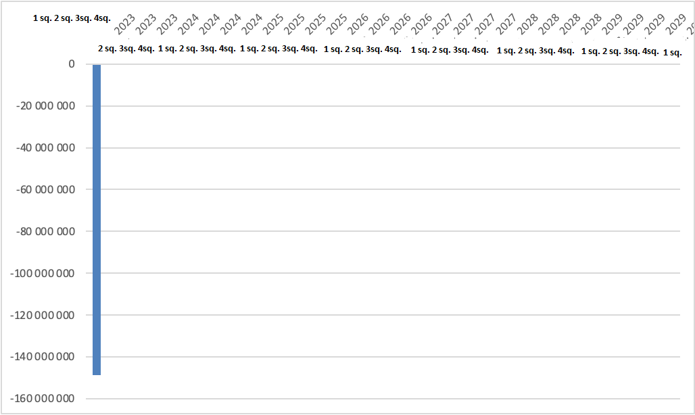**Graph: Investment cash flows**

## Data on availability of equity capital

The company initiator of the project intends to make investments in the project with its own funds in the amount of 11 600 000 rubles.

## Data on planned loans and credits

To implement the project, the company plans to borrow funds from a credit institution (investor) at a preferential credit rate of 6.5% per annum. The total amount of funds to be attracted is: 150,006,995 rubles. The calculated amount of interest on the loan amounts to: 31,879,119 rubles. The estimated term of credit is: 4.8 years.

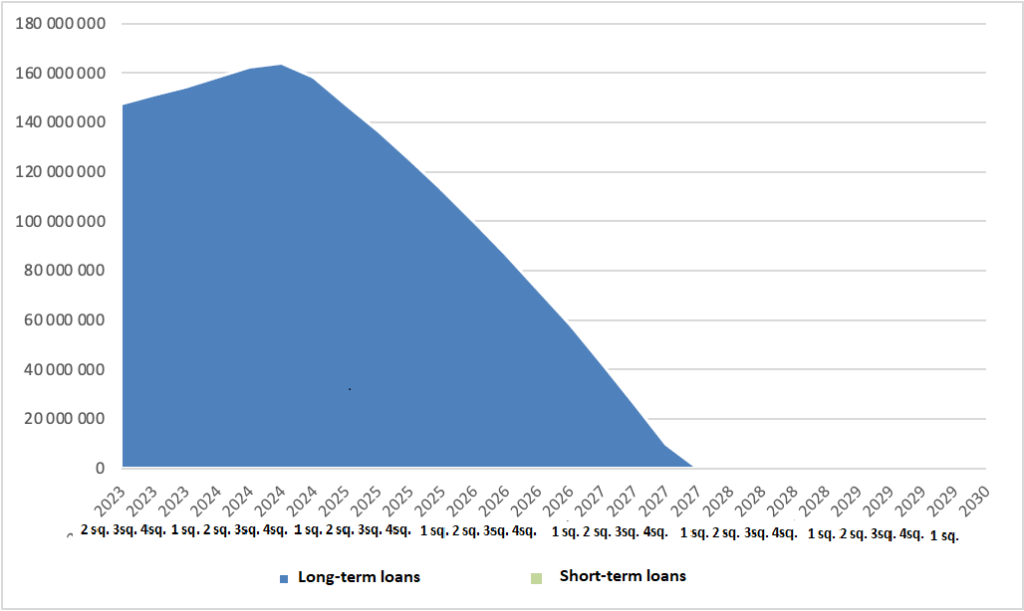**Graph: Indebtedness on loans**

## Data on tax payments

The company uses a special tax regime - the Single Agricultural Tax (SAT). With a rate of 6% on the difference between income and expenses. The company is a payer of social contributions. From other taxes the company is exempted.

Total for the estimated period of project activities (until Q1, 2030), the company will pay tax payments amounting to: 101,205,512 rubles.

## Profit and loss statement

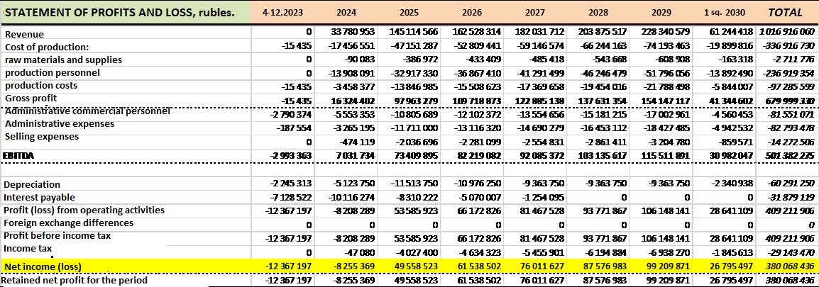

The total net profit of the project for the calculation period on an accrual basis by the 1st quarter of 2030 will be: 380,068,436 rubles.

## Statement of cash flows (direct)

Full repayment of the loan is scheduled for Q4 2027. Until then, the company's cash flow structure includes cash flows from operating activities, cash flows from investing activities and cash flows from financing activities.

Cash flows from investment activities cease as part of the investment phase of the project.

Cash flows from financing activities (receipt and return of borrowed funds) terminate in Q4 2027.

Thereafter, only cash flows from operating activities remain in the structure of the company's cash flows.

### 

### Graph: Cash balance at the end of the period

## Forecast balance of the company

The projected indicators of the company's balance sheet make it possible to conclude on its potential financial stability.

During the estimated period of the project total current assets of the company increases from 3 million rubles at the end of 2023 to 314 million rubles at the beginning of 2030.

The total non-current assets of the company at the end of the calculation period, taking into account depreciation, will be 153 million rubles.

## Calculation of project efficiency for the company (FCFF)

Calculation of the project efficiency for the company at a discount rate of 15.4% gives the following results:

* Net present value (NPV): 103,939,960 rubles
* Internal rate of return (IRR): 31,3%
* Modified rate of return (MIRR): 26,3%
* Discounted Payback Period (DPBP): 4.7 years
* Simple Payback Period (PBP): 3.7 years
* Rate of return on discounted costs (PI): 1.7 times.

### Graph: Payback for the company (FCFF)

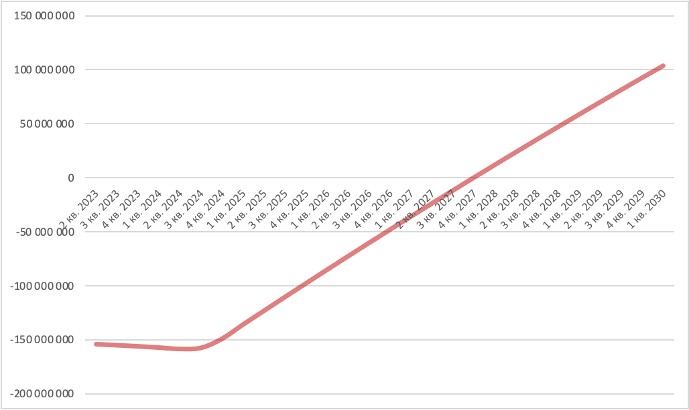

As can be seen from the graph, the payback period for the company is the 4th quarter of 2027.

## Calculation of project efficiency for shareholders (FCFE)

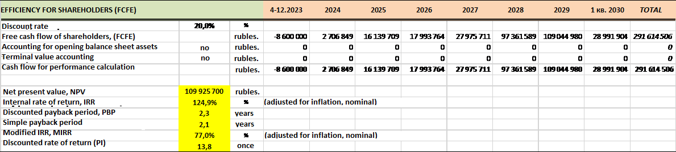

Calculation of the project efficiency for the company at a discount rate of 20% gives the following results:

* Net present value (NPV): 109,925,700 rubles
* Internal rate of return (IRR): 124,9%
* Modified rate of return (MIRR): 77,0%
* Discounted payback period (DPBP): 2.3 years
* Simple Payback Period (PBP): 2.1 years
* Rate of return on discounted costs (PI): 13.8 times.

### Graph: Payback for the company (FCFE)

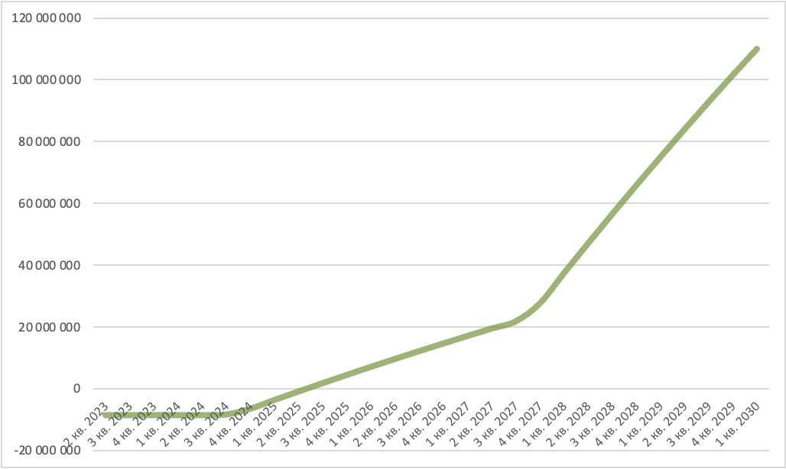

## Calculation of debt indicators

## Calculation of efficiency for the bank (CFADS)

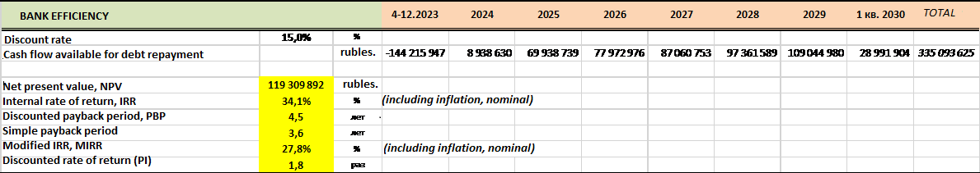Calculation of the efficiency of the project for the bank (investor) at a discount rate of 15% gives the following results:

* Net present value (NPV): 119,309,892 rubles
* Internal rate of return (IRR): 34,1%
* Modified rate of return (MIRR): 27,8%
* Discounted Payback Period (DPBP): 4.5 years
* Simple Payback Period (PBP): 3.6 years
* Rate of return on discounted costs (PI): 1.8 times.

### Graph: Payback for the bank (CFADS)

## Calculated estimate of business value

Estimation of the estimated value of the business by year:

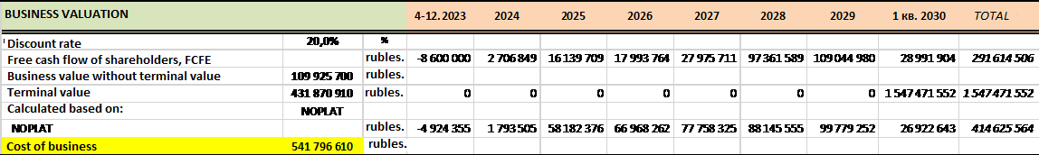

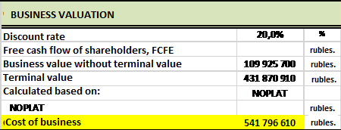The final assessment of the estimated value of the business:

At a discount rate of 20%, the estimated value of the business without regard to its terminal value would be: 109,925,700 rubles.

The estimated terminal value of the business will be: 431,870,910 rubles.

**The calculated amount of the full value of the business on the basis of NOPLAT will be: 541,796,610 rubles.**

Net operating income less adjusted taxes (NOPLAT) is earnings before interest and taxes (EBIT) after adjustments for deferred taxes. It is essentially a measure of earnings that includes the costs and tax benefits of debt financing.

## Calculation of profitability and turnover

Calculations show that the planned business will have good indicators of profitability and turnover, a significant "margin of safety" and a high ratio of current liquidity in all periods of the estimated duration of the project after the end of the investment phase from 2024.

## Calculation of the budgetary efficiency of the project

Within the estimated period of the project, cumulative tax receipts from the company will be as follows:

* to the federal budget - 78,648,245 rubles
* to the regional budget - 54,161,202 rubles
* total to all budget levels - 132,809,448 rubles

Taking into account discounting, the cumulative net present value (NPV) will be:

* to the federal budget - 44,255,315 rubles
* to the regional budget - 29,728,705 rubles
* to all levels of the budget - 73,984,020 rubles

# Sensitivity analysis of the project

Sensitivity analysis of the project allows you to judge the sustainability of the project in the case of changes in its main parameters.

The project shows the following sensitivity to changes:

## Sensitivity of the Net Present Value (NPV) parameter

### Sensitivity of NPV of the project to sales volume:

A 20 or 30% decrease in sales volume makes the project unprofitable.

This indicator is critical for the project.

### Sensitivity of NPV of the project to sales prices:

A 30% decrease in sales prices makes the project unprofitable.

This indicator is significant for the project.

### Sensitivity of NPV of the project to the costs of raw materials:

A 30% increase in the cost of raw materials and supplies does not lead to a significant change in the NPV of the project.

This indicator is not significant for the project.

### Sensitivity of NPV of the project to personnel costs:

A 30% increase in personnel costs leads to a 50% decrease in the NPV of the project.

This indicator is important for the project.

### Sensitivity of NPV of the project to operating costs:

A 30% increase in operating costs leads to a 30% decrease in the NPV of the project.

This indicator has no significant impact on the project.

### Sensitivity of NPV of the project to investment costs:

An increase in investment costs by 30% leads to a 50% reduction in the NPV of the project.

This indicator is important for the project.

## 8.2 Sensitivity of the Internal Rate of Return (IRR) parameter

### Sensitivity of project IRR to sales volumes:

A 30% decrease in sales leads to a reduction in the project's IRR below the discount rate - to 4.6%. The indicator is critical for the project.

### Sensitivity of project IRR to sales prices:

A 30% decrease in sales leads to a reduction in the project's IRR below the discount rate - to 4.6%. The indicator is critical for the project.

### Sensitivity of the IRR of the project to the costs of raw materials:

A 30% increase in the cost of raw materials and supplies leads to a negligible reduction in the IRR of the project: from 31.3% to 31.2%.

### Project IRR sensitivity to personnel costs:

A 30% increase in personnel costs leads to a reduction in project IRR from 31.3% to 24.1%.

### Sensitivity of project IRR to operating costs:

An increase in operating expenses of 30% leads to a slight decrease in the IRR of the project: from 31.3 to 27%.

### Sensitivity of project IRR to investment costs:

An increase in operating costs of 30% leads to a reduction in the IRR of the project by the value: from 31.3 to 22,8%.

## Sensitivity of the Discounted Payback Period Parameter (DPBP)

### DPBP project sensitivity to sales volumes:

A decrease in sales of 20 or 30% leads to an underachievement of the project's payback. The indicator is critical for the project.

### DPBP project sensitivity to sales prices:

A decrease in sales prices of 20 or 30% leads to an underachievement of the project's payback. The indicator is critical for the project.

### DPBP project sensitivity to raw material costs:

A 30% increase in the cost of raw materials and supplies does not lead to a noticeable change in the DPBP indicator of the project.

### DPBP project sensitivity to personnel costs:

A 30% increase in project personnel costs results in a change in the project DPBP from 4.7 years to 5.5 years - that is, the impact is significant.

### DPBP project sensitivity to operating costs:

A 30% increase in project operating costs results in a change in the project DPBP from 4.7 years to 5.2 years.

### DPBP project sensitivity to investment costs:

An increase in investment costs of the project by 30% leads to a change in the DPBP indicator of the project from 4.7 years to 5.7 years, that is, by 1 year.

## Conclusions on sensitivity analysis

**Based on the sensitivity analysis of the project, we can conclude that the main parameters that have a significant impact on the sustainability of the project are:**

* **sales volume - critical impact**
* **sales prices - critical impact**
* **investment costs - average impact**
* **Staff costs - average impact**
* **operating costs - moderate impact**
* **raw material costs - negligible impact.**

# Risk analysis

## SWOT analysis of the project

**S – project strengths:**

* Close location of the object to the main markets;
* Experience of the project initiator in the agricultural business;
* Ready base of potential consumers of finished products;
* Planned autonomy and reduced cost of basic expendable categories (gas and electricity);

**W – project weaknesses:**

* Sufficiently high saturation of the market with similar goods;
* The need to build and connect the object to the communications "from scratch";
* Dependence on resource supplying organizations-monopolists on the main cost items of operating costs.

**O – project features:**

* Possibility to organize further processing of products within the framework of a greenhouse complex with extra added value;
* Potential of export orientation to foreign markets;
* Achievement of full independence from the resource supplying organizations-monopolists in some major items of operating costs (water and electricity);
* Project scaling.

**Т – potential threats:**

* The main potential threat is the risk of a significant and sudden increase in tariffs to pay for basic operating costs (gas, electricity, water) from organizations-monopolists;
* The second most important is the risk of changes in the marketing situation in the direction of overstocking of the market and the excess of supply over demand (especially in the summer and autumn months).

# Conclusion on the project

# Contact information

Contact information of the project initiator:

**Persona:**

Ibragim Ibragim Hajimusaevich

**The address is:**

Russian Federation

Moscow Region

г. Orekhovo-Zuyevo

ul. 2, Moskovskaya St., office 011

**Phone:**

+7 928 800 55 57

**e-mail:**

agromoskva09272018@mail.ru