# Is Harry Styles Having a Tour in 2023?

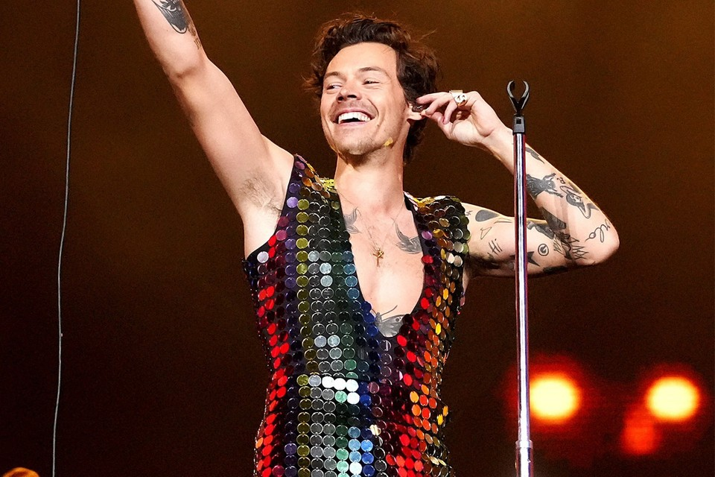

<https://image-cdn.hypb.st/https%3A%2F%2Fhypebeast.com%2Fwp-content%2Fblogs.dir%2F6%2Ffiles%2F2022%2F07%2Fharry-styles-texas-state-university-course-class-info-0.jpeg?w=960&cbr=1&q=90&fit=max>

Harry Styles is one of the most iconic musicians nowadays. He toured a lot in 2021-22, performing in 43 well-known arenas in New York City, London, and many other countries. “Is Harry Styles having a tour in 2023?” many fans ask. Sure! It will be a highly anticipated tour devoted to his new album “Harry’s House.” In 2023, his European tour will be Harry’s first full-stadium tour in the European arenas.

However, his first European tours are going to take place in spring 2023 as the continuation of his “Love On Tour.” He will perform on three tour dates in Munich, Dusseldorf, and Frankfurt venues. There will probably be additional dates for these three locations because of the huge demand.

Yes, Harry Styles is one of the most influential musicians of this day. You can listen to his tracks on many streaming platforms. YouTube Music, Spotify, Tidal, [Amazon Music](https://musconv.com/amazon-music-to-apple-music/), and others are happy to host his works. You may be immensely interested in his record-breaking single “As It Was” for the latest, and third in order, the album “Harry’s House.” The album was warmly praised by critics worldwide.

Harry Style’s two other albums are the self-titled one, released in 2017 as a debut solo album, and “Fine Line,” released in 2019. The former became one of the ten best-selling albums of the year, while the latter reached the top of the Billboard 200.

Harry has won many prestigious awards since he started his solo career. They include a Grammy Award, two BRIT awards, an American Music Award, an Ivor Novello Award, and several others. He appeared on the cover of Vogue alone, and it was the first case of this kind.

The artist also achieved the most successful sales week as a solo male singer in the UK. nevertheless, he is also well-appreciated as a talented live performer. His first concert on “Love On Tour” shows was postponed many times because of the pandemic and took place only in September 2021 in Las Vegas. 40 other concerts followed it in the USA and gained him a lot of praise and appreciation from both fans and critics. On April 15 and April 22, 2022, Harry became a headliner of the legendary Coachella Festival. He performed his hit singles “Lights Up,” “Watermelon Sugar,” “Sign of the Times,” and others in front of more than 100 thousand people.

All of Harry’s fans are looking forward to his European tour this year. You can join the club, buy tickets for live performances, or follow his tours online.