M. V. LOMONOSOV MOSCOW STATE UNIVERSITY

FACULTY OF FUNDAMENTAL MEDICINE

Essay on

«Rare allergic diseases»

**Allergy to own child**

The essay was done by student of group 403

Kanevsky Fedor Vladimirovitch

Moscow

2023

Contents

List of used abbreviations 2

Introduction 2

Etiology 2

Epidemiology 3

Pathogenesis 3

Clinical presentation 4

Diagnostics 6

Differential diagnosis 8

Therapy 8

Risks for fetus and newborn 9

Conclusion 9

References 9

# List of used abbreviations

* BM – basal membrane
* BP – bullous pemphigoid
* PG – pemphigoid gestationis
* PEP – polymorphic eruption of pre

# Introduction

In April 2021 a young woman from England Fiona Hooker found urticarial plaques on her body that looked like “nettle stings”. At that moment she was in her 7th month of pregnancy. Topical steroids were prescribed to her but after delivery, an exacerbation with blisters occurred. Fiona couldn’t even hold her baby. However, soon the woman felt better and almost all of the lesions disappeared [11].

In fact, Mrs. Hooker suffered an allergic reaction to her own baby. Doctors diagnosed pemphigoid gestationis (PG), which is a specific autoimmune dermatosis of pregnancy [6, 11].

# Etiology

There are several cause-effect relationships in the development of PG. Thus, PG may appear as a paraneoplastic syndrome caused by a trophoblastic tumor or choriocarcinoma. It can also be due to by hydatidiform mole [4].

The development of PG is supposed to be associated with the level of female sex hormones. It should be noted that progesterone depresses and estrogens enhance immunity. Therefore, there are many cases of exacerbation of PG pre-menstrually and right after delivery. In such situations, there is an increase in progesterone blood level and decrease in estrogens. One of the causes of PG may also be use of oral contraceptives [6].

A study shows that there are some genetic predeterminants of PG. Women with HLA-DR3 and HLA-DR4 alleles bear a higher risk of developing PG [2]. The presence of allele MHC III could also impact the pathogenesis of PG [6].

# Epidemiology

Incidence of PG composes 1 case per 20000 – 50000 pregnancies [4]. It usually hits multiparous women [8].

# Pathogenesis

The key point of PG pathogenesis is the production of autoantibodies against a component of skin namely collagen XVII (BP180). This protein represents a transmembrane glycoprotein contained in hemidesmosomes. Hemidesmosomes provide contact between epithelium cells and specific extracellular matrix–basal membrane (BM). Collagen XVII is expressed most abundantly in skin, mucosa, and trophoblastic cells [2, 10].

It should be noted that trophoblastic cells do not express MHC II in normal pregnancy. Some of these cells contact with the maternal blood and some of them even circulate within it [3]. In the absence of MHC II, trophoblastic cells cannot present antigens to mother immune cells. By PG these cells get the ability to express MHC II and to present antigens. Thus, the presentation of collagen XVII epitopes (usually this is NC16A domain) begins. This causes the synthesis of antibodies (usually IgG) against collagen XVII. The immunocomplexes are formed in the basal membrane, the complement system is activated, and inflammation develops (Fig. 1) [2, 6].

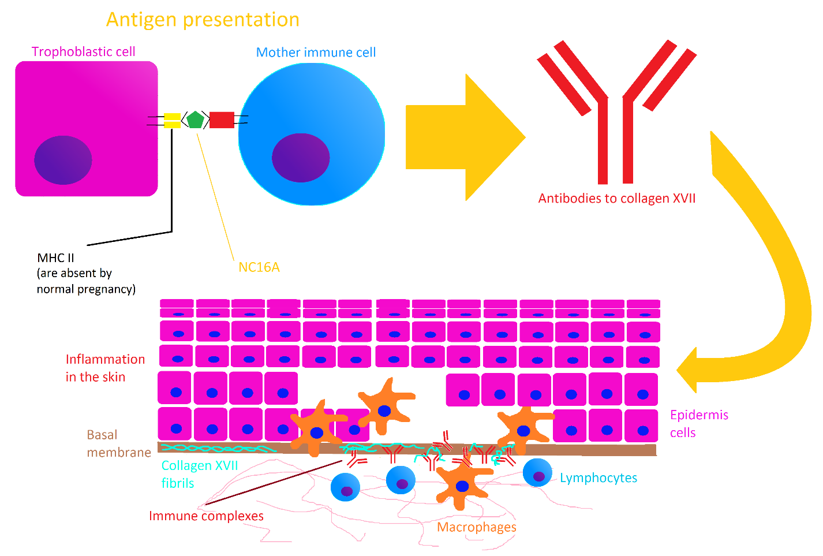

Figure 1. Pathogenesis of PG. The image is of author.

# Clinical presentation

The development of inflammation in the basal membrane of the epidermis leads to the typical clinical presentation of PG. Firstly, urticarial lesions appear on the skin: macules up to erythema, papules, blisters, and annular plaques (Fig.2 – B, C). Henceforth, vesicles change these lesions. As a result, big tense bullae are formed. (Fig. 2 – A, Fig. 3). It is important that pruritus is the main symptom of PG [2, 5].

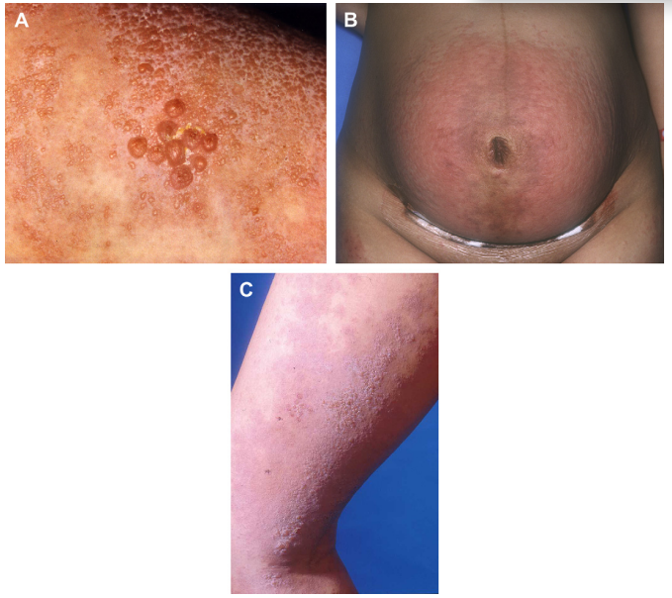

Figure 2. Skin lesions by PG. A – bullae in the midst of papules and erythema. B – erythema on the stomach. C – blisters, papules and erythema on the leg [2].

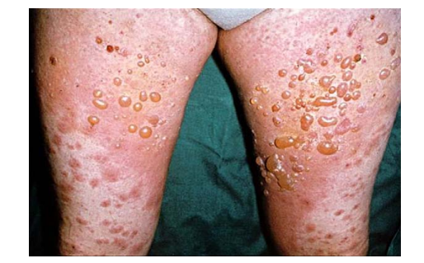

Figure 3. Big tense bullae in the midst of erythema and blisters [6].

The time interval between primary lesions and tense bullae varies from days to 4 weeks [2].

The lesions are generally localized on the skin of the periumbilical area, thighs, palms, and soles [2]. Eruptions may rarely appear (less than 10% of patients) on the face and mucosa [7].

Lesions initially appear in the periumbilical area (50% of patients) but they can also initially appear on the extremities [7].

The onset of PG typically falls in the second or third trimester of pregnancy. Sometimes it could begin earlier. PG often manifests after delivery. Whereby the postnatal PG is typically explosive and begins most commonly in the first 3 days postpartum [7].

The disease may be solved after the end of pregnancy but it is an inconstant clinical tendency. Postpartum exacerbation is a common event. The mean duration of such a condition composes about 28 weeks and depends on many things, including the severity of PG, type of lesions, and the number of pregnancies hit by PG. There is also a relation between breastfeeding and PG duration [6, 7].

# Diagnostics

The diagnosis requires generally two main investigation methods: histopathology and direct immunofluorescence. In unclear cases, additional approaches may be used: ELISA, immunoblotting, and indirect immunofluorescence [6]. It is also possible to make a genetic test for the presence of HLA-DR3 and HLA-DR4 [2].

There are specific features of PG for every investigation approach:

1. ***Histopathology***Spongiosis up to blister development is specific for PG. There are eosinophils in the spongiotic fluid. The edema in the derma with perivascular infiltrates, which include eosinophils and lymphocytes, is also present (Fig. 4) [2].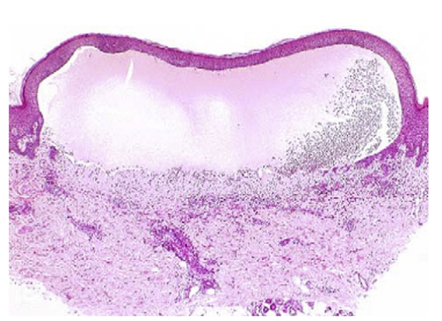

Figure 4. Histopathologic features of PG. There is a subepidermal blister with big mount of eosinophils [2].

1. ***Immunofluorescence***
   1. *Direct*The deposits of C3 and sometimes IgG could be found in the basal membrane of the epidermis (Fig. 5) [2].

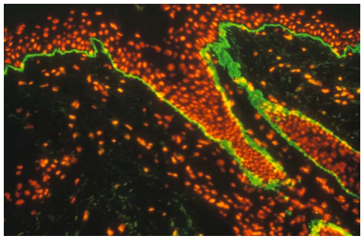

Figure 5. Direct immunofluorescence of the peri-lesional skin. There are deposits of C3 along the epidermo-dermal junction, i. e. in the basal membrane area [6].

* 1. *Indirect*By using indirect immunofluorescence the circulating C3 against BM may be found out (90% of cases). Circulating IgG may also be detected but less often (less than 25% of cases) [6].

1. ***ELISA***This method allows to detect IgG to collagen XVII namely to NC16A and other epitopes [2].
2. ***Immunoblotting***Through immunoblotting circulating antibodies to 180 kDa and 230 kDa proteins may be detected. For this reason, immunoblotting is useful for cases that are negative by indirect immunofluorescence. In such cases other PG-specific antigens besides collagen XVII (BP180) could be found, e.g. BP230 [2].

# Differential diagnosis

By differential diagnostics of PG, it is necessary to exclude two main diseases: polymorphic eruption of pregnancy (PEP) and bullous pemphigoid (BP).

1. *Polymorphic eruption of pregnancy*PEP is a much more frequent disease than PG (1 case per 120-200 pregnancies) [9]. PEP represents a benign dermatosis of pregnancy. It usually hits primiparous women in the third trimester. It is difficult to distinguish PEP and the initial stages of PG. PEP is characterized by urticarial papules and plaques. Small vesicles can be formed but big tense bullae almost never occur with PEP. Skin lesions are localized in the area of striae on the stomach but not in the periumbilical area [6].
2. *Bullous pemphigoid*BP most often hits the skin of the thighs and lower legs. The predominant age of patients is over 50 years old. There is no noted association between pregnancy and the development of BP [6].

Other skin conditions, which coincide with pregnancy, should also be excluded. History and clinical presentation usually allow the establishment of a correct diagnosis. In unclear cases, other approaches noted above may be used [6].

# Therapy

Therapy of PG still represents an unsolved problem [8]. Therapy during pregnancy is especially difficult because it requires finding the equilibrium between struggling with the severity of the disease and saving the fetus that suffers because of drugs [6].

During pregnancy, the main goal of therapy is to ease itchiness and prevent new blisters formation [6]. Treatment of choice includes high-potency topical steroids [4]. In difficult cases, systemic steroids may be used in a dose of 0.5 mg/kg/day [8]. Systemic therapy must be prescribed only in cases when the severity of PG overcomes the risks for the fetus [6]. It also should be noted that placental enzymes inactivate around 88% of prednisolone crossing the placenta. Dexamethasone and betamethasone do not suffer such an inactivation and cross the placenta easily. That is why these two drugs can have a strong impact on the state of the fetus. They can cause growth retardation and suppress adrenal function [6]. For prednisolone, it should also be noted that it is excreted in small amounts in breast milk. Doses up to 40 mg are thought to be safe [6]. It is also very important that topical steroids especially those with high potency can be absorbed by the skin and cause systemic effects [1].

Topical steroids may be prescribed in combination with the 1st generation H1 – blockers for higher effectiveness in struggling the itchiness. The main H1 – blockers are diphenhydramine and chlorpheniramine [4, 6].

For patients that are resistant to steroids immunoadsorption and intravenous immunoglobulin are indicated [4].

By postpartum PG additional classes of drugs become available. However, they are used only in cases when there is no breastfeeding. Thus, further immunosuppressants may be prescribed: methotrexate, azathioprine, gold, pyridoxine, sulfapyridine, dapsone, and rituximab. The combination of tetracycline with nicotinamide may also be effective [4].

# Risks for fetus and newborn

PG generally carries no grave danger for the child. It is known that PG may cause a pre-term delivery and prematurity of the fetus. The association between the early manifestation of the disease (in the first or second trimester of pregnancy) with the presence of blisters and preterm delivery with lack of weight of the newborn is revealed. Systemic steroids used correctly have almost no risks of damage to the fetus [2].

PG can rarely cause skin lesions in the newborn. But such lesions disappear rapidly (in days or weeks) and bear no negative outcomes [2].

# Conclusion

Pemphigoid gestationis is a rare disease. Therefore, it is very important to exclude other more frequent conditions (e.g. PEP) before establishing this diagnosis. If PG is confirmed it should be treated carefully keeping in mind the possible risks and side effects of drugs for the fetus. Systemic therapy should be prescribed only in extreme cases. Betamethasone and dexamethasone must not be prescribed. Prednisolone should be indicated in a dose less than 40 mg. Topical steroids must not be used uncontrollably. Patients should not put it very abundantly on the skin or use it for a very long time. With correct therapy, PG will not carry any negative consequences for both mother and child.

# References

1. Coondoo A, Phiske M, Verma S, Lahiri K. Side-effects of topical steroids: A long overdue revisit. Indian Dermatol Online J. 2014 Oct;5(4):416-25. doi: 10.4103/2229-5178.142483. PMID: 25396122; PMCID: PMC4228634.
2. Intong LR, Murrell DF. Pemphigoid gestationis: pathogenesis and clinical features. Dermatol Clin. 2011 Jul;29(3):447-52, ix. doi: 10.1016/j.det.2011.03.002. PMID: 21605810.
3. Loke YW, Hiby S, King A. Human leucocyte antigen-G and reproduction. J Reprod Immunol. 1999 Jul;43(2):235-42. doi: 10.1016/s0165-0378(99)00023-6. PMID: 10479059.
4. Sadik CD, Lima AL, Zillikens D. Pemphigoid gestationis: Toward a better understanding of the etiopathogenesis. Clin Dermatol. 2016 May-Jun;34(3):378-82. doi: 10.1016/j.clindermatol.2016.02.010. Epub 2016 Feb 9. PMID: 27265076.
5. Schmidt E, Zillikens D. Pemphigoid diseases. Lancet. 2013 Jan 26;381(9863):320-32. doi: 10.1016/S0140-6736(12)61140-4. Epub 2012 Dec 11. PMID: 23237497.
6. Semkova K, Black M. Pemphigoid gestationis: current insights into pathogenesis and treatment. Eur J Obstet Gynecol Reprod Biol. 2009 Aug;145(2):138-44. doi: 10.1016/j.ejogrb.2009.05.012. Epub 2009 Jun 10. PMID: 19520487.
7. Shornick JK. Herpes gestationis. J Am Acad Dermatol. 1987 Oct;17(4):539-56. doi: 10.1016/s0190-9622(87)70237-0. PMID: 3312312.
8. Soutou B, Aractingi S. Skin disease in pregnancy. Best Pract Res Clin Obstet Gynaecol. 2015 Jul;29(5):732-40. doi: 10.1016/j.bpobgyn.2015.03.005. Epub 2015 Mar 17. PMID: 25862358.
9. Taylor D, Pappo E, Aronson IK. Polymorphic eruption of pregnancy. Clin Dermatol. 2016 May-Jun;34(3):383-91. doi: 10.1016/j.clindermatol.2016.02.011. Epub 2016 Feb 9. PMID: 27265077.
10. Tuusa J, Kokkonen N, Tasanen K. BP180/Collagen XVII: A Molecular View. Int J Mol Sci. 2021 Nov 12;22(22):12233. doi: 10.3390/ijms222212233. PMID: 34830116; PMCID: PMC8623354.
11. WEB resource: <https://www.independent.co.uk/news/health/mother-allergic-severe-rash-stomach-gene-rare-b2012879.html>