**Scientific Society of History of Diplomacy and International Relations**

**Hans Seidel Foundation in Ukraine**

Information partner:

**“Mediacenter” Directorate of the State Enterprise**

**“Directorate-General for Rendering Services to Diplomatic Missions"**

Research partner:

**Institute of History of Ukraine of the National Academy of Sciences of Ukraine**

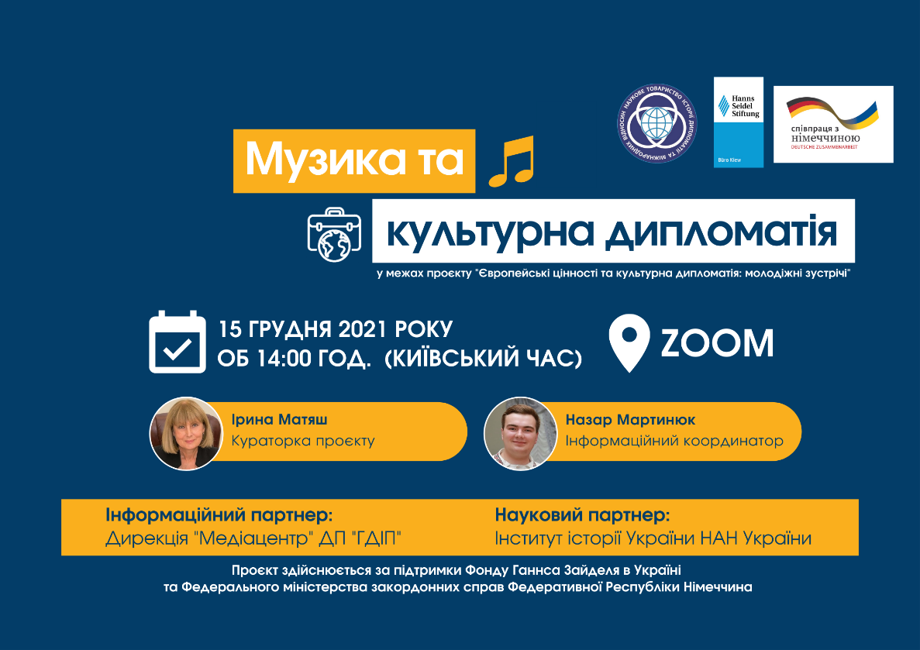

**______________________________________________________________________________________________**

programme of the online event

**«MUSIC AND CULTURAL DIPLOMACY»**

within the project

“European Values and Cultural Diplomacy: Youth Meetings”

*December 15, 2021*

**Participants:**

* representatives of the Ministry of Foreign Affairs of Ukraine, representatives of Ukrainian foreign diplomatic missions
* experts in diplomatic relations and cultural diplomacy
* students and professors of the Institute of Humanities and Social Sciences of the Lviv Polytechnic National University
* students and professors of the National University of Ostroh Academy
* students and professors of the Institute of International Relations and the Faculty of History of Taras Shevchenko National University of Kyiv
* students and professors of the Bohdan Khmelnytskyi National University of Cherkasy
* students and teachers of the Odesa National University named after II Mechnikov
* students and teachers of Shota Rustaveli Batumi State University (Batumi, Georgia)
* students and teachers of the Georgian Aviation University
* students and teachers of the Institute of Ukrainian Studies and the Faculty of Psychology and Pedagogy of Ivane Javakhishvili Tbilisi State University (Tbilisi, Georgia);
* students and teachers of Sokhumi State University (Tbilisi, Georgia);
* students and professors of the Faculty of International Relations, Political and Administrative Sciences of the Moldova State University
* students and professors of the Faculty of International Relations of the Free International University of Moldova (ULIM)
* students and professors Gregory Tsamblak Taraclia State University

**Venue:**

Kyiv, 6-A Pyrohova St

GDIP “Mediacenter” Directorate

**Event coordinator:**

**Iryna Matiash** – Chairman of the Scientific Society of the History of Diplomacy and International Relations, Doctor of Historical Sciences, Professor, Leading Researcher of the Department of History of International Relations and Foreign Policy of Ukraine of the Institute of Ukraine’s History of NAS of Ukraine, Curator of the project “European Values and Cultural Diplomacy: Youth Meetings”

**Information coordinator:**

**Nazar Martyniuk −** Information Secretary of the Scientific Society of History of Diplomacy and International Relations, Research Fellow of the Institute of the Ukrainian Diaspora Studies of National University of Ostroh Academy named after Professor Liubomyr Vynar

**Link to the Facebook event:** <https://fb.me/e/1ivsgcx6a>

**Start of the Event:** 14:00 (Kyiv time)

**Languages:** Ukrainian, English

**Connection Data**

**Zoom**

*Connection data:*

Identifier: 870 8700 4054

Code: 967803

Link:

<https://us02web.zoom.us/j/87087004054?pwd=eWN5Y2piY0JSaWpSVllSZ2w2Q2FZUT09>

Record on the GDIP Media Center YouTube channel: <https://youtu.be/EcZuqEEcNaw>

*Модераторка:* **Iryna Matiash** – Curator of the project “European Values and Cultural Diplomacy: Youth Meetings”

14.00 – 14:15 *Opening remarks:*

* **Oresta Starak** − Head of the Public Diplomacy Department of the Ministry of Foreign Affairs of Ukraine
* **Levan Tsurtsumiia** − Deputy Ambassador, Counselor-Envoy of the Embassy of Georgia in Ukraine
* **Ion Stevile** − Diplomat, Historian, Ambassador Extraordinary and Plenipotentiary of Moldova to Ukraine (2010 − 2011)
* **Olena Maksymova** − Deputy Director of the Hans Seidel Foundation in Ukraine

14.15 – 16.30 *Main part:*

* **Tatiana Homon** − pianist, candidate of art history, curator of the Borys Liatoshynskyi Cabinet-Museum
* **Victor Rekalo** − cellist of “New Era Orchestra” (Kyiv), participant in the baroque music project “Open Opera Ukraine” (Kyiv), artist of the NGO “Kyiv Soloists”, music director of the Gallery of Contemporary Art “COME IN” (Kharkiv) and CXID Chamber Stage CXID OPERA of the Kharkiv National Academic Opera and Ballet Theater named after M.V. Lysenko
* **Anna Nikitina** − artist of the theater “Dakh”, Dakh Daughters and Ragapop bands
* **Iveri Kekenadze** − Specialist of the Department of International Relations of the Tbilisi State Conservatory, ERASMUS + Program Coordinator
* **Nini Kutelia** − Assistant Rector of the Tbilisi State Conservatory, ERASMUS + Program Coordinator
* **Vasile Mereuca** − singer, actor, folk singer, host of the National Radio of the Republic of Moldova
* **Vali Boghean** − composer, arranger, leader of the Vali Boghean Band
* **Ion Warta** − doctor of historical sciences, a member of the Scientific Society of History of Diplomacy and International Relations

16.30 – 16.45 *Presentation of students of Sukhumi State University (Tbilisi, Georgia), mentor - Doctor of Philology, Professor Indira Dzagania*

16.45 – 17.15 *Presentation and discussion of works within the framework of the amateur video contest “Musical business card of the country and native land: how to tell about your country in 5 minutes through music / song”*

17.15 – 17.30 *Discussion; summing up the event*