Tactile and audio navigation system for visually impaired people

Author: ______
Instructors: ______
Date: 20/02/2023
Organization: Chemistry and Biology Nazarbayev Intellectual School in Almaty

Problem
Visually impaired individuals face challenges in navigating and orienting themselves in unfamiliar environments. Current assistive technologies, such as canes, guide dogs and yellow-colored tactile tiles have limitations and do not provide comprehensive guidance for safe and efficient navigation. As a result, visually impaired individuals may experience difficulties in accessing and engaging with their surroundings, leading to reduced independence and quality of life. The objective of this project is to develop an effective and reliable navigation aid system for visually impaired individuals. The system should provide real-time, accurate, and personalized information about the environment to help users navigate safely and efficiently. The navigation aid system should be easy to use, portable, and adaptable to different environments and situations.

Description of the project
One type of device that can assist visually impaired individuals in navigation is an obstacle detection system. This system typically consists of one or more sensors that can detect nearby obstacles and provide alerts to the user when they get too close. The sensors use technologies such as ultrasonic, infrared, or laser to detect the distance between the user and the obstacles. When an obstacle is detected, the system provides feedback to the user in a variety of ways, such as audio, tactile, or vibration feedback. For this project’s prototype the ultrasonic sensors and audio feedback were applied. The system is configured to detect obstacles at different heights and distances, independent on the angle it’s tilted by and can be adjusted based on the user's individual needs and preferences. The device is also designed to create mapping of the room and any detected motionless obstacles based on determined distance and angles of all axes to use as a future reference to improve the navigation process with the use of accelerometer, gyroscope, and magnetometer sensors. All the sensors are properly calibrated, filtered, and can read accurate angle measurements. Data from sensors allows for 3D mapping and navigation via tactile feedback glove or sound. To obtain clean data, gyroscope and accelerometer samples go through a complementary filter, whereas magnetometer samples undergo hard and soft-iron calibration.
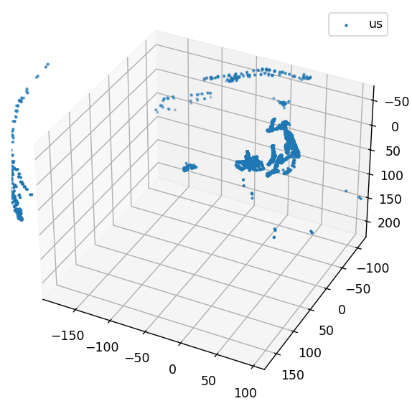
Figure 1. 3D plot of the room obtained by our device. Blue dots indicate obstacles

Overall, the obstacle detection system is designed to provide visually impaired individuals with an additional layer of awareness and safety when navigating their environment. By alerting the user when they get too close to obstacles, this device can help prevent accidents and promote greater independence and confidence in navigation. This project also has economic benefits by reducing installment of tactile yellow flooring inside the buildings or other certain areas that would otherwise require the use of the new navigation device. A pack of 10 of such tiles would cost around 20 euros.

Existing examples
In Kazakhstan, according to the detailed internet research, there is only one organization responsible for providing the technologies for rehabilitation and assisting persons with various disabilities, including those visually impaired – www.istok-audio.kz. While its role is to provide, the organization does not possess or claim any ownership over the technologies. The prices on their website are disclosed, however as seen from sales in other countries the prices vary between 50000 and 150000 tenge, which speaks low of the accessibility and affordability of those items in the area of Kazakhstan.
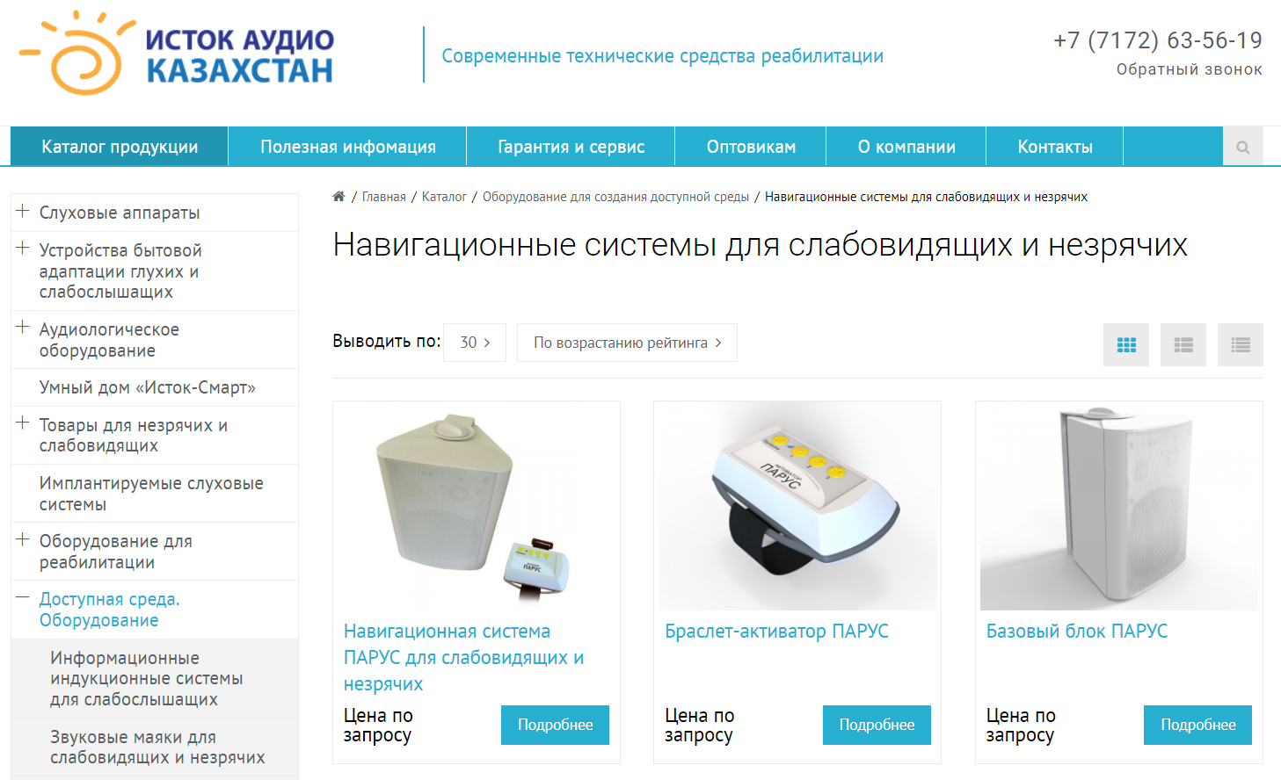
Figure 2. Istok-audio products

Some examples of obstacle detection systems used in other countries include wearable devices that use ultrasonic sensors, such as the Ultracane, or handheld devices that use both audio and tactile feedback, such as the BAWA Cane. Guide dogs are also commonly used to assist visually impaired individuals in navigation, and there are many organizations around the world that provide guide dogs to those in need. These organizations are typically non-profit and rely on donations and support from volunteers. Some well-known organizations that provide guide dogs include:
- Guide Dogs for the Blind - With locations in the United States and the United Kingdom, Guide Dogs for the Blind is one of the largest guide dog organizations in the world.
- The Seeing Eye - Based in the United States, The Seeing Eye is the oldest guide dog organization in the world and has been providing guide dogs since 1929.
- Canadian Guide Dogs for the Blind - Based in Canada, this organization provides guide dogs to Canadians who are visually impaired, Deaf-Blind, or who have other disabilities.

Additionally, there are several smartphone apps that use GPS and audio feedback to provide directions and information about the user's surroundings, such as BlindSquare and Nearby Explorer, which are irrelevant to the type of technology used in this project.

Recommendations for use
The device can be worn by the user in a variety of ways, such as:
- Head-mounted device: The ultrasonic sensor-based device can be mounted on a headband or a pair of glasses. This way, the device can detect obstacles in the user's path and provide audio feedback through earphones or a speaker placed near the user's ear.
- Hand-held device: The ultrasonic sensor-based device can also be designed as a hand-held device that the user can hold while walking. The device can be held at waist height, and it will detect obstacles in the user's path and provide audio feedback through a speaker or earphones.
- Waist-mounted device: Another way to wear the device is to mount it on the user's waist. This way, the device can detect obstacles in the user's path and provide audio feedback through a speaker or earphones placed near the user's waist.
- Ankle-mounted device: The ultrasonic sensor-based device can also be mounted on the user's ankle. This way, the device can detect obstacles in the user's path and provide audio feedback through a speaker or earphones placed near the user's ankle.
- Smartwatch device: A smartwatch equipped with an ultrasonic sensor-based device can also assist visually impaired people. The device can detect obstacles in the user's path and provide audio feedback through a speaker or through vibration alerts.

The choice of the wearing style may depend on the user's preference, comfort, and convenience. The device should be designed in a way that it can provide accurate detection of obstacles, clear audio feedback, and ease of use for the user.

References
https://www.istok-audio.kz/catalog/dostupnaya_sreda/navigatsionnye_sistemy/
https://www.best-microcontroller-projects.com/
https://www.youtube.com/watch?v=fIlklRIuXoY
http://sailboatinstruments.blogspot.com/2011/08/improved-magnetometer-calibration.html
https://sites.google.com/site/wayneholder/self-driving-rc-car/calibrating-the-compass
https://en.wikipedia.org/wiki/GPS_for_the_visually_impaired
https://en.wikipedia.org/wiki/Visual_impairment
https://en.wikipedia.org/wiki/Guide_dog
https://cablematic.com/en/products/yellow-rubber-tactile-tile-30x30cm-avance-stripes-10-pack-BT092/
https://www.allaboutcircuits.com/uploads/articles/A_comparison_of_complementary_and_kalman_filtering.pdf
https://arxiv.org/pdf/2201.02449.pdf
https://www.magnetic-declination.com

