Svitlana Lorman

Tel: +380683665095

+380935469158

Email: svlormanua@gmail.com

Telegram: @svitlanalorman

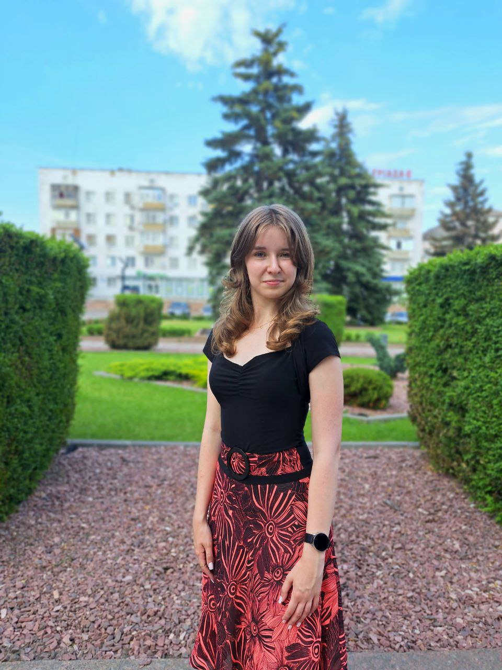

**Portfolio:**

https://drive.google.com/drive/folders/1bzFhy4tPvEnFh-rSv0VExnhWmyuhrbFp

I am a specialist with 3 years of experience in written and oral translation. I have translated and written over 50 projects, from documents to entire websites. I have also created more than 20 custom presentations for students.

**Hard skills:**

• Proficient in Ukrainian and Russian as a native speaker, English - C1, German – B2, French - A2.

• Excellent skills in Power Point, Word, Canva, and Figma.

• Junior in C#, HTML and CSS.

• Junior in UI/UX design.

• Creative writing and copywriting skills.

**Soft skills:**

• Excellent verbal, nonverbal, and written communication.

• Analytical and research skills.

• Goal-oriented and communicative.

• Self-management and self-motivation.

• Time management and multitasking.

**Work experience:**

Freelance Translation and Presentation Creation (since July 2021)

• Oral and written translation in topics such as literature, economics, philosophy, finance, etc. based on specified requirements and technical task.

• Translation of technical texts and standard documents into agreed terms.

• Writing works, course papers, homework assignments in English and German.

• Creation of plans and summaries in foreign languages.

• Creation of presentations in Ukrainian and foreign languages.

**Content Maker at Maneskin Ukraine (June 2022 - January 2023)**

• Translation of interviews and films from English to Ukrainian.

• Processing and creation of subtitles for videos.

• Creation of presentations.

**Work at “MK:Translations” ( November 2022 – July 2023)**

• Translation from Ukrainian to English and from English to Ukrainian of journalistic documents, texts related to the field of lawyer, video games and cinema.

**Work at "GIS Corporation” (June 2023 – August 2023) – part-time job**

* Writing articles about electronic tickets, AI etc.
* Creating and checking texts for presentations

**Work at "Clever Study" (since April 2023)**

• Writing translation of diplomas, course papers, and homework assignments in topics such as literature, economics, philosophy, finance, etc. based on specified requirements and technical task from Ukrainian to English.

• Creation of custom presentations.

• Completion of homework assignments in all school subjects (+ algebra and geometry, English, and German).

**Work at "Everstake” as a Content Maker (July 2023 – September 2023)**

* Creating Content plans for each week
* Creating publication, writing threads for Twitter and Linkenin
* Creating banners in Figma

**Volunteer Experience (June 2022 - August 2022)**

English Teacher. Summer camp.

Conducted free online lessons for children from Ukraine.

**Education:**

• Completed secondary education at Korosten City Lyceum No. 4 (2012 - 2023).

•Currently getting bachelor degree in Software Engeneering in the National University 'Kyiv-Mohula Academy'

• Linguistic center: English, German, French languages (since 2017).

• "Business English Language" course from Genius Space (May 2022 - August 2022).

• Free 2-week Courses from GoIT school on UI, UX design, Frontend development, and testing. • UI, UX design course from Taras Shypka.