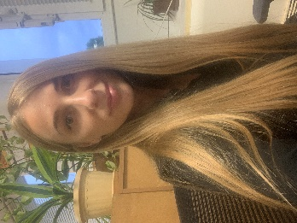
Belchykova Alyona
Mobile phone: +48 451147581, +380955245228 (viber, telegram)
Email: alona202222@gmail.com
Higher education (2005 – 2010): National Aviation University, specialist: logistics
Program: MS Excel, Microsoft Word, 1C, Smart Bricks.
Language: English B2 (upper-intermediate), Russian and Ukrainian (fluency)
Hobbies: cycling, books - great way to unwind, distress, and keep the mind sharp.
Personal qualities: result-oriented, organizational capacity, resistance to stress, good manners

Experience:
Procurement manager 04/2019 to current day
Retail Auchan Ukraine, FMG Kiev

- Managing by FMG product category «Tastes of the World» (noodles, sugar and salt sauces, sugar and salt snacks, beverages). In my products category were represented 600 articles from 20 countries.
- Searching new authentic products which associated with current country, for instance, noodles for Chinese, turrones and paella for Spain, Turkish delight, seeds for Turkey, e.t.c
- Searching new suppliers, agreeing on prices, planning promo, volumes of orders.
- Collecting the q-ty from stores and placing an order for import suppliers for big promo, where participating 1000 articles from others country.
- Controlling of arriving orders to our DC.
- Creating new articles, contracts in program.
- Agreeing on bonuses load with local suppliers.
- Control of turnover for category, if there were decreasing for sales, trying to find out ways for increasing realization products.

Procurement manager assistant 05/2017 – 04/2019
Retail Fozzy Group, FMG Kiev

- Managing by non-food category «Kitchenware, household ware»
- Creating new articles, contracts in program
- Control of turnover for category, if there were decreasing for sales, trying to find out ways for increasing realization products with procurement manager.
- Distribution the stocks from DC to stores according with sales some products on these stores.

Manager – logist 11/2013 – 03/2017
Distributor Centre Obriy – 2000, Stoyanka

- Placing orders to Suppliers FMG: Lantmannen(dry breakfast), Dolina Laniv (salt grocery)
- Control of delivery to our distributor center;
- When the orders arrived, distribute them to Ukrainian retailers such as Fozzy Group, Auchan Ukraine, Epicentr, Metro
- Work with return of goods from buyers
- Entering new suppliers to program Smart Bricks

Manager – logist assistant 11/2010 – 09/2013

Kyivstar, purchasing of equipment for the construction mobile towers

- Assist to manager-logist.
- Print documents (consignment notes, invoices, bills of lading).
- Warehouse inventory.

