**America's Best Cities  
for Singles**

**What makes a good singles scene? Sometimes it’s charming locals, great weather—or a little of both.**

By Katrina Brown Hunt

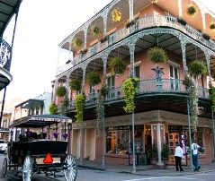 New Orleans

Social media strategist Jani Bowe moved to Chicago from Minneapolis in 2007 and was glad she did. “Before moving to Chicago I wondered where on earth all the 20- to 30-year-olds went, as the dating scene in Minneapolis was extremely thin,” she says. But she found a lot more action in the Windy City. “Chicago is a vibrant, tech-savvy city, and this is where people come to start their careers,” she says. “So many men, so little time!”

Lots of people feel the same way. Chicago came in as the sixth-best U.S. city for singles in the annual America’s Favorite Cities survey, where Travel + Leisure readers rated urban areas on culture, hotels, weather, and even how good-looking the locals are.

That’s not to say smaller cities don’t have their appeal for unmarried types. Austin cracked the top 5 thanks to its unbeatable music scene and smart, friendly locals. But the capital city wasn’t the lone star in Texas—nearby Houston also has a sizzling scene. What gives? Warm-weather spots did well in the survey, since more people can get out year-round to enjoy the city’s offerings.

Read on to see which city has the singles scene for you.

[**#1 New Orleans**](http://travel.yahoo.com/p-travelguide-191501939-new_orleans_vacations-i)

The Crescent City is a nightlife triple threat in the AFC survey: not only does it rank first for singles, but it wins for its cocktail hour and live music scenes—and it’s the winner in the wild weekend category too. Its locals rank high in friendliness (No. 2) and diversity (No. 3), and if they’re not letting the *bon temps rouler*, they’re sitting down (and we do mean sitting down—the Big Easy came in last place for active people) for a nice beignet.

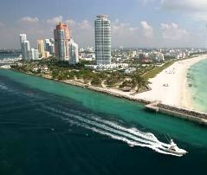 Miami

[**#2 Miami**](http://travel.yahoo.com/p-travelguide-191501910-miami_vacations-i)

As the AFC survey’s three-year champ for good-looking locals, this sizzler of the South has all the makings of a great singles scene: stylish locals (No. 2), good cocktails (No. 4), and great weather (No. 5), so that the fun can go on year-round. It’s also a spectator sport: Miami ranks fifth in the U.S. for great people-watching.

 Austin

[**#3 Austin**](http://travel.yahoo.com/p-travelguide-191502013-austin_vacations-i)

It has a legendary music scene, unbeatable Tex-Mex and barbecue restaurants, and locals who seem too good to be true. This is one of the few cities where the degree of good looks is not balanced out by a lack of brains or an ability to smile. These urbane Texans are attractive (No. 5), smart (No. 2), friendly (No. 4), and athletic to boot (No. 3).

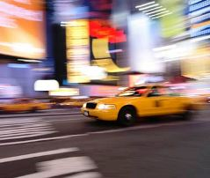 New York

[**#4 New York**](http://travel.yahoo.com/p-travelguide-191501980-new_york_city_vacations-i)

Manhattan has (almost) everything going for its millions of singles: it’s No. 1 in both big-name and ethnic restaurants as well as theater and classical music. Its locals are also the country’s most stylish and diverse. The only things weighing down the scene here: New York is the least affordable city in America, and those well-dressed locals are the least friendly. (Whaddayou lookin’ at??)

 Las Vegas

[**#5 Las Vegas**](http://travel.yahoo.com/p-travelguide-191501967-las_vegas_vacations-i)

Clearly it doesn’t matter that survey-takers rated Vegas’s locals as not terribly attractive (they rank 19th), friendly (24th), or smart (dead last). After all, this is Vegas, which rates No. 2 for wild weekends and tells visitors they’re allowed to keep their Sin City secrets to themselves.

 Chicago

[**#6 Chicago**](http://travel.yahoo.com/p-travelguide-191501928-chicago_vacations-i)

The Windy City bar scene may be bustling thanks to its young workforce, or just because everyone’s out looking for a nightcap after chowing down. Chicago ranks second for big-name restaurants, third for ethnic dining, and fourth for neighborhood joints.

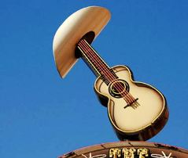 Nashville

[**#7 Nashville**](http://travel.yahoo.com/p-travelguide-191502011-nashville_vacations-i)

Despite the city’s twangy history, singles here aren’t crying into their beers: they rank No. 1 in friendliness and No. 9 in looks. Stroll Broadway or the rest of downtown and you’ll see tomorrow’s Taylor Swifts (and a bunch of other types too) polishing their acts on street corners and in pizza joints—so it’s also no surprise that Nashville ranks second in live music.

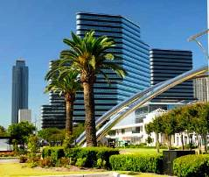 Houston

[**#8 Houston**](http://travel.yahoo.com/p-travelguide-191502016-houston_vacations-i)

Adieu, mechanical bull. Houston has come a long way since its Urban Cowboy days. Clearly it’s also attracting singles, and survey-takers also gave the city a top-10 ranking for cocktails and stylish, attractive locals.

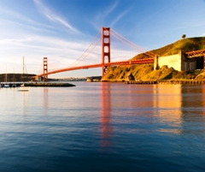 San Francisco

[**#9 San Francisco**](http://travel.yahoo.com/p-travelguide-191501889-san_francisco_vacations-i)

The locals are stylish and diverse, and they’re not hard on the eyes either (No. 11 in attractiveness). Pub-crawling is easy, too—San Fran ranks fourth in the survey as being pedestrian-friendly. Just bring your plastic: the City by the Bay is pricey (No. 27 in affordability).

 Providence

[**#10 Providence**](http://travel.yahoo.com/p-travelguide-191502001-providence_vacations-i)

The Rhode Island capital ranks eighth for its cocktail hour, but you might do better mingling with the singles if you pull up a stool at a neighborhood joint (the city ranks second in that category) or a cozy coffee bar (sixth).

[See the rest of America's Best Cities for Singles](http://www.travelandleisure.com/articles/americas-best-cities-for-singles/12%20)