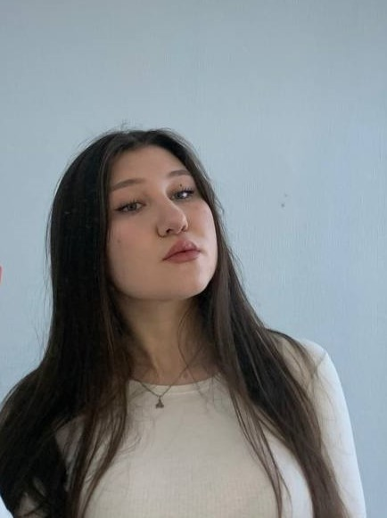 | ALINA SHEVTSOVA  UI/UX Designer  Minsk, Belarus (ready to remote job)  +375 29 358-54-00  shevtsovaalin@gmail.com  Linkedin  Portfolio
ㅡ  Skills | Working in Figma, Tilda. User Experience and User Interface design. Creating web-sites and mobile apps. User interface development. Interaction design.  English level – B2
ㅡ  Project | IT-Academy / Internship  Oct. 2023 – Nov. 2023, Minsk  Name of the project: Dooit  Description of the project: My final project "Dooit" were fully created by me. It's an app for active leisure lovers. Not only to make routes, track data, search for places, but also a social network for true fans of their hobby - share any interesting information connected with your hobby.  Main responsibilities: It all started from UX part - various researches (you can read more in my Behance file), and after I'vemade all UI part - design, prototypes,useble prototype etc.  Link
ㅡ  Education | IT-Academy / UX/UI Design  Aug. 2023 – Nov. 2023, Minsk  I learned how to create information architectures, analyze competitors and describe MVP, create User Flows, create adaptive layouts.  I've studied the goals and needs of potential users, working with meta messages and trends. Also, the most important parts of the design, such as working with color, typography, gestalt principles, interface layout, and working with grids.  Also i've practiced in creating landing pages, mobile and web user interfaces.  IT-Academy / UX/UI Design tools  Nov. 2022 – Dec. 2022, Minsk  I learned how to effectively use the Figma graphic editor to create web and mobile interfaces.  College of Linguistics and Humanities/ Documentation and Management Documentation support  Nov. 2022 – Dec. 2022, Minsk

