A Guide On How To Build An Iron-Like Fortress Around Your Babies and Kids’ Immunity With The “Right” Food & Proper Eating Habits Only

DECEMBER 25, 2022

*Last updated on December 26, 2022*

Why we parents are fed up with all those who put forth the wrong information about the nutrition and eating habits of our baby’s kids? But getting our kids healthy and happy for the rest of their life is our prime goal. Smartest ways to in 2023 and later. Best & worst ways at the present day.

*In this issue on babies and children’s food & eating, you’ll discover:*

— *How to properly feed your babies and kids with the right food;*

— *What are the “must-have” products must be in your kitchen?*

— *What is the “quality” of the products? Especially, where you can find them and how you can check the nature of these goods?*

— *Accurate explanation on how to feed your children “well” in life periods: from 0 to 12 months? From 1 to 3, 4 to 8, 9 to 13, and 14 up to 18 years and further?*

— *How much time to wait between each eating to maintain health?*

*— Hot topic! Discover the influence on the babies’ health and intellect development because of breast milk. You’ll discover the reason why the first 4-6 months of the baby’s life must be connected to the mom’s breast milk! Spoiler: This is how the natural immunity of the kids is forming. And that’s the best immunity babies will ever get for the rest of their life;*

*— Find out the essentials of elements such as Omega 3 and Omega 6, Vitamins B6 and B12, Vitamin D, Fiber, Zinc, Iron, Iodine, and many more. Not one but all of these elements are equally important for the proper body and intellect development;*

*— Hot topic! Here’s what you perhaps don’t know about the dangerous impact on your children’s health of sweets, candies, store cakes (not hand-made), Coca-Cola, Pepsi, Sprite, Fanta, and similar products! All of them are more dangerous than people thought! And doctors are silenced!*

— *Hot topic! The dangers of artificial yeast 99% of people don’t know about. And seems nobody care. Spoiler: In short – it’s one of the factors of cancer development. And you’ll find out exactly why!*

If our doctors and “diet advisors” would talk about it more, and talk about it in a way – as it is in the real world – the healthy kids would be much stronger today!

First thing first. Children’s body has the biggest safety margin such as recovery after diseases, bone fusion, and wound regeneration, you name it.

That’s because “mother nature” is giving every baby the “starting power for a lifetime”. Still, the factor of food –  and eating habits – is the only 100% guarantee that their health mechanism will be always at its best.

In short, the right food and eating habits anticipate babies’ and children’s immunity, internal organs, muscle, and intellectual development.

But there are also simple facts you need to know before you are planning to have a baby and then feed it right. The vast majority of people would like to know this info at least 10 years ago – to save their child’s health more.

To give them fuller lives. But it’s now your chance to find out what others wanted to know years ago.

How to sharply prevent the cause of a kid’s illness?

In short, food and eating habits are major causes of illness. And because food & habits anticipate everything. Rarely the cause of the particular disease is one particular. Typically, there are dozens of them undergo simultaneously.

That’s why it’s so hard sometimes to accurately identify the cause-effect of the illness nature in kids and later in adults. So if you want to make your kids healthier – your first move is to look at their eating habits and food. But don’t fret, we’ll tell you how to prevent illness of babies and kids for their life through eating habits and food.

Have you made these mistakes in developing proper eating habits in your kids?

Because billions (not millions) of people do. Even if you are feeding your kids the very best products in the world, but they don’t have the proper eating habits – soon health issues come out to the surface. And many “wealthy” parents noticed that.

Now, the first rule of thumb is the timing of when kids are drinking water, juices, and other fluids – important to maintain the right level of digestion (natural acid-like digestion process in the stomach).

Remember this! Drinking of water, juice, tea, or other sorts of drinks: for babies, kids, and adults: 10-15 minutes before eating whether it’s breakfast, lunch, dinner, supper, or any other snack!

And then you have to wait 1 hour and 30 minutes after eating dishes (if the food was non-meat and non-fish), like porridge, fruits, vegetables, etc. And 2 hours after the fish and meat-like food! Frankly, we can call it – “the laws of Nature” for eating habits. Here’s a detailed explanation of [proper drinking habits](https://wellness-today-journal.com/proper-water-drinking-habits-for-healthy-life/).

Do you remember all these movies… where everybody drinks during eating or shortly after, in restaurants, bars, McDonald’s, Wendy’s, and so on and so forth? Well, that’s how wrong we’ve been developing our eating habits through TV. Don’t do as in movies or TV – do it right!

Frankly, as parents, the biggest investment of a lifetime would be: to prohibit your kids to drink during eating, and soon after it and they will never start to collect the dangerous chemical compounds coming right after each poor digestion process.

These compounds later on damage kids’ skin, internal organs, and immunity, and consistently progress on everything they reach, as long as they occur.

Let’s take meat as a frank example. If your kid eats meat and drinks water or juice during the eating or soon after. Then in a stomach, instead of the right digestion process and animal-protein separation – occurs the cadaverine.

What is the cadaverine? One of the very dangerous chemical compounds that poison a body. That’s one of the first causes of any illness, triggered by poor eating habits.

***The rule of thumb: How to convince kids to stop drinking during eating? You can’t do it overnight, so explain to them why you are saying: “Darling it’s not healthy to do this because your stomach is unable to digest food”. Educate your kids – not by force but through explanation!***

***Pull back slightly if your kids are hesitant to quickly grab the gist of these eating habits. Then come again and do it day after day. Soon your kids by themselves will experience the difference in the ease and pleasure of their eating habits – and when they are breaking “laws of eating habits”.***

Soon after you’ll fix babies’ and children’s eating habits…

You’ll notice such things happen – they rarely catch the flu, they have no pain in the stomach, and they are more energized and eager to study. They will be more active. Their intellectual abilities will increase tremendously. And will increase as long as you follow the rules. And all of these are thanks to food and eating habits.

For instance, two weeks period of eating habits – dramatically increase the health and feeling of kids. Just 2 weeks – to see changes. Frankly, adults also after 2 weeks will feel the same. Because these laws are working as well on children as on adults.

How does it work in a kid’s body?

In this way: the body explores more energy from the right food and eating habits to tackle any sort of illness. Something that kids’ organisms were unable to do before. And that’s straight because of these eating habits and food.

Have you heard about the myth: the more your kids and babies are eating – the better?

To keep your babies and kids healthy, you do not need a lot of food (as nearly every person in the world is thinking today). And many would be surprised by discovering the fact that “healthy” is enough for proper intellect and body development: require small portions of food.

***The scientifically proven fact is this: the stomach of an adult person has a natural 500-600 grams in volume.***

***Approximately that’s how much food you can pour into both of your hands. Now, take your kid’s hands and you’ll see how much food they can pour food in their hands: 100-150 grams at max. That’s the amount of food for 1 healthy intake.***

The problem with the large amounts of food for adults – (more than 500-600 grams for an adult) and for kids, more than 100-150 grams accordingly is this.

If you give more than that, consequently you’ll launch slow harming of your children’s health. That’s stretching stomach walls and abnormal increasing their stomach in volume. Create additional pressure on the internal organs.

Further children are forced to go to the bathroom frequently because their stomach must get rid of the excess food (the body takes what it needs and then get rid of everything else). Yes, the stomach is able to overcome this increase in volume, approximately to a person’s 20 years old. But then… wrong eating habits start to show up.

The implications on health are the following: uncomfortable feeling in the stomach or even dangers of pathologies such as high blood sugar, fatness, heart diseases, teeth problems, and physical and intellectual negatives.

And negative effects grow like a snowball because the wrong eating habits and food will add bitterness to the Mom and Dad. But most tragically – to babies and kids. Unfortunately, sometimes – for the rest of their lives…

By the way. Soon after your kid starting from 6 months will eat small portions (not larger than 100 grams per time), and their stomach will come to the normal size. Approximately 2 weeks for the stomach takes to become of the normal size, for both kids and adults.

Sharp explanation of the importance of feeding your children with the “right” products

Knowing the eating habits we are proceeding to the gist of our issue and here’s how we want to present it to you. Look closely at children’s development and ask the question: why kids are so active? In moving, speaking, thinking, understanding, reacting, etc.

The answer is resounding – the fast pace of development in all areas: physically, mentally, intellectually – at one time! They are “on fire” from dusk till dawn. It seems they are capable of anything – just give them time and space. And of course, it’s the normal way of behavior.

There’s only one condition. The children’s “natural internal flame” requires constant feeding not only deliberately through space for activity but through food as well. The brain, internal organs, bones, and muscles demand a constant stream of proteins, carbohydrates, fats, vitamins, elements, and so on.

Here’s the pivotal moment in which all parents must know how exactly how to fuel their children’s “developing flame”.

How to choose proper periods and wait before each eating?

Many of today’s people presume that their children must have 24 hours a day – access to food. In case kids want to eat – they can have a snack right? Well, not right at all.

The problem with unlimited access to food is that your baby or child will eat constantly, nearly every hour of the waking hours. They will not eat only when they are asleep. And this food will do no good to a child. For kids – it’s “comfortable” to have such access.

The result? A child that eats this way – will constantly overeat, day after day. Typically, they are constantly visiting the bathroom because their stomach is getting rid of all unnecessary food.

Add to this circumstance where parents have to distract from homework or work because babies and kids want to constantly eat.

So what are the periods between eating to keep your babies and children healthy?

Here are the periods:

— Brest-fed baby, eats nearly every time it cries. So that’s up to 6 months after the birth;

— Later after 6 months (Mother can feed child longer than 6 months, up to 1.5 years or so), parents can feed the child, when necessary, but trying already to build a schedule of eating. For instance: 8 A.M. (breakfast), 10 A.M. (lunch), 12 A.M. (fruits, cottage cheese), 2 P.M. (porridge,) and so on.

***The ideal model looks as follows: 3-4-5 hours between the food intake. But there are rules when you are giving either meat-like or non-meat-like food. For meat-like food, and seafood, you try to make at least 4 hours of pause, between the next intake. After the non-meat food (porridge, cottage cheese, fruits, etc).***

Why make these periods? The thing is that stomach and whole digestion system are working and it needs some “rest”. If a baby and child, when 1-year-old, overeat, eat each hour – no schedule. Then the whole digestion system almost never rests! Moreover, as you’ve read above – the stomach will get rid of all the excess food that it doesn’t need.

**The bottom line: every 3-4-5 (4 is a golden standard) hours your babies after 1 year old, must eat something.**

The accurate schedule of when to give food?

One of the rules of thumb that nearly everyone is breaking is this: they are eating when their organism is unprepared. And scientists who deeply study the case discovered an accurate time frame when you need to eat and never outside of these hours:

From 5 A.M till 7 P.M. of your local time. Why? Because the pancreas of kids and adults is working without harming itself in this timeframe. We bet you’ve never known this information before.

But yes, the pancreas of babies as well as the pancreas of adults awaken at 5 A.M. and “go to sleep” at 9 P.M. of your local time. But before it can – it must deal with the food in the stomach. So 2 hours is something around when the pancreas is able to fully rest after eating. That’s why 7 P.M. is the mark.

What’s happening if you are still eating after 7 P.M. Here’s what is really going on. Your pancreas awakening from a nature-defined sleep again. And start to allocate ferments to digest food. But since it’s working outside of a schedule, the pancreas is “forced” to work with the double or triple effort.

Do you know why there are a lot of problems with the pancreas today? That’s unhealthy eating outside of the pancreas’ normal working – is one of the main reasons.

***Remember: Feed your kids in this time frame: from 5 A.M. till 7 P.M. As parents – it’s in your best interests to adhere to the same schedule!***

After you gain the first right feeding schedule, it’s much easier to maintain the health of your kids and later adults. Later on, you just need to keep on going. Because that’s easier than it seems.

How to give only “must-haves” products for fuller body and intellect development?

In this issue, we’ll tell you everything – how to feed properly starting from the first days a baby. And up to 18 years and even further. Just give us a little time and read this information carefully. There’s really not much to study.

The first and most important starting period of feeding is the breastfeeding period. Unfortunately, a large majority of women commit the grave mistake in the first 4-6 months of their babies’ lives.

Perhaps your doctor may not be told you this but the breast milk feeding period – is the must-have nutrition.

Despite recommendations, rumors, and buzz around “baby porridges as alternatives” to breast milk – that’s the tragical mistake.

The reason? Breast milk contains the natural immunity to develop the immune, intellect, and physical condition in a baby.

How to feed your baby with breast milk – accurate period

Most of today’s mothers that feeding babies with breast milk and have previously developed healthy habits such as avoiding smoking and alcohol. Were under good emotional conditions (husband and relatives – must create them!).

They often have more milk in the breast than children needs. Of course, there are exceptions but a mother with healthy habits nearly always has enough milk.

Breast milk must be delivered not less than 4 months (better 6 and up to 1.5 years) after the birth of a baby! Or the immune system of the child will be underdeveloped and vulnerable to illnesses of various kinds.

Popular topic: How to survive during the medical-treatment period and give milk anyway?

The only exception to not giving breast milk – is the period of the medication treatment of the mother. Because everything a mother consumes goes straight to breast milk, for sure such milk must not reach a baby. In this case, it’s necessary to avoid feeding with breast milk.

But remember, soon as the mother recovered and can feed with breast milk again, she must! (consult with a doctor: for how long medications stay in the mother’s bloodstream and the breast milk).

Thus make a few extra bottles (5-10 items of 0.5 liters or so) of this milk in advance. And put them in the refrigerator for freezing.

Then if such circumstances as using medications for your mother occur – you will have the bottles of milk in your refrigerator. Take one of these bottles, and heat up the bottle in warm water – so the milk became warm! Is it warm now? – then it’s ready to go!

Hot topic: Brest milk vs Baby porridges

Only if you have no other choice due to your mother’s illness or you can’t find the other’s mother’s milk – use baby porridges. Sound barbarian? To use other’s mother milk…

Well, the immune system of a baby is on the line. If someone thinks that it’s barbarian to either give or not give another mother’s breast milk. We can say that it’s your baby – and you have to decide their fate.

Just take a moment to think about baby porridges in this way: Some doctors and diet trainers recommend baby porridges as an alternative to breast milk. Because it’s comfortable and because the mother will save its physique… Have these advisors any evidence? Any research? Any data? Or anything to support this claim?

These advisors claim they are able to cancel the laws of nature. Perhaps they can cancel the laws of gravitation as well? We are sure to make a buck and receive an affiliate commission on product sales – they would claim they are able to cancel gravitation… But they can’t. So unless you really have no choice – avoid baby porridges.

And now try to view this in this way: Nature would never give such an ability to a human being if it would carry some harm in the future. So breast milk is existing only because it’s necessary!

Simple as 1-2-3 explanation of the elements including Omega 3 and Omega 6, Vitamins B6 and B12, Vitamin D, Dietary Fiber, Zinc, Iron, and Iodine

Let’s uncover each of these elements one by one and the cause-effect impact on the kids’ health and mind

After the 6-month – 1.5-year-old period of breastfeeding – you don’t need the baby porridge. Thus later on the baby must achieve the constant nutrition of the products listed below. Your 6 months baby is unable to chew food, so just take a blender and make the porridge from natural food.

***Omega 3 and Omega 6***

Omega 3 and Omega 6 fatty acids are the most important for brain development and proper function.

These are essential fatty acids that play a central role in brain tissue. This kind of tissue is responsible for the transmission of electric signals in the brain. Of the dry mass of the human brain, 60% is made up of lipids, of which 20% are Omega 3 and Omega 6. These are the two main fatty acids found in gray matter.

They are the basic building blocks that make up the walls of our mini factory, that is, membrane cells. They influence their thickness, affect nutrition, and the activity of receptors and enzymes.

They also affect ion channels, which are the structural parts of cells that directly provide the transmission of signaling substances out of the body’s cell and into the cell.

Omega 3 and Omega 6 contribute to the growth of nerve spines, and dendritic cells, which affects the processing and transmission of signals in the brain. Essential fatty acids are also precursors of the active mediators, which play a key role in the inflammation process and the immune response to hazardous micro-organisms. The role of the mediators is key in inflammation and immune response.

***Zinc***

Zinc deficiency is a major problem worldwide, affecting 40% of the world’s population. Recent studies show that young children and adolescents are at higher risk of deficiency. Zinc is believed to be a vital nutrient for the brain and plays an important structural and functional role.

Specifically, zinc is a helper molecule for the construction of more than 200 enzymes that regulate various metabolic processes in the body, including protein, DNA, and RNA synthesis.

In addition, Zinc plays a role in neurogenesis, neuronal maturation and migration, and synapse formation. Zinc is also found in high concentrations in the synaptic vesicles of hippocampal neurons, which are centrally involved in learning and memory.

Zinc supplements have a positive effect on the immune status of children and prevent birth defects.

***Iron***

One of the most common nutritional deficiencies in developing and developed countries is iron deficiency. In developed countries, it can be as high as 20%, especially in pregnant women, babies, and children.

Over the past decades, substantial literature has been published on the relationship between iron deficiency and cognitive development in children. Iron is thought to be involved in various enzyme systems of the brain, including the enzyme system in energy production. It influences fatty acid synthesis and the formation of dopamine receptors.

In addition, iron modifies developmental processes in hippocampal neurons by altering the growth of connections. Significantly poorer performance in language skills, fine motor skills, and attention in children 5 years of age whose mothers had iron levels below 60% of the normal.

***Iodine***

It is now well known that severe iodine deficiency during pregnancy can cause “cretinism” in children.

Studies show that various places in China with iodine deficiency in the soil have found a decrease in IQ of 12.3 points in those children whose mothers lived in iodine-deficient areas compared to those who had enough iodine. Iodized salt is one of the single and most important products you and your kids must consume each day. Later on in this issue, we’ll tell how much.

This is because iodine is part of the thyroid hormones produced by the thyroid gland, thyroxine, and triiodothyronine, which have multifaceted effects on growth, development, and metabolism. As a result, the deficits of iodine are one of the causes of thyroid cancer (one of the most widespread causes of cancer).

***Vitamins B6 and B12***

Play an important role in brain development and the development of strong memory. Vitamin B6 is involved in the processes of glucose assimilation by nerve cells, which means it directly affects how well “body factories” get energy.

Vitamin B12 significantly affects the quality of connections between cells, which is important for impulse conduction and also protects neurons from being destroyed.

***Fiber***

Fiber is also an essential nutritional element. These are coarse polysaccharide fibers that we cannot digest, but they serve as food for the microflora in our intestines.

In a healthy adult, the bacteria that live in the intestines add up to about 1.35 pounds. Today, scientists are beginning to think of these bacteria as one of the organs of the human body.

Good bacteria eat fiber, why are they good and why do we benefit from feeding them? Because they give out a lot of useful substances, vitamins, and active compounds in return for their food, which has a positive effect on the whole body and in particular on the development and healthy functioning of the brain.

To sum up the impact of these elements

***Omega 3, Omega 6:***

— Construction Role

— Signal transmission

— Stimulation of cell growth

— Protection

***Zink:***

— Construction and Functional Role

— Cell Growth Stimulation

— Protection

***Iron:***

— Energy role

— Functional role

— Cell Growth Stimulation

***Iodine***:

— Build

— Cell Growth Stimulation

***Vitamins B6 and B12:***

— Energy Role

— Improves communication

— Stimulates cell growth

***Vitamin D***:

— Building and Functional Role

— Cell Growth Stimulation

— Protection

***Fiber***:

— Building and Functional Role

— Cell Growth Stimulation

Now, how much of this nutrition is necessary for the bodies and brains of children?

How you can differentiate this mg and mkg?

The table to remember in your children’s nutrition calculations:

1g = 1000 mg;

1mg = 1000 mkg;

Fiber

Although you need to know how much fiber you’ll provide each day. For instance, 10-15 mg. We’ll include the kcal calculations of fiber with calories and kcal as they are widely known today.

1kcal – 1000 calories.

Hint: To calculate fiber and not go through all of the sophisticated calculation, when choosing how much your child needs fiber – ensure your kid consume not less than 15 g of fiber per day.

This info you can check on the back of a package of porridges you’re buying and from internet sources.

So if you are interested in the more sophisticated calculation. Here’s how it works: 100-gram porridge (carbohydrates) – approximately 400 calories. Thus on 100 grams of food, we achieve 771 kcal. Equally 200 grams of porridge equals 800 calories, and 250 grams – 1 kcal.

For instance, 100 grams of beef – equals 259 calories. When you get your 1kcal (1000 calories, or 1.5 kcal (1.500 calories), you’ll see in the tables below how much you need fiber (products) per these 1000 calories in grams. Simple!

***Remember: When your kids are at their 1-year-old they are capable to consume 100-150 grams of any food at max for 1 intake. And as they grow – you slightly by ten grams increase their intake each year. The normal size of an adult person has 500-600 grams in volume!***

The following tables represent how much your child must consume Omega 3/6, Zink, Iron, Iodine, Vitamins B6/B12/D, and Fiber per day! In the end, you also receive an explanation of how to calculate or how to construct your children’s eating program for healthier and fuller life!

By the way: Vitamin C – 100mg/per day for a kid (The golden standard). While 90 mg/per day is good enough. Enough of the Vitamin C gives your kids: active healing, increased endurance, strong immunity, and active cell growth.

The deficit of the Vitamine C – below 80 mg/per day for a kid: dry skin, bleeding gums, hair loss, delayed wound healing, decreased immune system

Where you can find this nutrition and here they are

We’ve told you that nearly in every corner of the world – you can find them in your local market. One condition as always – seek only naturally produced one! When buying groceries, allow an extra 15% to the weight to avoid errors in weighing. Especially, when you are making portions by eye.

Here are the proportions and identification

***Children from 1 to 3 years:***

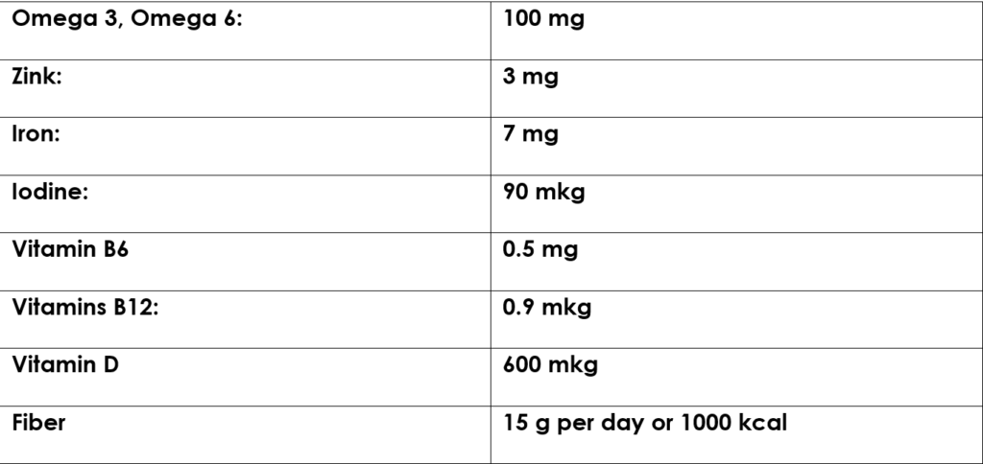

***Child of 4-8 years old:***

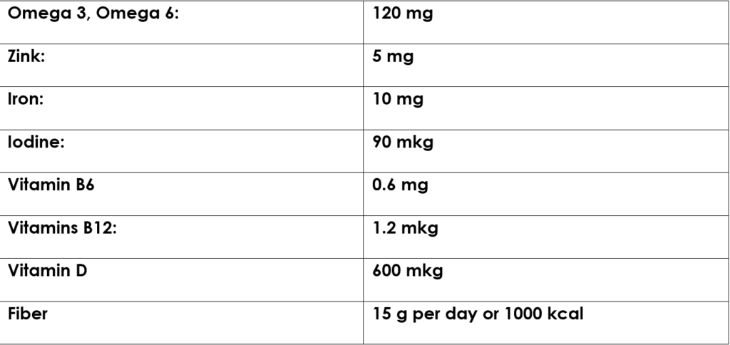

***Child of 9-13 years old:***

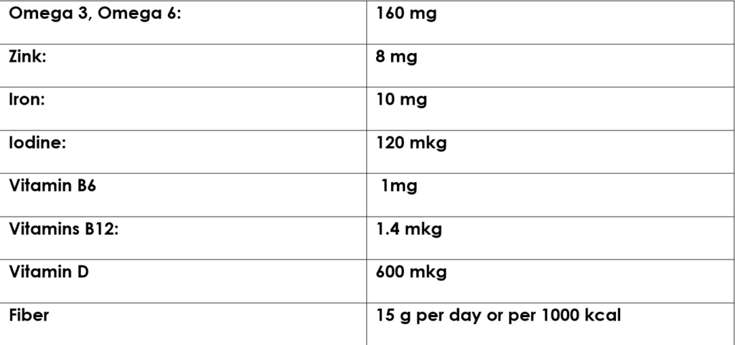

***Child 14-18:***

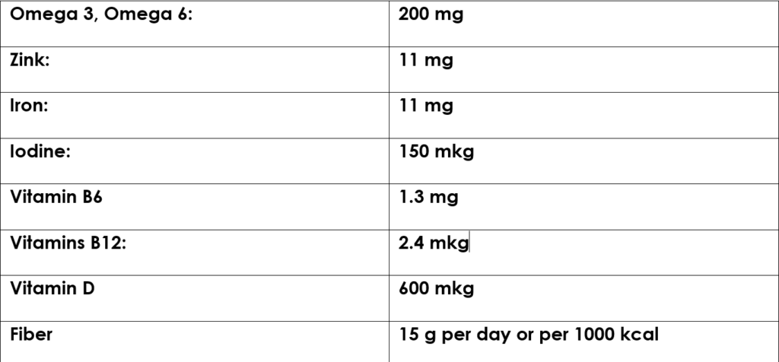

***By the way: Vitamin C – 100mg/per day for a kid*** (The golden standard). ***While 90 mg/per day is good enough***. Enough of the Vitamin C gives your kids: active healing, increased endurance, strong immunity, and active cell growth.

The deficit of the Vitamine C – below 80 mg/per day for a kid: dry skin, bleeding gums, hair loss, delayed wound healing, decreased immune system

Where you can find this nutrition

We’ve told you that nearly in every corner of the world – you can find them in your local market. One condition as always – seek only naturally produced one! When buying groceries, allow an extra 15% to the weight to avoid errors in weighing. Especially, when you are making portions by eye.

***Here are the proportions and identification***:

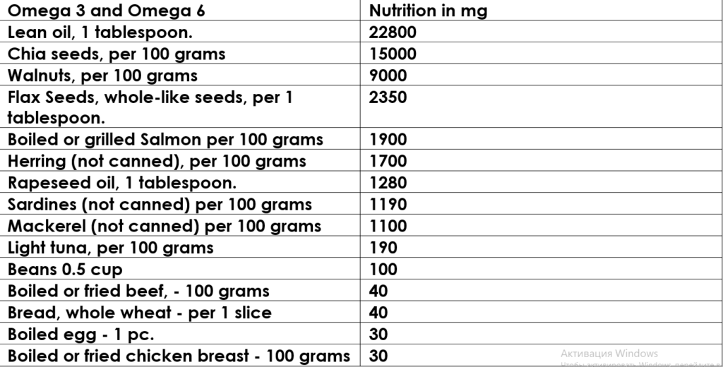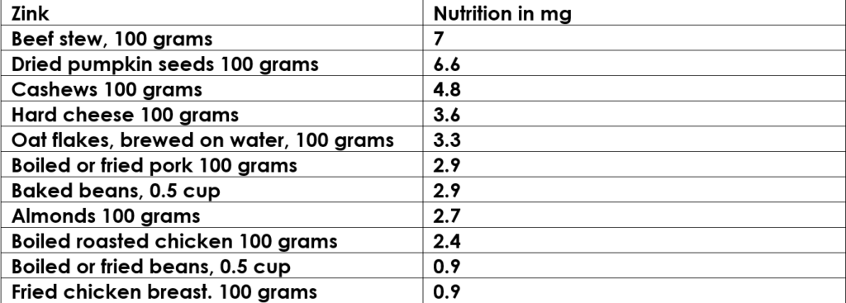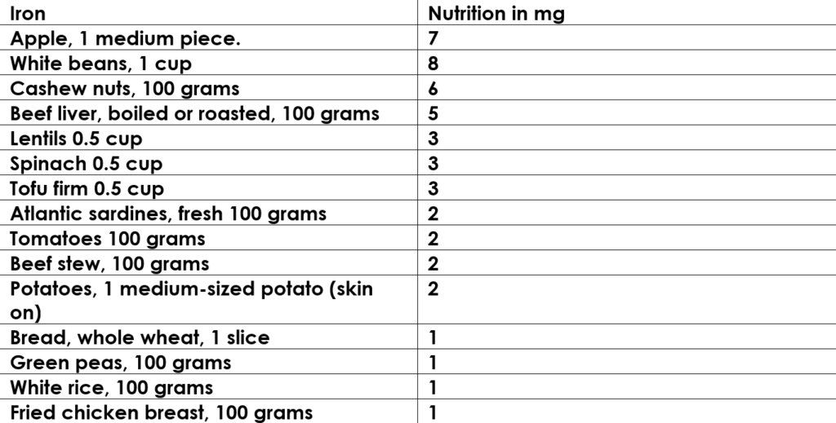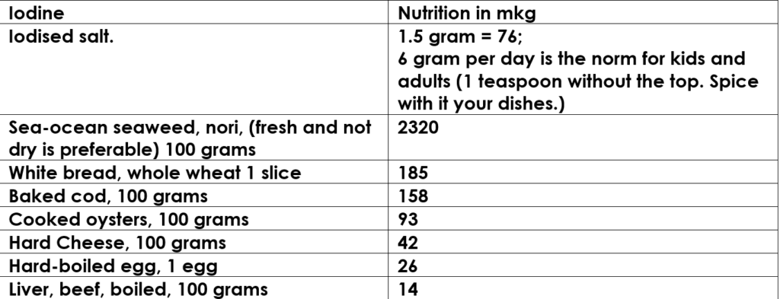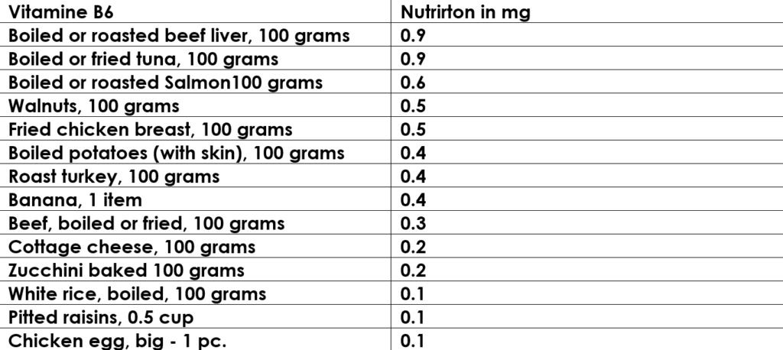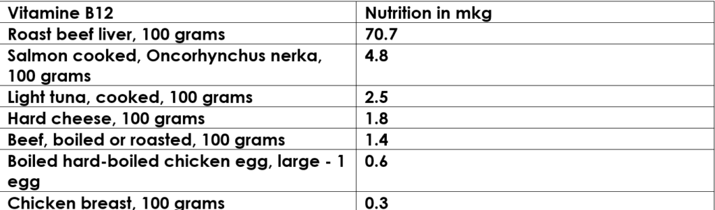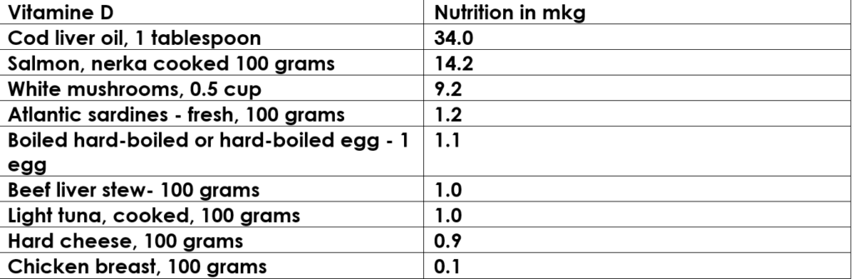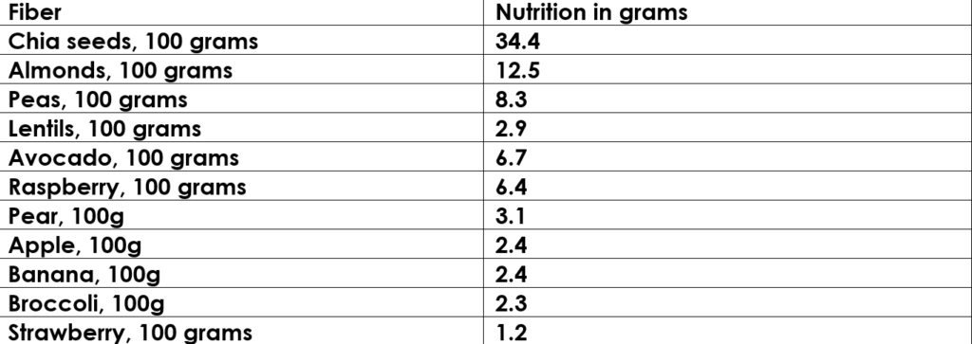

How to use these tables to calculate your children’s nutrition without mistakes?

Just calculate how much you need, let’s say, apples – to reach a good enough level of iron in the children’s blood you need at least 1 apple, but it’s always better as we said above – to have a surplus of 15%. So take 2 apples instead of 1.

Again about fiber – all you need to provide is 15 g per day for your kid. Calories and kcalories we’re providing for those who are interested in accurate numbers.

These tables are the easy-to-understand! They’re presenting the “per day” numbers of the nutritions of each of the components such as Omega, Vitamins, Fiber, Iodine, Zink, and Iron.

Critically important information your doctor we bet never tell!

***Remember:*** The whole wheat porridge outperforms the non-whole wheat porridges in terms of richness by microelements and all other features – by an order of magnitude. The reason: the more rough wheat – the better. Because as in the fruits and vegetables –  in the skin of the wheat always a lot of nutrition.

***Bread:***The bread that on sprouted grains and is yeast-free is the single healthy bread you’ll ever give your kids. Why? Because artificial yeasts (those nearly all flour products available today) are the cause of the development of cancer.

Here’s the problem: your stomach is unable to properly digest the chemical compounds in these artificial yeasts. Decades ago yeasts were natural. But today, all of them are artificial – at the present day, they are nothing more than mold and paddling.

Every cancer professional knows that cancer cells are almost unable to develop and grow if they haven’t mold and paddling in an organism – as a foundation.

These yeasts begin to harm cells until one of the healthy cells will be damaged genetically. Just think about it – 1 cell could be the beginning of cancer. And someday, depending on the accident, rays emission, immunity drop, or whatever – this damaged cell can start to multiply avalanche-like and cause cancer! Yes – unfortunately, today’s yeasts are that dangerous.

What’s more ***sweets, candies, and cakes***based on artificial yeasts also carry the danger of cancer. Because they are produced on the basis of these yeasts. And you must know it now, but most importantly change their nutrition and eating habits.

What about meat-like products in cities?

Today’s meat, especially, in the big cities – is in a poor state. These meats nearly in all cases never reach the final consumer fast. So you aren’t achieving fresh meat. Sausages or kielbasa and like products – are also proven to be chemically processed and free of what advertising tells.

 Frankly, today it never has what the advertising tells about them. Of course, it is one of the most common products but it has zero benefits for children’s bodies! But a lot of harm for sure!

 Where to look for the “right” quality of meat?

You can achieve fresh meat, either from the countryside or the village. At the place where the cattle or rabbits, or chicken, you name it. At the place where they are grown and slaughtered.

Remember the rule of thumb regarding meat: the more ecological region the cattle (meat) is growing and the faster you consume it after the slaughter – the better for your children and your health.

What about seafood and especially fish?

Fish caught in the ecologically pure region is more healthy for the children’s bodies. It contains a lot of Omega 3/6. And it drastically faster digesting in the stomach than any meat-like product.

People say when they have eaten a fish, after 30 minutes, they experience the kind of feeling – like they haven’t eaten anything at all. That’s how digestion is working faster for fish and sea-origin products. Much faster than when you are eating meat-like goods.

What about widespread canned goods? You must know about them!

***Canned goods – are dangerous…***more than we’ve been told. Maybe you haven’t known but all canned goods are dangerous because they are chemically processed (there’s nothing left from the natural essence of the initial product). Canned goods carrying a danger to babies’ and kids’ health. Of course, for adults and aging people as well!

Kefir, Yogurt, Yogurt – must be made from natural products, (not store-bought). Do not be lazy and make your own homemade kefir and yogurt. Cottage cheese should be natural, not factory-made. Honey and natural jams, berries, etc. can be used as additives.

Sugar that is the modern killer of kids…

Sweets, candies, cakes, Coca-Cola, Sprite, Fanta, and other products filled with artificial sugar almost guarantee group I diabetes from 3 – 4 years of age to children who have been eating and drinking these products since childhood.

Yes, parents, unfortunately – it is so serious and has even become very common. Doctors say these diabetes are hereditary… Really? Remember what parents and their kids consume – that is a cause of any illness.

And remember also about leukemia, which also appears as a consequence of excessive consumption of artificial sugar. Instead of it give to your kids natural honey it always well strengthens the immune system of children and adults.

Honey is your savior!

Again, a few words about natural honey. Natural honey contains no pesticides, nitrates, or chemical additives – a pure source of true immunity. How to name it in two words? An “ultra-powerful” booster of immunity. But as long as it is produced naturally on a bee pasture and not processed chemically or by heat further.

Iodized salt is a lift raft against these diseases

Iodized salt (not regular salt) is good for the child’s body. It’s defined that 6 gram per day of iodized salt – solve the problems with the iodine deficit for a kid or adult. That is a little bit every day. If your child wants to salt his food a little, let him do it. Naturally, you can not consume too much salt, all that excessive – has a negative effect!

The value of iodized salt is so huge – it’s the prevention of thyroid disease, autism, negative emotions, and mental destabilization.

By the way, in China – not so long ago, there was a problem with thyroid cancer because of iodine deficits. And guess what? The government of China just prohibited selling non-iodized salt and left only iodine salt on a market. And the problem with thyroid cancer was solved! Because every citizen instantly received the necessary amount of iodine. Simple!

What are the best products and where to find them?

You can achieve fresh meat, either from the countryside or the village. At the place where the cattle or rabbits, or chicken, you name it. At the place where they are grown and slaughtered.

Remember the rule of thumb regarding meat: the more ecological region the cattle (meat) is growing and the faster you consume it after the slaughter – the better for your children and your health.

Here’s what you need to know in addition

This issue is so important that the difference between well-feeding children and others like day and night. Frankly, well-feeding children rarely fell ill. Growing fast. Have a sharp mind and am competitive in everything. Here’s [more about the food](https://wellness-today-journal.com/top-food-for-healthier-life/) you perhaps don’t know yet.

Quite the contrary is the situation with all other children with wrong eating habits and nutrition. And here’s how products and micro-elements they are consuming make this difference. Moreover, the right eating habits in the youth – guarantee success or failure in the adult sense in the personal life, career, sport, you name it. And even in aging years when health starts to decline due to natural causes.

***Share this issue with your peers, friends, and colleagues who can benefit from it!***  
  
We are only beginning to benefit you with the money-free content. Free of advertising and other unscientific and irrelevant junk information, which in case of health are dangerous! We’ll never allow ourselves to publish something that may hurt the health of people!

And since we do our best, during the research, verifying, and confirming the information before the final publishing. It would be nice to receive a donation once in a while from our readers! So if you want to say thank you: You can do it by donating **3 dollars** to the site’s author’s team: