How To Eat Healthy For Nickles And Dimes Today?

AUGUST 17, 2022

*Last updated on December 18, 2022*

The Out-Of-The-Box Guide On How To Eat Healthy And With The Pleasure For Nickles and Dimes? Hint: Absolutely Healthy Food Is Also Tasty

In this issue, you’ll discover:

*How to eat healthy for nickels, even in the recession?*

*How to know whether you need to have a concern about your digestion or not?*

*How to live much longer with healthy eating?*

*What do you need to know about the mixing of the food? Relevant question: Can you mix every kind of food with every other kind of food? Answer – no! And you’ll find out exactly why it’s dangerous for your health.*

*How to eat healthy for dimes if you already have some troubles with digestion? Hint: No sophisticated food is necessary, and that’s possible even in the recession.*

*What time frame do you have throughout the day to eat healthily and without concerns? Hint: Pancreas has a limited time for digestion. Then it also works… But you need to know caveats.*

*What to know about drinking during eating or after? And what time do you need to wait until your food is fully digested?*

*How does the mental condition influence your eating? Hint: the impact is serious – you must know this!*

*How to prevent diseases through healthy eating?*

*What exactly products will surely help you to fix digestion? Hint: there are plenty of products you can enjoy every day of your life. And be fuller and energized as never before!*

*What are the carbonic, protein, and other products? Hint: The table that shows these products – remember this table, print it, and put it in your kitchen. And you will forget the visits to your doctor!*

*Bonus: How to drink whiskey, beer, vine, or other alcohol properly and be fresh as a baby in the morning;*

*What are the top rules for eating at any age? And many more!*

Did you know that your body’s margin of safety is 8 to 10 times against any defeating factors, both external and internal?

Any kind of defeating factors: radiation, electromagnetic pulses, infections. Bacteria of various kinds or whatever!

…But If breaking the nature rules in eating has a systematic approach then sooner or later this ultimately-powerful body’s margin of safety starts to go off-line.

…But you’ll say: it is so tasty! Of course, McDonald’s, Wendy’s, other fast foods, Coca-Cola, etc.;

…We cannot have a bad day if we catch one or two snacks with the fast food;

…Or a bottle of Coca-Cola;

This natural-origin strength becomes vulnerable in case you are eating everything you want by mixing inappropriate kinds of foods. Drinking water during the eating or afterward, etc.

The meaning of immune protection and healthy eating

Immune protection also weakens, and diseases will consequently arouse. Fortunately, below you’ll find out the exacts and facts regarding eating that maintains and improve your body.

Well, everyone can have one snack of fast food or a bottle of Coca-Cola once in a while. The caveat is this: a large majority never follow the rules of healthy eating habits.

They rarely think about what they are eating. What they are drinking and the consequences. Knowing the facts about healthy eating make a difference between happiness and wellness in life or regrets for the rest of your life.

Between the complete life’s fullness or diseases and pain. Between longer life free from diseases or a life full of regrets and failures.

What is the major buzz around healthy eating?

This guide will take you through the rumors and buzz around eating right to the destination – healthy eating. You’ll know for sure the basics of healthy eating. Once you’ll read till the end and see facts and tables, you’ll say: Aha!

On the other hand, you wouldn’t believe how much people regret that they never heard about these tips about healthy eating. Or that they discovered them too late when health issues already bring pain into their brain.

Frankly, it’s so easy to prevent the pain… establish happiness… and save thousands or even hundreds of thousands… By the way, this guide is not only about healthy eating but how to with pleasure and for cheap.

Proper eating habits guarantee happiness and visiting the doctor becomes rare. Of course, remember that outside of the base of the health – eating.

You also have the effects such as wrong habits (smoking, drinking alcohol, drugs, etc), physical activity throughout a day condition (physical exercises, 1 or 2 hours of walking, etc.), the external environment (your workplace place, your living room, how much). The time you spend in the fresh air), mental condition (that nearly always puts stress on you and triggers a lot of problems). Without further ado, let’s begin.

[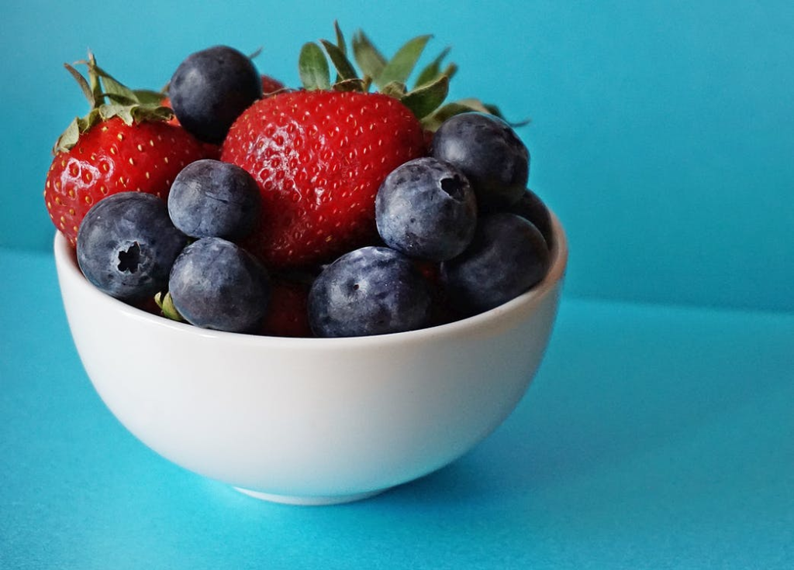](https://www.pexels.com/photo/blueberries-and-strawberries-in-white-ceramic-bowl-1120575/)

Is it costly to eat healthily and with pleasure?

For nickels and dimes really in comparison with the fast foods or other junk food. The price never was the case. But some people ignite sometimes the buzz that eating healthy is too costly. But a large majority believe in the rumors. Here’s how you can eat healthily and with pleasure. Prices on food sometimes go up but really in comparison with Mcdonald’s and other fast foods you are constantly purchasing – this would never be the case.

Make simple calculations just for 1 month and you’ll find out that healthy eating is not even close to the situation to shortage your budget. Even if you have children and significant other.

In addition, you need to eat small portions of food. Eat frequently yet never overdue with the eating – till the discomfort, unpleasant feeling, etc.

***The question is this:*** How much do I need to eat to maintain health? And what is the weight of these portions of healthy foods? The answer is this:

***The stomach is normally 500-700 grams*** in volume and if you eat more, the walls of the stomach become thinner and at the same time begin to press on other internal organs (intestines, pancreas, kidneys, spleen, and even organs related to sexual functions). Because the stomach sinks down due to excessive weight.

***Remember this rule carefully!***So never overeat. ***Don’t eat more than 500-700 grams at a time***. And in doing so, your wallet and health will tell you – Thank you!

Rarely do people around the globe know how to eat properly

Moreover, they are unable to find out how much and when. Is healthy eating means diets and clichés such as special prescriptions and unpleasant food? Of course not. Some sort of buzz around healthy eating already triggered negativity in people’s minds.

Yet it must be changed. Because healthy eating is never about prohibiting certain sorts of foods (unless your doctor totally prohibited these foods in your rationale).

And consequently, this brings many people to treat with negativity the only thought about healthy food. On the contrary, naturally grown and stored food is everything necessary for healthy food.

The only unhealthy food is fast food, filled with chemical compounds for the strengthening of taste and likewise products.

Frankly, nearly everything anyone needs to know to be healthy and happy is proper eating habits. And all diseases will yield because the body will achieve the untapped power for overcoming any kind of health issue.

What do you need to know about eating habits first? Hint: If you don’t know it now – you will regret it later!

First of all, remember one simple truth about nutrition that you may not have known! There are only three kinds of eating:

**Vegetarian eating.**Means a complete abandonment of animal proteins (meat, fish, eggs, etc). Instead of this plant food has a predominance position. One of the advantages of the plant is this. Plant food is capable of 50% digesting itself. And save ultimately a lot of energy on the digesting process.

And it has ***1.5-2 times more macro and micro elements*** (especially in plant haulm) than animal proteins. Due to the accumulation of energy from the sun, this type of food – contains chlorophyll, which helps increase hemoglobin in the body. But in childhood and adolescence, a complete switch to a vegetarian diet is not desirable.

***The separate eating.***When you are eating protein, carbohydrates, or plant foods separately from each other. Let’s take a look: ***Protein (meat, fish, eggs, milk, legumes, broths, mushrooms, nuts, seeds).*** ***Carbohydrates (cereals, cereal products, bread, potatoes, sugar, jam, honey, candy) Plant foods (vegetables, fruits, juices)***

***The mixed eating.*** This is the kind of eating when you are eating, for instance: plant foods (second group) with the protein (first group) in the table below.

Or carbohydrates **(third group)** with plant foods **(second group)**. Remember mixing the protein (first group) and carbohydrates **(third group)** – are ultimately harmful and dangerous for all of your health.

Here’s the table of the proteins, carbohydrates, and plant foods:

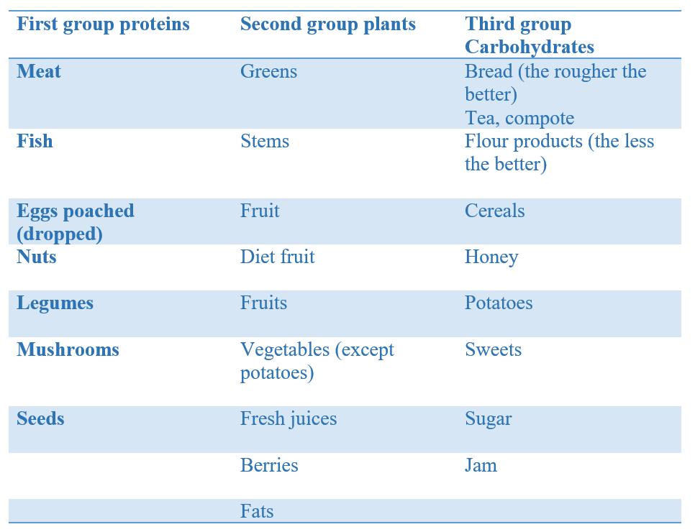

***The table about the group of the products separated by the predominance of protein, carbohydrates, and plant foods***

What are the predominances of the meaning of the predominance of the protein, carbohydrate, and fatty foods

When we talk about protein, carbohydrate, and fatty foods – we mean the predominance of proteins, carbohydrates, or fatty foods over other components.

Know this truth about healthy eating – the product’s predominance. Since pure proteins, carbohydrates, and fats do not exist in nature, they all have only the predominance of one component over the other two. And we’re talking about products regarding the predominances.

Interestingly, your brain, just before eating through the eyes smelling, thoughts, taste, etc. – instantly identifies what kind of products you are being to eat. Then, starts to prepare your saliva in your mouth and the ferments in your stomach.

What are the concerns about the inappropriate mixing in day-by-day eating habits?

For example, the Hot Dog (the bun part is the carbohydrate part (the flour product). And the sausage is the meat). Or sandwich: bread with meat (sausage, beef, chicken, pork, etc.).

Bread is a carbohydrate food, and meat is a protein food. You perhaps say: if it’s tasty then it’s healthy? There’s nothing mutual with healthy eating – mixing proteins with carbohydrate food.

As you have already figured out nuts in honey is a protein and carbohydrate food. Yes – it’s delicious, but it’s dangerous, unfortunately, unless you want stomach and health problems in various forms.

Which even experienced doctors can not discern. Stop eating nuts in honey. And stop eating any kind of protein with carbohydrate foods.

I know what you’re thinking of – but all the movies show how to eat sandwiches, meat with porridge, nuts in honey, etc. Yes, they’ve shown and keep doing it today. But unfortunately, they’d committed a big mistake – showing what is bad for the body.

They did not do it consciously, because all over the world so eat. But if you want to be healthy, stop mixing proteins with carbohydrates, and you will eat healthier and feel much better. And prevent many diseases such as peptic ulcers, stomach cancer, and many others.

By the way, you will immediately feel the positive effects of nutrition once you start to separately eat proteins and carbohydrates.

To eat healthily and with pleasure – it’s better to know how to differentiate the Acidic and Alkaline products. Hint: The impact of this knowledge has a perceived value as knowledge about proteins, carbohydrates, and plants.

***Take a look at the table about the Alkaline and Acidic types of foods***

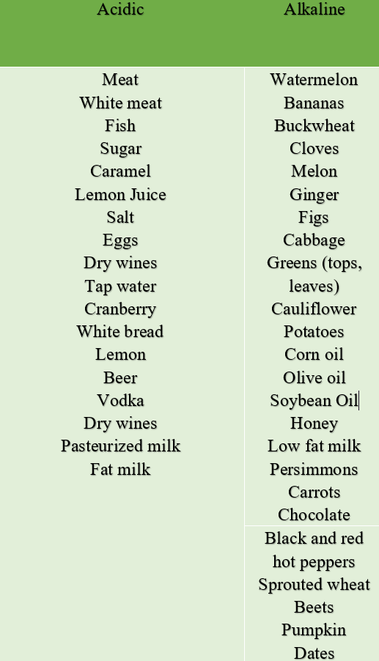

What is the meaning of the acid load index in your healthy eating?

Now keep watching and reading. There’s something perhaps you’ve never heard or read previously. Strive to have a fuller knowledge about healthy eating. Thus know about the acid load (AL) index. What’s the meaning of this?

If sulfuric acid-forming components (sulfur-containing amino acids in proteins) or organic acids (fats, carbohydrates) predominate in the food, AL is positive.

If alkaline-forming components (organic salts of magnesium, calcium, and potassium) predominate in the food, AL is negative. Computer analysis was used to determine the acid load for some foods.

The table below is represented in milliequivalents per 240 kilocalories.

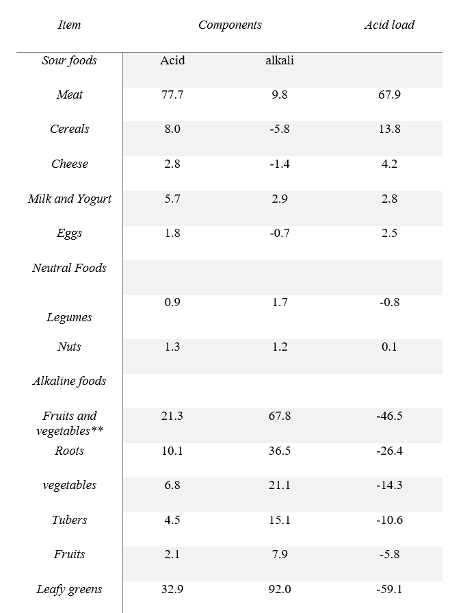

***The source is the American Journal of Clinical Nutrition. 2002, 76 (6): 1308-1316*.**

Fruits and vegetables** – Tomatoes, zucchini, eggplant, cucumbers, watermelon, melon, pumpkin, etc.

As you see, the meat-like products represent most of the acid-like foods. This means your digestion needs more energy and ferments to process the food. And all other foods with a high-acid index require more ferment, digestion work, and energy. On the other hand, alkaline-like products require fewer ferments for digestion.  
  
Knowing these facts, you will drastically improve your eating habits and improve your life

[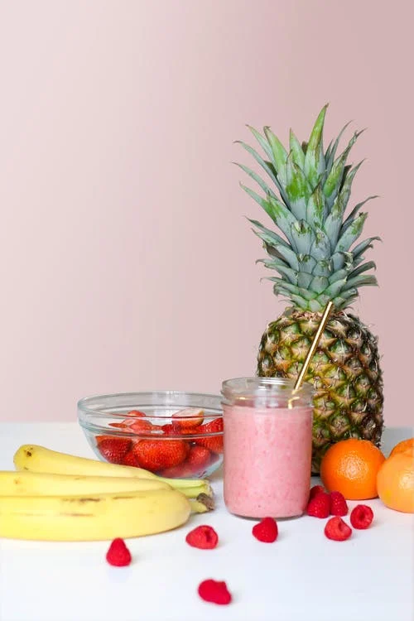](https://www.pexels.com/photo/strawberry-smoothie-on-glass-jar-775032/)

It’s time for you. Yes, to take charge of your health or let the doctors deal with your problem later. But you and I know – that we don’t want to give to doctors. Right? Keep reading about the pillars of healthy eating habits!

What are the pillars of healthy eating habits you either follow or face the bitterness of life?

First of all. Every man and woman of any age must remember these pillars of healthy eating. And here they are:

What is the best time for healthy eating?

Put your eating habits to work by eating from***5 AM till 7 PM***and never outside of these hours. If you want to eat outside these hours, just drink a lot of water to overcome hunger. Why? Because your pancreas gives special secrets to digestion and works at the best performance from 5 AM ***till 7 PM of your local time***. Why?

Because after **7 PM**, **your pancreas is literally going asleep till 5 AM.** This means eating later than **7 PM**means unhealthy eating and dangerous one on the long haul. And pass the work to ***the pineal gland*** ***(the epiphysis)***that produces –***melatonin***, the hormone responsible for good sleeping.

Interestingly, did you know how small this life-giving organ is in the center of the brain? **Just 3-4 mm.** Yet without this extremely valuable organ, none of the human beings are able to sleep and live.

***Remember this fact that make difference between life and death***: If the **pancreas** still working (if you’re eating after 7 PM). Then the pineal gland***is unable to receive the relay from the pancreas***until the pancreas finishes the work.

One of the common effects of lack of sleep and melatonin is very unpleasant diseases such as type 2 diabetes. Moreover, the pancreas works not rest and consequently suffers because of the constant work. That also triggers or aggravates various diseases.

Interestingly, nearly always diseases awake at the weakest point of the body. For instance, the heart, stomach, pancreas, or other organs. Once the certain organ is already exhausted – that is the best moment for the diseases to come.

Here’s the blueprint on how you can organize your healthy eating throughout the day

*Let’s say you eat at****7 AM****(cereals with vegetables or fruits).****At 12 PM****meat, fish, eggs, etc.****The exception is potatoes – this product isn’t appropriate to mix with protein-like food****because of the predominance of carbohydrates.*

***At 4 or 5 PM,****you take a lot of fruits, vegetables, meat, or whatever. Thus up to****7 PM, you’ve eaten 3 times.****And you’re fully energized. In addition, if you take a brief exercise or go to the gym (for 1 hour or so), you also would have the option to eat 3 times or so.*

Thus when you eat during certain hours: your body knows when you are eating and adjusts its system. And even prepares everything for the top quality digestion!

[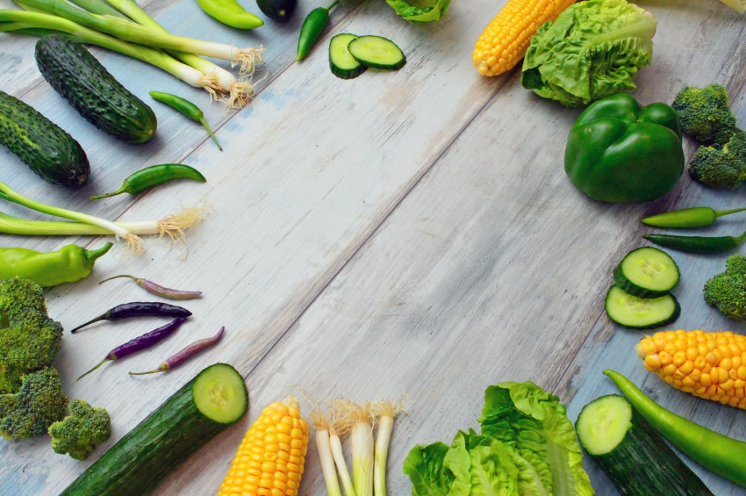](https://www.pexels.com/photo/assorted-vegetables-on-brown-wooden-table-1414651/)

Disobeying these rules already literally destroyed the health of billions of people around the globe so far

***The first rule of thumb is this:***you never, ever drink water, coffee, tea, or whatever. And even never make a single dip of water or sooner than 1.5 hours after the actual eating (for non-meat food or non-fish).

Drink water no sooner than 2 hours after the dish contained fish or meat. That’s because water is mixing the stomach’s juice. And all your stomach’s chain will be unable to fully digest the dish.

Basically, inappropriate drinking of water become one of the major problems and one of the most dangerous unhealthy eating habits. And one of the main causes of nearly all diseases imaginable!

***The second rule of thumb.***Food must be warm – approximately 36.6 degrees Celsius. And there’s the real cause of this – because our digestion starts to process the food, only in a case the temperature of everything you are eating or drinking reaches 36.6 degrees celsius – your current body temperature.

Thus if you eat hot food or drink hot coffee or hot tea or whatever, your natural digestion process will start only when the temperature will fall down to 36.6. Hint: It’s more dangerous than eating cold food. Because takes a lot of time for the colling (no conditioning inside your tract).

While cold food – heats faster to 36.6 (because of the body’s temperature). However, both cases are damaging the digestion system.

In the case of cold food or drinks, your food temperature must reach 36.6 celsius. Either way, it’s well known that hot food is more dangerous than cold.

But both of them are unlikely to improve your digestion and health. Try to always eat only warm food. Touch food or drink with your lips – it must feel nice, neither cold nor hot to you.

***The third rule of thumb.*** Food must be chewed well and carefully to facilitate digestion. In addition, remember to salivate the food in your mouth while chewing. Your mouth’s saliva contains special enzymes for the so-called primary processing of food, which prepare it for proper digestion in the stomach.

So various kinds of foods, especially fatty and meaty ones largely prepared for better digestion by careful chewing and salivating thoroughly.

Thus you never hurry up when you are eating because everything that is not properly chewed will damage the digestion. And take a lot of energy with time for the stomach’s system to properly digest. Want to know how much you need to chew the food? The food ready to swallow must be like the water you are drinking.

***The fourth rule of thumb.***Never mix carbohydrates (cereals, cereal products, bread, potatoes, sugar, jam, honey, candy) and protein (meat, fish, eggs, milk, legumes, broths, mushrooms, nuts, seeds).

While plant foods (vegetables, fruits, juices) are possible to mix with either Carbohydrates or Protein-like foods.

***Two exceptions you need to know and remember!*** ***The first exception*** is the mixing of proteins with the potato – because potato has prevailed of carbohydrates and consequently unhealthy as mixing other types of carbohydrates with proteins.

***The second:*** Meat, Fish, Eggs, and other proteins require a different composition of gastric juice. So, you never mix 2 types of proteins in one dish.

To achieve the perfect digestion effect! Further, eating proteins from one colon, as you’ve seen above – doesn’t also mean it’s safe to mix them in one dish.

Mixing mushrooms with nuts or something **requires a different type of acid** in your stomach. The same work with carbohydrates as well. Plants, however, in case of mixing – will have little or no difference because of the ability to be digested fast and easily.

***Remember the next rule of thumb.*** After the dish consisted of proteins, your carbohydrates-like dish is safe to eat after**4-5 hours**. And after the carbohydrates-like dish. It’s safe to eat the protein-like dish after **3-4-5 hours.**

Additionally, it’s highly recommended to eat the plant-like food **10-15 minutes** in advance before eating the protein or carbohydrate-like food. That’s how you’ll prepare and empower your digestion system for the top and healthy dish digestion.

The question about food proportion is very relevant, and here’s what you need to know. The proportion is this: 3/4 of your dish must consist of alkaline products and 1/4 of acid one. In the tables above you see what are the major acid and alkaline products.

[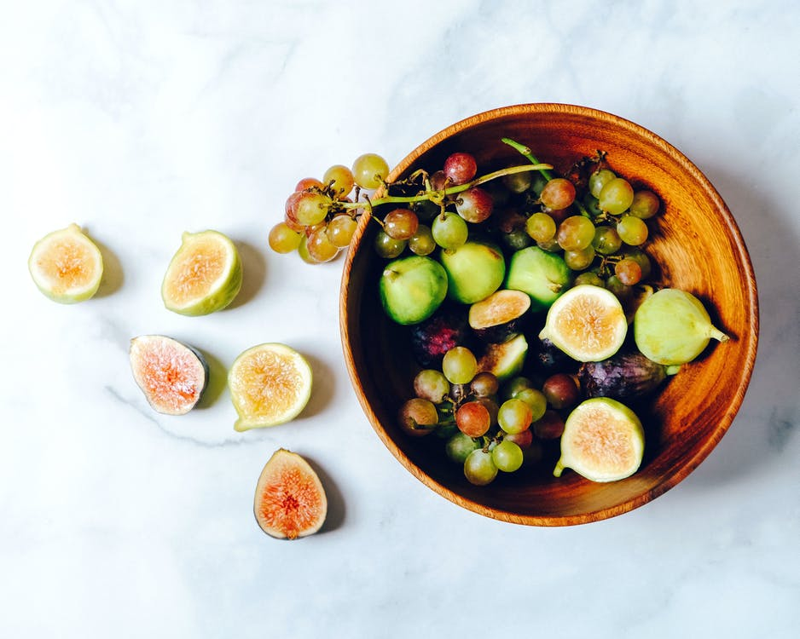](https://www.pexels.com/photo/assorted-fruits-in-bowl-1458695/)

Why do diseases are awakening once healthy eating habits suffer?

Believe it or not. Your health in the vast is dependent on your digestion and eating habits. Everything you consume is not going anywhere else except your bloodstream and organs. Moreover, the processes of elimination of toxins through the rectum or pores also depend on eating habits and the quality of food.

As the matter of fact, none of the diseases are arousing suddenly. In the case of eating habits, it’s the same. Bad eating habits are equal – the step-by-step destruction of the stomach’s microflora and digestion’s ability to process the food.

How do prevent diseases through healthy eating?

Firstly one of the areas of the digestion system starts to suffer. After a few years, other organs in the chain start to go offline (not working properly). And then this effect is summing up.

Moreover, decomposition products eliminated through the rectum must work perfectly. However, if bad eating habits and elimination processes start to suffer – then the real health issues are about to come.

Further, once the digestion is suffering, the body’s margin of the safety and compensation of the organism as a whole to prevent some degeneration processes are opening the doors to diseases.

Not only regarding the stomach but any kind of organ in the body. If to be accurate, those organs have already exhausted their safety margin.

Next, the men’s or women’s immune system starts to go off-line, and the option to prevent diseases is slowing from year to year… Consequently, your immune system will try to take everything they need to prevent or tackle a disease of any kind. Whether cancer or nearly every disease imaginable.

These days, after 20 or 30 years, problems are starting to show up. Teenagers, from 13 to 19 start to suffer from digestion relating problems. And the tendency is slowly moving toward bad habits even more.

If the bad eating habits continue, soon we’ll see, or maybe you already see the children from 8 to 12 years that already suffer from the wrong eating habits. It’s easy to stop the health-destruction process by the immediate implementation of the right eating habits listed above.

How to restore and improve your digestion with healthy eating?

You need to know the quality of products (origin, manufacturing, chemical compounds, storage history, etc.). The more you know about the products you are buying. The more you are healthy and wealthy in the end.

Even if you are a super-busy person and you experience a lack of time. Think about it for a moment – would you put your health on the line just because you are too busy to know what exactly you are buying and eating?

Moreover, if you have a family, children, and significant other. You are the one who is able to train them to eat healthily and be happier in their lives. Sometimes one person is capable to make all other healthier. Why not you?

The meaning of the meat you need to know to never have trouble with the animal-like proteins

The sensible thing to do is for people who live in villages or mountains who directly herd their cattle and consume them immediately after they are slaughtered.

The fact is that cattle, and other animals, as soon as they go to slaughter, have the least amount of toxins in their bodies. On the contrary, an animal that went to slaughter a few days ago or stored for a long time in a refrigerator – already has a certain amount of toxins – is not favorable for humans.

That’s why people living in the countryside or in the mountains rarely have health problems related to eating. Why? Because they eat fresh meat. Not the kind of meat that was achieved a few days ago. But today, nearly all big cities, except villages suffer from this.

Thus if you have to carry the straight diet – that’s probably because you already have the issue, which is guided by doctors. So, if you are lucky and have now digestion-related problems, you are capable of strengthening your body with the right eating habits listed above.

Any kind of stress is capable to disrupt your digestion and you need to know how to tackle this problem. Here are the winning methods you can apply [*to tackle a lot of stress issues.*](https://wellness-today-journal.com/winning-mental-power-that-beats-any-health-related-issues/)

[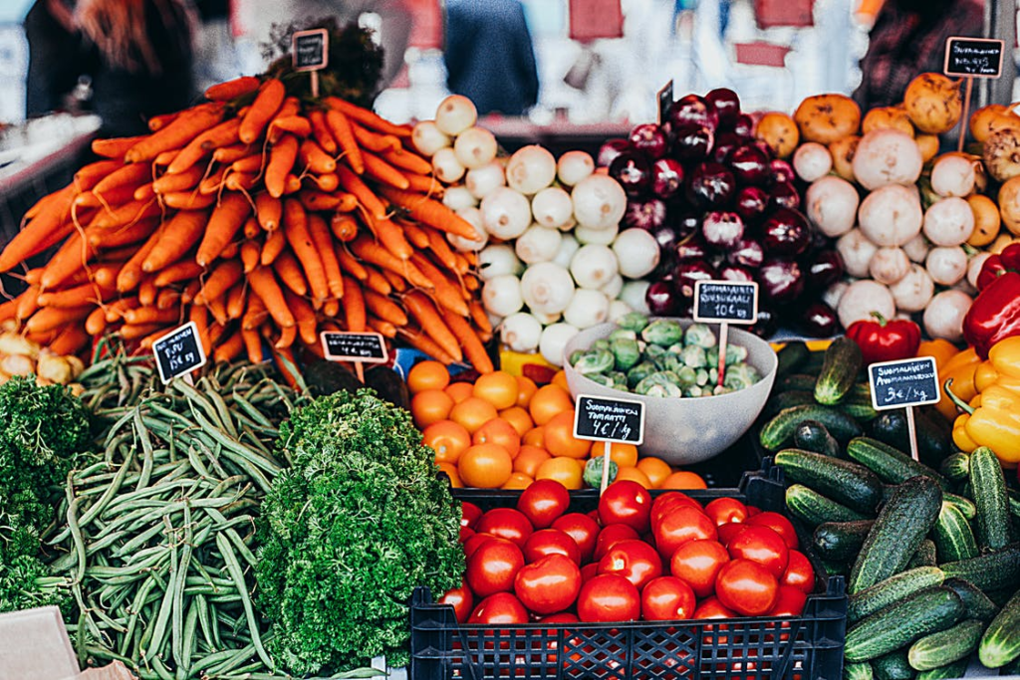](https://www.pexels.com/photo/variety-of-vegetables-on-display-1508666/)

Bonus: For those who want to learn how to properly drink alcohol during a feast

Of course, mixing the food is not very healthy. However, if you do it once in a while, let’s say up to 4 times per year. Nothing bad can happen if doctors prohibit this – you know the rules.

What’s prohibited – that is not allowed. Let’s begin to reveal the secret of proper alcohol drinking. Let’s get to it:

**Drink before you arrive at the feast – 2 glasses of clean water of 200 grams;**  
You must drink only pure water at a feast. And never you must drink Coca-Cola, coffee, tea, etc., or other types of drinks. Because all drinks except pure water will disrupt the process of neutralization of the alcohol.

Whiskey, wine, beer, vodka, or whatever. ***Now, read this rule carefully: After each glass of alcohol you drink, you must drink 2 glasses of water. This helps the liver to break down the alcohol very quickly.***

You drink clean water in the morning, right after you wake up (a glass or two). And you won’t have headaches, stomach aches, etc. Since the liver quickly cleared the body of any alcohol. Drager or other policeman’s device will also show nothing if you have followed the 3 rules above!

Your healthy eating habits are totally in your control

Everything you’ve read above is discovered by the Soviet-Russian professor of medicine [Neumyvakin Ivan Pavlovich](https://en.wikipedia.org/wiki/Ivan_Neumyvakin).

This wonderful person was one of the top doctors held responsible for the health of the soviet astronauts. Starting the [Vanguard Six mission,](https://en.wikipedia.org/wiki/Vostok_programme#Vanguard_Six) and following space missions from Vostok-1 to Vostok-6 and beyond.

The main idea was: How to put the astronauts and maintain their health under any circumstances in the spacecraft throughout all the space flight missions. This idea moves him to design such a system of eating and maintaining health when none of the doctors or surgery is possible.

Then his ideas passed to citizens and the idea was this: How to make everyone eat healthier and maintain healthier. Plus, make the visits to the doctors as rare as possible.

***If you like this issue why not share it with someone you love or respect? Our team wishes you the best! More often! Keep in touch with us!***

By the way!

We are only beginning to benefit you with the money-free content. Free of advertising and other unscientific and irrelevant junk information, which in case of health are dangerous! We’ll never allow ourselves to publish something that may hurt the health of people!