
Guangdong Eastern Packaging Machinery Co., Ltd

Instruction Book
Horizontal type premade bag packing machine

Attention
1.All parameters of computer controller and frequency converter of this machine have been set up and locked by password before delivery, The factory will not be responsible for any faults or damage due to user changes without permission.
During the testing period, operators should be under the guidance of our experienced staff , and know well the operating for this machine as soon as possible.
2.This machine should be earthed properly at level to ensure safety!
Note:
Due to the continuous improvement & update of our packing machine, please understand such relevant information would not further notice!
The company reserves the right to final interpretation!
Preface
Thank you for choosing the automatic packing machine series designed and manufactured by Guangdong Eastern Packaging Machinery Co., Ltd, Our products has the advantages of reasonable structure, superior performance, beautiful appearance, strong durability and safety. It may help you to save working labor, increase working efficiency and economic benefits.

Before installation and operating packaging machine, please be familiar with the contents of the "manual", it will help you understand the basic properties, structure, operation and maintenance methods, so that you can operating the packaging machine properly to prolong the service life.
Easternpack would be your sincere partner!

Catalogue

Chapter 1Safety………………………………………………………..……..……4
1、Safety matters………………………………..………..…………….…4
2、Safety devices……………………………………………….…………4
Chapter 2 Main Specification & Technical Parameter…………….………....5
1、Main specification………………………………………….……....….5
2、Technical parameter……………………………………….………..…5
3、Machine picture………………………………………...………………6
Chapter 3 Machine packing and handling……………………………….….…7
1、Packing………………………………………………………………..…7
2、Handling…………………………………………..…………..…………7
Chapter 4 Installation, power supply connection and start-up………...…7
1、Installation…………………………………………………………..…7
2、Power supply connection………………………………………..…7
3、Trial packing running……………………………..…………………7
Chapter 5 Machine adjustment while changing of bag size………………8
1、Shape of bag……………………………………………………….…8
2、Puting bag ……………………………………………………………9
3、Adjustment of vacuum bag opening………………………….…9
4、Upper conveying and bag stretching device adjusment……10
5、Lower conveying device adjustment……………………………11
6、Liquid filling & measuring device adjustment……….….….…12
Chapter 6 Maintenance …………………………………………….………...…12
1、Maintenance…………………………………………………….……12
2、Lubrication……………………………………………………..….…12
Chapter 7 Common problem and removing methods….……..………..…13
1、Electric common problem and removing methods……….…13
2、Mechanical common problem and removing methods…..…14

Chapter 1 safety
Notice
Before installing the machine, please read this “manual “carefully to avoid personal injury or machine damage.

1.Safety matters:
● For your safety, please turn off the safety protection device (such as a door and the door switch) when start running the machine ; and such safety device must not be removed or failure.
● When running the machine, the operator will check all the running parts. These areas shall not contain foreign bodies that may damage the machine
● In the running of the machine, it is strictly forbidden to extend the hand into the heat sealing area, other opening & closing area as well as moving parts.
● The air source and power supply shall be cut off When clean, repair or maintainance,
● If the machine is equipped with a filling device, do not put the hand into the device when it is filling.
● The total power supply and air source of the machine must be cut off during the period of stoping production.

**Safe areas where should be paid attention to**
The parts of the machine that may cause bodily harm are:
The heating block of the heat sealing device during the operation of the machine, opening and closing area of the heating sealing device, the running area of bag opening and delivery device and the conveyor belt area.

2.Safety device:
2.1 Safety door
Use transparent plexiglass safety door to prevent damaging machine and causing human body injury.
2.2 Emergency stop button
In the event of an emergency, press red "emergency" button on the control box , the machine will immediately stop running. After the fault is removed, just turn the button to the right side to reset.
2.3 Safety device examination
● Before starting, check the safety device whether on the normal working condition.
● The working condition of the safety device must be examined annually by professional technicians.

Warning
The heating temperature of the heat sealing device will be very high while the machine working. So when removing the protective devices in the area Should: “ Caution Heat”

Chapter 2 Main Specification & Technical Parameters
1.Main machine picture
See as below: picture: 2-1
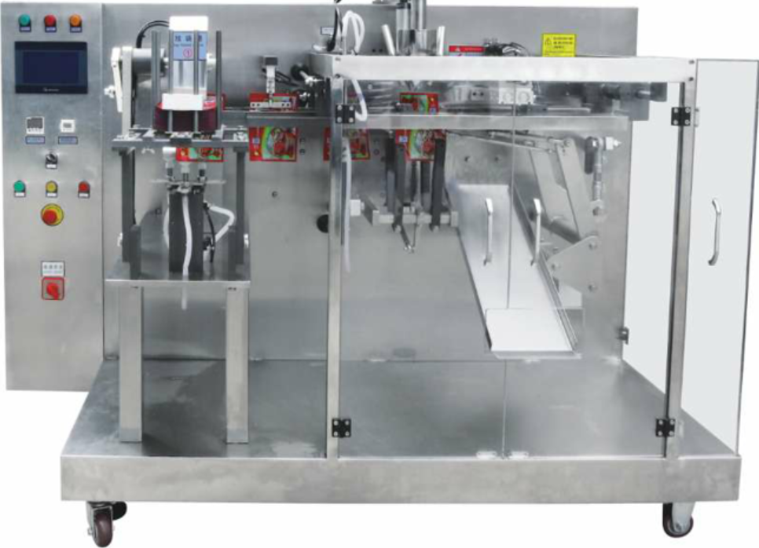
2.Technical Parameters

2.2 Working environment
Working temperature： 5-35°C
Relative temperature： ≤85%
Voltage： 380V±20V（3 phase/4 wires）/220V
2.3 Initial password: 1111
Notice:
- The actual work environment shall be based on the characteristics of the packaging material;
- The output shall be based on the net weight of the packaging material, i.e., the heavier the weight of each bag, the slower the rate of packing.
Picture 2-1
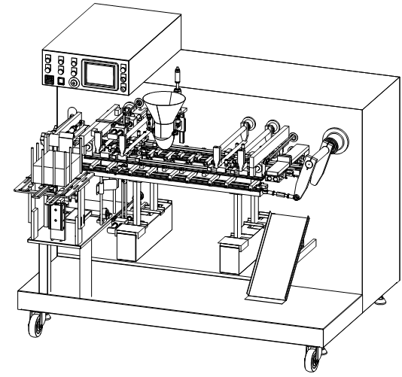
Chapter 3 packing and handling
1.Packing :
In addition to the user's instructions, the machine is usually packed in wooden cases. it should be handled with care, avoiding collisions and inversions, stacking of two machines is not allowed.

2.Handling :
After unpacking, the forklift fork into the bottom in front of the machine , the foot length of forklift must be long enough to reach the machine behind bars.

Chapter 4 Installation, power supply connection and start-up

- Installation
1.1 Sufficient space must be left in the vicinity of the machine so as to facilitate the adjustment of the product specifications, maintenance, lubrication and maintenance operations.
1.2 Adjusting the level of machine can be by adjusted the supporting legs, so that the machine is basically level to ensure machine stable.

2. Power supply connection
2.1 This machine adopts the lack of phase and phase sequence protection. First,confirm whether the voltage is consistent with this machine. After the power is “on”, the main switch on the lower right side of the box will turn to "ON" , if indicator light is ON. Means input voltage is correct ,and the machine can start working properly. Otherwise, indicating that the input voltage is incorrect and phase sequence does not agree with each other. The input power supply voltage shall be checked or any two phase lines of the three-phase power line to be switched.
2.2 The motor’s rotary direction whether is correct
Motor rotary direction has been tested before leaving the factory. Users are not allowed to change, otherwise it will cause damage to the machine.

3.Trial runing :
When the machine leaves the factory, it is usually tested well according to the packing material provided by the user, so it can be done as follows:
3.1 Turn the button on the touch screen to "automatic", and make sure the premade bags flat and pressed into the bag magazine.
3.2 Open the switches required on the touch screen.
3.3 Turn on the thermostat and set the temperature of the sealing head on the operating board until the set temperature is reached. (the temperature is usually based on the user's packing material)
3.4 Switch on ” vacuum pump open " on the touch screen .
3.5 Note： when machine running under no manual operation condition, press the in inching button , the machine slowly into the operating state, when determine the normal operation of the machine, then press the start button, the machine works properly
3.6 When determine the machine runing well, set the filling weight according to the operating instructions (when necessary , check the filling system by manual ), while continuous bag taking, machine will open feeding screw and valve, start feeding.

How to operate the machine:
Start-up steps; check whether the main packaging machine and supporting equipment are normally installed, check whether the power supply is in normal contact, voltage check (220/380). Tracheal examination, whether the air pressure is normal (0.62). Firstly, adjust the size of the bags needed in the bagging trough, adjust the size of the bags needed in each station, open the power supply to select the required energy, and put the bags into the bagging trough neatly. Press start to observe whether each station is working properly. Open the supporting equipment to cooperate with the operation.

- Parameters set-up
  - Homepage
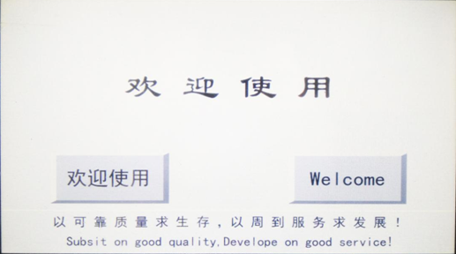

欢迎使用 | Click to enter Chinese interface  点击进入中文操作界面
Welcome | Click to enter English interface  点击进入英文操作界面

  - Function page
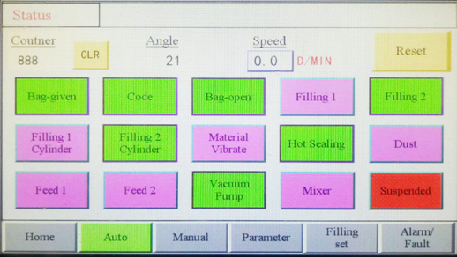

Auto: Click to start automatically running
自动：点击进入自动运行页
Buttons turn GREEN means ON, turn PURPLE means OFF.
按键为绿色表示已开启，为紫色表示已关闭。
Status  设备状态 | Any fault conditions will be displayed on the right  任何故障情况将在右侧显示
Coutner 生产计数 | How many bags have been produced  计算已生产包装数
Angle 当前角度
Speed 生产速度 | Packing speed 包装速度
Reset 故障复位 | If failure occurs, click to reset  如发生故障，点击复位
Bag-given 给袋 | Click to on/off automatically bag-giving  点击开关自动给袋
Code 打码 | Click to on/off automatically coding  点击开关自动打码
Bag-open 开袋 | Click to on/off automatically bag-opening  点击开关自动开袋
Filling1 下料1 | Click to on/off automatically material filling1  点击开关自动下料1
Filling2 下料2 | Click to on/off automatically material filling2  点击开关自动下料2
Filling1 Cylinder 下料气缸1 | Click to on/off filling1 cylinder  点击开关下料1气缸
Filling2 Cylinder 下料气缸2 | Click to on/off filling2 cylinder  点击开关下料2气缸
Material Vibrate 整料 | Click to on/off automatically material vibrating  点击开关自动整料
Hot Sealing 热封 | Click to on/off automatically hot sealing  点击开关自动热封
Dust 吸尘 | Click to on/off automatically dusting  点击开关自动吸尘
Feed1 给料1 | Click to on/off automatically feeding1  点击开关自动下料1
Feed2给料2 | Click to on/off automatically feeding2  点击开关自动下料2
Vacuum Pump 真空泵 | Click to on/off vacuum pump  点击开关真空泵
Mixer 搅拌 | Click to on/off automatically mixing  点击开关自动物料搅拌
Suspend 暂停 | Click to stop machine running  点击暂停机器运行

  - Manual
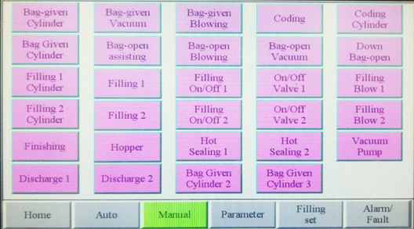
Manual: Each button clicks once and the section runs once.
人工操作：每个按键点击一次，该部分运作一次。
Buttons turn GREEN means ON, turn PURPLE means OFF.
按键为绿色表示已开启，为紫色表示已关闭。
Bag-given Cylinder  给袋气缸 | Click to run bag giving cylinder once  点击运行给袋气缸一次 | Bag-given Vacuum  真空给袋 | Click to run bag giving once  点击运行真空给袋一次
Bag-given Blowing  给袋吹气 | Click to run bag giving blowing once  点击运行给袋吹气一次 | Coding  打码 | Click to run coding once  点击打码一次
Coding Cylinder  打码气缸 | Click to run coding cylinder once  点击运行打码气缸一次 | Bag Given Cylinder  开袋气缸 | Click to run bag opening cylinder once  点击运行开袋气缸一次
Bag-open assisting  开袋辅助 | Click to run bag opening assisting once  点击运行给袋辅助一次 | Bag-open Blowing  开袋吹气 | Click to run bag opening blowing once  点击运行开袋吹气一次
Bag-open Vacuum  真空开袋 | Click to run bag opening once  点击运行真空开袋一次 | Down Bag-open  下开袋 | Click to run down bag opening once  点击运行下开袋一次
Filling1 Cylinder  下料气缸1 | Click to run filling1 cylinder once  点击运行下料气缸1一次 | Filling1  下料1 | Click to run filling1 once  点击下料1一次
Filling On/Off 1  下料开关1 | Click to on/off filling1  点击开关下料1 | On/Off Valve 1  开关阀1 | Click to on/off filling1 valve  点击开关下料1阀门
Filling Blow 1  下料吹气1 | Click to run filling1 blowing once  点击运行下料1吹气一次 | Filling2 Cylinder  下料气缸2 | Click to run filling2 cylinder once  点击运行下料气缸2一次
Filling2  下料2 | Click to run filling2 once  点击下料2一次 | Filling On/Off 2  下料开关2 | Click to on/off filling2  点击开关下料2
On/Off Valve 2  开关阀2 | Click to on/off filling2 valve  点击开关下料2阀门 | Filling Blow 2  下料吹气2 | Click to run filling2 blowing once  点击运行下料2吹气一次
Finishing  下料结束 | Click to finish filling  点击结束下料 | Hot Sealing1  热封1 | Click to run hot sealing1 once  点击运行热封3一次
Hot Sealing2  热封2 | Click to run hot sealing2 once  点击运行热封2一次 | Vacuum Pump  真空泵 | Click to on/off vacuum pump  点击开关真空泵
Discharge1  排料1 | Click to run discharge1 once  点击运行排料1一次 | Discharge2  排料2 | Click to run discharge2 once  点击运行排料2一次
Bag Given Cylinder2  给袋气缸2 | Click to run bag giving cylinder2 once  点击运行给袋气缸2一次 | Bag Given Cylinder3  给袋气缸3 | Click to run bag giving cylinder3 once  点击运行给袋气缸3一次

  - Password for Parameter page
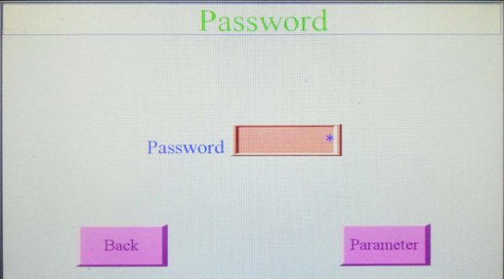
Password 密码 | Input password 输入密码
Back 返回 | Back to previous 返回上一级
Parameter 参数 | After input password, click to enter parameter setup  输入密码后点击进入参数设置

  - Parameter Page 1
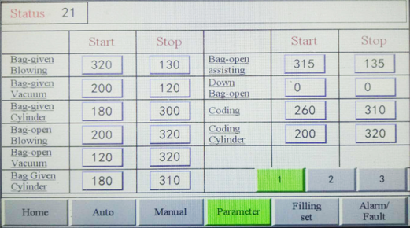

Status  设备状态 | Any fault conditions will be displayed on the right  任何故障情况将在右侧显示
Start 起始 | Starting parameter 起始参数设定
Stop 终止 | Termination parameter终止参数设定
Bag-given Blowing 给袋吹气 | Setting bag-given blowing parameter  设置给袋吹气参数
Bag-given Vacuum 真空给袋 | Setting bag-given vacuum parameter  设置真空给袋参数
Bag-given Cylinder 给袋气缸 | Setting bag-given cylinder parameter  设置给袋气缸参数
Bag-open Blowing 开袋吹气 | Setting bag-open blowing parameter  设置开袋吹气参数
Bag-open Vacuum 真空开袋 | Setting bag-open vacuum parameter  设置真空开袋参数
Bag Given Cylinder 开袋气缸 | Setting bag-open cylinder parameter  设置开袋气缸参数
Bag-open assisting 开袋辅助 | Setting bag-open assisting parameter  设置开袋辅助参数
Down Bag-open 下开袋 | Setting down bag-open parameter  设置下开袋参数
Coding 打码 | Setting coding parameter  设置打码参数
Coding Cylinder 打码气缸 | Setting coding cylinder parameter  设置打码气缸参数
1 第一页 | Page 1
2 第二页 | Page 2
3 第三页 | Page 3

  - Parameter page 2
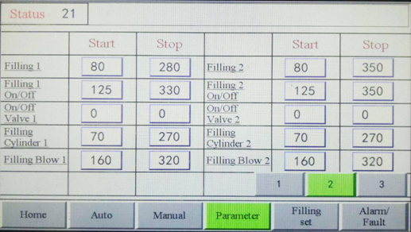

Status  设备状态 | Any fault conditions will be displayed on the right  任何故障情况将在右侧显示
Start 起始 | Starting parameter 起始参数设定
Stop 终止 | Termination parameter终止参数设定
Filling 1 下料1 | Setting filling 1 parameter  设置下料1参数
Filling 1 On/Off 下料1开关 | Setting filling 1 On/Off parameter  设置下料1开关参数
On/Off Valve 1 开关阀1 | Setting On/Off valve parameter  设置开关阀1参数
Filling Cylinder 1 下料气缸1 | Setting filing cylinder1 parameter  设置下料气缸1参数
Filling Blowing 1 下料吹气1 | Setting filling blowing 1 parameter  设置下料吹气1参数
Filling 2 下料2 | Setting filling 2 parameter  设置下料2参数
Filling 2 On/Off 下料2开关 | Setting filling 2 On/Off parameter  设置下料2开关参数
On/Off Valve 2 开关阀2 | Setting On/Off valve 2 parameter  设置开关阀2参数
Filling Cylinder 2 下料气缸2 | Setting filling cylinder 2 parameter  设置下料气缸2参数
Filling Blowing 2 下料吹气2 | Setting filling blowing 2 parameter  设置下料吹气2参数
1 第一页 | Page 1
2 第二页 | Page 2
3 第三页 | Page 3

  - Parameter page 3
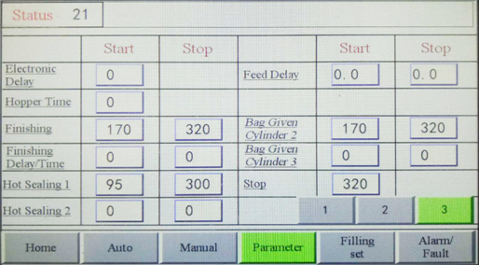

Status  设备状态 | Any fault conditions will be displayed on the right任何故障情况将在右侧显示
Start 起始 | Starting parameter 起始参数设定
Stop 终止 | Termination parameter终止参数设定
Electronic Delay 电子延迟 | Setting electronic delay parameter  设置电子延迟参数
Hopper Time 料斗下料时间 | Setting hopper filling time parameter  设置料斗下料时间参数
Finishing 下料结束 | Setting finish filing parameter  设置下料结束参数
Finishing Delay/Time 下料结束延迟 | Setting filling delay parameter  设置下料结束延迟参数
Hot Sealing 1 热封1 | Setting hot sealing 1 parameter  设置热封1参数
Hot Sealing 2 热封2 | Setting hot sealing 2 parameter  设置热封2参数
Feed Delay 给料延迟 | Setting feeding delay parameter  设置给料延迟时间参数
Bag Given Cylinder 2 给袋气缸2 | Setting bag-given cylinder 2 parameter  设置给袋气缸2参数
Bag Given Cylinder 3 给袋气缸3 | Setting bag-given cylinder 3 parameter  设置给袋气缸3参数
Stop 暂停 | After press the stop button, machine stop running for how long  按下暂停按键后机器暂停运行时间
1 第一页 | Page 1
2 第二页 | Page 2
3 第三页 | Page 3

  - Filling set
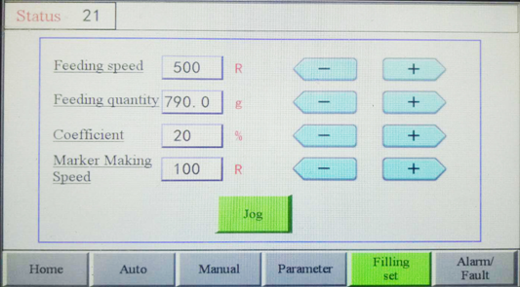

Filling set 下料设置
Status  设备状态 | Any fault conditions will be displayed on the right  任何故障情况将在右侧显示
Feeding speed 给料速度 | Adjust feeding speed设置给料速度
Feeding quantity 给料数量 | Adjust feeding quantity设置给料数量
Coefficient  重量系数 | Adjust feeding weight coefficient  设置给料重量系数
Marker Making Speed  排料速度 | Adjust material making speed  设置排料速度
Jog  点动 | When the button is pressed, the machine runs, and when the button is released, the machine stops.  按住按键不放机器持续运行，松开按键机器停止运行。
4.9.Alarm/Fault page
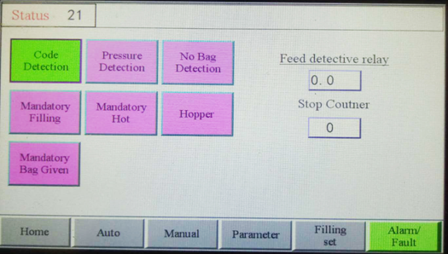

Buttons turn GREEN means ON, turn PURPLE means OFF.
按键为绿色表示已开启，为紫色表示已关闭。
Status  设备状态 | Any fault conditions will be displayed on the right  任何故障情况将在右侧显示
Code Detection  色带检测 | Click to on/off coding ribbon detection  点击开关打码色带检测
Pressure Detection  气压检测 | Click to on/off air pressure detection  点击开关气压检测
No Bag Detection  无袋检测 | Click to on/off no bag detection  点击开关无袋检测
Mandatory Filling  强制下料 | Click to filling mandatory  点击强制下料
Mandatory Hot  强制热封 | Click to hot sealing mandatory  点击强制热封
Mandatory Bag Given  强制给袋 | Click to giving bag mandatory  点击强制给袋
Feed detective relay  上料故障检测时间 | Setting after how many seconds feeding error happens the alarm sounds  上料故障发生后，报警延迟时间设置
Stop Coutner  停机延包 | How many bags can still be packed after press the stop button  按下暂停按键后，停机延迟可包装袋数

Attention:
Press the emergency stop button if necessary (Red mushroom button)

Chapter 5 machine adjustment while changing of bag size

1.Bag shape:
Within the specified bag size range, the machine can be used for the separation, operation and sealing of various prefabricated bags. And sealing forms are diverse, sealing mould can be changed according to customer requirements. Examples are shown in Figure 5-1 below:

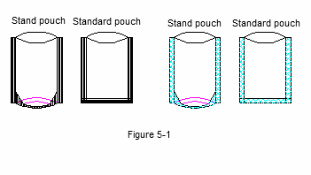
2.Puting bag :
On the left side of the machine, there is a prefabricated bag magazine, please make sure the prefabricated bag flat placed well, and use pressure bag block gently put down, as shown in figure 5-2:

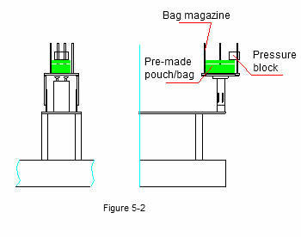

3.Adjustment of vacuum bag opening :
The suction device is divided into upper suction port and lower suction port (see Figure 6-10). The specific adjustment method is shown in figure 6-11. Upper suction parts, Move the E to the A, the bag opening becomes larger, move to B becomes smaller. Lower suction part, Move the H to the C. The opening of bag becomes larger; move to D then become smaller. the above adjustment, F and G should be adjusted together.
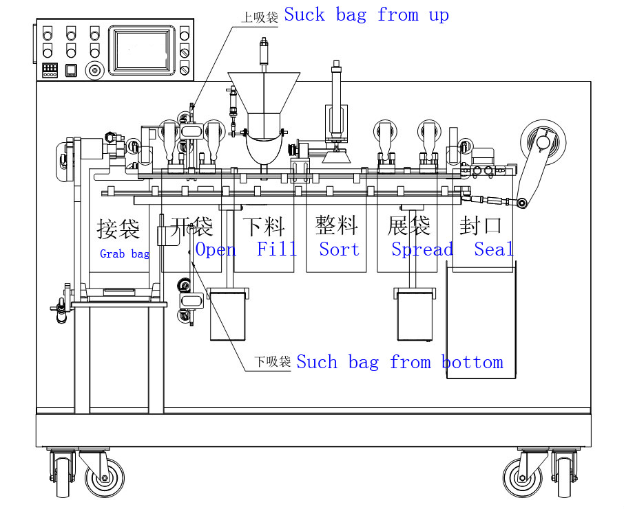

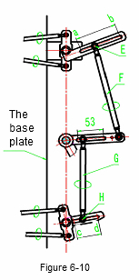
4.Upper conveying and bag stretching device adjusment
4.1 This adjustment is required only if the package size is changed. As shown in Figure 6-12, just adjust the position of the sliding axle seat of the extension bag zone, and tighten the fixed bolt when the adjustment is finished.
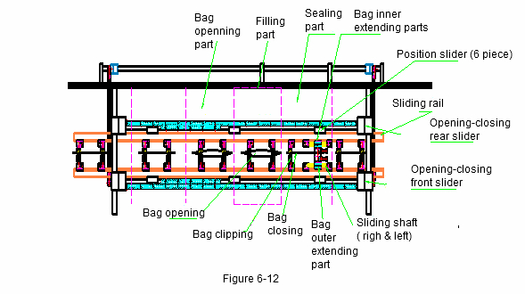
4.2 You can choose the positions of different hole to set sealing bag position so as to achieve the best effect on the smoothness of the sealing. But it should be noted that after adjustment, the location of the two side expansion of bag must be corresponding

5.Lower conveying device adjustment
This adjustment is required only when the bag size need to be changed. As shown in Figure 6-13, when F moves to C, the opening distance becomes smaller; it moves to D, and the opening distance becomes larger.
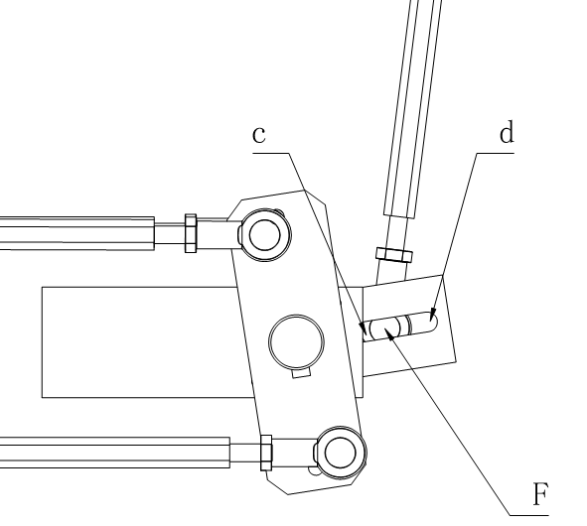
6.Liquid filling & measuring device adjustment:
Liquid paste filling metering, through the electrical system control panel button, "increasing feeding" or "reducing feeding" to adjust the weight , until achieve the required dose..
Make fine tuning by setting the electrical parameters. It can adjust the angle of filling material to realize the early and late time of filling as well as the long and short time of filling.

Chapter 6 Maintenance
1.Maintenance
- According to the nature of the products packaged by users, the machines are cleaned regularly, according to the 8 hours/day work regulation.
- Clean the surface of the heat sealing block with copper wire brush every day, keep the tooth surface clean so that the sealing edge of the bag can be sealed and leveled.
- Vertical and horizontal join axis and other rolling axis should keep clean, every week
- Regular cleaning of air systems and vacuum system filters.
- Electronically control system cleaning work once a week.
- Lubrication
- Dust or dirt should be removed before lubrication.
- Most of the rotating parts of the machine are equipped with self-lubricating bushings, which should be lubricated when they are daily maintained.
- Additional lubrication point distribution points (Fig 7-2).
- In order to ensure the normal operation of the machine, the lubrication interval is provided as a reference because it also depends on the ambient humidity, dust conditions and corrosion conditions.
- The cam contact surfaces are lubricated daily.
- Other rolling bearings are lubricated weekly, and all types of joint bearings are lubricated weekly.
- The gear box is changed oil once a year.
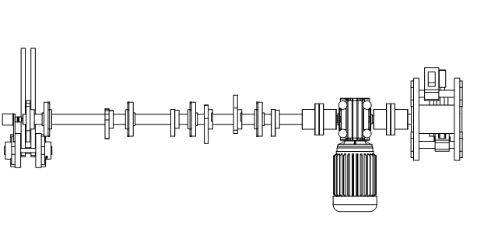
Chapter 7 Common problem and removing methods
1.Electric common problem and removing methods
Faults | Reasons | Removing methods
Cannot start | 1.No power input, indicator no light | Check power supply and circuit breaker in electric box.
Cannot start | 2.Emergency stop button is pressed | Reset emergency stop button
Cannot start | 3.Converter overload or parameter error | Turn off the power switch and turn on in 2 minutes.
Cannot start | 4.Machine is in automatic runing mode | Start the manual mode on the touch screen
Can start but  Cannot runing | 1. Machine is in automatic runing mode | Start the auto run mode on the touch screen
Can start but  Cannot runing | 2. Machine is in the output alarm state | Alarm signals such as temperature exceeding difference should be checked
Self stop | 1. Motor overload protection has started | Check thermal relay, motor load and mechanical overload
Self stop | 2. Abnormal or excessive temperature | Check the heating rod voltage and temperature sensors
Self stop | 3.No power | Check whether the input power and load switch are tripped
Filling not workable | 1.Filling switch off | Open the filling switch in the touch screen
Filling not workable | 2.No bag | Put bag

2.Mechanical common problem and removing methods
Faults | Reasons | Removing mathods
Empty bag seal not firm | 1. The surface of the block tooth is stained or stained with packing inner membrane, colloid and material | Wipe off the surface of the sealing block with copper brush
Empty bag seal not firm | 2. The blocking temperature does not match the melting temperature of the packing material | Proper sealing temperature should be adjusted according to different packing materials
Empty bag seal not firm | 3. The sealing pressure is not enough or the teeth are uneven | Adjust the cylinder pressure or the adjusting screw and nut of the sealing block
Sealing not firm after filling | 1. Poor adjustment of bag spreading device | The position of the expansion bag should be readjusted
Sealing not firm after filling | 2. The packing bag is too small, and the upper sealing has material inclusion | Check the capacity of the packing bag to meet the requirements and remove the dirt on the sealing block
Sealing not firm after filling | 3. Increase the packing speed without increasing the temperature | Increase packing speed should be increase sealing temperature accordingly
Sealing unevenly | 1. Package material problem | Choose more reasonable package materials
Sealing unevenly | 2. Sealing temperature is too high | Setting the temperature that suits the package
Noisy | lack of oil lubrication equipment caused by screw loosening | Regular refueling and inspection of moving or vibrating parts screws
Mechanical crash while runing | The reset spring or tension spring of the cam is broken cause the mechanical action is in conflict | Press the stop button quickly, replace the intact spring or the extension spring, then start again after troubleshooting
Bag fell on the platform | The suction angle of Suction cylinder is wrong | Correct the angle of each suction bag cylinder in the touch screen
Bag skew after sealing | Bag puting unevenly | There are 3 pipe panels in front of the bag magazine to adjust the direction of the bag (Figure 5-2)

